Machine Learning Techniques for Cybersecurity: Malicious Website Classification

Josh Clayton
Department of Computers & IT, Victoria University
NIT3202: Data Analytics for Cybersecurity
Dr. Bee Bee Chua
April 13, 2025

Table of Contents
Executive Summary 1
Introduction 1
Literature Review 2
Dataset Description 3
Methodology 4
Technical Demonstration 5
Performance Evaluation 9
Conclusion 12
Bibliography 13

Figures & Tables
Figure 1 Malicious Website Detection Workflow 4
Figure 2 Data Loading and Preprocessing 5
Figure 3 Encoding Categorical Variables, Removing Irrelevant Columns, and Splitting the Dataset 6
Figure 4 Encoding Categorical Variables, Removing Irrelevant Columns, and Splitting the Dataset 6
Figure 5 Random Forest Algorithm Result 7
Figure 6 Logistic Regression Algorithm Result 8
Figure 7 Support Vector Machine (SVM) Algorithm Result 8
Figure 8 Creating Table Comparison and Visualize it with Plot 9
Figure 9 Creating Table Comparison and Visualize it with Plot 10
Figure 10 Bar Chart Comparison Between Each Algorithm 10

Executive Summary
This report presents a mini-project on detecting malicious websites using machine learning techniques. A structured dataset containing URL characteristics and network traffic features is used to train and evaluate supervised classification models. The primary objective is to assess the effectiveness of three algorithms—Random Forest, Support Vector Machine (SVM), and Logistic Regression—implemented in R. Data preprocessing involved handling missing values, encoding categorical variables, and splitting the data into training and testing subsets. The models were evaluated using performance metrics including accuracy, precision, recall, and F1-score. Existing research highlights that traditional methods such as blacklisting URLs and IP addresses, although commonly used, are inefficient due to their reliance on manual updates and limited scalability (Eshete, 2011). Machine learning offers a more dynamic and scalable solution for identifying previously unseen threats. However, limitations of this project include the static nature of the dataset and constrained feature diversity.

Introduction
As the internet rapidly expands, malicious websites have become one of the biggest cybersecurity concerns, serving as vehicles for phishing, malware distribution, and data theft. Conservative blacklisting method, although widely adopted, are impractical due to the need of constant updates and their inability to detect uncommon threats. To address this, machine learning offers a scalable and dynamic solution for classifying malicious websites based on identifiable URL and network traffic features.
This study applies three supervised learning algorithms—Random Forest, Support Vector Machine (SVM), and Logistic Regression—to detect malicious websites using a structured dataset that includes both lexical and network-based features. The dataset comprises characteristics such as URL length, special character frequency, TCP exchange volume, and WHOIS metadata.
Model performance is evaluated using four key metrics: accuracy, precision, recall, and F1-score. These metrics provide a balanced assessment of each model’s ability to correctly identify malicious versus benign websites.
Previous research, including the study (Eshete, 2011) and the conference (Xu, 2013), demonstrated the effectiveness of machine learning models in outperforming traditional blacklists by analyzing lexical and host-based features. These insights reinforce the suitability of automated classification methods in cybersecurity analytics.
The remainder of this report includes a literature review of detection approaches, a description of the dataset and preprocessing steps, a methodological workflow, technical implementation in R, a performance evaluation of the models, and a conclusion summarizing key findings and recommendations.

Literature Review
Detecting malicious websites is a crucial aspect of modern cybersecurity. Traditional methods such as blacklisting and heuristic-based detection have been widely used. Blacklists rely on manually or automatically compiled databases of known malicious URLs and IP addresses, offering fast lookups but lacking the ability to detect zero-day threats. Heuristic approaches, on the other hand, inspect suspicious behaviors such as hidden iFrames or obfuscated JavaScript, but they often produce false positives and require frequent manual updates.
Recent research has emphasized the effectiveness of machine learning (ML) techniques for malicious website detection. (Eshete, 2011) demonstrated that classification models trained on lexical and host-based features significantly outperform blacklist-based methods in both accuracy and generalizability. Their models used features such as URL length, character patterns, and WHOIS information to identify malicious intent.
In a separate study, (Xu, 2013) highlighted the challenges of relying solely on human-generated rules, noting that manual analysis cannot scale with the dynamic nature of web-based threats. Machine learning, by contrast, can learn from large volumes of labeled data and adapt to evolving attack patterns.
Additionally, the work by (Singhal, 2020) introduced a hybrid deep learning framework that incorporates content-based features and behavioral signals to enhance detection accuracy further. These studies collectively illustrate that ML not only improves threat detection but also provides a scalable, automated alternative to human analysis, which is prone to delays, biases, and inconsistency.

Dataset Description
The dataset used in this study consists of labelled website records classified as either malicious (1) or benign (0), based on a variety of lexical, network, and WHOIS-based features. It was provided in CSV format with structured columns and includes 20 features such as URL_LENGTH, CHARSET, CONTENT_LENGTH, and TCP_CONVERSATION_EXCHANGE. These features were extracted from honeypot-based traffic logs and WHOIS database queries, offering a comprehensive profile for each URL.
Before analysis, the dataset underwent preprocessing to ensure data quality and model compatibility. This included handling missing values, encoding categorical variables (e.g ., CHARSET, SERVER, and WHOIS_COUNTRY) using one-hot encoding, and converting date fields like WHOIS_REGDATE into numerical formats. The dataset was then split into training (70%) and testing (30%) subsets using stratified sampling to maintain class balance.
Key features identified for classification include lexical indicators such as URL_LENGTH and NUMBER_SPECIAL_CHARACTERS, WHOIS attributes like WHOIS_UPDATED_DATE, and network activity data including REMOTE_IPS and APP_BYTES. These features collectively enable the detection of abnormal patterns that are typical of malicious websites.

Methodology
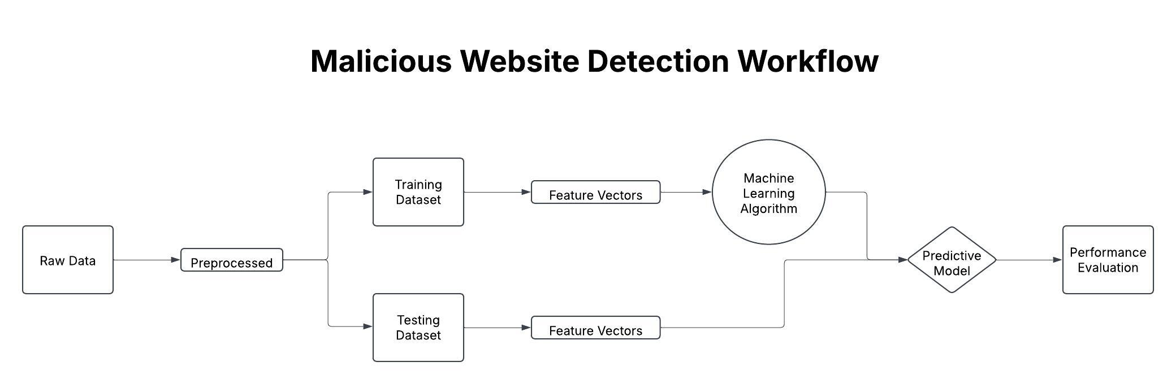
Figure 1 Malicious Website Detection Workflow
The workflow for malicious website detection begins with collecting raw data consisting of URL and network-based features. The dataset is preprocessed to handle missing values and encode categorical variables. It is then split into training and testing sets. Feature vectors are extracted and used to train machine learning algorithms, including Random Forest, SVM, and Logistic Regression. The trained predictive model is then applied to the testing set to generate predictions. Finally, the model's performance is evaluated using accuracy, precision, recall, and F1-score metrics to determine the most effective classifier.

Technical Demonstration
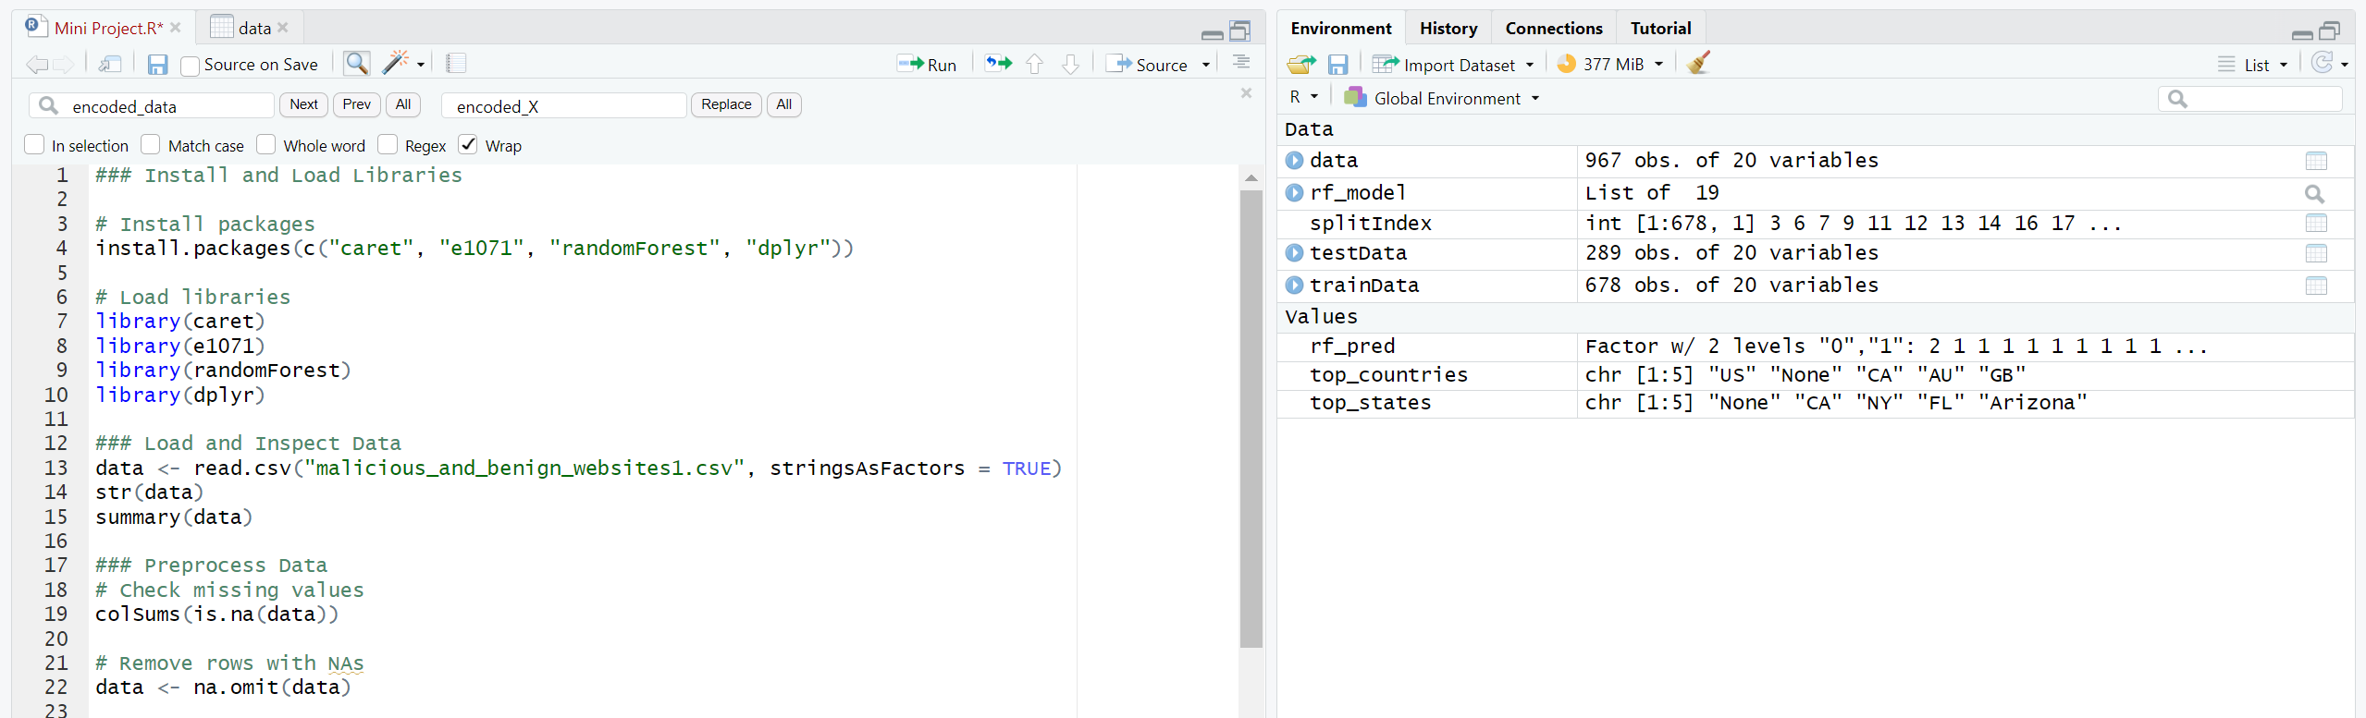
Figure 2 Data Loading and Preprocessing

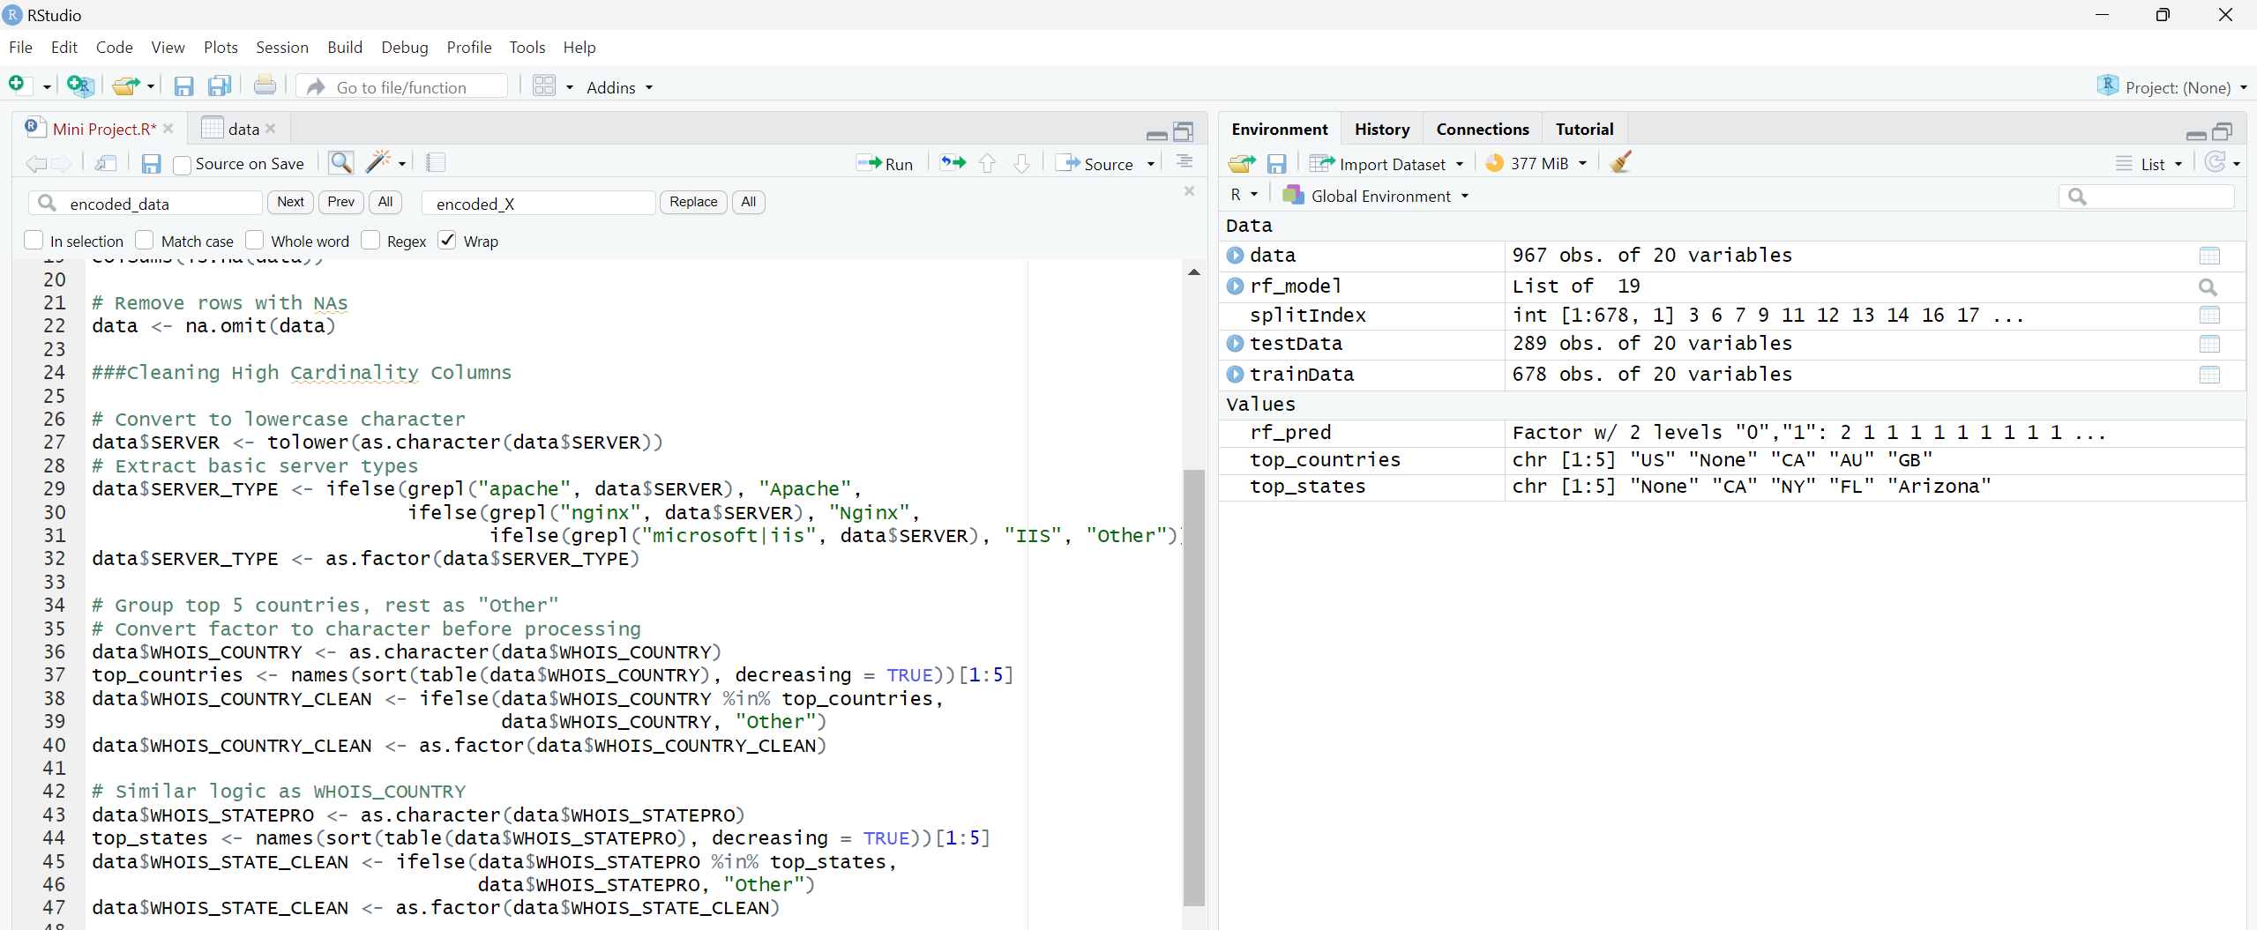
Figure 3 Encoding Categorical Variables, Removing Irrelevant Columns, and Splitting the Dataset
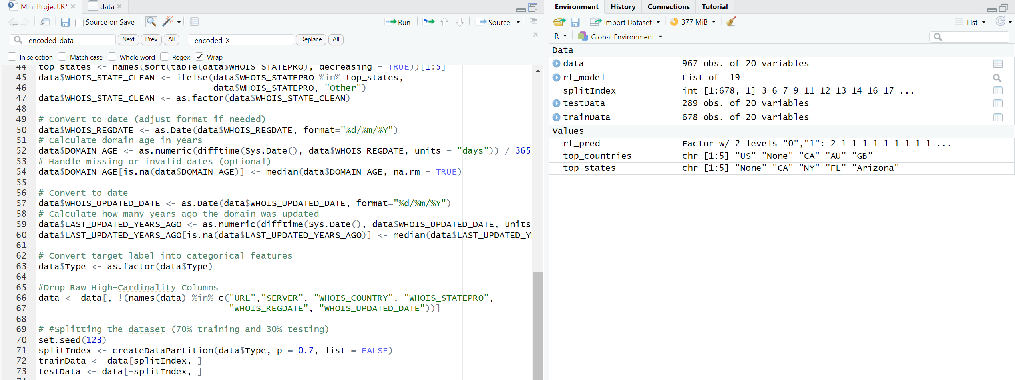
Figure 4 Encoding Categorical Variables, Removing Irrelevant Columns, and Splitting the Dataset
This chapter demonstrates the process of building and evaluating classification models in R to detect malicious websites. The dataset was first loaded and pre-processed by removing missing values and encoding categorical variables with low cardinality. Irrelevant columns like URL were excluded. The cleaned dataset was then split into 70% training and 30% testing sets.
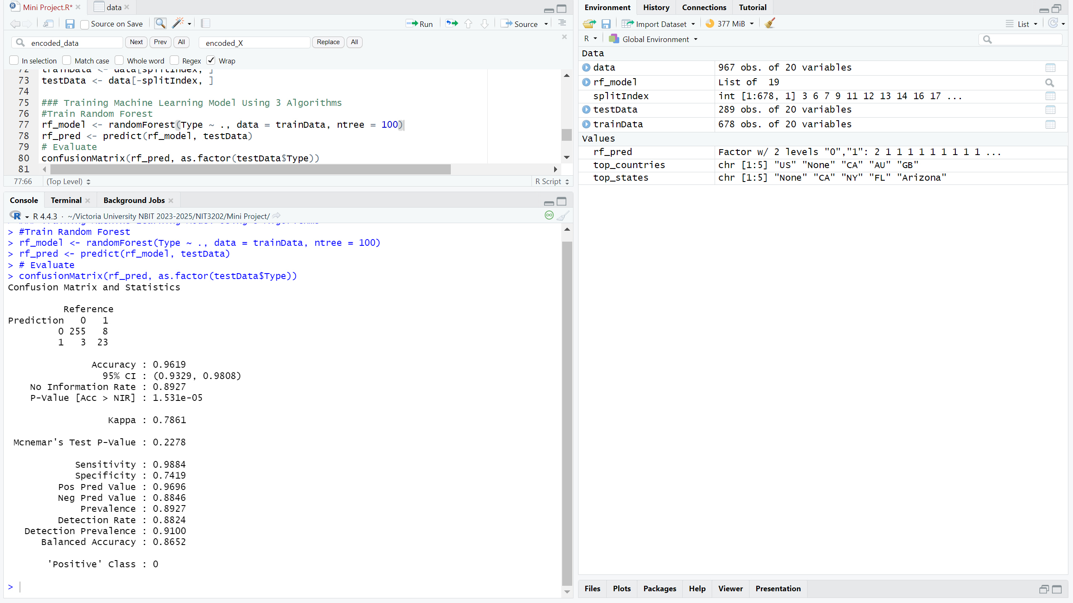
Figure 5 Random Forest Algorithm Result

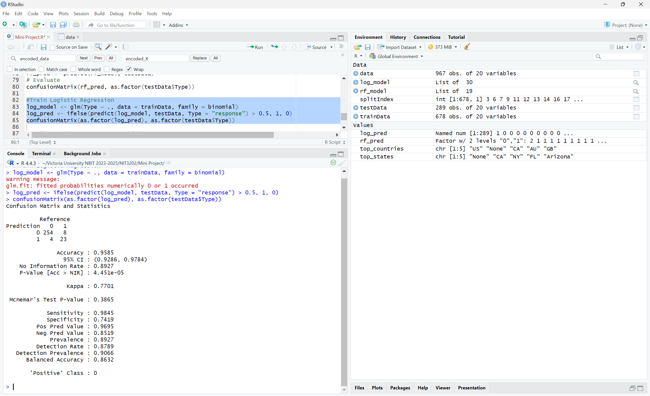
Figure 6 Logistic Regression Algorithm Result
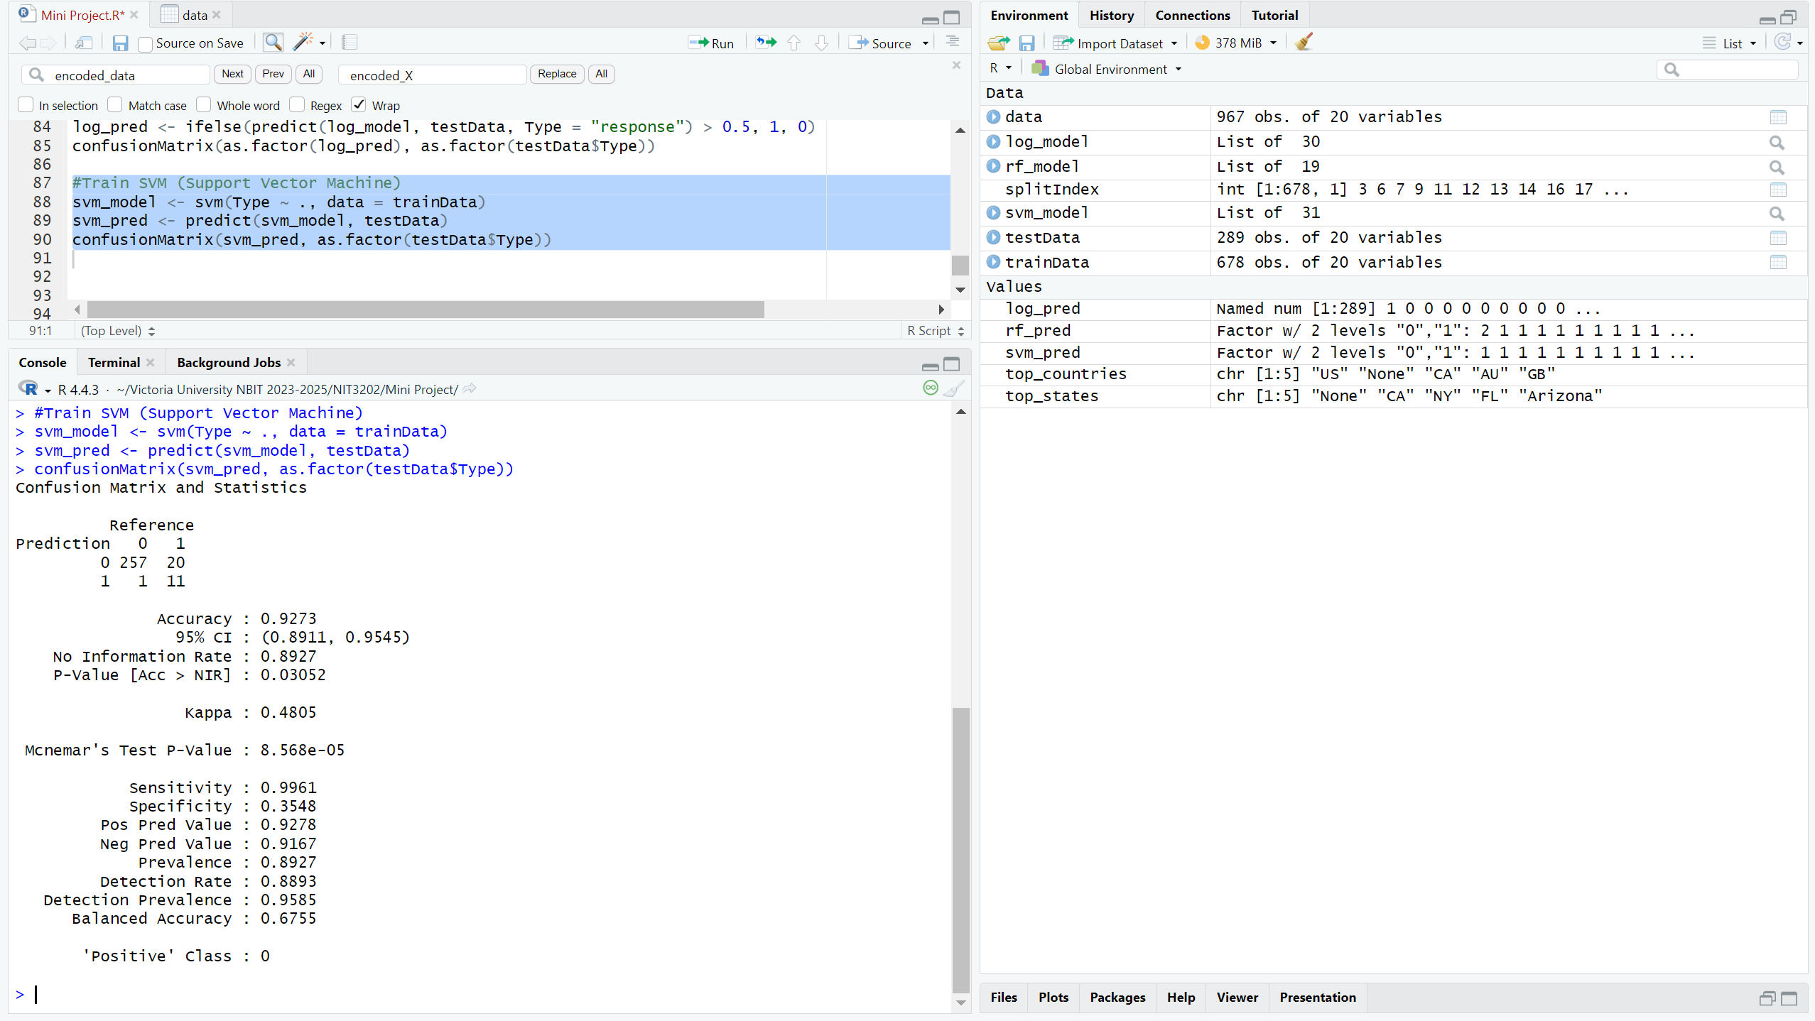
Figure 7 Support Vector Machine (SVM) Algorithm Result

Three machine learning models were trained: Random Forest, Logistic Regression, and Support Vector Machine (SVM). The Random Forest model was implemented using the randomForest package with 100 trees and achieved high accuracy. Predictions were made on the test set and evaluated using confusion matrices and metrics such as accuracy, precision, recall, and F1-score.
Similarly, Logistic Regression and SVM were trained and evaluated as shown in Figures 6 and 7. Each model’s performance was compared to determine the most effective classifier for this task. The results show that Random Forest consistently outperformed others across almost all metrics.

Performance Evaluation
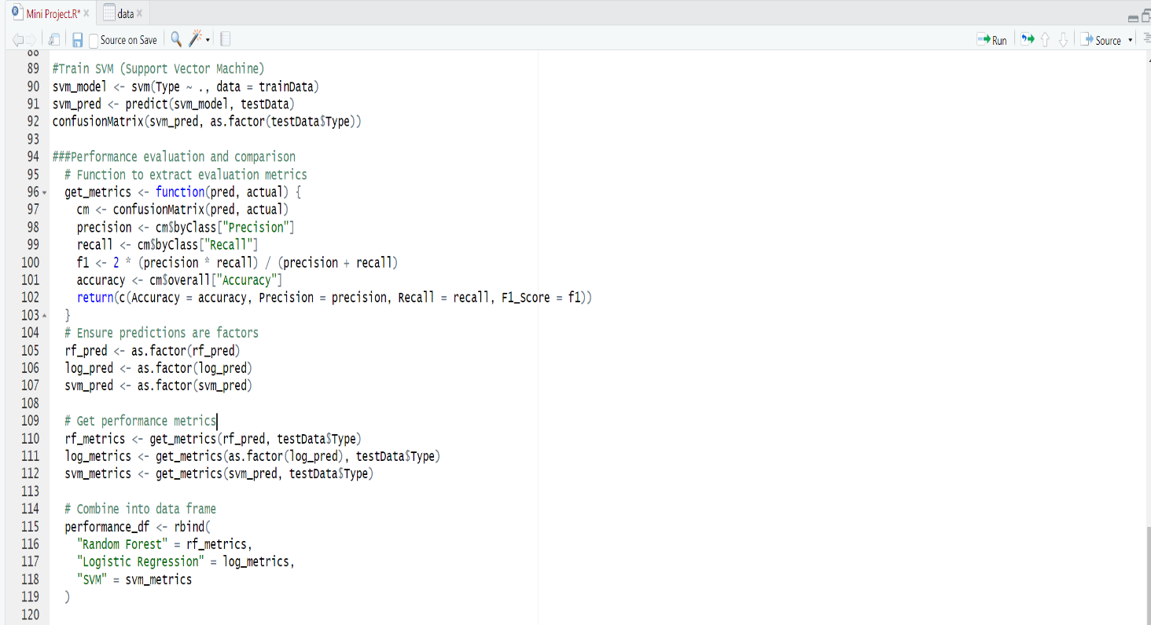
Figure 8 Creating Table Comparison and Visualize it with Plot
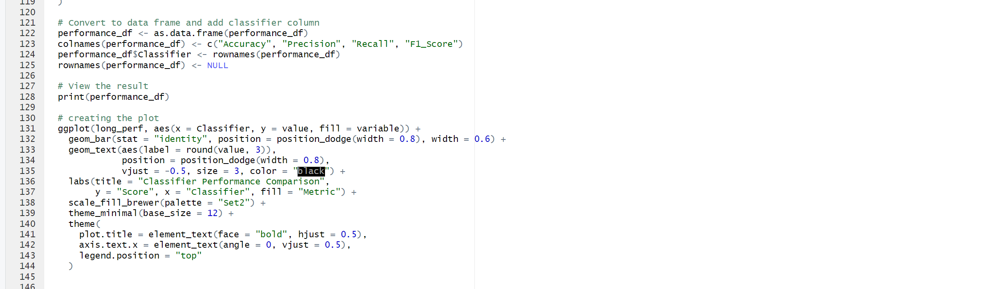
Figure 9 Creating Table Comparison and Visualize it with Plot
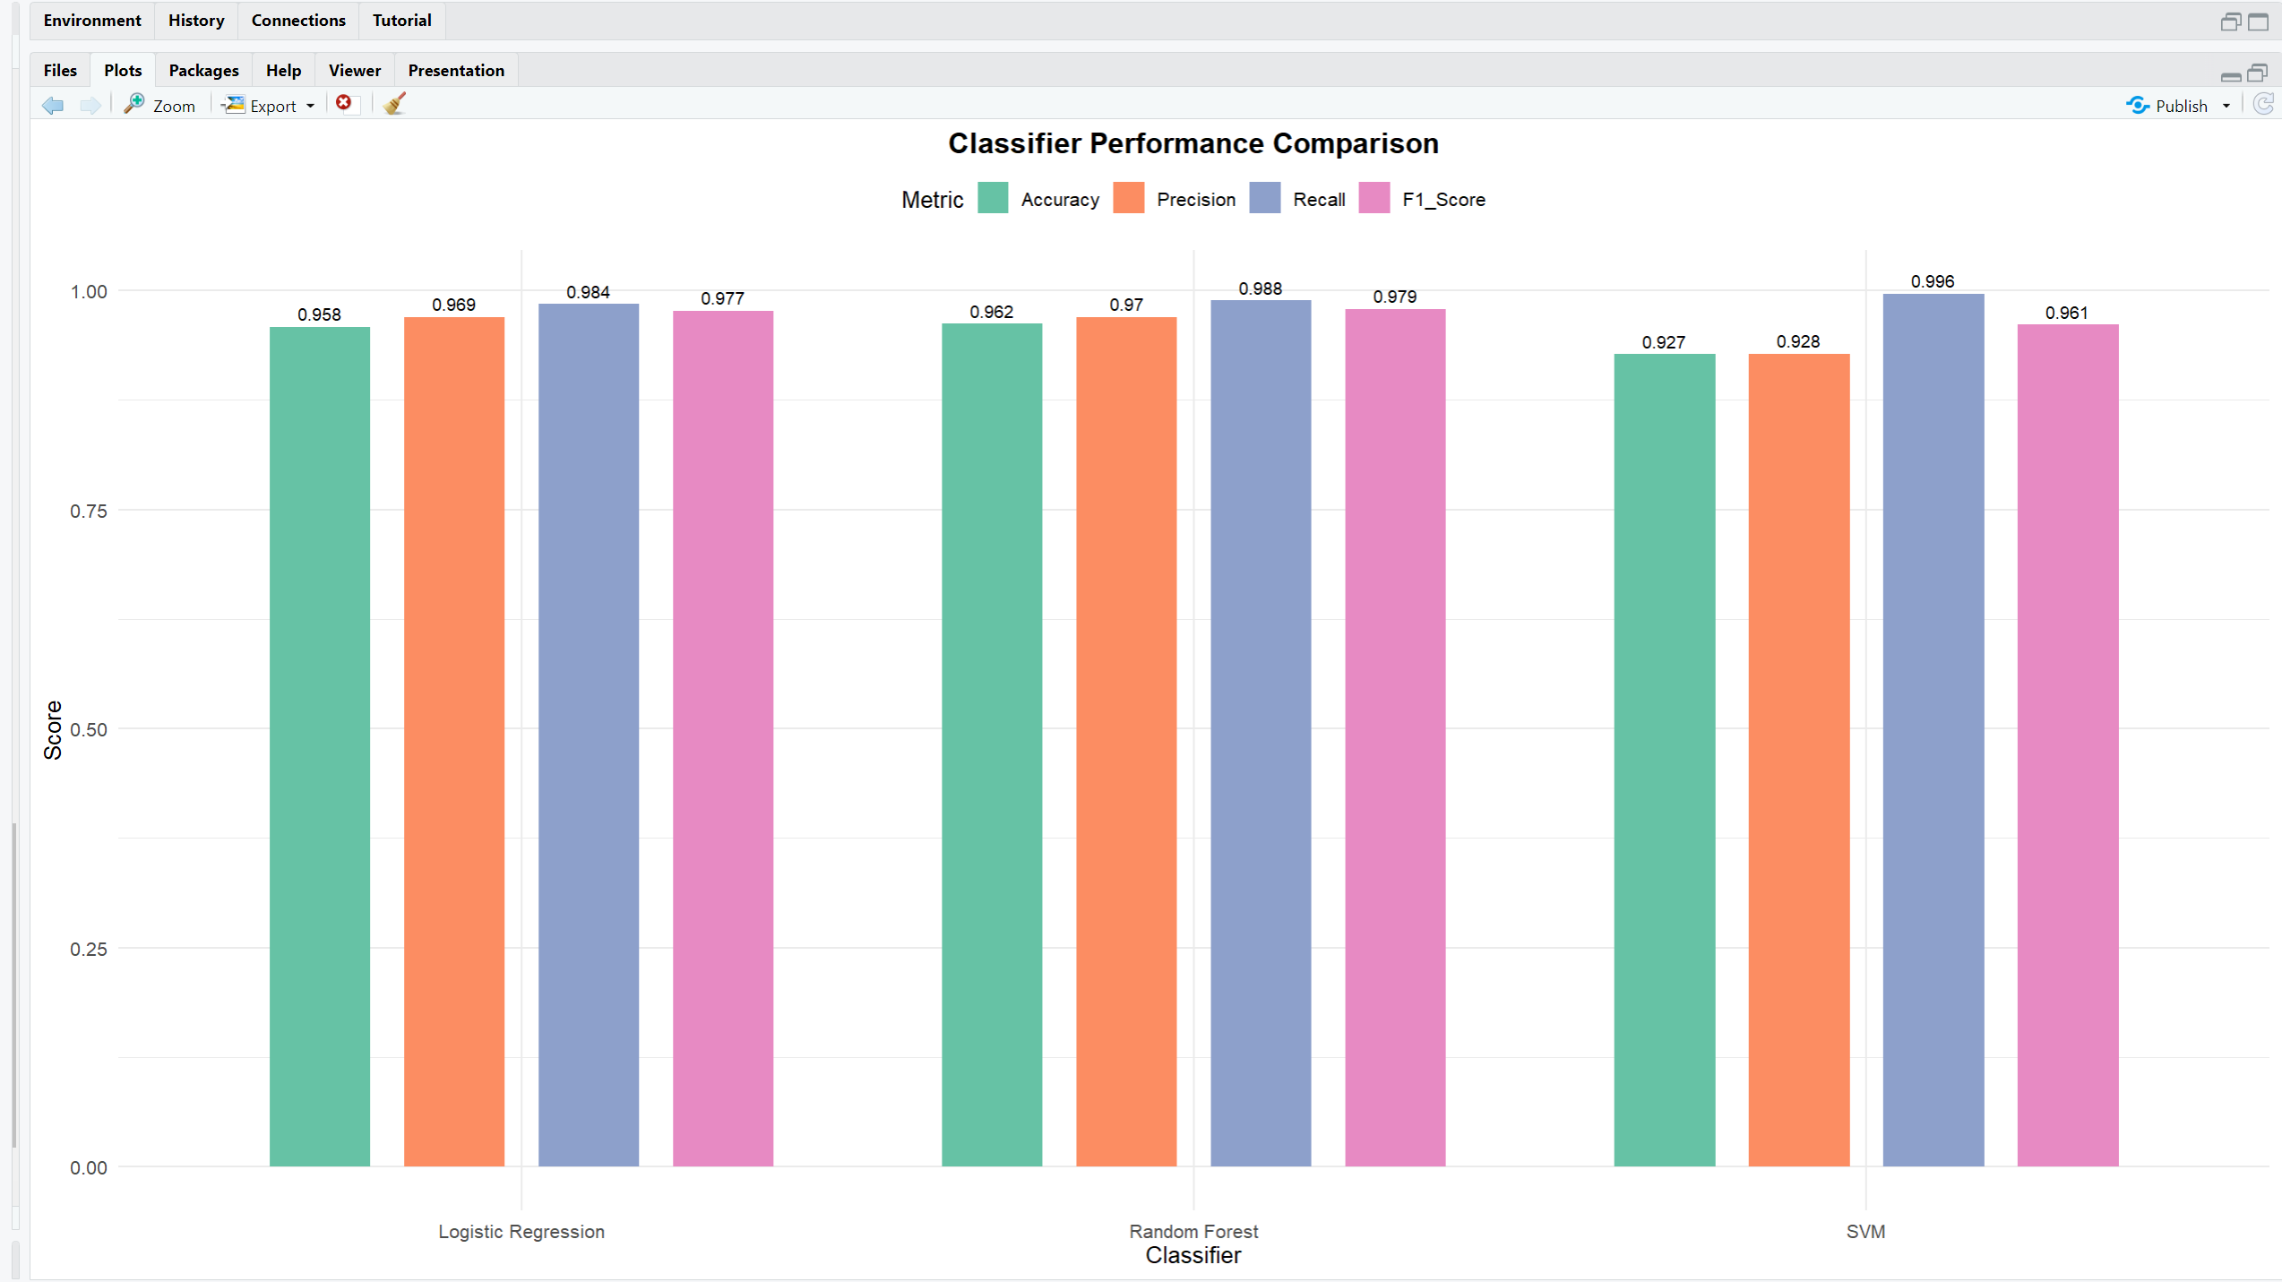
Figure 10 Bar Chart Comparison Between Each Algorithm

This chapter presents a performance comparison of three machine learning classifiers—Random Forest, Logistic Regression, and Support Vector Machine (SVM)—for the task of malicious website detection. The models were evaluated using key metrics: accuracy, precision, recall, and F1-score, which are essential in binary classification problems, especially in cybersecurity contexts where false positives and false negatives have significant implications.
As shown in Figure 10, Random Forest demonstrated the highest overall performance, achieving an accuracy of 96.2%, precision of 97%, recall of 98.8%, and an F1-score of 97.9%. This indicates that the model is both accurate and balanced, effectively minimizing both false positives and false negatives.
Logistic Regression followed closely, with 95.8% accuracy, slightly lower precision (96.9%) and recall (98.4%), and an F1-score of 97.7%. While still a strong model, its slightly reduced sensitivity suggests a higher likelihood of missing some malicious websites compared to Random Forest.
SVM had the highest recall at 99.6%, suggesting strong detection capability for malicious websites. However, this came with a trade-off in precision (92.8%) and overall accuracy (92.7%), which could increase false positives.
Based on these results, Random Forest is the most suitable model due to its balance across all metrics. The visualized bar chart provides a clear comparison, making it evident that Random Forest offers the best trade-off between precision and recall, which is critical for minimizing detection errors in cybersecurity systems.

Conclusion
This project focused on developing a machine learning model to detect malicious websites using a structured dataset containing various technical features. After preprocessing and transforming high-cardinality attributes, three classification algorithms—Random Forest, Logistic Regression, and Support Vector Machine (SVM)—were implemented and evaluated. The evaluation was based on accuracy, precision, recall, and F1-score.
The findings showed that Random Forest outperformed the other classifiers, achieving the highest accuracy (96.2%) and a strong balance between precision (97%) and recall (98.8%), making it the most reliable model for identifying malicious sites. Although SVM showed superior recall, its lower precision could lead to more false positives, which is undesirable in real-world applications.
In conclusion, Random Forest is recommended as the best-performing algorithm for malicious website detection due to its consistent performance across all metrics. This model can significantly enhance cybersecurity efforts by providing accurate and dependable threat detection.

Bibliography
Eshete, B. a. V. A. a. W. K., 2011. 2011 First SysSec Workshop. Malicious Website Detection: Effectiveness and Efficiency Issues, pp. 123-126.
Singhal, S. a. C. U. a. S. R., 2020. Machine Learning & Concept Drift based Approach for Malicious Website Detection. s.l., s.n.
Xu, L. a. Z. Z. a. X. S. a. Y. K., 2013. Cross-layer detection of malicious websites. New York, Association for Computing Machinery.

