In this presentation I will demonstrate why the HLS tool could improve the development of detector electronics.

This software would accomplish this by increasing the accessibility and productivity of digital circuit design for the physics community.

It is important to mention that I started from complete scratch, i.e., no knowledge of HLS, FPGAs and how to test digital circuits. The reason I mention this is to demonstrate later on how HLS could open up firmware development to more people.

Before I go into the aims of my project, I think it would be useful to give some context. First of all, I will explain what DUNE is and what it is trying to accomplish.

Next slide

DUNE Experiment

- The DUNE collaboration is an international organisation tasked with probing the neutrino sector
- DUNE involves a long baseline neutrino experiment consisting of two underground detectors. The neutrino beam reaches about 30 km underground near the midpoint of the travel line between the near and far detectors, which spans the width of North America.
- One of the requirements of DUNE operation is that several thousand neutrino interactions must be recorded over the period of 10 years. This is influenced by four things:
  - The intensity of the neutrino beam
  - The probability of neutrino oscillation within the DUNE baseline (2%)
  - The cross section of the detector interaction
  - The detector mass.
- Proton beam intensity is limited by damage to target, so a large detector mass and multiple detectors are required at the far detector.
- Each far detector cryostat will contain 17.5 kt of liquid argon.
- The reason for DUNE being underground is the 165 kHz cosmic ray rate interfering with neutrino event readout
- Near detector reduces uncertainty to the few % required: measurements are made by comparing the difference between the results from both detectors.

So what are DUNE’s objectives?

Objectives

- DUNE aims to provide insight into lepton sector CP violation, in order to explain neutrino mass, neutrino oscillation and the dominance of baryonic matter in the universe.
- Other objectives include studying black hole formation via large-signal neutrino detection from supernova events, and observation of proton decay modes.

How do neutrinos link into the standard model and LCPV?

Next slide

Neutrinos and the SM
- All particles predicted by the SM have been experimentally confirmed. The community is beginning to look at ways to probe BSM physics to find the solution for unexplained issues such as the asymmetry of matter and antimatter
- Experiments probing the neutrino sector could help with this. Things that are still unknown involve:
  - If neutrinos are Majorana or Dirac type, or if right handed neutrinos exist (don’t explain, no time).
  - Why their mass scale is so much lower than other fermions
  - What the mass of each neutrino is exactly (besides a cosmological limit set in place for the sum of all three – 50 eV)
  - The exact values of the parameters that govern their flavour oscillation
- Leptonic CP violation could explain the matter-antimatter asymmetry via leptogenesis, since the well-established CPV in the quark sector does not provide a rate high enough to account for the current composition.

Now we need to know how DUNE acquires this data.

Next slide

ProtoDUNE DAQ

- ProtoDUNE detectors consist of a LAr TPC contained within a cryostat. The detector contains two drift volumes separated by a central cathode plane. This is flanked by two anode planes, made up of APAs that connects and send data to the FELIX interface system.
- Neutrino nucleon interactions ionise charges and produce scintillation photons which are collected by the APAs and photo-multiplier tubes respectively
- Mention APA setup: 2560 wires, 10 fibres accommodating 256 wires each. Their connection to FELIX which contains 10 inputs (one for each fibre)

It would be useful to explain what FELIX is.

Next slide

FELIX

- The APA data is fed into 10 MGT modules (one for each fibre) that convert it into computational bits. Each MGT is fed into a HF processor, tasked primarily with identifying neutrino events from the incoming data.

Lets zoom in to the HF processor

Next slide

- Initially the data enters the HF via a formatting module called the data router, which outputs the formatted data packets into the TPG core.
- The TPG core strips the packet header containing the source wire, time stamp and origin of the data. It then filters and processes 64 ADC samples, with 4 processing units. The purpose is to detect hits from the filtered signal.
- This processed data is then multiplexed by the arbitrator into the CR interface.
- The CR interface acts to prevent back pressure events. These are instances where the processing rate of a module further ahead in the interface cannot match the speed of incoming data. This leads to a pausing of operations to let it catch up. This mechanism is a central theme in this project. It also filters out corrupted or zero-hit packets and formats the remaining packets to be received by the CR module
- The CR module accepts the hit data produced by the DUNE firmware, buffers and formats them to be sent to a direct memory access interface for further processing outside of FELIX.

So what is HLS, and how does it relate to FELIX?

Next slide

HLS

- HLS converts high abstraction languages such as C++, ANSI, SystemC and MATLAB into hardware description languages at the register transfer level.
- RTL is a digital circuit design abstraction that models a synchronous digital circuit in terms of the flow of signals between registers and logical operations performed on said signals. The circuit is synchronised to a clock signal of constant frequency.
- HDLs describe digital logic circuits that can be implemented by an FPGA. FPGAs contain components like
  - BRAMs
  - LUTs
  - FFs
  - DSPs and more
- One can synthesize a top function into a HDL with the support of implementation instructions called directives.
- Directives aid in customising the performance, resource implementation and interface protocol.

What am I using this for?

Next slide

Aims

- Provide an account of the user experience when generating HLS design
- Determine if HLS is a viable tool for physicists to use for detector-based FPGA development
- Determine if HLS could increase the pace of data acquisition at DUNE and other particle physics projects
- Address points on the slide and diagram

Before I talk about the findings, I will give you some background on the algorithms that were redesigned. This will provide some insight into the behaviour being implemented as a digital circuit, starting with the first module in the TPG core.

Next slide

Pedestal Subtraction
- The pedestal subtraction algorithm was the first mechanism to be redesigned in HLS
- It is the first of two signal filtration modules. Its purpose is to subtract the base background noise level, a.k.a the pedestal, from each ADC sample, to isolate the true signal peaks
- Each data channel has its own constantly changing pedestal, as per the algorithm (explain the algorithm).
- It operates via an AXI4 stream protocol framework. The AXI4 signals act as:
  - Validation signals
  - End of packet flags
  - Back pressure flags
  - Carriers of the 16-bit ADC samples
- Discuss flow diagram

Next Slide

FIR filter

- The second signal filtration module to be redesigned from the TPG core, connected to the output of the pedestal subtraction block.
- The purpose is to remove random signal noise from the pedestal-subtracted ADC sample, as well as amplify signal peaks. This makes it easier for the hit finding algorithm to identify hits. Peaks are more distinct and less noisy (as you can see by the analogue waveform), meaning less false hits.
- It achieves this by employing a 32 tap register, low pass filter with customisable coefficients.
- Discuss algorithm diagram

So what contingencies do we need to fit in with the FELIX framework?

Next slide

Required behaviour and solutions

- The most important requirement of each design is that it is self-sufficient. This means register continuity during the process of a packet and between packets. Achievable via permanent memory elements like BRAMs and power-on initialisation registers.
- After a packet is processed in one of the 64 wires processed by a TPG unit, said wire is assigned its own values (e.g. the pedestal and accumulator values) that need to be remembered and processed the next time a packet enters that wire.
- There must exist an SSR mechanism that saves these values at the end of each packet, and then restore the values assigned to the next wire. This was achieved in two ways:
  - The first was to connect to an external SSR block written manually in HDL and restore from port inputs.
  - The second was to generate a permanent internal BRAM or partitioned memory that is accessed to save and restore these values
  - Restoration had to be delayed several clock cycles after the end of the current packet and before the next packet to avoid the invalidation of output values from the current wire or the next wire
- All modules in the TPG core must be pipelined to ensure a steady throughput. Therefore all the redesigned blocks were required to accept inputs on every clock cycle, regardless of the latency. This can be achieved by:
  - Optimisation directives
  - Additional logic branching and avoidance of register dependency issues
- The final requirement was a back pressure response of maximum one clock cycle, meaning all block operations must pause within the clock period. This could also be achieved in two ways:
  - Engineer designs with a latency of one clock cycle, so that any pipelined input signal would have an effect one clock cycle afterwards.
  - Use HLS’s AXI4 stream interface directives that handle this behaviour automatically

New slide
- The operation of these blocks were tested in a software called Questasim, which provided a visualisation of the incoming and outgoing signals as well as an output sample text file to compare to the expected results.
- Reference the waveform

So how did the validated designs compare to the manually developed versions?

New slide

Design Comparison

- In the end, singular-clock latency was achieved for all designs in order to accommodate the required back pressure behaviour
- Generating a HLS-automated AXI4 interface was not possible within the time constraints
- This meant that significantly more resources were required to implement the in-built SSR designs, as you can see by the utilization statistics.
- The most important disparity is the difference in the numbers of LUTs and FFs required. This was caused in part by the logical complexity of each block being forced to perform at a latency of one.
- If the performance could be reduced in order to reduce the resource utilization, then a fair comparison between HLS and manual HDL implementations could be made. AXI4 directives would have allowed this (mention test that proved working back pressure at latency greater than one).

What did we learn from these findings?

Conclusion
- Requires some knowledge of FPGAs and digital circuits in order to write implementable high abstraction code. Learned lots of techniques not explicitly mentioned in the documentation. Too many to go into.
- The synthesized, machine-written code is illegible, meaning the debugging process offers very little transparency into what is going wrong. This is in contrast to manual HDL development.
- HLS provides an edge in the pace of firmware development and offers very varied results in the efficiency of resource delegation according to the wider community. It depends on the required behaviour and experience of the user.
- HLS can provide very high performance, even in complex designs
- Total resource usage for LUTs and FFs did not exceed 0.5% of the total available, which over 10 HF processors would sum to 5%. This is manageable.
- Considering where I started from, I can vouch for the accessibility of HLS
- This could be an extremely useful tool that allows physicists, who are typically familiar with high abstraction languages, to quickly develop high-speed digital circuitry. This was only previously possible by expert firmware engineers.
- The pace of detector development could increase drastically as a result.

Future work

- Redesign hit finder algorithm
- Generate automatic AXI4 interface in HLS
- Design a new algorithm and compare to the redesign process.

Extra slides
focus on the first 3 bullet point and the top picture.
-It's a bidirectional interface between the FrontEnd ( Detector) and the PC (computers that readout dat from the FPGA and store it)
-the ATLAS FELIX can support different protocols but DUNE basically uses the so called Full Mode/GBT (that's the one that provides the 9.6 Gbps)
-there have been different types of FELIX boards, but the one we currently use is the FLX-712 with 16 PCIe links and 12 available links

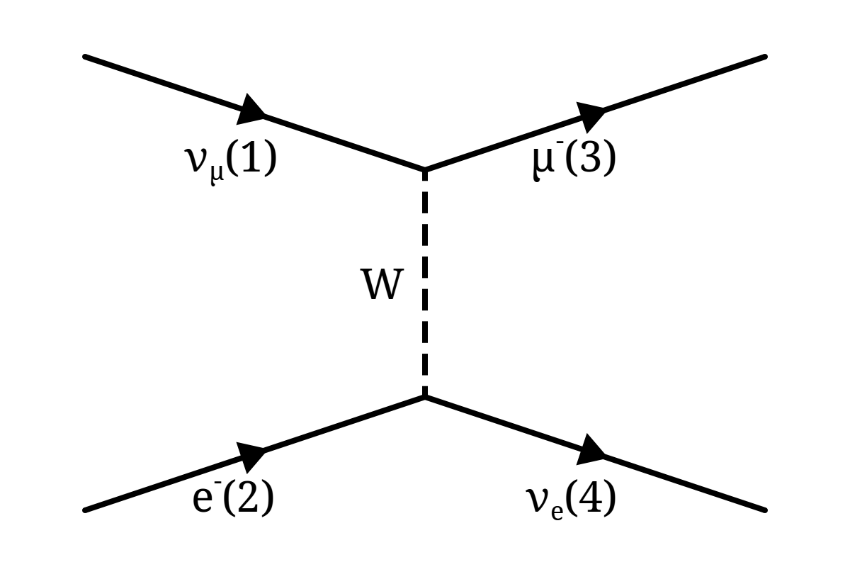
Remember this inverse muon decay interaction for viva!

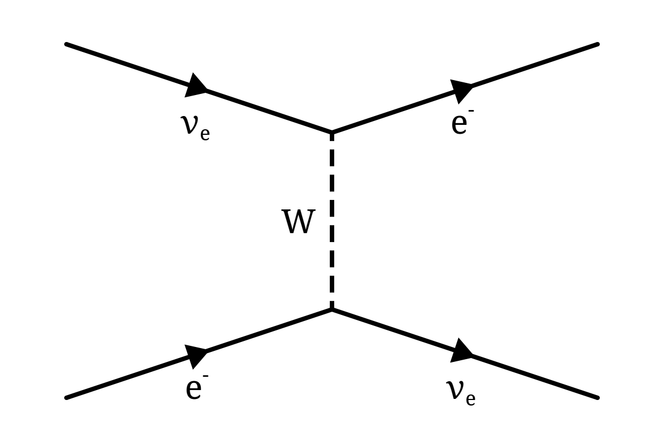
Electron elastic scattering

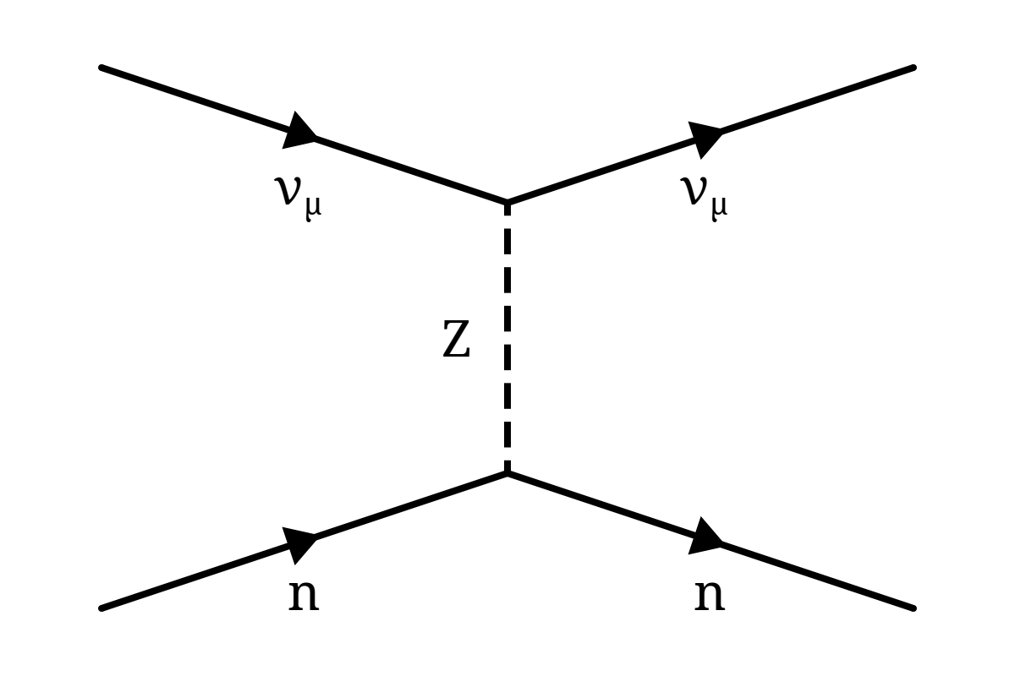
neutron scattering with neutrino

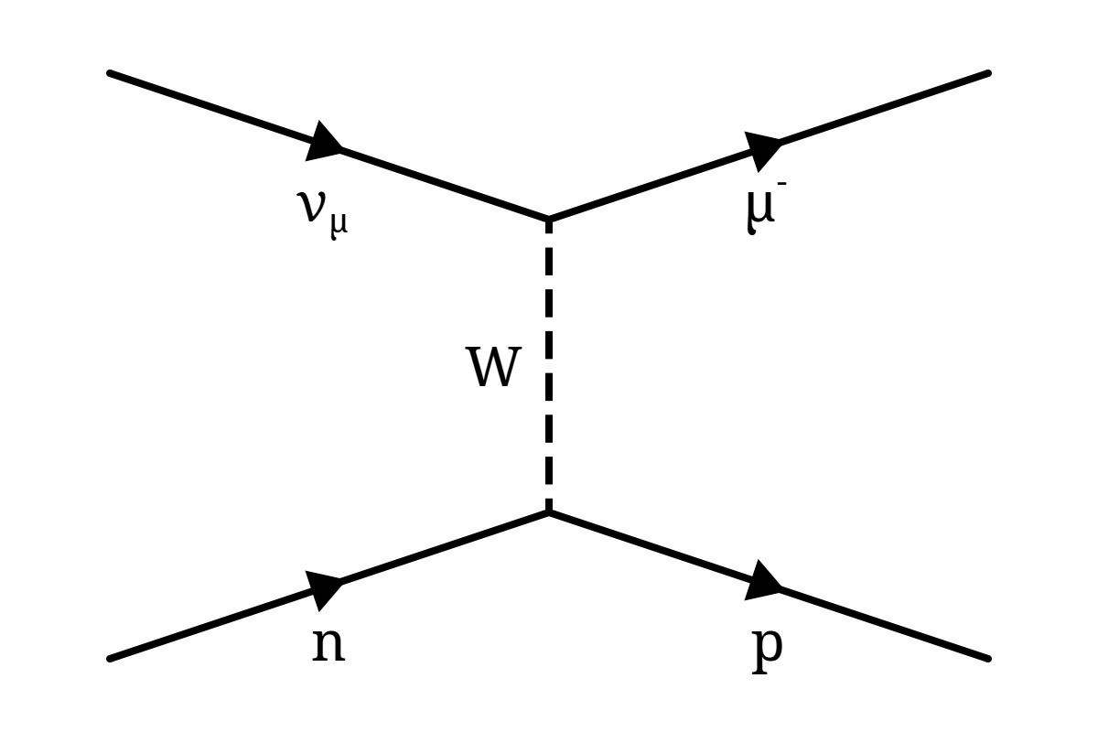
Same but proton is produced and charged current boson is used

