Josh Cordova

Math 189Z

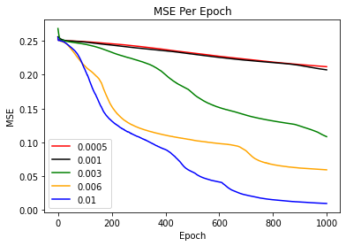Homework 4

Learning Rate Investigation

Layer Size Investigation:

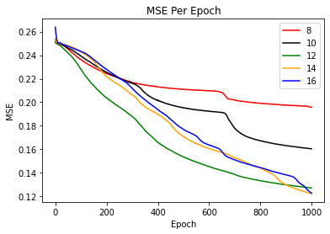

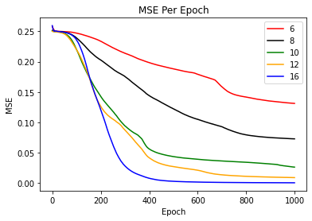Two Layer Investigation

For Fun: 5 layer investigation 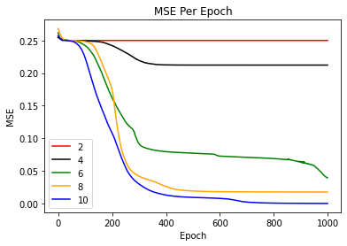

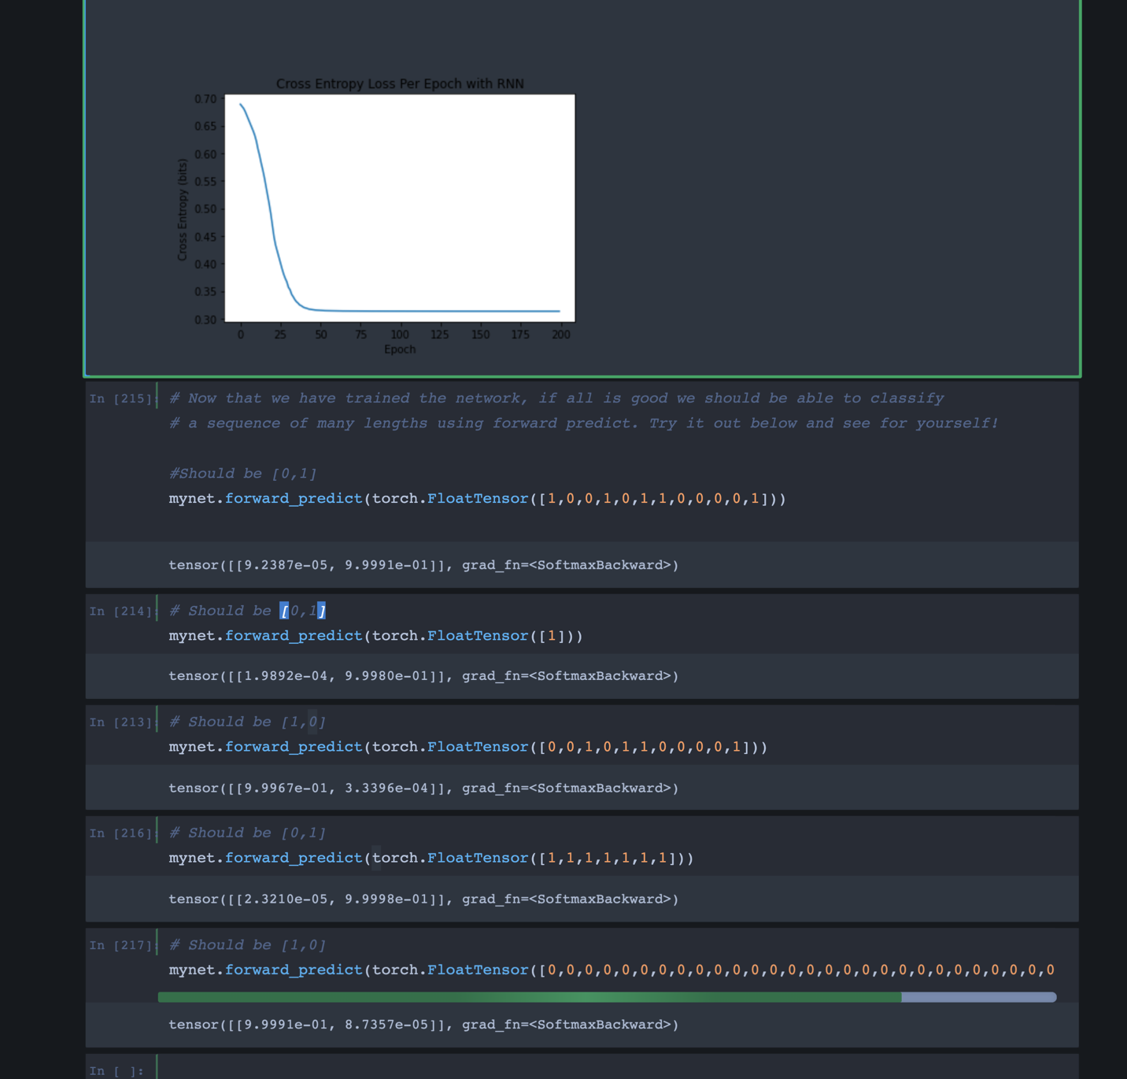RNN Investigation: