**[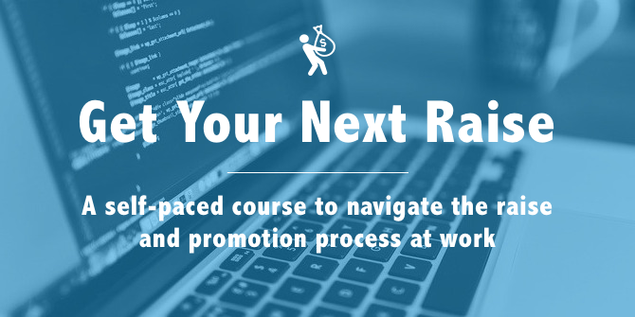](http://GetYourNextRaise.com)**

**Get Your Next Raise worksheet**

**Learn more about *Get Your Next Raise*:** [**GetYourNextRaise.com**](http://GetYourNextRaise.com)

**Use this worksheet as you work through the course so you have one place with your research, goals, action items and results.**

**Estimate your market value and Set your goal**

My market value estimation: ___________

My target salary: ___________

**Build your case**

**Examples of accomplishments that focus on a quantitative result**

* “Actively managed four concurrent projects (up from three), bringing an additional $20,000 in revenue this year.”
* “Took control of the new project assignment process from Tiffany, saving her about two hours a week.”
* “Configured a more resilient IT setup, making failure less likely and recovery easier, saving 40 hours per recovery.”

**Accomplishments [replace each bullet with an accomplishment of your own]**

* Activity 🡪 result
* Activity 🡪 result
* Activity 🡪 result
* Activity 🡪 result
* Activity 🡪 result

**Examples of accomplishments that focus on a quantitative result**

* “Alison introduced a new time tracking tool that saves every Project Manager about three hours a week in administrative time. This has saved our team over a hundred hours so far this year.”—Christina Smith, PMO Director
* Spotlight Award—For working three straight weekends on pre-sales for the ACME Corp deal to close it before end of year, bringing in an additional $15,000 in revenue for 2014.

**Accolades [replace each bullet with an accolade of your own]**

* Client or co-worker name—“Quote” or general feedback documented in email or survey
* Client or co-worker name—“Quote” or general feedback documented in email or survey
* Client or co-worker name—“Quote” or general feedback documented in email or survey

**Put your case in writing**

**Draft the email you will send to your manager *after* your verbal discussion.**

**To: [Your manager’s email address]**  
  
**Subject: [Your name]** salary adjustment discussion—follow-up  
  
Hi **[Your manager’s name]**  
  
Thanks for your time the other day. As we discussed, it has been **[amount of time]** since **[“my last significant salary adjustment” OR “since I was hired”]**, and I would like to revisit my salary now that I’m contributing much more to the company. I’ve been researching salaries for **[job title]** in **[industry]** industry, and it looks like the mid-point is around **[mid-point from your research]**. So I would like to request a raise to **[target salary].**I’ve been working very hard to find ways to contribute value to our company. Here are some of my accomplishments over the past several months:

* **Activity 🡪 result**
* **Activity 🡪 result**
* **Activity 🡪 result**
* **Activity 🡪 result**

And here is some feedback I’ve received from clients and co-workers over the past several months—their feedback speaks louder than anything I could say:

* **Client or co-worker name—“Quote” or general feedback documented in email or survey**
* **Client or co-worker name—“Quote” or general feedback documented in email or survey**
* **Client or co-worker name—“Quote” or general feedback documented in email or survey**

I believe these accomplishments and feedback show that my work merits a higher salary, and **[target salary]** seems well aligned to the current market and with the additional value I am adding to our company since my current salary was set. I look forward to hearing what I can do to help make this happen.  
  
Thanks again for your time and consideration!  
  
All the best  
  
**[Your name]**

**Plan your next steps**

**For each of the three common outcomes to your raise request, plan your next steps.**

**Not yet**

My plan and timeline to achieve this goal:

**No**

Other jobs I could consider at my current company:

Other jobs I could consider in other companies or industries:

**Yes**

My next goal—target salary or target job: