Creating minutiae from a fingerprint requires getting a black and white image, then processing the image into black and white, and then thinning the lines of the fingerprint. Once the lines are only 1 pixel wide, the image can then be processed for minutiae. In this project, endpoints and bifurcations are detected and displayed for two different fingerprints. This is done in mat lab, using the bwmorph function, which performs detection for the line pixels, and finds when ends and branches happen. This is done by determining when a pixel has three pixels in it’s neighborhood of the same type, thus predicting that there are three paths to this pixel. For the endpoints, pixels that only have one connecting pixel of the same type, it is considered an endpoint. In the following pictures, you can see the original image, and then the processed image with the minutiae found, with the red for endpoints, and the blue for branch points, or bifurcations.

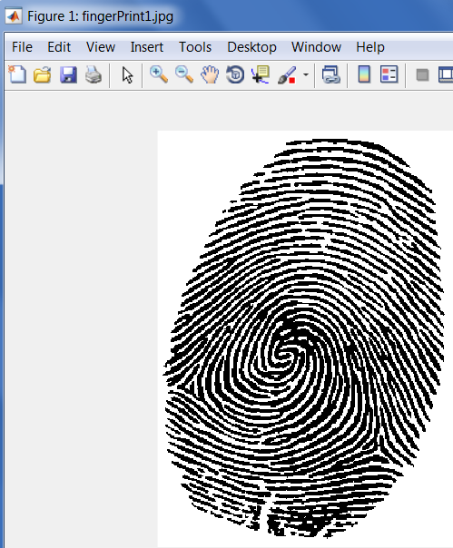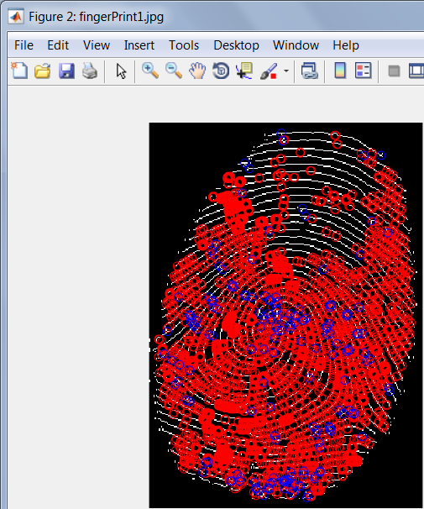

As can be seen above, this detection is not perfect, and could likely be improved on for improved accuracy. However, this does not only give subpar results, as the following second fingerprint produced superior results that are far more realistic and usable. In summary, mat lab provides methods to use for thinning and altering thinned fingerprints (such as removing spikes and gaps). I found examples of information I could use at:

<https://www.mathworks.com/help/images/ref/bwmorph.html>

<https://www.mathworks.com/matlabcentral/fileexchange/16728-fingerprint-application?focused=6781496&tab=example>

<https://www.mathworks.com/matlabcentral/fileexchange/31926-fingerprint-minutiae-extraction?focused=5190983&tab=function&requestedDomain=true>

