\* This project is an Instagram-like site created using Ruby on Rails.

\* The code for this project came from a YouTube video titled "Make an

Instagram-like site in under 30 minutes! (Ruby on Rails)", published

by Beginner Programmers.

\* Register:

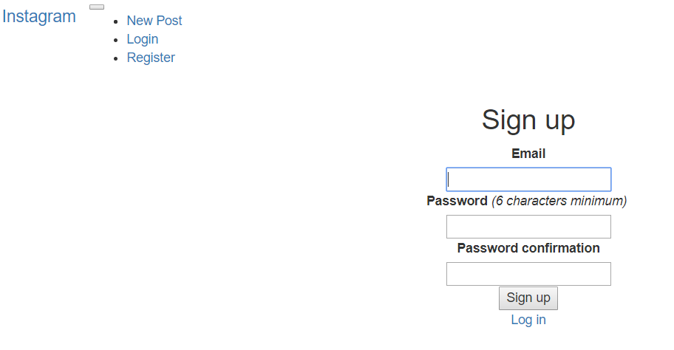

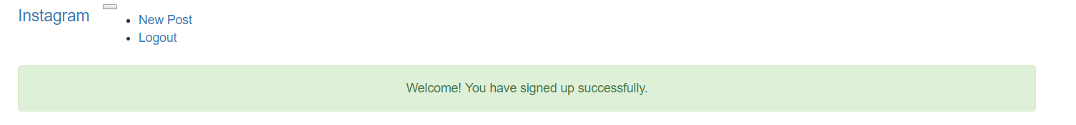

\* Login:

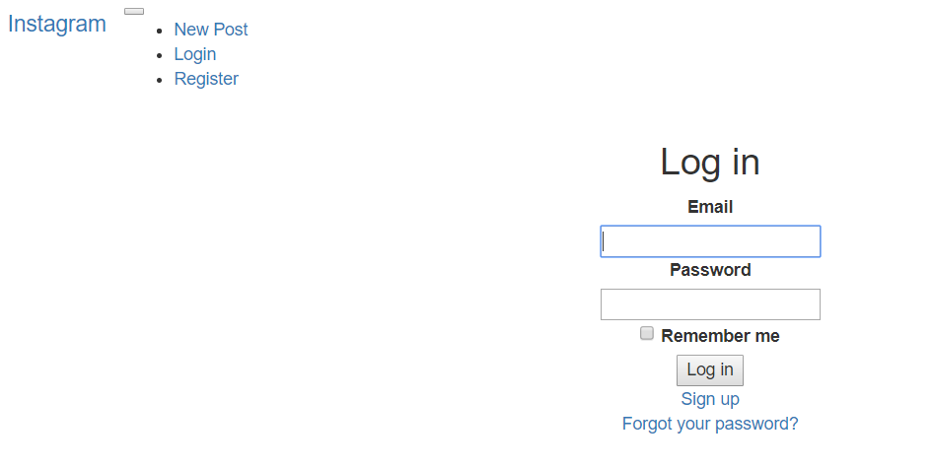

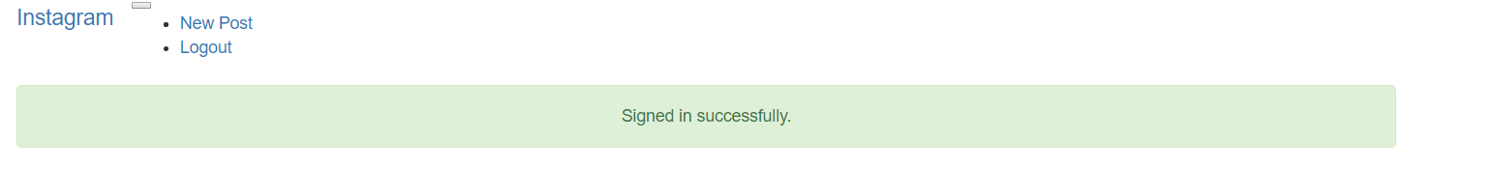

\* Logout:

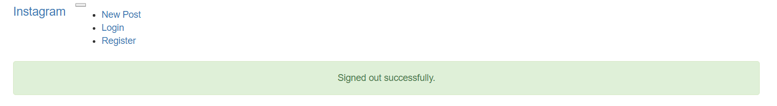

\* New Post:

