The Impact of UI and UX Design on Web Application Quality: A Mixed Methods Study.

# **Abstract summary**

This study aims to examine the relationship between design, user interface, and user experience in web applications using a mixed methods approach. The study will use a literature review and then use a combination of qualitative analysis via a questionnaire and quantitative data via a click map to analyze the relationship between the three variables.

# **Background**

With the launch of Web 3.0, website builders have gained popularity because they allow users to easily create and customize their website designs without needing to know HTML or CSS. In 2020, 43% of websites used the website builder WordPress, an increase from 13% in 2011. These builders are popular with non-developers creating their first website, as they may not have the same level of knowledge and expertise as experienced web developers. However, website builders may negatively impact user experience (UX) by offering only a set of predetermined tools. Good UX can help a website stand out, increase traffic, and improve search engine optimization, while poor UX can impact brand perception and decrease product value.

# **Methodology**

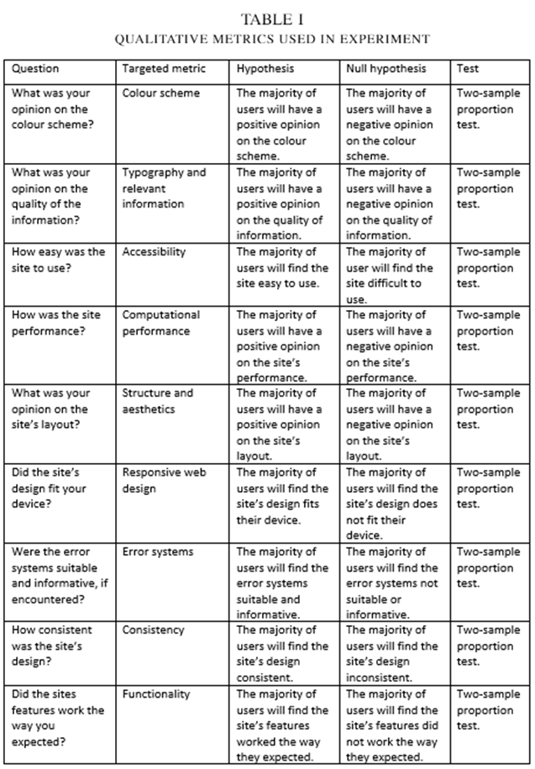The study uses an A/B test between an e-commerce website with specific alterations to its design informed by the literature review and a similar website made with a website builder. Participants will be tasked with selecting several products from different categories, adding them to the site's basket or cart, and reaching the checkout or confirmation page. Participants will then fill out a questionnaire with the questions used from this table so their results can be thematically analyzed.

# **R code**

Using the 'ggplot' library, the R code below creates a column chart for each metric from the questionnaire. The x-axis of each chart displays a positive and negative bar representing the number of positive or negative results for the corresponding metric. The number of positive results is compared to the total number of results through a two-sample proportional test to determine the resulting z-score. This z-score, along with questionnaire data, can be used to determine the effectiveness of each artefact for each metric

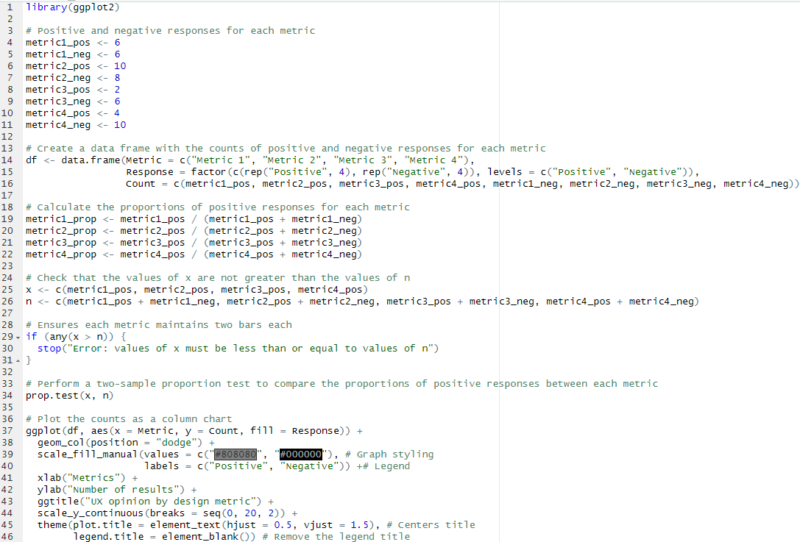

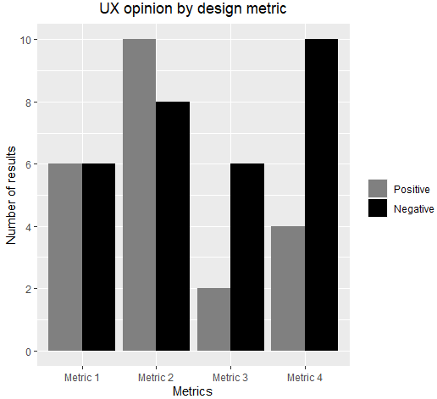

# **Artefact - Summary**

Artefact A is an ecommerce website specifically for electronic goods, and it is the artifact demonstrated in this study. Artefact B is a similar website created with a website builder, and it is strictly used for comparison within the scope of this study. Both websites will have login and registration, search and filtering, and cart systems, as well as a checkout page.

**Artifact A Artefact B**

* Web builder hosting
* HTML
* PHP
* SQL
* React
* Node JS
* Express JS
* SQL
* Heroku
* ClearDB

# **Artefact - Life cycle**

The artefact's development cycle is incremental, as it allows the artefact to be divided into sections that can be improved upon iteratively. This development cycle was chosen over an agile approach because, although it follows many of the same practices, it is more suited to a situation where the requirements of the artifact are unlikely to change. The incremental approach also allows for individual features to receive feedback throughout the development process.

# **Artefact - Test plan**

* Unit testing: This involves manually testing individual features by interacting with them, including the cart, search, checkout, and product systems. Automated systems can also be used to assist with this process.
* Integration testing: This involves manually testing the functionality of site-wide features, such as testing the search system with product pages or the cart displaying on the checkout page.
* Acceptance testing: This involves manually or through heuristic evaluation to verify that the site meets user requirements and expectations.
* Usability testing: This involves using the same methods as acceptance testing to verify accessibility and responsive web design practices.