CS 1632 – DELIVERABLE 5: Static Analysis

By Nigel Bernard & Josh Koshy

GitHub: https://github.com/nib58/DELIVERABLE5

Summary:

We found several issues with FindBugs and Checkstyle when devising our Pairwise test generator:

1. Missing a Javadoc comment

Solved: By inserting proper documentation into the program

2. ‘X’ is not preceded by whitespace

Solved: By inserting newline before opening bracket

3. ‘X’ is not followed by whitespace. Empty blocks may only be represented as () when not part of a multi-block statement (4.1.3)

Solved: By inserting a space after the character

4. Line is longer than 120 characters

Solved: By inserting a new line when appropriate

5. Method concatenates strings using + in a loop

Solved: By using StringBuffers instead of Strings to append string in a loop

6. Dead store to local variable

Solved: Ignored since the requirements state this is allowed

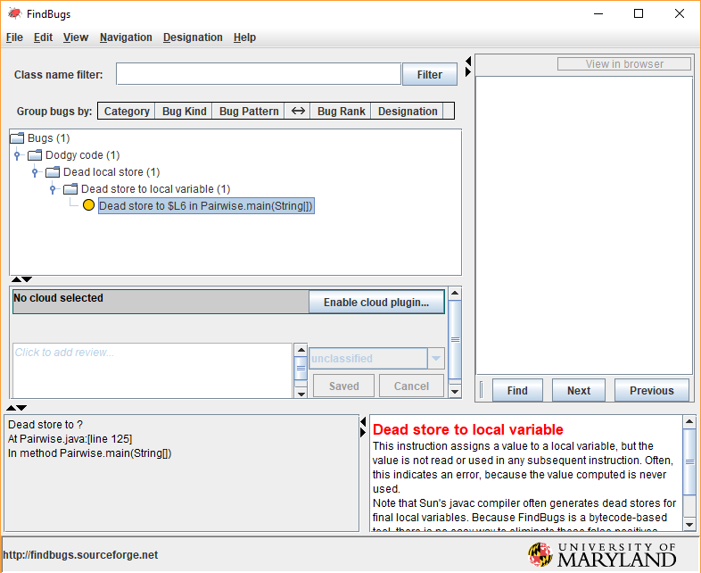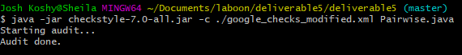Screenshots: