**Repositories:**

<https://github.com/JoshKostka/NewRR>

<https://github.com/JoshKostka/RealestateRepo>

**Hack ‘n’ Plan**

<https://app.hacknplan.com/p/178091/admin?section=general>

**2. To ensure you have a clear understanding of the gamified application you are producing**

**for the client, you will need to research the gameplay elements and objectives for**

**different genres of video games and gamified applications. Identify, analyse, and review**

**at least one (1) genre of video games relevant to the gamified application you will be**

**producing. In your review of the genre explain the core mechanics and other gameplay**

**elements it is typically associated with, and describe the player objectives typically**

**presented in the genre. Document the findings of your analysis and review in your**

**production diary.**

Gameplay elements and objectives of walking simulators:

Walking simulators are usually simple games showcasing nature or aesthetics. They rarely have more than one or two main mechanics which are usually walking and or teleporting to locations. Walking simulators can be heavily story driven games which run through the main story whilst moving through an environment.

Core mechanics:

The ability to walk around or move through an environment (sometimes teleporting around like Google Maps)

The ability to interact with objects and play or read texts.

**3. In order to produce an application that efficiently fulfils its intended purpose, it is critical**

**to build a clear understanding of the primary audience(s) it will be built for. In your**

**production diary identify the primary target market that the gamified application is being**

**produced for, and clearly describe the relationship between the intended purpose of the**

**application and the needs of the market.**

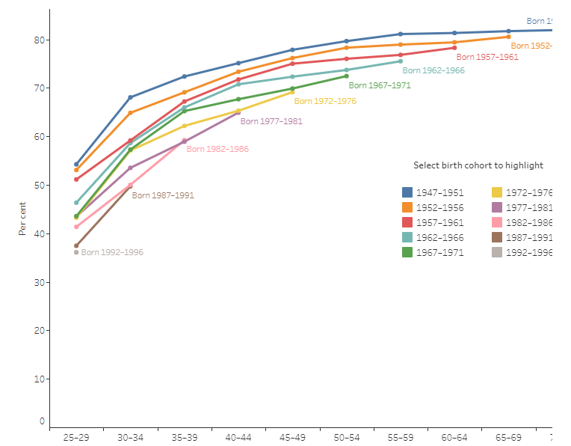This gamified project will be made for the real-estate environment and used primarily by people who may have little to no experience in video games. As such, the experience will need to be simple to use and intuitive. As the project is for real-estate it is safe to assume an older audience (30+ years old as seen in the below diagram) will be using the program and is the intended target audience. This program will be used so that clients can view a remote property that is not easily accessed for inspection.

**a) After you have identified and described the primary demographic for the**

**application, you need to understand the motivations of the market. Research the**

**consumer choices and patterns for the target demographic(s) of the application, and**

**in your production diary describe your interpretation of these choices and patterns**

**and how they may impact the marketing of the product.**

With the target audience of people above 30 years old, a wide variety of applications and options will be available for marketing. With the older demographic a simpler application may be needed to cater for the wide array of game-savvy people who may use it.

**4. With an understanding of the genre and target demographics relevant to your selected**

**gamified application, you need to determine how your selected project can be ‘gamified’.**

**Research and identify at least two (2) game design principles and two (2) gameplay**

**strategies, and in your production diary outline how they can be applied to your selected**

**project.**

Principles

* Design the game so that you can see each aspect of the building for sale
* Allow the client to learn about the building like a virtual tour

Strategies

* Make the building able to be walked around simply
* Create text to speech so that clients can have a virtual tour guide

**5. In order to efficiently maintain and monitor the production cycle, you must consider the**

**industry standards and organisational guidelines that need to be followed throughout**

**production. In your production diary outline the guidelines for version control and project**

**management that will be followed throughout the production of the project.**

**a) Describe how version control (such as Git) and other relevant software (such as**

**GitHub or SourceTree) will be used to maintain the integrity of the project files**

**during production. Here you must include a link to a software repository you have**

**created for storing the project files throughout production.**

GitHub and Sourcetree allow for backed up version of files in the cloud. This allows for fall backs should a game breaking bug occur, multiple versions of a file and sharing of files. Should a file become corrupted on your hard drive, a backup will be available at any time to replace it, depending on how often you commit changes to the repo.

**Repo links:**

<https://github.com/JoshKostka/NewRR>

<https://github.com/JoshKostka/RealestateRepo>

**b) Describe how agile project management software (such as Hack ‘n’ Plan) will be**

**used to monitor and maintain the progress of production for the project.**

Hack and Plan allows for time management planning, small form file management and sharing, multi-person allocation and an overview of the project. This software has been used for my Pacman project as a time and resource management tool. Each requirement in the game brief has been implemented in such a way to display what needs to be completed, in what order and how much time is left to complete each step. With this tool a project will be completed at a much higher efficiency and be sure that each requirement is met before submission/completion.

**6. It is important to create a production and testing schedule for the development of the**

**project so that you can track production progress and prioritise your work accordingly.**

**Use relevant project management software (such as Hack ‘n’ Plan) to organise and**

**maintain a schedule for production and testing throughout the development cycle of the**

**project.**

**a) To build an effective schedule you will need to ensure that you have identified all**

**of the required technical specifications for the gamified application, as well as the**

**assets that need to be sourced and/or produced. For each of the tasks and tests**

**being generated and managed through project management software, ensure you**

**include all of the required details as according to the creative and production**

**requirements of the project.**

Hack ‘n’ Plan: <https://app.hacknplan.com/p/178091/admin?section=general>

**b) Your schedule will need to outline the development sequence for the construction**

**of a beta prototype of your selected project. Use relevant features and tools**

**provided by your project management software in order to create and plan iterative**

**phases of production (sprints) for the entire production cycle.**

This project will be managed with the web based application “hack ‘n’ plan”. This goes through each step of the creation process including:

* Pre production
* Prototype
* Peer review / user trials
* Gold master version

<https://app.hacknplan.com/p/178091/admin?section=general>

**7. With the different types of assets required for the application identified and a list of**

**required assets defined, you will need to consider the standards and procedures for**

**implementing the asset files within a game engine. Meet with the studio manager to**

**evaluate various types of file formats for different types of assets, and discuss potential**

**issues that may be encountered when integrating the assets into a game engine.**

Files imported into the project will be:

Audio

.WAV would be the ideal choice due to the ability to loop audio without a gap

Assets

FBX format due to its ease of use and accessibility from the program blender.

**9. To ensure that production runs smoothly it is important to ensure you have considered**

**how you will maintain the progress of production against the planned progress outlined**

**in the schedule. In your production diary describe at least two (2) strategies that you will**

**use throughout production to actively monitor the actual production progress against the**

**planned production progress.**

Two Strategies to actively monitor the production:

* Use of Hack ‘n’ Plan for detailed breakdown of individually required steps for completion.
* Use of GitHub to manage production through visually inspecting where I’m currently at with production.

**10.The final element of pre-production that needs to be defined is the game-engine**

**software that will be used to construct the application. There are many commercial**

**game-engines available to choose from, with each having different strengths and**

**weaknesses. As such it is important to research and consider the tools and features**

**provided by different game-engines in relation to the concepts of your selected project,**

**to determine which engine is most suitable for producing the gamified application you**

**will be developing. In your production diary evaluate at least two (2) different gameengines available for commercial use, describing their strengths and weaknesses as well**

**as some of the unique tools and features they provide.**

**Unity:**

Strengths:

* Simple to use and many tutorials available online
* Asset Store
* C#
* Royalty Free
* Large Community

Weaknesses:

* Performance intensive

**Unreal Engine:**

Strengths:

* Open Source Code
* Better Visuals
* Better inbuilt world building tools including scalable objects.

Weaknesses:

* Large executable size
* Difficult to use
* Constant updates that may cause issues
* Documentation is old

Background music: [https://pixabay.com/music/future-bass-lifelike-126735/](https://pixabay.com/music/future-bass-lifelike-126735/%20)

**User Trials:**

**Trial 1: Richard**

Feedback:

* Hitbox for waypoints are a little off in the bedroom

**Trial 2: Colton Onderwater**

Feedback:

* Bottom teleport pad should be clickable
* Text saying to click on the waypoints rather than use WASD which is natural to most people for first person applications.

**Trial 3: Josh**

Feedback:

* Bottom green waypoints are sometimes unclickable
* Not all audio implemented

Chosen to fix based on budget/time constraints:

* Fix waypoint issues
* Add text saying “Look around with the mouse and click on waypoints and text bubbles”