* Describe what problems you encountered and how did you solve them when implementing the basic and advanced functions. (2%)

When I was writing model.backward(), I kept having error like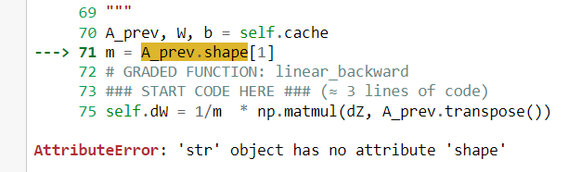.

After spending lots of time debugging, I found that I should write like this 

If I write something like the line that I comment, the string A,W,b will be store into cache.

* Briefly describe the structure of your binary and multi-class classifiers. (2%)

Basic

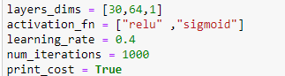

Advanced

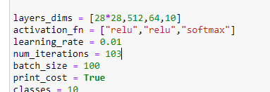

* Describe effort you put to improve your model (e.g., hyperparameter finetuning). (1%)

Test the layer of the model and activation function to determine which is better.