- Your name and student ID
113062535 李佳栩

- How to compile and execute your program, and give an execution example.

先去HW2/src,打make
然後去HW2/bin
./bin/hw2 ../testcase/public1.txt ../output/public1.out

(3) The final cut size and the runtime of each testcase. Paste the screenshot of the result of running the HW2_grading.sh as the picture shown below.
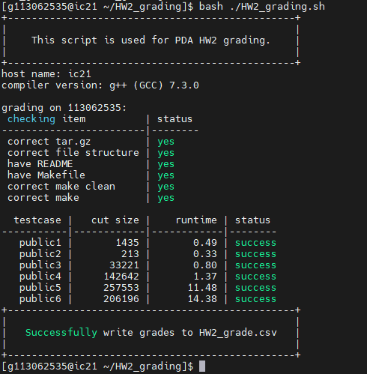

(4) The details of your algorithm. You could use flow chart(s) and/or pseudo code to help elaborate your algorithm. If your algorithm is similar to some previous work, please cite the corresponding paper(s) and reveal your difference(s).
FM演算法大致流程如下
Init_partition()->Init_Net_Group()->Initial_Gain()->Build_Bucket_List()->FindMaxcell()->CheckBalance()
->Update_Gain()->Calculate_maxPartialSum()
->RollBack()
補充Init_partition，我有兩個function，一個是根據面積差來排序，然後依次放進剩餘面積比較大的die，第二個是cell根據max(sizea,sizeb)來排序，一樣一次放進剩餘面積比較大的die。
我是利用FM演算法，那過程就跟講義上差不多，然後我把FM的+1、-1，改成直接加weight，讓他先去動weight大的net，還有一開始演算法都要跑很久，所以有寫限制條件讓他不要跑那麼久，特別是當違反balance的時候，找下一個cell不能找太久。

(5) What techniques did you use to improve your solution's quality? Additionally, analyze how they contributed to the improvements. Plot the effects of those different settings like the ones shown below.
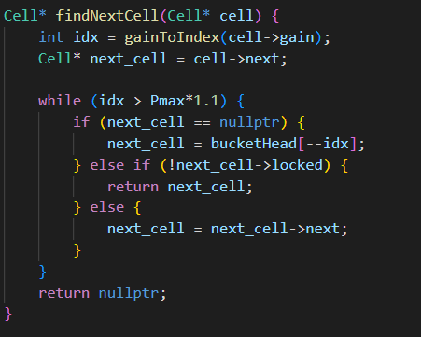
(Pmax*1.1那邊)

如果找到Imbalance的cell時要回去bucketlist找其他可以的cell，因為cell數太多，所以要話很多時間找，我限制他只能找到特定idx以上，如果沒有就break。
 | Without Constraint | With  Constraint
Public1 | 80s / 1pass | 0.4s / 1pass
Public2 | 47s / 1pass | 0.02 / 1pass
Public3 | 128s / 1pass | 0.52s / 1pass

(6) If you implement parallelization (for algorithm itself), please describe the implementation details and provide some experimental results.

(7) What have you learned from this homework? What problem(s) have you encountered in this homework?
因為很久沒有寫C++，對於很多資料結構以及指標都忘了很多，也在寫的過程一直改data structure，最後才可以得到還ok的結果。

另外我覺得比起每個pass去做完每個cell，不如多做幾次pass。就像如果我不設條件讓它結束，會花很久時間且cutsize不會減少非常多，表現跟時間有點不成正比，我認為這跟這演算法前幾步比較重要有關(不確定)。所以如果可以越早結束進行下個pass最好。

