- Your name and student ID
  - 113062535 李佳栩
- How to compile and execute your program and give an execution example.
先去HW3/src,打make
然後去HW3/bin
./bin/hw3 <input.txt> <output.out> dead_space_ratio
./bin/hw3 ../testcase/public1.txt ../output/public1.out 0.1
- The wirelength and the runtime of each testcase with the dead space ratios 0.15 and 0.1, respectively. Paste the screenshot of the result of running the HW3_grading.sh.
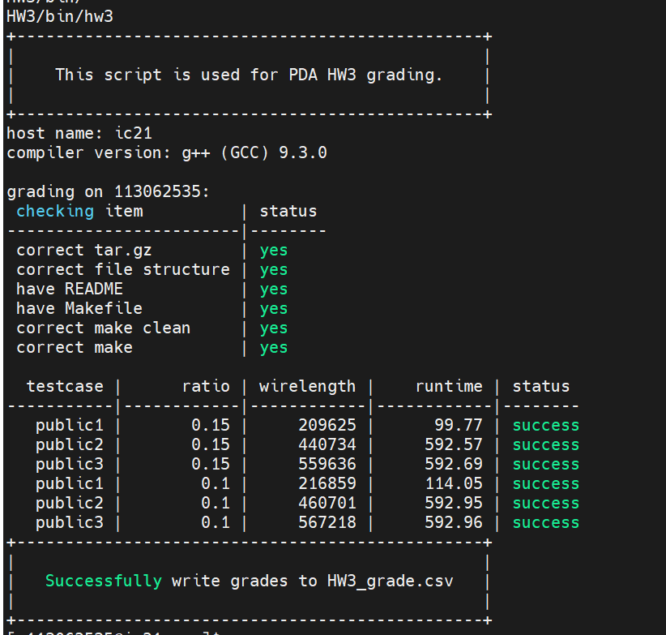
- Please show that how small the dead space ratio could be for your program to produce a legal result in 10 minutes.

 | Public1 | Public2` | Public3
dead space ratio | 0.05 | 0.08 | 0.05

- The details of your implementation. If there is anything different between your implementation and the algorithm in the DAC-86 paper, please reveal the difference(s) and explain the reasons.
- Initial floorplan->If the width or height are bigger than the outline, do SA1(for minimizing area) , then do SA2(for minimizing length).
要做SA1的原因是，因為public2無論如何initial都放不進去，如果同時優化area跟wirelength的話，會花超過10分鐘去找答案，所以想出這個兩階段的優化，但如果開始就在outline裡面的話，就直接優化wirelength，而我的結果來看，如果都在outline裡面只要swap operand就可以了，其他的改結構感覺很容易超出邊界。
另外還有一個M4，是random swap two operand，其實是一開始寫錯，但後來拿來測試發現效果蠻好，於是就保留繼續用。
- Please describe your method of your initial floorplan.
我就是先把每個按照max(height, width)排列，從最大的開始排，如果超過outline就往上疊，同時在排的時候也直接考慮旋轉，因此我的public1和public3一開始都可以直接排進outline裡。
舉例來說，假設大小是1234…，我就是1234…如果超過outline，就補v，變成1234VVVH然後繼續從新的一排往右。

(7) What tricks did you do to speed up your program or to enhance your solution quality? Please use HW3_printer to generate the image to compare different stages (e.g., initial floorplan → trick 1 → trick 2 → final result) of your floorplanning results.
就如上面提到了有新增，m4這個move，又增加了更多隨機性。
然後因為我是每次都重新建tree，所以code都會跑超久><。

以public2 dead_space_ratio0.1為例

Initial floorplan
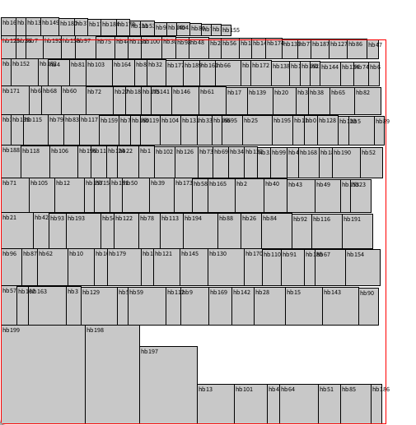可以看到有些超出outline了->
SA1(for area)
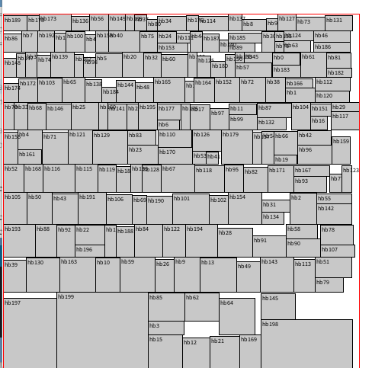成功塞進outline，但wirelength很差->
SA2(wirelength)
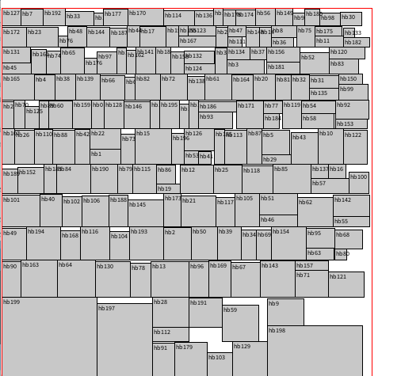
在outline內，且wirelength有提升。
Public1、public3都是initial完直接做SA2。如下圖
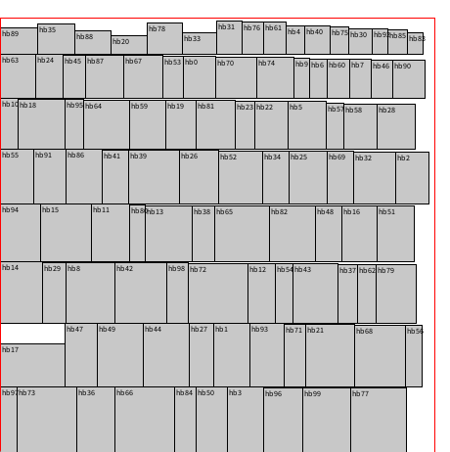->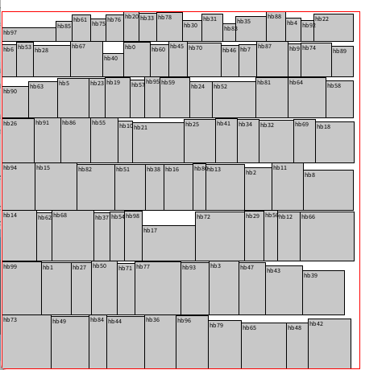
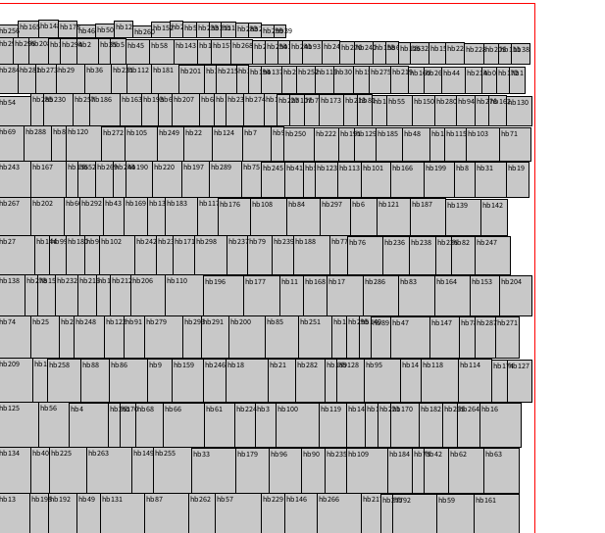->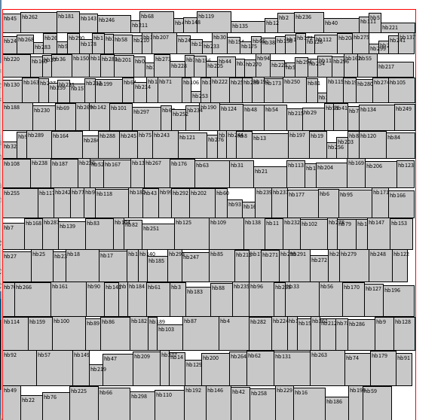

(8) What have you learned from this homework? What problem(s) have you encountered in this homework?
其實這次寫的code好像沒有上次那麼難，但如果要寫到優化的部分，就是老師上課提到，每次交換的話只有兩條path會動到，這個部份我花了很多時間寫，畢竟指標就是C++裡面最難的部分，再來其他部分就是要一直調參數，有點在靠運氣XD。

Result
Public1 0.1

Public1 0.15
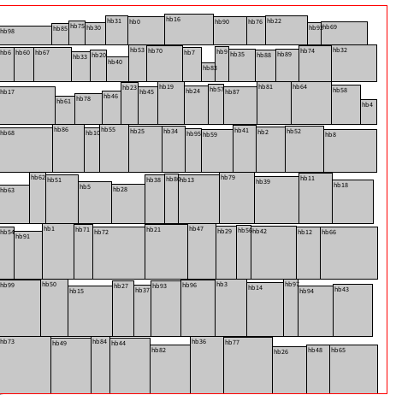
Public2 0.1

public2 0.15
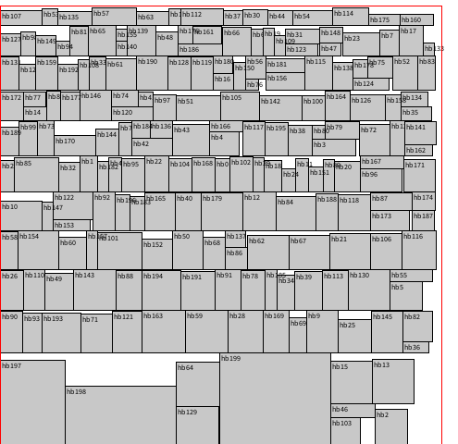
Public3 0.1


public3 0.15
