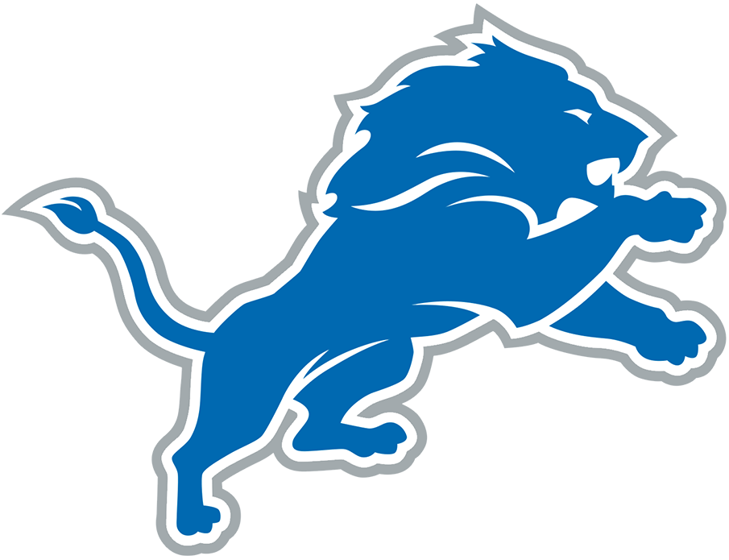  B | I | N | G | O
"I don't know what he's doing!" | Asserts a player cannot write their name | "The Lions will never be great" | Complains about a commercial break | Complains about Aaron Glenn
Uses the term "schizophrenic defense" | Uses a racial slur | "What is that playcall?" | "'Prevent defense' prevents you from winning" | "I don't watch losers"
"He needs to go away" | Threatens to throw something through the wall |  | Call a player a gangbanger | Mentions Amon-Ra's Dad Was Universe
"HOLDING!" | Asserts the NFL/referees are against Detroit | "Shut up so I can hear" | "Why would you play a zone defense?" | Asserts a player did not finish high school
"It makes no sense to me!" | "Why isn't that reviewable?" | "If I was the owner..." | Complains about Jared Goff | "Are you kidding me?"

