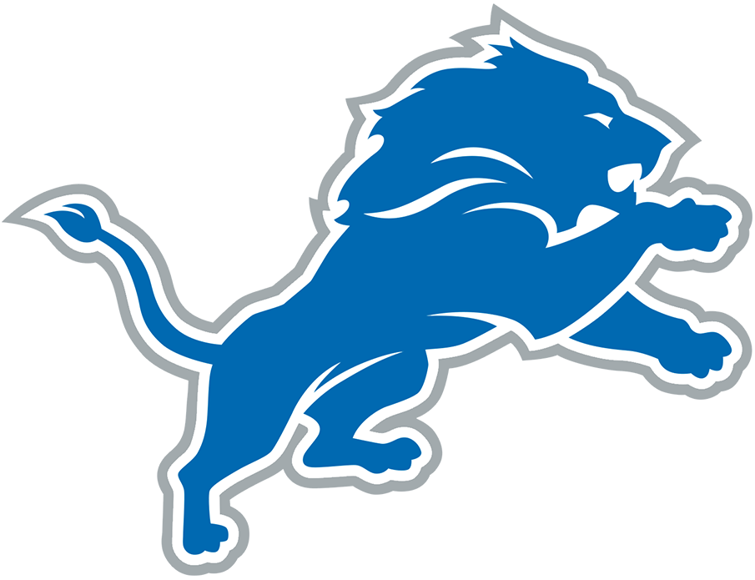  B | I | N | G | O
Wrings hands | Complains about a commercial break | "Tackle him!" | "How can they not see this?" | Complains about Aaron Glenn
Threatens to throw something through the wall | Asserts a player cannot write their name | "Why isn't that reviewable?" | "The Lions can't get off the field" | "He needs to go away"
Mentions Amon-Ra's Dad Was Universe | "If the Lions don't invest in the defense net year, they're idiots" |  | Uses a racial slur | "The Lions will never be great"
"How do you leave that guy so wide open?" | "HOLDING!" | Asserts the NFL/referees are against Detroit | Complains about Jared Goff | "If I was a player..."
"I don't watch losers" | "Why would you play a zone defense?" | "This game shouldn't be this close" | Complains about Aidan Hutchinson's play | Call a player a gangbanger

