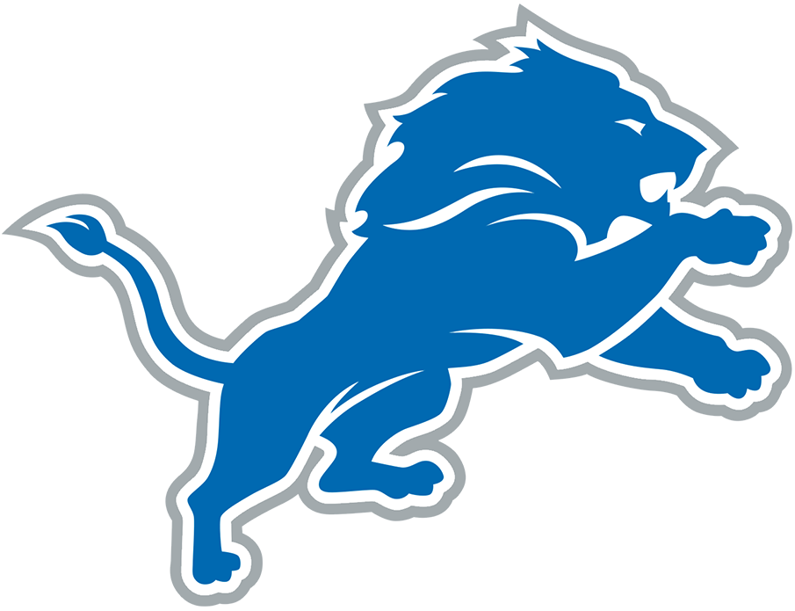  B | I | N | G | O
"What is that playcall?" | Call a player a gangbanger | Mentions that Barry Sanders never celebrated touchdowns | "Are you kidding me?" | "He needs to go away"
Comes up with an alternate score without turnovers, back luck, etc. | Complains about Aidan Hutchinson's play | "How do you leave that guy so wide open?" | "If I was the owner..." | "If I was a player..."
"Tackle him!" | Complains about Aaron Glenn |  | "It makes no sense to me!" | "This game shouldn't be this close"
Uses the term "schizophrenic defense" | "I don't know what he's doing!" | "HOLDING!" | Suggests a player should be cut on the spot | "The Lions can't get off the field"
Says the Lions need to only draft defensive players | Slams the remote | Says the Lions needs to sign a specific free agent | Wrings hands | "How can they not see this?"

