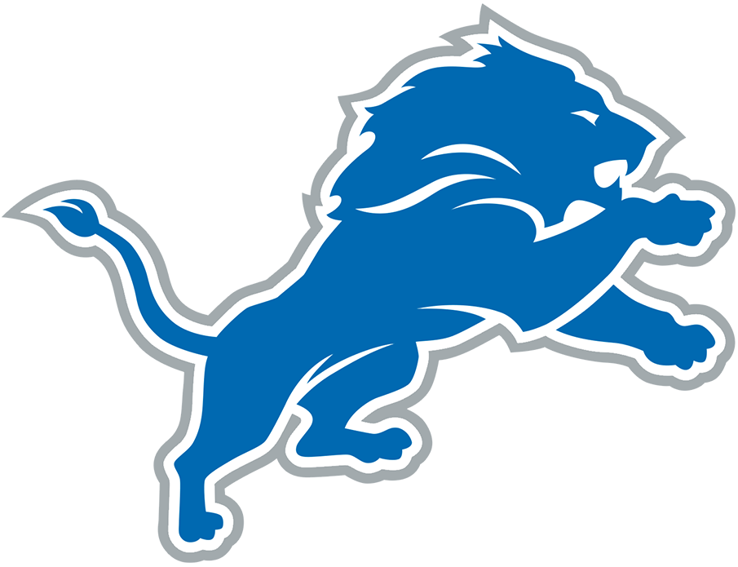  B | I | N | G | O
"The Lions will never be great" | "Why isn't that reviewable?" | Asserts a player did not finish high school | "I don't watch losers" | "Why would you play a zone defense?"
Uses a racial slur | Says the Lions needs to sign a specific free agent | Says the Lions need to only draft defensive players | "What is that playcall?" | Complains about running backwards
Mentions that Barry Sanders never celebrated touchdowns | "This game shouldn't be this close" |  | "How can they not see this?" | Mentions Amon-Ra's Dad Was Universe
"If I was the owner..." | "It makes no sense to me!" | Mention hiring someone to take out someone's knees | Complains about a spot | "What were you thinking?!"
Asserts a player cannot write their name | "The Lions can't get off the field" | "If I was the coach..." | Refers to the Lions as "unwatchable" | "Shut up so I can hear"

