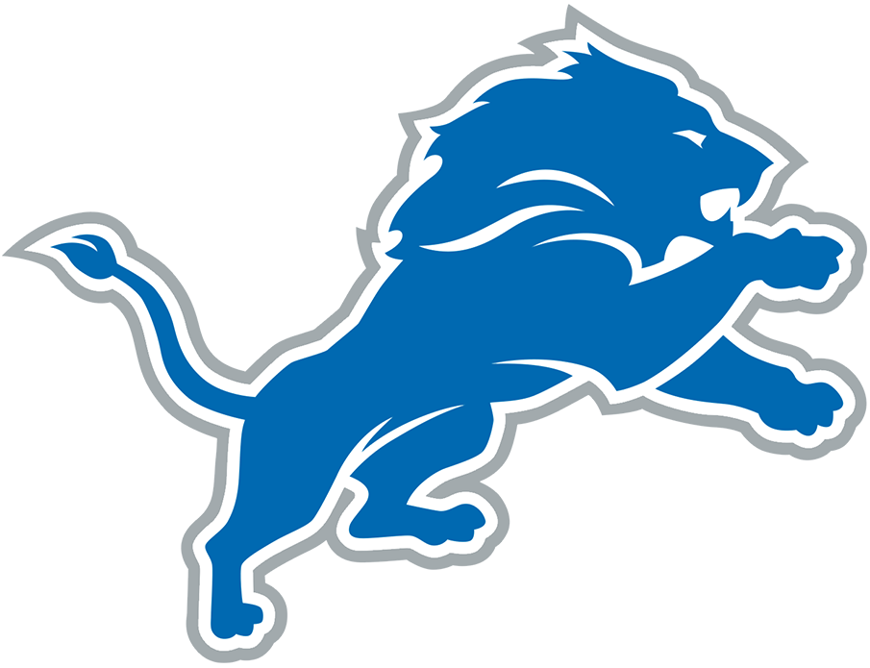  B | I | N | G | O
"What is that playcall?" | "How can they not see this?" | Complains about running backwards | Uses the term "schizophrenic defense" | "If I was the coach..."
Asserts the NFL/referees are against Detroit | Comes up with an alternate score without turnovers, back luck, etc. | Complains about Aaron Glenn | Uses a racial slur | "How do you leave that guy so wide open?"
"Why isn't that reviewable?" | Mentions Amon-Ra's Dad Was Universe |  | "The Lions can't get off the field" | "The Lions will never be great"
"Tackle him!" | "HOLDING!" | "If I was the owner..." | "That guy hasn't missed too many meals" | Slams the remote
Says the Lions need to only draft defensive players | "Why would you play a zone defense?" | "If I was a player..." | "What were you thinking?!" | Complains about a commercial break

