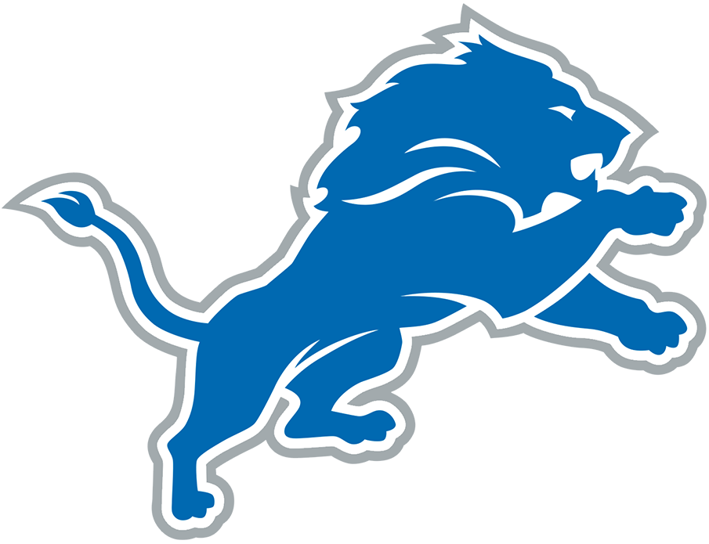  B | I | N | G | O
"Are you kidding me?" | "How can they not see this?" | "What were you thinking?!" | "How do you leave that guy so wide open?" | Complains about Aaron Glenn
"'Prevent defense' prevents you from winning" | Call a player a gangbanger | Suggests a player should be cut on the spot | "Why isn't that reviewable?" | "If I was a player..."
"It makes no sense to me!" | Complains about Jared Goff |  | Comes up with an alternate score without turnovers, back luck, etc. | "He needs to go away"
Mentions CJGJ's torn pec | "The Lions will never be great" | Mentions that Barry Sanders never celebrated touchdowns | Threatens to throw something through the wall | "Oh for Christ sake!"
"I don't know what he's doing!" | Complains about running backwards | Refers to the Lions as "unwatchable" | "What is that playcall?" | Says the Lions needs to sign a specific free agent

