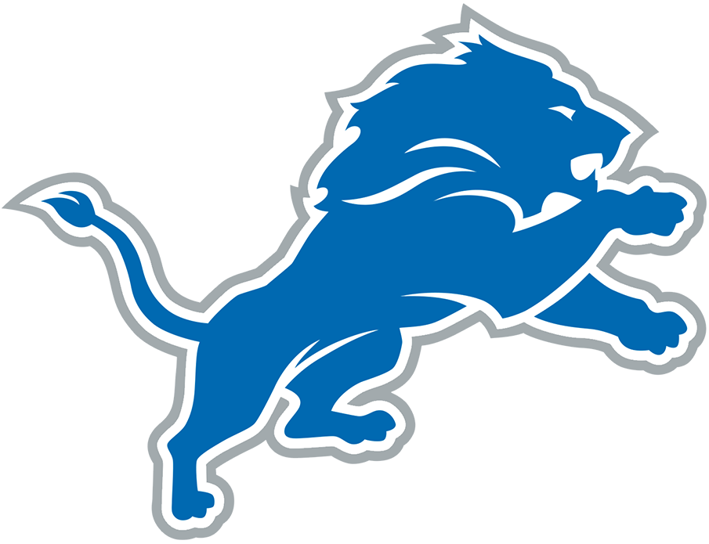  B | I | N | G | O
Asserts a player cannot write their name | "'Prevent defense' prevents you from winning" | Uses the term "schizophrenic defense" | "HOLDING!" | "If I was a player..."
"If I was the owner..." | "Tackle him!" | Says the Lions needs to sign a specific free agent | "The Lions will never be great" | "What were you thinking?!"
"Why would you play a zone defense?" | Mentions CJGJ's torn pec |  | "Oh for Christ sake!" | Asserts a player did not finish high school
Complains about a spot | Complains about running backwards | "Are you kidding me?" | Slams the remote | Complains about Aidan Hutchinson's play
"Shut up so I can hear" | Mention hiring someone to take out someone's knees | "The Lions can't get off the field" | "He needs to go away" | "How can they not see this?"

