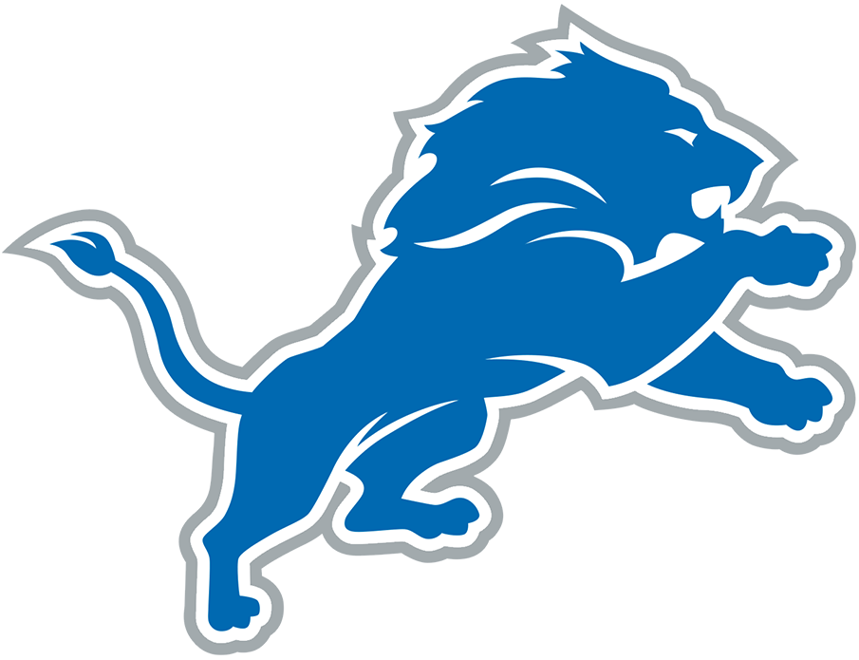  B | I | N | G | O
"If the Lions don't invest in the defense net year, they're idiots" | "The Lions will never be great" | Says the Lions need to only draft defensive players | Complains about running backwards | Slams the remote
Complains about Jared Goff | Complains about a spot | Complains about Aaron Glenn | Mentions CJGJ's torn pec | "HOLDING!"
"Why would you play a zone defense?" | "What is that playcall?" |  | "Oh for Christ sake!" | "'Prevent defense' prevents you from winning"
Uses a racial slur | "How can they not see this?" | "If I was a player..." | Mention hiring someone to take out someone's knees | "Shut up so I can hear"
Suggests a player should be cut on the spot | "It makes no sense to me!" | Wrings hands | Complains about Aidan Hutchinson's play | Asserts a player did not finish high school

