- EMISSION MODULE

3.1 OVERVIEW
The emission module was developed to provide emission rates for each of the 10-meter roadway segments (blocks) during each phase of the signal cycle. At the time HYROAD was developed, the current federally approved mobile source emission factor model was MOBILE5a (EPA, 1993). The emission module was developed specifically around the form and approaches of this model, but was also designed to make realistic use of the detailed vehicle activity outputs provided by the traffic module (i.e., speed and acceleration distributions by signal phase). The emission module produces both the emission rate inputs for the dispersion module, as well as calculating the traffic volume and average speed at locations through the intersection which is used by the dispersion module in calculating vehicle induced airflows and turbulence. Emission factor models are undergoing continuing refinement and modification, with several significant changes in model formulation anticipated in future years. Thus, although the design of the emission module of HYROAD was tailored to MOBILE5a, it was designed to be adaptable to alternative forms of emission factor models, including other cycle-based emission factor models (e.g., MOBILE6) or “modal” emission factor models (e.g., those predicting emissions based on vehicle speed and acceleration). The most recent release of the model includes an interface with MOBILE6. However, all of the model verification and sensitivity studies discussed in Sections 5 and 6 of this document are based on MOBILE5.
The remainder of this section describes: (1) the inputs required for the emission module, including both user-provided inputs and those generated by the traffic module; (2) the manner in which the emission factor and total emissions are calculated for each time period; (3) the spatial and temporal allocation of emissions for each phase of the signal cycle; (4) outputs of the emission module that are provided to the dispersion module; and (5) potential modifications to the emission module that may be made as emission factor models evolve.

3.2 Emission Factor calculation

Cycle-derived Emissions
Composite gram per mile emission factors produced by MOBILE5a and other cycle-based emission factor models represent the best estimate of cumulative emissions for vehicle operations over the course of a driving cycle, such as the Federal Test Procedure (FTP) driving cycle used in vehicle emissions certification testing. Driving cycles are defined through second-by-second specification of vehicle speed. Figure 3-1 shows the FTP cycle. Statistical analysis of emissions testing on a total of eight driving cycles provided the basis for the internal speed correction factors in MOBILE5a that are used to calculate speed-specific emissions corresponding to MOBILE inputs (Sierra, 1994). Thus the emission rate produced by MOBILE for the speed of one of these eight different driving cycles can be thought of as being representative of emissions for vehicle operations on that cycle. Emission rates for speeds between those of the speed correction cycles represent weighted 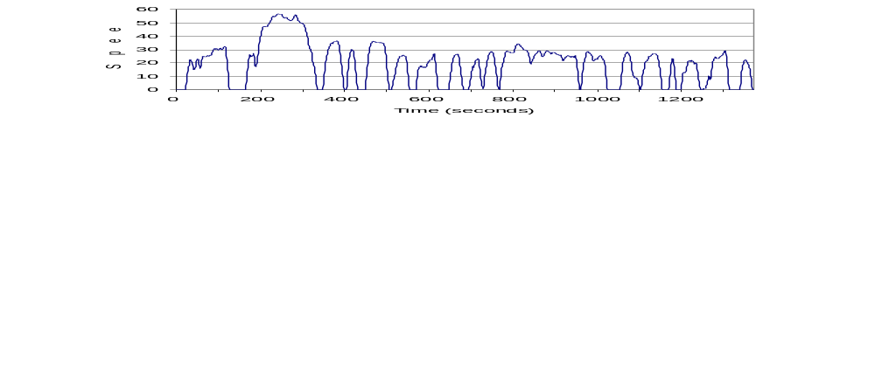averages of the emissions for the two closest cycles.

Figure 3-1. Federal test procedure driving cycle.
Rather than using this interpolation approach, the HYROAD emission module is designed to calculate a weighted average of the emission rates at the speeds of each of the speed correction cycles, where the weights are those that provide the best statistical match of speed distributions produced by the traffic module. The rationale for this is that vehicle operations for a given average speed (e.g., 15 mph) might be made up of either relatively constant speeds between 15 to 25 mph with minimal idle time, or relatively large amounts of higher speed driving (say 45 mph) and significant idle and creep time during red phases. The interpolation approach would provide the same emission rate for both, whereas the HYROAD approach would assign weights to those driving cycles that most closely match the different speed distributions (number of vehicle-seconds in each speed bin) from the traffic module.
In HYROAD, for the MOBILE5 emissions, three low speed correction cycles with average speeds below 5 mph (LS1, LS2, and LS3) were merged into a single low-speed cycle (LS-Comb), whose average speed is 3.4 mph. The cycles corresponding to the other five cycles are known as the New York City Cycle (NYCC), the 12-mph and 36-mph Speed Correction Cycles (SCC12 and SCC36), the FTP cycle, and the Highway Fuel Economy Test Cycle (HFET). Table 3-1 summarizes the characteristics of these cycles, and Figure 3-2 shows the speed distributions, expressed as fraction of driving cycle in each of the speed bins used in the traffic module, including idle.
A similar approach is used for MOBILE6, but for different driving cycles. A total of seven driving cycles were used in the analysis. MOBILE6 uses the same low speed correction cycle of 3.4 mph and the NYCC average speed of 7.1 mph. The five other driving cycles have corresponding average speeds of 11.6, 19.2, 24.8, 30.5 and 52.9 mph.
Table 3-1. Driving cycle characteristics.
 | LS-Comb | NYCC | SCC12 | FTP | SCC36 | HFET
Average Speed (mph) | 3.4 | 7.1 | 12.1 | 19.5 | 35.9 | 48.3
Duration (seconds) | 1875 | 597 | 348 | 1372 | 995 | 765
Length (miles) | 1.76 | 1.18 | 1.17 | 22.9 | 9.92 | 12.8

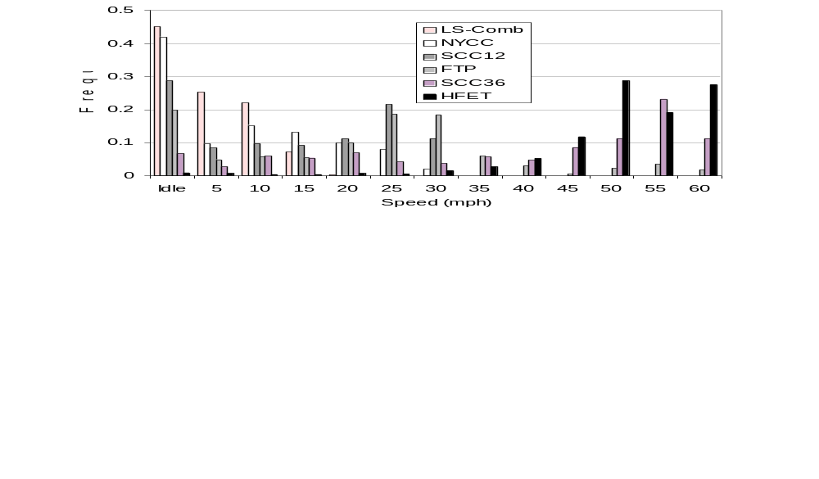
Figure 3-2. Speed distributions of the speed correction cycles.
The algorithm used to calculate the running emission factor for a specific time period calculates non-negative weights to be assigned to each cycle, using linear regression to provide the best fit possible for the speed distribution from the traffic module (i.e., the sum over all blocks of the sum over all acceleration bins of vehicle seconds of operation in each speed bin). Idle time is excluded from the regression fit, and is treated separately. The linear regression algorithm itself cannot be constrained to produce non-negative weights, so a “branch-and-bound” method is used to explore regression-derived weights for all combinations of the six cycles. The derived weights define a speed distribution, as well as a composite running emission factor and an associated total idle time. The speed distribution derived from the weights is given by
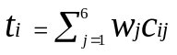
where: t_{i} = predicted vehicle seconds of operation in speed bin i
w_{j} = weight assigned to cycle j
c_{ij} = vehicle seconds of operation in speed bin i for cycle j.
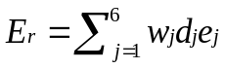The composite emission factors for each cycle (grams per mile) along with the length of each cycle (miles) and the weights are used to derive the total running emissions for the time period:
where: E_{r} = cycle derived running emissions (grams)
d_{j} = length of cycle j (miles)
e_{j} = emission factor for average speed of cycle j (grams/mile).

Excess Idle Emissions
In effect, for emissions purposes, the formulation just presented describes non-idle vehicle operations during the time period as the combination of w_{j} occurrences of cycle j. Because each cycle also includes a certain amount of idle time, the running emissions E_{r} include the emissions occurring during the idle periods of each cycle. That is, there is an implicit amount of idle time T₀ given by the sum over the six cycles of w_{j}c_{0j}, where c_{0j} is the vehicle seconds of idle in cycle j. The total amount of idle time from the traffic module is almost certainly different from the amount of weighed cycle-derived idle. For congested intersections, it will almost invariably be greater. The emissions from the excess idle time are calculated based on the difference between the traffic module idle time and T₀:
E_{i} = e₀(T_{idle} - T₀)
where E_{i} = excess idle emissions (grams)
e₀ = the idle emission factor (grams per second)
T_{idle} = total idle time from the traffic module (seconds).
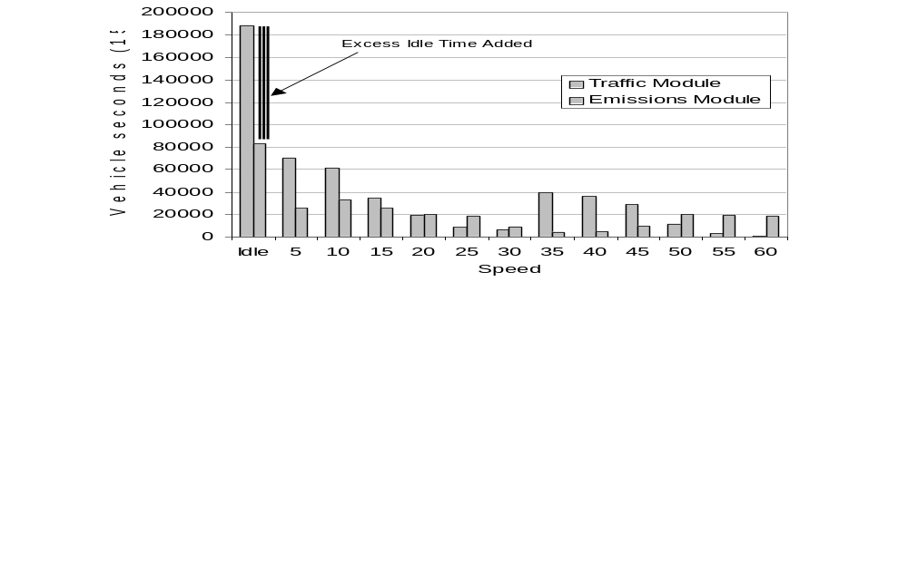
Figure 3-3. Comparison of traffic module and emission module speed distributions.
Total intersection emissions for the time period are the sum of E_{r} and E_{i}. Figure 3-3 shows an example speed distribution produced by the traffic module for a four-legged intersection simulation and the corresponding speed distribution generated by the emission module.

3.3 Spatial and temporal distribution
The emissions calculated as described above must be spatially and temporally allocated to provide inputs for the dispersion module. The emission module does this allocation based on estimated fuel consumption in each block during each signal phase. A matrix containing nominal fuel consumption rates (gallons per second) for each of the speed and acceleration bins used in the traffic module is used along with the speed and acceleration distribution for each block and phase. The fraction of the total predicted fuel consumed during the time period within each block and phase is assumed to be the fraction of CO emissions occurring in that block and phase. This assumption is based on experimental results obtained during Phase II of this project.
As part of the Phase II field measurement program of this project, concurrent ambient measurements of CO and CO₂ were made at multiple locations around the Denver and Virginia test intersections (Ireson and Carr, 1997). These measurements allowed the determination of the incremental concentrations contributed by vehicles at the intersection to both species, which was then used to calculate CO emission rates in units of grams per gallon of fuel. In addition, for selected locations next to idle and depart legs of the intersections, separate measurements were made during green and red signal phases. The objective of this monitoring was to determine the significance of such processes as extended idle time (with postulated cool-down of catalysts and increases in emissions) or power enrichment (increases of emissions during hard and sustained acceleration) on actual emission rates. Power enrichment was observed to occur during low concentration periods, but did not affect gram per gallon emission rates during periods of high concentrations. This observation can be explained by the fact that under congested conditions, only a small fraction of total traffic volume (i.e., the vehicle at the front of each lane’s idle queue) is able to sustain acceleration rates leading to enrichment. Induced airflows during congested periods may also have spatially distributed such excess emissions over a broader area. Therefore, it was concluded that using fuel consumption as a spatial and temporal surrogate for the distribution of emissions was appropriate.
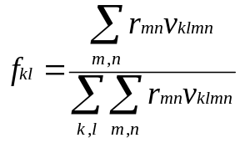The fuel consumption rate matrix is shown graphically in Figure 3-4. It was derived from data provided by Oak Ridge National Laboratory (West, 1996), with some adjustments to achieve correspondence with the speed and acceleration bins used in the traffic module, and to avoid discontinuities arising from vehicles, transmission gearing and shiftpoints in the underlying data set. For each phase, the fuel consumption for each block is calculated as the sum over speeds and accelerations of the product of vehicle seconds of operation (from the traffic module) and the corresponding fuel consumption rate, and the fraction of total fuel consumption is calculated:

where: f_{kl} = fraction of total fuel consumed in block k during phase l (dimensionless)
r_{mn} = fuel consumption rate for speed m and acceleration n
(gallons per second)
v_{klmn} = vehicle seconds of operation for speed m and acceleration n
in block k during phase l.
Emissions in grams for each block and phase are simply the product f_{kl}(E_{r}+E_{i}). The emission rate in grams per second is obtained by dividing the emissions for the phase by the number of seconds during the time period for that phase.
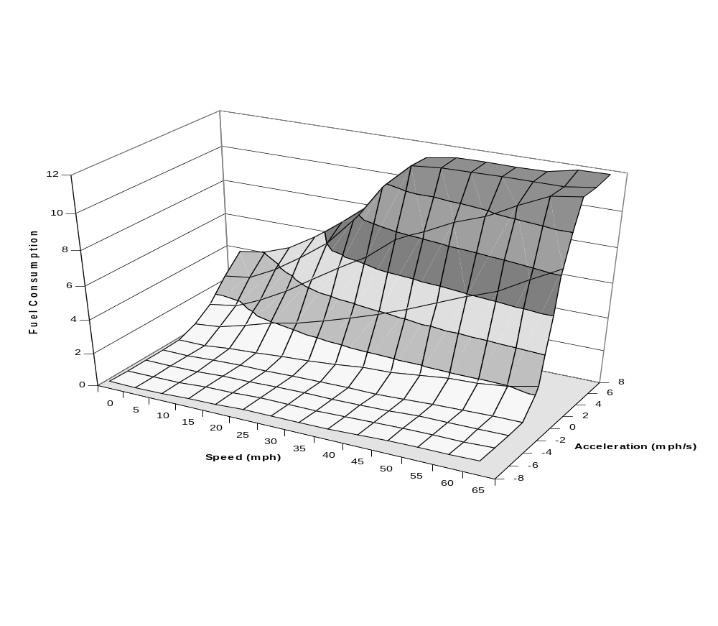
Figure 3-4. Fuel consumption rates by speed and acceleration.

3.4 potential modifications of the emission module
A possible additional refinement is to derive regression weights that match the joint speed-acceleration distribution, rather than just the speed distribution. Careful testing of the results obtained from such an approach would be needed, however, given the limited number of driving cycles, it is possible that the weights derived from regression might prove to be sensitive to small changes acceleration rate assumptions in the traffic module.
At the present time, research efforts are on-going to develop so-called “modal” emission factor models that calculate second-by-second emissions based on vehicle speed and engine load. The acceptance of such models in the regulatory community is not expected for several years, but the HYROAD emission module can be readily adapted to such models. The speed-acceleration distributions from the traffic module can be mapped directly to corresponding modal emissions. Even in advance of regulatory acceptance of modal models, studies of the emissions and air quality effects of ITS measures might be undertaken with them.

