- DISPERSION MODULE
The dispersion module in the integrated air quality intersection model uses a Lagrangian puff approach. This approach uses a Gaussian puff to transport and disperse material. Vehicle-induced flows are incorporated into the model using methods developed by Eskridge (1987) and Eskridge, Petersen and Rao (1991) from the ROADWAY model, creating non-uniform wind fields for puff advection, as well as enhanced vertical dispersion over roadways. Portions of the puff formulation of the model are adapted from the CALPUFF modeling system (Earth Tech, 2000).

4.1 LAGRANGIAN PUFF DISPERSION APPROACH
This section discusses the dispersion algorithm and modeling parameters used for wind speed modeling scenarios. This aspect of the HYROAD model is primarily an adaptation of the ROADWAY dispersion model developed by USEPA’s Office of Research and Development (Eskridge, 1987) combined with the puff algorithm as adapted from the CALPUFF (EPA, 1995) model. This section describes how these modeling approaches were integrated. For a detailed discussion of the ROADWAY model, users should review the ROADWAY User’s Guide (Eskridge, 1987).

ROADWAY Background
The ROADWAY model is a numerical model for predicting air pollution concentration near roadways. It was first released in 1985, and with additional modifications in 1986. The unique part of the model adopted for inclusion in HYROAD is the vehicle wake theory, which was originally developed by Eskridge and Hunt (1979), and modified by Eskridge and Thompson (1982) and Eskridge and Rao (1983,1986). A vehicle wake is a region of increased turbulence and decreased velocity relative to the vehicle. The intensity of the wake is a function of vehicle speed, downwind distance, and distance from the center of the wake. In HYROAD, an average velocity field is calculated across the highway based on traffic volume average speed, and ambient atmospheric (upwind) conditions. The model then uses the calculated velocity in combination with the puff algorithm to determine pollutant concentrations upwind and downwind of the roadway.

CALPUFF Background
The CALPUFF model is a non-steady-state Lagrangian puff model used for prediction of pollutant concentrations (Earth Tech, 2000). The model was initially distributed in 1995, and on-going releases have continued to the present. The CALPUFF model includes an efficient algorithm for calculating concentration contribution from overlapping puffs. This algorithm was adopted for use in HYROAD. HYROAD uses the integrated puff algorithm to efficiently calculate concentration for each puff at each time step.

Vehicle Wake Theory
This section briefly describes the single and multiple wake theory employed in the puff module. Further details about the development of the wake theory are discussed in Eskridge and Hunt (1979).

Cross-Roadway Grid
The HYROAD puff dispersion module uses a fixed Cartesian grid of winds and stabilities that is derived from both the input meteorological variables and perturbations due to traffic flows during each signal phase. A separate meteorological field is calculated for each signal phase. Vehicle-induced flows and turbulence are calculated using the algorithms of ROADWAY, which superimposes a grid of cells over the roadway that is aligned with the wind direction. As this wind-axis grid in general will not align with the HYROAD grid, flows and turbulence are interpolated from the ROADWAY calculations to the centers of the fixed grid used in puff advection and dispersion. There are up to 28 wind-axis grid cells spread over a distance defined by the roadway width, number of lanes, wind speed and the angle of the wind relative to the road. Cells are more closely spaced over the road.
Table 4-1. Algorithm used to set grid dimensions and the steady-state time period.
Horizontal Scale
Road-wind angle: | Dimensions:
> 10° | scale begins 20 m upwind of first lane;
 | scale ends 30 m downwind of last lane
≤ 10° | scale begins 20 m upwind of first lane;
 | scale ends 25 m downwind of last lane;

Vehicle Wake Theory
The vehicle wake theory was developed by Eskridge and Hunt (1979) and modifications were made based upon wind tunnel experiments by Eskridge and Thompson (1982) and Eskridge and Rao (1983, 1986). All known constants in the wake theory are based upon wind tunnel measurements. A brief description of the relevant parts from those studies is given below:
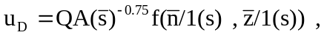The wake velocity deficit of a single vehicle is given by
(4-1)
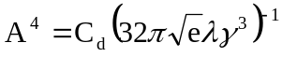Where h is the height of the vehicle set to the constant value of 1.4 m; Q is the wind speed relative to the vehicle; A is the strength of the wake determined by the overturning momentum acting on the vehicle; γ and λ are constants with experimentally-determined (wind tunnel) values of 0.95 and 1.14, respectively; s is the coordinate along the centerline of the wake; n is the coordinate in the horizontal plane perpendicular to s; z is the vertical coordinate; 1(s) is the vertical scale length of the wake; and w_{d} is the width of the vehicle set to the constant value 1.8 m. A and 1(s) are given by
(4-2)
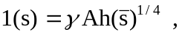
(4-3)
Where C_{d} is the drag coefficient and the other variables are given above.
The function f in Eq. (4-1) is the solution to a partial differential equation that does not have a closed form solution (Eskridge and Thompson, 1982). However, the equation is separable as follows,
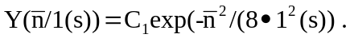where
(4-4)

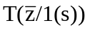 is found by fitting a polynomial to wind tunnel measurements of velocity deficit given by
(4-5)

where the coefficients b₀,…,b₆ are listed in Table 4-2.

Table 4-2. Constants for the polynomial fits in Eq. (4-5)
Coefficient | Value
b₀ | 0.0179349
b₁ | 2.5765870
b₂ | -2.3062584
b₃ | 0.8951468
b₄ | -0.1758604
b₅ | 0.0169970
b₆ | -0.0006404

Multi-vehicle Velocity and Turbulence Fields
The equations describing multi-vehicle wind velocity are presented below. The derivations for these equations are given in Eskridge and Rao (1983).
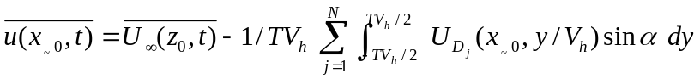The horizontal wind velocity components are computed by
(4-6)
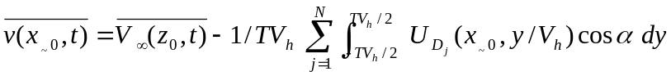
Where V_{h} is the average vehicle speed, x_{~0} = (x₀, y₀, z₀), u_{Dj} is given by Eq. (4-1), N is the number of vehicles passing the point x₀ during the time interval (-T/2, T/2), α is the angle between the relative wind and the highway, and U∞(z,t) and V∞(z,t) are upwind ambient wind component conditions.
This equation is then solved for each 10-m segment of roadway to develop a two-dimensional flow field in the vicinity of the intersection.

Lagrangian Puff Algorithm
Puff models represent a continuous plume as a number of discrete packets of pollutant material. Puff models (e.g., Ludwig et al., 1977; van Egmond and Kesseboom, 1983; Peterson, 1986) have traditionally evaluated the contribution of a puff to the concentration at a receptor by a “snapshot” approach. Each puff is “frozen” at particular time intervals (sampling steps). The concentration due to the “frozen” puff at that time is computed (or sampled). The puff is then allowed to move, evolving in size, until the next sampling step. The total concentration at a receptor is the sum of the contributions of all nearby puffs averaged for all sampling steps within the basic time step.
A traditional drawback of the puff approach has been the need for the release of many puffs to adequately represent a continuous plume close to a source. An alternatives integrated puff sampling approach to the conventional snapshot sampling function was first developed for the MESOPUFF II model (Scire et al., 1984a,b). This approach was further refined and implemented in CALPUFF and now extended to the HYROAD model.

Puff Sampling Function Formulation
The basic equation for the contribution of a puff at a receptor is:
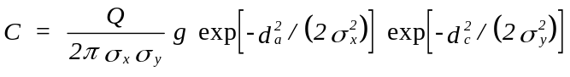 (4-7)
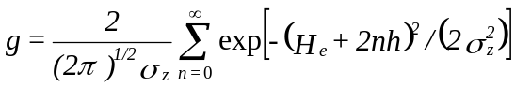 (4-8)

where, C is the ground-level concentration (g/m³),
Q is the pollutant mass (g) in the puff,
σ_{x} is the standard deviation (m) of the Gaussian distribution in the along-wind direction,
σ_{y} is the standard deviation (m) of the Gaussian distribution in the cross-wind direction,
σ_{z} is the standard deviation (m) of the Gaussian distribution in the vertical direction,
d_{a} is the distance (m) from the puff center to the receptor in the along-wind direction,
d_{c} is the distance (m) from the puff center to the receptor in the cross-wind direction,
g is the vertical term (m) of the Gaussian equation,
H_{e} is the effective height (m) above the ground of the puff center, and,
h is the mixed-layer height (m).

The summation in the vertical term, g, accounts for multiple reflections off the mixing lid and the ground. It reduces to the uniformly mixed limit of 1/h for σz > 1.6 h. In near roadway conditions under typical mixed-layer heights only the n=0 term is important.
For a horizontally symmetric puff, with σ_{x} = σ_{y}, Eq. (4-7) reduces to:

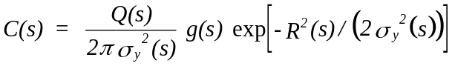 (4-9)
where,
R is the distance (m) from the center of the puff to the receptor, and,
s is the distance (m) traveled by the puff.

The distance dependence of the variables in Eqn. (4-9) is indicated (e.g., C(s), σ_{y}(s), etc.). Integrating Eqn. (4-9) over the distance of puff travel, ds, during the sampling step, dt, yields the time averaged concentration, C.
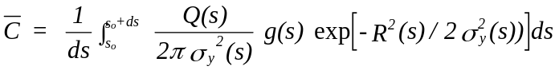 (4-10)
where s_{o} is the value of s at the beginning of the sampling step.
If it is assumed that the most significant s dependencies during the sampling step are in the R(s) and Q(s) terms, an analytical solution to this integral can be obtained. Assuming the trajectory segment is a straight line, and transforming s to a dimensionless trajectory variable, p, the radial distance to the receptor at (x_{r},y_{r}) is:
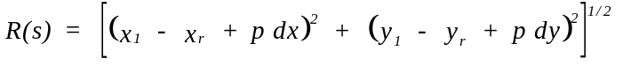 (4-11)

where, p is zero at the beginning of the trajectory segment (i.e., at (x₁,y₁)),
p is one at the end of the trajectory segment (i.e., at (x₂,y₂)), and,
dx, dy are the incremental X and Y distances traveled by the puff (i.e., dx = x₂ - x₁, and dy = y₂ - y₁).

The exponential variation of Q is expressed as a linear function of the sampling interval:

(4-12)

Using Eqn. (4-12), and transforming to p coordinates, Eqn. (4-10) becomes:
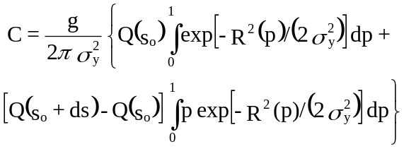 (4-13)
The solution of the integrals in Eqn. (4-13) is expressed in terms of error functions and exponentials:
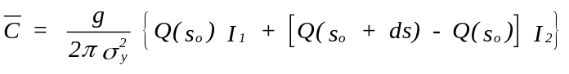 (4-14)
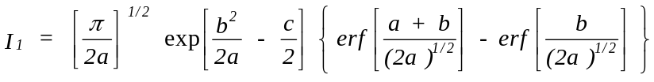 (4-15)
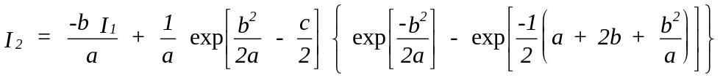 (4-16)
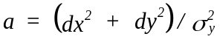 (4-17)
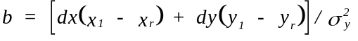 (4-18)
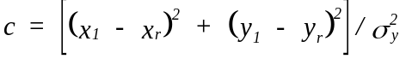 (4-19)

The horizontal dispersion coefficient, σy, and the vertical term, g, are evaluated and held constant throughout the trajectory segment. Within HYROAD both σy and g are computed at the mid-point of the trajectory segment (p = 0.5). For the relatively short travel distances in HYROAD, the fractional change in the puff size during one time step (one second) is small, and the use of the mid-point values of σy and g is adequate. This assumption reduces the number of times that the dispersion coefficients and vertical reflection terms need be computed to one per time step (independent of the number of receptors).

Dispersion Algorithms
A key element for modeling is the specification of the lateral and vertical Gaussian dispersion coefficients, σ_{y} and σ_{z}. In HYROAD the algorithms used to grow the size of the puff once outside the roadway mixing zone have been adopted based on a number of studies (Smith, 1972, McElroy and Pooler, 1968, Pasquill, 1974, Gifford, 1975, Benson, 1981 and Hanna et. al, 1977). In all cases the choice of the dispersion for implementation in the HYROAD model have been based on studies from near-ground level releases. In all cases the defining choice of the rate of dispersion within HYROAD has been the surface roughness and location (relative to the roadway) of the puff.

Initial Dispersion and Growth
Initial puffs have been assigned a minimum longitudinal length of 10 m (the smallest resolution of the emissions along each roadway). The cross-roadway dimension of the puff is assigned the mean lane width. An initial value of 1.5 m is used for the initial vertical dispersion parameter, (z_{i}). This value was initially developed by Calder (1973) and later used by Zimmerman and Thompson (1974) in the original HIWAY model as well as in CALINE4 (Benson, 1989). This value was held constant for all stability classes as the study by Johnson (1974) concluded that vertical dispersion near the roadway was independent of atmospheric stability.
Puffs within the roadway grow at the local rate of dispersion based on the local turbulent flow field and diffusivity as determined from semi-empirical theory of Monin-Obukhov similarity theory with second moment closure (Binkowski, 1979). The local turbulent diffusivity, K_{h} is then used in combination with the relationships between the crosswind concentration distribution σ_{y} (Hanna, 1977) and the non-dimensional function of travel time, f_{y} from Draxler (1976) for surface releases with travel times of less than 550 seconds to determine the standard deviation of the horizontal wind angle, σ_{θ} as
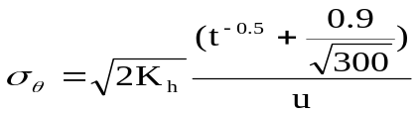

(4-20)

σ_{θ} is then used to determine local P-G stability class. The rate of dispersion then proceeds at the local P-G stability class for the puff’s downwind travel distance (x = ut). Each puff’s downwind travel distance is retained over the duration of the simulation.
Puffs are tracked and followed through one full signal cycle that includes different traffic patterns and wind/turbulence fields for each signal cycle phase. Concentrations are determined from the summed combination of these puffs for each signal phase assuming steady-state conditions prevail during each signal cycle phase. Puff trajectories and dispersion for those receptors whose location is beyond the travel distance of a single signal cycle phase are continued beyond the near field using the ambient winds and stability. Puff trajectories and dispersion pattern for a complete cycle at the end of each signal phase are retained for subsequent transport and dispersion. These patterns are advected and repeated, but with the updated downwind dispersion parameters until the most distant receptors from the intersection are included.

Lateral Dispersion
After the puff has been initially dispersed, the rate of lateral dispersion is dependent upon the surface roughness and “urban” dispersion curves of the St. Louis study performed by McElroy and Pooler (1968). Briggs (1974) parameterized these values as a function of stability class and his formulas are presented in Table 4-3. For areas in which the surface roughness is less than 50 cm, the lateral dispersion is modified as a function of surface roughness. As suggested by Hanna et al. (1977), a roughness correction factor is applied to σ_{y} as z₀^{0.2}, where z₀ is in meters. To minimize the computational burden, two representative size categories are used within the model as shown in Table 4-4.
Table 4-3. Briggs formulas used to calculate McElroy-Pooler, _{y}
Pasquill Stability Category | σ_{y} (meters)**
A  B  C  D  E  F | 0.32 x (1.0 + 0.0004 x)^{-1/2}  0.32 x (1.0 + 0.0004 x)^{-1/2}  0.22 x (1.0 + 0.0004 x)^{-1/2}  0.16 x (1.0 + 0.0004 x)^{-1/2}  0.11 x (1.0 + 0.0004 x)^{-1/2}  0.11 x (1.0 + 0.0004 x)^{-1/2}
* Source: Gifford (1976)
** where x is in meters

Table 4-4. Adjustment factor for surface roughness (Hanna, et al., 1977)
Surface Roughness  (cm) | Representative z₀  (cm) | Adjustment Factor  z₀^{0.2}
5 - 50 | 10 | 0.631
< 5 | 1 | 0.398

Vertical Dispersion
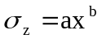As with lateral dispersion, after the puff has been initially dispersed, the rate of vertical dispersion is dependent upon the surface roughness and the “urban” dispersion curves of the St. Louis study performed by McElroy and Pooler (1968). Smith (1973) developed power-law approximations to these values of vertical dispersion as a function of stability class and surface roughness. These more realistic representations of the vertical spread are used in HYROAD. The dispersion curves are calculated using a power-law approximation of the form:
(4-21)

Values for a and b are shown in Table 4-5 for three ranges of surface roughness used in HYROAD.
Table 4-5. Power-law Constants (a and b in equation 4-21) for Growth of Vertical Diffusion (σ_{z}) with Distance (x)
Stability Category | Coefficient, a |  |  | Power, b
Stability Category | Surface Roughness, z₀, and  Range in HYROAD |  |  | Surface Roughness, z₀, and  Range in HYROAD
Stability Category | 1 cm | 10 cm | 100 cm | 1cm | 10 cm | 100 cm
Stability Category | <5 cm | 5<z₀<50 cm | > 50 cm | <5 cm | 5<z₀<50 cm | > 50 cm
A  B  C  D  E  F | 0.102  0.062  0.043  0.029  0.017  0.009 | 0.140  0.080  0.056  0.038  0.023  0.012 | 0.190  0.110  0.077  0.050  0.031  0.017 | 0.94  0.89  0.85  0.81  0.78  0.72 | 0.90  0.85  0.80  0.76  0.73  0.67 | 0.83  0.77  0.72  0.68  0.65  0.58
* Source: Smith (1973)
** where x and σ_{z} is in kilometers

Portions of the following text and figures describing ROADWAY formulation are taken from the Roadway User Guide (Eskridge and Catalano, 1987).
Portions of the following text and figures describing the puff algorithm are taken from CALPUFF User Guide (Earth Tech, 2000).

