- MODELING SYSTEM VERIFICATION

5.1 VERIFICATION OF MODIFICATIONS TO TRAF-NETSIM
As noted previously, the software modifications to incorporate TRAF-NETSIM within HYROAD involved the addition of new vehicle performance measures and the transferal of these measures to a new file (LU92) for use by the emission and dispersion modules. The underlying TRAF-NETSIM logic responsible for representing driver behavior and vehicle movements remains unchanged. Previous validation efforts over TRAF-NETSIM’s long history demonstrate the ability of the model to realistically simulate traffic operations. All simulation statistics previously provided by TRAF-NETSIM are unaffected by the additional traffic measures output by the NETSIM module.
To confirm that this was the case, and that modifications to add new vehicle performance measures for the HYROAD model did not inadvertently affect the traffic model’s basic output statistics, a series of tests were performed:
The standard TRAF-NETSIM model (version 5.0) without any modifications was executed to provide a set of baseline traffic performance statistics.
The NETSIM module within HYROAD was run with the same data file used by the standard model. This data file did not include a request to provide new vehicle performance measure statistics. Thus, new code to provide vehicle performance measure statistics was not executed in this run.
The NETSIM module within HYROAD was run a second time but the data file included a request for the new vehicle performance statistics to be computed and stored on file, LU92. The new software developed under this project was fully executed in this run.
As expected, each of the three runs produced identical standard statistics demonstrating that the modified software did not affect the computation of original TRAF-NETSIM traffic performance statistics in any way. The third run produced an additional set of statistics in file, LU92 as expected.
These new statistics essentially stratify TRAF-NETSIM’s standard link-specific estimates of vehicle-miles and vehicle-seconds of travel into:
1) Estimates of vehicle-miles of travel across a link stratified by speed
2) Estimates of vehicle-miles of travel across a link stratified by vehicle-type
3) Estimates of vehicle-seconds of travel within individual roadway blocks 10 m by 1 lane, stratified by travel speed, acceleration, and signal phase.
As part of the effort to confirm that the modified software properly performs these stratifications to create the new vehicle performance measure statistics, tests were performed to verify that:
Aggregating vehicle-miles of travel over all speed ranges yields the link-specific estimate of vehicle-miles already provided by TRAF-NETSIM.
Similarly, aggregating vehicle-miles of travel over all vehicle-types also yields the same link-specific estimate of vehicle-miles already produced by TRAF-NETSIM.
Aggregating vehicle-seconds of travel within all roadway blocks on a link for all travel speeds, accelerations, and signal phases yields the same link-specific estimate of vehicle-seconds of travel produced by TRAF-NETSIM.
There are however, some important differences in the way that TRAF-NETSIM computes its link-specific statistics and how the NETSIM module within HYROAD gathers statistics:
1) The standard TRAF-NETSIM measures of link-specific travel time and vehicle-miles of travel reflect only vehicles which have completed their trip across a link and discharged from the link. Incomplete trips are not reflected in these link-specific measures but are included within the NETSIM module of HYROAD.
2) TRAF-NETSIM includes a period of time known as “initialization time” to load vehicles on the network. At the conclusion of “initialization,” the simulation clock is reset to zero and simulation begins. For those vehicles which enter a link during initialization, and leave the link after the initialization period is completed, the standard TRAF-NETSIM link-specific travel time, includes the travel time spent during both of these periods. The travel time estimates for the NETSIM module within HYROAD exclude all travel time during the initialization period.
For purposes of verification, additional temporary versions of NETSIM’s link-specific travel time and vehicle-mile estimates were added into the code, adjusting the standard statistics to account for these differences. These adjusted measures are directly comparable to aggregates of the air quality statistics over all roadway “blocks” comprising a direction of travel.
Three test cases were executed to compare aggregate statistics of vehicle-seconds and vehicle-miles of travel generated from the new NETSIM module logic with comparable adjusted statistics from the existing TRAF-NETSIM model as described above. Since within HYROAD “blocks” associated with a link extend into the middle of the intersection, and the standard TRAF-NETSIM links end at the stop-line, statistics were aggregated to include the approach and departing link in each direction to eliminate this difference in the statistics.
The three test cases represent real-world intersections in Tucson, Arizona; Denver, Colorado; and Loudoun County, Virginia for which data was collected during Phase II of the NCHRP 25-6 project. The results of these comparisons are shown in Table 5-1.
As seen in this table, the maximum difference in estimates of vehicle-seconds of travel by the NETSIM module of HYROAD logic and comparable logic based on the existing TRAF-NETSIM is no more than one-tenth of one percent. Similarly, estimates of vehicle-miles differ by no more than 1.4 percent in any of the cases examined. This difference is likely caused by round-off differences within the internal computations. These comparisons indicate that the logic to provide estimates of vehicle-seconds of travel by 10 m × 1 lane roadway “blocks” is working properly. In addition, logic to compute vehicle-miles of travel by vehicle type, and by speed is also functioning properly.
Table 5-1. Comparison of TRAF-NETSIM and the Aggregate NETSIM module of HYROAD.
Intersection | Direction | TRAF-NETSIM (veh-sec) | Aggregate NETSIM module of HYROAD (veh-sec) | Difference % | TRAF-NETSIM (veh-miles) | Aggregate NETSIM module of HYROAD (veh-miles) | Difference %
Tucson, AZ | Eastbound  Westbound  Northbound  Southbound | 59476  51028  55891  50844 | 59463  51015  55814  50845 | 0.0  0.0  0.1  0.0 | 536.7  435.6  391.8  324.5 | 533.2  433.7  390.2  322.2 | 0.7  0.4  0.4  0.7
Denver, CO | Eastbound  Westbound  Northbound  Southbound | 134354  123790  40562  51288 | 134299  123748  40505  51270 | 0.0  0.0  0.1  0.0 | 759.6  730.2  363.6  441.5 | 756.3  726.6  361.2  438.1 | 0.4  0.5  0.7  0.8
Loudoun County, VA | Eastbound  Westbound  Northbound  Southbound | 19802  48454  120864  63070 | 19791  48447  120738  63033 | 0.1  0.0  0.1  0.1 | 168.4  293.8  792.8  540.1 | 166.0  290.7  789.7  537.0 | 1.4  1.1  0.4  0.6

5.2 Verification of Overall Modeling System
This section presents a model evaluation study from data collected during Phase II of this study. The data set includes three roadway intersections that were intensively instrumented and seven National Air Monitoring Sites (NAMS) or State or Local Air Monitoring Sites (SLAMS) at which hourly CO measurement were made.
Microscale dispersion models are most commonly used in assessing the impacts of carbon monoxide (CO) from motor vehicles on air quality. EPA has chosen CAL3QHC 2.0 (EPA, 1992a) as the preferred guideline model for evaluating CO concentrations within this environment. This evaluation compares the HYROAD model with CAL3QHC using a data set that was ONLY used to develop a conceptual understanding of the CO behavior. The HYROAD model does not use empirical relationships, which may be present in the data, but relies upon first principals to develop the underlying physical relationships simulated by the model.

The Intensive Monitoring Sites and Traffic Database
During Phase II of NCHRP 25-6, three roadway intersections were intensively monitored for six to 12 week periods. The three intersections were in broadly different climate areas: Loudoun County, Virginia; Denver, Colorado; and Tucson, Arizona. The three intersections were intensively instrumented with a network of CO measurements. The resulting data set was previously analyzed for better understanding of the relationships between CO concentrations near roadway intersections and traffic volume and behavior near the intersection (Carr and Ireson, 1997). For this final phase of the study, the collected data and the MOBILE5a emission factor model have been used as inputs to the HYROAD model as well as CAL3QHC and the resulting predictions compared with monitored concentrations. The intensive monitored data set represents the best data set for model comparison and validation because of the comprehensive spatial and temporal data collected.

Data Selection
The dates chosen for simulation were selected randomly from a group of dates that fulfilled several different criteria. The dates were required to contain the complete twenty-four hours of traffic volume and meteorological data to be valid. Only Tuesdays through Thursdays were chosen, as Mondays, Fridays, and weekends may not accurately represent the average traffic volumes. The selected dates were checked to ensure an approximate equal mix of Tuesdays, Wednesdays, and Thursdays, spread evenly over the given three-month time period.
For the intensive intersections in Virginia and Denver, seven full days of data were selected for simulation and comparison. The criteria used for the Loudoun County, Virginia site was weekday periods, Tuesday through Thursday, where complete traffic volumes and meteorological data were available for the full twenty-four-hour period, during the dates 1/25/95 through 3/19/95. After evaluating the data set, sixteen days were determined to have complete data, and from these seven were selected. These dates were 1/31/95, 2/8/95, 2/21/95, 2/23/95, 3/1/95, 3/9/95 and 3/15/95. These dates were selected at random, with an afterward verification that an approximate equal mix of Tuesdays, Wednesdays, and Thursdays were included, spread evenly over the three months. The other intensive intersection, Denver, Colorado, had the criteria of weekday periods, Tuesday through Thursday, where complete volume and meteorological data was available for the full twenty-four-hour period during 12/19/94 through 3/12/95. The holidays of Christmas and New Year’s were excluded. After examining the data, thirty-one days were deemed suitable for selection, out of the total thirty-four days. The seven dates selected were 12/17/94, 1/4/95, 1/19/95, 1/31/95, 2/15/95, 3/1/95, and 3/9/95. The criteria for the Tucson, Arizona site was weekday periods, Monday through Friday, where complete meteorological data was available. Monday and Friday were included as possible candidate days as local agencies considered them representative of typical weekdays. (Traffic volume data was incomplete for most time periods, and a composite of typical weekday data was used in the analysis). After evaluating the data set, fifteen days were determined to have complete data and from these seven were selected for the analysis. The days selected were 2/23/94, 2/24/94, 2/28/94, 3/1/94, 3/4/94, 3/7/94,3/9/94,and 3/15/94.

Statistical Analysis Approach

Data Groupings
Statistical analyses were performed on several groups of data to determine model performance for the two models for both the intensive and SLAMS/NAMS data sets. Data were grouped as follows:
Grouped by site using all concentration pairs (paired in time and space);
Grouped by site using a subset of data with the highest observed concentrations (paired in time and space);
Grouped by site using a subset of data with the highest observed and predicted concentrations (unpaired) - rank ordered.
The first grouping is used to evaluate overall performance of the models at a specific site. The latter two groupings are used to evaluate model performance in predicting peak concentrations at a given site. These latter two groupings are the most important groups when using model results for determining exceedances of a short-term standard.

Performance Measures
Several measures of performance are used to evaluate the two models. Graphical measures consisted of scatter plots of observed and predicted concentrations. The distributions of observed and predicted concentrations are paired in both time and space. These plots are useful in providing insight into model behavior. However, graphical measures alone are insufficient for evaluating and comparing model performance
Statistical procedures developed by Cox and Tikvart (1990) provide for an objective comparison of the performance between models. To evaluate the models’ performance the following statistical measures were used in this analysis: average residual (bias), standard deviation of average residual, root mean square error, absolute average residual, Pearson correlation coefficient, fractional bias and robust highest concentration.
Fractional bias is defined as:

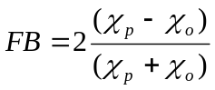,
Where χ_{p} is the average predicted concentration and χ_{o} is the average observed concentration. Thus a positive bias indicates an over prediction. It should be noted that the above definition differs from that originally used by Cox and Tikvart in that the numerator in their paper is χ_{o} – χ_{p}. Two features of the fractional bias are 1) it ranges between 2 (extreme over prediction) and −2 (extreme under prediction), and 2) it is a dimensionless value. The fractional bias can be translated into equivalent “factors” of over and under prediction. For, example, a fractional bias of +0.67 represents a “factor of two” over prediction while -0.67 represents a “factor of two” under prediction.
The robust highest concentration (RHC) test statistic proposed by Cox and Tikvart is also used in this evaluation. This statistic represents a “smoothed” estimate of the highest concentrations, based on a tail exponential fit to the upper end of the distribution. In other words, the effect of extreme values on model comparison is lessened. The statistic is given by:

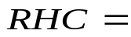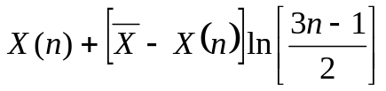
where:
M₀ = number of values used to characterize the “upper end” of the distribution

M = number of values exceeding a threshold value
n = min (M₀, M)
 = average of the N-1 largest values, and
X(n) = nth largest value.
For the evaluation, two values of M₀ were used. For the Tucson, Denver and Virginia intensive intersections, a total of 168 hours each were selected for modeling, and M₀ was set at 25. For Seattle; Lake Tahoe, CA; Albuquerque, NM; and Tucson (SLAMS only) nine full days were modeled and M₀ was set at 25. For the other three SLAMS sites, between 82 and 111 hours were selected for simulation, and M₀ was set at 10.

Intensive Intersection Model Results
The analysis of model performance focuses on these intensively monitored intersections. There are two key factors motivating this emphasis. First, during the intensive monitoring periods, concurrent measurements of CO were made at 14 locations in Tucson and 20 locations in Denver and Virginia, allowing the analysis to examine spatial variations in observed and predicted concentrations. Second, each intersection had four additional “background” CO monitoring locations well away from the intersection proper in each quadrant of the intersection. Thus, it is not necessary to rely on the neighborhood-scale SLAMS station alone as the source of background concentration information. The use of the neighborhood-scale SLAMS station as the background concentration leads to significant scatter in determining intersection “only” contribution. In addition, evaluations of the CAL3QHC and HYROAD models were conducted using actual meteorological inputs rather than current EPA regulatory guidance which may be tied to an individual model’s bias rather than capability of the model to simulate actual conditions.

Tucson
The Tucson, Arizona intensive and SLAMS site is the intersection of 22nd Street and Alvernon Way. 22nd Street runs east and west, and is crossed by Alvernon way, which runs north and south. The posted speed limits are 40 mph for 22nd street and 35 mph for Alvernon Way. The intersection configuration and lane widths are shown in Figure 5-1. The locations of the 18 sites are shown in Figure 5-1. They are enclosed in circles. Circles on top of each other are sites with readings are at multiple levels.
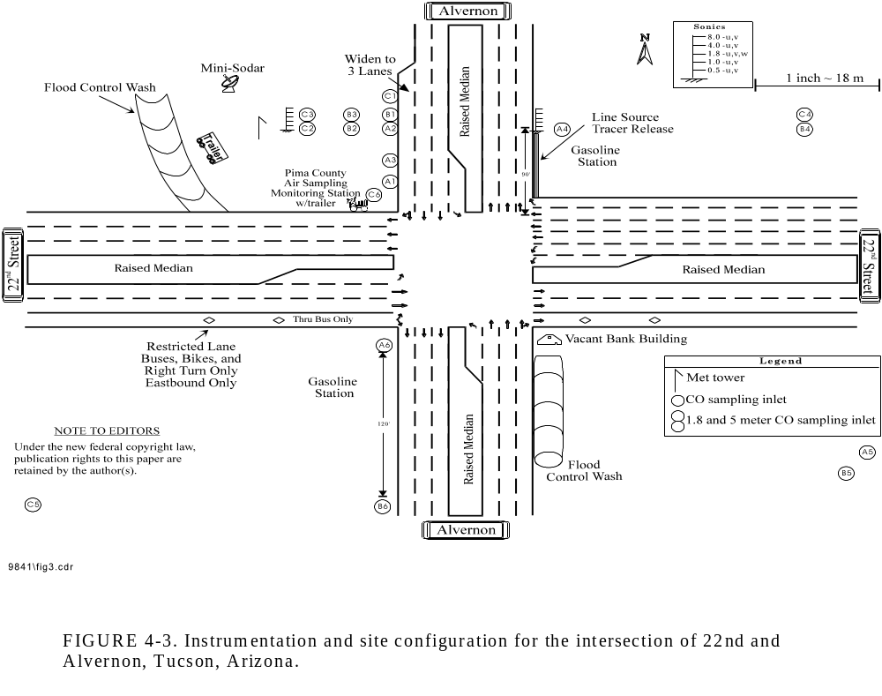
Figure 5-1. Intersection layout and instrumentation for the Tucson site.
For the Tucson analysis we examined both the Gaussian puff model algorithms (PUFF), as currently implemented in HYROAD, and the CALINE4 Gaussian line source algorithm (CL4), not currently implemented in HYROAD, to determine the need for the HYROAD model to carry both algorithms. For the remaining discussion on the Tucson performance evaluation both results are presented.
The ability of a model to reproduce the statistical distribution of high concentrations can be assessed by comparisons of predictions and observations unpaired in time. Figure 5-2 shows this comparison for HYROAD and CAL3QHC for the Tucson dataset for the SLAMS monitoring location (C6). Ideal performance would produce a straight line through the origin with slope of 1. The HYROAD with CALINE4 dispersion algorithm (CL4) over predicts, with a maximum prediction being about 10.5 ppm, while CAL3QHC’s predicts a concentration of less than 3 ppm, versus an observed maximum of about 7.5 ppm. The HYROAD PUFF algorithm does best with a maximum prediction of just over 6 ppm. To more fully understand the conditions affecting the relationships between predictions and observations, graphical analyses were conducted for subsets of the data based on stability class, wind speed, and wind direction.
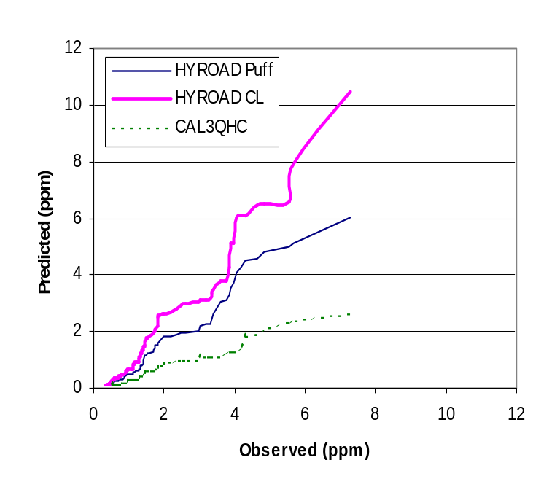Figure 5-2. Comparison of HYROAD PUFF and HYROAD CL4 and CAL3QHC performance at Tucson microscale (C6) monitoring location unpaired in time.
Figure 5-3 shows the scatterplots of data grouped by wind direction, wind speed, and stability. HYROAD PUFF results are plotted as diamonds, HYROAD CL4 as triangles, and CAL3QHC results are plotted as circles. Figure 5-4 shows the corresponding plots for data unpaired in time. Wind directions between 90 and 180 degrees represent conditions in which airflow is diagonally across the intersection toward the monitoring site, whereas the other winds represent airflows across either the north or west leg of the intersection. The highest observed concentrations occurred during “diagonal” flow conditions. Both the HYROAD PUFF and HYROAD CL4 are more successful than CAL3QHC in predicting these concentrations. For the cross-roadway flow CAL3QHC tends to under predict while HYROAD CL4 has an over prediction bias. HYROAD PUFF appears to do best at predicting these concentrations.
Stratifying for wind speed above and below a threshold of 1.25 m/s separates the HYROAD results into groups that are conceptually steady-state conditions or puff dispersion treatment. For the low wind speed conditions, the HYROAD PUFF appears to offer the best performance. At higher wind speeds all models show some under prediction bias. Across stability conditions, HYROAD PUFF appears to provide more accurate predictions than CAL3QHC and on average better estimates than HYROAD CL4.
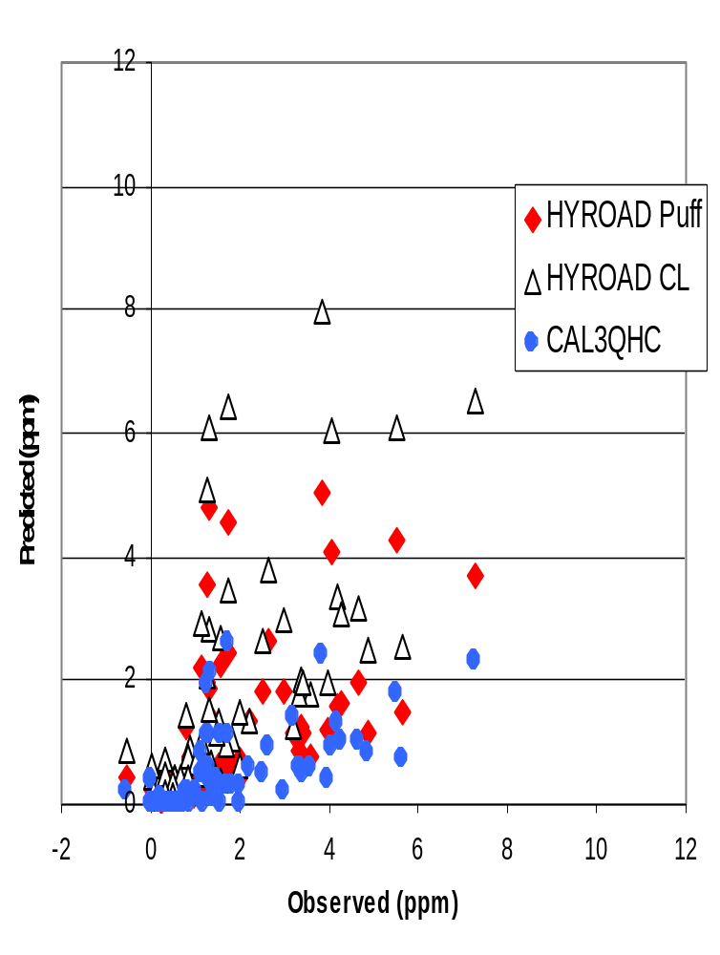
Figure 5-3. Comparison of HYROAD PUFF, HYROAD CL4 and CAL3QHC at Tucson microscale site (C6) for eight days (N=192).

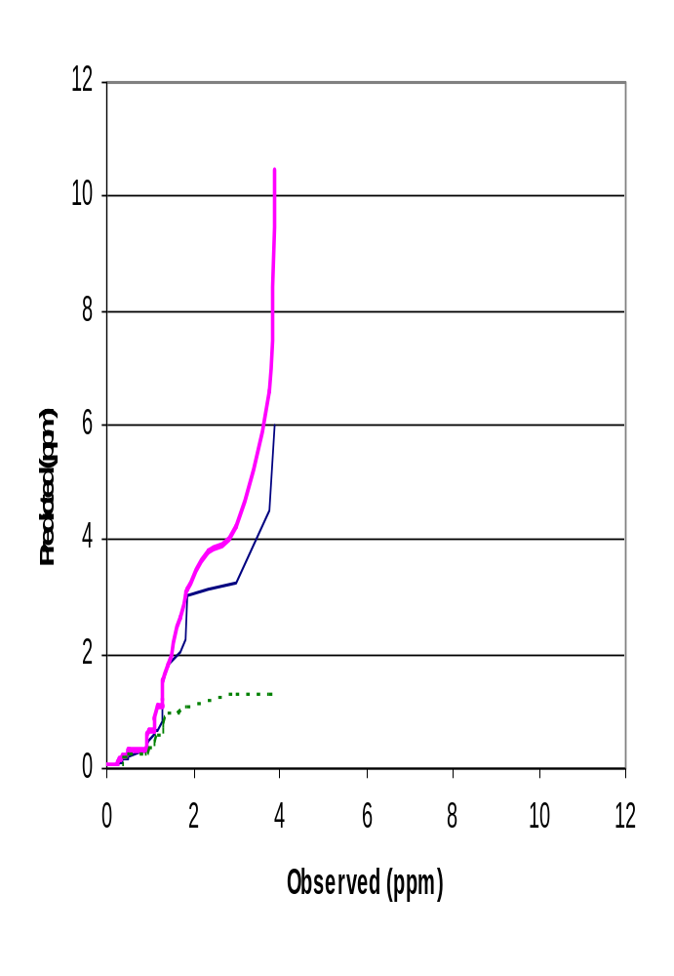
Figure 5-4. HYROAD PUFF, HYROAD CL4, CAL3QHC performance, unpaired in time (N=192).

Statistical analysis confirms these subjective assessments. Results for all pairs of data are shown in Table 5-2. HYROAD PUFF and CL4 performance exceeds that of CAL3QHC for most performance measures. Table 5-3 and Table 5-4 show results for the highest 25 concentrations, paired and unpaired in time. HYROAD PUFF and CL4 exceed CAL3QHC measures for nearly all categories and key measures such as the fractional bias and RHC show significant improvement. Between the two dispersion algorithms HYROAD PUFF and HYROAD CL4 model results show mixed results.
Table 5-2. Comparison of HYROAD PUFF, HYROAD CL4 and CAL3QHC performance statistics (all data).
 | HYROAD Puff | HYROAD CL4 | CAL3QHC
Average residual (bias) | -0.22 | 0.07 | -0.59
Standard deviation of average residual | 1.09 | 1.24 | 1.09
Root mean square error | 1.11 | 1.24 | 1.24
Absolute average residual | 0.75 | 0.75 | 0.84
Pearson correlation coefficient | 0.63 | 0.68 | 0.64
Fractional bias | -0.29 | 0.07 | -1.01

Table 5-3. Comparison of HYROAD PUFF, HYROAD CL4 and CAL3QHC performance statistics for the top 25 observed concentrations (paired in time).
 | HYROAD Puff | HYROAD CL4 | CAL3QHC
Average residual (bias) | -1.58 | -0.37 | -2.81
Standard deviation of average residual | 1.53 | 2.11 | 0.97
Root mean square error | 2.18 | 2.11 | 2.97
Absolute average residual | 1.88 | 1.61 | 2.81
Pearson correlation coefficient | 0.39 | 0.46 | 0.65
Fractional bias | -0.54 | -0.11 | -1.23
Robust highest conc (pred) | 6.84 | 10.82 | 3.33
Robust highest conc (obs) | 8.44 | 8.44 | 8.44

Table 5-4. Comparison of HYROAD PUFF, HYROAD CL4 and CAL3QHC performance statistics for the top 25 observed concentrations (rank ordered).
 | HYROAD PUFF | HYROAD CL4 | CAL3QHC
Average residual (bias) | -0.49 | 0.87 | -2.33
Standard deviation of average residual | 0.39 | 0.90 | 0.78
Root mean square error | 0.62 | 1.24 | 2.46
Absolute average residual | 0.52 | 0.89 | 2.33
Pearson correlation coefficient | 0.95 | 0.96 | 0.94
Fractional bias | -0.14 | 0.21 | -0.92
Robust highest conc (pred) | 7.07 | 9.95 | 2.92
Robust highest conc (obs) | 8.44 | 8.44 | 8.44

To examine the spatial variability in observed and predicted concentrations, graphical analyses were conducted, examining the effects of wind speed and stability on model performance at three receptors located roughly in a line across the north leg of the intersection (from west to east, receptors B2, A2, and A4, as shown in Figure 1), and for two receptors on the south leg (receptors A6 and B6). Scatterplots of these modeling results are shown in Figure 5-5 through Figure 5-9. For receptors in the northwest quadrant (B2 and A2), observed concentrations are slightly lower than at the SLAMS site. Here, both the HYROAD PUFF and CL4 show better skill in accurately predicting higher concentrations under both light wind and stable conditions. CAL3QHC again consistently under predicts. On the east side of the north leg (receptor A4), observed concentrations are also generally lower than at C6, again HYROAD CL4 and PUFF perform better than CAL3QHC in its paired prediction. HYROAD PUFF appears to do generally better at this location as it has less over prediction bias than HYROAD CL4.
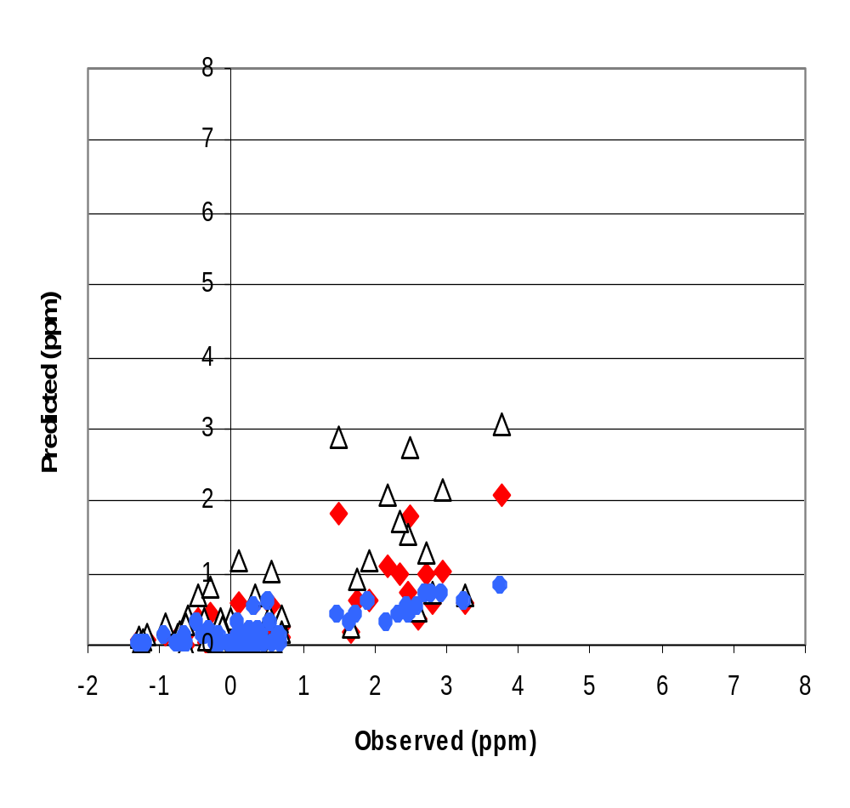
Figure 5-5. Comparison of HYROAD PUFF, HYROAD CL4 and CAL3QHC – Southbound approach (receptor A2) (N=183).
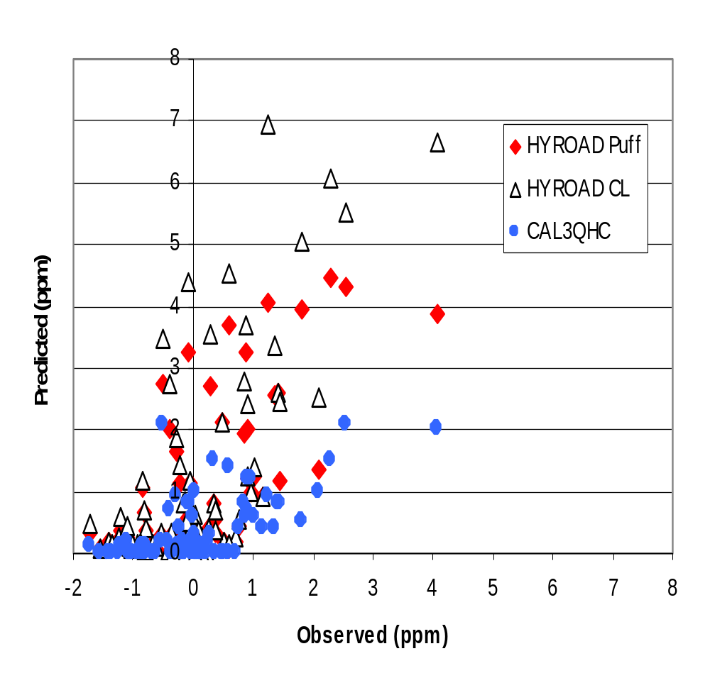
Figure 5-6. Comparison of HYROAD PUFF, HYROAD CL4 and CAL3QHC – Northwest quadrant (receptor B2) (N=183).

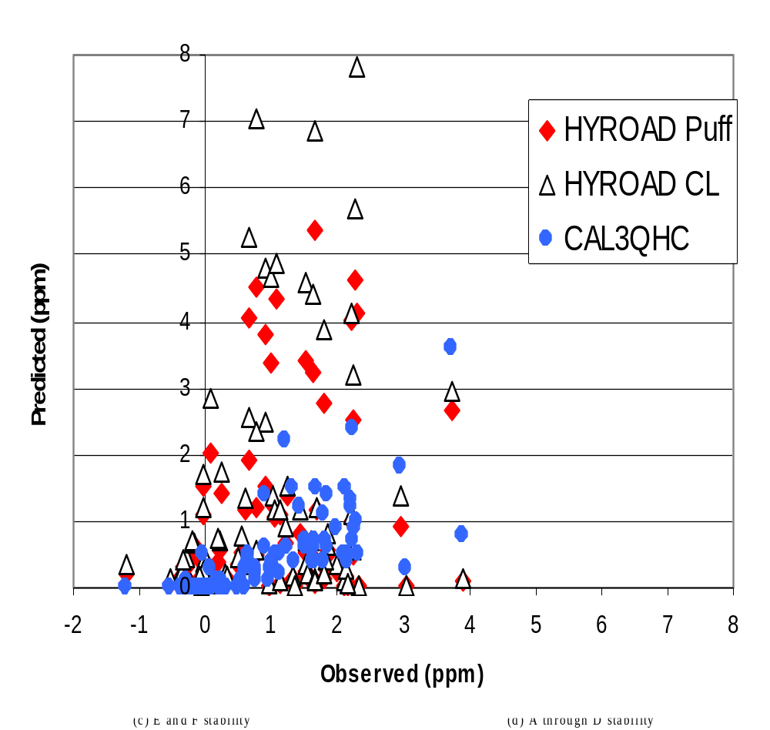
Figure 5-7. Comparison of HYROAD PUFF, HYROAD CL4 and CAL3QHC – North bound depart (receptor A4) (N=183).
Observed concentrations at the southwest corner are higher than those at the SLAMS site, with maximum concentrations occurring under light wind, stable conditions. Performance of both HYROAD PUFF and HYROAD CL4 is better for both of these locations than CAL3QHC. However, the HYROAD CL4 approach shows some tendency towards over prediction, particularly under neutral or unstable conditions. Concentrations along the southbound depart lanes (receptor B6) are comparable to those at the C6 site. Again, HYROAD PUFF and CL4 show better predictions, with HYROAD PUFF showing less tendencies for over predicting high concentrations.

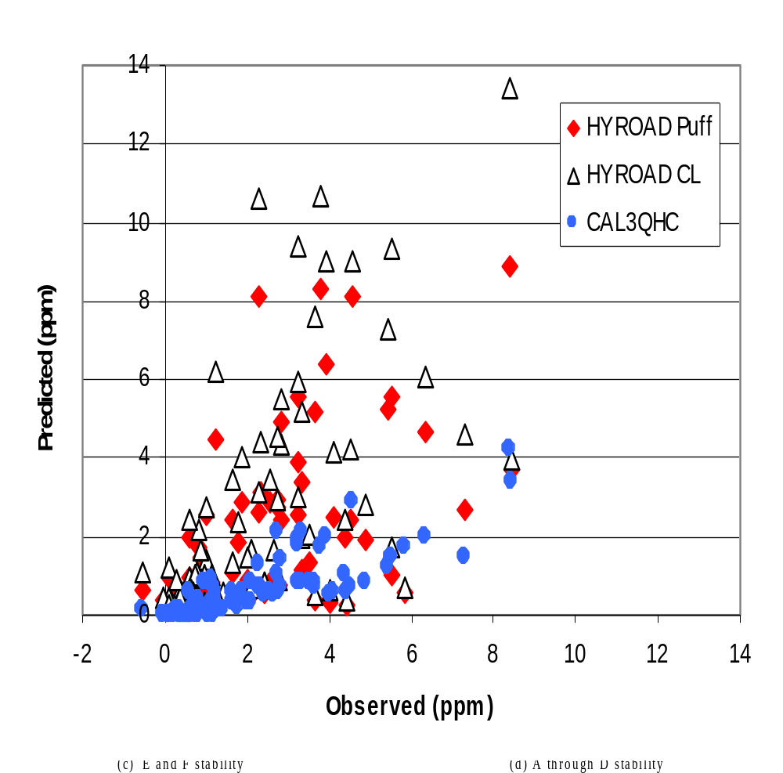
Figure 5-8. Comparison of HYROAD PUFF, HYROAD CL4 and CAL3QHC – Southwest corner (receptor A6) (N=183).

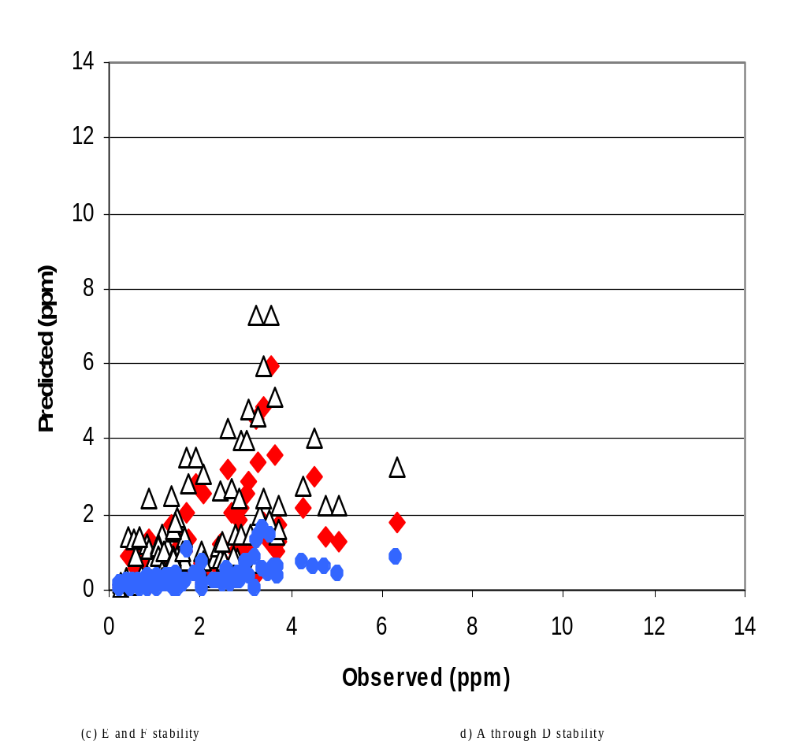
Figure 5-9. Comparison of HYROAD PUFF, HYROAD CL4 and CAL3QHC – South bound depart (receptor B6) (N=183).
Statistical performance measures were calculated using a data set containing predictions and observations for all 12 near field receptors at the Tucson intersection. The results of this analysis are shown in Table 5-5. HYROAD PUFF and CL4 show consistently smaller bias (less tendency to under predict) than CAL3QHC, lower or equal RMS error, and lower fractional bias. Other statistics were very similar across all models. The Pearson correlation coefficient for the paired top 25 concentrations is poor for all models, however this statistic is largely meaningless for small subsets of data selected high observed concentrations.
Overall, the analysis shows that the HYROAD model (either PUFF or CL4) consistently produces results superior to CAL3QHC for the Tucson intersection. When using the model results for determining potential exceedances of the short-term standard then it’s ability to simulate the peak concentration across the intersection is evaluated by examining the ranked statistics (unpaired in time and space). The HYROAD PUFF formulation consistently shows the best results across all performance indicators. The key measures of fractional bias and robust highest concentration are also significantly better than the other models.
Table 5-5. Comparison of performance statistics for HYROAD and CAL3QHC for 12 receptors from the Tucson intensive data base.
 | All data |  |  | Top 25 concentrations  (paired in time and space) |  |  | Top 25 concentrations  (rank ordered)
 | HYROAD PUFF | HYROAD CL4 | CAL-3QHC | HYROAD PUFF | HYROAD CL4 | CAL-3QHC | HYROAD PUFF | HYROAD CL4 | CAL-3QHC
Average residual (bias) | -0.25 | 0.02 | -0.61 | -4.08 | -2.44 | -5.55 | -0.78 | 2.02 | -4.32
Standard deviation of average residual | 1.29 | 1.41 | 1.27 | 2.45 | 3.76 | 1.01 | 0.49 | 0.84 | 0.33
Root mean square error | 1.31 | 1.41 | 1.41 | 4.73 | 4.42 | 5.64 | 0.92 | 2.18 | 4.33
Absolute average residual | 0.85 | 0.89 | 0.91 | 4.24 | 3.76 | 5.55 | 0.82 | 2.02 | 4.32
Pearson correlation coefficient | 0.55 | 0.59 | 0.60 | 0.13 | 0.03 | 0.38 | 0.97 | 0.94 | 0.95
Fractional bias | -0.32 | 0.02 | -0.99 | -0.81 | -0.42 | -1.29 | -0.12 | 0.25 | -0.87
Robust highest conc (pred) |  |  |  | 10.80 | 16.72 | 4.98 | 9.61 | 14.09 | 4.38
Robust highest conc (obs) |  |  |  | 10.12 | 10.12 | 10.12 | 10.12 | 10.12 | 10.12

Denver
The Denver, Colorado intensive intersection of Hampden Avenue (US 285) runs east and west, and is crossed by University Avenue (State Hwy 177), which runs north and south. Both are divided roadways, however Hampden Avenue has significantly higher traffic volume. The posted speed limits are 40 mph for University Avenue and 45 mph for Hampden Avenue. The intersection configuration and lane widths as well as the locations of the 24 sites are shown in Figure 5-10. They are enclosed in circles or triangles (see legend). Circles on top of each other are sites with readings at multiple levels.
For the Denver analysis we examined both the Gaussian puff model algorithms (PUFF) and the CALINE4 dispersion Gaussian line source algorithm (CL4) to determine the need for the HYROAD model to carry both algorithms. For the remaining discussion on the Denver performance evaluation both results are presented.
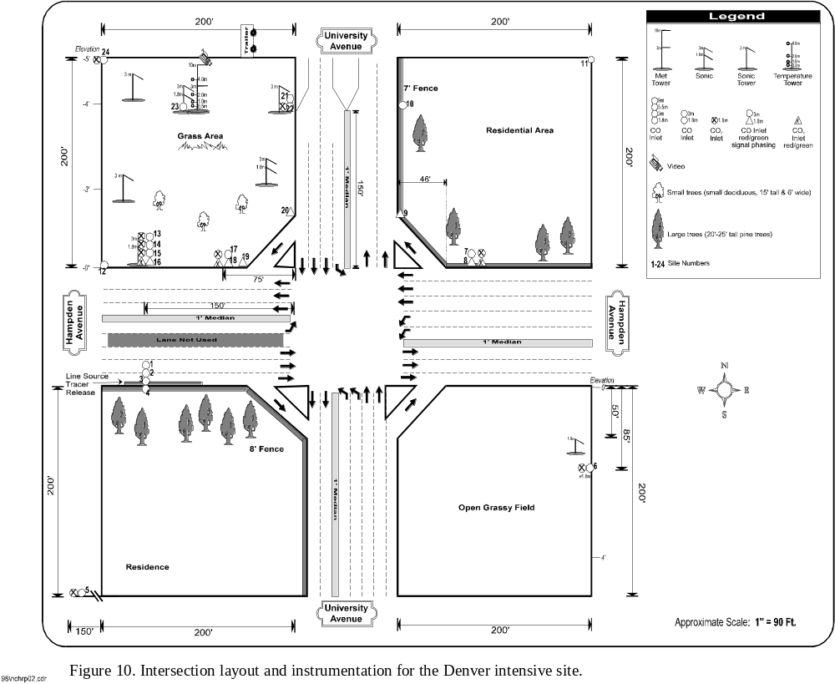
Figure 5-10. Intersection layout and instrumentation for the Denver intensive site.
The ability of a model to reproduce the statistical distribution of high concentrations can be assessed by comparisons of predictions and observations unpaired in time. Figure 5-11 shows this comparison for HYROAD and CAL3QHC for the Denver data set for two sites (16 and 20) which are both located in the northwest quadrant and are frequently in the downwind direction of the intersection. These two sites measured some of the highest concentrations during the study period. Ideal performance would produce a straight line through the origin with slope of 1. For location 16 the HYROAD PUFF algorithm under predicts, with a maximum prediction of about 5 ppm, while CAL3QHC’s predicts a concentration well in excess of 16 ppm, versus an observed maximum of about 8.8 ppm. The HYROAD CL4 algorithm does slightly better than HYROAD PUFF with a maximum prediction of just over 6.6 ppm. For location 20, HYROAD PUFF slightly under predicts, with a maximum being about 5.1 ppm, while CAL3QHC again predicts a maximum concentration well in excess of 16 ppm, versus an observed maximum of about 7.4 ppm. Again, the HYROAD CL4 algorithm does slightly better than HYROAD PUFF with a maximum prediction of just over 7.3 ppm. Other locations around the intersection exhibited the same characteristics, that is CAL3QHC grossly over predicting with HYROAD (both versions) slightly under predicting. To more fully understand the conditions affecting the relationships between predictions and observations, graphical analyses were conducted for subsets of the data based on stability class, wind speed, and wind direction.

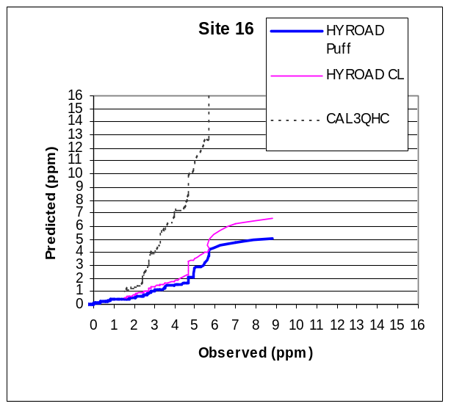
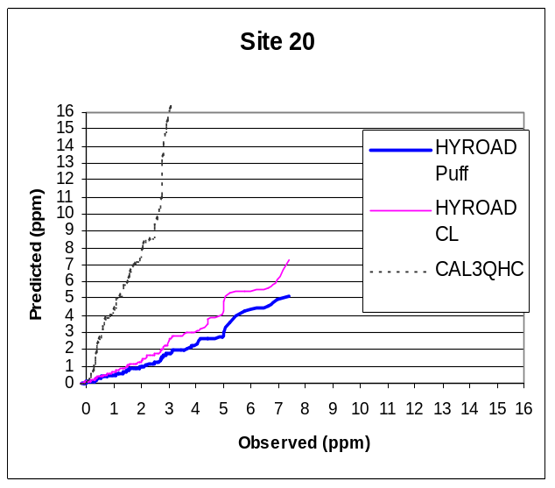

Figure 5-11. Comparison of HYROAD and CAL3QHC performance at Denver site locations 16 and 20 unpaired in time.

Figure 5-12 shows the scatterplots of data grouped by stability for the near intersection location (Site 20) and the site near the roadway but approximately 50 meters west of the intersection (Site 16). CAL3QHC over predicts most frequently during the most stable conditions (E and F stability) and for both site locations. Both versions of HYROAD are biased low during these periods. Under neutral or unstable conditions at Site 16 the CAL3QHC does best, with HYROAD under predictng. For Site 20 CAL3QHC significantly over predicts, while HYROAD has an under prediction bias but exhibits much less scatter. These same distribution tendencies are exhibited at most other monitoring locations.
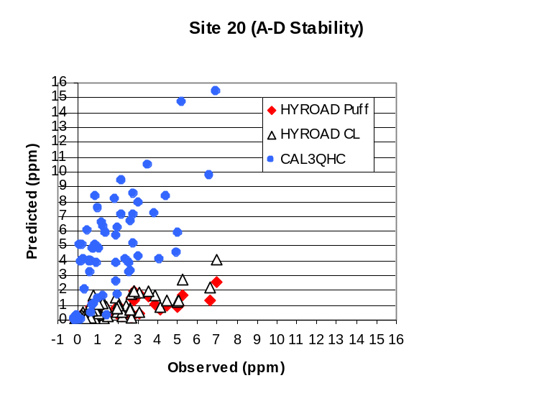
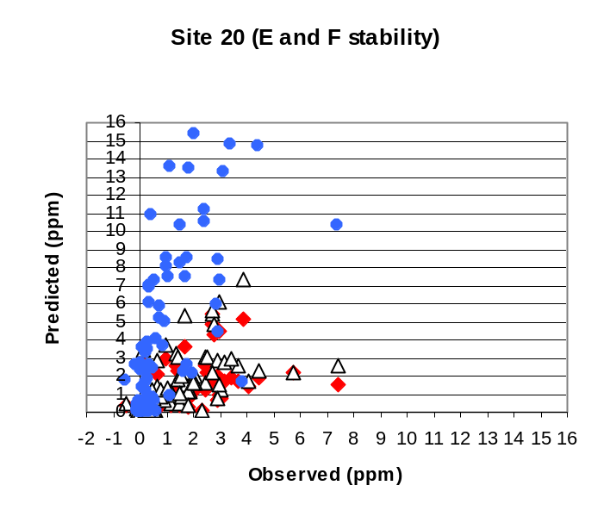
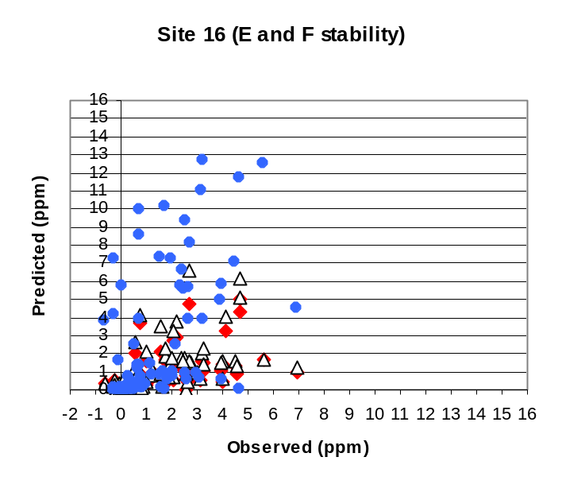
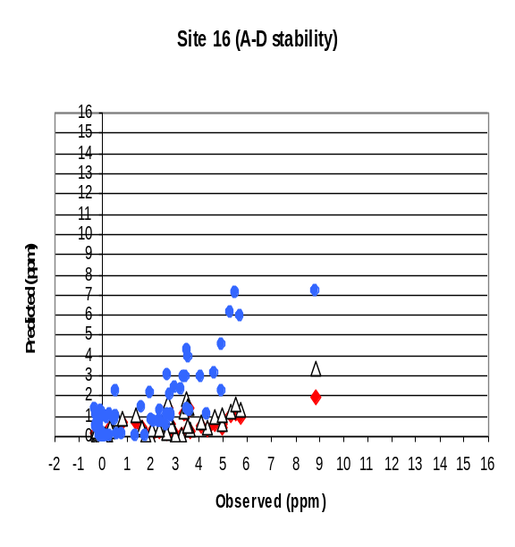

Figure 5-12. HYROAD and CAL3QHC at Denver intensive, Sites 16 and 20.
Scatterplots of the ratio of the predicted to observed (P/O) concentration as a function of wind speed are shown in Figure 5-13. These plots show how well the HYROAD PUFF and CL4 dispersion algorithms performed as a function of wind speed. The plots are limited to observed values greater than 2 ppm. Ideally, performance would produce a horizontal line on the 1:1 line. For speeds below 1 m/s, the HYROAD PUFF algorithm shows somewhat better cluster near the 1:1 line; at greater speeds both algorithms show about an equal under prediction tendency.
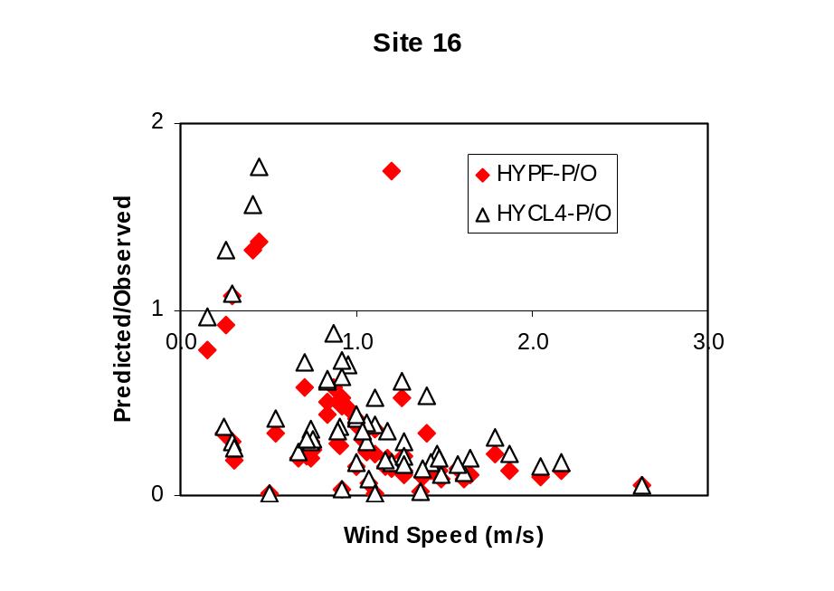

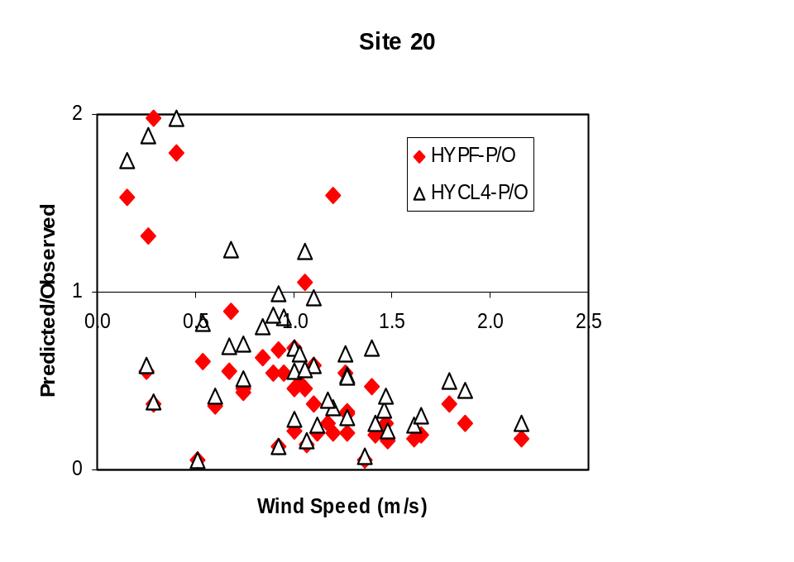

Figure 5-13. Comparison of HYROAD PUFF and CL4 at Denver intensive, Site 16 and 20 for concentrations greater than 2 ppm.
The same tendencies seen at sites 16 and 20 hold at most other locations around the intersection, although the magnitude is generally smaller as concentrations are generally lower. Thus, statistical performance measures were calculated using a data set containing predictions and observations for all 11 near field receptors at the Denver intersection. The results of this analysis are shown in Table 5-6. HYROAD PUFF and CL4 show consistently smaller bias (less tendency to over predict) than CAL3QHC, lower RMS error, and lower absolute average residual. The fractional bias was low (within a factor of 2) for all concentrations and when looking at the highest concentrations across the intersection. The HYROAD model performance during high concentration periods was particularly good relative to CAL3QHC as shown in the small difference between the observed and predicted robust highest concentration statistic. Differences between HYROAD PUFF and CL4 were small across all statistics.
Overall, the analysis shows that the HYROAD model (either PUFF or CL4) consistently produces results superior to CAL3QHC for the Denver intersection. When using the model results for determining potential exceedances of the short-term standard then it’s ability to simulate the peak concentration across the intersection is evaluated by examining the ranked statistics (unpaired in time and space). The HYROAD CL4 formulation shows slightly better skill across the performance indicators; however, the HYROAD PUFF results are nearly comparable. It also worth noting that while CAL3QHC tends to significantly over predict concentrations at the Denver intersection for the top 25 highest observations the model had the opposite behavior for Tucson intersection, while the HYROAD model (both CL4 and PUFF) exhibited much smaller biases in both cases.
Table 5-6. Comparison of performance statistics for HYROAD and CAL3QHC for 11 receptors from the Denver intensive database.
 | All data |  |  | Top 25 concentrations  (paired in time and space) |  |  | Top 25 concentrations  (rank ordered)
 | HYROAD PUFF | HYROAD CL4 | CAL-3QHC | HYROAD PUFF | HYROAD CL4 | CAL-3QHC | HYROAD PUFF | HYROAD CL4 | CAL-3QHC
Average residual (bias) | -0.62 | -0.44 | 2.97 | -5.40 | -4.74 | 5.63 | -2.04 | -1.01 | 48.21
Standard deviation of average residual | 1.45 | 1.47 | 8.22 | 1.43 | 1.66 | 13.86 | 0.09 | 0.29 | 21.55
Root mean square error | 1.57 | 1.53 | 8.73 | 5.58 | 5.01 | 14.70 | 2.04 | 1.05 | 52.63
Absolute average residual | 1.00 | 0.97 | 3.56 | 5.40 | 4.74 | 8.17 | 2.04 | 1.01 | 48.21
Pearson correlation coefficient | 0.49 | 0.50 | 0.34 | -0.20 | -0.14 | -0.31 | 0.99 | 0.96 | 0.97
Fractional bias | -0.58 | -0.37 | 1.03 | -1.16 | -0.95 | 0.55 | -0.32 | -0.15 | 1.53
Robust highest conc (pred) |  |  |  | 6.64 | 9.05 | 47.75 | 7.12 | 8.98 | 117.07
Robust highest conc (obs) |  |  |  | 9.36 | 9.36 | 9.36 | 9.36 | 9.36 | 9.36

Virginia
The Loudoun County, Virginia intensive intersection of Old Ox Road (Route 606) runs east and west, and is crossed by Sully Road (Route 28), which runs north and south. Both are divided roadways; however, Route 28 has a significantly higher traffic volume. The posted speed limit is 55 mph on the north-south bound approach and 50 mph on the east-west approach to the intersection. For the Virginia analysis both the Gaussian puff model algorithm (PUFF) and the CALINE4 dispersion Gaussian line source algorithm (CL4) were used to determine the need for the HYROAD model to carry both algorithms. Model simulations were performed for all 11 near field receptors using HYROAD and CAL3QHC models.
The observed average concentration across all 11 receptors for the seven days was only 0.5 ppm. The HYROAD PUFF, HYROAD CL4 and CAL3QHC simulated average concentrations of 4.0, 5.2, and 2.1 ppm, respectively. Scatterplots only show that all three models significantly over predict the observed concentrations. Previous study of the intersection (Carr and Ireson, 1997) based on the mass flux measurements suggested that the MOBILE5 model over estimates emissions on average by about 60%. This is likely attributable to Virginia DOT’s suggested use of the national default for the vehicle fleet age distribution. It is also likely, that at this intersection location the fleet age is significantly newer than the national average, vehicle maintenance higher than average and the tampering rate lower than average as the intersection borders on one of the most affluent areas of the country, Fairfax County, VA. The use of these more likely representative fleet conditions could easily reduce emissions estimates by more than a factor of two. It is also possible (though not as likely) that the intersection has important wind flow (e.g., strong vertical shear) or dispersion effects that are not well simulated by these two-dimensional models. Additional simulation were made using a fleet at the Virginia intersection that was on average 3-years newer than the national default. Concentrations were on average 41% lower than in the base simulations. However, the model concentrations are still significantly larger than the observed concentration.
Statistical performance measures were calculated using the entire data set to further identify and quantify the magnitude of the problem. For all data, all three models have very high biases and the problem is more exaggerated for the top 25 concentration statistics (Table 5-7). This bias overwhelms all other model statistics.
The tendency for all models (HYROAD PUFF, HYROAD CL4, and CAL3QHC) to over predict may indicate systematic errors in the model. However, as will be seen in the following section, no grossly large biases are found in the analyses of the SLAMS intersections for either HYROAD or CAL3QHC and previous studies of CAL3QHC have not revealed such large biases. It therefore appears that the cause for the over prediction bias for the Virginia intersection is a problem with inputs (and or possibly observed concentrations) to the model rather than a systematic error in model formulation.
Table 5-7. Comparison of performance statistics for HYROAD and CAL3QHC for 11 receptors from the Virginia intensive database.
 | All data |  |  | Top 25 concentrations  (paired in time and space) |  |  | Top 25 concentrations  (rank ordered)
 | HYROAD PUFF | HYROAD CL4 | CAL-3QHC | HYROAD PUFF | HYROAD CL4 | CAL-3QHC | HYROAD PUFF | HYROAD CL4 | CAL-3QHC
Average residual (bias) | 3.54 | 4.75 | 1.62 | 10.19 | 14.31 | 5.48 | 23.89 | 32.03 | 22.85
Standard deviation of average residual | 4.53 | 5.97 | 3.98 | 8.01 | 10.76 | 13.69 | 4.65 | 6.22 | 7.51
Root mean square error | 5.74 | 7.63 | 4.30 | 12.86 | 17.77 | 14.49 | 24.32 | 32.61 | 24.01
Absolute average residual | 3.54 | 4.75 | 1.97 | 10.19 | 14.31 | 8.31 | 23.89 | 32.03 | 22.85
Pearson correlation coefficient | 0.46 | 0.49 | 0.19 | 0.02 | 0.12 | -0.07 | 0.93 | 0.97 | 0.98
Fractional bias | 1.61 | 1.70 | 1.31 | 1.33 | 1.47 | 1.03 | 1.65 | 1.72 | 1.63
Robust highest conc (pred) |  |  |  | 39.80 | 51.19 | 30.27 | 40.05 | 52.23 | 45.37
Robust highest conc (obs) |  |  |  | 4.03 | 4.03 | 4.03 | 4.03 | 4.03 | 4.03

Conclusions From the Intensive Monitoring Studies
Based on the results from the intensive sites of Tucson and Denver, the HYROAD model appears to be the better model, particularly in regulatory applications where exceedances of a short-term highest concentration standard is most important. Further, the HYROAD PUFF and HYROAD CL4 dispersion algorithms appear to perform about equally well with no choice clearly superior to the other. However, the HYROAD PUFF algorithm has been selected as the preferred choice over the HYROAD CL4 algorithm because:
- The approach represents a significant improvement in model simulation realism and would likely integrate better within a modal emissions model;
By selecting only one dispersion algorithm approach problems are avoided with the transition and potential discontinuities between the two dispersion algorithms.
Therefore, in the remainder of model evaluation only the HYROAD PUFF and CAL3QHC model comparisons are discussed.

5.3 Verification of Modeling System Using the SLAMS/NAMS Data Base
This evaluation is a direct comparison between HYROAD and CAL3QHC using the same data base available to both models. The purpose of the comparison is to evaluate the performance of HYROAD and CAL3QHC using data available from routine State Local Air Monitoring Systems (SLAMS) and National Air Monitoring Systems (NAMS) sites, along with routine traffic data (volumes by approach, turn movements, signal timing, fleet characteristics) collected during Phase II of the NCHRP 25-6 Study.

The SLAMS/NAMS Database and Traffic Data base
This collected data set was not used in any component of the model development study, but elements were collected during Phase II of the study. This independent data set consists of CO and meteorological (wind speed, direction, temperature) data collected from existing State Local Air Monitoring Systems (SLAMS) and National Air Monitoring Systems (NAMS), along with traffic data collected during Phase II of the study. This data included on-site traffic data (volumes, turning movements, speeds, and fleet characteristics), geometry (lane widths, street orientation, turn bays and pockets) and CO measurements (microscale and neighborhood-scale). Data used to determine atmospheric stability (cloud cover) were gathered from nearby National Weather Service sites and used in combination with SLAMS/NAMS wind speed to calculate atmospheric stability.

Data Selection
During Phase II of the study, additional traffic data was collected at nine SLAMS/NAMS sites and the site-specific CO and meteorological monitoring data was secured. Of the nine sites, two have been excluded from the model evaluation study: the Phoenix and El Paso intersections. The Phoenix intersection is a six-legged intersection and HYROAD has only been designed to handle up to five legs; additionally the CO monitoring site is located more than 1300 feet from the roadway intersection which brings into question the percent contribution from other sources, making a modeled and observed comparison questionable. The El Paso CO monitor is located midway between two intersection, Campbell and Missouri, and Campbell and Franklin. While this introduces some complication to the modeling, the significant percentage of non-US fleet introduces a large uncertainty into the emission estimates and will not allow a fair comparison to be made between modeled and observed concentrations.
The dates chosen for simulation were selected randomly from a group of dates that fulfilled several different criteria. The dates needed to span a complete twenty-four hours of traffic volume and meteorological data. Only Tuesdays through Thursdays were chosen, as Mondays, Fridays, and weekends may not accurately represent typical average weekday traffic volumes. The selected dates were checked to ensure an approximate equal mix of Tuesdays, Wednesdays, and Thursdays, spread evenly over the given three-month time period.
For the SLAMS/NAMS intersections of Lake Tahoe, CA; Albuquerque, NM; and Tucson, AZ, nine full days were selected for modeling. The dates were chosen from the time period 10/1/92 through 12/31/92, excluding the holidays Thanksgiving, Christmas Eve, and New Year’s Eve. There was a total of 37 potential days for selection during this time period. For Lake Tahoe, Tucson and Albuquerque, meteorological data were complete for the entire time period. The nine days were chosen randomly, ensuring an approximate equal mix of Tuesdays, Wednesdays, and Thursdays, spanning evenly the three months. The days chosen for Albuquerque include 11/5/92, 11/10/92, 11/18/92, 10/6/92, 10/15/92, 10/28/92, 12/8/92, 12/17/92, and 12/29/92. For Lake Tahoe, the final dates were 10/7/92, 10/13/92, 10/22/92, 11/4/92, 11/12/92, 11/17/92, 12/3/92, 12/16/92, and 12/22/92. The dates selected for Tucson were 10/1/92, 10/14/92, 10/27/92, 11/3/92, 11/11/92, 11/19/92, 12/2/92, 12/10/92, and 12/29/92. For Seattle, WA (a site which we instrumented) meteorological measurements were available from 2/8/95 to 3/16/95 and then again starting 3/29/95 through 4/19/95. Concurrent CO measurements were readily available from 1/1/95 through 3/31/95. From these available dates nine days were chosen randomly, ensuring an approximate equal mix of Tuesdays, Wednesdays, and Thursdays. The dates selected for Seattle were 2/14/95, 2/15/9, 2/16/95, 2/28/95, 3/1/95, 3/7/95, 3/8/95, 3/9/95, and 3/30/95. The last three intersections had been previously modeled: Elizabeth, NJ, St. Paul, MN and Long Beach, CA. So as to allow comparison with previous model simulations, the same time periods were used for these three intersections these were from 10/5/92 through 10/16/92 for Long Beach, CA; 1/10/94 through 12/21/94 for Elizabeth, NJ and 2/2/95 through 3/24/95 for St. Paul, MN.

SLAMS/NAMS Modeling Results
Graphical and statistical analyses were conducted for a total of seven SLAMS/NAMS microscale sites: Elizabeth, NJ; St. Paul, MN; Long Beach, CA; South Lake Tahoe, CA; Albuquerque, NM; Seattle, WA and Tucson, AZ. Background concentrations were assumed given by measurements at the closest neighborhood scale SLAMS monitor. Unavoidably, this approach results in background concentrations being used that for some fraction of the simulation hours are, in fact, measurements made downwind of the microscale site intersection. The relative influence of local emissions near the neighborhood scale monitors is not known. Also, it is possible that the actual background concentrations for the microscale monitors may include the impacts of emissions nearby (e.g., within about 1 km) that do not influence the neighborhood scale measurements.
Figure 5-14 shows the scatterplots obtained for the first three monitoring sites (Elizabeth, NJ; St. Paul, MN; Long Beach CA). Results at the Elizabeth site show that HYROAD appears to show considerable scatter exhibiting both moderate under predictions and significant over predictions depending on conditions. At St. Paul, there appears to be little correlation between predictions and observations for either model. At Long Beach, both models show little correlation and were too low to provide meaningful results. Statistical performance measures for the complete data sets are given in Table 5-8. Correlation coefficients are uniformly poor. The most likely reason for this poor performance is the uncertainty in actual background concentrations. Table 5-9 and Table 5-10 show performance statistics for the top 10 concentrations (paired and unpaired). Although correlations are generally higher for the paired data subset, neither model’s predictions consistently agree well with the observed values. Statistics for the top 10 unpaired concentrations generally improve, but neither model appears to be consistently better in key measures (particularly, fractional bias and RHC). As noted, we believe that the actual performance of both models is masked in this data set by the noise introduced by uncertainty in background concentrations.
The second set of SLAMS/NAMS monitoring data consists of sets of data from South Lake Tahoe, Albuquerque, Seattle and Tucson over a period of nine days each. These sites still have the same problem with background concentrations being used such that for some fraction of the simulation hours, measurements are made downwind of the microscale intersection site. However, two of theses sites, Lake Tahoe and Seattle, are located such that when the winds at the microscale site are not downwind of the background monitor the flow is generally over water bodies which should have relatively low CO concentration levels.

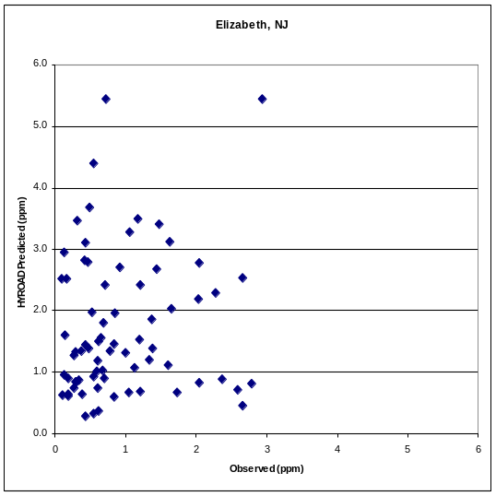
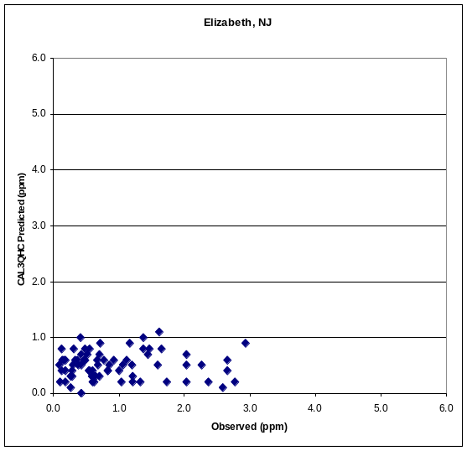
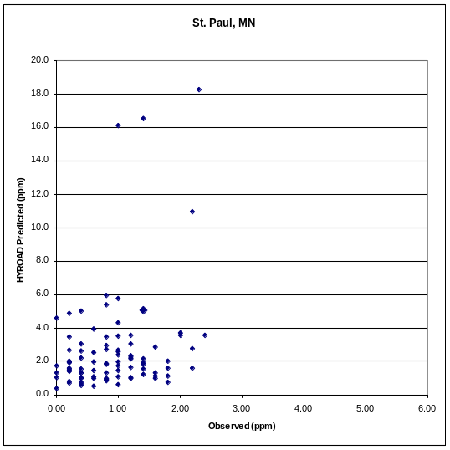
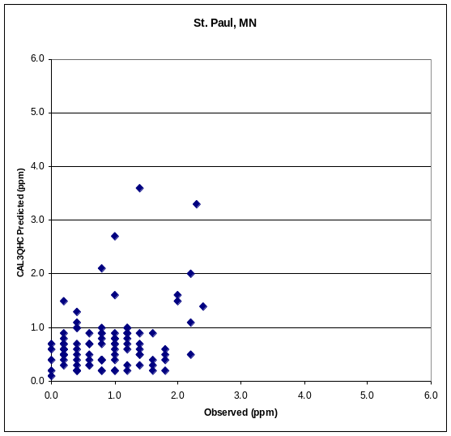
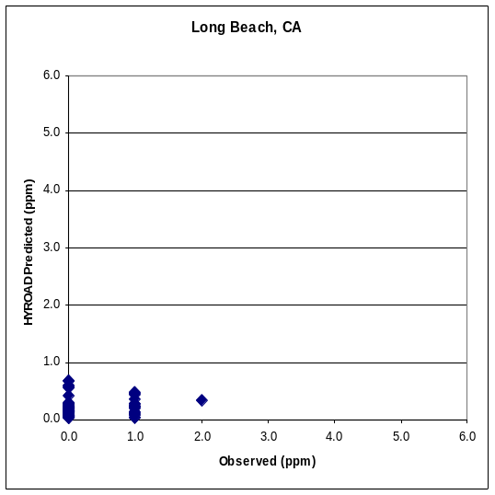
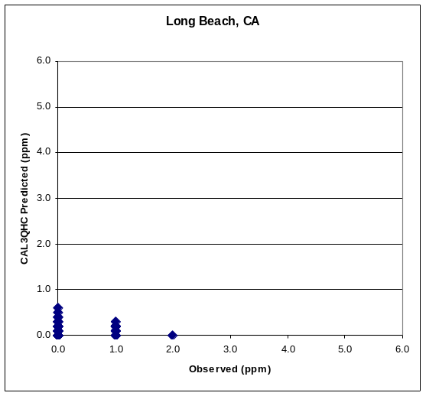
Figure 5-14. Comparison of HYROAD and CAL3QHC at Elizabeth, St. Paul and Long Beach.
Table 5-8. Comparison of HYROAD and CAL3QHC performance statistics (all data).
 | Elizabeth NJ |  | St. Paul MN |  | Long Beach CA
 | HYROAD | CAL3QHC | HYROAD | CAL3QHC | HYROAD | CAL3QHC
Average residual (bias) | 0.94 | -0.26 | 1.79 | -0.13 | 0.46 | 0.42
Standard deviation of average residual | 1.35 | 0.92 | 2.90 | 0.72 | 0.88 | 0.93
Root mean square error | 1.64 | 0.95 | 3.40 | 0.72 | 0.99 | 1.01
Absolute average residual | 1.24 | 0.67 | 1.90 | 0.57 | 0.72 | 0.70
Pearson correlation coefficient | 0.10 | -0.10 | 0.30 | 0.32 | 0.30 | -0.04
Fractional bias | 0.76 | -0.41 | 1.02 | -0.16 | N/A* | N/A*
*Due to the large number of negative concentrations (microscale-background) this statistic could not be determined

Table 5-9. Comparison of HYROAD and CAL3QHC performance statistics for the top 10 concentrations (paired in time and space).
 | Elizabeth NJ |  | St. Paul MN |  | Long Beach CA
 | HYROAD | CAL3QHC | HYROAD | CAL3QHC | HYROAD | CAL3QHC
Average residual (bias) | -0.54 | -2.01 | 2.84 | -0.81 | -0.89 | -0.98
Standard deviation of average residual | 1.48 | 0.40 | 5.36 | 0.81 | 0.30 | 0.37
Root mean square error | 1.51 | 2.04 | 5.82 | 1.12 | 0.94 | 1.04
Absolute average residual | 1.23 | 2.01 | 3.14 | 1.01 | 0.89 | 0.98
Pearson correlation coefficient | 0.22 | 0.13 | 0.51 | 0.62 | 0.35 | -0.41
Fractional bias | -0.25 | -1.40 | 0.81 | -0.49 | -1.37 | -1.61
Robust highest concentration (pred) | 4.74 | 1.08 | 12.35 | 3.35 | 0.53 | 0.36
Robust highest concentration (obs) | 3.24 | 3.24 | 2.60 | 2.60 | 1.30 | 1.30

Table 5-10. Comparison of HYROAD and CAL3QHC performance statistics for the top 10 concentrations (rank ordered).
 | Elizabeth NJ |  | St. Paul MN |  | Long Beach CA
 | HYROAD | CAL3QHC | HYROAD | CAL3QHC | HYROAD | CAL3QHC
Average residual (bias) | 1.46 | -1.44 | 7.32 | 0.06 | -0.55 | -0.67
Standard deviation of average residual | 0.63 | 0.19 | 5.35 | 0.61 | 0.28 | 0.26
Root mean square error | 1.58 | 1.45 | 8.91 | 0.58 | 0.61 | 0.71
Absolute average residual | 1.46 | 1.44 | 7.32 | 0.48 | 0.55 | 0.67
Pearson correlation coefficient | 0.84 | 0.86 | 0.84 | 0.89 | 0.50 | 0.88
Fractional bias | 0.46 | -0.84 | 1.28 | 0.03 | -0.67 | -0.88
Robust highest concentration (pred) | 5.43 | 1.39 | 18.26 | 3.57 | 0.79 | 0.49
Robust highest concentration (obs) | 3.24 | 3.24 | 2.60 | 2.60 | 1.30 | 1.30

Figure 5-15 shows the scatterplots obtained for the first four monitoring sites (South Lake Tahoe, CA; Albuquerque, NM; Seattle, WA and Tucson, AZ). Results at the South Lake Tahoe site show that HYROAD appears to do better at predicting concentrations than CAL3QHC even though a significant bias remains. At Seattle and Tucson, HYROAD shows a weak relationship, while CAL3QHC shows almost no correlation between predictions and observations. Statistical performance measures for the complete data sets are given in Table 5-11. Correlation coefficients are uniformly poor. The most likely reason for this poor performance is the uncertainty in actual background concentrations. Table 5-12 and Table 5-13 show performance statistics for the top 25 concentrations (paired and unpaired). Correlations remain generally unchanged for the paired data subset, neither model’s predictions consistently agree well with the observed values. Statistics for the top 25 unpaired concentrations generally improve, with HYROAD showing the lowest fractional biases for three of the four intersections, and with the South Lake Tahoe and Seattle sites showing the most positive relationships. As noted earlier, it highly probable that the actual performance of both models is still masked in this data set by the noise introduced by uncertainty in background concentrations.
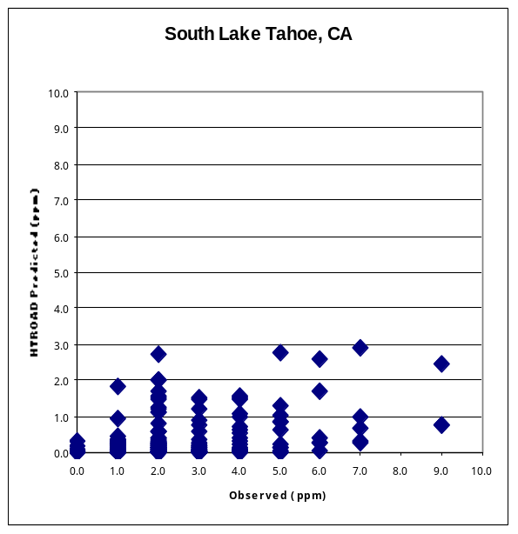
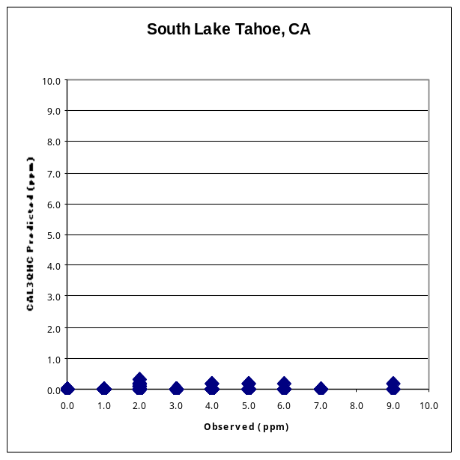
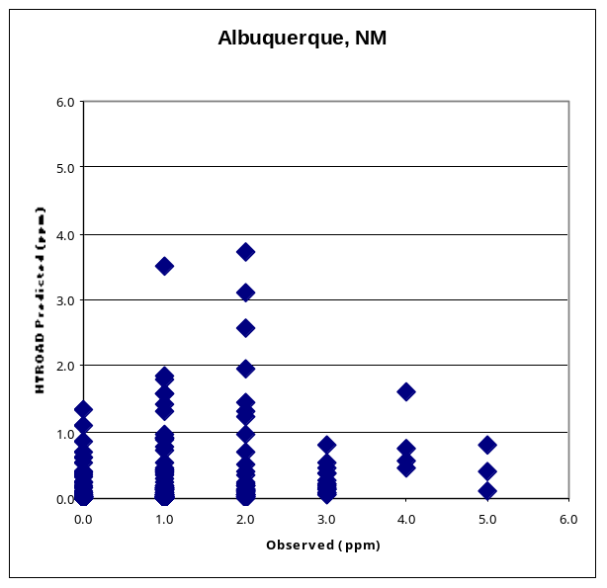
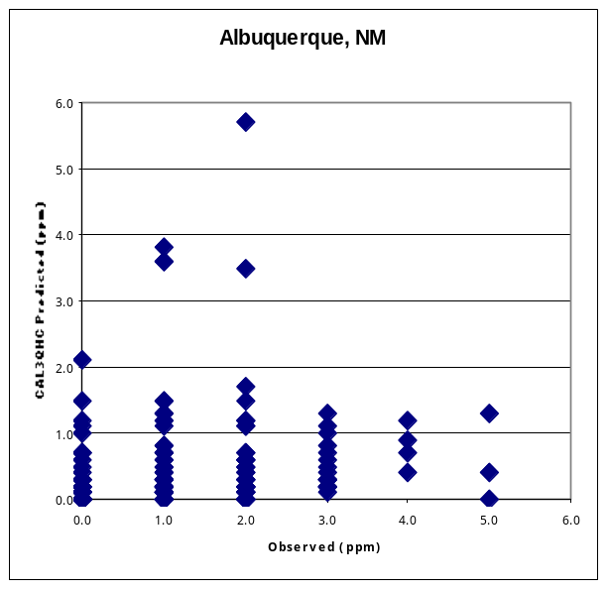
Figure 5-15. Comparison of HYROAD and CAL3QHC at South Lake Tahoe, California and Albuquerque, NM.

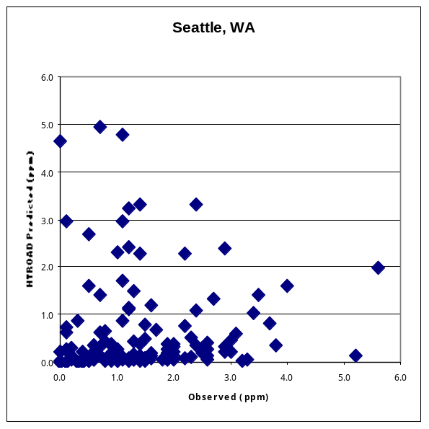
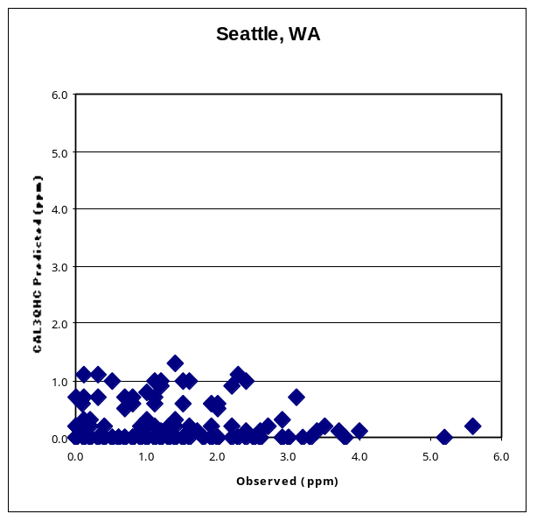
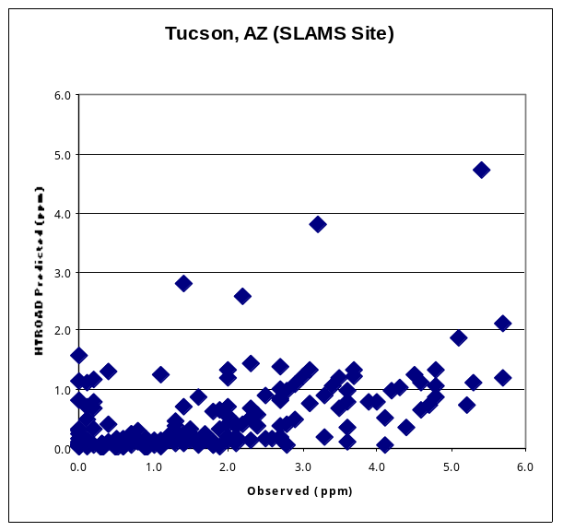
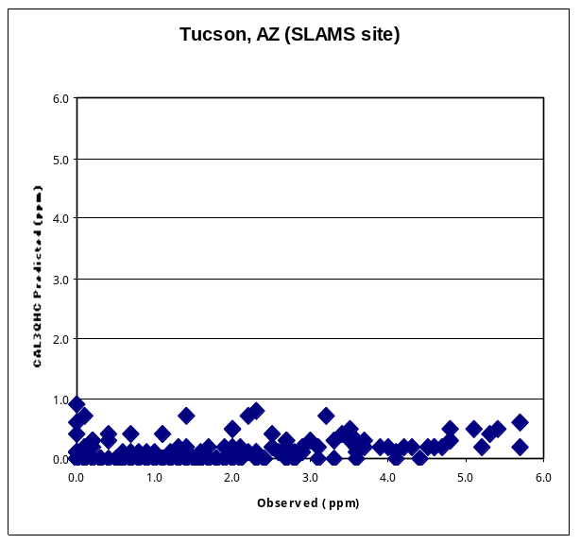
Figure 5-15. (Continued) Comparison of HYROAD and CAL3QHC at Seattle, WA and Tucson, AZ.
Table 5-11. Comparison of HYROAD and CAL3QHC performance statistics (all data).
 | South Lake Tahoe, CA |  | Albuquerque, NM |  | Seattle, WA |  | Tucson, AZ
 | HYROAD | CAL3QHC | HYROAD | CAL3QHC | HYROAD | CAL3QHC | HYROAD | CAL3QHC
Average residual (bias) | -2.16 | -2.50 | -0.66 | -0.52 | 0.03 | -0.48 | -0.96 | -1.32
Standard deviation of average residual | 1.58 | 1.69 | 1.23 | 1.38 | 2.04 | 1.40 | 1.62 | 1.70
Root mean square error | 2.67 | 3.02 | 1.39 | 1.48 | 2.03 | 1.48 | 1.88 | 2.15
Absolute average residual | 2.18 | 2.50 | 1.02 | 1.06 | 1.35 | 1.15 | 1.39 | 1.58
Pearson correlation coefficient | 0.37 | 0.15 | 0.23 | 0.19 | 0.05 | -0.07 | 0.36 | 0.24
Fractional bias | -1.50 | -1.97 | -1.04 | -0.74 | 0.04 | -1.08 | -0.99 | -1.67

Table 5-12. Comparison of HYROAD and CAL3QHC performance statistics for the top 25 concentrations (paired in time and space).
 | South Lake Tahoe, CA |  | Albuquerque, NM |  | Seattle, WA |  | Tucson, AZ
 | HYROAD | CAL3QHC | HYROAD | CAL3QHC | HYROAD | CAL3QHC | HYROAD | CAL3QHC
Average residual (bias) | -5.26 | -6.08 | -2.98 | -2.68 | -2.39 | -3.03 | -3.69 | -4.61
Standard deviation of average residual | 1.42 | 1.33 | 0.71 | 1.15 | 1.09 | 0.87 | 1.04 | 0.85
Root mean square error | 5.44 | 6.23 | 3.07 | 2.91 | 2.62 | 3.15 | 3.83 | 4.68
Absolute average residual | 5.26 | 6.09 | 2.98 | 2.80 | 2.46 | 3.03 | 3.69 | 4.61
Pearson correlation coefficient | 0.25 | 0.04 | 0.35 | -0.23 | 0.13 | -0.08 | 0.30 | 0.47
Fractional bias | -1.51 | -1.98 | -1.60 | -1.33 | -1.22 | -1.85 | -1.22 | -1.79
RHC (pred) | 3.21 | 0.12 | 1.26 | 2.54 | 2.76 | 0.47 | 4.30 | 1.01
RHC (obs) | 9.21 | 9.21 | 7.12 | 7.12 | 5.23 | 5.23 | 8.12 | 8.12

Table 5-13. Comparison of HYROAD and CAL3QHC performance statistics for the top 25 (concentrations rank ordered).
 | South Lake Tahoe, CA |  | Albuquerque, NM |  | Seattle, WA |  | Tucson, AZ
 | HYROAD | CAL3Q | HYROAD | CAL3Q | HYROAD | CAL3Q | HYROAD | CAL3Q
Average residual (bias) | -4.40 | -6.00 | -1.77 | -1.11 | 1.08 | -2.26 | -2.98 | -4.31
Standard deviation of average residual | 0.83 | 1.26 | 0.32 | 1.08 | 1.98 | 0.66 | 0.29 | 0.77
Root mean square error | 4.47 | 6.13 | 1.80 | 1.53 | 2.22 | 2.36 | 2.99 | 4.38
Absolute average residual | 4.40 | 6.00 | 1.77 | 1.41 | 1.44 | 2.26 | 2.98 | 4.31
Pearson correlation coefficient | 0.94 | 0.80 | 0.92 | 0.90 | 0.90 | 0.89 | 0.95 | 0.95
Fractional bias | -1.12 | -1.92 | -0.72 | -0.39 | 0.29 | -1.12 | -0.88 | -1.59
RHC (pred) | 3.50 | 0.45 | 3.76 | 5.43 | 11.46 | 1.41 | 3.79 | 1.02
RHC (obs) | 9.21 | 9.21 | 7.12 | 7.12 | 5.23 | 5.23 | 8.12 | 8.12

conclusion
The HYROAD model has been tested over a wide variety of meteorological conditions and for a number of site locations. The model performance evaluation has shown that HYROAD performs better than current EPA preferred guideline model CAL3QHC in nearly all situations. In sensitivity testing, the HYROAD model was shown to behave realistically, for a variety of changes in meteorology inputs. Thus the model appears suitable as an alternative candidate model to current guideline model, CAL3QHC. The HYROAD model should be considered as an alternative model when CAL3QHC shows questionable or suspect results.

5.4 Additional Model Performance Evaluation Analyses
This section addresses three areas concerning the HYROAD model performance evaluation, and provides additional information as to the superiority of the HYROAD model over the current regulatory model, CAL3QHC. The three specific areas address in this section are:
- Adjust emission estimates at intensive sites to match mass flux emission measurements;
- Include analyses of 8-hour averages;
Investigate and explain the cause of the “flip-flop” in CAL3QHC performance relative to HYROAD between the Tucson and Denver sites.
Additional analyses were conducted for each of these three areas. The results are presented and discussed as to the implications of these findings on the model performance.

Mass Flux Emission Measurements
Reliable mass flux measurements are only available for the Virginia intersection. Measurements taken in Denver were found unreliable due to interference from a nearby retaining wall/fence. No measurements of mass flux were made in Tucson. Based on earlier analysis of the Virginia intersection (Carr and Ireson, 1997) it was estimated that MOBILE5 model over estimates emissions on average by about 60% when compared to the mass flux measurements, however there is substantial uncertainty in this estimate. The Virginia intersection emissions were adjusted based on these mass flux measurements and the model performance was reassessed using the mass flux emission measurements. Table 5-14 summarizes the results using the mass flux measurements.
The results suggest that for the Virginia intersection that the performance of the CAL3QHC and HYROAD PUFF models are comparable when using the model results for determining potential exceedances of the short-term standard and it’s ability to simulate the peak concentration across the intersection (ranked statistics). However, the skill of the CAL3QHC model to predict concentrations is open to question given the very low correlation (0.19) for all data, suggesting the skill of the model is no better than that due to chance alone. The biases for all models remain quite high for the top 25 concentrations. This suggests that at least for the Virginia intersection, that all three models are not able to simulate some important wind flow or dispersion effects.
This adjustment/correction scheme for emissions was also considered for the other two intersections (Denver and Tucson), but because of other differences (e.g., altitude, fleet characteristics, type of oxygenate, etc.) the uncertainty as to the correct level of adjustment was considered high and of limited value to clearly assess the models performance.
Table 5-14. Comparison of performance statistics for HYROAD and CAL3QHC for 11 receptors from the Virginia intensive database using mass flux measurements.
 | All data |  |  | Top 25 concentrations (paired in time and space) |  |  | Top 25 concentrations (rank ordered)
 | HYROAD PUFF | HYROAD CL4 | CAL-3QHC | HYROAD PUFF | HYROAD CL4 | CAL-3QHC | HYROAD PUFF | HYROAD CL4 | CAL-3QHC
Average residual (bias) | 1.96 | 2.68 | 0.80 | 5.08 | 7.56 | 2.26 | 13.31 | 18.19 | 12.68
Standard deviation of average residual | 2.65 | 3.50 | 2.39 | 4.82 | 6.45 | 8.23 | 2.63 | 3.56 | 4.34
Root mean square error | 3.29 | 4.41 | 2.52 | 6.94 | 9.85 | 8.38 | 13.55 | 18.52 | 13.38
Absolute average residual | 1.97 | 2.52 | 1.21 | 5.18 | 7.57 | 5.29 | 13.31 | 18.19 | 12.68
Pearson correlation coefficient | 0.46 | 0.49 | 0.19 | 0.02 | 0.12 | -0.07 | 0.93 | 0.97 | 0.98
Fractional bias | 1.40 | 1.52 | 0.97 | 0.99 | 1.19 | 0.61 | 1.44 | 1.56 | 1.42
Robust highest conc (pred) |  |  |  | 23.88 | 30.72 | 18.16 | 24.03 | 31.34 | 27.22
Robust highest conc (obs) |  |  |  | 4.03 | 4.03 | 4.03 | 4.03 | 4.03 | 4.03

Comparison of MOBILE and CO/CO_{x} Derived Emission Rates
CAL3QHC uses only two emission factors for each leg of an intersection: an idle rate derived from the MOBILE 2.5 mph g/mile rate, expressed in g/hr, and a g/mile rate for the speed of traffic under “free-flow” conditions. For Denver, the idle emission rate is typically ~ 450 g/hr (depending upon temperature), corresponding to approximately 900 g/gal, based on idle fuel consumption rate of 0.5 gal/hr. The CO/CO_{x} analysis shows emission rates that center at 350-400 g/gal, even during red phase on approach legs (i.e., cases where idling vehicles should dominate observed concentrations). For Virginia, the MOBILE-derived idle emission rate is typically ~ 400 g/hr (depending upon temperature), corresponding to approximately 800 g/gal. The CO/CO_{x} analysis shows emission rates that center at 200-250 g/gal, again even during red phase on approach legs. For Tucson, the MOBILE-derived idle emission rate is typically ~ 250 g/hr (depending upon temperature), corresponding to approximately 500 g/gal. The Tucson intersection did not collect ambient measurements of CO and CO₂; however, remote sensing using the University of Denver’s Fuel Efficiency Automobile Test (FEAT) was conducted on some 14,000 vehicles both along departure and approach legs. The average emission rates were found to range from 300-400 g/gal. Although the FEAT remote sensing data are measured for moving vehicles rather than idling, the CO and CO₂ data at Denver and Virginia showed that g/gal emission rates were the same for moving vehicles (i.e., during green phase on approach and depart links) as for idling vehicles (i.e., during red phase on approach links). Thus, we believe that the actual idling emission rate at Tucson is 300-400 g/gal.
The difference between MOBILE and observed emissions offers some useful insight into the tendency of models to over or under predict. MOBILE-derived idle rates for Virginia are three to four times higher than observed rates; those for Denver are two to three times higher; and those for Tucson are about one and one half times higher. This conclusion applies only to idle rates, and it is quite difficult to convert MOBILE running emissions from g/mi to g/gal. Nevertheless, to the extent that CAL3QHC (or HYROAD) predictions are driven by idling emissions in queues, the tendency to over predict concentrations would be greatest in Virginia, less so in Denver, and smallest in Tucson.
These results strongly suggest that the CAL3QHC model inappropriately emphasize idling emissions in queues, while perhaps underestimating the contributions of emissions during through movements. Determination of the relative proportion of idling contributions to predicted concentrations for both HYROAD and CAL3QHC would be needed to further assess these results.

Eight Hour Averages
To evaluate how the models perform when persistence factors are not used, 8-hour average concentrations were calculated for the same time periods and data sets as in the technical memorandum for Tucson, Denver and Virginia. These are presented in Table 5-15 through Table 5-20.
The first three tables show the model performed at the collocated SLAMS Tucson monitoring site (C6). The first table shows that for all pairs of data the HYROAD PUFF model performance exceeds CAL3QHC for all statistical measures. and Table 5-17 show results for the highest 25 concentrations, paired and unpaired in time. These results show similar results as the 1-hour comparison – that the HYROAD PUFF and CL4 exceed CAL3QHC measures for nearly all categories and key measures such as fractional bias and RHC show significant improvement. summarizes the statistical results for all 12 near field receptors at the Tucson intersection. HYROAD PUFF and CL4 show in most cases consistently smaller bias (less tendency to under predict) than CAL3QHC, lower or equivalent RMS error, and lower fractional bias. Overall, the analysis shows that the HYROAD models (both PUFF and CL4) are superior to CAL3QHC. However, in this case of 8-hour averages, the HYROAD CL4 version seems to offer better performance than the PUFF version. The Pearson correlation coefficient for the paired top 25 concentrations is poor for all models. Despite this statistic being largely meaningless for small subsets of data selected for high observed concentrations, it is presented here for completeness.
Table 5-19 summarizes the statistical results for predictions and observations for all 11 near field receptors at the Denver intersection. The table shows that the HYROAD PUFF and CL4 have much lower standard deviation of the average residual than CAL3QHC, lower RMS error, and better robust highest concentration. The HYROAD model performance during high concentration periods was particularly good relative to CAL3QHC as shown in the relatively small difference between the observed and predicted robust highest concentration statistic for HYROAD in comparison with CAL3QHC. Differences between HYROAD PUFF and CL4 were generally small across all statistics. When using the model results for determining potential exceedances of the 8-hour standard then it’s ability to simulate the 8-hour peak concentration across the intersection is evaluated by examining the ranked statistics (unpaired in time and space). The HYROAD CL4 formulation shows slightly better skill across the performance indicators, however the HYROAD PUFF results are nearly comparable.
Table 5-20 summarizes the statistical results for predictions and observations for all 11 near field receptors at the Virginia intersection with the emissions adjusted based on the mass flux measurements. These results show that CAL3QHC has the smallest bias and fractional bias for all data and the top 25 concentrations, however the correlation coefficient (0.03) shows that the CAL3QHC model has almost no relationship between predicted and observed concentrations, in fact the test for significance for the 1309 pairs of data suggests that skill of the model is no better than random chance. Comparison of HYROAD and CAL3QHC ability to assess the potential exceedances of the key 8-hour standard using the ranked statistics shows that the HYROAD PUFF is comparable in skill to CAL3QHC. Thus the HYROAD PUFF formulation appears to be the preferred model at this location.
Overall, the findings show that the HYROAD model performance is better than or equal to CAL3QHC and is particularly better when used to determine potential exceedances of the 8-hour standard. This is generally consistent with the 1-hour finding which showed that the HYROAD PUFF formulation was generally superior to CAL3QHC.
Table 5-15. Comparison of HYROAD Puff, HYROAD CL4 and CAL3QHC 8-hour performance statistics (all data) for Tucson location C6.
 | HYROAD PUFF | HYROAD CL4 | CAL3QHC
Average residual (bias) | -0.12 | 0.18 | -0.52
Standard deviation of average residual | 0.62 | 0.66 | 0.72
Root mean square error | 0.63 | 0.69 | 0.89
Absolute average residual | 0.49 | 0.54 | 0.67
Pearson correlation coefficient | 0.72 | 0.77 | 0.75
Fractional bias | -0.16 | 0.20 | -0.90

Table 5-16. Comparison of HYROAD Puff, HYROAD CL4 and CAL3QHC 8-hour performance statistics for the top 25 observed concentrations (paired in time) for Tucson location C6.
 | HYROAD PUFF | HYROAD CL4 | CAL3QHC
Average residual (bias) | -0.90 | -0.10 | -1.72
Standard deviation of average residual | 0.58 | 0.75 | 0.30
Root mean square error | 1.06 | 0.75 | 1.75
Absolute average residual | 0.93 | 0.65 | 1.72
Pearson correlation coefficient | 0.23 | 0.25 | 0.50
Fractional bias | -0.48 | -0.05 | -1.18
Robust highest conc (pred) | 4.1 | 4.0 | 1.2
Robust highest conc (obs) | 4.1 | 4.1 | 4.1

Table 5-17. Comparison of HYROAD Puff, HYROAD CL4 and CAL3QHC 8-hour performance statistics for the top 25 observed concentrations (unpaired in time) for Tucson location C6.
 | HYROAD PUFF | HYROAD CL4 | CAL3QHC
Average residual (bias) | -0.44 | 0.40 | -1.56
Standard deviation of average residual | 0.20 | 0.10 | 0.20
Root mean square error | 0.48 | 0.41 | 1.58
Absolute average residual | 0.44 | 0.40 | 1.56
Pearson correlation coefficient | 0.93 | 0.95 | 0.97
Fractional bias | -0.21 | 0.16 | -1.02
Robust highest conc (pred) | 2.5 | 4.1 | 1.5
Robust highest conc (obs) | 4.1 | 4.1 | 4.1

Table 5-18. Comparison of 8-hour performance statistics for HYROAD and CAL3QHC for 12 receptors from the Tucson intensive database.
 | All data |  |  | Top 25 concentrations  (paired in time and space) |  |  | Top 25 concentrations  (rank ordered)
 | HYROAD PUFF | HYROAD CL4 | CAL-3QHC | HYROAD PUFF | HYROAD CL4 | CAL-3QHC | HYROAD PUFF | HYROAD CL4 | CAL-3QHC
Average residual (bias) | -0.24 | 0.09 | -0.67 | -3.49 | -3.06 | -3.31 | -1.45 | .04 | -1.83
Standard deviation of average residual | .95 | 1.01 | 0.99 | 0.80 | 1.04 | 0.42 | 0.33 | 0.42 | 0.10
Root mean square error | 0.98 | 1.01 | 1.21 | 3.58 | 3.22 | 3.34 | 1.48 | 0.41 | 1.83
Absolute average residual | 0.69 | 0.75 | 0.84 | 3.49 | 3.06 | 3.31 | 1.45 | 0.27 | 1.83
Pearson correlation coefficient | 0.56 | 0.59 | 0.63 | 0.01 | -0.02 | 0.53 | 0.96 | 0.74 | 0.98
Fractional bias | -0.26 | 0.08 | -0.95 | -1.22 | -0.99 | -1.38 | -0.37 | 0.01 | -0.49
Robust highest conc (pred) |  |  |  | 3.5 | 4.9 | 1.7 | 3.9 | 5.8 | 4.4
Robust highest conc (obs) |  |  |  | 6.2 | 6.2 | 6.2 | 6.2 | 6.2 | 6.2

Table 5-19. Comparison of 8-hour performance statistics for HYROAD and CAL3QHC for 11 receptors from the Denver intensive database.
 | All data |  |  | Top 25 concentrations  (paired in time and space) |  |  | Top 25 concentrations  (rank ordered)
 | HYROAD PUFF | HYROAD CL4 | CAL-3QHC | HYROAD PUFF | HYROAD CL4 | CAL-3QHC | HYROAD PUFF | HYROAD CL4 | CAL-3QHC
Average residual (bias) | -0.77 | -0.57 | 3.13 | -3.21 | -2.93 | 1.18 | -1.82 | -1.44 | 15.72
Standard deviation of average residual | 0.99 | 0.98 | 3.93 | 0.41 | 0.42 | 3.13 | 0.10 | 0.09 | 2.6
Root mean square error | 1.26 | 1.13 | 5.03 | 3.24 | 2.96 | 3.28 | 1.83 | 1.45 | 15.92
Absolute average residual | 0.95 | 0.86 | 3.40 | 3.21 | 2.93 | 2.44 | 1.82 | 1.44 | 15.72
Pearson correlation coefficient | 0.46 | 0.49 | 0.28 | -0.22 | -0.25 | -0.37 | 0.98 | 0.98 | 0.96
Fractional bias | -0.93 | -0.43 | 0.99 | -1.18 | -1.02 | 0.24 | -0.53 | -0.46 | 1.29
Robust highest conc (pred) |  |  |  | 2.4 | 3.0 | 13.7 | 3.0 | 3.3 | 27.9
Robust highest conc (obs) |  |  |  | 5.2 | 5.2 | 5.2 | 5.2 | 5.2 | 5.2

Table 5-20. Comparison of 8-hour performance statistics for HYROAD and CAL3QHC for 11 receptors from the Virginia intensive database (emissions adjusted based on mass flux).
 | All data |  |  | Top 25 concentrations  (paired in time and space) |  |  | Top 25 concentrations  (rank ordered)
 | HYROAD PUFF | HYROAD CL4 | CAL-3QHC | HYROAD PUFF | HYROAD CL4 | CAL-3QHC | HYROAD PUFF | HYROAD CL4 | CAL-3QHC
Average residual (bias) | 2.23 | 3.09 | 0.94 | 3.69 | 5.77 | -0.27 | 7.23 | 9.73 | 7.10
Standard deviation of average residual | 1.81 | 2.35 | 1.82 | 2.85 | 3.56 | 2.80 | 1.06 | 1.25 | 0.70
Root mean square error | 2.87 | 3.88 | 2.05 | 4.62 | 6.74 | 2.76 | 7.30 | 9.81 | 7.14
Absolute average residual | 2.23 | 3.09 | 1.34 | 3.69 | 5.77 | 2.07 | 7.23 | 9.73 | 7.10
Pearson correlation coefficient | 0.35 | 0.41 | 0.03 | -0.32 | -0.33 | -0.30 | 0.96 | 0.97 | 0.85
Fractional bias | 1.37 | 1.50 | 0.96 | 1.10 | 1.32 | -0.20 | 1.41 | 1.53 | 1.41
Robust highest conc (pred) |  |  |  | 13.8 | 19.8 | 4.6 | 12.3 | 15.5 | 13.6
Robust highest conc (obs) |  |  |  | 4.0 | 4.0 | 4.0 | 4.03 | 4.03 | 4.03

Potential Cause for the “flip-flop” in CAL3QHC performance relative to HYROAD between the Tucson and Denver Intersections
While a comparison using an independent measure of emissions (mass flux) is not possible for the Tucson and Denver intersections, an investigation was performed to explore the potential cause for the change in the CAL3QHC model bias (that is the change in bias from –4.3 for Tucson to +48.2 for Denver for the top 25 one-hour concentrations), while the HYROAD model saw only small changes (–0.78 for Tucson to –2.0 for Denver) in the bias. Previous work has suggested that the cause for the CAL3QHC over prediction is tied primarily to the concentration being driven by emissions from idle queues. To test the sensitivity of the CAL3QHC model concentration to idle queue contribution the model was exercised for varying levels of progression for both the Denver and Tucson intersections during relatively high concentration periods (Dec 27th 1800-1900 for Denver and March 1st 0700-0800 for Tucson). By varying the arrival time from worst platooning (arrival at the beginning of the red cycle) to the best platooning (arrival at beginning of green cycle) the models sensitivity to queue contribution (for a variety of conditions) can be assessed since all other parameters (traffic volume, turn movements, signal cycle timing) remained fixed.
Queue lengths for the Denver intersection were found to be very large. Maximum queue lengths ranged from 244 m (worst arrival time) to 207 m (best arrival time) for the immediate downwind receptor having the highest concentration. Hourly average concentration at the maximum receptor varied from 40.6 ppm (worst arrival time) to 34.5 ppm (best arrival time). The contribution of the adjacent queue accounted for 35 to 42 percent of the total contribution. All other queues accounted for an additional 44 to 53 percent. All together the queues in total accounted for between 86 to 88 percent of the total mass. Similar percentage contributions were found for other high concentration receptors (> 9 ppm). Thus the contribution from queues dominates the source contribution for all arrival times at the Denver intersection.
For the Tucson intersection traffic volumes were lower with fewer turn movements relative to the Denver intersection resulting in much shorter queue lengths. These simulations showed no change in concentration across all combinations of progression, the average queue lengths ranged from a longest distance of 0.6 to 3 meters. The maximum contribution of all queues to receptor with concentrations greater than 1 ppm was 2 percent. Thus the influence from queue emissions is minimal at the Tucson intersection.
Recalling that the CAL3QHC model did reasonably well for Tucson it appears that a likely explanation for the cause for the significant over prediction in Denver is tied to an overestimate of queue length and/or the queue source strength.

