- SENSITIVITY ANALYSIS
A sensitivity analysis was performed to provide users of the model with a better understanding of how the model behaves for a variety of conditions and a metric by which users can determine the relative importance of the input parameters and to assess model behavior. The focus of the sensitivity runs was to evaluate the most common input variables that typically vary from intersection to intersection or vary frequently in time. These were judged to be most useful to the user of the model when trying to determine the best allocation of input model resources.
A set of sensitivity analyses of simulated CO concentrations was examined at four receptor locations for the 22nd and Alvernon Tucson, AZ intersection. All four receptors were placed in the northwest quadrant 3 m from the edge of the traveled roadways at a height of 1.8 m. The first receptor (Corner) was placed at the corner of the intersection, 3 m from 22nd and 3 m from Alvernon. The second receptor (W30) was placed 30 m to the west along 22nd, the third (N30) 30 m to the north along Alvernon and the fourth 30 m to the west and 30 m to the north (N30W30) of the corner of the intersection. Peak AM traffic volumes were used in all model simulations. All simulations used identical traffic and temperature. Three sets of simulations were performed to examine model characteristics for varying wind direction, wind speed and stability. Model input values are shown in Table 6-1.
Table 6-1. Input values for the HYROAD Tucson sensitivity analysis.

Site Variables
Temperature | 5° C
Wind Speed | Varied
Wind Direction | Varied
Atmospheric Stability | Varied
Mixing Height | 1000 m
Surface Roughness, z₀ | 110 cm
Settling Velocity | 0 cm/s
Deposition Velocity | 0 cm/s

Traffic and Emission Variables
Traffic Volume | AM Peak
Roadway Length | 300 m
Roadway Width | 9-15 feet
Emission Factor | MOBILE5b
Idle Emission Factor | MOBILE5b

6.1 Meteorological Variables

Wind Speed
Modeling results are sensitive to wind speed. The sensitivity tests have been performed for two versions of the dispersion algorithm of the HYROAD model, the CALINE4 line source dispersion algorithm (CL4) and the puff dispersion algorithm (PUFF). Sensitivity simulations were conducted over a range of wind speeds (0.2 to 2.0 m/s) every 0.2 m/s, for two wind directions (90 and 135 degrees), and stability classes (D and F).
Table 6-2 shows the results of these simulations. For all receptors and meteorological scenarios, the wind speed sensitivity simulations show a decreased concentration with increasing wind speed. In general, the model shows that the PUFF algorithm has higher concentrations at the very low wind speeds (0.2-0.4 m/s) after which a transition occurs and the PUFF dispersion has lower concentrations than CL4 (Figure 6-1). This behavior for very low wind speed conditions is consistent with the model formulation for the PUFF algorithm. That is, the CO tends to stay near the roadway as the vehicular movement dominates its direction of flow, which tends to retain the CO along the roadway axis. In all cases, the 135-degree direction flow has lower concentrations than the 90-degree direction for both the PUFF and CL4. Also, as expected, for each meteorological scenario the corner receptor shows the highest concentration.
The result of these tests show that for wind speed, HYROAD is a well-behaved model that is intuitively consistent and in general agreement with the CO trends observed in the database.

Stability Class
Sensitivity simulations were conducted over all ranges of stability classes (A through F), for two wind directions (90 and 135 degrees), and two wind speeds (1.0 and 1.5 m/s). Table 6-3 shows the results of these simulations. The sensitivity results for stability class show the effect of allowing vehicle-induced flows and turbulence on spatial patterns and concentrations. The PUFF algorithm shows a highest maximum concentration at the W30 receptor, not the corner receptor. This is consistent with the concept that under conditions in which vehicle-induced flows dominate (e.g., at 1.0 m/s) the corner receptor experiences greater mixing due to the complex vehicle movement near the intersection which results in lower concentrations. At higher ambient wind speeds (1.5 m/s) the advection dominates and the corner receptors show the highest concentrations. In general, both the PUFF and CL4 algorithm show increased concentration with increasing stability. However, the PUFF algorithm shows a more complex pattern because of the effects of vehicle induced flows and turbulence having a near equal importance as the ambient stability on mixing. Overall, the change in concentration with the change in stability class for the PUFF algorithm can be explained by the impact from vehicle induced flows. The CL4 algorithm shows the lack of this effect by always increasing concentration with increasing stability.

Table 6-2. HYROAD Wind speed sensitivity tests (ppm) -- Tucson 8 AM traffic.
 | Wind Speed (m/s)
 | 0.2 | 0.4 | 0.6 | 0.8 | 1.0 | 1.2 | 1.4 | 1.6 | 1.8 | 2.0

HYROAD PUFF Model Results
HYROAD Puff Model Results

D stability, 90 degrees
Corner | 36.72 | 18.16 | 9.46 | 6.34 | 5.64 | 4.55 | 3.75 | 3.59 | 3.17 | 2.87
W30 | 39.91 | 18.71 | 10.30 | 7.08 | 5.43 | 3.60 | 2.92 | 2.61 | 2.18 | 1.87
N30 | 17.39 | 8.48 | 4.85 | 3.88 | 3.10 | 2.13 | 1.73 | 1.54 | 1.32 | 1.15
N30W30 | 21.13 | 10.13 | 5.67 | 4.19 | 3.26 | 2.03 | 1.54 | 1.32 | 1.05 | 0.85

D stability, 135 degrees
Corner | 34.54 | 13.74 | 7.69 | 5.10 | 4.57 | 4.30 | 4.16 | 3.44 | 3.21 | 2.99
W30 | 27.01 | 12.32 | 6.96 | 4.66 | 3.33 | 2.42 | 1.97 | 1.57 | 1.40 | 1.32
N30 | 38.59 | 17.14 | 10.05 | 5.86 | 4.45 | 3.52 | 2.93 | 2.56 | 2.24 | 1.96
N30W30 | 31.66 | 13.89 | 8.27 | 5.21 | 3.53 | 2.56 | 1.99 | 1.60 | 1.37 | 1.23

F stability, 90 degrees
Corner | 40.86 | 20.14 | 10.59 | 6.93 | 6.13 | 5.28 | 4.32 | 4.09 | 3.57 | 3.32
W30 | 48.91 | 22.99 | 14.07 | 9.44 | 6.57 | 4.99 | 4.11 | 3.69 | 3.03 | 2.61
N30 | 19.45 | 10.17 | 5.69 | 4.09 | 3.05 | 2.39 | 1.76 | 1.52 | 1.32 | 1.13
N30W30 | 23.70 | 12.01 | 7.72 | 5.84 | 4.19 | 2.95 | 2.01 | 1.64 | 1.20 | 0.96

F stability, 135 degrees
Corner | 34.59 | 12.96 | 7.83 | 4.78 | 4.22 | 3.91 | 3.84 | 3.20 | 3.03 | 2.86
W30 | 30.17 | 12.96 | 8.20 | 5.07 | 3.64 | 2.73 | 2.20 | 1.71 | 1.49 | 1.37
N30 | 43.68 | 20.52 | 11.25 | 6.55 | 4.84 | 3.92 | 3.28 | 2.88 | 2.55 | 2.15
N30W30 | 33.35 | 14.36 | 8.57 | 5.30 | 3.55 | 2.77 | 2.22 | 1.68 | 1.53 | 1.40

HYROAD with CALINE4 (line source) Dispersion Algorithm - Model Results

D stability, 90 degrees
Corner | 28.34 | 21.97 | 17.94 | 15.13 | 13.07 | 11.49 | 10.24 | 9.23 | 8.40 | 7.71
W30 | 21.07 | 15.52 | 12.45 | 10.43 | 8.99 | 7.91 | 7.06 | 6.37 | 5.81 | 5.34
N30 | 6.94 | 5.34 | 4.34 | 3.64 | 3.12 | 2.73 | 2.42 | 2.18 | 1.97 | 1.81
N30W30 | 4.17 | 3.02 | 2.45 | 2.08 | 1.81 | 1.61 | 1.44 | 1.31 | 1.20 | 1.11

D stability, 135 degrees
Corner | 27.17 | 22.08 | 18.58 | 15.99 | 14.00 | 12.43 | 11.17 | 10.13 | 9.26 | 8.53
W30 | 15.78 | 11.89 | 9.70 | 8.23 | 7.15 | 6.33 | 5.68 | 5.15 | 4.72 | 4.35
N30 | 19.92 | 15.40 | 12.71 | 10.85 | 9.47 | 8.40 | 7.55 | 6.85 | 6.27 | 5.77
N30W30 | 17.27 | 12.90 | 10.47 | 8.87 | 7.70 | 6.82 | 6.11 | 5.54 | 5.07 | 4.67

F stability, 90 degrees
Corner | 32.35 | 24.89 | 20.24 | 17.03 | 14.68 | 12.89 | 11.48 | 10.34 | 9.40 | 8.62
W30 | 28.13 | 20.55 | 16.37 | 13.65 | 11.72 | 10.27 | 9.15 | 8.24 | 7.50 | 6.88
N30 | 7.39 | 5.65 | 4.60 | 3.86 | 3.32 | 2.91 | 2.58 | 2.32 | 2.11 | 1.93
N30W30 | 5.65 | 4.05 | 3.29 | 2.78 | 2.42 | 2.15 | 1.93 | 1.75 | 1.61 | 1.48

F stability, 135 degrees
Corner | 29.61 | 23.97 | 20.11 | 17.27 | 15.11 | 13.40 | 12.03 | 10.90 | 9.96 | 9.17
W30 | 20.34 | 15.17 | 12.29 | 10.37 | 8.98 | 7.92 | 7.09 | 6.42 | 5.86 | 5.39
N30 | 24.48 | 18.74 | 15.37 | 13.08 | 11.38 | 10.08 | 9.04 | 8.19 | 7.48 | 6.89
N30W30 | 23.61 | 17.56 | 14.20 | 11.98 | 10.38 | 9.17 | 8.21 | 7.43 | 6.78 | 6.24
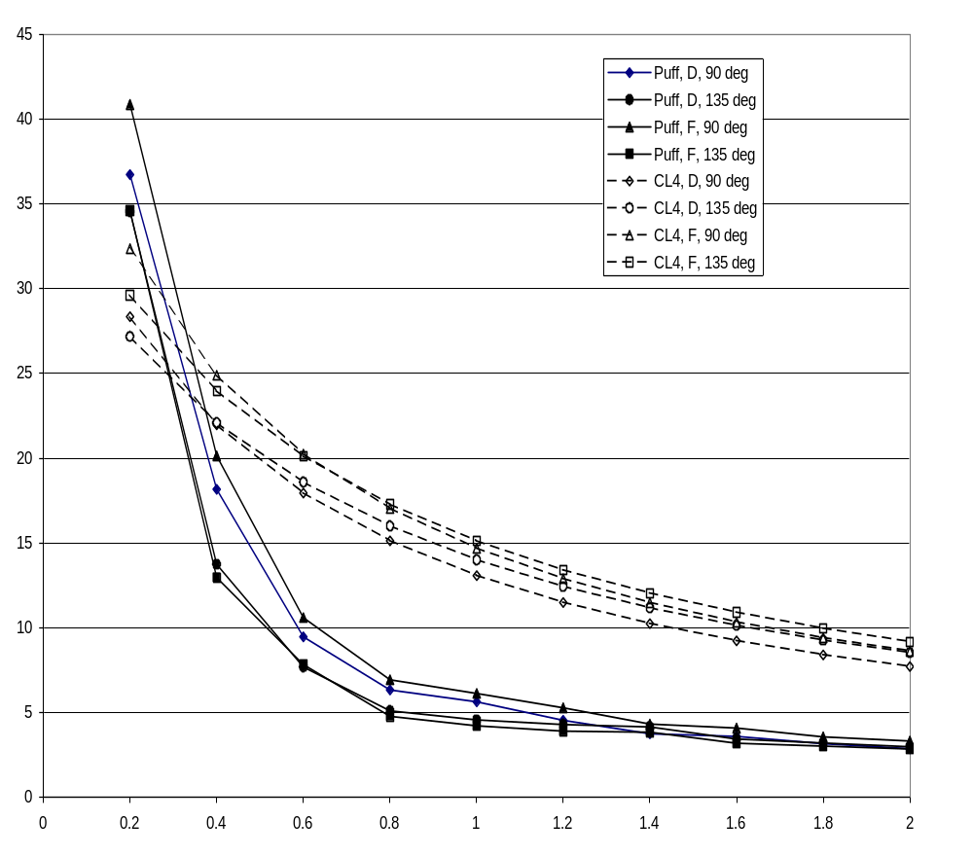

Figure 6-1. Concentration (ppm) vs. wind speed (m/s) at corner receptor (3 m from curb).
Table 6-3. HYROAD Stability sensitivity tests (ppm) -- Tucson 8 AM traffic.
 | Stability
 | A | B |  | C | D | E | F

HYROAD PUFF Model Results

WD 90, WS 1.0
Corner | 4.91 | 4.88 |  | 5.12 | 5.64 | 5.61 | 6.13
W30 | 4.88 | 4.77 |  | 5.00 | 5.43 | 6.01 | 6.57
N30 | 2.86 | 2.81 |  | 2.85 | 3.10 | 3.18 | 3.05
N30W30 | 2.76 | 2.72 |  | 2.93 | 3.26 | 3.58 | 4.19

WD 90, WS 1.5
Corner | 3.27 | 3.29 |  | 3.40 | 3.55 | 3.53 | 3.90
W30 | 2.18 | 2.19 |  | 2.38 | 2.45 | 2.68 | 3.35
N30 | 1.60 | 1.60 |  | 1.59 | 1.64 | 1.64 | 1.58
N30W30 | 1.25 | 1.25 |  | 1.27 | 1.34 | 1.41 | 1.60

WD 135, WS 1.0
Corner | 4.53 | 4.57 |  | 4.61 | 4.57 | 4.53 | 4.22
W30 | 3.30 | 3.28 |  | 3.33 | 3.33 | 3.38 | 3.64
N30 | 4.12 | 4.13 |  | 4.37 | 4.45 | 4.56 | 4.84
N30W30 | 3.39 | 3.37 |  | 3.48 | 3.53 | 3.59 | 3.55

WD 135, WS 1.5
Corner | 3.94 | 4.00 |  | 4.01 | 3.98 | 3.91 | 3.78
W30 | 1.75 | 1.75 |  | 1.76 | 1.76 | 1.80 | 1.95
N30 | 2.53 | 2.57 |  | 2.67 | 2.69 | 2.73 | 3.05
N30W30 | 1.63 | 1.69 |  | 1.76 | 1.78 | 1.80 | 2.01
HYROAD with CALINE4 (line source) Dispersion Algorithm - Model Results

WD 90, WS 1.0
Corner | 11.59 |  | 12.15 | 12.59 | 13.07 | 13.70 | 14.68
W30 | 6.61 |  | 7.50 | 8.21 | 8.99 | 10.04 | 11.72
N30 | 2.95 |  | 3.01 | 3.07 | 3.12 | 3.20 | 3.32
N30W30 | 1.28 |  | 1.48 | 1.63 | 1.81 | 2.05 | 2.42

WD 90, WS 1.5
Corner | 8.63 |  | 9.04 | 9.36 | 9.71 | 10.17 | 10.88
W30 | 4.95 |  | 5.61 | 6.12 | 6.70 | 7.46 | 8.67
N30 | 2.16 |  | 2.21 | 2.25 | 2.29 | 2.35 | 2.45
N30W30 | 0.97 |  | 1.12 | 1.24 | 1.38 | 1.55 | 1.84

WD 135, WS 1.0
Corner | 12.91 |  | 13.33 | 13.65 | 14.00 | 14.44 | 15.11
W30 | 5.50 |  | 6.13 | 6.61 | 7.15 | 7.86 | 8.98
N30 | 7.73 |  | 8.39 | 8.90 | 9.47 | 10.22 | 11.38
N30W30 | 5.37 |  | 6.24 | 6.93 | 7.70 | 8.73 | 10.38

WD 135, WS 1.5
Corner | 9.81 |  | 10.13 | 10.37 | 10.63 | 10.95 | 11.44
W30 | 4.18 |  | 4.65 | 5.01 | 5.40 | 5.92 | 6.74
N30 | 5.88 |  | 6.37 | 6.76 | 7.18 | 7.73 | 8.59
N30W30 | 4.07 |  | 4.72 | 5.24 | 5.81 | 6.58 | 7.80

Wind Direction
Sensitivity simulations were conducted over a range of wind direction (0 to 270 degrees) every 15 degrees, for two wind directions (90 and 135 degrees), and stability classes (D and F). Table 6-4 shows the results of these simulations. The sensitivity results for wind direction for the corner receptor show generally consistent relative patterns within the PUFF and CL4 modules (Figure 6-2). The CL4 pattern shows peaks at around 105 and 165 degrees, which is consistent with the favorable fetch of emissions along the road axes for the line source algorithm. The PUFF dispersion simulations show a much more complex pattern with relative peaks at around 50, 105 and 195 degrees associated with the favorable fetch of emissions along the roadway axes in conjunction with the local flow field. Overall, these concentration patterns appear consistent with the more realistically complex interaction of the roadway geometry, vehicle-induced flows and associated turbulence.

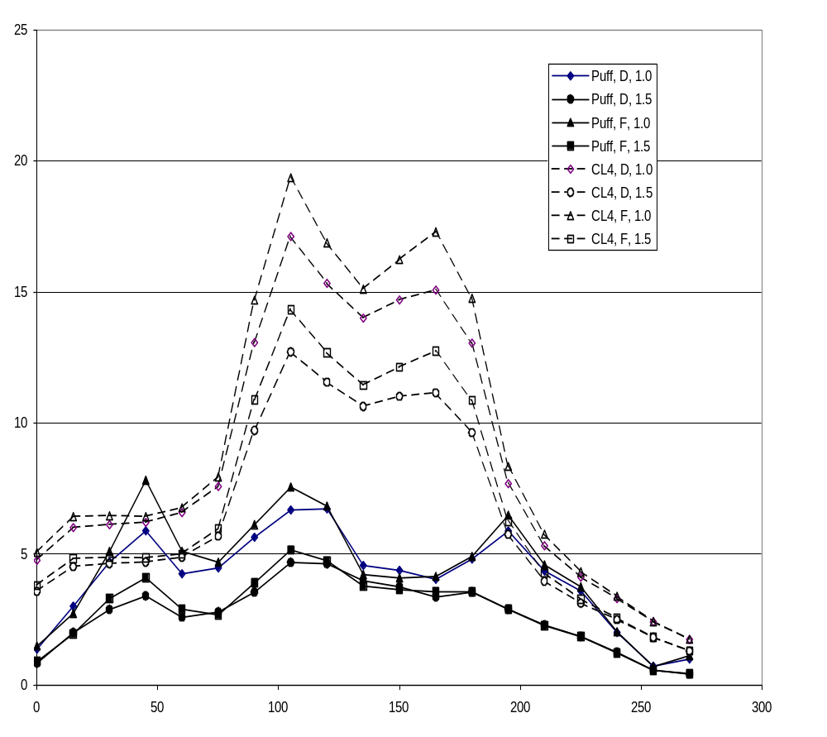
Figure 6-2. Concentration (ppm) vs. wind direction (degrees), Corner receptor.

Table 6-4. HYROAD wind direction sensitivity tests (ppm) -- Tucson 8 AM traffic.
 |  | Wind Direction (degrees)
 |  | 0 | 15 | 30 | 45 | 60 | 75 | 90 | 105 | 120 | 135 | 150 | 165 | 180 | 195 | 210 | 225 | 240 | 255 | 270

HYROAD PUFF Model Results

D Stability, 1.0 m/s
Corner |  | 1.37 | 3.01 | 4.70 | 5.89 | 4.25 | 4.47 | 5.64 | 6.68 | 6.73 | 4.57 | 4.38 | 4.04 | 4.81 | 5.88 | 4.36 | 3.59 | 2.01 | 0.72 | 1.00
W30 |  | 0.10 | 0.30 | 0.84 | 2.30 | 4.30 | 3.80 | 5.43 | 4.92 | 3.48 | 3.33 | 3.02 | 2.81 | 2.17 | 0.96 | 0.33 | 0.15 | 0.04 | 0.02 | 0.33
N30 |  | 0.51 | 0.87 | 1.43 | 2.57 | 2.16 | 2.13 | 3.10 | 2.85 | 5.19 | 4.45 | 4.23 | 3.93 | 5.57 | 4.12 | 2.26 | 0.83 | 0.33 | 0.16 | 0.11
N30W30 |  | 0.02 | 0.09 | 0.16 | 0.25 | 1.29 | 1.85 | 3.26 | 3.61 | 4.47 | 3.53 | 3.19 | 2.84 | 2.74 | 1.01 | 0.31 | 0.09 | 0.02 | 0.00 | 0.02
D Stability, 1.5 m/s
Corner |  | 1.49 | 2.74 | 5.10 | 7.82 | 5.11 | 4.69 | 6.13 | 7.56 | 6.83 | 4.22 | 4.09 | 4.15 | 4.91 | 6.48 | 4.59 | 3.75 | 2.04 | 0.71 | 1.13
W30 |  | 0.08 | 0.25 | 0.71 | 2.96 | 5.55 | 4.85 | 6.57 | 6.37 | 3.52 | 3.64 | 3.24 | 3.56 | 2.33 | 1.08 | 0.31 | 0.13 | 0.04 | 0.01 | 0.39
N30 |  | 0.55 | 0.90 | 1.55 | 3.62 | 2.67 | 2.35 | 3.05 | 2.97 | 6.64 | 4.84 | 4.68 | 4.15 | 6.60 | 4.30 | 2.74 | 0.88 | 0.30 | 0.14 | 0.09
N30W30 |  | 0.02 | 0.08 | 0.15 | 0.16 | 1.40 | 2.67 | 4.19 | 4.46 | 5.65 | 3.55 | 3.30 | 4.00 | 3.18 | 1.08 | 0.28 | 0.07 | 0.01 | 0.00 | 0.01
F Stability, 1.0 m/s
Corner |  | 0.84 | 2.00 | 2.88 | 3.40 | 2.59 | 2.79 | 3.55 | 4.68 | 4.63 | 3.98 | 3.75 | 3.36 | 3.55 | 2.90 | 2.29 | 1.86 | 1.25 | 0.57 | 0.42
W30 |  | 0.03 | 0.14 | 0.49 | 1.58 | 1.91 | 1.61 | 2.45 | 2.86 | 1.90 | 1.76 | 1.79 | 1.55 | 1.14 | 0.46 | 0.19 | 0.07 | 0.03 | 0.01 | 0.07
N30 |  | 0.33 | 0.53 | 0.84 | 1.43 | 1.23 | 1.24 | 1.64 | 1.76 | 2.92 | 2.69 | 2.45 | 2.47 | 3.27 | 1.92 | 0.99 | 0.39 | 0.18 | 0.08 | 0.07
N30W30 |  | 0.01 | 0.04 | 0.10 | 0.19 | 0.80 | 0.78 | 1.34 | 1.87 | 2.27 | 1.78 | 1.63 | 1.49 | 1.33 | 0.46 | 0.15 | 0.03 | 0.01 | 0.00 | 0.00
F Stability, 1.5 m/s
Corner |  | 0.90 | 1.96 | 3.30 | 4.10 | 2.90 | 2.68 | 3.90 | 5.16 | 4.75 | 3.78 | 3.64 | 3.58 | 3.57 | 2.89 | 2.27 | 1.85 | 1.23 | 0.56 | 0.44
W30 |  | 0.02 | 0.13 | 0.52 | 2.58 | 2.39 | 2.02 | 3.35 | 3.65 | 1.90 | 1.95 | 2.08 | 2.03 | 1.14 | 0.46 | 0.18 | 0.06 | 0.02 | 0.01 | 0.07
N30 |  | 0.35 | 0.55 | 0.91 | 1.88 | 1.44 | 1.23 | 1.58 | 1.86 | 3.74 | 3.05 | 2.76 | 2.73 | 3.80 | 2.11 | 1.14 | 0.38 | 0.16 | 0.07 | 0.06
N30W30 |  | 0.01 | 0.04 | 0.08 | 0.16 | 1.07 | 1.22 | 1.60 | 2.30 | 3.01 | 2.01 | 1.95 | 2.17 | 1.49 | 0.48 | 0.14 | 0.03 | 0.01 | 0.00 | 0.00
Table 6-4. HYROAD wind direction sensitivity tests (ppm) -- Tucson 8 AM traffic – concluded.
 |  |  | Wind Direction (degrees)
 |  |  |  | 0 |  | 15 | 30 | 45 | 60 | 75 | 90 | 105 | 120 | 135 | 150 | 165 | 180 | 195 | 210 | 225 | 240 | 255 | 270

HYROAD with CALINE4 (line source) Dispersion Modeling Results

D Stability, 1.0 m/s
Corner |  |  |  |  | 4.76 | 6.01 | 6.12 | 6.21 | 6.58 | 7.58 | 13.07 | 17.12 | 15.33 | 14.00 | 14.70 | 15.07 | 13.05 | 7.69 | 5.32 | 4.12 | 3.30 | 2.41 | 1.74
W30 |  |  |  |  | 0.01 | 0.17 | 0.64 | 1.31 | 2.07 | 3.81 | 8.99 | 10.92 | 8.64 | 7.15 | 5.19 | 3.09 | 0.95 | 0.41 | 0.16 | 0.02 | 0.00 | 0.00 | 0.00
N30 |  |  |  |  | 1.81 | 2.17 | 2.20 | 2.16 | 2.33 | 2.78 | 3.12 | 4.52 | 7.11 | 9.47 | 11.35 | 13.00 | 10.32 | 4.23 | 1.54 | 0.51 | 0.26 | 0.36 | 0.23
N30W30 |  |  |  |  | 0.00 | 0.05 | 0.24 | 0.47 | 0.74 | 1.10 | 1.81 | 4.43 | 7.46 | 7.70 | 6.17 | 3.77 | 1.09 | 0.19 | 0.02 | 0.00 | 0.00 | 0.00 | 0.00
D Stability, 1.5 m/s
Corner |  |  |  |  | 5.06 | 6.43 | 6.46 | 6.43 | 6.76 | 7.95 | 14.68 | 19.36 | 16.88 | 15.11 | 16.23 | 17.30 | 14.76 | 8.34 | 5.76 | 4.33 | 3.39 | 2.43 | 1.74
W30 |  |  |  |  | 0.01 | 0.23 | 0.85 | 1.68 | 2.66 | 4.87 | 11.72 | 14.08 | 10.87 | 8.98 | 6.77 | 4.28 | 1.27 | 0.51 | 0.20 | 0.03 | 0.00 | 0.00 | 0.00
N30 |  |  |  |  | 1.91 | 2.31 | 2.30 | 2.25 | 2.45 | 2.89 | 3.32 | 5.26 | 8.59 | 11.38 | 13.79 | 16.32 | 13.09 | 5.23 | 1.87 | 0.57 | 0.27 | 0.36 | 0.23
N30W30 |  |  |  |  | 0.00 | 0.07 | 0.32 | 0.60 | 0.95 | 1.43 | 2.42 | 6.20 | 10.26 | 10.38 | 8.64 | 5.55 | 1.58 | 0.27 | 0.03 | 0.00 | 0.00 | 0.00 | 0.00
F Stability, 1.0 m/s
Corner |  |  |  |  | 3.58 | 4.52 | 4.63 | 4.69 | 4.87 | 5.68 | 9.71 | 12.71 | 11.55 | 10.63 | 11.01 | 11.15 | 9.63 | 5.75 | 3.96 | 3.12 | 2.49 | 1.81 | 1.30
W30 |  |  |  |  | 0.01 | 0.13 | 0.49 | 0.99 | 1.56 | 2.94 | 6.70 | 8.17 | 6.56 | 5.40 | 3.89 | 2.28 | 0.74 | 0.31 | 0.13 | 0.02 | 0.00 | 0.00 | 0.00
N30 |  |  |  |  | 1.37 | 1.63 | 1.66 | 1.64 | 1.73 | 2.03 | 2.29 | 3.36 | 5.31 | 7.18 | 8.58 | 9.68 | 7.68 | 3.24 | 1.17 | 0.41 | 0.20 | 0.26 | 0.17
N30W30 |  |  |  |  | 0.00 | 0.04 | 0.18 | 0.36 | 0.55 | 0.82 | 1.38 | 3.30 | 5.55 | 5.81 | 4.60 | 2.77 | 0.85 | 0.15 | 0.02 | 0.00 | 0.00 | 0.00 | 0.00
F Stability, 1.5 m/s
Corner |  |  |  |  | 3.80 | 4.83 | 4.87 | 4.85 | 5.00 | 5.97 | 10.88 | 14.33 | 12.68 | 11.44 | 12.13 | 12.74 | 10.86 | 6.24 | 4.28 | 3.27 | 2.55 | 1.82 | 1.30
W30 |  |  |  |  | 0.01 | 0.18 | 0.65 | 1.27 | 1.99 | 3.75 | 8.67 | 10.47 | 8.21 | 6.74 | 5.04 | 3.12 | 0.99 | 0.38 | 0.15 | 0.02 | 0.00 | 0.00 | 0.00
N30 |  |  |  |  | 1.44 | 1.73 | 1.74 | 1.69 | 1.81 | 2.11 | 2.45 | 3.91 | 6.39 | 8.59 | 10.37 | 12.08 | 9.66 | 3.99 | 1.42 | 0.45 | 0.20 | 0.26 | 0.17
N30W30 |  |  |  |  | 0.00 | 0.06 | 0.24 | 0.46 | 0.71 | 1.06 | 1.84 | 4.59 | 7.58 | 7.80 | 6.40 | 4.06 | 1.23 | 0.21 | 0.02 | 0.00 | 0.00 | 0.00 | 0.00

