- INTRODUCTION
The Hybrid Roadway Intersection Model (HYROAD) is designed to predict the concentrations of carbon monoxide (CO) that occur near intersections. Motor vehicle operations in congested conditions can cause high localized concentrations of CO, and the design of HYROAD addresses the three key aspects controlling the magnitude of these concentrations: traffic operations at intersections; vehicle emissions; and atmospheric transport and dispersion. HYROAD includes three linked modules to provide a detailed treatment of the traffic behavior, vehicle emissions, and the effects of meteorology on concentration patterns within 500 meters of the intersection. The model was designed to allow its practical use with minimal input from the user. Default inputs are specified for many of the variables, allowing them to be bypassed.
HYROAD permits the specification of up to five approach and five departure legs for the intersection, each of which can include up to seven lanes. Each leg can consist of one or more linked, straight segments of roadway having a constant width, and specified starting and ending locations. The model can simulate up to a maximum of sixty receptors and fifty roadway segments. The location of a receptor is specified in three dimensions using a Cartesian coordinate system. Thus, HYROAD can be used to model concentrations near complex intersection configurations with limited curved alignments, and dynamically varying emissions and traffic.
This report has been developed to assist the user of HYROAD in understanding and applying the model. Section 2 provides the user with a brief discussion of the mechanics of running the model and system requirements for its execution. Section 3 provides an introduction to the graphical user interface developed for the model. The user of the model should be familiar with the workings of the overall model and the three major modules. Section 4 presents an overview of each of these modules. Section 5 provides example inputs and outputs from two model simulations.

1.1 SYSTEM OVERVIEW
The integrated air quality intersection dispersion modeling system consists of three modules (traffic, emissions, and dispersion) and a graphical user interface. All models are written in FORTRAN. A schematic diagram of the three modules is shown in Figure 1-1. The function of these three modules is as follows:
Traffic module – The traffic module (Traffic) simulates urban traffic flows over space and time based on traffic volumes, signalization, roadway geometry and vehicle movement through acceleration, deceleration, cruising and idling states. The module is based on the Traffic Network Simulation model (NETSIM). Changes to the NETSIM software were made to provide accurate and additional outputs needed for the emission factor, and dispersion module, components.
Emission module – The emission module (Emission) calculates vehicle emissions based on traffic flow outputs from the traffic module and emission factors from either EPA’s MOBILE5 or MOBILE6 model. The module calculates emissions using a weighted average composite emission factor, where the weights assigned to emission factors for different average speeds provide a best fit for the predicted speed distributions from the traffic module. Emissions are then allocated temporally and spatially around the intersection based on vehicle operations predictions.
Dispersion module – The dispersion module (Dispersion) uses a Gaussian puff approach in which dispersion processes are affected by induced traffic flows. For this Lagrangian approach, a two-dimensional non-uniform wind and turbulence function has been added within the module based on work of Eskridge (1987) as coded from the ROADWAY model.
The integration of individual well-accepted models and newly-developed code into an integrated modeling system makes it easier to conduct comprehensive intersection air quality assessments and enables the new model to attain acceptability for regulatory purposes, including demonstrations of attainment, conformity determinations and EIS/EIR analyses. The model is designed to allow both a “screening” or worst-case analysis, as well as more refined assessments. The modular design allows an independent evaluation of the performance of each of the individual components: traffic behavior, emissions and dispersion. This design also enables the model to be easily updated over time to include the latest research results.
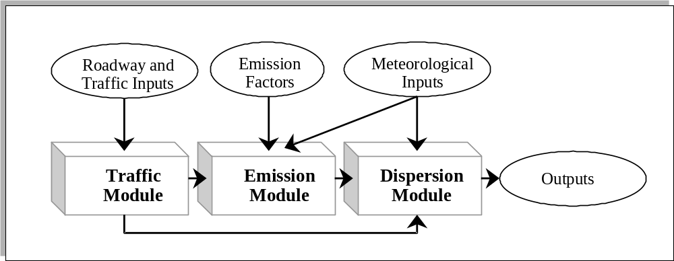
Figure 1-1. Integrated intersection air quality model.

1.2 HOW TO USE THIS MANUAL
This User’s Guide provides background information and user instructions for the individual modules that comprise the HYROAD model. Users of the intersection air quality modeling system, especially novice modelers and those involved in air quality management or decision-making capacities, will benefit most from first reviewing Sections 1 and 2 of this User’s Guide to gain a conceptual overview of the model, its input data needs, and computer hardware requirements. Although not necessary for model operation, users may benefit from the discussion of the graphical user interface in Section 3 of this guide, which has been developed to assist in input preparation.
This report is meant to help the potential user of the HYROAD model to understand and apply the modeling system. The user should become thoroughly familiar with the workings of its various modules and, particularly, their limitations. This knowledge will help the user decide when and how to best use the modeling system.

