- HYROAD USER INTERFACE SYSTEM

4.1 HYROAD MODEL DESCRIPTION
The Hybrid Roadway Intersection Model (HYROAD) is designed to predict the concentrations of carbon monoxide (CO) that occur near intersections from roadway traffic emissions. The HYROAD model user interface includes the following key components. Detailed information on the data fields for each component can be obtained by clicking on the context-sensitive Help button on the interface.

CORE MODULES
1) Traffic: This module provides the interface to enter information related to traffic characteristics and geometric attributes of the intersection under study. Running this module creates the output file required to run the dispersion module.
2) Dispersion: This module provides the interface to enter meteorological data along with information on the locations of receptors, roadway segments, etc. Running this module requires the specification of emission rates as a separate input, along with an output file from the traffic module. If the traffic module is not run before running the dispersion module, it automatically uses the Traffic output from the last run.

SPECIAL FUNCTIONS
1) Emission Factors: The dispersion module offers you the option to select the national default emission rates for either the MOBILE5 or MOBILE6 emission factor models. If you wish to specify custom emission rates, you can use the Emission Factors interface to create a file for custom emission rates.
2) Multiple Hour Simulation: This function provides the interface to select one Traffic scenario and multiple Dispersion scenarios, to run a multiple hour simulation.
3) Screening Mode Analysis: This special function can be used to determine the critical wind direction resulting in maximum concentration. This function allows the user to select a Traffic and Dispersion scenario, and then simulates a change in wind direction for each Dispersion run by 10-degree increments from 0 to 350 degrees. It then calculates and displays the wind direction resulting in maximum concentration.
Each Traffic, Emission, and Dispersion scenario gets saved as a unique record in the built-in HYROAD database, and can be retrieved at any time to make modifications or copies. The user can create a new record, modify an existing record, or save an existing record as a new record.

OTHER OPTIONS
1) HYROAD: The HYROAD interface allows the user to select the desired Traffic and Dispersion scenarios from the database, and then run the model.
2) File Locations: The File Locations interface allows you to specify pre-created Traffic and/or Dispersion text input files, and run the model.

4.2 File Locations SUBMENU
The File Locations submenu is located in the File menu. It offers the following functionalities:
1) Running the traffic module directly from the interface by specifying the location of the Traffic input file.
2) Running the dispersion module directly from the interface by specifying the location of the Dispersion input file.
3) Running the HYROAD module directly from the interface by specifying the location of both the Traffic and Dispersion input files.
In order to successfully run HYROAD or the individual modules, the user needs to have the required input files created and saved in the desired folder before invoking the run functionality. The File Locations submenu is especially useful for running Traffic scenarios containing optional records that are not offered by the traffic module interface and database.

4.3 HYROAD MODULE
The HYROAD submenu is located in the Run menu. It offers the ability to select a Traffic scenario from the Traffic scroll-down menu, a Dispersion scenario from the Dispersion scroll-down menu, and then run HYROAD on the selected scenarios. The scroll-down menus for both Traffic and Dispersion display all the files previously created using the HYROAD interface, and saved in the database.
The HYROAD model first runs the traffic module for the selected Traffic scenario, and then runs the dispersion module using the Traffic outputs and the selected Dispersion scenario.

4.4 Traffic MODULE
The traffic module in the HYROAD model is an enhanced version of the TRAF-NETSIM simulation model developed for the U.S. Federal Highway Administration by KLD Associates. The traffic module provides a detailed representation of the dynamics of traffic flow over space and time using input data that are readily available to local traffic engineers.
Data can be entered to run the traffic module using the Traffic data-entry form, which is divided into nine (9) different tabs:
Main
Time Periods
Link Names
Link Characteristics
Turning Movements
Traffic Controls
Vehicle/Driver Info
Node Coordinates
Link Volumes
All data entered to the forms can be saved in the database for future retrievals and modifications.
The Traffic interface is designed to take typical NETSIM records that can have significant impacts on emission rates. These records include Record Nos. 00, 01, 02, 03, 04, 05, 10, 11, 21, 35, 36, 50, 140, 141, 142, 170, 195, and 210. The following fixed node configuration and naming convention is used by the traffic module to read the intersection:
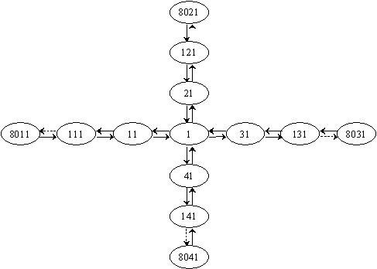
Figure 1. Traffic module fixed nodes and naming convention.
The data-entry forms can also be populated with data from pre-created files by using the Get from File functionality, as long as the files follow the node structure and naming convention given above, and as long as the NETSIM record numbers used are not different from the ones specified above.

OVERVIEW - MAIN TAB (TRAFFIC)
The Main tab in Traffic is used for entering the key model parameters including the unique traffic scenario name, company information, and some other values that control the traffic simulation. Details on each of these fields can be obtained by viewing the Main tab Fields.
It is important to note that typically, the user accesses the traffic module for one of the following reasons:
1) Updating an Existing Traffic Scenario:
This can be done by selecting a previously entered Traffic scenario from the Record Name scroll-box, making the desired modification on each of the tabs, and clicking on the Save button.
2) Saving an Existing Traffic Scenario as a New Scenario:
This can be done by selecting a previously entered Traffic scenario (say Traffic-1) from the Record Name scroll-box, clicking on the Save As button, giving it a new Record Name (say Traffic-2), and clicking the Save button. This essentially creates a copy of Traffic-1 as a new scenario, Traffic-2, which can always be modified without effecting the original Traffic scenario, Traffic-1.
3) Entering a New Scenario to the Database:
This can be done by:
Clicking on the New button, entering a new record name (say Traffic-3) and other required information, and clicking on the Save button to save the new scenario. The user can then go to all the tabs, enter new information into the form, and hence, save a completely new Traffic scenario.
Clicking on the New button, entering a new record name (say Traffic-3), clicking on the Browse button to select a previously-created input file, clicking on the Get from File button once the input file is selected, and finally clicking on the Save button to save the values from the input file into the database.

Fields - Main Tab (Traffic)

Field: Record Name
Description | A unique name used to save and identify the Traffic scenario in the database.
NETSIM Record Number | Not applicable
Default Value | None
Sample | Netsim
Unit | Not applicable
Comments | None

Field: User Name
Description | Used for keeping an identification record of the user entering the Traffic scenario.
NETSIM Record Number | 01
Default Value | None
Sample | John Smith
Unit | Not applicable
Comments | None

Field: Title
Description | Used for identification of the Traffic scenario in the input file, and also in the output file.
NETSIM Record Number | 00
Default Value | None
Sample | Analysis of Tucson Intersection # 34 (AM)
Unit | Not applicable
Comments | None

Field: Date
Description | Date of scenario creation.
NETSIM Record Number | 01
Default Value | None
Sample | 12 07 02
Unit | Not applicable
Comments | None

Field: Agency Name
Description | Used for identification of the agency entering the Traffic scenario.
NETSIM Record Number | 01
Default Value | None
Sample | ICF Consulting
Unit | Not applicable
Comments | None

Field: Fill Time
Description | Pre-simulation time specified to allow the simulated traffic to fill the network from origin to destination to allow it to reach equilibrium.
NETSIM Record Number | 02
Default Value | 15
Sample | 15
Unit | Minutes
Comments | None

Field: Random Seed-1
Description | Random number for generating vehicles in the simulation stream.
NETSIM Record Number | 02
Default Value | 7719
Sample | 7719
Unit | None
Comments | The number should always end with a 1, 3, 7 or 9.

Field: Random Seed-2
Description | Random number for generating responses to traffic choices.
NETSIM Record Number | 02
Default Value | 9917
Sample | 9917
Unit | None
Comments | The number should always end with a 1, 3, 7 or 9.

Field: Time Step
Description | Time interval.
NETSIM Record Number | 04
Default Value | None
Sample | 60
Unit | Seconds
Comments | None

Field: Time Periods
Description | Time periods for simulation.
NETSIM Record Number | 03
Default Value | None
Sample | 48
Unit | None
Comments | Maximum number of 114 time periods are permissible.

Functions - Main Tab (Traffic)
Get From File:
Clicking on the Get From File button pulls the data from the input file, the location of which is specified in the top right-hand corner of the screen. This function populates the form with all the fields from the specified file in their respective positions. If the specified input file uses a different intersection node naming convention, or if it uses records different from the ones specified in Traffic Overview, an error log is displayed.
Write To File:
Clicking on the Write To File button provides the option to specify a new file name and location, and create a new file with that name, containing all the data from the form in the required NETSIM input format.
Run:
Clicking on the Run button runs the traffic module.
View Output:
The View Output button gets enabled only after the completion of a Traffic run. Clicking on the View Output button opens the output file on the screen.
New:
Clicking on the New button clears all the form fields and provides the option to enter and save a new Record Name (scenario). After creating a new record, the user can either start entering the values directly on the form, or can click the Browse button to specify a pre-created input file, followed by clicking the Get From File button.
Save:
Clicking on the Save button saves all the updates made to the form. If the user moves to different tab after making some updates and not clicking on the Save button, a message is prompted, asking the user whether the Save function needs to be invoked or not.
Save As:
Clicking on the Save As button copies the existing scenario/database record as a new record.
Delete:
Clicking on the Delete button deletes the existing scenario/database record from the database.
Help:
Clicking on the Help button opens up the Overview of Main tab help directly from the Help file.
Close:
Clicking on the Close button closes the traffic module.

OVERVIEW - TIME PERIODS TAB (TRAFFIC)
The Time Periods tab in Traffic is used for entering the value of time periods. The number of cells listed on this tab is always equal to the number of time periods specified in the Main tab (Time Periods field).

Fields - Time Periods Tab (Traffic)
Field: Duration
Description | Duration of each of the time periods.
NETSIM Record Number | 03
Default Value | None
Sample | 900
Unit | Seconds
Comments | The duration has to be a multiple of the value specified in the Time Steps field on the Main tab. This value is currently set to a standard value of 900.

Functions - Time Periods Tab (Traffic)
Get From File:
This button is disabled for the Time Periods tab.
Write To File:
This button is disabled for the Time Periods tab.
Run:
This button is disabled for the Time Periods tab.
Graphics:
This button is disabled for the Time Periods tab.
New:
This button is disabled for the Time Periods tab.
Save:
Clicking on the Save button saves all the updates made to the form. If the user moves to different tab after making some updates and not clicking on the Save button, a message is prompted, asking the user whether the Save function needs to be invoked or not.
Save As:
This button is disabled for the Time Periods tab.
Delete:
This button is disabled for the Time Periods tab.
Help:
Clicking on the Help button opens up the Overview of Time Periods tab help directly from the Help file.
Close:
Clicking on the Close button closes the traffic module.

OVERVIEW - LINK NAMES TAB (TRAFFIC)
The Link Names tab in Traffic is used for entering the names of the street of the intersection under study.

Fields - Link Names Tab (Traffic)
Field: Upstream Node
Pre-filled on the form.
Field: Downstream Node
Pre-filled on the form.
Field: Street Name
Description | Name of the street specific to the corresponding links.
NETSIM Record Number | 10
Default Value | None
Sample | 22nd Street
Unit | None
Comments | None

Functions - Link Names Tab (Traffic)
Get From File:
This button is disabled for the Link Names tab.
Write To File:
This button is disabled for the Link Names tab.
Run:
This button is disabled for the Link Names tab.
Graphics:
This button launches the screen for point-and-click graphical entry of the link names.
New:
This button is disabled for the Link Names tab.
Save:
Clicking on the Save button saves all the updates made to the form. If the user moves to different tab after making some updates and not clicking on the Save button, a message is prompted, asking the user whether the Save function needs to be invoked or not.
Save As:
This button is disabled for the Link Names tab.
Delete:
This button is disabled for the Link Names tab.
Help:
Clicking on the Help button opens up the Overview of Link Names tab help directly from the Help file.
Close:
Clicking on the Close button closes the traffic module.

OVERVIEW - LINK CHARACTERISTICS TAB (traffic)
The Link Characteristics tab in Traffic is used for entering the key link attributes such as link length, number of through, right, and left lanes, length of right and left turning pockets, desired free-flow speed, channelization code, etc.

Fields - Link Characteristics Tab (Traffic)
Table-1:
Field: Upstream Node
Pre-filled on the form.
Field: Downstream Node
Pre-filled on the form.
Field: Thru Lanes
Description | Number of lanes that go through the entire length of the corresponding link.
NETSIM Record Number | 11
Default Value | None
Sample | 4
Unit | None
Comments | For Table-1, these are always equal to the number of through lanes.

Field: Channelization Code
Description | Lane attribute that specifies lane usage, e.g. if it is for through traffic only, left turn only, carpool only, etc.
NETSIM Record Number | 11
Default Value | T
Sample | 2TTT
Unit | None
Comments | The number of codes should equal the number of lanes per entire link, starting from curbside to median, which is always equal to the number of through lanes for Table-1. Following is the list of permissible channelization codes for Table-1:  2 = Buses Only  5 = Carpool Only  6 = Carpools & Buses Only  T = Through

Field: Through Traffic Reception Node
Pre-filled on the form.
Table-2:
Field: Upstream Node
Pre-filled on the form.
Field: Downstream Node
Pre-filled on the form.

Field: Link Length
Description | Length of the corresponding link.
NETSIM Record Number | 11
Default Value | None
Sample | 100
Unit | Feet
Comments | The link length cannot be less than 50 feet and greater than 4000 feet.

Field: Thru Lanes
Description | Number of lanes that go through the entire length of the corresponding link.
NETSIM Record Number | 11
Default Value | None
Sample | 3
Unit | None
Comments | For Table-2, these are always equal to the number of through lanes.

Field: Channelization Code
Description | Lane attribute that specifies lane usage, e.g. if it is for through traffic only, left turn only, carpool only, etc.
NETSIM Record Number | 11
Default Value | T
Sample | TTT
Unit | None
Comments | The number of codes should equal the number of lanes per entire link, starting from curbside to median, which is always equal to the number of through lanes for Table-2. Following is the list of permissible channelization codes for Table-2:  2 = Buses Only  5 = Carpool Only  6 = Carpools & Buses Only  T = Through

Field: Through Traffic Reception Node
Pre-filled on the form.
Field: Desired Freeflow Speed
Description | Desired free flow speed for the corresponding link in the network.
NETSIM Record Number | 11
Default Value | None
Sample | 35
Unit | Miles Per Hour (MPH)
Comments | The desired free flow speed cannot be less than 10 MPH and greater than 65 MPH.

Table-3:
Field: Upstream Node
Pre-filled on the form.
Field: Downstream Node
Pre-filled on the form.
Field: Link Length
Description | Length of the corresponding link.
NETSIM Record Number | 11
Default Value | None
Sample | 656
Unit | Feet
Comments | The link length cannot be less than 50 feet and greater than 4000 feet.

Field: L-Pocket Length
Description | Length of the left turn pocket.
NETSIM Record Number | 11
Default Value | None
Sample | 250
Unit | Feet
Comments | The value should be zero or blank if there is no left turn pocket. The length of left turn pocket cannot be less than 20 feet and greater than 1000 feet.

Field: R-Pocket Length
Description | Length of the right turn pocket.
NETSIM Record Number | 11
Default Value | None
Sample | 0
Unit | Feet
Comments | The value should be zero or blank if there is no right turn pocket. The length of right turn pocket cannot be less than 20 feet and greater than 1000 feet.

Field: Thru Lanes
Description | Number of lanes that go through the entire length of the corresponding link.
NETSIM Record Number | 11
Default Value | None
Sample | 4
Unit | None
Comments | For Table-3, these are always equal to the sum of the number of through lanes, left turn lanes, and right turn lanes. Note that this sum has to be less than or equal to 7.

Field: L-Pocket Lanes
Description | Number of lanes in the left turning pocket.
NETSIM Record Number | 11
Default Value | None
Sample | 1
Unit | None
Comments | The value should be zero if there is no left turn pocket. The maximum number of lanes in the left turn pocket is 3.

Field: R-Pocket Lanes
Description | Number of lanes in the left turning pocket.
NETSIM Record Number | 11
Default Value | None
Sample | 0
Unit | None
Comments | The value should be zero if there is no right turn pocket. The maximum number of lanes in the right turn pocket is 3.

Field: Channelization Code
Description | Lane attribute that specifies lane usage, e.g. if it is for through traffic only, left turn only, carpool only, etc.
NETSIM Record Number | 11
Default Value | None
Sample | 2TTT
Unit | None
Comments | The number of codes should be equal to the number of lanes per entire link, starting from curbside to median, which includes through lanes, left turn lanes, and right turn lanes in Table-3. Following is the list of permissible channelization codes:  0 or Blank = Unrestricted  1 = Left Turn Only  2 = Buses Only  3 = Closed  4 = Right Turn Only  5 = Carpool Only  6 = Carpools & Buses Only  T = Through

Field: Left Traffic Reception Node
Pre-filled on the form.
Field: Through Traffic Reception Node
Pre-filled on the form.
Field: Right Traffic Reception Node
Pre-filled on the form.
Field: Upstream Node Number Opposing L-Turn
Pre-filled on the form.
Field: Desired Freeflow Speed
Description | Desired free flow speed for the corresponding link in the network.
NETSIM Record Number | 11
Default Value | None
Sample | 40
Unit | Miles Per Hour (MPH)
Comments | The desired free flow speed cannot be less than 10 MPH and greater than 65 MPH.

Field: R-Turn on Red
Description | Right turn on red code.
NETSIM Record Number | 11
Default Value | 0
Sample | 0
Unit | None
Comments | Value can only be 0 (turn permitted) or 1 (turn not permitted).

Field: Pedestrian Traffic
Description | Pedestrian code for pedestrian traffic.
NETSIM Record Number | 11
Default Value | 0
Sample | 0
Unit | 0
Comments | Values can only be 0, 1, 2, or 3, where:  0 = No Pedestrian Traffic  1 = Light Pedestrian Traffic (100-250 Pedestrians/Hr)  2 = Moderate (250-500 Pedestrians/Hr)  3 = Heavy (above 500 Pedestrians/Hr)

Functions - Link Characteristics Tab (Traffic)
Get From File:
This button is disabled for the Link Characteristics tab.
Write To File:
This button is disabled for the Link Characteristics tab.
Run:
This button is disabled for the Link Characteristics tab.
Graphics:
This button launches the screen for point-and-click graphical entry of the link characteristics.
New:
This button is disabled for the Link Characteristics tab.
Save:
Clicking on the Save button saves all the updates made to the form. If the user moves to different tab after making some updates and not clicking on the Save button, a message is prompted, asking the user whether the Save function needs to be invoked or not.
Save As:
This button is disabled for the Link Characteristics tab.
Delete:
This button is disabled for the Link Characteristics tab.
Help:
Clicking on the Help button opens up the Overview of Link Characteristics tab help directly from the Help file.
Close:
Clicking on the Close button closes the traffic module.

OVERVIEW - TURNING MOVEMENTS TAB (traffic)
The Turning Movements tab in Traffic is used for entering information related to turning movements of traffic for each of the links in the network. The data is entered to specify percentage of vehicles going through, turning right, and turning left. It is important to note that except for the four approach links (11-1, 21-1, 31-1, and 41-1), the percentage of traffic going through always remains at 100 percent.

Fields - Turning Movements Tab (Traffic)
Field: Upstream Node
Pre-filled on the form.
Field: Downstream Node
Pre-filled on the form.
Field: % Left
Description | Percentage of traffic turning left from the corresponding link.
NETSIM Record Number | 21
Default Value | None
Sample | 11
Unit | None
Comments | Should always be less than or equal to 100. Value should only be greater than zero if downstream node equals 1 and there is a left turn.

Field: % Through
Description | Percentage of traffic going through (straight) from the corresponding link.
NETSIM Record Number | 21
Default Value | None
Sample | 70
Unit | None
Comments | Should always be less than or equal to 100. Value should only be less than 100 if downstream node equals 1 and there is a left or right turn.

Field: % Right
Description | Percentage of traffic turning right from the corresponding link.
NETSIM Record Number | 21
Default Value | None
Sample | 19
Unit | None
Comments | Should always be less than or equal to 100. Value should only be greater than zero if downstream node equals 1 and there is a right turn.

Functions - Turning Movements Tab (Traffic)
Get From File:
This button is disabled for the Turning Movements tab.
Write To File:
This button is disabled for the Turning Movements tab.
Run:
This button is disabled for the Turning Movements tab.
Graphics:
This button launches the screen for point-and-click graphical entry of the Turning Movements.
New:
This button is disabled for the Turning Movements tab.
Save:
Clicking on the Save button saves all the updates made to the form. If the user moves to different tab after making some updates and not clicking on the Save button, a message is prompted, asking the user whether the Save function needs to be invoked or not.
Save As:
This button is disabled for the Turning Movements tab.
Delete:
This button is disabled for the Turning Movements tab.
Help:
Clicking on the Help button opens up the Overview of Turning Movements tab help directly from the Help file.
Close:
Clicking on the Close button closes the traffic module.

Overview - Traffic Controls Tab (traffic)
The Traffic Controls tab in Traffic is used for entering information related to pre-timed signal controls or sign controls for the intersection. Typical entries include number of signal intervals, duration, control code, etc. Before entering the information in the Traffic Controls tab, it is important to first determine whether the intersection is controlled by signs or by pre-timed signals. Based on that determination, proper data entry can be made.

Fields - Traffic Controls Tab (Traffic)
Field: Node Number
Pre-filled on the form.
Field: Upstream Node Approach-1
Pre-filled on the form.
Field: Upstream Node Approach-2
Pre-filled on the form.
Field: Upstream Node Approach-3
Pre-filled on the form.
Field: Upstream Node Approach-4
Pre-filled on the form.
Field: Interval Duration
Description | Duration of each interval.
NETSIM Record Number | 35
Default Value | None
Sample | 28
Unit | Seconds
Comments | Should be left blank for Sign controls.

Field: Control Code
Description | Control code for each duration for all four approach links.
NETSIM Record Number | 36
Default Value | None
Sample | 9292
Unit | None
Comments | For Node-1 (intersection), the values range from 0 to 9, with the following rule:  0 = Yield or Yellow  1 = Green  2 = Red  3 = Red with Green Right Arrow  4 = Red with Green Left Arrow  5 = Stop Sign  6 = Red with Green Diagonal Arrow  7 = No Turns (Green Through Arrow)  8 = Red with Green Left & Right Arrows  9 = No Left Turn (Green Through & Right Arrows)  For nodes 11, 21, 31, 41, 111, 121, 131, and 141, the controls codes should remain 1 (Green) for both approaches.  For Sign Controls, the Control Code should be set to 0, 1 or 5 for each of the four approach links. Refer to the TRAF-NETSIM User's Guide for details.

Functions - Traffic Controls Tab (Traffic)
Get From File:
This button is disabled for the Traffic Controls tab.
Write To File:
This button is disabled for the Traffic Controls tab.
Run:
This button is disabled for the Traffic Controls tab.
Graphics:
This button is disabled for the Traffic Controls tab.
New:
This button is disabled for the Traffic Controls tab.
Save:
Clicking on the Save button saves all the updates made to the form. If the user moves to different tab after making some updates and not clicking on the Save button, a message is prompted, asking the user whether the Save function needs to be invoked or not.
Save As:
This button is disabled for the Traffic Controls tab.
Delete:
This button is disabled for the Traffic Controls tab.
Help:
Clicking on the Help button opens up the Overview of Traffic Controls tab help directly from the Help file.
Close:
Clicking on the Close button closes the traffic module.

Overview - Vehicle/Driver Info (traffic)
The Vehicle/Driver Info tab is used for entering information related to vehicle sizes, driver decision behavior, turn speeds, etc. These values are represented in Record Nos. 140, 141, and 142 in NETSIM. They are typically not critical for air quality analysis, since the default values are used in most cases. The fields included in this tab are:
Space Needed to Change Lanes;
Maximum Right Turn Speed;
Maximum Left Turn Speed;
Spillback join probability (for up to 4 cars in the queue); and
Effective Length of Auto, Truck, Carpool, and Bus.

Functions - Vehicle/Driver Info Tab (Traffic)
Get From File:
This button is disabled for the Vehicle/Driver Info tab.
Write To File:
This button is disabled for the Vehicle/Driver Info tab.
Run:
This button is disabled for the Vehicle/Driver Info tab.
Graphics:
This button is disabled for the Vehicle/Driver Info tab.
New:
This button is disabled for the Vehicle/Driver Info tab.
Save:
Clicking on the Save button saves all the updates made to the form. If the user moves to different tab after making some updates and not clicking on the Save button, a message is prompted, asking the user whether the Save function needs to be invoked or not.
Save As:
This button is disabled for the Vehicle/Driver Info tab.
Delete:
This button is disabled for the Vehicle/Driver Info tab.
Help:
Clicking on the Help button opens up the Overview of Vehicle/Driver Info tab help directly from the Help file.
Close:
Clicking on the Close button closes the traffic module.

Overview - Node Coordinates Tab (traffic)
The Node Coordinates tab provides a Cartesian reference that is used to synchronize the NETSIM outputs with the dispersion module. An arbitrary origin value may be selected as long as all values remain positive.

Fields – Node Coordinates Tab (Traffic)
Field: X-Node
Description | Cartesian coordinate.
NETSIM Record Number | 195
Default Value | None
Sample | 5000
Unit | Feet
Comments | Origin value can be arbitrary, so long as it does not cause other nodes to have negative coordinates (e.g. X-node should not equal zero, since that will cause nodes left of the origin to have negative coordinates).

Field: Y-Node
Description | Cartesian coordinate.
NETSIM Record Number | 195
Default Value | None
Sample | 5000
Unit | Feet
Comments | Origin value can be arbitrary, so long as it does not cause other nodes to have negative coordinates (e.g. Y-node should not equal zero, since that will cause nodes below the origin to have negative coordinates).

Functions - Node Coordinates Tab (Traffic)
Get From File:
This button is disabled for the Node Coordinates tab.
Write To File:
This button is disabled for the Node Coordinates tab.
Run:
This button is disabled for the Node Coordinates tab.
Graphics:
This button is disabled for the Node Coordinates tab.
New:
This button is disabled for the Node Coordinates tab.
Save:
Clicking on the Save button saves all the updates made to the form. If the user moves to different tab after making some updates and not clicking on the Save button, a message is prompted, asking the user whether the Save function needs to be invoked or not.
Save As:
This button is disabled for the Node Coordinates tab.
Delete:
This button is disabled for the Node Coordinates tab.
Help:
Clicking on the Help button opens up the Overview of Node Coordinates tab help directly from the Help file.
Close:
Clicking on the Close button closes the traffic module.

Overview - Link Volumes (traffic)
The Link Volumes tab in Traffic is used for entering information on entry volumes at the four entry nodes in the network (8011, 8021, 8031, and 8041). The fields on this tab include the total volume flow rate, percentage carpools, and percentage trucks. Separate values can be provided for each iteration. The number of iterations is always equal to the number of time periods specified in the Main tab (Time Periods field).

Fields - Link Volumes (traffic)
Field: Iteration Number
Pre-filled on the form.
Field: Upstream Node
Pre-filled on the form.
Field: Downstream Node
Pre-filled on the form.

Field: Flow Rate
Description | Traffic volume flow rate from the corresponding entry node.
NETSIM Record Number | 50
Default Value | None
Sample | 124
Unit | Vehicles/Hour
Comments | None

Field: Percentage Trucks
Description | Percentage of trucks in the volume generated by the corresponding entry node.
NETSIM Record Number | 50
Default Value | None
Sample | 20
Unit | None
Comments | Should be less than or equal to 100.

Field: Percentage Carpools
Description | Percentage of carpools in the volume generated by the corresponding entry node.
NETSIM Record Number | 50
Default Value | None
Sample | 20
Unit | None
Comments | Should be less than or equal to 100.

Functions - Link Volumes (Traffic)
Get From File:
This button is disabled for the Link Volumes tab.
Write To File:
This button is disabled for the Link Volumes tab.
Run:
This button is disabled for the Link Volumes tab.
Graphics:
This button is disabled for the Link Volumes tab.
New:
This button is disabled for the Link Volumes tab.
Save:
Clicking on the Save button saves all the updates made to the form. If the user moves to different tab after making some updates and not clicking on the Save button, a message is prompted, asking the user whether the Save function needs to be invoked or not.
Save As:
This button is disabled for the Link Volumes tab.
Delete:
This button is disabled for the Link Volumes tab.
Help:
Clicking on the Help button opens up the Overview of Link Volumes tab help directly from the Help file.
Close:
Clicking on the Close button closes the traffic module.

TRAFFIC MODULE INPUTS
The input data required for the NETSIM module are intended to be routinely available to traffic engineers through site measurements, traffic studies, and volume counts. This information includes: a description of roadway geometry; operational attributes (mean free-flow speed, start-up loss time, etc.); traffic volume and composition; and intersection traffic control. An overview of these data requirements is presented in Table 4-1. The minimum inputs of data typically assumed available are:
hourly approach volumes for each approach leg
turning movement by time period (AM peak and PM peak) for each approach leg
signal timing and phasing plans by time period (seconds of green, yellow, and all red for each phase and approach) at the subject intersection. If the signal control at this intersection is coordinated with the control of neighboring intersections, then the control at these neighboring intersections should also be specified as well as the relative offsets along all approaches
intersection geometry for each approach and departing leg (number of lanes and turn lanes, turn bay lengths, and simple compass point orientations: east, west, north, south; or coordinates of subject and neighboring intersections)
the posted speed limit or prevailing “free-speed” of traffic flow on each approach and departing leg
In addition, the user may provide additional data for a more refined modeled simulation. These data may include:
vehicle fleet composition
actuated signal timing and signal coordination information
approach volumes in 15-minute increments or peak hour factor
turning movements by hour or 15-minute increment
approach capacity and mean queue discharge headways
roadway and lane widths
pedestrian demand
parking activities
approach grades

Specifying TRAF-NETSIM Input Data
The data identified in Table 4-1 is specified to the NETSIM module as an ASCII data file. This file is given extension .trf to identify it as the NETSIM input module file. The file consists of various 80 column records. The format of these records varies based upon the type of information they contain. Each record “type” has its own format and is used to specify a specific category of data such as: geometry; turning movements; signal control; volumes; and the like. Each different record type is assigned its own number. This number is placed at the end of the record (ending in column 80) so that the software knows which format to employ and how to store the data when reading each record.
A detailed description of each of the TRAF-NETSIM record types and their order of appearance within the input file is contained in the TRAF User Reference Manual (FHWA, 1995). Typical record types employed for an air quality analysis with TRAF-NETSIM are identified in Table 4-2.
In the event that an intersection includes other traffic characteristics such as: extensive parking activity; double-parked cars; trucks loading and unloading; or frequent buses stopping at stations near the intersection; other optional record types may be included within the NETSIM input file module to describe these characteristics. Some of the more common of these optional record types that could be included in air quality analyses are presented in Table 4-3.
An important feature of the NETSIM module is its ability to represent the variation in traffic conditions over time. For example, the level of pedestrian activity, traffic volumes, and turning movements can all change over time. Thus, several of the NETSIM module record types are repeated in the input file to identify these changes to input conditions over time. The more common of these record types are shown in Table 4-4.

NETSIM Module Inputs
The modified version NETSIM used in the air quality model has only one additional input requirement beyond that required for TRAF-NETSIM. This requires the user to identify the intersection for which air quality data is requested. This information is specified in columns, 37-40 on record type 02. Additionally, record type 195 (node coordinates) is mandatory for an air quality modeling.
In addition, the previous restriction on the number of time periods with varying data has been extended from 19 periods to 114 periods. This ensures that the model can be used for a 24 hour simulation with input data conditions varying every 15 minutes. This means that an input file can now contain up to 6 records of type 03 rather than only 1 such record. A list of all modifications to TRAF-NETSIM inputs for air quality modeling is presented in Table 4-5.
The NETSIM module represents the physical roadway network as a combination of links, (uni-directional sections of roadway), and nodes (intersections). A link-node diagram for an air quality assessment of a typical 4 legged intersection is shown in Figure 4-2.
The intersection of interest for the air quality modeling is shown as node 1 in this diagram. This node number, (1) would be specified in column 40 of Record Type 02 to indicate that air quality information is requested for this intersection. The air quality data would be furnished for intersection approach roadway links: (11, 1), (21, 1), (31, 1) and (41, 1) as well as for departure roadway links (1, 11), (1, 21), (1, 31), (1, 41) as shown in Figure 4-2.
Additional roadway segments, shown as links: (111, 11), (121, 21), (131, 31), and (141, 41) are necessary so that vehicles can obtain realistic trajectories of motion prior to entering the intersection approach links where air quality statistics are gathered. These additional links should be at least 100 feet in length. Similarly, additional links: (11, 111), (21, 121), (31, 131) and (41, 141) are necessary to allow the NETSIM module to realistically model the trajectories of vehicles as they leave the departing links of the intersection. These links should be approximately 100 feet in length.
Links: (8011, 111), (8021, 121), (8031, 131) and (8041, 141) are known as ENTRY links. These links serve as a mechanism to allow traffic to enter the roadway system. Detailed vehicle trajectories are not computed on these links, thus requiring the additional links described above. Similarly, links: (111, 8011), (121, 8021), (131, 8031), and (141, 8041) are known as EXIT links where vehicles disappear from the roadway system immediately upon entering these links.
Figure 4-4 shows an example of the NETSIM module inputs for a typical major four-legged intersection, whose geometry is shown in Figure 4-3. Further explanations and default values used by the module can be obtained from the TRAF-NETSIM Reference Manual (FHWA, 1995).
Table 4-1. Overview of NETSIM module input data requirements.
Geometric Attributes by Link (i.e., uni-directional section of roadway)
- Number of lanes
- Length (from stop-line to stop-line) and width
- Number of lanes in left and right turning bays
- Length of each turning bay
- Grade (%)
- Lane restrictions (e.g., right turns only, buses only, closed, etc.)
- Location of parking zones (if you wish to simulate the impedance of parking maneuvers to moving traffic)
- Location of bus stations (if any), station capacity (length), Routes serviced
- Lane alignment to next through street (if unusual)

Traffic Operations Attributes by Link
- Presence or absence of Right-Turn-On-Red
- Mean free-flow speed
- Mean start-up loss time for first vehicle in queue
- Mean queue discharge headway (for fourth and following vehicles in queue)
- Average duration of parking maneuvers and average number of maneuvers/hour
- Lanes blocked by short and long-term incidents (i.e., accidents, incidents, trucks unloading, etc.) and the average duration of these incidents
- Turning and through movement volumes discharging at intersection
- Pedestrian volume encountered by right-turning vehicles discharging from this link

Traffic Volume and Composition
- Traffic volumes (vehicles per hour) at network entry points
- Mid-street traffic generators (net change +/- in volume)
- Traffic mix (cars, trucks, buses, carpools)
- Mean headway of transit vehicles

Traffic Control Attributes by Intersection
- Type of control (STOP, YIELD, Uncontrolled , Fixed Time or Actuated Signal)
- For signalized intersections:
- Traffic movements (left, right, through, diagonal) during each signal interval
- Duration of each signal interval (duration of green, yellow, all-red)
- Signal offset to first interval, relative to a system-wide reference
- Force-off times, detector locations, etc. for actuated controlled intersections

Simulation Control Attributes
- Duration of simulation
- Type and frequency of output
- Length of each time period over which all traffic inputs (volume rates, etc.)
- remain fixed

Table 4-2. Typical NETSIM record types used for air quality modeling.
Record Type(s) Description

00 Title
01 Identification
02 Run Control
03 Time Period Durations
04 Time Step Control
05 Output Options
11 Link Characteristics
21 Turning Movements by Link
35-36 Specifications for Fixed Time Traffic Controllers
43-48 Specifications for Actuated Traffic Controllers
50 Entry Link Volumes
80 Link Geometric Features
170 Delimiter Record
195 Node Coordinates
- Time Period Delimiter

Table 4-3. Optional NETSIM record types.
Record Type(s) Description

10 Link Names
22 Conditional Turn Probabilities
51 Source/Sink Volumes
52 Vehicle Occupancy
54-56 Lane Blockages Due to Parking, Double-parking
58 Vehicle Characteristics
140-150 Calibration Data for Driver Decision Processes
185-189 Bus Transit Operations

Table 4-4. NETSIM record types describing time varying data.
Record Type(s) Description

11 Link Characteristics
21 Turning Movements by Link
22 Conditional Turn Probabilities
35-36 Specifications for Fixed Time Traffic Controllers
50 Entry Link Volumes
51 Source/Sink Volumes
56 Parking Activity
170, 210 Delimiter Records
186, 189 Bus Dwell Time at Stations, Route Volumes

Table 4-5. Modifications to standard TRAF-NETSIM input for HYROAD.

Record Type Modifications

02 The node number identifying the intersection where air quality data is to be provided, must be specified in columns, 37-40.

03 The number of Type 03 records permitted in the input data file has been extended from 1 to 6. The total number of Time Period durations specified on these records has been extended from 19 to 114. This enables the integrated air quality model to consider a 24 hour simulation with 96, 15 minute Time Periods of varying traffic conditions.

04 The user specified Time Interval duration (sec), in columns, 17-20, should be a number such that the division: (900 seconds / Time Interval duration) results in an integer number. If not, the software will internally assign a Time Interval duration of 60 seconds.

- This record type for TRAF-NETSIM is required only if the user requests animated graphical output. It must also be specified for air quality modeling. This record type is used to specify the coordinates of each node and enables HYROAD to identify the angle of each approach to the intersection.

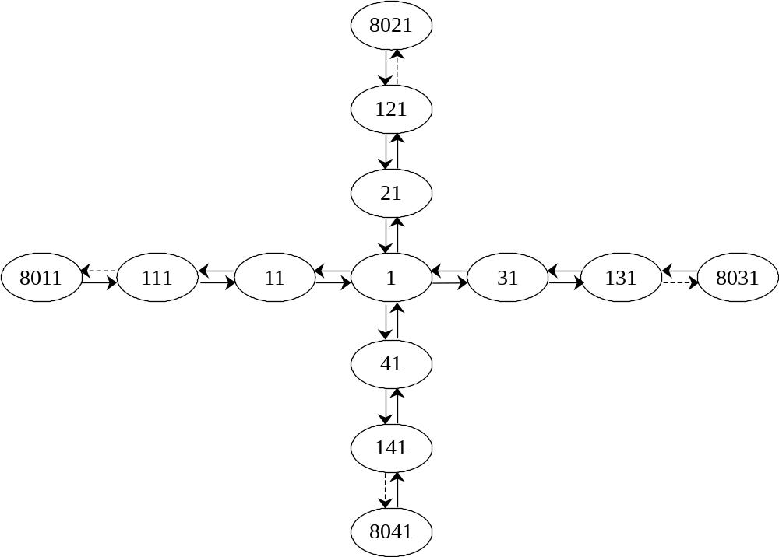

Figure 4-2. Typical link/node diagram for HYROAD.

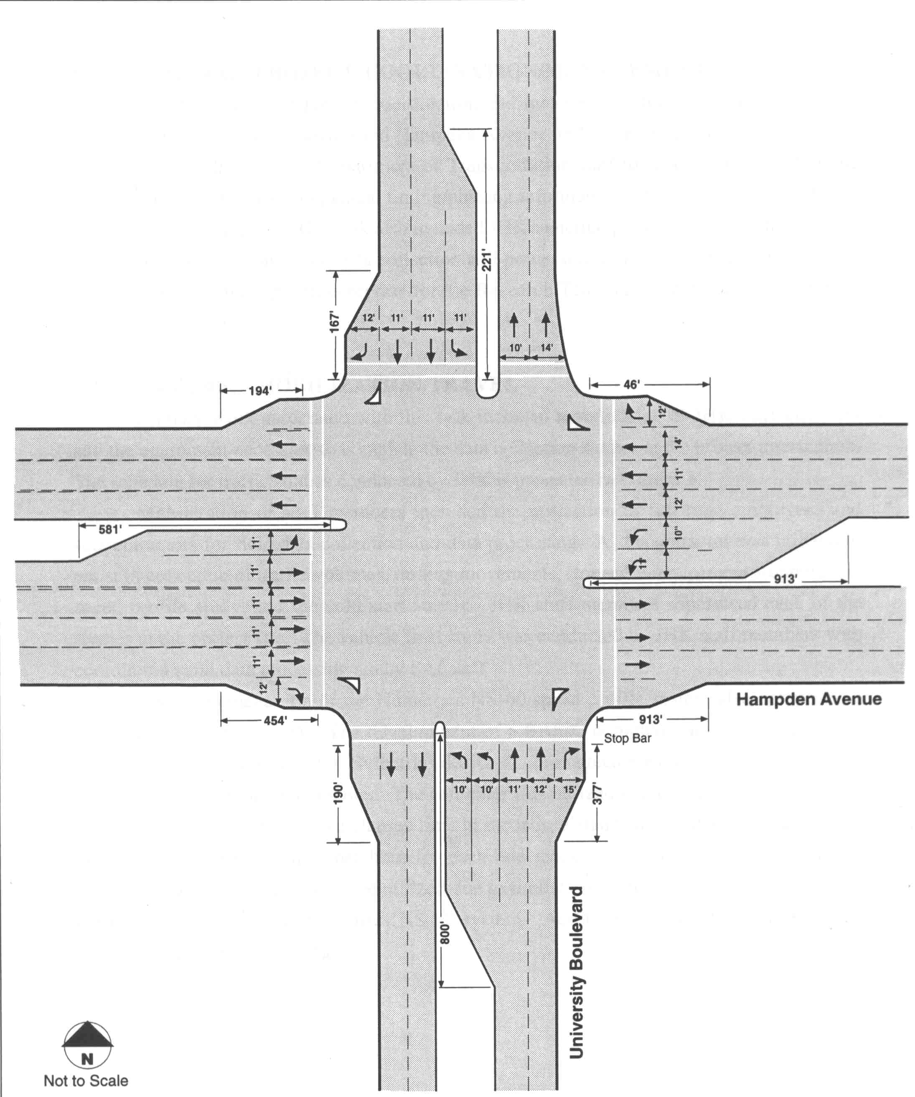

Figure 4-3. Intersection geometry used in developing the sample NETSIM.TRF input file.

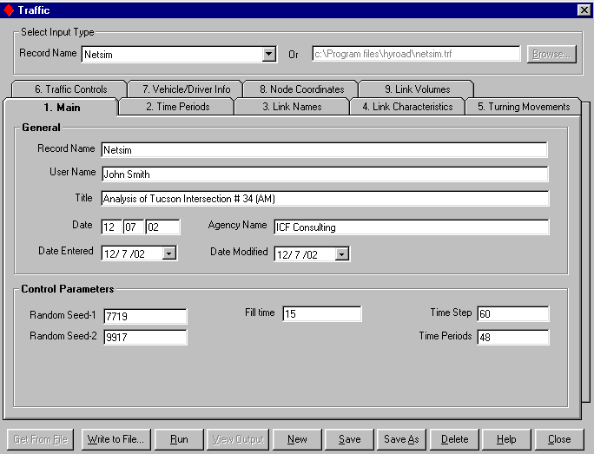

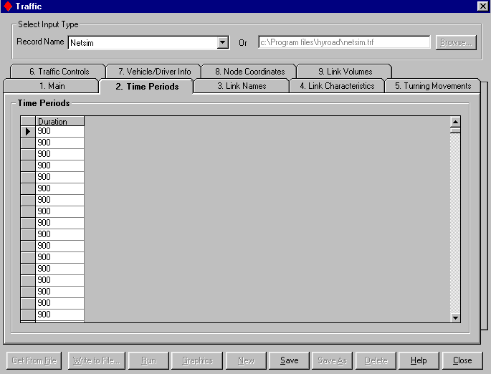
Figure 4-4. Sample NETSIM.TRF inputs.

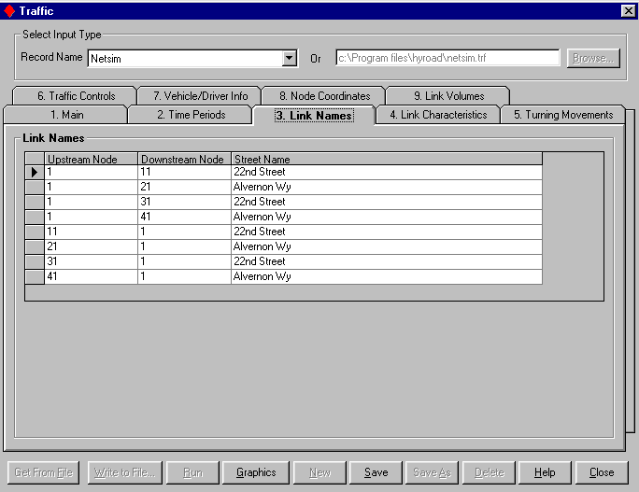

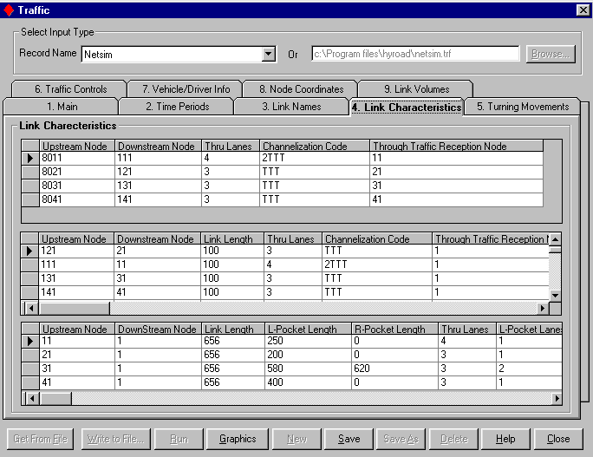
Figure 4-4. Continued.

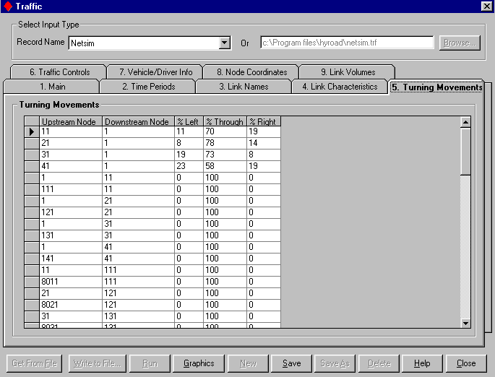

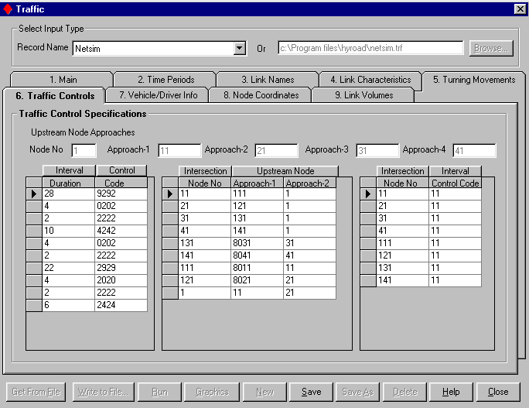
Figure 4-4. Continued.
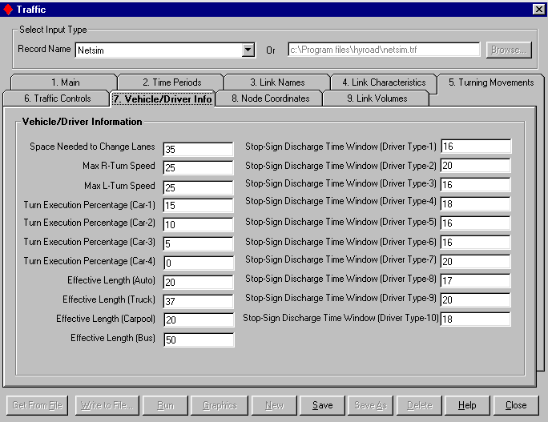
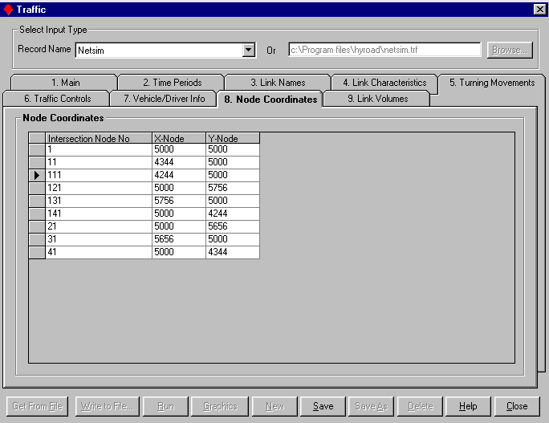
Figure 4-4. Continued.

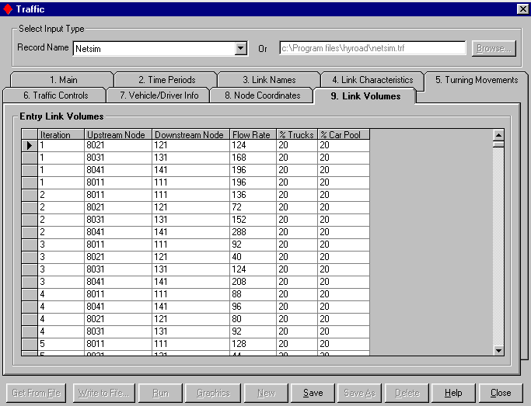
Figure 4-4. Concluded.

4.5 Dispersion MODULE
The dispersion module in the HYROAD model takes user input on key factors affecting air quality, the output from the last run of traffic module, and the specified emission factors file (MOBILE5 national default, MOBILE6 national default, MOBILE5 custom, or MOBILE6 custom), to estimate emission concentration at the intersection under study.
Data can be entered to run the dispersion module using the Dispersion data-entry form, which is divided into five different tabs:
Main
Receptor Data
Link Data
Met Data
Lane Data
All data entered to the forms can be saved in the database for future retrievals and modifications.
The following fixed link configuration and naming convention is used by the dispersion module to read the intersection:
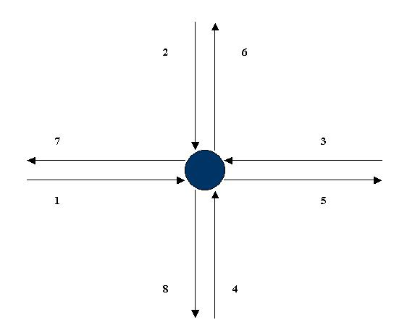
Figure 4-5. Dispersion module fixed link configuration and naming convention.
The data-entry forms can be populated by entering new information directly into the forms, or by retrieving data from pre-created files by using the Get from File functionality, as long as the files follow the link structure given above.

Main Tab (Dispersion)
The Main tab in Dispersion is used for entering the key model parameters including the unique Dispersion scenario name, emission factor file name, and some other values that control the run. Details on each of these fields can be obtained by viewing the Main tab fields.
It is important to note that typically, the user accesses the Dispersion module for one of the following reasons:
1) Updating an Existing Dispersion Scenario:
This can be done by selecting a previously-entered Dispersion scenario from the Record Name scroll-box, making the desired modification on each of the tabs, and clicking on the Save button.
2) Saving an Existing Dispersion Scenario as a New Scenario:
This can be done by selecting a previously-entered Dispersion scenario (say Dispersion-1) from the Record Name scroll-box, clicking on the Save As button, giving it a new Record Name (say Dispersion-2), and clicking the Save button. This essentially creates a copy of Dispersion-1 as a new scenario, Dispersion-2, which can always be modified without effecting the original Dispersion scenario, Dispersion-1.
3) Entering a New Scenario to the Database:
This can be done by:
Clicking on the New button, entering a new record name (say Dispersion-3) and other required information, and clicking on the Save button to save the new scenario. The user can then go to all the tabs, enter new information into the form, and hence, save a completely new Dispersion scenario.
Clicking on the New button, entering a new record name (say Dispersion-3), clicking on the Browse button to select a previously-created input file, clicking on the Get from File button once the input file is selected, and finally clicking on the Save button to save the values from the input file into the database.

Fields - Main Tab (Dispersion)
Field: Title
Description | Project title, or title of the intersection under study.
Data Set | Title
Default Value | None
Sample | TucsonAM Concentrations
Unit | Not applicable
Comments | None

Field: Record Name
Description | A unique name used to save and identify the Dispersion scenario in the database.
Data Set | Not applicable
Default Value | None
Sample | Disperse
Unit | Not applicable
Comments | None

Field: Traffic Output File
Description | Name of the traffic output file from the last traffic run.
Data Set | Files
Default Value | lu92.bin
Sample | lu92.bin
Unit | Not applicable
Comments | This file is use as a key input to the dispersion module.

Field: Date Entered
Description | Date of data entry.
Data Set | Not applicable
Default Value | Today's date
Sample | 12/ 7 /02
Unit | Not applicable
Comments | None

Field: Emission Type
Description | A unique name used to save and identify of the emission scenario in the database.
Data Set | Not applicable
Default Value | MOBILE5
Sample | MOBILE5
Unit | Not applicable
Comments | MOBILE5 and MOBILE6 are pre-entered into the database based on national defaults settings. Any customized emission factors can be created using the Special Functions. The record names for those customized emission scenarios can be seen in the Emission Type scroll-box once they are created.

Field: Emission Factor File
Description | The emission file saved in the program folder, that is to be used for the disperse run.
Data Set | Files
Default Value | MOBILE5.dat
Sample | MOBILE5.dat
Unit | Not applicable
Comments | MOBILE5 and MOBILE6 are based on national default values and are included with the installation in the program folder.

Field: Time Periods to Read
Description | Time periods to read.
Data Set | Files
Default Value | 1
Sample | 1
Unit | None
Comments | None

Field: Time Periods to Average
Description | Time Periods to Average.
Data Set | Files
Default Value | 1
Sample | 1
Unit | None
Comments | None

Field: 15 Minute Time Blocks
Description | 15 minute time blocks.
Data Set | Link Definition
Default Value | 1
Sample | 1
Unit | Not applicable
Comments | None

Field: Height of Met. Readings
Description | Height of met. readings.
Data Set | Met Data
Default Value | None
Sample | 10.0
Unit | Meters
Comments | None

Field: Number of Receptors
Description | Number of receptors.
Data Set | Receptor Data
Default Value | None
Sample | 16
Unit | None
Comments | Cannot be more than 60.

Field: Number of Approaches
Description | Number of approaches.
Data Set | Lane Data
Default Value | 8
Sample | 8
Unit | None
Comments | Total 8 approaches.

Field: Time Step
Description | Time step.
Data Set | Lane Data
Default Value | 900
Sample | 900
Unit | Seconds
Comments | Must be set to 900.

Field: Start Time
Description | Start time for the run in military hours.
Data Set | Link Definition
Default Value | None
Sample | 1830
Unit | None
Comments | None

Field: Lane Width
Description | Lane width.
Data Set | Lane Data
Default Value | 3.33
Sample | 3.33
Unit | Meters
Comments | None

Field: Number of Links
Description | Number of links.
Data Set | Link Definition
Default Value | 8
Sample | 8
Unit | None
Comments | None

Field: Number of Signal Phases
Description | Number of signal phases.
Data Set | Lane Data
Default Value | None
Sample | 10
Unit | None
Comments | Same as traffic.

Field: Surface Roughness
Description | Surface Roughness.
Data Set | Deposition Data
Default Value | None
Sample | 0.05
Unit | Meters
Comments | Following values can be used based on area type:  Central Business District: 0.321  Suburb: 0.108  Rural (Forest): 0.283  Rural (Wheat Field): 0.022  Rural (Long Grass): 0.011  Rural (Bare Earth): 0.0003

Field: Settling Velocity
Description | Settling velocity.
Data Set | Deposition data
Default Value | 0.00
Sample | 0.00
Unit | Meters/Second
Comments | None

Field: Deposition Velocity
Description | Deposition velocity.
Data Set | Deposition Data
Default Value | 0.00
Sample | 0.00
Unit | Meters/Second
Comments | None

Field: Altitude
Description | Altitude.
Data Set | Deposition Data
Default Value | 0.00
Sample | 0.00
Unit | Meters
Comments | None

Functions - Main Tab (Dispersion)
Get From File:
Clicking on the Get From File button pulls the data from the input file, the location of which is specified in the top right-hand corner of the screen. This function populates the form with all the fields from the specified file in their respective positions. If the specified input file uses a different intersection link naming convention, or if it uses entries different from the required format, an error log is displayed.
Write To File:
Clicking on the Write To File button provides the option to specify a new file name and location, and create a new file with that name, containing all the data from the form in the required input format.
Run:
Clicking on the Run button runs the dispersion module.
View Output:
The View Output button gets enabled only after the completion of a Dispersion run. Clicking on the View Output button opens the output file on the screen.
New:
Clicking on the New button clears all the form fields and provides the option to enter and Save a new Record Name (scenario). After creating a new record, the user can either start entering the values directly on the form, or can click the Browse button to specify a pre-created input file, followed by clicking the Get From File button.
Save:
Clicking on the Save button saves all the updates made to the form. If the user moves to different tab after making some updates and not clicking on the Save button, a message is prompted, asking the user whether the Save function needs to be invoked or not.
Save As:
Clicking on the Save As button copies the existing scenario/database record as a new record.
Delete:
Clicking on the Delete button deletes the existing scenario/database record from the database.
Help:
Clicking on the Help button opens up the Overview of Main tab help directly from the Help file.
Close:
Clicking on the Close button closes the dispersion module.

Link Data Tab (DISPERSION)
The Link Data tab is used for entering the name numbering, location and other information on each link of the intersection under study.

Fields - Link Data Tab (Dispersion)
Field: Serial Number
Description | Link number.
Data Set | Link Definition
Default Value | 1-8 for link numbers 1-8
Sample | 01
Unit | None
Comments | Always appears as pre-filled data in the entry form.

Field: X1
Description | X1.
Data Set | Link Definition
Default Value | None
Sample | 0000.0
Unit | Meters
Comments | None

Field: Y1
Description | Y1.
Data Set | Link Definition
Default Value | None
Sample | -009.1
Unit | Meters
Comments | None

Field: X2
Description | X2.
Data Set | Link Definition
Default Value | None
Sample | -200.000
Unit | Meters
Comments | None

Field: Y2
Description | Y2.
Data Set | Link Definition
Default Value | None
Sample | -009.100
Unit | Meters
Comments | None

Field: Block Length Per 10m
Description | Block Length Per 10 Meters.
Data Set | Link Definition
Default Value | None
Sample | 020
Unit | 10-m
Comments | None

Field: Number of Links
Description | Number of Links.
Data Set | Link Definition
Default Value | 1
Sample | 1
Unit | None
Comments | Always appears as pre-filled data in the entry form.

Field: Block Length
Description | Block length.
Data Set | Link Data
Default Value | 10
Sample | 10
Unit | Meters
Comments | Always appears as pre-filled data in the entry form.

Field: Road Height
Description | Road height.
Data Set | Link Definition
Default Value | 00.0
Sample | 00.0
Unit | Meters
Comments | Always appears as pre-filled data in the entry form.

Field: Mixing Width
Description | Mixing width.
Data Set | Link Definition
Default Value | Always appears as pre-filled data after conversion of values from Traffic file.
Sample | 17.0
Unit | Meters
Comments | The value is always equal to sum of width of all lanes, plus 3 meters on each side.

Functions - Link Data Tab (Dispersion)
Get From File:
This button is disabled for the Link Data tab.
Write To File:
This button is disabled for the Link Data tab.
Run:
This button is disabled for the Link Data tab.
Graphics:
This button is disabled for the Link Data tab.
New:
This button is disabled for the Link Data tab.
Save:
Clicking on the Save button saves all the updates made to the form. If the user moves to different tab after making some updates and not clicking on the Save button, a message is prompted, asking the user whether the Save function needs to be invoked or not.
Save As:
This button is disabled for the Link Data tab.
Delete:
This button is disabled for the Link Data tab.
Help:
Clicking on the Help button opens up the Overview of Link Data tab help directly from the Help file.
Close:
Clicking on the Close button closes the dispersion module.

Met Data Tab (DISPERSION)
The Met Data tab is used for entering the information related to meteorological conditions specific to each time step at the intersection under study.

Fields - Met Data Tab (Dispersion)
Field: Ambient Wind Speed
Description | Ambient Wind Speed.
Data Set | Met Data
Default Value | None
Sample | 1.00
Unit | Meters/Second
Comments | None

Field: Ambient Wind Direction
Description | Ambient Wind Direction.
Data Set | Met Data
Default Value | None
Sample | 10
Unit | Degrees
Comments | None

Field: Ambient St. Dev. Direction
Description | Ambient Standard Deviation Direction.
Data Set | Met Data
Default Value | None
Sample | -1.0
Unit | Degrees
Comments | None

Field: Stability Class (1-6)
Description | Stability Class.
Data Set | Met Data
Default Value | None
Sample | 4
Unit | None
Comments | Values range from 1 to 6.

Field: Mixing Height
Description | Mixing height.
Data Set | Met Data
Default Value | 1000
Sample | 1000
Unit | Meters
Comments | Doesn't change with Time Step.

Field: Ambient Concentration
Description | Ambient Concentration.
Data Set | Met Data
Default Value | 00
Sample | 00
Unit | PPM
Comments | Doesn't change with Time Step.

Field: Ambient Temperature
Description | Ambient Temperature.
Data Set | Met Data
Default Value | None
Sample | 9.48
Unit | Degree Celsius
Comments | None

Functions - Met Data Tab (Dispersion)
Get From File:
This button is disabled for the Met Data tab.
Write To File:
This button is disabled for the Met Data tab.
Run:
This button is disabled for the Met Data tab.
Graphics:
This button is disabled for the Met Data tab.
New:
This button is disabled for the Met Data tab.
Save:
Clicking on the Save button saves all the updates made to the form. If the user moves to different tab after making some updates and not clicking on the Save button, a message is prompted, asking the user whether the Save function needs to be invoked or not.
Save As:
This button is disabled for the Met Data tab.
Delete:
This button is disabled for the Met Data tab.
Help:
Clicking on the Help button opens up the Overview of Met Data tab help directly from the Help file.
Close:
Clicking on the Close button closes the dispersion module.

Lane/signal Data Tab (DISPERSION)
The Lane/Signal Data tab is primarily used for entering the information related to various "segments" on each link. The number of segments in a link can be 1, 2, or 3, and depend on the presence of left and right turning pockets. Example of typical links with 1, 2, and 3 segments is shown below:
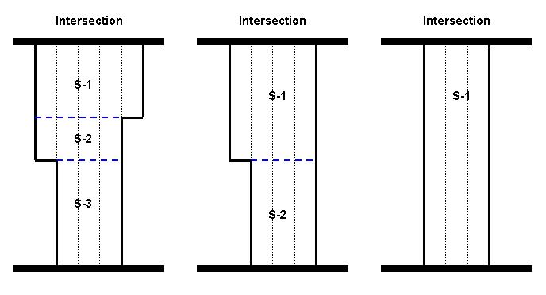
Figure 4-6. Typical links with 1, 2, and 3 segments.

Fields - Lane Data Tab (Dispersion)
Field: Link Directions
Description | Link Directions.
Data Set | Lane Data
Default Value | 1 1 1 1 0 0 0 0 for links 1-8 respectively
Sample | 1
Unit | None
Comments | Always appears as pre-filled data in the entry form.

Field: Number of Segments Per Link
Description | Number of segments per link.
Data Set | Lane Data
Default Value | Always appears as pre-filled data in the entry form, calculated directly from the traffic file. The value for link nos. 1-4 is determined by the formula below, while the value for link nos. 5-8 is always 1.
Sample | 2
Unit | None
Comments | N = Number of segments per approach  R = Length of right turn pocket (from traffic's Link Characteristics tab)  L = Length of left turn pocket (from traffic's Link Characteristics tab)  If R=L=0 Then N = 1  Else If R=L>0 Then N=2  Else If R>0 and L=0 Then N=2  Else If R=0 and L>0 Then N=2  Else N=3

Field: Segment Ends-X
Description | Segment Ends-X.
Data Set | Lane Data
Default Value | None
Sample | 76.0
Unit | Meters
Comments | None

Field: Segment Ends-Y
Description | Segment Ends-Y.
Data Set | Lane Data
Default Value | None
Sample | 10000
Unit | Meters
Comments | None

Field: Segment Ends-Z
Description | Segment Ends-Z.
Data Set | Lane Data
Default Value | 10000
Sample | 10000
Unit | Meters
Comments | None

Field: Number of Lanes-A
Description | Number of lanes in segment A.
Data Set | Lane Data
Default Value | Always appears as pre-filled data in the entry form, calculated directly from the Traffic file.
Sample | 5
Unit | None
Comments | None

Field: Number of Lanes-B
Description | Number of Lanes in segment B.
Data Set | Lane Data
Default Value | Always appears as pre-filled data in the entry form, calculated directly from the Traffic file.
Sample | 4
Unit | None
Comments | None

Field: Number of Lanes-C
Description | Number of lanes in segment C.
Data Set | Lane Data
Default Value | Always appears as pre-filled data in the entry form, calculated directly from the Traffic file.
Sample | 4
Unit | None
Comments | None

Field: Median Width-A
Description | Median width in segment A.
Data Set | Lane Data
Default Value | 10
Sample | 10
Unit | Feet
Comments | Always appears as pre-filled data in the entry form.

Field: Median Width-B
Description | Median width in segment B.
Data Set | Lane Data
Default Value | 10
Sample | 10
Unit | Feet
Comments | Always appears as pre-filled data in the entry form.

Field: Median Width-C
Description | Median Width in segment C.
Data Set | Lane Data
Default Value | 10
Sample | 10
Unit | Feet
Comments | Always appears as pre-filled data in the entry form.

Field: Segment Coordinates-A1
Description | Segment Coordinates-A1. These are the coordinates at which the centerline of median intersects limit line with respect to the center of intersection.
Data Set | Lane Data
Default Value | None
Sample | -14.0
Unit | Feet
Comments | None

Field: Segment Coordinates-A2
Description | Segment Coordinates-A2. These are the coordinates at which the centerline of median intersects limit line with respect to the center of intersection.
Data Set | Lane Data
Default Value | None
Sample | -14.0
Unit | Feet
Comments | None

Field: Segment Coordinates-B1
Description | Segment Coordinates-B1. These are the coordinates at which the centerline of median intersects limit line with respect to the center of intersection.
Data Set | Lane Data
Default Value | None
Sample | -14.0
Unit | Feet
Comments | None

Field: Segment Coordinates-B2
Description | Segment Coordinates-B2. These are the coordinates at which the centerline of median intersects limit line with respect to the center of intersection.
Data Set | Lane Data
Default Value | None
Sample | -14.0
Unit | Feet
Comments | None

Field: Segment Coordinates-C1
Description | Segment Coordinates-C1. These are the coordinates at which the centerline of median intersects limit line with respect to the center of intersection.
Data Set | Lane Data
Default Value | None
Sample | -14.0
Unit | Feet
Comments | None

Field: Segment Coordinates-C2
Description | Segment Coordinates-C2. These are the coordinates at which the centerline of median intersects limit line with respect to the center of intersection.
Data Set | Lane Data
Default Value | None
Sample | -14.0
Unit | Feet
Comments | None

Field: Segment X Offset
Description | Segment X Offset.
Data Set | Lane Data
Default Value | -10.0 0.0 10.0 0.0 10.0 0.0 -10.0 0.0
Sample | -10.0
Unit | Feet
Comments | The above values are for links 1-8 respectively.

Field: Segment Y Offset
Description | Segment Y Offset.
Data Set | Lane Data
Default Value | 0.0 10.0 0.0 -10.0 0.0 -10.0 0.0 10.0
Sample | -10.0
Unit | Feet
Comments | The above values are for links 1-8 respectively.

Field: Phase Times
Description | Phase Times.
Data Set | Lane Data
Default Value | None
Sample | 28
Unit | Seconds
Comments | These values should be the same as described in the traffic file. The value must be in the same order as in traffic module, and should represent the total signal time (red+green+yellow) for each phase.

Functions - Lane Data Tab (Dispersion)
Get From File:
This button is disabled for the Lane Data tab.
Write To File:
This button is disabled for the Lane Data tab.
Run:
This button is disabled for the Lane Data tab.
Graphics:
This button is disabled for the Lane Data tab.
New:
This button is disabled for the Lane Data tab.
Save:
Clicking on the Save button saves all the updates made to the form. If the user moves to different tab after making some updates and not clicking on the Save button, a message is prompted, asking the user whether the Save function needs to be invoked or not.
Save As:
This button is disabled for the Lane Data tab.
Delete:
This button is disabled for the Lane Data tab.
Help:
Clicking on the Help button opens up the Overview of Lane/Signal Data tab help directly from the Help file.
Close:
Clicking on the Close button closes the dispersion module.

Receptor Data Tab (DISPERSION)
The Receptor Data tab is used for entering the location and height of receptors. The receptors can be placed on or around the intersection to measure emission concentration. The model displays a warning message if a receptor is placed on the roadway. The placement of receptors can also be viewed graphically by clicking on the graphics button on the Receptor Data tab. However, it only shows which quadrant into which the receptor falls.

Fields - Receptor Data Tab (Dispersion)
Field: Receptor Name
Description | Receptor Name.
Data Set | Receptor Data
Default Value | None
Sample | N0W90
Unit | None
Comments | None

Field: X
Description | X coordinate of the receptor location.
Data Set | Receptor Data
Default Value | None
Sample | -107.6
Unit | Meters
Comments | None

Field: Y
Description | Y coordinate of the receptor location.
Data Set | Receptor Data
Default Value | None
Sample | 26.8
Unit | Meters
Comments | None

Field: Z
Description | Z coordinate of the receptor location.
Data Set | Receptor Data
Default Value | 1.8
Sample | 1.5
Unit | Meters
Comments | Fixed at 1.8

Functions - Receptor Data Tab (Dispersion)
Get From File:
This button is disabled for the Receptor Data tab.
Write To File:
This button is disabled for the Receptor Data tab.
Run:
This button is disabled for the Receptor Data tab.
Graphics:
This button provides you with the option to graphically view the location of each receptor.
New:
This button is disabled for the Receptor Data tab.
Save:
Clicking on the Save button saves all the updates made to the form. If the user moves to different tab after making some updates and not clicking on the Save button, a message is prompted, asking the user whether the Save function needs to be invoked or not.
Save As:
This button is disabled for the Receptor Data tab.
Delete:
This button is disabled for the Receptor Data tab.
Help:
Clicking on the Help button opens up the Overview of Receptor Data tab help directly from the Help file.
Close:
Clicking on the Close button closes the dispersion module.

DISPERSION MODULE INPUTS
The emission and dispersion modules of HYROAD are integrated and are run together. They allow several useful program input options that are specified in the user input file. In particular, the user input file is where the model input parameters are specified and where detailed intersection geometry and flow are set. There are several other inputs that are supplied to the dispersion module through the emission model and through the read of the binary output from the traffic module.
Figure 4-7 shows an example of the dispersion module inputs. The filenames and parameters specified in the user input file are:
Input files: (1) emission factor file, (2) traffic module output file
Modeling parameters: receptor data, deposition data, link definition, information, meteorological data
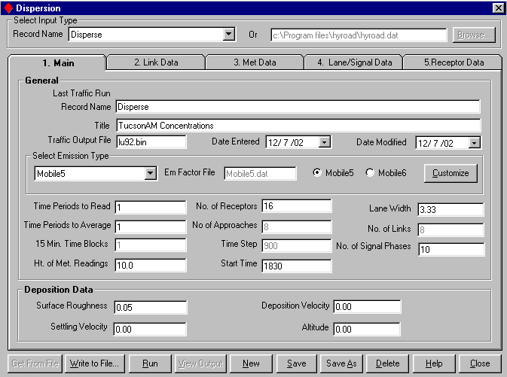
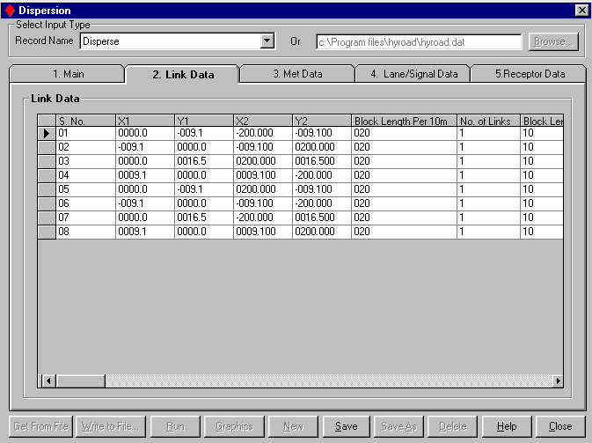
Figure 4-7. Sample dispersion module inputs.
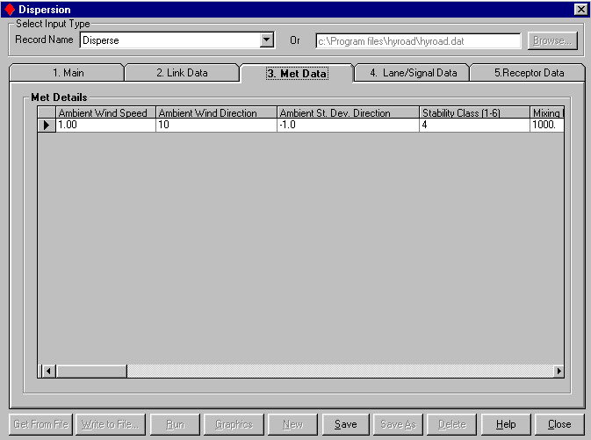
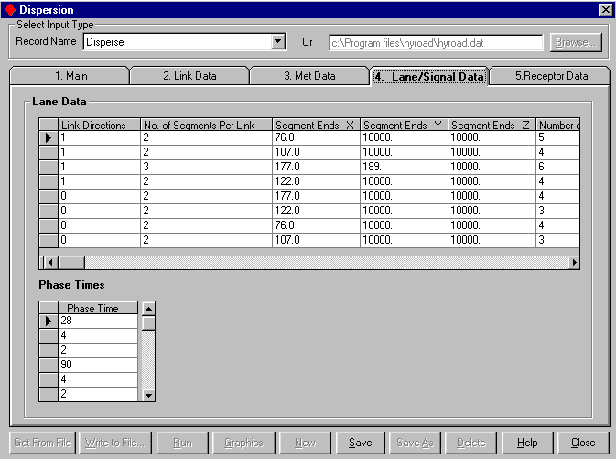
Figure 4-7. Continued.
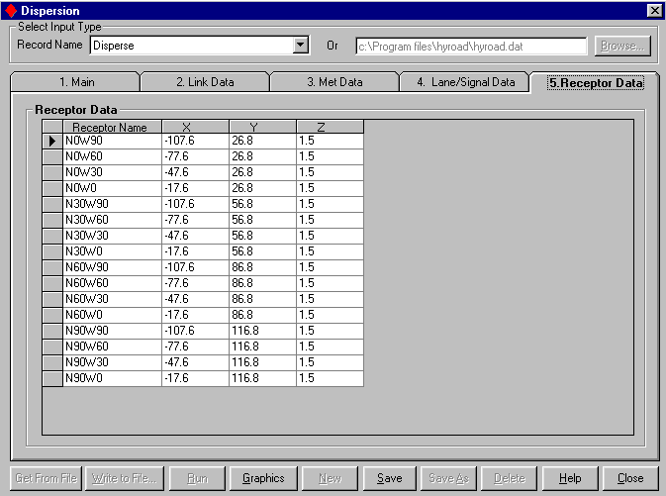
Figure 4-7. Concluded.
The default values shown in Table 4-6 should be used when site-specific data are unavailable.
Table 4-6. Default values for selected modeling parameters.
Variable | Default value
Mixing Width (m) | # lanes * 3.66 m/lane + 6 meters
Surface Roughness (m) | 0.01 meters
Settling Velocity (m/s) | 0.0 meters/second
Deposition Velocity (m/s) | 0.0 meters/second
Standard Deviation in Wind Direction (deg) | (0.25 (m/s) / ws (m/s)) * 57.296¹
Mixing Height (m) | 1000 meters
Ambient Concentration (ppm) | 0.0 ppm
¹ This formulation is based on general forms of stability classification schemes and sigma curves as described by Hanna et al., 1977. The 0.25 m/s represents the typical minimum value seen in the standard deviation of the horizontal crosswind component of the wind. If values is missing or set to a negative number the model automatically uses this formulation to determine the standard deviation in wind direction.

Table 4-7 is intended to help the user assign proper and realistic values to the input variables used by the model.
Table 4-7. Typical values and ranges of input variables.
Variable | Size Range | Comments
Surface Roughness (m) | Typical range, 0.01 to 0.50 meters | Typical Values:  Central Business District: 0.321 m  Suburban: 0.108 m  Rural Sites  Forest: 0.283 m  Wheat: 0.022 m  Corn: 0.074 m  Long Grass (60-70 cm): 0.011 m  Short Grass (5-6 cm): 0.0075 m  Bare Earth: 0.0003 m
Length of Block (m) | Fixed @10-m | User must use 10-m “block” lengths. Where “block” is the length of roadway resolved by the traffic/emission module.
Height of meteorological readings (m) | Typically varies from 2 to 33-m above ground level. | Height above ground level at which wind observations were measured.
Stability Class | 1 (A) to 6 (F) | Classification scheme for defining atmospheric stability (Pasquill, 1974).
Mixing Height (m) | 10 to 5000 m | Generally, unimportant unless extremely low mixing heights are used (< 20 m).
Number of segments per approach | Typically varies from, 1 to 3 | Number of times each approach changes it’s total width. 1 indicates no change
Width of median (m) | Typically varies from 0 to 10-m | Change in width of median as referenced from roadside curb to the stop limit line location for each road segment
Segment Coordinates (m) |  | The coordinates at which the centerline of median intersects stop limit line relative to the center of the intersection
Signal Phase Times (s) | Typically, 4 to 60 | Duration of each signal phase. Must be in same order as input to NETSIM.

DISPERSION MODULE OUTPUTS
The output contains a full summary of all pertinent input values, descriptive titles for the job, data used, links and receptor locations and simulated concentrations. Exhibit 4-1 contains an example output listing from the dispersion model. The user has the option of averaging the data for periods as short as 15-minutes or averaging over any multiple of 15-minutes.
Exhibit 4-1. Sample HYROAD output file.
HYROAD Version 1.10 Feb 2002 for MOBILE5 or 6
Concentrations provided using puff module only
Tucson - MOBILE6 test

FILES
Traffic file:
lu92.d

Emission factor model:
MOBILE6

Emission factor file:
tucm6.dat

Number of time steps: 1
Number of time steps for average: 1
RECEPTOR DATA
Number of receptors: 16
N0W90
-107.6000 26.80000 1.500000
N0W60
-77.60000 26.80000 1.500000
N0W30
-47.60000 26.80000 1.500000
N0W0
-17.60000 26.80000 1.500000
N30W90
-107.6000 56.80000 1.500000
N30W60
-77.60000 56.80000 1.500000
N30W30
-47.60000 56.80000 1.500000
N30W0
-17.60000 56.80000 1.500000
N60W90
-107.6000 86.80000 1.500000
N60W60
-77.60000 86.80000 1.500000
N60W30
-47.60000 86.80000 1.500000
N60W0
-17.60000 86.80000 1.500000
N90W90
-107.6000 116.8000 1.500000
N90W60
-77.60000 116.8000 1.500000
N90W30
-47.60000 116.8000 1.500000
N90W0
-17.60000 116.8000 1.500000
DEPOSITION DATA
Surface roughness: 0.5000000
Settling velocity: 0.0000000E+00
Deposition velocity: 0.0000000E+00
LINK DEFINITION
Wind speed cutoffs: 1.000000 1.500000 0.3000000
Min wind speed reset to 0.3 m/s. Counting . . .
Diffusion flags: T T
Number of time periods: 1
Start time: 0
Number of links: 8
1 0.0000000E+00 -9.100000 -200.0000 -9.100000
20 1 10 0.0000000E+00 20.60000 0
2 -9.100000 0.0000000E+00 -9.100000 200.0000
20 1 10 0.0000000E+00 20.60000 0
3 0.0000000E+00 16.50000 200.0000 16.50000
20 1 10 0.0000000E+00 20.60000 0
4 9.100000 0.0000000E+00 9.100000 -200.0000
20 1 10 0.0000000E+00 17.00000 0
5 0.0000000E+00 -9.100000 200.0000 -9.100000
20 1 10 0.0000000E+00 20.60000 0
6 -9.100000 0.0000000E+00 -9.100000 -200.0000
20 1 10 0.0000000E+00 17.00000 0
7 0.0000000E+00 16.50000 -200.0000 16.50000
20 1 10 0.0000000E+00 20.60000 0
8 9.100000 0.0000000E+00 9.100000 200.0000
20 1 10 0.0000000E+00 17.00000 0
MET DATA
Wind speeds: 1.000000
*** Min windspeed invoked 0times !
Wind directions: 180.0000
Sigma WD: 14.32500
Stability classs: 4
Mixing height: 1000.000
Ambient conc.: 0.0000000E+00
Temperatures: 5.000000
LANE DATA
Lane width: 3.658000
Number of approaches: 8
Approach directions: T T T T F F F F
Segments / Approach: 2 2 3 2
2 2 2 2
Segment # 1
Segment end points: 76.00000 10000.00 10000.00
Segment # 2
Segment end points: 107.0000 10000.00 10000.00
Segment # 3
Segment end points: 177.0000 189.0000 10000.00
Segment # 4
Segment end points: 122.0000 10000.00 10000.00
Segment # 5
Segment end points: 177.0000 10000.00 10000.00
Segment # 6
Segment end points: 122.0000 10000.00 10000.00
Segment # 7
Segment end points: 76.00000 10000.00 10000.00
Segment # 8
Segment end points: 107.0000 10000.00 10000.00
Segment # 1
Lanes / Segment: 5 4 4
Segment # 2
Lanes / Segment: 4 3 3
Segment # 3
Lanes / Segment: 6 4 3
Segment # 4
Lanes / Segment: 4 3 3
Segment # 5
Lanes / Segment: 4 4 4
Segment # 6
Lanes / Segment: 3 3 3
Segment # 7
Lanes / Segment: 4 3 3
Segment # 8
Lanes / Segment: 3 3 3
Segment # 1
Median widths: 7.300000 11.00000 11.00000
Segment # 2
Median widths: 3.700000 7.300000 7.300000
Segment # 3
Median widths: 3.700000 11.00000 11.00000
Segment # 4
Median widths: 3.700000 7.300000 7.300000
Segment # 5
Median widths: 3.700000 11.00000 11.00000
Segment # 6
Median widths: 3.700000 6.400000 6.400000
Segment # 7
Median widths: 3.700000 9.400000 9.400000
Segment # 8
Median widths: 3.700000 7.000000 7.000000
Segment # 1
Coor.: 0.0000000E+00 5.500000 0.0000000E+00 3.800000
0.0000000E+00 3.800000
Segment # 2
Coor.: 1.700000 0.0000000E+00 0.0000000E+00 0.0000000E+00
0.0000000E+00 0.0000000E+00
Segment # 3
Coor.: 0.0000000E+00 0.0000000E+00 0.0000000E+00 3.800000
0.0000000E+00 3.800000
Segment # 4
Coor.: -1.700000 0.0000000E+00 0.0000000E+00 0.0000000E+00
0.0000000E+00 0.0000000E+00
Segment # 5
Coor.: 0.0000000E+00 0.0000000E+00 0.0000000E+00 3.800000
0.0000000E+00 3.800000
Segment # 6
Coor.: -1.700000 0.0000000E+00 0.0000000E+00 0.0000000E+00
0.0000000E+00 0.0000000E+00
Segment # 7
Coor.: 0.0000000E+00 5.500000 0.0000000E+00 3.800000
0.0000000E+00 3.800000
Segment # 8
Coor.: 1.700000 0.0000000E+00 0.0000000E+00 0.0000000E+00
0.0000000E+00 0.0000000E+00
X offsets: -10.00000 0.0000000E+00 10.00000 0.0000000E+00
10.00000 0.0000000E+00 -10.00000 0.0000000E+00
Y offsets: 0.0000000E+00 10.00000 0.0000000E+00 -10.00000
0.0000000E+00 -10.00000 0.0000000E+00 10.00000
Number of phases: 4
Phase times: 34.00000 16.00000 28.00000 12.00000
Time step: 900.0000
0.00 0.00 0.00 0.00 0.00 14.50 3.12
ss = 1.2306534E+07
0.00 0.00 0.00 0.00 10.82 0.00 3.84
ss = 1.1456646E+07
0.00 0.00 2.74 0.00 9.35 0.00 4.34
ss = 1.1418836E+07
0.00 5.20 0.00 0.00 8.43 0.00 4.85
ss = 1.1011851E+07
0.00 0.00 0.00 0.00 0.00 4.42 1.16
ss = 1198800.
0.00 0.00 0.00 0.00 3.45 0.00 1.31
ss = 1085313.
0.00 1.10 0.00 0.00 2.94 0.00 1.52
ss = 1065511.
0.00 0.00 0.00 0.00 0.00 9.64 3.81
ss = 8213271.
0.00 0.00 0.00 0.00 8.15 0.00 3.88
ss = 7336621.
0.00 0.88 0.00 0.00 7.74 0.00 4.05
ss = 7323782.
0.00 0.00 0.00 0.00 0.00 2.21 1.61
ss = 660772.1
0.00 0.00 0.00 0.00 2.15 0.00 1.50
ss = 575947.8
For time period 1
N0W90 0.2156260 ppm
N0W60 0.5208874 ppm
N0W30 1.659035 ppm
N0W0 3.666216 ppm
N30W90 0.2887121 ppm
N30W60 0.7247229 ppm
N30W30 2.085010 ppm
N30W0 4.239869 ppm
N60W90 0.3749074 ppm
N60W60 0.8998858 ppm
N60W30 2.237442 ppm
N60W0 4.079793 ppm
N90W90 0.4611594 ppm
N90W60 1.007512 ppm
N90W30 2.045970 ppm
N90W0 3.277148 ppm

Graphical DISPLAYS

Entry (Traffic module)
Clicking on the Graphics button on the Link Names, Link Characteristics, and Turning Movements tab displays the graphical entry form. This form can be used as an alternative to tabular entry on the form, or to view the information graphically after entering it in the data tables on the data entry tabs.
The figure below shows how the image looks when the intersection is not defined:
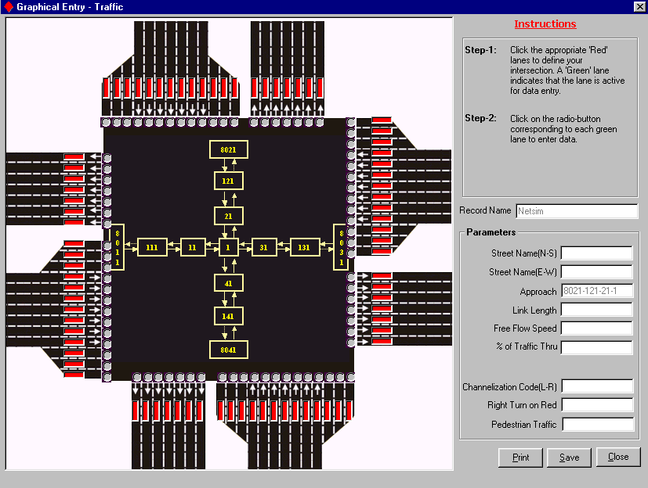
Figure 4-8. Graphical entry – traffic with a non-defined intersection.
In order to define the intersection, the “Red” bars on the links needed to be made active should be clicked. This changes the color of the bar to “Green,” and enables the radio-button in front of the active link for data entry. Figure 4-9 shows a sample image of a defined intersection for a right turn (in the upper right-hand corner) after selecting active lanes on each link.
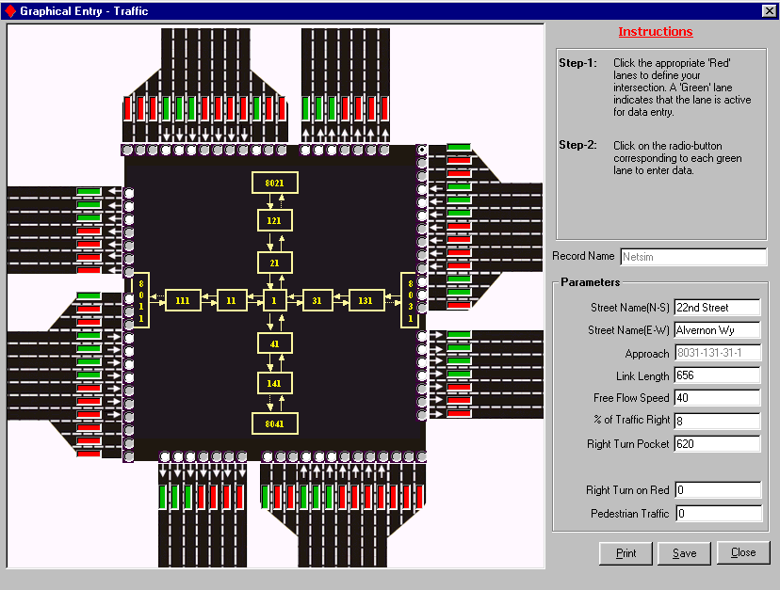
Figure 4-9. Graphical entry – traffic with defined intersection.
Lane-level attributes can be added for each of the links by clicking on the radio-button of the desired lane, and filling out the fields on the right side of the form. The required fields for the two lane types are listed below:
Turning Lanes | Through Lanes (Approach)
Street Name (N-S) | Street Name (N-S)
Street Name (E-W) | Street Name (E-W)
Approach Links (Pre-Filled) | Approach Links (Pre-Filled)
Link Length | Link Length
Free flow Speed | Free flow Speed
Percentage of Traffic Right (or Left) | Percentage of Traffic Through
Length of Right (or Left) Turn Pocket | Channelization Code
Right Turn on Red | Right Turn on Red
Pedestrian Traffic | Pedestrian Traffic

Graphical View (Dispersion)
Clicking on the Graphics button on the Receptor Data tab displays the graphical view form. This form can be used to view the receptor location quadrant graphically after entering them in the data tables on the data entry tabs.
The figure below (Figure 4-10) shows sample receptor locations. Note that any receptor(s) falling on the roadway are shown in red.
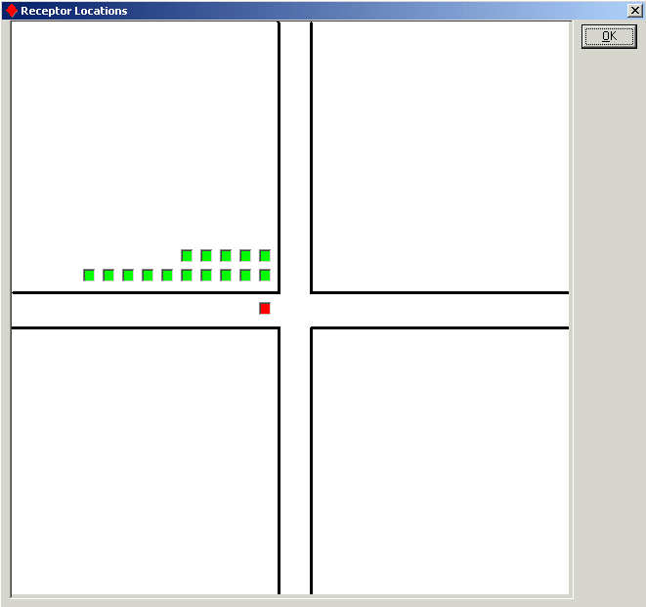
Figure 4-10. Graphical Entry – Receptor Locations.

4.7 Special Functions

EMISSION FACTORS

Main Tab (Emission)
The Main tab in Emission is used for creating and updating custom MOBILE5 or MOBILE6 emission factors. This tab can be accessed by clicking on the Customize button on the Main tab of the dispersion module. This tab need not be accessed if MOBILE5 or MOBILE6 national default emission factors are used.
Typically, the user accesses the emission module for one of the following reasons:
1) Updating an Existing Emission Scenario:
This can be done by selecting a previously entered Emission scenario from the Record Name scroll-box, making the desired modification on each of the tabs, and clicking on the Save button.
2) Saving an Existing Emission Scenario as a New Scenario:
This can be done by selecting a previously-entered Emission scenario (say M5Custom) from the Record Name scroll-box, clicking on the Save As button, giving it a new Record Name (say Emission-2), and clicking the Save button. This essentially creates a copy of Emission-1 as a new scenario, Emission-2, which can always be modified without effecting the original Emission scenario, Emission-1.
3) Entering a New Scenario to the Database:
This can be done by:
Clicking on the New button, entering a new record name (say M5Custom) and other required information, and clicking on the Save button to save the new scenario. The user can then go to all the tabs, enter new information into the form, and hence, save a completely new Emission scenario.
Clicking on the New button, entering a new record name (say M5Custom), clicking on the Browse button to select a previously-created input file, clicking on the Get from File button once the input file is selected, and finally clicking on the Save button to save the values from the input file into the database.

Fields - Main Tab (Emission)

Field: Record Name
Description | A unique name used to save and identify the Emission scenario in the database.
Default Value | None
Sample | M5Custom
Unit | Not applicable
Comments | None

Field: Input File
Description | Name of the Emission Factors file, which is used for the given record.
Default Value | None
Sample | M5Custom.dat
Unit | Not applicable
Comments | The name of input file should always have a .dat extension. The HYROAD model contains MOBILE5 and MOBILE6 record names, containing MOBILE5.dat and MOBILE6.dat files with national default emission factors as part of the installation.

Field: Total Temperatures
Description | Total temperatures for which emission factors are listed in the Emission Rates tab.
Default Value | None
Sample | 10
Unit | None
Comments | None

Field: Date Entered
Description | Date of record entry.
Default Value | None
Sample | 12/ 7 /02
Unit | Not applicable
Comments | None

Field: Type
Description | Emission model type (MOBILE5 or MOBILE6).
Default Value | MOBILE5
Sample | MOBILE5
Unit | None
Comments | This should correspond to the emission model type being used.

Functions - Main Tab (Emission)
Get From File:
Clicking on the Get From File button pulls the data from the input file, the location of which is specified in the top right-hand corner of the screen. This function populates the form with all the fields from the specified file in their respective positions. If the specified input file uses a different intersection link naming convention, or if it uses entries different from the required format, an error log is displayed.
View Output:
The View Output button shows the emission factor (.dat) file in plain text format.
New:
Clicking on the New button clears all the form fields and provides the option to enter and Save a new Record Name (scenario). After creating a new record, the user can either start entering the values directly on the form, or can click the Browse button to specify a pre-created input file, followed by clicking the Get From File button.
Save:
Clicking on the Save button saves all the updates made to the form. If the user moves to different tab after making some updates and not clicking on the Save button, a message is prompted, asking the user whether the Save function needs to be invoked or not.
Save As:
Clicking on the Save As button copies the existing scenario/database record as a new record.
Delete:
Clicking on the Delete button deletes the existing scenario/database record from the database.
Help:
Clicking on the Help button opens up the Overview of Main tab help directly from the Help file.
Close:
Clicking on the Close button closes the emission module.

Rates Tab (Emission)
The Emission Rates tab displays the emission factors for the given number of temperatures. This form can be used to enter custom emission factors when national defaults are not used.
The following emission rates are input differently for speeds in MOBILE5 versus MOBILE6 as shown in Table 4-8. The AM and PM periods are assumed different because of change in hot and cold-start percentages between the AM and PM periods.
Table 4-8. Speed bins for MOBILE5 and MOBILE6 emission factors.
MOBILE5 | MOBILE6
Temperature | Temperature
Idling (AM) | Idling (AM)
3.4 MPH (AM) | 3.4 MPH (AM)
7.1 MPH (AM) | 7.1 MPH (AM)
12.1 MPH (AM) | 11.6 MPH (AM)
19.5 MPH (AM) | 19.2 MPH (AM)
35.9 MPH (AM) | 24.8 MPH (AM)
48.3 MPH (AM) | 30.5 MPH (AM)
Idling (PM) | 52.9 MPH (AM)
3.4 MPH (PM) | Idling (PM)
7.1 MPH (PM) | 3.4 MPH (PM)
12.1 MPH (PM) | 7.1 MPH (PM)
19.5 MPH (PM) | 11.6 MPH (PM)
35.9 MPH (PM) | 19.2 MPH (PM)
48.3 MPH (PM) | 24.8 MPH (PM)
 | 30.5 MPH (PM)
 | 52.9 MPH (PM)

Functions - Rates Tab (Emission)
Get From File:
This button is disabled for the Rates tab.
View Output:
The View Output button shows the emission factor (.dat) file in plain text format.
New:
This button is disabled for the Rates tab.
Save:
This button is disabled for the Rates tab.
Save As:
This button is disabled for the Rates tab.
Delete:
This button is disabled for the Rates tab.
Help:
Clicking on the Help button opens up the Overview of Rates tab help directly from the Help file.
Close:
Clicking on the Close button closes the emission module.

Emission Model Input Requirements
The user is required to provide MOBILE5a composite emission factors for CO in grams per mile for six specific speeds (or for MOBILE6 for seven specific speeds), and an idle emission rate in grams per second, over a range of ambient temperatures. These emission factors will reflect the effects of all variables treated in MOBILE5a or MOBILE6, including: vehicle type, age, model year and mileage accumulation rates; cold-start and hot-start fractions; fuel quality; and inspection/maintenance program effects.
Users should develop inputs for MOBILE5a or MOBILE6 that best represent the vehicle fleet at the intersection of interest, following standard guidance and assumptions. Temperatures should be selected that span the range of conditions for which the model will be applied (emission factors for each time period are interpolated from emission factor inputs to the time period’s temperature). The fractions of cold start, hot start and hot stabilized driving is a key input to MOBILE that may vary widely within an urban area, and for specific locations, by time of day. While default values can be used per EPA guidance, it is likely that the fraction of vehicles in cold-start conditions (i.e., during the first 505 seconds of operation) at a heavily congested intersection is small. Survey data or traffic engineering estimates may provide better estimates of this input.
The six average speeds for which emission factors are required for MOBILE5 are: 3.4 mph; 7.1 mph; 12.1 mph; 19.5 mph; 35.9 mph; and 48.3 mph and the seven speeds for MOBILE6 are: 3.4 mph; 7.1 mph; 11.6 mph; 19.2 mph; 24.8 mph, 30.5 mph; and 52.9 mph. These speeds are the average speeds of driving cycles that were used in the development of MOBILE5a or MOBILE6 speed correction factors. An idle emission rate is also required. HYROAD is designed to accept emission factor inputs for two general time periods, AM and PM, each of which can have its own cold-start fractions (and possibly, fleet mix). Figure 4-11 shows an example of the emission module inputs.

Vehicle Activity Inputs
The traffic module provides all vehicle activity inputs to the emission module. The traffic module accumulates vehicle activity data in each 10-meter block for each signal phase during the current time period. This accumulated vehicle activity data consists of vehicle-seconds of operation that occur within a block in each of the speed-acceleration bins defined in the traffic module. These arrays can be quite large, and to reduce the running time for the HYROAD model, the emission module extracts all of the information required for both emission calculations, and for dispersion (i.e., calculating traffic volume and average speed along intersection legs for use in estimating vehicle-induced flows and turbulence).
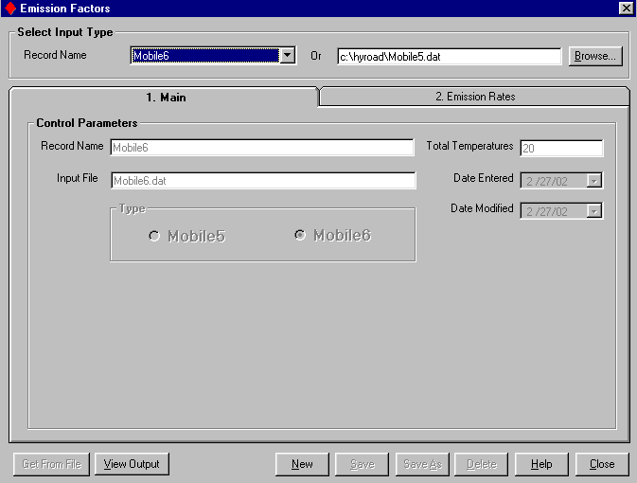
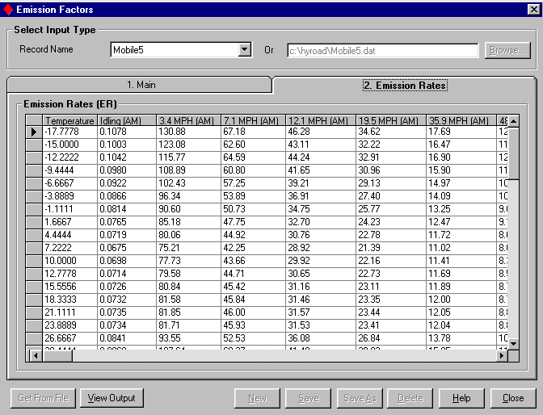
Figure 4-11. Sample emission module inputs.

Emission module output
The primary output provided by the emission module to the dispersion module is the gram per second CO emission rate for each block and phase for the current time period. In addition, during the emission calculation steps in which the speed and acceleration distributions for each block are processed, traffic volumes (vehicles per second) and average speeds for each 10-meter segment of road (summed across lanes) are calculated for use by the portion of the dispersion module that calculates vehicle-induced flows and turbulence.

Multiple Hour Simulations
The Multiple Hour Simulation window can be accessed through the Special Functions menu. This window provides the option to run Multiple Hour Simulation by selecting a Traffic scenario, and multiple Dispersion scenarios from the database. The output files are saved in the folder selected directly from the screen by the user. The simulation start time and the Dispersion scenario run are also displayed on the screen at all times.

Screening Analysis
The Screening Analysis window can be accessed through the Special Functions menu. This window provides the option to run Screening Analysis by selecting a Traffic and a Dispersion scenario from the database. The model automatically runs the selected Dispersion scenario 36 times, increasing the wind direction by 10 degrees for each run. The starting wind direction is set to 0 degrees, so the wind direction for the last run in the simulation is always 350 degrees. The output files are saved in the folder selected directly from the screen by the user. The simulation start time and current wind direction under run are also displayed on the screen at all times. At the end of the simulation, the model calculates the highest concentration, and displays it along with the critical wind direction on the screen.

Traffic Output Management
The Traffic Output Management window can be accessed through the Special Functions menu. This feature can be used for converting the Traffic output (LU92) into a .bin file (LU92.BIN). This procedure automatically takes place at the end of a Traffic run, so the LU92.BIN from the last Traffic run is always present in the HYROAD Program folder. This interface can also be used to save the LU92.BIN file at a different location.

Options
The Options window can be accessed through the Special Functions menu. The following options can be set globally for the HYROAD model:
Display of Getting Started window at the start of the program, and
Display of simulation processing during runtime.
By default, the Getting Started window is set to appear at the start of the program, and the simulation processing is set to display during runtime.

