- LEVELS OF ANALYSIS AND EXAMPLES
The following two examples demonstrate an example of a worst-case screening analysis and a more refined analysis using the HYROAD model. For each example, the input and output files are given. Both examples use the Hampden and University, Denver intersection for the modeling. The reader is referred to Chapter 6 of the model formulation document for a further description of the intersection.

5.1 Worst-Case Screening Analysis
HYROAD was developed with the idea that simulation modeling of a roadway intersection would be based on plausible meteorological conditions. As such the worst-case analysis differs slightly from current guidance for modeling CO roadway intersections (EPA, 1992). However, in general the same approach is used. Receptors are placed about the intersection at a constant distance of 3-m from the intersection every 5-m at a height of 1.8-m. Figure 5-1 shows the placement of twenty receptor sites about the intersection.
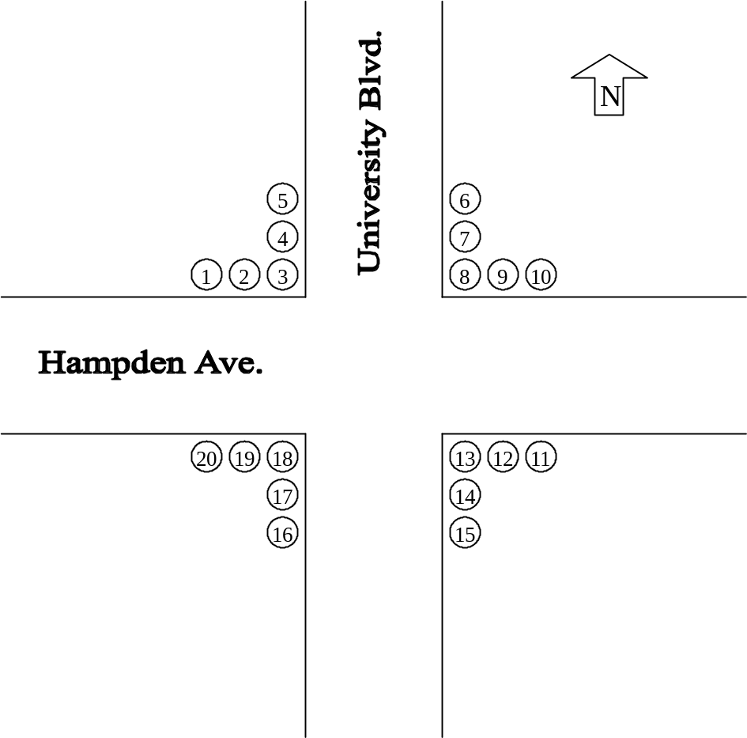
Figure 5-1. Worst-case analysis – receptor layout and identifying number.
Meteorological inputs for the screening analysis are recommended as follows:
- Temperature – Mean January minimum temperature (e.g., 19.5° F)
- Height of Meteorological Data – 2.0-m
- Wind Speed – 1.0 m/s
- Wind Direction – Every 10° of wind direction from 0 to 350°
- Stability – F (as model will use urban or rural dispersion curves based on z₀)
- Mixing Height – 1000 m
- Surface Roughness – Site Specific (e.g., 108 cm)
- Altitude – site-specific (e.g., 1524-m)
- No deposition or settling velocity
Traffic inputs for the screening analysis are recommended as follows:
- Site-specific geometry (e.g., number of lanes and width, width of median)
- Link-length – Minimum of 300-m for each leg of the intersection
- Peak hour traffic volume (e.g., AM peak – 0700-0800h)
- Emission Factor – MOBILE using site-specific information (e.g., % cold-start, I/M program, % oxygenate, etc. if available; otherwise national default values)
- Signal Cycle Timing – Intersection specific signal cycle timing
The screening analysis window can be accessed through the Special Functions menu. This window provides the option to run the screening analysis by selecting a Traffic and a Dispersion scenario from the database. In Figure 5-2, for example, the screening analysis is set to run the NETSIM and Dispersion scenarios that were presented as sample record names in Section 4. It is important to note that the model is set to run the screening analysis for only those Dispersion scenarios where the value of 15 Minute Time Blocks (from the Main tab of the Disperse module) is set to 1.

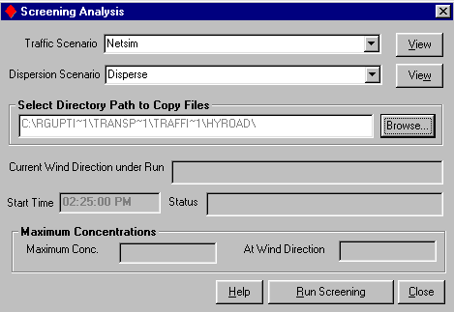
Figure 5-2. Sample screening analysis inputs.
The model automatically runs the selected Dispersion scenario 36 times, increasing the wind direction by 10 degrees for each run. The starting wind direction is set to 0 degrees, so the wind direction for the last run in the simulation is always 350 degrees. The output files are saved in the folder selected directly from the screen by the user. The simulation start time and current wind direction under run are also displayed on the screen at all times. At the end of the simulation, the model calculates the highest concentration, and displays it along with the critical wind direction on the screen.
If the highest concentration is found at one of the end receptors (1,5,6,10,11,15,16 or 20) then additional receptors should be extended every 5-m along the row with the highest concentration to locate the maximum concentration. The identified one-hour maximum represents the highest concentration due to emissions from the intersection. Background concentration should then be added to this concentration per EPA guidance (EPA, 1992).
Exhibit 5-1 presents the output file for the simulation that yielded the maximum concentration. The maximum 1-hour concentration of 16.45 ppm is found for the 260° wind direction at a distance of 80-m from the intersection. The maximum 1-hour concentration should be converted to an 8-hour concentration following current EPA roadway intersection guidance (EPA, 1992). In the absence of historical monitored data a 0.7 persistence factor is recommended. In this example the maximum 8-hour concentration is 16.45 × 0.7 = 11.52 ppm. Since this is above the current 8-hour CO standard a more detailed analysis is warranted and the recommended approach is presented in the next example.
Simulation of this intersection using the current EPA regulatory model CAL3QHC and following the worst-case screening methodology as described in the guidance results in a maximum 1-hour concentration of 53.8 ppm.
Exhibit 5-1. Sample HYROAD output file.
HYROAD Version 1.10 Feb 2002 for MOBILE5 or 6
Concentrations provided using puff module only

FILES
Traffic file:
lu92
Emission factor file:
denef.dat
Number of time steps: 4
Number of time steps for average: 4
RECEPTOR DATA
Number of receptors: 23
#8
15.2000 21.0000 1.80000
#9
20.2000 21.0000 1.80000
#10
25.2000 21.0000 1.80000
#10.1
30.2000 21.0000 1.80000
#10.2
35.2000 21.0000 1.80000
#10.3
40.2000 21.0000 1.80000
#10.4
45.2000 21.0000 1.80000
#10.5
50.2000 21.0000 1.80000
#10.6
55.2000 21.0000 1.80000
#10.7
60.2000 21.0000 1.80000
#10.8
65.2000 21.0000 1.80000
#10.9
70.2000 21.0000 1.80000
#10.10
75.2000 21.0000 1.80000
#10.11
80.2000 21.0000 1.80000
#10.12
85.2000 21.0000 1.80000
#10.13
90.2000 21.0000 1.80000
#10.14
95.2000 21.0000 1.80000
#10.15
100.200 21.0000 1.80000
#10.16
105.200 21.0000 1.80000
#10.17
110.200 21.0000 1.80000
#10.18
115.200 21.0000 1.80000
#10.19
120.200 21.0000 1.80000
#10.20
125.200 21.0000 1.80000
DEPOSITION DATA
Surface roughness: 0.110000
Settling velocity: 0.000000
Deposition velocity: 0.000000
LINK DEFITION
Number of time periods: 4
Start time: 700
Number of links: 8
1 0.000000 9.00000 -930.000 9.00000
93 1 10 0.000000 30.0000 5000
2 7.00000 0.000000 7.00000 930.000
93 1 10 0.000000 30.0000 1345
3 0.000000 -9.00000 930.000 -9.00000
93 1 10 0.000000 30.0000 3323
4 -7.00000 0.000000 -7.00000 -930.000
93 1 10 0.000000 30.0000 4190
5 0.000000 -9.00000 -930.000 -9.00000
93 1 10 0.000000 30.0000 3413
6 7.00000 0.000000 7.00000 -930.000
93 1 10 0.000000 30.0000 2949
7 0.000000 9.00000 930.000 9.00000
93 1 10 0.000000 30.0000 5305
8 -7.00000 0.000000 -7.00000 930.000
93 1 10 0.000000 30.0000 1653
MET DATA
Wind speeds: 1.00000 1.00000 1.00000 1.00000
Wind directions: 260.000 260.000 260.000 260.000
Sigma WD: 14.3250 14.3250 14.3250 14.3250
Stability classs: 6 6 6 6
Mixing height: 1000.00 1000.00 1000.00 1000.00
Ambient conc.: 0.000000 0.000000 0.000000 0.000000
Temperatures: -6.94000 -6.94000 -6.94000 -6.94000
LANE DATA
Lane width: 3.35300
Number of approaches: 8
Approach directions: F F T T T F F T
Segments / Approach: 2 1 2 2
3 3 3 3
Segment # 1
Segment end points: 59.1000 10000.0 10000.0
Segment # 2
Segment end points: 10000.0 10000.0 10000.0
Segment # 3
Segment end points: 278.300 10000.0 10000.0
Segment # 4
Segment end points: 57.9000 10000.0 10000.0
Segment # 5
Segment end points: 138.400 177.100 10000.0
Segment # 6
Segment end points: 114.900 243.800 10000.0
Segment # 7
Segment end points: 14.0000 278.300 10000.0
Segment # 8
Segment end points: 50.9000 67.4000 10000.0
Segment # 1
Lanes / Segment: 4 3 3
Segment # 2
Lanes / Segment: 2 2 2
Segment # 3
Lanes / Segment: 4 3 3
Segment # 4
Lanes / Segment: 3 2 2
Segment # 5
Lanes / Segment: 5 4 3
Segment # 6
Lanes / Segment: 5 4 3
Segment # 7
Lanes / Segment: 6 5 3
Segment # 8
Lanes / Segment: 4 3 2
Segment # 1
Median widths: 0.000000 0.000000 0.000000
Segment # 2
Median widths: 0.000000 0.000000 0.000000
Segment # 3
Median widths: 0.000000 0.000000 0.000000
Segment # 4
Median widths: 0.000000 0.000000 0.000000
Segment # 5
Median widths: 0.000000 0.000000 6.70000
Segment # 6
Median widths: 0.000000 0.000000 6.70000
Segment # 7
Median widths: 0.000000 0.000000 6.70000
Segment # 8
Median widths: 0.000000 0.000000 3.30000
Segment # 1
Coor.: -14.0000 3.30000 -14.0000 3.30000
-14.0000 3.30000
Segment # 2
Coor.: 3.30000 16.0000 3.30000 16.0000
3.30000 16.0000
Segment # 3
Coor.: 14.0000 -3.30000 14.0000 -3.30000
14.0000 -3.30000
Segment # 4
Coor.: -3.30000 -16.0000 -3.30000 -16.0000
-3.30000 -16.0000
Segment # 5
Coor.: -14.0000 3.30000 -14.0000 3.30000
-14.0000 1.65000
Segment # 6
Coor.: -3.30000 -16.0000 -3.30000 -16.0000
3.30000 -16.0000
Segment # 7
Coor.: 14.0000 -3.30000 14.0000 -3.30000
14.0000 -1.65000
Segment # 8
Coor.: -3.30000 16.0000 -3.30000 16.0000
1.65000 16.0000
X offsets: -10.0000 0.000000 10.0000 0.000000
-10.0000 0.000000 10.0000 0.000000
Y offsets: 0.000000 10.0000 0.000000 -10.0000
0.000000 -10.0000 0.000000 10.0000
Number of phases: 6
Phase times: 9.00000 4.00000 41.0000 10.0000
4.00000 32.0000
Time step: 900.000
For time period 1
#8 13.8190 ppm
#9 13.9695 ppm
#10 14.0647 ppm
#10.1 14.1252 ppm
#10.2 14.1632 ppm
#10.3 14.1938 ppm
#10.4 14.2348 ppm
#10.5 14.3029 ppm
#10.6 14.4098 ppm
#10.7 14.5623 ppm
#10.8 14.7615 ppm
#10.9 15.0014 ppm
#10.10 15.2705 ppm
#10.11 15.5525 ppm
#10.12 15.8272 ppm
#10.13 16.0735 ppm
#10.14 16.2702 ppm
#10.15 16.4007 ppm
#10.16 16.4536 ppm
#10.17 16.4256 ppm
#10.18 16.3216 ppm
#10.19 16.1518 ppm
#10.20 15.9304 ppm

5.2 Refined Analysis
In the event that HYROAD simulates a concentration greater than the 1 or 8-hour maximum CO NAAQS, an additional refinement is recommended for the analysis. In this analysis, receptors are still retained at the same location as in the worst-case analysis. To perform the refined analysis, meteorological data (wind speed, direction and temperature, and stability) and hourly traffic volume from the ten highest non-overlapping 8-hour CO monitoring days in the air basin for the past three years should be obtained. These are meteorological and traffic conditions conducive to the formation of high CO concentrations. The HYROAD model should then be used to simulate each of the ten highest days. If the modeled concentration in conjunction with the background concentration does not show concentrations that exceed the CO NAAQS then the intersection passes the refined analysis. If the simulation fails the refined analysis, consideration should be given to the reasonableness of the receptor locations as well as the need for refinement to the determination of the background concentration.
Figure 5-3 shows the meteorological tab input files used in the model simulation for one of the most recent CO exceedance day for Denver (5 January 1995). Exhibit 5-2 is the output file for the corresponding period showing the maximum simulated concentration. The 1-hour maximum in conjunction with the maximum hourly background concentration should be used to compare to the 1-hour CO NAAQS.
To determine if the 8-hour CO NAAQS is exceeded, the hourly CO concentrations simulated and the appropriate hourly background should be added hour-by-hour. For the example Denver intersection, the maximum modeled 8-hour average concentration over the 24-hour period is 10.3 ppm for the period 11 AM to 7 PM. This exceeds the 8-hour CO standard suggesting the need for further refinements in the analysis.
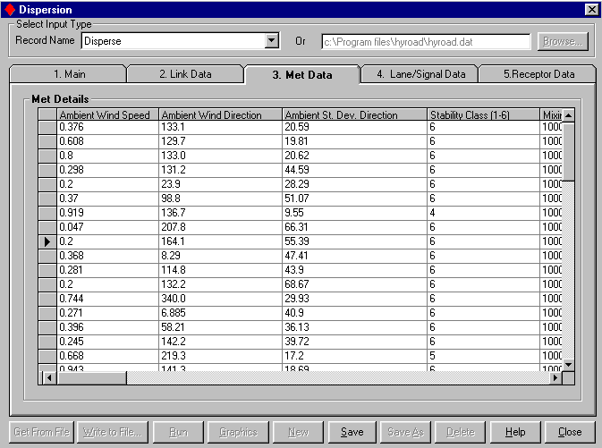
Figure 5-3. Meteorological tab data for Denver, 5 January 1995.

Exhibit 5-2. HYROAD model output for a refined analysis.
HYROAD Version 1.10 Feb 2002 for MOBILE5 or 6
Concentrations provided using puff module only
FILES
Traffic file:
lu92
Emission factor file:
denef.dat
Number of time steps: 48
Number of time steps for average: 4
RECEPTOR DATA
Number of receptors: 20
#1
-24.9000 21.0000 1.80000
#2
-19.9000 21.0000 1.80000
#3
-14.9000 21.0000 1.80000
#4
-14.9000 26.0000 1.80000
#5
-14.9000 31.0000 1.80000
#6
15.2000 31.0000 1.80000
#7
15.2000 26.0000 1.80000
#8
15.2000 21.0000 1.80000
#9
20.2000 21.0000 1.80000
#10
25.2000 21.0000 1.80000
#11
27.6000 -20.1000 1.80000
#12
22.6000 -20.1000 1.80000
#13
17.6000 -20.1000 1.80000
#14
17.6000 -25.1000 1.80000
#15
17.6000 -30.1000 1.80000
#16
-17.6000 -30.1000 1.80000
#17
-17.6000 -25.1000 1.80000
#18
-17.6000 -20.1000 1.80000
#19
-22.6000 -20.1000 1.80000
#20
-27.6000 -20.1000 1.80000
DEPOSITION DATA
Surface roughness: 0.110000
Settling velocity: 0.000000
Deposition velocity: 0.000000
LINK DEFINITION
Number of time periods: 48
Start time: 700
Number of links: 8
1 0.000000 9.00000 -930.000 9.00000
93 1 10 0.000000 30.0000 5000
2 7.00000 0.000000 7.00000 930.000
93 1 10 0.000000 30.0000 1345
3 0.000000 -9.00000 930.000 -9.00000
93 1 10 0.000000 30.0000 3323
4 -7.00000 0.000000 -7.00000 -930.000
93 1 10 0.000000 30.0000 4190
5 0.000000 -9.00000 -930.000 -9.00000
93 1 10 0.000000 30.0000 3413
6 7.00000 0.000000 7.00000 -930.000
93 1 10 0.000000 30.0000 2949
7 0.000000 9.00000 930.000 9.00000
93 1 10 0.000000 30.0000 5305
8 -7.00000 0.000000 -7.00000 930.000
93 1 10 0.000000 30.0000 1653
MET DATA
Wind speeds: 0.376000 0.608000 0.800000 0.298000
0.200000 0.370000 0.919000 0.470000E-01 0.200000
0.368000 0.281000 0.200000 0.744000 0.271000
0.396000 0.245000 0.668000 0.943000 0.480000
0.819000 0.276000 0.386000 0.821000 0.819000
0.200000 0.200000 0.349000 0.360000 0.594000
0.200000 0.583000 0.418000 0.536000 0.747000
0.200000 0.603000 0.200000 0.403000 0.975000
0.200000 0.819000 0.982000 1.18800 1.04100
0.307000 0.635000 1.93800 1.71100
Wind directions: 133.100 129.700 133.000 131.200
23.9000 98.8000 136.700 207.800 164.100
8.29000 114.800 132.200 340.000 6.88500
58.2100 142.200 219.300 141.300 172.000
138.600 281.100 199.700 130.500 129.200
109.700 286.100 57.9000 169.800 183.300
235.600 342.300 26.0100 156.500 224.600
259.100 336.400 68.2700 296.400 324.300
74.6000 190.100 190.900 200.800 218.100
338.800 333.400 323.300 334.500
Sigma WD: 20.5900 19.8100 20.6200 44.5900
28.2900 51.0700 9.55000 66.3100 55.3900
47.4100 43.9000 68.6700 29.9300 40.9000
36.1300 39.7200 17.2000 18.6900 56.1500
24.4800 48.1100 37.4900 10.9600 13.9000
65.5500 69.8600 33.1900 39.9500 28.2700
77.1000 18.6700 25.7900 43.1000 23.5500
63.0600 20.8400 68.6700 38.6300 12.5500
74.4000 22.2400 19.7000 23.7400 26.9900
54.7000 32.4500 14.8600 19.3900
Stability classs: 6 6 6 6 6
6 4 6 6 6 6
6 6 6 6 6 5
6 6 6 6 6 4
5 6 6 6 6 6
6 6 6 1 1 1
2 1 1 3 1 2
2 1 1 1 1 3
2
Mixing height: 1000.00 1000.00 1000.00 1000.00
1000.00 1000.00 1000.00 1000.00 1000.00
1000.00 1000.00 1000.00 1000.00 1000.00
1000.00 1000.00 1000.00 1000.00 1000.00
1000.00 1000.00 1000.00 1000.00 1000.00
1000.00 1000.00 1000.00 1000.00 1000.00
1000.00 1000.00 1000.00 1000.00 1000.00
1000.00 1000.00 1000.00 1000.00 1000.00
1000.00 1000.00 1000.00 1000.00 1000.00
1000.00 1000.00 1000.00 1000.00
Ambient conc.: 0.000000 0.000000 0.000000 0.000000
0.000000 0.000000 0.000000 0.000000 0.000000
0.000000 0.000000 0.000000 0.000000 0.000000
0.000000 0.000000 0.000000 0.000000 0.000000
0.000000 0.000000 0.000000 0.000000 0.000000
0.000000 0.000000 0.000000 0.000000 0.000000
0.000000 0.000000 0.000000 0.000000 0.000000
0.000000 0.000000 0.000000 0.000000 0.000000
0.000000 0.000000 0.000000 0.000000 0.000000
0.000000 0.000000 0.000000 0.000000
Temperatures: -13.7000 -14.0000 -14.3000 -14.0000
-13.8000 -14.2000 -14.3000 -13.6000 -13.3000
-13.0000 -12.5000 -12.5000 -11.6000 -11.2000
-10.9000 -10.7000 -10.9000 -11.6000 -11.7000
-11.4000 -11.5000 -11.3000 -11.9000 -11.6000
-10.8000 -10.5000 -10.0000 -9.00000 -8.70000
-8.40000 -9.20000 -8.60000 -7.70000 -6.60000
-5.90000 -6.10000 -5.50000 -4.30000 -4.60000
-2.50000 -0.400000 1.20000 3.00000 3.70000
4.10000 4.10000 3.60000 3.60000
LANE DATA
Lane width: 3.35300
Number of approaches: 8
Approach directions: F F T T T F F T
Segments / Approach: 2 1 2 2
3 3 3 3
Segment # 1
Segment end points: 59.1000 10000.0 10000.0
Segment # 2
Segment end points: 10000.0 10000.0 10000.0
Segment # 3
Segment end points: 278.300 10000.0 10000.0
Segment # 4
Segment end points: 57.9000 10000.0 10000.0
Segment # 5
Segment end points: 138.400 177.100 10000.0
Segment # 6
Segment end points: 114.900 243.800 10000.0
Segment # 7
Segment end points: 14.0000 278.300 10000.0
Segment # 8
Segment end points: 50.9000 67.4000 10000.0
Segment # 1
Lanes / Segment: 4 3 3
Segment # 2
Lanes / Segment: 2 2 2
Segment # 3
Lanes / Segment: 4 3 3
Segment # 4
Lanes / Segment: 3 2 2
Segment # 5
Lanes / Segment: 5 4 3
Segment # 6
Lanes / Segment: 5 4 3
Segment # 7
Lanes / Segment: 6 5 3
Segment # 8
Lanes / Segment: 4 3 2
Segment # 1
Median widths: 0.000000 0.000000 0.000000
Segment # 2
Median widths: 0.000000 0.000000 0.000000
Segment # 3
Median widths: 0.000000 0.000000 0.000000
Segment # 4
Median widths: 0.000000 0.000000 0.000000
Segment # 5
Median widths: 0.000000 0.000000 6.70000
Segment # 6
Median widths: 0.000000 0.000000 6.70000
Segment # 7
Median widths: 0.000000 0.000000 6.70000
Segment # 8
Median widths: 0.000000 0.000000 3.30000
Segment # 1
Coor.: -14.0000 3.30000 -14.0000 3.30000
-14.0000 3.30000
Segment # 2
Coor.: 3.30000 16.0000 3.30000 16.0000
3.30000 16.0000
Segment # 3
Coor.: 14.0000 -3.30000 14.0000 -3.30000
14.0000 -3.30000
Segment # 4
Coor.: -3.30000 -16.0000 -3.30000 -16.0000
-3.30000 -16.0000
Segment # 5
Coor.: -14.0000 3.30000 -14.0000 3.30000
-14.0000 1.65000
Segment # 6
Coor.: -3.30000 -16.0000 -3.30000 -16.0000
3.30000 -16.0000
Segment # 7
Coor.: 14.0000 -3.30000 14.0000 -3.30000
14.0000 -1.65000
Segment # 8
Coor.: -3.30000 16.0000 -3.30000 16.0000
1.65000 16.0000
X offsets: -10.0000 0.000000 10.0000 0.000000
-10.0000 0.000000 10.0000 0.000000
Y offsets: 0.000000 10.0000 0.000000 -10.0000
0.000000 -10.0000 0.000000 10.0000
Number of pahses: 6
Phase times: 9.00000 4.00000 41.0000 10.0000
4.00000 32.0000
Time step: 900.000
For time period 1
#1 1.66656 ppm
#2 1.55445 ppm
#3 1.50802 ppm
#4 1.62240 ppm
#5 1.73471 ppm
#6 1.24910 ppm
#7 1.35536 ppm
#8 1.44025 ppm
#9 1.31226 ppm
#10 1.17230 ppm
#11 0.180047 ppm
#12 0.187573 ppm
#13 0.186558 ppm
#14 0.972716E-01 ppm
#15 0.516692E-01 ppm
#16 0.406388 ppm
#17 0.446808 ppm
#18 0.475017 ppm
#19 0.480140 ppm
#20 0.464565 ppm

For time period 2
#1 2.69617 ppm
#2 2.85612 ppm
.
.
.
.

For time period 7
#1 14.5131 ppm
#2 14.2671 ppm
#3 13.8993 ppm
#4 12.6284 ppm
#5 11.5462 ppm
#6 9.32155 ppm
#7 10.4799 ppm
#8 11.9381 ppm
#9 11.9008 ppm
#10 11.8649 ppm
#11 12.5164 ppm
#12 12.8554 ppm
#13 13.3066 ppm
#14 11.9429 ppm
#15 10.7543 ppm
#16 16.4504 ppm
#17 16.7691 ppm
#18 16.9317 ppm
#19 16.2298 ppm
#20 15.6718 ppm

For time period 8
#1 19.6597 ppm
#2 20.3272 ppm
#3 20.7820 ppm
#4 20.2130 ppm
#5 19.4225 ppm
#6 21.0122 ppm
#7 20.5612 ppm
#8 20.0876 ppm
#9 19.8833 ppm
#10 20.1199 ppm
#11 14.0723 ppm
#12 13.7820 ppm
#13 13.5045 ppm
#14 13.4765 ppm
#15 13.9259 ppm
#16 12.3300 ppm
#17 12.2251 ppm
#18 12.2083 ppm
#19 11.9347 ppm
#20 11.8070 ppm

For time period 9
#1 9.82992 ppm
#2 10.0500 ppm
#3 10.2577 ppm
#4 9.47389 ppm
.
.
.
.
.

For time period 12
#1 1.10864 ppm
#2 1.40659 ppm
#3 1.73420 ppm
#4 1.13697 ppm
#5 0.975471 ppm
#6 2.80584 ppm
#7 3.18867 ppm
#8 3.66136 ppm
#9 3.45368 ppm
#10 3.11798 ppm
#11 7.97918 ppm
#12 8.25880 ppm
#13 8.35229 ppm
#14 8.55019 ppm
#15 8.14483 ppm
#16 5.06603 ppm
#17 5.35221 ppm
#18 5.56699 ppm
#19 4.87699 ppm
#20 4.55650 ppm

