Joshua Monaghan
c3580928
gYM tRACKER
SENG1110 – Programming Assignment 2
Abstract
Report covering the development of the Gym Membership Management System using object-oriented programming principles. Includes documentation of features implemented, bugs and errors encountered, UML diagrams, IDE screenshots, and handwritten pseudocode from the source code.

Development Log
Date | Time Spent | Activity | Specific Errors Encountered | Debugging & Resolution
18/05/2026 | 1.5h | Refactored the Assignment 1 procedural solution into the new object-oriented structure using GymSystemUI, GymBranch, and Member classes. | Existing methods relied heavily on global variables and did not fit the required OOP structure. | Reorganised variables and methods into separate classes with clearly defined responsibilities.
19/05/2026 | 2h | Implemented the Member class including membership details, add-ons, GST calculations, visit tracking, and cost calculations. | Membership totals calculated incorrectly when multiple add-ons were selected together. | Updated calculateCosts() to correctly combine trainer and locker costs before GST calculation.
20/05/2026 | 2h | Implemented the GymBranch class with member array management, registration functionality, statistics tracking, and member modification/removal systems. | Duplicate member IDs caused registration conflicts and incorrect member storage. | Added isDuplicateMemberId() and generateUniqueMemberId() methods to automatically assign unique IDs.
21/05/2026 | 1.5h | Added support for multiple branches using a GymBranch[] array in GymSystemUI. Implemented branch creation, active branch selection, and active branch display. | Active branch information did not update correctly after switching branches. | Updated activeBranchIndex handling and refreshed active branch display logic.
22/05/2026 | 1h | Implemented configurable membership plans using plans.txt and added validation for invalid or missing plan data. | Program crashed when plans.txt did not exist or contained invalid data. | Added try-catch handling and fallback default plans using loadDefaultPlans().
23/05/2026 | 1h | Added safe input helper methods such as getIntInRange(), getYesNo(), and getNonEmptyString() to improve validation. | Program crashed when letters or invalid values were entered instead of numbers. | Added try-catch validation inside helper methods to safely handle invalid user input.
24/05/2026 | 2h | Implemented promotional offers, file saving/loading, and member/branch recreation from saved data. | Branch revenue and statistics doubled after loading branch data from file. | Found that addCounters() was being called twice during loading. Removed the duplicate counter update and recalculated statistics once after loading completed.
25/05/2026 | 2h | Final testing, formatting improvements, validation refinement, and full system debugging across all program features. | Minor formatting inconsistencies and invalid file edge cases occurred during final testing. | Refined output formatting using String.format(), improved validation checks, and tested all features together including registration, modification, saving/loading, and branch management.

Annotated IDE Screenshots

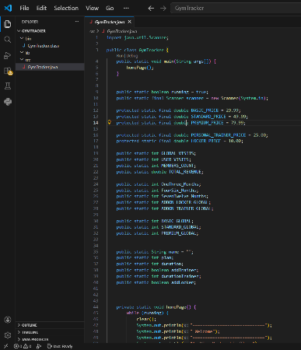
Project Structure
This screenshot shows the Gym Tracker program in VS Code. The projects classes are shown in the src folder while the plans and branchData are shown in the project root folder. The structure demonstrates encapsulation and separation of responsibilities between user interaction, branch management, and member data handling.

Runtime Error
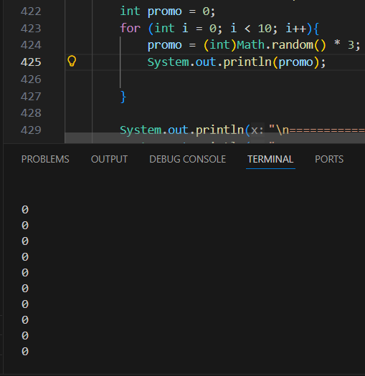
This screenshot shows a bug where the promo value always printed 0. This happened because Math.random() was cast to an int too early. It was fixed by changing it to (int)(Math.random() * 3).

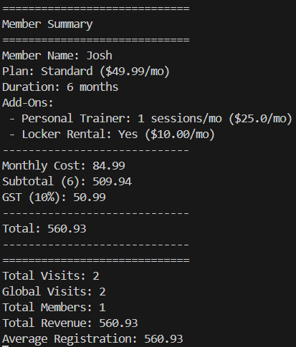
Program Running
This screenshot shows the program running with test data. A member named Josh is registered with a standard plan for 6 months, including a trainer and locker. The output shows correct calculations for cost, GST, total, and stats like visits and revenue.

Error Analysis
Most of the errors were coding errors (around 70%), with the rest being design errors (about 30%).
Coding Errors:
These were mostly small mistakes like syntax or incorrect usage. For example, the Math.random() issue caused the promo to always be 0.
Design Errors:
These were logic problems. For example, in the modify feature, I removed counters before calculating the old total, which caused incorrect revenue.
Coding errors were easier to fix, while design errors took more time to think through and fix properly.

Handwritten Pseudocode

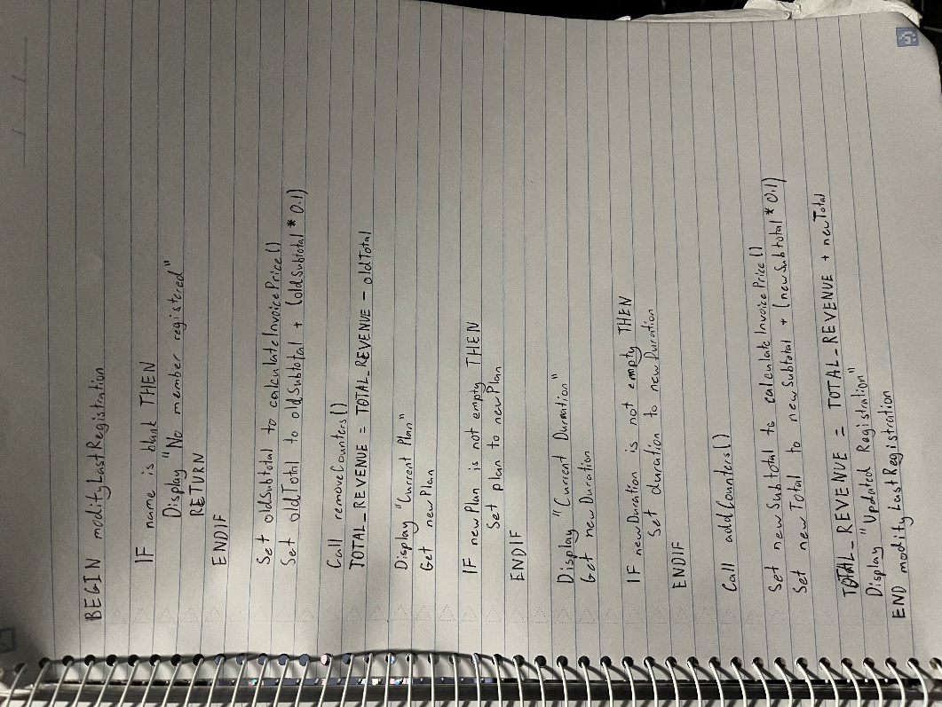
The pseudocode shows how the modify feature works. It checks if a member exists, removes the old total, then lets the user update the plan or duration. After that, it recalculates the new total and updates the revenue and counters, so everything stays correct.

