

Game Design Document (GDD)

01/10/2015 - **/**/2015

**Fallen Hero**

Authors: Josh Mooney

Student Number: C00165897

Project Supervisor: Ross Palmer

Honor Bachelors in Computer Games Development

Table of contents

Overview

The Elevator Pitch / High Concept

Theme, Setting and Genre

Core Aesthetics

Fellowship/Coach Co-op

Look and feel

View

Game Flow Summary

Experience duration

Target Audience

Key Features

Influences

What sets this project apart ?

Targeted platforms

Technical Requirements

Gameplay

The First Five Minutes

Game Progression

Level progression

Objectives

Mechanics

Physics

Movment

Objects

Actions

Combat

Economy

Skill tree

Game World

Game Geography

Game World Elements

Levels

Level description

Interface

Controls

In game overlays & dialogs

HUD

Screenflow

Control system

AI

Opponent AI

Game Art & Audio

Visual aesthetics

Audio

Art assets

Characters/ animation frames

Items (in-game & icons)

level backgrounds/maps/environment textures

Visual effects

explosions

particles

HUD graphics, typeface

Controls screen/menu/dialog backgrounds/borders/typefaces

Spirit and Features

Spirit 1

Spirit 2

## 

## Overview

### The Elevator Pitch / High Concept

Fallen Hero is a 2D puzzle platformer where the player is tasked to make friends, fight demons and hold off the impending invasion from below; while trying to discover the truth about his family and mysterious past.

### Theme, Setting and Genre

The game will be set in a fantasy land where mythical creatures as well as wizards, trolls and demons exist but have since died out during the Culling of the common lands. The forces of Below* found the people of the common lands weak and inferior, after centuries of inhouse brawling all the clans of Below where brought together over a single common goal. To retake the common lands and crawl out of there molten prison. It has been long since the culling and the people have little to remind them of how things use to be but the odd witch or problematic minx.

*\*Below is another way of saying hell. My game deals with a lot of good and evil, black and white to break away from the christian ideas of Angels, God and Heaven/Hell I choose to rename certain aspects of the game to help it stand out.*

### Core Aesthetics

Sensation

Using FMOD I hope to apply 3D spatial audio to most of the world to give the feeling of being in the world. To add to the emersion the backgrounds of the worlds will be animated and use parallax to add a degree of depth to the game. Particles will brighten up the game and tease the senses in aspects such as combat, lighting and exploration.

Narrative

The story will be told over a hand full of medians such as short cutscenes, visual collectibles such as diary entries and character dialog.

Challenge

To test the player there will be a variety of gems for completing a level.

**PURPLE** - Finishing the standard level.

**GREEN** - Finish the Challenge* level.

**WHITE** - Against the clock some sort of time trial.

**RED** - Killing all enemies in the level.

**GOLD** - Finding all the collectibles and opening all the treasure chests in the level.

*\*Challenge levels will be like playing level+ some will be with simple modifications such as tougher enemies and others could be using game tweaks as in reversed controls, less or more gravity even as far as no weapons. It is meant to put a new fun spin on a level the player could have completed 3-4 times before.*

### Fellowship/Coach Co-op

The game will be a 2 player coach co-op experience where the player has the option to bring a friend into battle with drop in drop out co-op.

### Look and feel

The game will be a 2D side on pixel based world, all the assets will be animated using sprite sheets ripped from the internet or made specifically for the game. The game will be using tile based mapping for creating levels and will have multi layer

### View

The player will have no control of the camera as it will be locked to the players center position.

### Game Flow Summary

Fallen Hero is a indie project for *Xbox One* and *Windows Store..*The player controls a fallen angel and must traverse a tile mapped 2D pixel landscape and defeat a wide variety of enemies who can differ in kinds and size. Each with their own fighting type and effect

(e.g. ***Black Spider,***can walk left or right and has a melee attack*.* ***Blue Spider,*** can walk on ceilings and has a ranged attack, ***Grey Bat,*** is a flying enemy is restricted to movement on the x-axis and has a long range attack.)

Each level the player must navigate rooms filled with platforms, treasure chests and collect keys to progress. The player has a multitude of special powers available to the player. At the end of each level the player knocks down a flag pole.

Simple clean pixel graphics and controls combine to give an easy but enjoyable gaming experience,

### Experience duration

Each standard level should take no more than 5 minutes to complete with boss levels being significantly longer. Player deaths should be between 1-3 per level allowing for combat and missing platform jumps, boss levels will have 5-6 deaths for the average gamer.

### Target Audience

Fallen Hero will appeal to male gamers of age 12-24 who typically play Platforming and 2D combat games. In particular, lovers of Fantasy worlds, pixel art and challenging but engaging platforming experiences will be immediately drawn fallen hero and its Action Fantasy setting and theme.

### Key Features

* **Simple yet powerful physics,** that provides an enjoyable Platforming experience.
* **Strong overpowering hero abilities,** that will allow for quick changes in battle.
* **Scaling enemy** difficulties and effects creates an enemy entity pool to challenge the player.
* **A Hero ability upgrade tree,** for reducing cooldowns and increasing the damage or effects of power.
* **World Map,** that provides an engaging level select system which treats the player to multiple paths to the boss levels.
* **Player upgrade tree** allows for player improvement like increase health and knockback.
* **World Shop**, that allows the player to upgrade their base weapons and armor.
* **Dynamic Platforms**, differing in size, movement and effects (e.g. Moving, expanding, timed)

### Influences

Shovel Knight

* Game, 2D plaform adventure game from Yacht Club Games
* With simple controls and a fun 2D pixel platform world the source of my original idea came from the first time I seen the gameplay.

Rogue Legacy 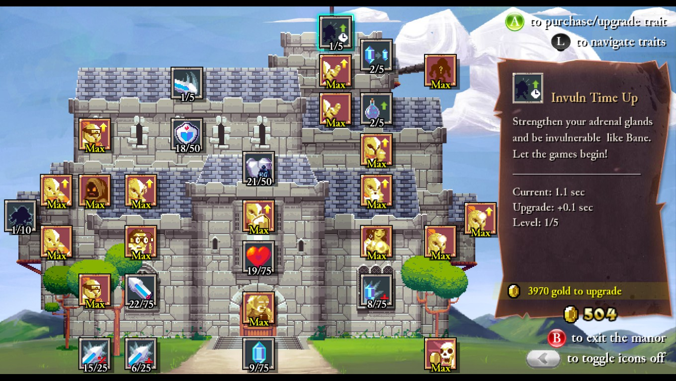

* Game, Roguelike platformer from Cellar Door Games.
* While playing this game during the summer i was inspired by its engaging upgrade tree and found it both advancing the player's stats as well as providing new ways to play

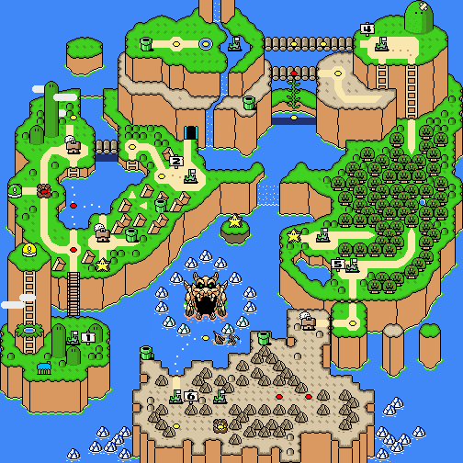

Mario World

* Game, 2D Platforming game from Nintendo
* From memories of playing platforming games at a young age Mario of course stood out, Mario Worlds level select system interests me and i hope to mimic and adapt it to Fallen Hero

### What sets this project apart ?

I hope to combine the simple controls and experience of Mario with the in depth world and game mechanics seen in games such as Shovel Knight and Rogue Legacy. Fallen hero will deal with themes such as good vs evil, family and death exploring each though an evolving narrative. Fallen Hero hopes to stand out as a fluid, challenging but fair platforming experience that combines fun player powers and combat. Defeat a variety of differing enemies with increasing difficulty and unique boss AI.

### Targeted platforms

Xbox One and Windows 10 Store

### Technical Requirements

External Libraries:

* Box2D
* TinyXML / JSON
* SFML::Audio / FMOD
* Chai Script
* SFML 2.3.2
* Thor
* Boost

Development Requirements

* Xbox One controller ✔
* PC with Windows 10 installed ✔
* Windows Developer Account ✔

## 

## 

## Gameplay

### The First Five Minutes

After the splash screen the player will be presented with the main menu with a list of options such as create a new game, continue and settings. After selecting the option to create a new game the player will be prompted to select a save slot. Once complete the opening cut scene setting the world and main character will take place. The game will then return to the world map and will be limited to completing the tutorial. 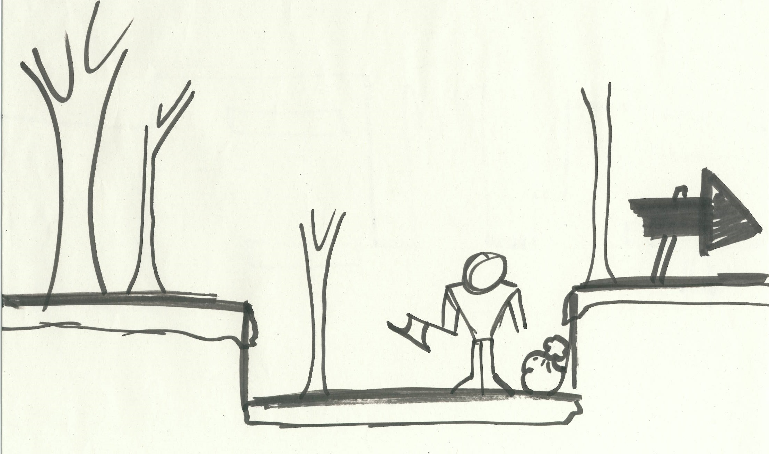

Once the first level has been loaded the player will be prompted to complete a variety of seemingly simple tasks such as “Chop down n number of trees for firewood” and so on. These tasks will teach the player about **core** mechanics of the game without the need of a over obvious *“Tutorial sequence”*.

The Player's goal will continue to prompt them to move forward (Move Right) where they will experience **game** mechanics. The player will be tasked with jumping a series of gaps beginning with no penalty ramping slowly up using a combination of timed jumps and moving platforms with spike pits to punish mistakes.

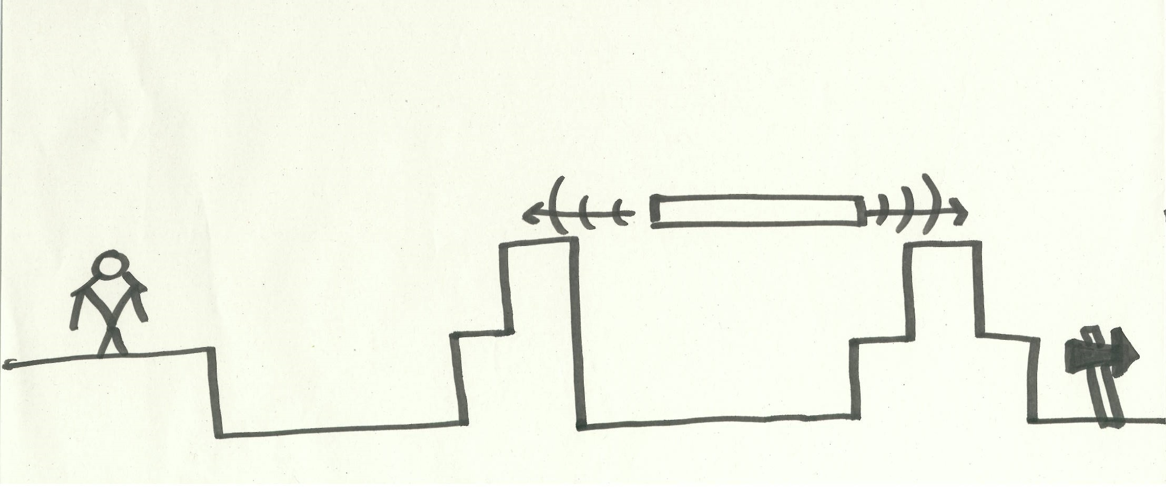

Upon completing the player will come across their first altar where they light a torch which essentially becomes a checkpoint for the player to respawn at upon death. This will be tripped automatically once the player crosses it.

The player will enter a room with a series of platforms, treasure chests and must confront their first enemy. There will be multiple ways to approach this room the player may use the platforms

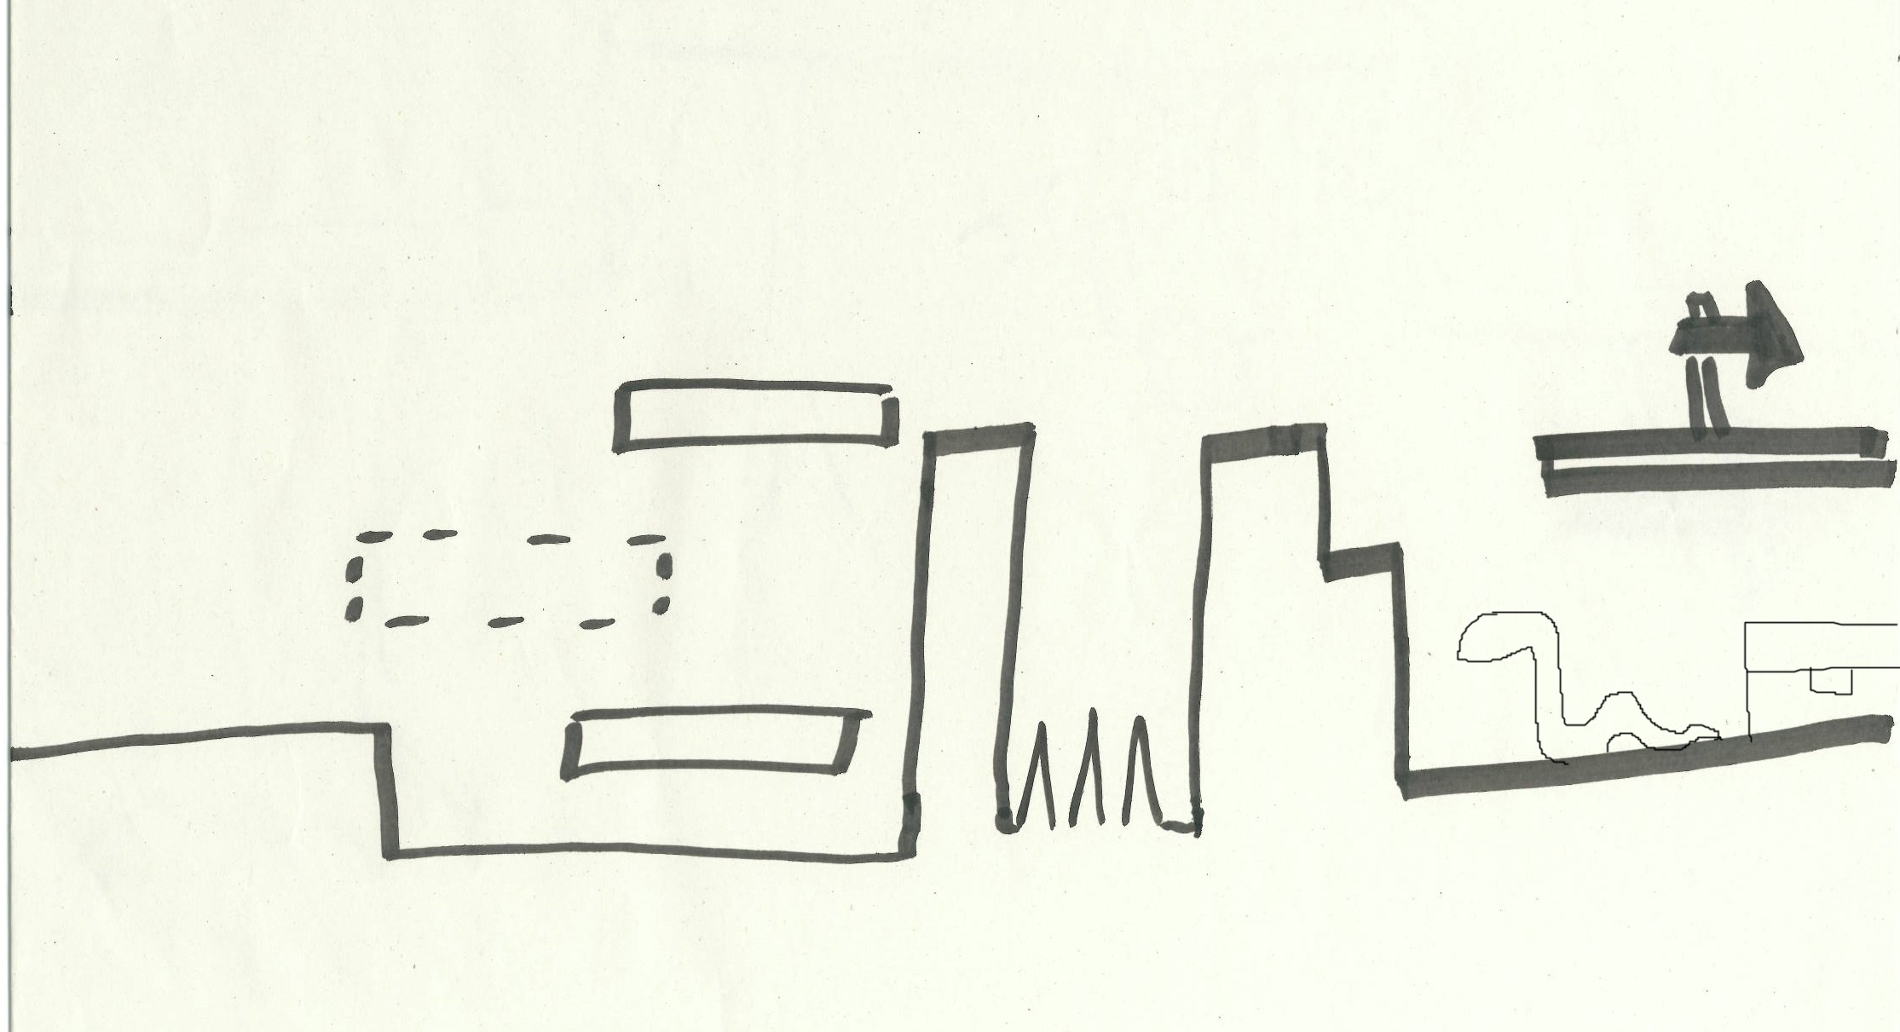

to cross the room safely or fight the enemies to see what the chest holds. Once complete the player will progress till they cannot anymore there will be an exit sign once crossed the player will be kicked back to the world map, next level will unlock and the player will be free to progress further.

### Game Progression

The player will **progress** from level to level via the world map which is available to the player through the ingame pause menu and the player will be returned to this point after each level also.

With a wide enemy pool the **difficulty** will be managed by smartly using these enemy types and effects in situations that they swarm, overpower and outsmart the player. Accompanying this, a degree of difficulty may be added with new platforms, multi-layered levels and requiring the player to use their unique player powers to solve combat and platforming puzzles.

To **reward** the player for their efforts they will have the opportunity to collecting gold for increasing base stats and weapons, gathering collectibles to piece together the story and find relics that allow the player to upgrade their player abilities.

### Level progression

To complete a level the player must progress past all the obstacles, enemies and challenges the level provides. Once in the final room the player will chop down a flagpole with the enemy legion flag on it.

### Objectives

The main objective of the game is to defeat each of the *Below’s* legion’s generals to challenge the commander of the invasion, the infamous **Black Knight.** Level objectives consist of reaching the end of each level and knocking down the enemy flag.

## Mechanics

### Physics

All entities within the game e.g.Player, Enemies and Pick-ups will be affected by gravity normally.

### Movment

The player has full control of their character while in game. The character can move left and right freely, as well as while falling under gravity and jumping. The player is effected normally by gravity and can jump with a force of 15. The player is still restricted to the rules of the game world and continues to collide with platforms and walls while moving, jumping and falling. The Jump will be a single function that will have a cooldown and will not give any advantages when held. Double and triple jumps will be available to the player through the in game upgrade tree.

### Objects

The player comes across may pick items on there journey:

* Gold, From chests, gems and money bags.
* Runes, a currency specifically for upgrading player powers.
* Signposts, For leading(or misleading) the player.
* Consumables, such as Health pots and gold modifiers.

Gold, runes and consumables are collected and are carried on the player without restriction.

### Actions

Talking to NPC can be done in all village levels these characters will give you tips and tricks on playing the game and can also unlock new items in general areas such as the shop. (e.g. talk to mary the shop owner will unlock the shop, talk to the blacksmiths brother get better deals.)

Down strike can be done once in the air the player puts their weapon underneath them. If the player then falls on another entity or game object they can bounce off of there head for increased height.

Consum Health Pot, these can be found around the world, in treasure chest and purchased in the shop. These will heal the player by 25 hp a second for n number of seconds.

Strike from above is the first player ability to be unlocked and will have a relatively short cooldown. Once summoned an explosion of particles will take place at the top of the screen a step in the direction the player is looking. A large sword will then fall from the sky. When fully upgraded the ability can fall from the sky hit multiple enemies and doesn't stop till it hits the ground the player is on. This sword stuck into the ground can then be rotated and kicked in the direction the player is looking. At its base stats the sword will fall from the sky be much smaller than the final fully upgraded version and will stop when it hits the ground first or hits an enemy.

Spinning Scythe is a short range throwable item that when used a spinning scythe blade is sent from the outwards from the player. When the blade reaches its maximum distance it can behave in handful of ways depending the blades upgrade level. When fully upgraded the scythe will seek out up to 3 enemies depending on range upon reaching its maximum spinning distance. At its base level the scythe will return to the player when it reaches its max distance.This ability will have medium cooldown and is not restricted to colliding with the platforms and the world.

Bow and Arrow is a long range shootable player ability where the player must perform a short charge before shooting a arrow. The arrow does collide with the world and game entities. At its base level the arrow will have a long charge and when shot the projectile will stop once it collides with something on its path. When fully upgraded the arrow will have a short charge and can pass through as many entities as it can before reaching a wall or platform. This player ability will have a long cooldown,

Mirror force is the first utility ability that will be made available to the player. When activated a sparkling wall will appear in front of the player. Any projectiles that collide with the mirror will be reflected off. The mirror has a short cooldown and at its base level will have a short time to live. When fully upgraded the mirror will be physically larger as well as apply a charge to any projectiles that are reflected from the mirror. This charge will allow the projectile to bounce off up to 3 surfaces before the projectile depletes. At this level the mirror will have a much longer time to live.

Blink is a short range teleport that will allow the player to change up combat situations and complete various platforming challenges. This will have a medium cooldown. At its base level the blink will have a short range and will be a quick movement of the player. When traveling the player can still collide with enemies and walls of the world and cancel the ability. At maximum level the blink will have a short charge to allow for further distance and has the ability to pass through the game world and entities. If the player collides with treasure or gold on their path they will still collect it.

Armor up is short term invincibility power that will have a long cooldown period. At its base level the armor will give the player an extra health bar that is slowly decaying. At its maximum level decay rate is reduced but the extra health bar can not be reduced. The Armor cancels all stuns, knockbacks and status effects at this level.

### Combat

The combat will be simple and to the point using per pixel collision to detect for contact when the player attacks. The player will press the attack button and the character will swing his weapon. The combat is reaction based and will rely on the player perceiving enemies and jumps appropriately.

### Economy

The game will contain two different types of currencies. **Gold** can be collected in game from treasure chests, gens and defeating enemies. This can then be used to purchase upgrades from the player upgrade tree, new weapons from the smith and consumables from the shop

**Runes** are a more valuable type of currency as it can only be earned by defeating minibosses and/or NPC quest and killing each of the generals of *Below.* This type of currency will be used for upgrading the player powers. Runes cannot be converted into gold. Runes cannot be used to purchase weapons or upgrade the player.

### 

### 

### Skill tree

Player Ability tree

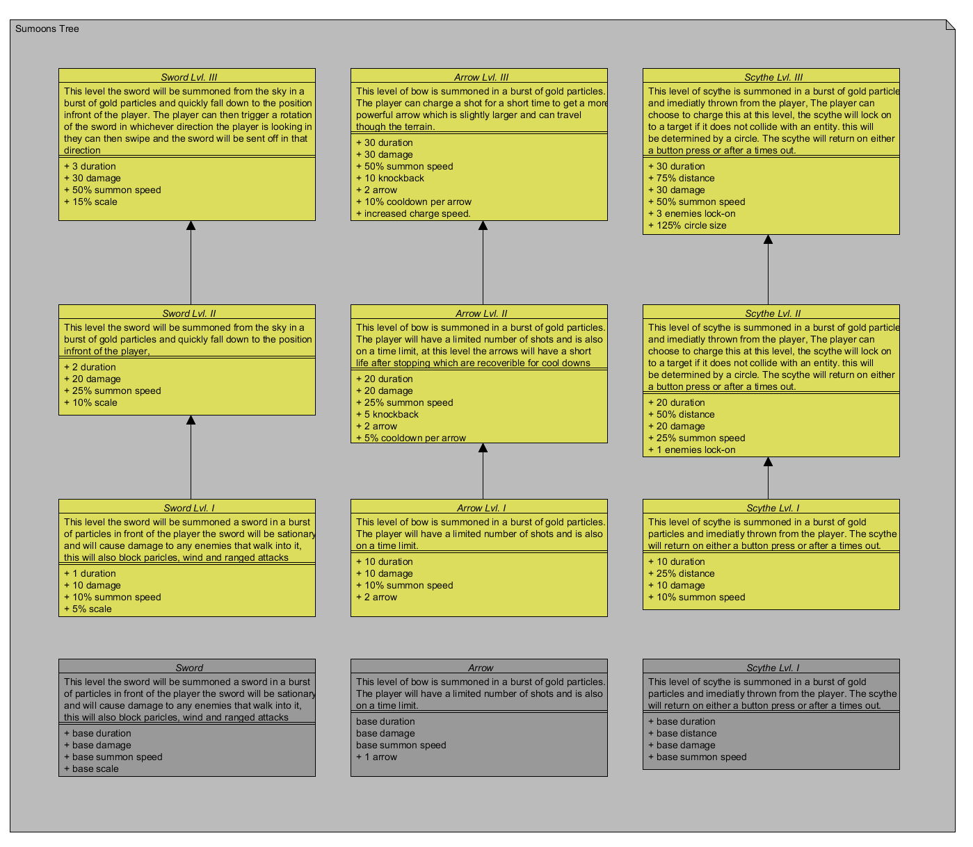

Player Upgrade tree

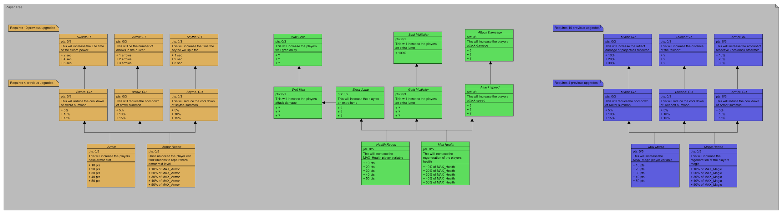

## Game World

### Game Geography

The game world is that of a fantasy world lost in time. Creatures and ghouls where once the norm in these lands. Now they have been driven back, by the common folk. Under assumptions that all magical and mythical creatures are the same and they can be dangerous. This opinion came about due to the Culling of the Common lands and the need for assistance from *Above* required to chase back the war crazy orcs and demons of *Below.* The land is ripe with forest and mountainous areas some of whom still hold battle scars from a time ago. The player will venture into caves, jungles and forest areas as well as visit towns and conquer castles.

In later levels the player will be brought to new lands to face the other generals each with their own landscapes, enemy types and themes (e.g. Frozen lands, mechanical).

### Game World Elements

**Player**

Description & Appearance:

* The player will be a short stocky knight in armor and can have a variety of different weapons.

Backstory Synopsis:

* The player is the son of an angel who fought in the Culling of the common land and upon being recalled found solace in a human soldier and started a family. One night when our character was a child a creature came in the night and murdered the mother (angel from above) as his father went to enact revenge he never returned. Our character spent his life in the surrounding woods and is a capable fight taught by his father at a young age.

Abilities:

* Offensive:
  + Strike from Above
  + Spinning Scythe
  + Bow and Arrow
* Defensive:
  + Mirror Force
  + Blink
  + Armor Up

Strength & Health:

* Base Health: 50 health point
* Base Level: 0 level
* Base Sword: 1 hit point

**Pickup**

Description & Appearance

backstory synopsis or relationship to other elements (if important)

abilities

cost

strength

privileges

**Enemy**

Description & Appearance

backstory synopsis or relationship to other elements (if important)

abilities

cost

strength

privileges

**Mother**

Description & Appearance

backstory synopsis or relationship to other elements (if important)

abilities

cost

strength

privileges

**Black Knight**

Description & Appearance

backstory synopsis or relationship to other elements (if important)

abilities

cost

strength

privileges

## Levels

### Level description

Each level must be described;

* Introductory material (is the player given any hints, back-story or goals prior to starting level)
* What are objectives
* What additional skills are needed
* Level map & critical path
* Important encounters
* what elements are available/unlocked in the level
* For training levels, what skills are developed

## Interface

### Controls

insert controller image here

### In game overlays & dialogs

How does the player interact with complex ingame systems like tech tree, inventory, trade, communication. Show mock up dialog boxes and be explicit about how the player activates, navigates and dismissed these.

### HUD

insert picture of hud

### Screenflow

Main menu screen flow will go here.

### Control system

How does the player control things like open/save game, network lobbies, custom controls. Show mock-up screenshots for these.

## AI

### Opponent AI

## Game Art & Audio

### Visual aesthetics

What is the visual style of this game. How does the style reinforce the gameplay?

### Audio

Background music

Audio effects

Dialog

### Art assets

##### Characters/ animation frames

##### Items (in-game & icons)

##### level backgrounds/maps/environment textures

##### Visual effects

##### explosions

##### particles

##### HUD graphics, typeface

##### Controls screen/menu/dialog backgrounds/borders/typefaces

## Spirit and Features

### Spirit 1

**Setup project,** get a project started and include all required external libraries for this sprite e.g. Box2D, SFML.

**Game,** set up game class and game loop.

**Movement,** As the player I can move freely on the x-axis.

**Jump,** As the player I can jump into the air and move freely while doing so.

**Level,** As the player I can move within the confines of the level.

**WorldMap,** As the player I can move around the graph and enter levels.

**Exit,** As the player I can exit a level by colliding with the level's exit and return to world map.

**Main Menu*,** As the player I can freely move around the menu and proceed to the world mwap.

*This is not essential to the sprite but i felt like it was worth keeping in incase there is any kind of free time overflow (Which is doubtful).

### 

### 

### Spirit 2

Predictive:

*Basic Platform*

*Snake Enemy*

*Enemy Manger*

*Entity pool*

*Parallax Background*

*Resource Manager*

*Animated Player*

### Sprint 3