<Title of the seminar paper>
< FIRSTNAME LASTNAME>
<Contact information>

Abstract
The purpose of the abstract is to give a complete, albeit small, picture of the whole article and its contents. About 15 to 20 rows should be enough. A short motivation, the used methods, and the most important results are typically included.

Introduction
An introduction to your topic. A background/motivation, the purpose of the research, and the research questions/objectives are typically presented here. Describe also shortly the structure of paper.

Section 1
Start presenting your work here. Number all sections as you see it done here.
Refer to literature in the number format like this.

Subsection 1
Remember to use subsections to keep your paper easy to read.
Other general guidelines:
- Make sure the title of the paper is in line with the text. Avoid repetition of matters in different parts of the paper, use cross-references instead.
- Make sure the language in your paper is finished. Avoid mixing expressions from British and American English language (e.g. favor vs. favour, analyze vs. analyse).
- Use tables, figures and graphs to summarize and illustrate your point. Figures should also be understood without reading the text (e.g. name the variables used in figures). Remember also to interpret the tables/figures in the text.
Take a caption of the table and insert table name above the table.
Table 1: Classes and values
Class/Value | values 1 | values 2 | values3
class 1 | 1 | 2 | 3
class 2 | 1 | 2 | 3
class 3 | 1 | 2 | 3

Caption figures and graphs as well, the name this time under the figure.
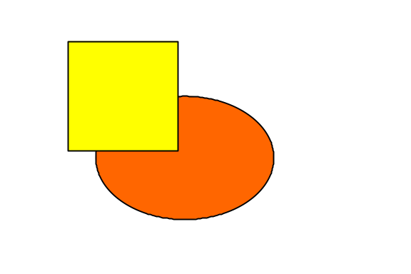
Figure 1 Orange and yellow

Conclusions
Could be also titled otherwise depending on contents, e.g. “Discussion”, “Summary”…
Summarize findings, present major conclusions, consider managerial relevance and further research….

References
Include at least the following information: Author, Title of the paper, Published where and when, possible www-address and quotation date, possible ISBN or ISSN number.
Examples:
- Wei C-P & Chiu I-T (2002). Turning telecommunications call details to churn prediction: a data mining approach. Expert Systems with Applications, Vol. 23 (August 2002), pp. 103-112.
- Ojala T., Hakanen T., Mäkinen T., Rivinoja V. (2005). Usage Analysis of a Large Public Wireless LAN. Proceedings of International Conference on Wireless Networks, Communications and Mobile Computing (IEEE WirelessCom 2005), June 13-16, 2005, Maui, Hawaii, USA.
- Google, Inc. web site [online]. Google Mobile, updated 2007 [accessed January 5, 2007]. Available in www-format: <URL: http://www.google.com/mobile/>.

