**ADVENTIST UNIVERSITY OF CENTRAL AFRICA**

**(AUCA)**

**Faculty of Information Technology**

**Department of Information Management**



E-Procurement Management System(e-PMS)

Case study MUSANZE District

**A research project presented in partial fulfillment of the requirements of the award of Bachelor’s Degree in Information Management**

**By**

**NDIZIHIWE Eric**

# Supervisor: INGABIRE Marie Ange

**Kigali, May 2012**

Abstract

This study focuses on developing and implementing a web-based procurement system of Musanze called E-procurement system that will help to improve the tender process in Musanze district, this project is conceived with an aim of providing an adequate solution to these problems. The objective of this study is to make software able to assist the District of Musanze to overcome with the problems.

The above mentioned system has three main parties that are tender management system, announcing the acquisition of goods and services, electronic access to tender documents, and tender evaluation in order to get the award bidder of a certain tender. The bidder will be able to get information they need for long as they have access to the internet.

Analysis and design approach, object oriented methodology was chosen and UML was used. The software methodology called waterfall model which has been used due to its good progress tracking and well-defined development stages used to provide a very robust notation, which grows from analysis into design.

# Acknowledgment

Success is the outcome for hard work and patience. I am therefore greatly indebted to all those persons who restlessly assisted me financially, materially, morally, spiritually or otherwise during the course of my study, in particular during this project work. I shall however talk about a few whose services were absolutely indispensable as it is difficult to mention all of you here. Special thanks go to the Mayor of Musanze District, Department of Public Procurement, in particular Mr. Charles RUZINDANA President of Tender Committee and Mr. Isaac BIDAHARINKA Secretary of Tender Committee moral support towards this noble cause. I wish to extend my sincere thanks to my supervisor, INGABIRE Marie Ange, for the professional and academic guidance she accorded me while carrying out this project.

I cannot end without thanking the entire Staff and fellow information technology Students (20082012) at the Institute, later on Faculty of Information Technology for the intellectual support throughout the course of my stay at the faculty.

Lastly, I thank the members of my family and friends.

# Table of Contents

Abstract............................................................................................................................................ i Acknowledgment...........................................................................................................................iii Table of Contents........................................................................................................................... iv List of Tables ................................................................................................................................vii List of Figures..............................................................................................................................viii

List of Abbreviations ..................................................................................................................... ix

CHAPTER 1: GENERAL INTRODUCTION ............................................................................... 1

1.1. Introduction.......................................................................................................................... 1

1.2. Problem statement................................................................................................................ 2

1.3. Motivation............................................................................................................................ 3

1.4. Objectives of the Study....................................................................................................... 3

1.4.1. General Objective............................................................................................................ 3

1.4.2. Specific Objectives.......................................................................................................... 3

1.5. Methodology and technical.................................................................................................. 4

1.6. Scope of the Study............................................................................................................... 5

1.7. Structure of the work .......................................................................................................... 5

CHAPTER 2: THE EXISTING SYSTEM ANALYSIS ................................................................ 6

2.1. Specific terminology................................................................................................................ 6

2.2. Thorough analysis of the existing system............................................................................ 7

2.2.1. The description of Musanze District............................................................................... 7

2.2.1.1. The District vision.............................................................................................................. 7

2.2.1.2. The District mission........................................................................................................... 8

2.2.1.3. District objectives .............................................................................................................. 8

2.2.2. Survey of the existing system............................................................................................... 8

2.2.2.1. Preparation of bidding documents ..................................................................................... 9

2.2.2.2. Invitation to tender........................................................................................................... 10

2.2.2.3. Advertisement.................................................................................................................. 11

2.2.2.4. Provision of bidding document........................................................................................ 11

2.2.2.5. Tender security................................................................................................................. 11

2.2.2.6. Submission and receipt of tenders ................................................................................... 12

2.2.2.7. Bids opening .................................................................................................................... 12

2.2.2.8. Evaluation of bids............................................................................................................ 14

2.2.2.9. Evaluation Award Recommendation............................................................................... 16

2.2.2.10. Notification of contract award....................................................................................... 17

2.2.2.11. Publication of Award Results ........................................................................................ 18

2.3. Problems of existing system .................................................................................................. 18

2.4. Proposed solutions................................................................................................................. 19

CHAPTER 3: ANALYSIS AND DESIGN OF THE NEW SYSTEM ........................................ 20

3.1. Introduction............................................................................................................................ 20

3.2. Analysis and design methodology......................................................................................... 20

3.3. System analysis...................................................................................................................... 22

3.3.1. Requirement analysis.................................................................................................. 22

3.3.1.1. Use case diagrams............................................................................................................ 22

3.3.2. Domain analysis.................................................................................................................. 35

3.3.2.1. A class diagram................................................................................................................ 35

3.4. System design ........................................................................................................................ 38

3.4.1. Architecture design............................................................................................................. 38

3.4.2. Mechanistic design.............................................................................................................. 39

3.4.2.1. Sequence diagram............................................................................................................ 39

1.Sequence diagram for create users............................................................................................. 40

2.Sequence diagram for create tender document.......................................................................... 41

3.Sequence diagram for create invitation to tender ...................................................................... 42

4.Sequence diagram for submit bids............................................................................................. 43

5.Sequence diagram for evaluation bids....................................................................................... 44

6.Sequence diagram for opening bids........................................................................................... 45

3.4.3.Detailed design..................................................................................................................... 45

3.4.3.1. Activity diagrams............................................................................................................. 45

3.4.3.2. Database schema diagram................................................................................................ 49

Database Summary ....................................................................................................................... 51 CHAPTER 4: NEW SYSTEM IMPLEMENTATION AND TESTING..................................... 58

4.1. Introduction............................................................................................................................ 58

4.2. Languages and tools used for the system implementation..................................................... 58

4.2.1. Microsoft Visual C#.Net 2008............................................................................................ 58

4.2.2. Microsoft SQL Server 2005................................................................................................ 59

4.2.3. Crystal Reports for Visual Studio .NET............................................................................. 60

4.2.4. ASP.NET 3.5 ...................................................................................................................... 61

4.2.5. Ozeki Message Server 6...................................................................................................... 61

4.3. Software Testing and Results................................................................................................. 61

4.3.1. Testing Methodology, Tools and techniques...................................................................... 61

4.3.2. Unit Testing Results............................................................................................................ 63

4.3.3. Integration Testing Results................................................................................................. 63

4.3.4. User Acceptance Test Results............................................................................................. 63

4.3.5. E-PMS graphical interfaces ................................................................................................ 64

CHAPTER 5: CONCLUSION AND RECOMMENDATION .................................................... 68

5.1. Conclusion ............................................................................................................................. 68

5.2. Recommendation ................................................................................................................... 68 REFERENCES ............................................................................................................................. 69

1. Bibliography.......................................................................................................................... 69
2. Websites................................................................................................................................. 69

**List of Tables**

Table 1: Users table details........................................................................................................... 51

Table 2: Tendering document details............................................................................................ 52

Table 3: Resources details ............................................................................................................ 52

Table 4: Procedures details........................................................................................................... 53

Table 5: Publications details......................................................................................................... 53

Table 6: InvitationToTender details.............................................................................................. 53 Table 7: Lots details...................................................................................................................... 53

Table 8: EvaluationCriteria........................................................................................................... 54

Table 9: Companies details........................................................................................................... 54

Table 10: RepresentativePersons details....................................................................................... 54

Table 11: Bids details.................................................................................................................... 55

Table 12: OpeningBids details...................................................................................................... 55

Table 13: PreliminaryEvaluations details..................................................................................... 55 Table 14: FinancialEvaluations details......................................................................................... 56

Table 15: Reports details .............................................................................................................. 56

Table 16: AwardContract details.................................................................................................. 56

Table 17: CommitteeMembers details.......................................................................................... 57

**List of Figures**

Figure 1**:** Procurement Stage and Activities................................................................................... 9 Figure 2: Procuring entity and committee member Use cases diagram........................................ 25 Figure 3: public and bidders Use case diagram............................................................................ 26

Figure 4**:** Class diagram for e-procurement management system ................................................ 37 Figure 5: System architecture for E-procurement management system....................................... 39 Figure 6: Sequence diagram for creating users............................................................................. 40

Figure 7: Sequence diagram for creating tender document.......................................................... 41

Figure 8: Sequence diagram for creating invitation to tender....................................................... 42

Figure 9: Sequence diagram for submit bids ................................................................................ 43 Figure 10: Sequence diagram for evaluation bids......................................................................... 44 Figure 11: Sequence diagram for opening bids ............................................................................ 45

Figure 12: Activity diagram for invitation to tender..................................................................... 47

Figure 13: Activity Diagram for download tender ....................................................................... 48

Figure 14: Activity Diagram for Evaluation and send notifications............................................. 48 Figure 15: Database schema for E-procurement management system......................................... 50

Figure 16: Home page................................................................................................................... 64 Figure 17: Download tender document......................................................................................... 65 Figure 18: Login page................................................................................................................... 65

Figure 19: Administrator menu..................................................................................................... 66

Figure 20: Evaluation form........................................................................................................... 67 **List of Abbreviations**

ASP: Active Server Page

BNR: Banque Nationale du Rwanda

CRL: Common Language Runtime

DML: Data Manipulation Language

E-PMS: Electronic Procurement Management System

GSM: Global System for Mobile Communication

GUI: Graphical User Interface

ICT: Information and Communications Technology

IDE: Integrated Development Environment

IT: Information Technology

OCL: Object Constraint Language OMT: Object Modeling Language

OO: Object Oriented

OOAD: Object Oriented Analysis and Design

SMS: Short Message Service

SQL: Structured Query Language

UML: Unified Modeling Language

XML: Extensible Markup Language

# CHAPTER 1: GENERAL INTRODUCTION

## 1.1. Introduction

Today, the use of technologies takes an increasing importance in our everyday life as it makes the world a small planetary village, and this constitutes a major concern for our country. Rwanda Government plans to use the ICT for Development and National Information and Communication infrastructure framework.

Achieving the implementation of the ICT framework in Rwanda, requires the government to spread the use of high technologies in all government institutions, which means, from offices to public academic centers to private academic centers. To do so, the government of Rwanda has started various programs to quicken (quick start) the use of the ICT in the country. Those programs include the distribution of computers, the installations of optic fibers, and the set up of the ICT departments at different government offices, so as to efficiently manage data. ICT has a lot of advantages for the government institutions, as it gives an easy way to store data. Traditionally, the bidders’ details had been kept manually on the shelves, and the evaluation process of tenders was erroneous and lengthy. Again, bidders were having difficulties to access results of their bids.

As technology advances, the world tends to be more technology dependent, as a way to improve their working environment. Procurement is the acquisition of goods and services and it is favorable goods and services be appropriate and procured at the best possible cost to meet the needs of the purchaser in terms of quality, quantity, time and location. The procurement departments have always been seeking effective ways to improve how the procurement process works. Bearing that in mind, it seems fitting for the Musanze district, to further embrace the use of the ICT, and introduce the e-procurement management system. The use of such a system could be of great importance, because it should be very supportive in terms of easy storage of bids and easy access of results.

This e-procurement management system has been designed to help the storage of data, and therefore, facilitating the Musanze district to store its data regarding the bids of goods, services and works.

## 1.2. Problem statement

As above mentioned, the manual system of data storage has many problems as any other manual systems. The following are problems we found in procurement unit in Musanze District:

1. The current system has a problem of keeping the records separately because of keeping the records separately in hard copies in shelves.
2. The procuring entity is facing the problem of getting the information on time because of searching the information related to one tender in disorderly classified files.
3. It is hard to get reports on time as they have to write them on papers and then take time to type them.
4. The current system is lacking enough security in controlling tender documents and other related documents.
5. In the current system, the process of evaluating tenders takes a lot of time doing analysis of each document as they write down.
6. The bidders are facing the problem of getting the information they want such as a tender document and also the final results, they have to go to the district, about the results they have to wait for notification letters or calls from district.

## 1.3. Motivation

The new system will help the District in the department of procurement unit to improve the speed of work, to reduce the time spent on writing reports and the staff will manage their documents more effectively and efficiently.

## 1.4. Objectives of the Study

### 1.4.1. General Objective

The main objective of the study was to design and implement an e-procurement management system that may be adopted for the public procurement in Musanze District to facilitate easy storage, retrieval and dissemination of information on public procurement to prospective providers and the public.

### 1.4.2. Specific Objectives

To achieve the main objective, the specific objectives of the study were the following:

1. To identify critical e-procurement user requirements for Musanze District.
2. To implement a procurement management system relevant to Rwanda basically at Musanze District office.
3. To develop a system that bidders will be able to get the information they want on time for example tendering document.
4. To develop a system that people will be able to know the final results of evaluation in specific tender.
5. To validate the developed system using historical data.

## 1.5. Methodology and technical

In programming, methodology is defined as an organized documented set of procedures and guidelines for one or more phases of the software life cycle, such as analysis or design.

The following techniques and methods were used in the e-procurement management system analysis and design:

* **The Unified Process:** is a software development process that is use-case driven, architecture centric, and iterative and incremental. A use-case is similar to a traditional functional requirements analysis except that every function must provide something of value to at least one of the users of that use case. A good architecture, on the other hand, provides a shared vision of various views of models of the system to be developed that allows development to be proceed, risks to be mitigated, and changes to be made, both now and in the future. Instead of a once and done strategy, which cannot be done in practice, the unified process is iterative and incremental.
* **The UML** is a visual system/language for specifying, developing, visualizing, and documenting software systems and, as such supports the Unified Process with a large number of diagrams that are connected together throughout the software development process.
* **Interview**: An interview is a conversation between two people (the interviewer and the interviewee) where questions are asked by the interviewer to obtain information from the interviewee.

We have used this tool to get the information we needed, for example to get detailed information about the current tendering system and identify the problems and solutions for the new system. We got a chance to interview three members among six members who are working in tender process.

* **Documentation:** is a method we used to collect data using their profile which contains tender documents.

We considered this tool as the main tool because we got full information about the system in collecting reports and reading different documents related to tender process.

* **Observation**: Observation method is a technique in which the behavior of research subjects is watched and recorded without any direct contact.

This tool gave us a clear picture of the existing system, spending time with them seeing how the documents are flowing within the current system.

## 1.6. Scope of the Study

The case study for this research is Musanze district. This research focused on designing and implementing e-tender, evaluation of bids and awards of contracts of tender.

## 1.7. Structure of the work

This research work has four chapters. The first chapter gives the general description of the research; the second chapter will highlight different procurement existing systems and explain the details of the current system of procurement. The third chapter will show the solutions about the problems found in the existing system. Also this chapter has full details of methods, techniques and procedures I am going to follow in order to solve the problems of the existing system. Chapter four will contain the details of implementation, testing and the software tools I have used to implement E-procurement management system. Finally, the last chapter has both the conclusion and recommendation.

# CHAPTER 2: THE EXISTING SYSTEM ANALYSIS

## 2.1. Specific terminology

In order to better understand the existing system, we are going to explore the following definitions of key terms that are used in the current system.

**Bid:** refers to offer from a bidder

**Bidder:** means any potential participant or participant in public procurement proceedings.

**Bid security:** means any guarantee by a bank or other relevant institution to allow the prospective bidder to participate in tendering.

**Contract:** means the agreement between the procuring entity and the successful bidder.

**Goods:** means objects of every kind and description including raw materials, products, equipment in solid, liquid or gaseous form.

**Procuring Entity**: means Central Government authority, Local Government authority, public institution, commission, Government Projector any specialized institution engaged in procurement process and entering in contract with successful bidder.

**Public Procurement**: refer to the supplies or goods, work, services they may be needed by a procuring entity.

**Tender Committee**: means a committee established by the procuring entity to assist the Procurement Unit, in the bid opening, evaluation and recommended for award of procurement contracts.

**Tendering Document:** means the document containing information required for the preparation of bids, the award process and tender execution

**Services:** refers to any services other than consultant services.

**Successful bidder**: means a bidder whose offer has been accepted after being considered the most competitive both technically and financially.

**Works:** means all activities related to the realization of building or engineering works upon the request by the clients

## 2.2. Thorough analysis of the existing system

### 2.2.1. The description of Musanze District

Musanze District is one of the 5 Districts of the Northern Province; its capital is Musanze town which is one of the largest cities in Rwanda.

Musanze district is bordered by Uganda and the Democratic Republic of Congo in the North, Gakenke district in the South, Burera district in the East, and in the West by Nyabihu district.

Musanze district has 15 sectors which are: Busogo, Cyuve, Gacaca, Gashaki, Gataraga, Kimonyi, Kinigi, Muhoza, Muko, Musanze, Nkotsi, Nyange, Remera, Rwaza and Shingiro.

The capital city Musanze is located in Muhoza Sector. Musanze city is in the middle of Muhoza Sector and it acts as the central hub for most businesses of Musanze district, such as trade, tourism…

In Muhoza, it is where the office of Musanze district is found as well as all the administrative work concerning the district’s governance. In Musanze city, transactions and business deals only take place during working hours.

#### 2.2.1.1. The District vision

The District aims at the well-being of its population, by the noticeable reduction of poverty, through obvious food security and the development of community tourism programs, sustained by good governance and quality education, centered on science and technology.

#### 2.2.1.2. The District mission

The mission of the District is to ensure the socio-economic development of its population through its active participation in the planning as well as the implementation of programs related to the promotion of good governance, education for all, agriculture, breeding and environment protection, trade, basic infrastructures and tourism.

#### 2.2.1.3. District objectives

1. To promote quality education for all, the Rwandese culture and sport.
2. To improve the health conditions of the population, gender and the rights of children.
3. To contribute in a lasting way to the increase of production and the marketing of agricultural and animal products.
4. To contribute to the improvement of rural and urban infrastructures.
5. To promote the well being of the population by good governance through the strengthening of collaborating approaches of decentralization and the participation of the population.
6. To improve the quality of human, material and financial management.
7. To ensure the establishment of the government’s policy on good governance, economic development, state of law and social affairs

### 2.2.2. Survey of the existing system

The existing system has procedures that must be followed according to the law and regulations of tender in Rwanda. I spent time at Musanze District analyzing, interviewing users and observing the way they prepare tenders.

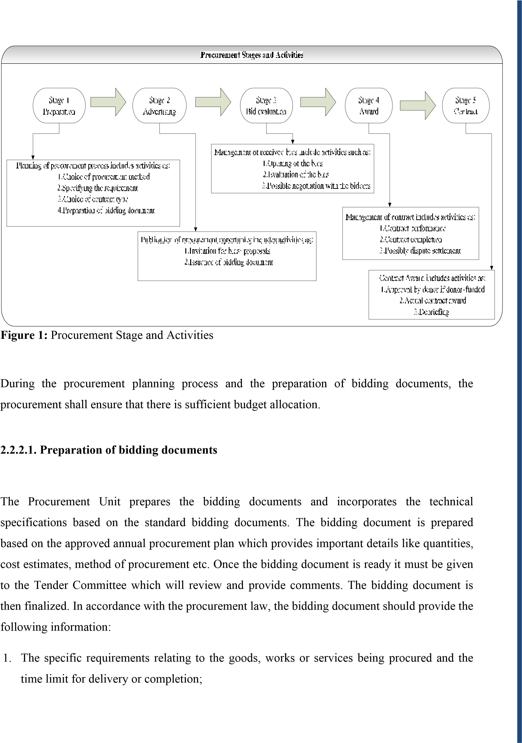

1. If works are being procured, relevant drawings and bills of quantities;
2. The general and specific conditions governing the contract, if the performance security is provided;
3. The tender number assigned to the procurement proceedings by the procuring entity;
4. Instructions for the preparation and submission of tenders including:
   1. The bid form;
   2. The number of copies to be submitted with the original bid;
   3. Any bid security required, the form and amount of such security;
   4. Any proof evidencing the bidder’s qualifications.
   5. A statement of where and when tenders shall be submitted,
   6. A statement of where and when the tenders shall be opened;
5. A statement of whether those submitting tenders or their representatives shall be allowed to attend the tender opening session;
6. A statement of the period during which tenders shall remain valid;
7. The procedures and criteria for bid evaluation and comparison;
8. A statement that the procuring entity may cancel the bids at any time before the signing of the contract;
9. Anything else as may be provided by the bidding document in accordance with this Law or public procurement regulations.

Administrative documents required for foreign bidders shall refer to the Laws in force in the bidders’ home countries.

#### 2.2.2.2. Invitation to tender

The procuring entity shall prepare invitations to tender that sets out the following:

1. The name and address of the procuring entity.
2. The tender number assigned to the procurement proceedings by the procuring entity.
3. A brief description of the works, goods, and services needed including the excepted time for delivery or completion.
4. An explanation of how to obtain the tender documents, including the amount of any fee.
5. An explanation of where and when tenders must be submitted and where and when tenders will be opened.
6. A statement that those submitting tenders or their representatives are allowed to attend the opening of tenders.
7. Currency to be used for bidding and payment of services rendered

#### 2.2.2.3. Advertisement

The procuring entity shall bring the invitation to tender to the attention of those who wish to submit tenders.

The procuring entity shall advertise the invitation to tender in at *least one newspaper of nationwide circulation and, if the procuring entity has a website, on its* website.

#### 2.2.2.4. Provision of bidding document

The procuring entity shall provide copies of the bidding document in accordance with the invitation to tender.

The procuring entity may charge a fee for obtaining copies of the bidding document. The procurement regulations shall establish such fee.

#### 2.2.2.5. Tender security

All tender proceedings conducted under open competitive bidding and restricted bidding shall request for a bid security.

The procuring entity may determine the form and amount of the tender security. The amount of tender security shall be a percentage of the bid price or a fixed fee not higher than 2% of the bid price.

#### 2.2.2.6. Submission and receipt of tenders

A tender shall be duly signed and well sealed in an envelope.

The envelope containing the tender must bear the tender number assigned to the procurement proceedings by the procurement entity.

A tender must be submitted before the deadline of tender submission and any tender received after that deadline shall be returned unopened.

The procuring entity shall ensure that the place where tenders must be submitted is open and accessible and shall provide in that place a secure area as safe keeping of received bids.

Every procuring entity shall have a register of received bids in which all bids received are recorded and a safe place where bids received are kept.

This place may be the office of the procurement unit which must be equipped with a cupboard or cupboards in which the received bids shall be kept and locked until the opening time when they will be moved to the opening room.

It shall be the duty of the procurement officer to receive the bids and record them in the register of received bids.

When a bid is submitted the one delivering it will have his/her name recorded in the register and shall sign for it.

#### 2.2.2.7. Bids opening

The Tender Committee is responsible for the bids’ opening. However Procurement Unit will coordinate the administration of the bids’ opening to assist the Tender Committee and ensure smooth operation of the proceedings including taking minutes and to advise on procedural issues if requested. The bid opening meeting will be chaired by the chairperson of the tender committee or any member of the tender committee nominated by him or her and attended by at least two more members of the committee.

The Chairman of the bids’ opening session will control and direct the bid opening and shall not allow anyone to interfere with proceedings. Any objections by a bidder to the procedures or decisions of the bids’ opening should be made in writing to the procuring entity. For purposes of transparency bids should be opened in one session and it is not permitted for a bids’ opening event to be halted or postponed once a bid has been opened.

During bids’ opening:

* Bidders’ representatives should be seated before from the officials of the Procuring Entity, and names of the organizations represented and contact details of all attendees are recorded on attendance list.
* Check that the writing on each envelope or sample inside confirms that it is for the correct bid Stack all envelopes in clear view of the bidders ready for opening. Samples supplied by bidders shall be stacked separately after checking that the bidder’s name is clearly identified on each sample provided.
* The Chairperson of the bids’ opening session will outline the procedures to be used for the Bid Opening.
* Bidders are not permitted to amend their bid or to submit any additional documents, after registration of their submission.
* Check for any withdrawals or modifications and match with the original bid before proceeding. Withdrawn bids shall not be opened once the authenticity of the withdrawal notice has been confirmed.
* Open bids’ envelopes and identify originals and copies including any separate sections and attachments. Also verify how many copies have been submitted.
* Read out the following details of each bid from the Original copy:
* Any bid modifications or withdrawals;
* The name and country of the bidder;
* A brief description of the goods or services and lot number if applicable;
* The currency of the bid;
* The total bid price;
* Any discounts offered;
* The presence or absence of any required bid security;
* The Chairperson and two members of the committee shall initial the original each bid and all attachments including any samples provided by the bidder. Any corrections to prices or obvious errors and omissions shall be initialed.
* Any envelopes containing substitutions, or modifications, must be subject to the same level of scrutiny, including the reading out of critical details, such as price changes.
* Minutes of the Bids’ Opening shall be prepared by the Procurement Unit, signed by all members of the tender committee who attended the opening session and made available to any bidder involved in the bidding who requests a copy in writing.

#### 2.2.2.8. Evaluation of bids

The Tender Committee will undertake the evaluation of received bids and make recommendations for the award of contract. The bids evaluation must be commenced and completed as soon as possible after the bid opening and within 21 days prescribed by procurement regulations and ensure that the award of contract is made within the period of bid validity.

Under the single envelope bidding system, the Tender Committee will conduct the preliminary examination of bids, technical evaluation and the financial evaluation in one stage. In preliminary examination, the bids are evaluated initially by reviewing responsiveness against the requirements stated in the bidding documents, and bids that are determined not to be substantially responsive will be rejected.

The procuring entity shall evaluate and compare the responsive tenders. The evaluation and comparison shall be done using the procedures and criteria set out in the bidding documents and no other criteria shall be used.

The technical evaluation should involve checking physical and chemical characteristics of goods offered and conformity of samples with the specification (where appropriate). Bids failing the technical examination are to be rejected.

The following requirements shall apply with respect to the procedures and evaluation criteria:

* The criteria must, to the possible extent, be objective and quantifiable;
* The criteria other than price must be expressed clearly and applied, in accordance with the procedures, for purposes of determining the lowest evaluated bid.

The financial evaluation of the bids will normally involve the following as specified in the bidding documents:

• Check the bids for arithmetic errors:

* Where there is a discrepancy between the amounts in figures and in words, the amount in words will govern;
* Where there is a discrepancy between the unit rate and the line item total resulting from multiplying the unit rate by the quantity, the unit rate as quoted will govern, unless in the opinion of the Committee there is an obviously gross misplacement of the decimal point in the unit rate, in which case the line item total as quoted will govern and the unit rate will be corrected.
* All corrections made in accordance with the procedure specified in the bidding document, are considered binding on the bidder.
* Modifications and Discounts: Discounts offered in accordance with the bidding document that are conditional on the simultaneous award of other contracts or lots in the bidding documents shall not be evaluated until the completion of all other evaluation steps. Nonconditional discounts should be included at this stage.
* Currency Conversions: If bids in different currencies are permitted in the bidding documents, convert the bid prices to the single currency (normally Rwandan Francs) as stated in the bidding documents:
* The selected source and date for currency exchange rates must be as specified in the bidding documents.
* The source of exchange rates will normally be the selling rate quoted by the National Bank of Rwanda (BNR) on the selected date.
* The selected date should not be earlier than four weeks prior to the deadline for the receipt of bids, or later than the original date for the closing of bids.

Apply the appropriate conversion rate to each corrected bid price to arrive at the evaluation price in the common currency.

#### 2.2.2.9. Evaluation Award Recommendation

The Tender Committee shall prepare an evaluation report containing a summary of the evaluation and comparison of bids and recommendation of award of contract to the bidder with the lowest evaluated bid.

The amount of the recommended contract award is the bid price as submitted by the lowest evaluated bidder and adjusted as described in the bidding documents for corrections, any discounts and acceptance of alternative offers from the lowest evaluated responsive bidder.

In brief, the evaluation report should ensure that:

* Justification is provided for any decisions reached by the committee on rejection of bidders (if necessary provide copies of selected pages from bids) and the recommendation for award of contract;
* Inconsistencies between prices and modifications to prices read out at bids’ opening are explained.
* Substantial corrections for arithmetic errors which may affect the ranking of bidders are explained.
* Any additions, adjustments, and priced deviations that may affect the ranking of bidders are explained.
* Clarification correspondence between the procuring entity and the bidders which result in major decision by the committee should be attached.
* Any separate evaluation or assessment report from a consultant, if one was engaged for this purpose is attached.

The tender committee undertaking an evaluation shall be composed of at least 3/5 members. Decisions of the committee shall be taken unanimously and all members present have to sign the report.

**NB:** In case of many successful bidders with equal prices, the procuring entity shall invite them to submit their new bids with reduced prices. In the event the bidders are again on par, the procuring entity shall resort to lot casting among those bidders.

#### 2.2.2.10. Notification of contract award

Before the expiry of the bid validity period, the procuring entity shall simultaneously notify the successful and the unsuccessful bidders of the provisional outcome of the bid evaluation. Every unsuccessful bidder shall be informed of the main reason(s) why it did not qualify for the award in the notification letter.

The notification shall specify that the major elements of the procurement process would be made available to the bidders upon request and that they have seven (7) days in which to lodge a protest, if any, before a contract is signed with the successful bidder.

The successful bidder shall be required to provide a performance security in accordance with the procurement regulations. Such security shall not exceed ten per cent (10%) of the contract price.

If the successful bidder fails to enter into a written procurement contract, the procuring entity may award the tender to the qualified bidder that ranked second. However if the period during which tenders must remain valid has already expired, then award may not be applicable.

#### 2.2.2.11. Publication of Award Results

Upon signature of a procurement contract, the procuring entity shall notify other bidders that their bids were not successful. The procuring entity shall publish the results of the tender as soon as the contract is signed. The results so published shall include at least the following: winner of the tender, amount of the tender awarded and the duration of the contract.

## 2.3. Problems of existing system

In this existing system that I have explained above, users face different problems:

1. The existing system has a problem of keeping the records separately because of using a filebased system.
2. Users are using Word or Excel to record companies’ names and personal details, writing one record many times in different sheets which leads to inconsistency of data. Consequently, users are facing the problem of getting reports on time because of searching the information related to one tender in different files.
3. The existing system has many problems associated with it, for instance: it wastes time for recording the process of tender information.
4. In the existing system, the process of evaluating tenders takes a lot of time to do analysis andto compare documents as they (users) write down and also remember they have to search for the documents they want manually.
5. It is hard to get reports on time because they have to type them manually. In other words, each record they keep is not in the format of reports, and at the time of issuing the report, they have to type it manually.

## 2.4. Proposed solutions

1. Design a database which is able to keep every transaction related to tender process.
2. The user will be able to generate a report they need on time because every record will be saved in database.
3. Implement the level of security so that every user will be able to access the information according to their role in the system.
4. This new system will avoid the duplication of data that leads to consistency of data.

# CHAPTER 3: ANALYSIS AND DESIGN OF THE NEW SYSTEM

## 3.1. Introduction

The goal of the system analysis and design phase in development is to refine the project goals into defined functions and operation of the intended application. System requirements are documented by using the Unified Modeling Language (UML).

**Analysis**: is the decomposition of problems into their component parts. In computing it is understood as the process of specification of system structure and function independently of the means of implementation or physical decomposition into modules or components. Analysis was traditionally done top-down using structured analysis, or an equivalent method based on functional decomposition, combined with separate data analysis.

**Design:** design is the process of defining the solution. It involves defining the ways in which the system satisfies each of requirements identified during analysis.

## 3.2. Analysis and design methodology

**Object-oriented analysis and design** (OOAD) is a software engineering approach that models a system as a group of interacting objects. Each object represents some entity of interest in the system being modeled, and is characterized by its class, its state (data elements), and its behavior. Various models can be created to show the static structure, dynamic behavior, and runtime deployment of these collaborating objects. There are a number of different notations for representing these models, such as the Unified Modeling Language (UML).

Object-oriented analysis and design consist two parts:

# 1. Object Oriented Analysis (OOA)

Object Oriented Analysis is concerned with developing requirements and specifications expressed as an object model (population of interacting objects) of a system, as opposed to the traditional data or functional views.

# 2. Object Oriented Design (OOD)

Object Oriented Design is concerned with developing object-oriented models of a software/system to implement the requirements identified during OOA.

There are a number of different notations for representing these models. In this project, the chosen modeling language is Unified Modeling Language (UML).

UML is a graphical language with sets of rules and semantics. The rules and semantics of a model expressed in English, in a form known as object constraint language (OCL). OCL is a specification language that uses simple logic for specifying the properties of a system.

The Unified Modeling Language (UML) is an object-oriented language for specifying, visualizing, constructing, and documenting the artifacts of software systems, as well as for business modeling. The UML was developed by Rational Software and its partners. It is the successor to the modeling languages found in the Booch, OOSE/Jacobson, OMT and other methods.

The UML, a visual modeling language, is not intended to be a visual programming language. The UML notation is useful for graphically depicting object oriented analysis and design models. It not only allows you to specify the requirements of a system and capture the design decisions, but it also promotes communication among key persons involved in the development effort. The emphasis in modeling should be on analysis and design, focusing on front-end conceptual issues, rather than back-end implementation issues, which unnecessarily restrict design choices.

These techniques are using diagramming technique such as use case diagram, sequence diagram, activity diagram and class diagram. Use case diagram explains about the system, environment and the association between the system and its environment. Use case diagram is presented through actors whereby the actors are modeling the processes that involved in the system and to give a view about overall system functions.

|  |
| --- |
| Sequence diagram explains the scenario of the use case, the actor actions and the sequences of the cases. Meanwhile, collaboration diagram presents the interactions which are occurred among objects in the system. Class diagram is a view of classes and objects involved in the system.  **3.3. System analysis**  System analysis involves the system as an object and considers it for environment use. A system analysis produces a specification that covers those aspects of a system that are relevant for its external representation and use.  **3.3.1. Requirement analysis**  The activity of requirements analysis involves trying to figure out what the users and customers of a software effort want the system to do. A number of UML techniques can come in handy here:  **3.3.1.1. Use case diagrams**  Use case diagrams consist of named pieces of functionality (use cases), the persons or things invoking the functionality (actors), and possibly the elements responsible for implementing the use cases (subjects).  • **Use cases**, which describe how people interact with the system.  Use cases give you a structured way of capturing the behavioral requirements of a system, so that you can reasonably create a design from them. They help you to answer some fundamental questions:  **What are the users of the system trying to do? What’s the user experience*?***    **Notation:**  22 |

|  |
| --- |
| * **Actor:** An actor represents any outside entity that interacts with your system. It may request services from your system; and it may perform services for your system. An actor can be a person; but it may also be another system, or perhaps a device such as a printer. * **Types of Actors**   + **Initiator versus participant:**   When there is more than one actor in a use case, the one that generates the stimulus is called **the initiator** and the others are **participants**.   * + **Primary versus secondary:**   The actor that directly interacts with the system is called the **primary** actor, others are called **secondary** actors.      **Notation:**   * **Relationships:**   + **Between Actors and Use Cases (communicates)**: This relationship shows participation of an actor in a use case, and is the only relationship between actors and use cases.   + **Between Use Cases**: here there is two type of relationship extends and uses.   **Extends:** An extend relationship from one use case to another indicates that an instance of another use case may include the behavior of use case one. This shows as a generalization arrow from the use case providing the extension to the base use case. The arrow is labeled with the stereotype <<extends>>.  **Uses:** A uses relationship from one use case to another indicates that an instance of the use case one will also include the behavior specified by another use case. This shows as a generalization arrow from the use case doing the use case to the use case being used. The arrow is labeled with the stereotype<<uses>>.   * + **Between Actors**: a user may act as one or several actors as it interacts with the system, while several individual users may act as different instances of one and the same actor.   23 |

• **System Boundary:** It is shown as a rectangle. It helps to identify what is an external verse internal, and what the responsibilities of the system are. The external environment is represented only by actors.

In this section requirements analysis of the e-Procurement management system are to be explained regarding a component of the system namely e-Tendering. These requirements have been identified in order to form a basis for the succeeding software development phases. The requirements, which have requirement traceability number, are implemented in the scope of this study.

Since the object oriented analysis and design methodology is used in this thesis, functional requirements are presented in terms of use cases.

The detailed descriptions of these use cases represent the requirements of the system. Use cases for e-procurement management system are presented in the both figure 2 and figure 3.

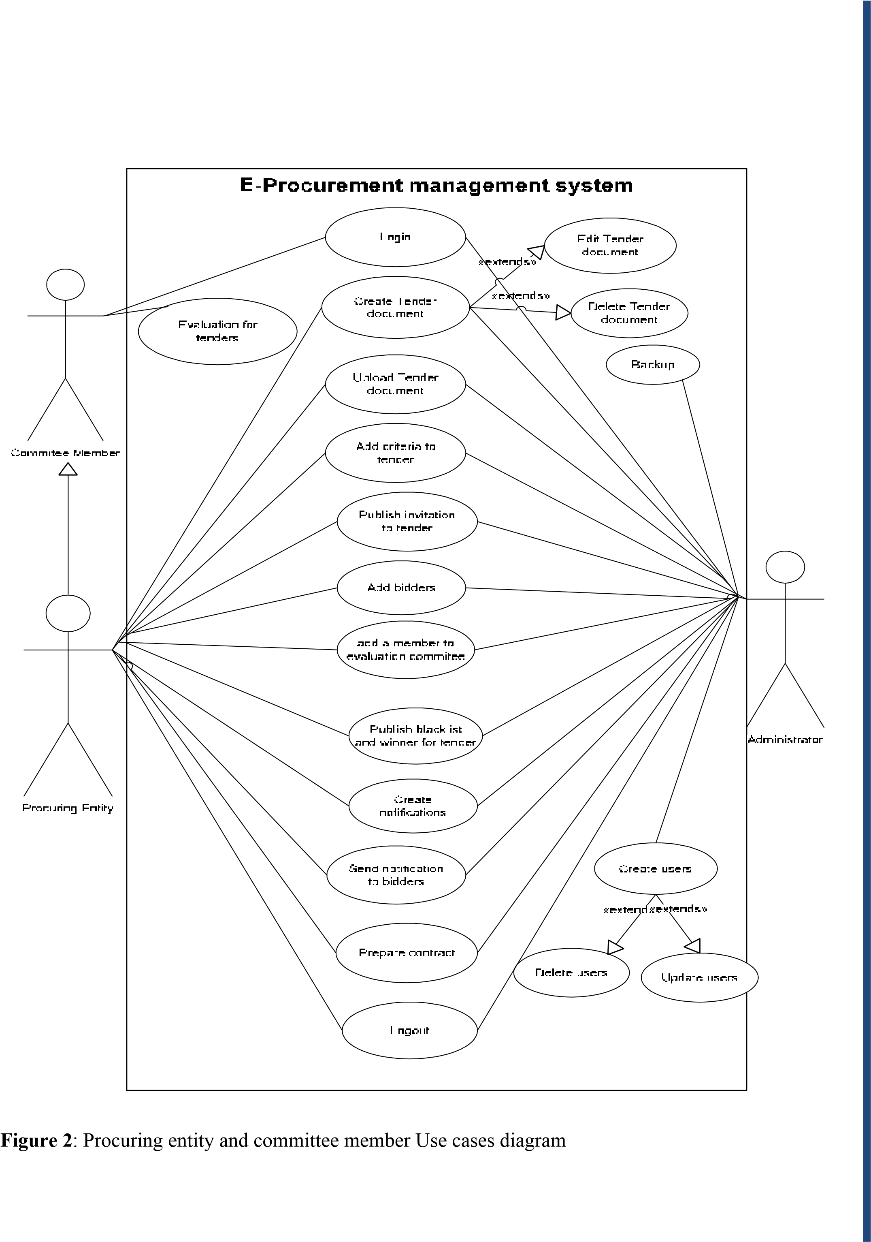

Bidders/Public

View announcement

Download Tender

Document

View black list

and winner

**E-Procurement Management System**

**Figure 3**

:

public and bidders Use case diagram.

# Use Case Description

There are twenty two use cases in this system and every use case has its use case description.

# 1. Use Case Description for Login

|  |
| --- |
| **Use case name :** Login System |
| ID : 1 |
| **Primary Actor:** Committee member, Administrator.  **Secondary Actor:** Procuring entity. |
| **Preconditions:** |
| **Flow of event**   1. The users insert their username and password. 2. If their username and password has been recorded in database, the user can access the system; else the user can not use the system. |
| **Post conditions:**  1.The users login in the system |

# 2. Use Case Description for Logout

|  |
| --- |
| **Use case name :** Logout System |
| ID : 2 |
| **Primary Actor:** Committee member, Administrator.  **Secondary Actor:** Procuring entity. |
| **Preconditions:** A valid procuring entity logged on to the system |
| **Flow of event**   1. After finishing access the system, the users will logout the system.   It is more for the security.   1. After Log out, the user back to main menu. |
| **Post conditions:** |

# 3. Use Case Description for Create Tender

|  |
| --- |
| **Use case name :** Create tender |
| ID : 3 |
| **Primary Actor:** Procuring entity, Administrator. |
| **Preconditions:** A valid procuring entity logged on to the system |
| **Flow of event**   1. After finishing access the system, the users will logout the system.   It is more for the security.   1. After Log out, the user back to main menu. |
| **Post conditions:** |

# 4. Use Case Description for Upload Tender

|  |
| --- |
| **Use case name :** Upload Tender document |
| ID : 4 |
| **Primary Actor:** Procuring entity, Administrator. |
| **Preconditions:** A valid procuring entity logged on to the system |
| **Flow of event**   1. Choose Upload tender menu 2. Browse where tender document is saved and upload it. |
| **Post conditions:** |

# 5. Use Case Description for Create Invitation

|  |
| --- |
| **Use case name :** create invitation |
| ID : 5 |
| **Primary Actor:** Procuring entity, Administrator. |
| **Preconditions:** A valid procuring entity logged on to the system |
| **Flow of event**   1. Choose create invitation menu 2. Fill all invitation information 3. Save and publish invitation information |
| **Post conditions:** |

# 6. Use Case Description for Add criteria for tender

|  |
| --- |
| **Use case name :** Add criteria to tender |
| ID : 6 |
| **Primary Actor:** Procuring entity, Administrator. |
| **Preconditions:** A valid procuring entity logged on to the system |
| **Flow of event**   1. Choose add criteria menu 2. Fill all criteria information according to tender document 3. Save all criteria information |
| **Post conditions:** |

# 7. Use Case Description for Add Bidders

|  |
| --- |
| **Use case name :** Add bidders |
| ID : 7 |
| **Primary Actor:** Procuring entity, Administrator. |
| **Preconditions:** A valid procuring entity logged on to the system |
| **Flow of event**   1. Choose opening tender document menu 2. Fill all information for bidder and representative person 3. Save all information |
| **Post conditions:** |

# 8. Use Case Description for Add a member to evaluation committee

|  |
| --- |
| **Use case name :** Add a member to evaluation committee |
| ID : 8 |
| **Primary Actor:** Procuring entity, Administrator. |
| **Preconditions:** A valid procuring entity logged on to the system |
| **Flow of event**   1. Choose add committee menu 2. Fill names for committee 3. Save |
| **Post conditions:** |

# 9. Use Case Description for publishing blacklist and winner

|  |
| --- |
| **Use case name:** publish blacklist and winner |
| ID : 9 |
| **Primary Actor:** Procuring entity, Administrator. |
| **Preconditions:** A valid procuring entity logged on to the system |
| **Flow of event**  1.Procuring entity create a report of all bidders and who are fail in evaluation and who is win and publish it. |
| **Post conditions:** |

# 10. Use Case Description for Create and send notification

|  |
| --- |
| **Use case name:** Create and send notification |
| ID : 10 |
| **Primary Actor:** Procuring entity, Administrator. |
| **Preconditions:** A valid procuring entity logged on to the system |
| **Flow of event**  1.Choose create and send notification menu  2.Create all notification and send it to all bidders |
| **Post conditions:** |

# 11. Use Case Description for Prepare Contract

|  |
| --- |
| **Use case name:** Prepare Contract |
| ID : 11 |
| **Primary Actor:** Procuring entity, Administrator. |
| **Preconditions:** A valid procuring entity logged on to the system |
| **Flow of event**   1. Choose create contract menu. 2. Create contract for awarded bidder. |
| **Post conditions:** |

# 12. Use Case Description for evaluation to tender

|  |
| --- |
| **Use case name:** Evaluation to tender |
| ID : 12 |
| **Primary Actor:** Committee member. |
| **Preconditions:** A valid procuring entity logged on to the system |
| **Flow of event**   1. Choose evaluation menu. 2. Evaluate every bidder. |
| **Post conditions:** |

# 13. Use Case Description for create users

|  |
| --- |
| **Use case name:** Create users |
| ID : 13 |
| **Primary Actor:** Administrator. |
| **Preconditions:** A valid procuring entity logged on to the system |
| **Flow of event**   1. Choose Create users menu. 2. Fill all information related to user and save it. |
| **Post conditions:** |

# 14. Use Case Description for Backup

|  |
| --- |
| **Use case name:** Backup |
| ID : 14 |
| **Primary Actor:** Administrator. |
| **Preconditions:** A valid administrator logged on to the system |
| **Flow of event**   1. Choose backup menu. 2. Make backup for all information in tender process. |
| **Post conditions:** |

# 15. Use Case Description for download tender document

|  |
| --- |
| **Use case name:** Download tender |
| ID : 15 |
| **Primary Actor:** Public, bidder. |
| **Preconditions** |
| **Flow of event**   1. From main page. 2. Choose download tender menu. 3. Download tender document. |
| **Post conditions:** |

# 16. Use Case Description for view announcement

|  |
| --- |
| **Use case name:** View announcement |
| ID : 16 |
| **Primary Actor:** Public, bidder. |
| **Preconditions** |
| **Flow of event**   1. From main page 2. Choose view announcement menu 3. Click on announcement you need. |
| **Post conditions:** |

# 17. Use Case Description for view blacklist and winner

|  |
| --- |
| **Use case name:** View blacklist and winner |
| ID : 17 |
| **Primary Actor:** Public, bidder. |
| **Preconditions** |
| **Flow of event**   1. From main page 2. Choose view blacklist and winner menu 3. All bidders displayed |
| **Post conditions:** |

## 3.3.2. Domain analysis

The main objective of domain object modeling is to improve understanding and communication by rigorously describing how concepts and phenomena in the domain are related. This is done by defining objects and classes that represent the domain phenomena and concepts.

### 3.3.2.1. A class diagram

A class diagram describes the types of objects in the system and the various kinds of static relationships that exist among them. Class diagrams also show the properties and operations of a class and the constraints that apply to the way objects are connected. The UML uses the term **feature** as a general term that covers properties and operations of a class.

A class represents the operations and attributes of one or more objects within your system.

**An attribute:** is a characteristic that describes objects of the class.

**An operation**: describes something an object of the class can do.

**Notation:**

|  |  |
| --- | --- |
|  | |
|  | |
|  |  |

In UML, a class appears as a rectangle broken into three sections. The top section identifies the name of the class, the middle section lists the attributes of the class, and the bottom section lists the operations of the class.

**A relationship** is a connection among things. The three most important relationships are:

**Dependency** is a relationship between two elements where a change to one element (the supplier) may affect or supply information needed by the other element (the client).

We use dependencies to model relationships between classifiers where one classifier depends on the other in some way, but the relationship is not really an association.

* **Generalization** is a process of organizing the features of different kinds of objects that share the same purpose.
* **Association** is a structural relationship that specifies that objects of one thing are connected to objects of another.
* **Aggregation** is a plain association between two classes represents a structural relationship between peers, meaning that both classes are conceptually at the same level, no one more important than the other.
* **Composition** is a form of aggregation, with strong ownership and coincident lifetime as part of the whole.



**Multiplicity:** constrains the number of objects of a class that can be involved in a particular relationship at any point in time.

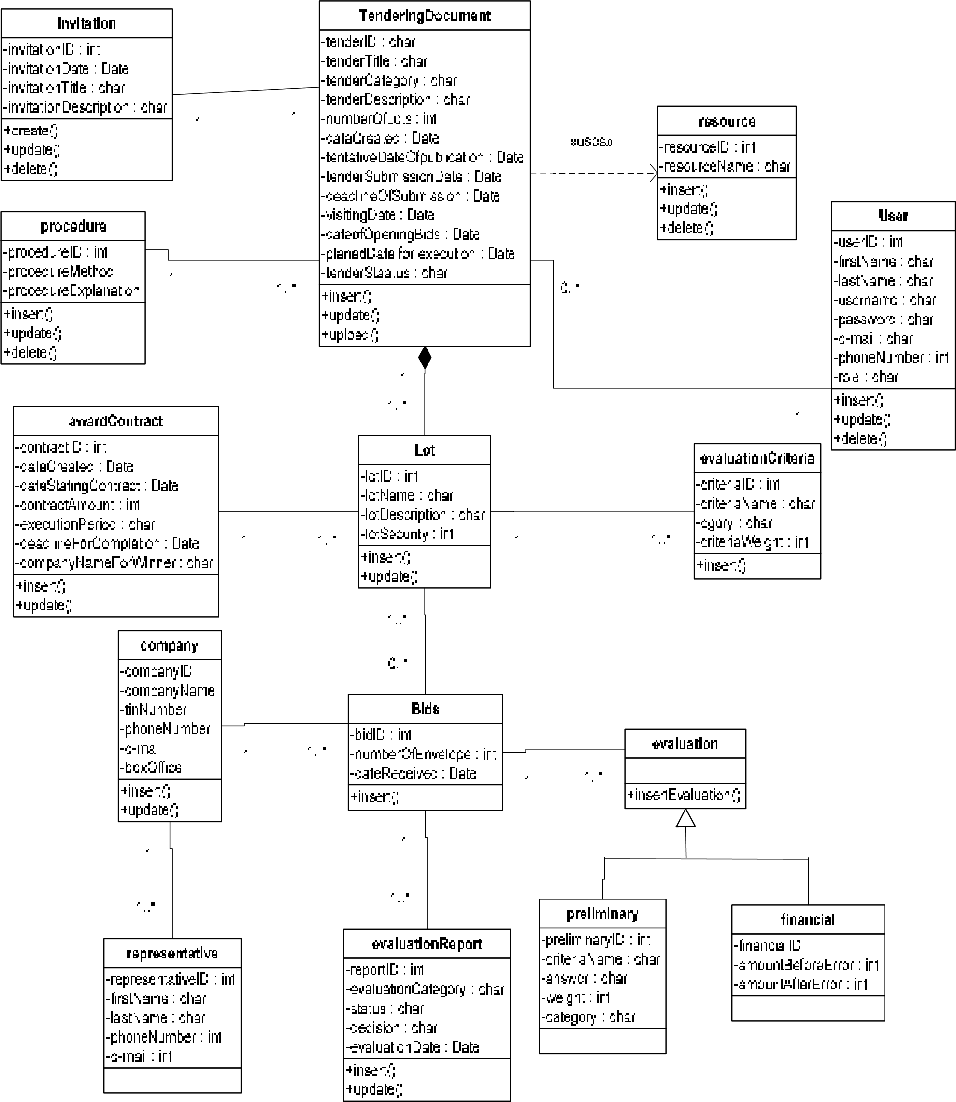

Figure 4**:** Class diagram for e-procurement management system

## 3.4. System design

System Design is the transformation of analysis models of the problem space into design models (based on the solution space).

It involves selecting strategies for building the system e.g. software/hardware platform on which the system will run and the persistent data strategy.

### 3.4.1. Architecture design

Architecture is a set of significant decisions about the organization of a software system. Such decisions include:

1. The selection of structural elements and their interfaces.
2. The composition of this structural and behavioral element into progressively larger subsystem.
3. The architectural style that guides this organization, the elements and their interfaces, their collaboration and composition.

This system will be built in a web based environment to allow users to access the system anywhere and anytime. The identified main users are committee members, procuring entity, bidders and administrator. The users have different roles when using the system and they will be connected to the database by interface. This interface will make the process of system user’s activities easier and practical.

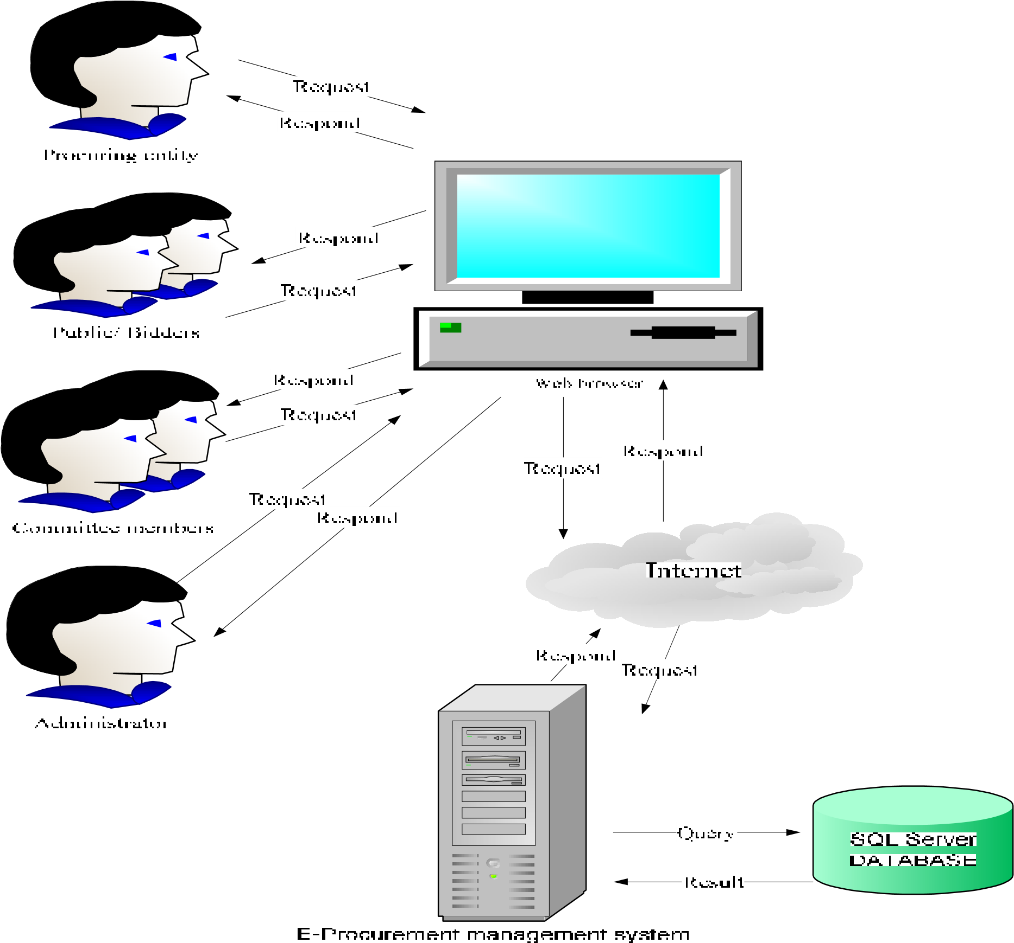

**Figure 5**: System architecture for E-procurement management system

### 3.4.2. Mechanistic design

#### 3.4.2.1. Sequence diagram

Sequence diagram shows simple interactions between objects arranged in a time sequence. It shows the objects with their lifeline and the exchange of messages between objects. If may also show the creation of new objects.

The sequence diagram shows if the object is activated with a rectangular lifeline. When an object is not active, just existing, and cannot be activated again.

The lifeline can be split into two or more concurrent lifelines. Each lifeline corresponds to a conditional branch in the message flow. The separate lifeline can merge together at some later point in time.

Along the time axis timing marks can be specified. These timing marks can be used to give constraints, like specify the maximum time a message exchange may take.

# 1. Sequence diagram for create users

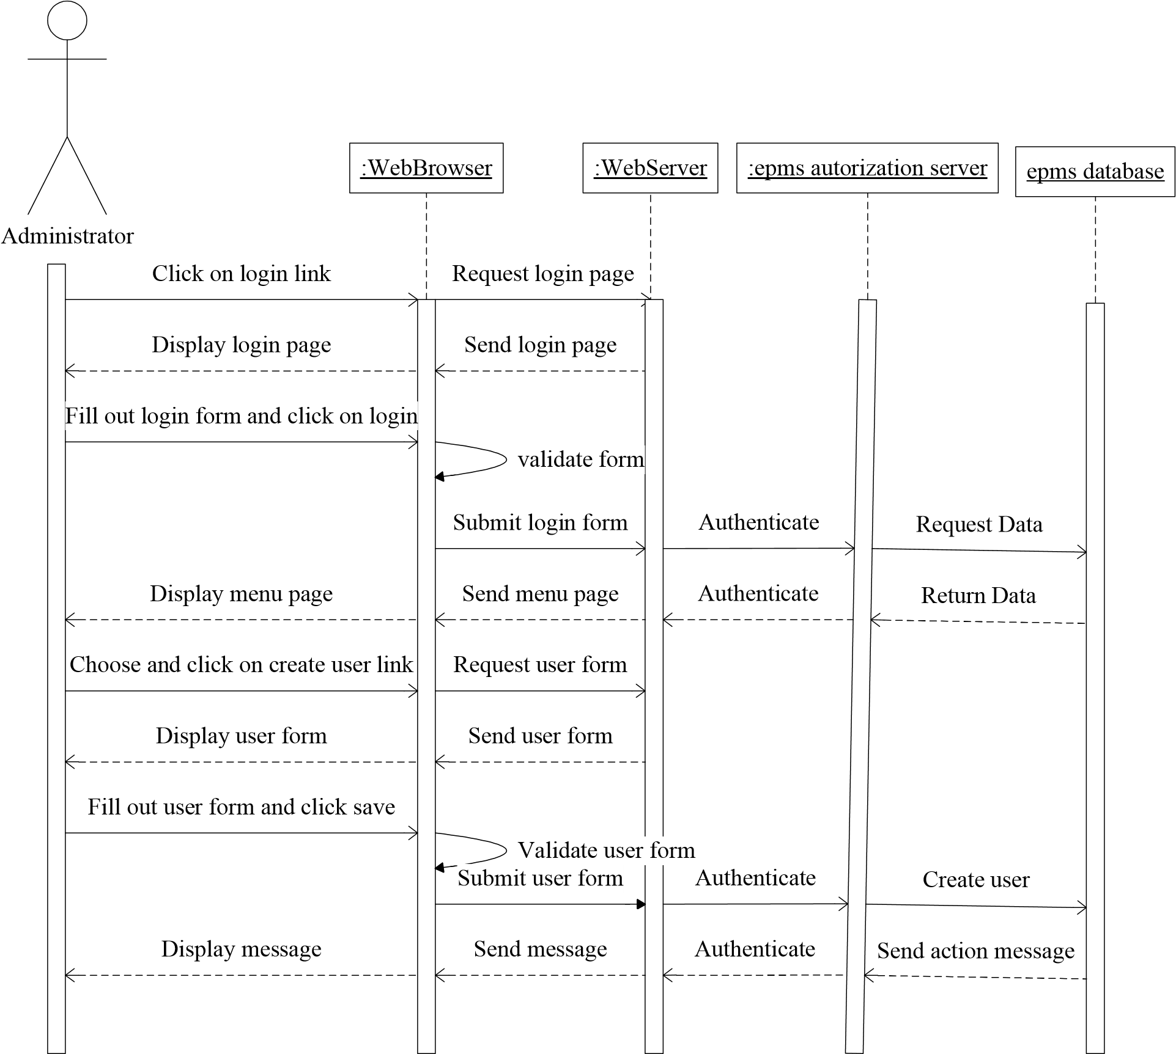

**Figure 6**: Sequence diagram for creating users

# 2. Sequence diagram for create tender document

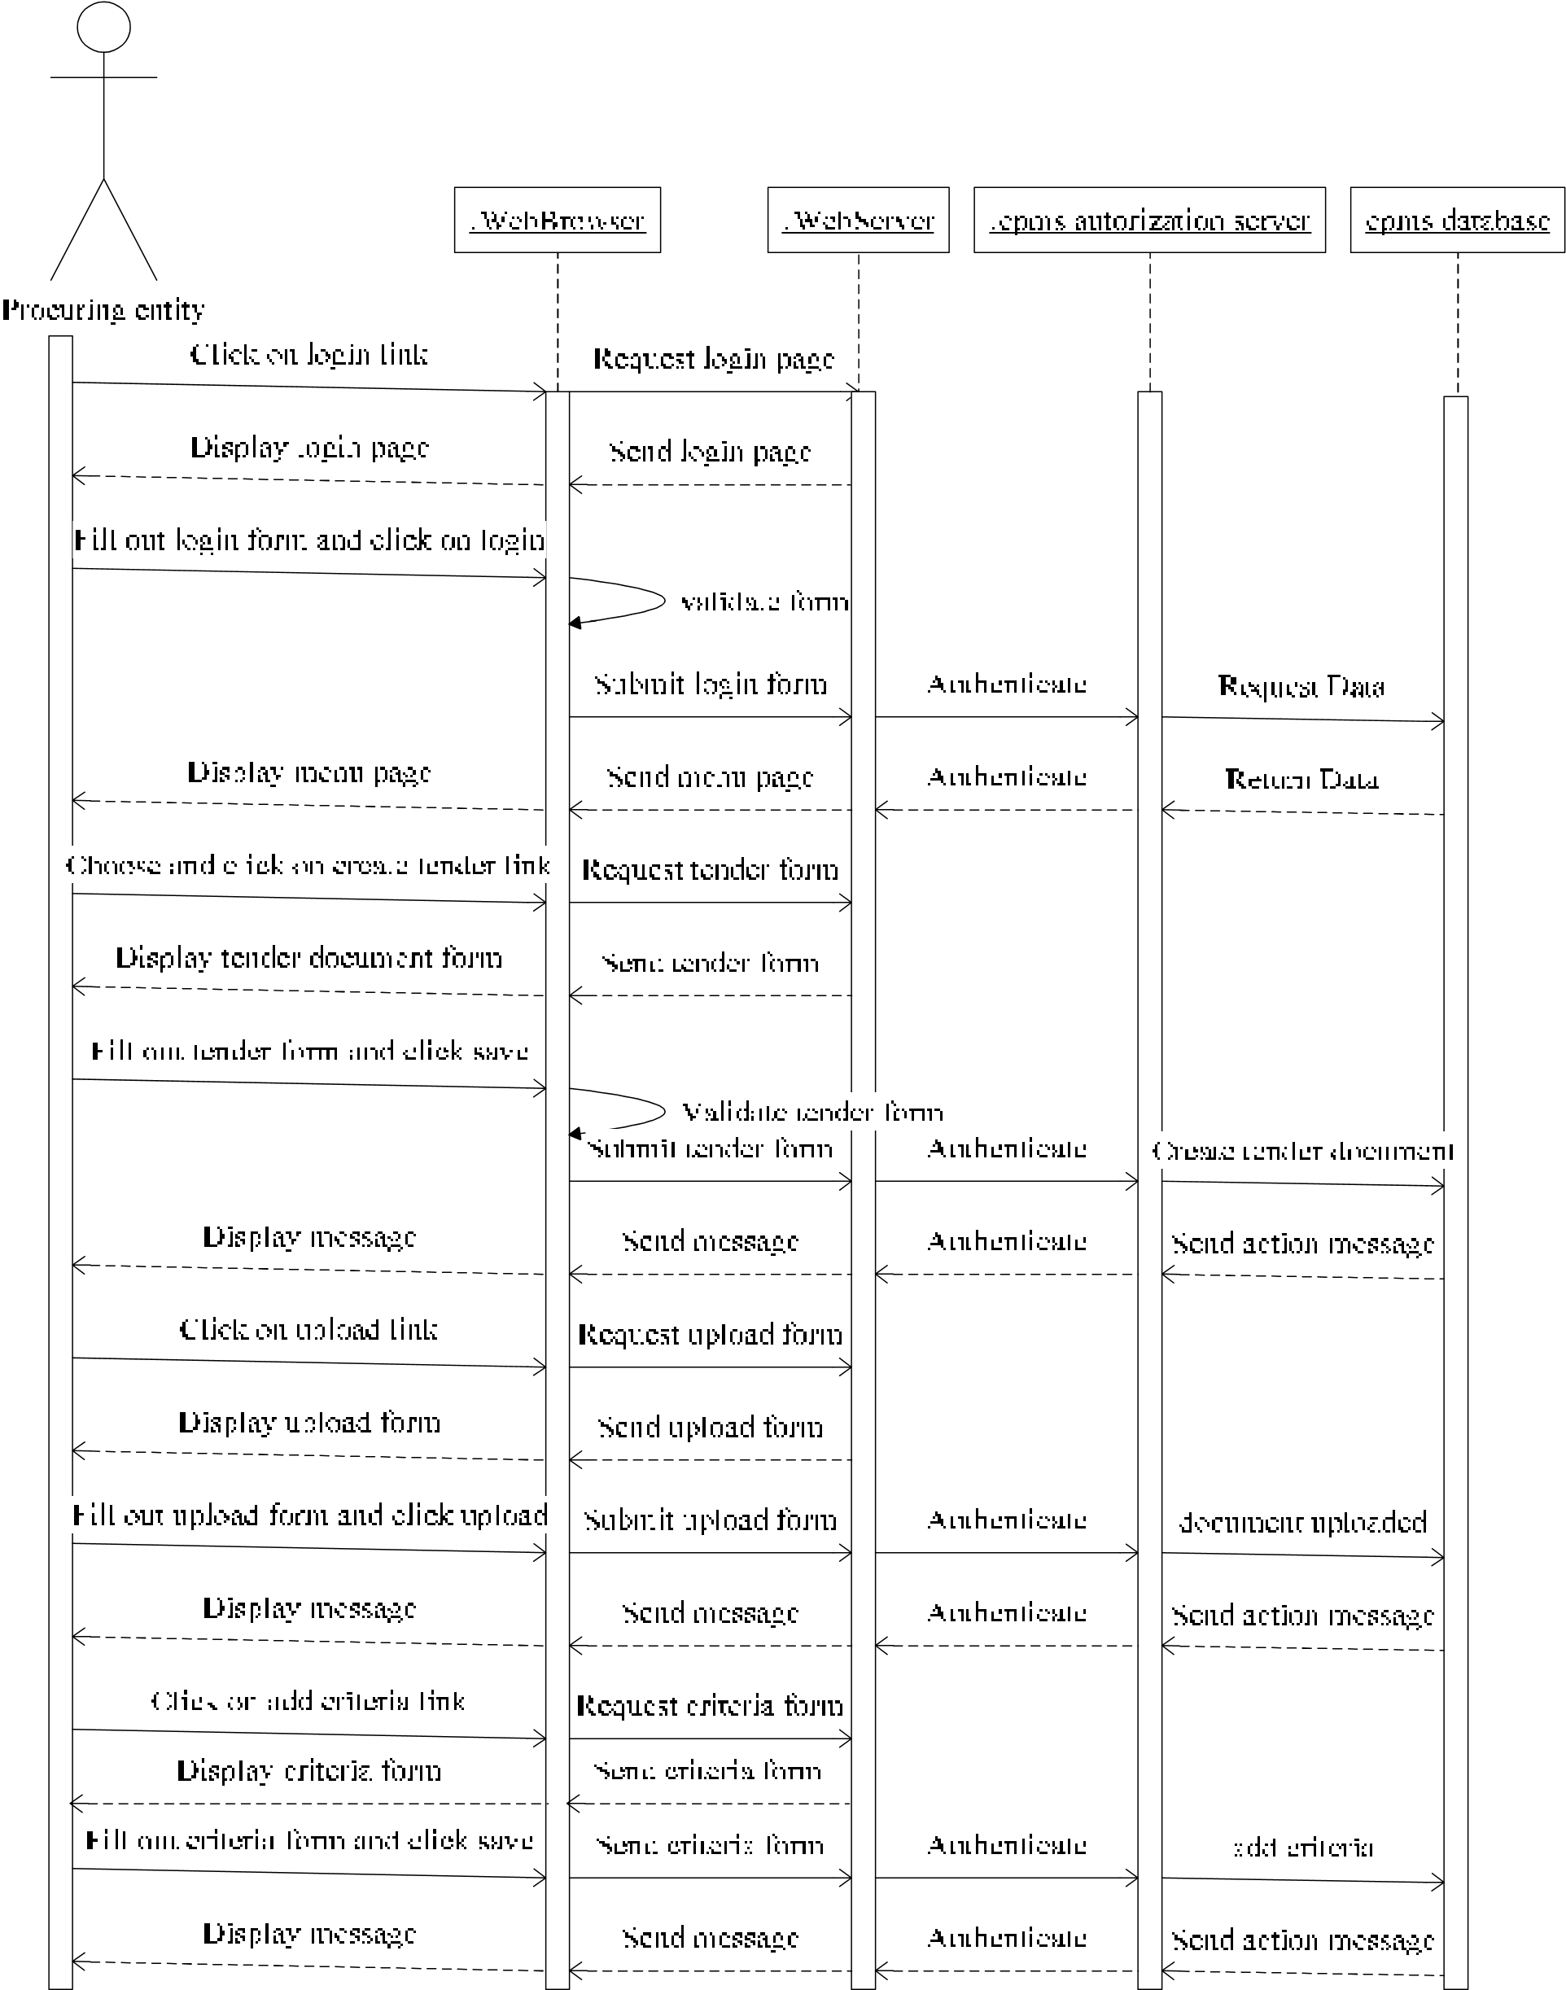

**Figure 7**: Sequence diagram for creating tender document

# 3. Sequence diagram for create invitation to tender

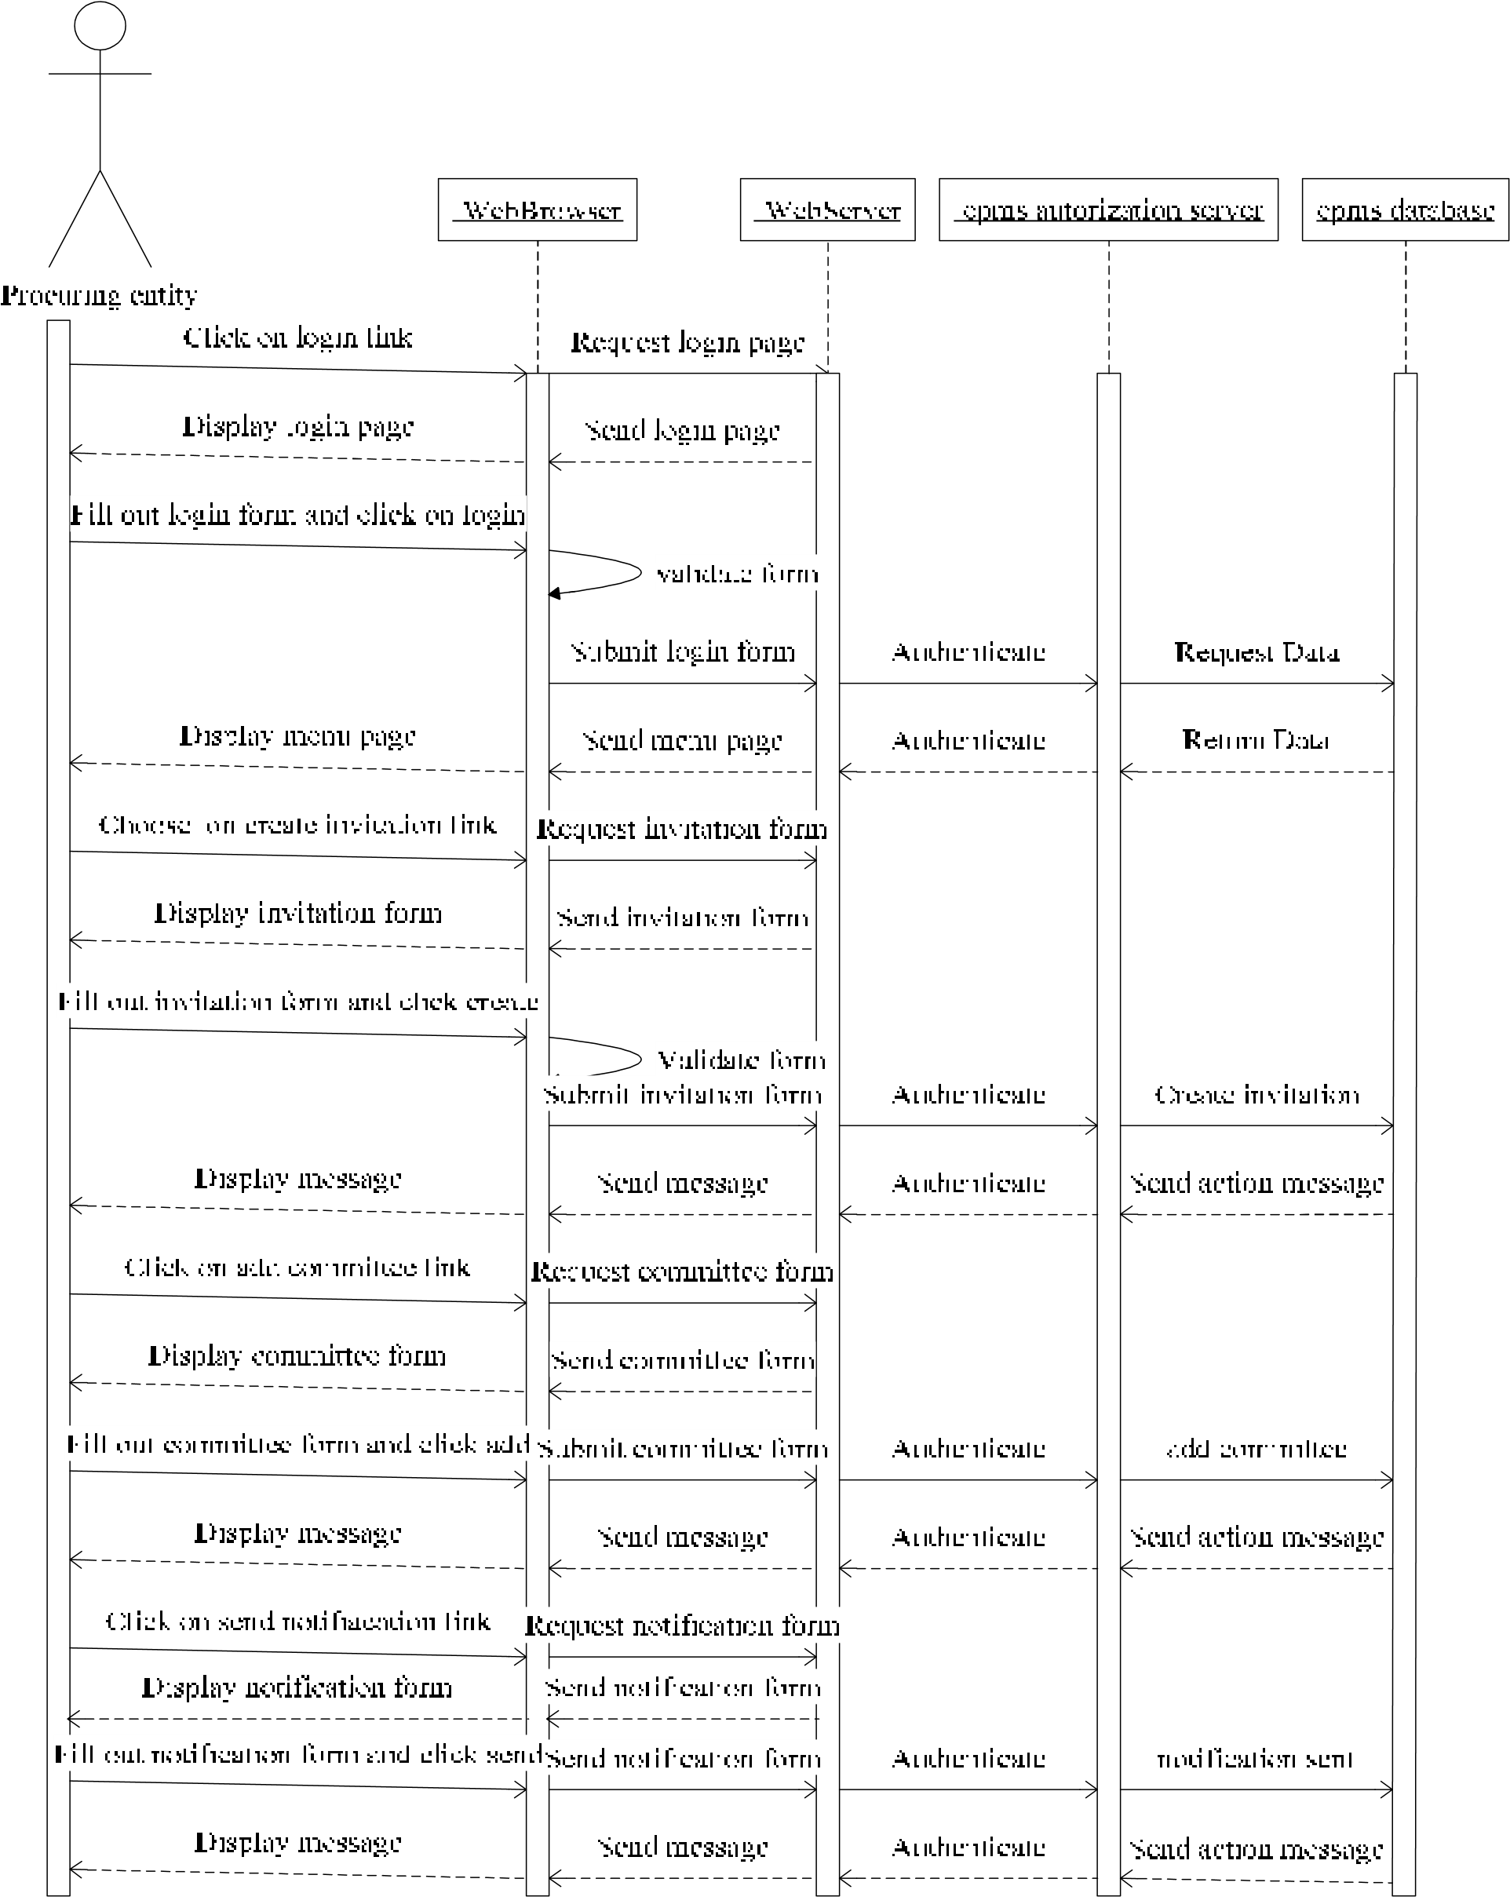

**Figure 8**: Sequence diagram for creating invitation to tender

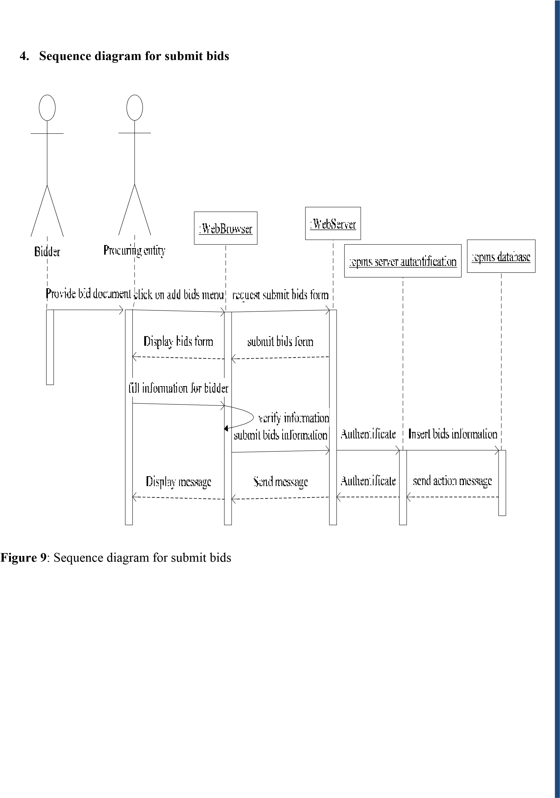

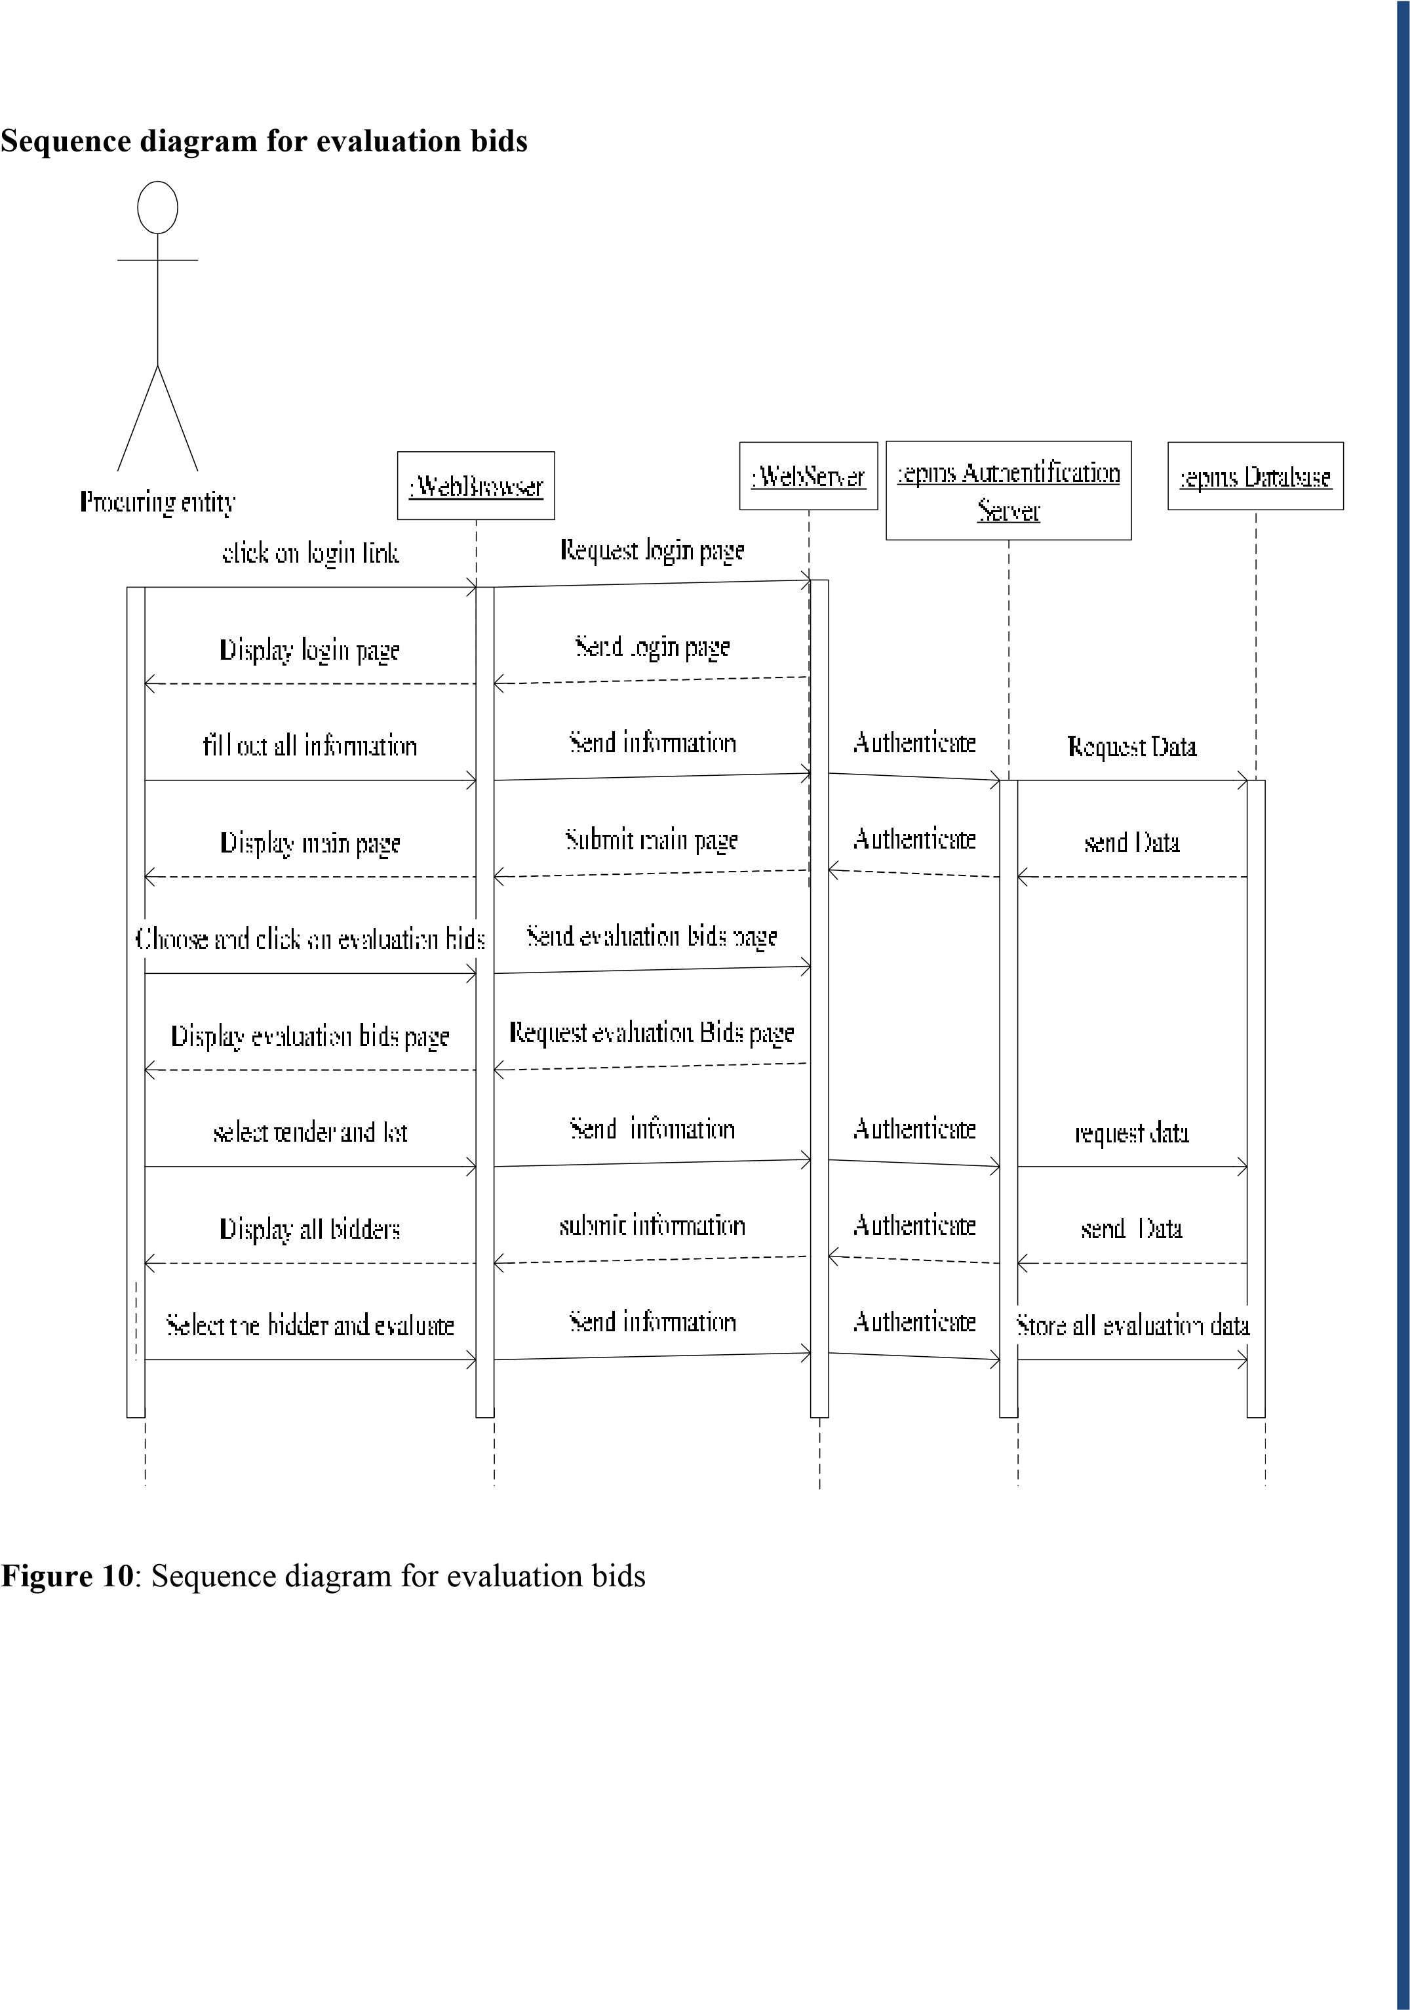

# 6. Sequence diagram for opening bids

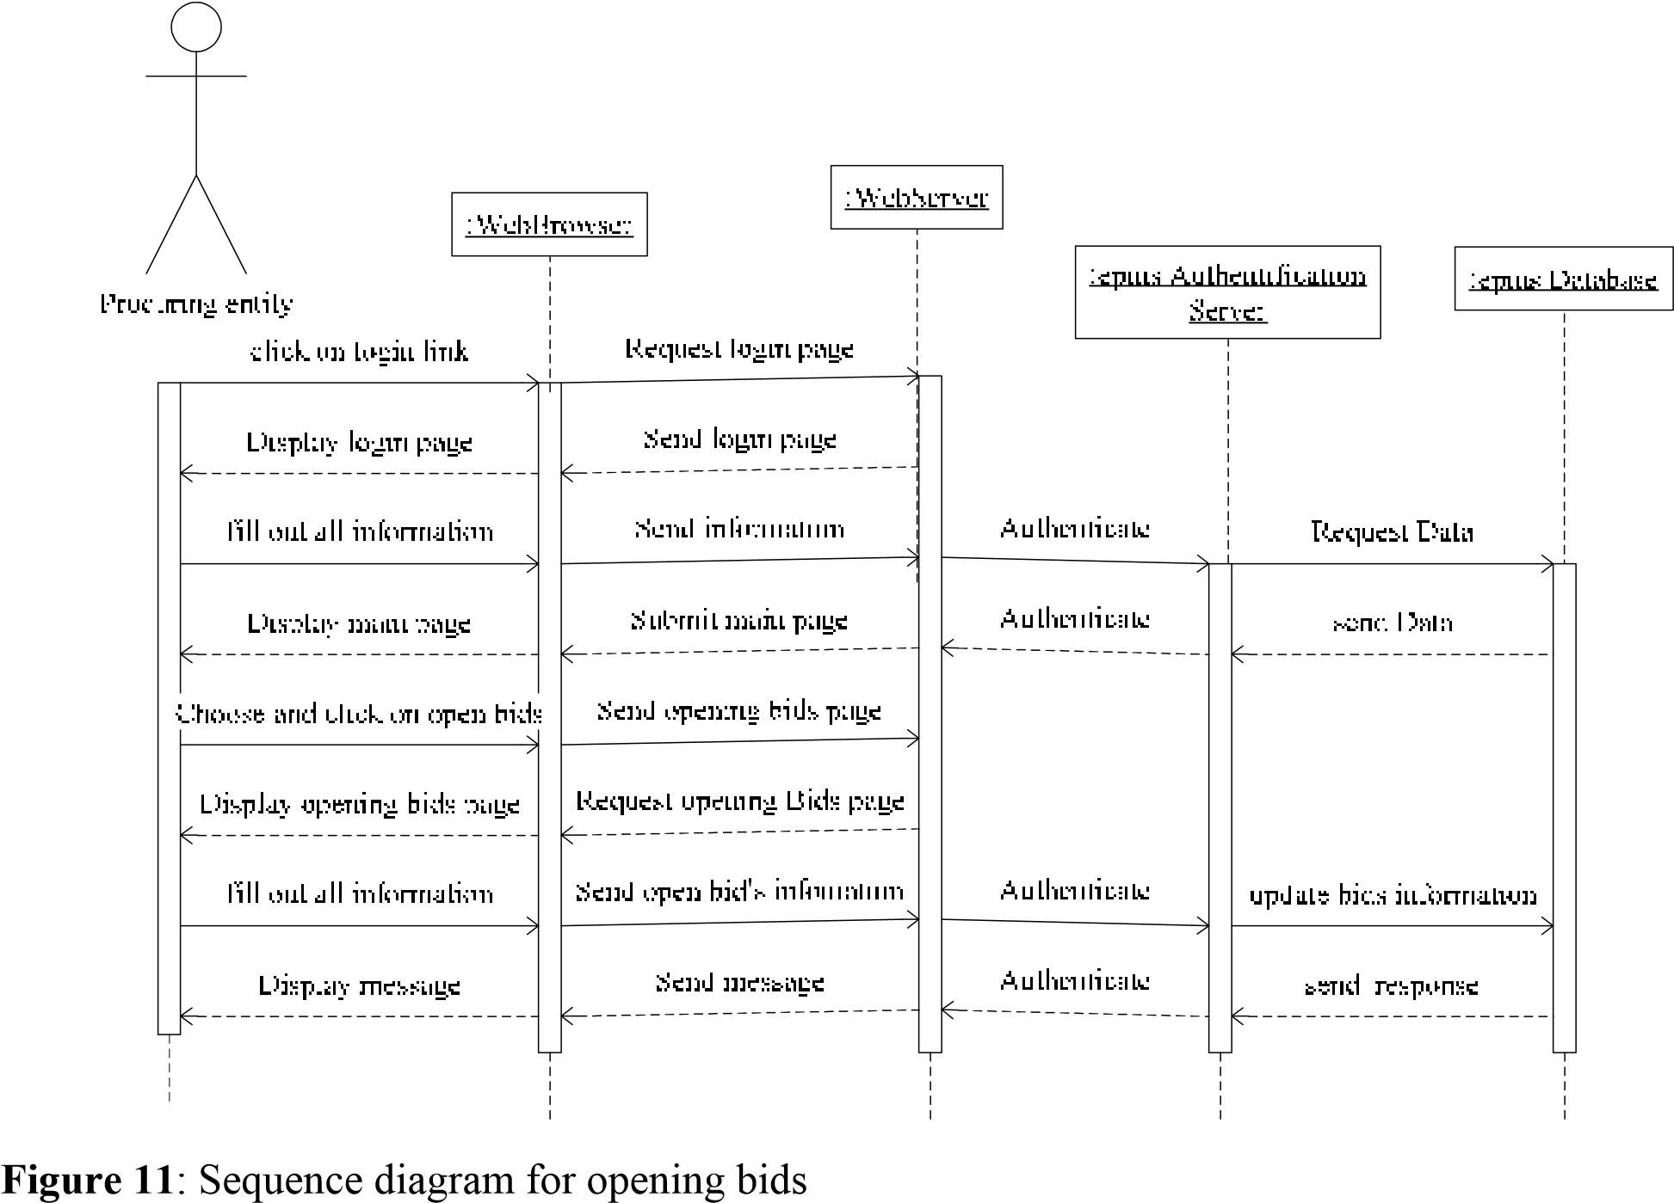

## 3.4.3. Detailed design

### 3.4.3.1. Activity diagrams

Activity diagrams are a technique to describe procedural logic, business process, and work flow. In many ways, they play a role similar to flowcharts, but the principal difference between them and flowchart notation is that they support parallel behavior.

The elements of activity diagram:

* **Start state**: signals the beginning of the activity diagram.

**Notation:** 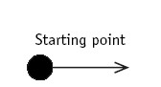

* **End state:** signals the end of the activity diagram.

**Notation:** 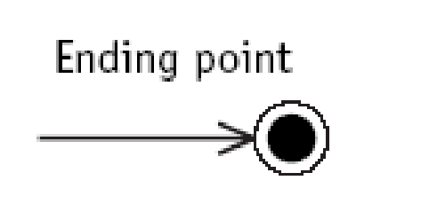

* **Action State:** shorthand for a state with an entry action and at least one outgoing transition involving the implicit event of completing the entry action.

Action expression is placed in the action state symbol.

**Notation:**

* **Fork:** used for modeling concurrency and synchronization in business processes uses a synchronization bar.

Fork represents the splitting of a single flow of control into two or more concurrent flows of controls and indicates that activities of each of these flows are truly concurrent when deployed across multiple nodes or sequentially interleaved if deployed on a single node.

**Notation:**

* **Decisions:** Decisions are expressed as guard conditions.

Different guards are used to indicate different possible transitions that depend on Boolean conditions of the owning objects. The predefined guard else may be defined for at most one outgoing transition which is enabled if all the guards labeling the other transitions are false.

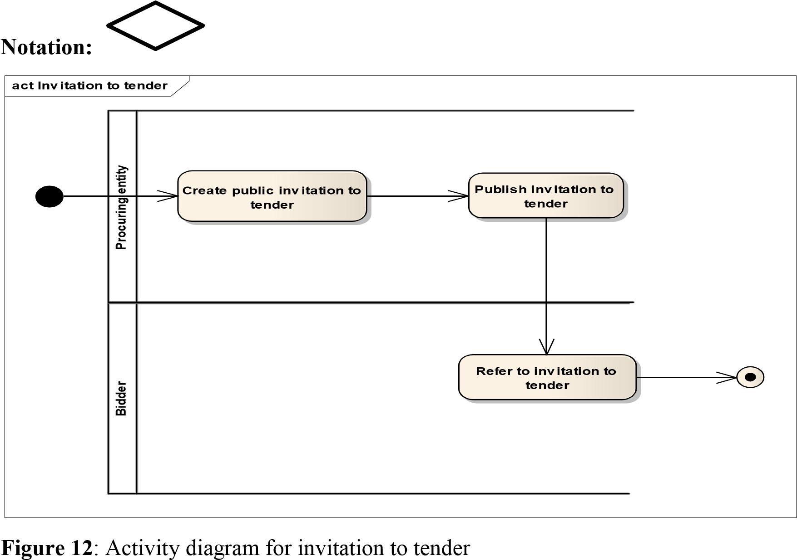

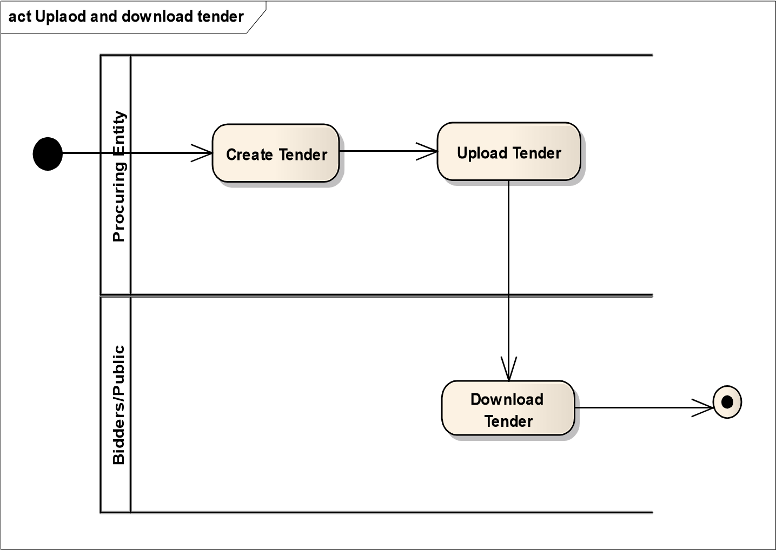

**Figure 13**: Activity Diagram for download tender

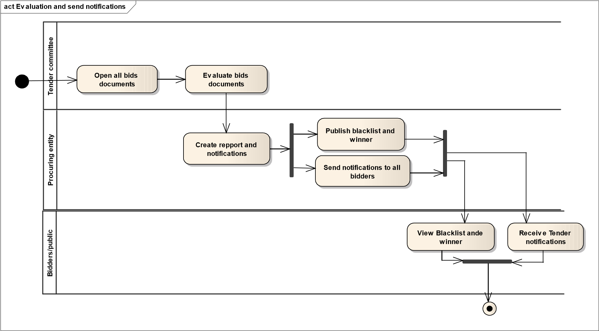

**Figure 14**: Activity Diagram for Evaluation and send notifications

### 3.4.3.2. Database schema diagram

The database, stored in the server-side, has been created to Store the information required for the proposed application.

Description of the database tables is given below.

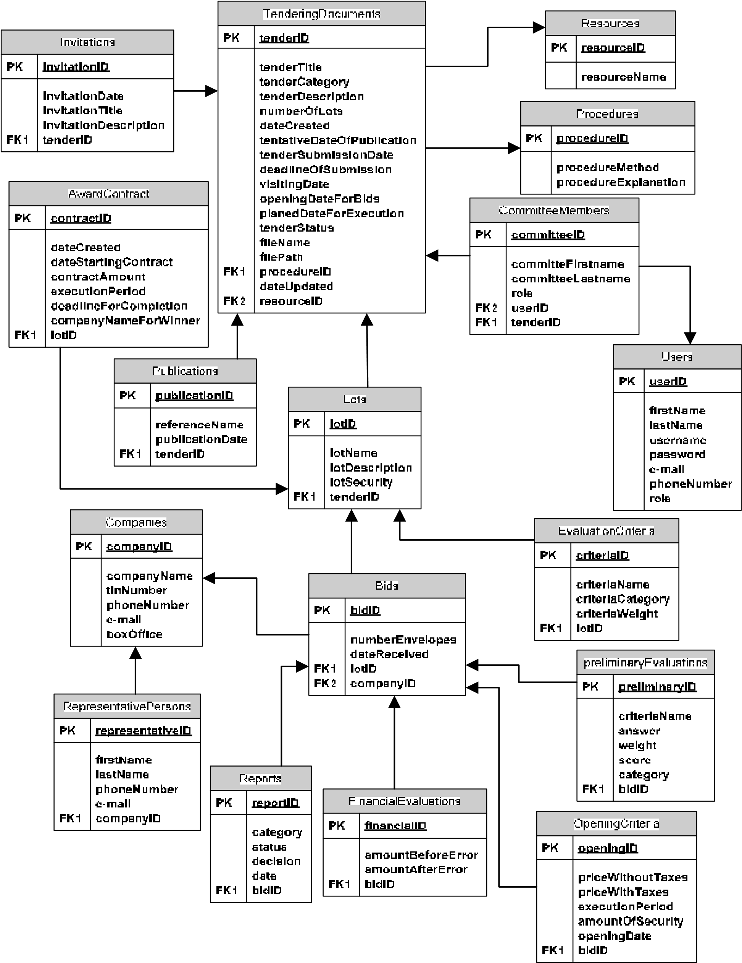

**Figure 15**: Database schema for E-procurement management system **Database Summary**

This section presents a list of all tables in the database.

A short description of each table is also provided. This list along with the database schema overview is meant to be the main point of reference, when explaining the function of each element in the database. **Number of tables: 17**

**Number of columns: 100 Number of primary keys: 17 Number of foreign keys: 14**

# Table 1: Users table details

|  |  |  |  |  |
| --- | --- | --- | --- | --- |
| **Columns** | **Constraints** | **Data type** | **Size** | **Description** |
| UserID  FirstName  LastName  Password  E-mail  PhoneNumber  Role | Primary key | Number  Text  Text  Text  Text  Number  Text | 4  20  20  20  20  10  15 | Uniquely identify User  First name of user  Last name of user Password of user e-mail of User  Mobile telephone numbers of user  Role of user |

# Table 2: Tendering document details

|  |  |  |  |  |
| --- | --- | --- | --- | --- |
| **Columns** | **Constraints** | **Data type** | **Size** | **Description** |
| TenderID  TenderTitle  TenderCategory  TenderDescription  NumberOfLots  DateCreated  TentativeDateOfPublication  TenderSubmissionDate  DeadlineOfSubmission  ClosingTimeForSubmission  VisitingDate  OpeningDateForBids  PlanedDateForExecution  TenderStatus  Filename  FilePath  DateUploaded  ProcedureID  ResourceID | Primary key  Foreign key  Foreign key | Text  Text  Text  Text  Number  Date  Date  Date  Date  Date  Date  Date  Date  Text  Text  Text  Date  Number  Number | 20  50  10  50  4  20  20  20  4  4 | Uniquely identify Tender  Title of tendering document  Category of tender document  Description of tender  Number of lots of tender  Date record was created  Date of tentative of publication  Date of beginning to submit bids  Deadline of submitting bids  Last time of submitting bids  Visiting date of tender  Date for opening bids  Planning date for execution  Status for tender  Name of file for tender  Path where tender is stored  Date for uploaded tender  Identify procedure  Identify Resource |

# Table 3: Resources details

|  |  |  |  |  |
| --- | --- | --- | --- | --- |
| **Columns** | **Constraints** | **Data type** | **Size** | **Descriptions** |
| ResourceID  ResourceName | Primary key | Number  Text | 4  20 | Uniquely identify resource  Name of resource |

# Table 4: Procedures details

|  |  |  |  |  |
| --- | --- | --- | --- | --- |
| **Columns** | **Constraints** | **Data type** | **Size** | **Descriptions** |
| ProcedureID  ProcedureMethod  ProcedureExplanation | Primary key | Number  Text  Text | 4  20  20 | Uniquely identify procedure  Method used in tendering process  Explanation of procedure |

# Table 5: Publications details

|  |  |  |  |  |
| --- | --- | --- | --- | --- |
| **Columns** | **Constraints** | **Data type** | **Size** | **Descriptions** |
| PublicationID  ReferenceName PublicationDate  TenderID | Primary key  Foreign key | Number  Text  Date/Time  Number | 4  50  4 | Uniquely identify publication  Name of journal  Date of publication for tender  Identify for tender document |

# Table 6: Invitations details

|  |  |  |  |  |
| --- | --- | --- | --- | --- |
| **Columns** | **Constraints** | **Data type** | **Size** | **Descriptions** |
| InvitationID  InvitationDate InvitationTitle  InvitationDescription  TenderID | Primary key  Foreign key | Number  Date/Time  Text  Text  Number | 4  50  500 | Uniquely identify invitation  Date of invitation to tender  Title of invitation for tender  Description of invitation  Identify for tender document |

# Table 7: Lots details

|  |  |  |  |  |
| --- | --- | --- | --- | --- |
| **Columns** | **Constraints** | **Data type** | **Size** | **Descriptions** |
| LotID  LotName  LotDescription  LotSecurity  TenderID | Primary key  Foreign key | Number  Text  Text  Number  Number | 4  50  300  9  4 | Uniquely identify lot  Name of lot  Description of lot  Security of lot  Identify for tender document |

# Table 8: EvaluationCriteria

|  |  |  |  |  |
| --- | --- | --- | --- | --- |
| **Columns** | **Constraints** | **Data type** | **Size** | **Descriptions** |
| criteriaID  CriteriaName  CriteriaCategory  CriteriaWeight  LotID | Primary key  Foreign Key | Number  Text  Text  Number  Number | 4  50  20  3 | Uniquely identify evaluation criteria  Name of criteria  Category of criteria  Weight of criteria  Identify for lot |

# Table 9: Companies details

|  |  |  |  |  |
| --- | --- | --- | --- | --- |
| **Columns** | **Constraints** | **Data type** | **Size** | **Descriptions** |
| CompanyID  CompanyName  TinNumber  PhoneNumber  E-mail  BoxOffice | Primary key | Number  Text  Text  Number  Text  Text | 4  20  20  10  20  15 | Uniquely identify company  Name of company(bidder)  Tin number of company  Telephone of company  E-mail of company  Office box of company |

# Table 10: RepresentativePersons details

|  |  |  |  |  |
| --- | --- | --- | --- | --- |
| **Columns** | **Constraints** | **Data type** | **Size** | **Descriptions** |
| personID  FirstName  LastName  PhoneNumber  E-mail  CompanyID | Primary key  Foreign key | Number  Text  Text  Number  Text  Number | 4  20  20  10  20  4 | Uniquely identify person  First Name of person  Last Name of person  Telephone of person  E-mail of person  Identify of company |

# Table 11: Bids details

|  |  |  |  |  |
| --- | --- | --- | --- | --- |
| **Columns** | **Constraints** | **Data type** | **Size** | **Descriptions** |
| bidID  NumberOfEnvelopes  DateReceived  LotID  CompanyID | Primary key  Foreign key  Foreign key | Number  Number  Date  Number  Number | 4  2  4  4 | Uniquely identify bid Number of envelopes  Date of receive bid  Identify of lot  Identify of company |

# Table 12: OpeningCriteria details

|  |  |  |  |  |
| --- | --- | --- | --- | --- |
| **Columns** | **Constraints** | **Data type** | **Size** | **Descriptions** |
| OpeningID  PriceWithoutTaxes  PriceWithTaxes  ExecutionPeriod AmountOfSecurity openingDate  BidID | Primary key  Foreign key | Number  Number  Number  Date  Number  Date  Number | 4  10  10  10  4 | Uniquely identify opening bid  Price of tender without taxes  Price of tender with all taxes  Period of execution  Amount of security of tender  Date of opening bids  Identify bid |

# Table 13: PreliminaryEvaluations details

|  |  |  |  |  |
| --- | --- | --- | --- | --- |
| **Columns** | **Constraints** | **Data type** | **Size** | **Descriptions** |
| PreliminaryID  CriteriaName  Answer  Weight Score category BidID | Primary key | Number  Text  Text  Number  Number  Text  Number | 4  20  50  4  4  20  4 | Uniquely identify Preliminary evaluation  Criteria name of evaluation  Answer of evaluation  Weight of evaluation  Score of evaluation  Category of evaluation  Identify bids |

# Table 14: FinancialEvaluations details

|  |  |  |  |  |
| --- | --- | --- | --- | --- |
| **Columns** | **Constraints** | **Data type** | **Size** | **Descriptions** |
| FinancialID  AmountBeforeError  AmountAfterError  BidID | Primary key  Foreign key | Number  Number  Number  Number | 4  10  10  4 | Uniquely identify Financial result  Amount of calculation of before error  Amount of calculation of after error  Identify bid |

# Table 15: Reports details

|  |  |  |  |  |
| --- | --- | --- | --- | --- |
| **Columns** | **Constraints** | **Data type** | **Size** | **Descriptions** |
| reportID  Category  Status  Decision  Date  BidID | Primary key  Foreign key | Number  Text  Text  Text  Date  Number | 4  20  20  20  4 | Uniquely identify of report  Decision of evaluation  Status of evaluation  Decision of evaluation  Date of evaluation  Identify bid |

# Table 16: AwardContract details

|  |  |  |  |  |
| --- | --- | --- | --- | --- |
| **Columns** | **Constraints** | **Data type** | **Size** | **Descriptions** |
| ContractID  DateCreated  DateStartingContract  ContractAmount  ExecutionPeriod  DeadlineForCompletion  CompanyNameForWinner  LotID | Primary key  Foreign key | Number  Date  Date  Number  Text  Date  Text  Number | 4  20  10  100  20  4 | Uniquely identify contract  Date created  Date of starting contract  Amount of contract for tender  Execution period for tender  Deadline of execution for tender  Name of bidder  Identify lot |

# Table 17: CommitteeMembers details

|  |  |  |  |  |
| --- | --- | --- | --- | --- |
| **Columns** | **Constraints** | **Data type** | **Size** | **Descriptions** |
| CommitteeID  CommitteeFirstname  CommitteLastname  Role UserID tenderID | Primary key  Foreign key  Foreign key | Number  Text  Text  Text  Number  Number | 4  20  20  20  4  4 | Uniquely identify committee members  First Name of committee member  Last Name of committee member  Role of committee member  Identify user  Identify tender |

# CHAPTER 4: NEW SYSTEM IMPLEMENTATION AND TESTING

## 4.1. Introduction

In this chapter, will describe more about the result from design phase whereas it is used as an input for the implementation and testing process before implement the new system, must complete the detail planning to ensure the developed system can be functioning well and complete. The end result which is e-Procurement Management System will undergo certain implementation steps which will be explained in the following part.

## 4.2. Languages and tools used for the system implementation

To develop e-Procurement Management System, we used the following tools:

* Microsoft Visual C#.Net 2008;
* Microsoft SQL Server 2005;
* Crystal Reports for Visual Studio .NET;
* Ozeki Message Server 6

### 4.2.1. Microsoft Visual C#.Net 2008

Microsoft Visual Studio is an integrated development environment (IDE) from Microsoft. It is used to develop console and graphical user interface applications along with Windows Forms applications, web sites, web applications, and web services in both native code together with managed code for all platforms supported by Microsoft Windows and Windows Mobile.

Visual Studio includes a code editor supporting IntelliSense as well as code refactoring. The integrated debugger works both as a source-level debugger and a machine-level debugger. Other built-in tools include a forms designer for building GUI applications, web designer, class designer, and database schema designer.

Visual Studio supports different programming languages by means of language services, which allow the code editor and debugger to support nearly any programming language, provided a language-specific service exists. Built-in languages include C/C++ (via Visual C++), VB.NET (via Visual Basic .NET) and C# (via Visual C#).

### 4.2.2. Microsoft SQL Server 2005

Microsoft SQL Server is a relational database server, developed by Microsoft: it is a software product whose primary function is to store and retrieve data as requested by other software applications, be it those on the same computer or those running on another computer across a network (including the Internet).

SQL Server 2005 released in October 2005, is the successor to SQL Server 2000. It included native support for managing XML data, in addition to relational data. For this purpose, it defined an xml data type that could be used either as a data type in database columns or as literals in queries.

XML is converted to an internal binary data type before being stored in the database. Specialized indexing methods were made available for XML data. XML data is queried using XQuery; Common Language Runtime (CLR) integration was a main feature with this edition, enabling one to write SQL code as Managed Code by the CLR. SQL Server 2005 added some extensions to the T-SQL language to allow embedding XQuery queries in T-SQL. In addition, it also defines a new extension to XQuery, called XML DML that allows query-based modifications to XML data.

A database is typically a group that includes at least a set of table objects and, more often than not, other objects, such as stored procedures and views that pertain to the particular grouping of data stored in the database’s tables.

### 4.2.3. Crystal Reports for Visual Studio .NET

Crystal Reports has enjoyed a long association with Microsoft and has shipped with Visual Studio as the default report writer since 1993.

In simplest terms, Crystal Reports is a report design tool that allows you to create reports that can retrieve and format a result set from a database or other data source.

In addition to a powerful toolset for actually creating reports, Crystal Reports also features a number of APIs and tools specifically created for developers to allow them to integrate these reports into their own applications.

To start with, Crystal Reports.NET includes an integrated Report Designer available within the Visual Studio IDE that you can use to create report files (.rpt) to integrate with your application.

Once you have a basic report designed, you can then add features like formula fields, running totals, graphs, and so on to make your report design as complex as required. Reports come in all shapes, sizes and forms.

After you have created a report, you need some way to display this report from your application, and Crystal Reports.NET has two different viewers to make this happen.

* The Windows Forms Viewer can be used with windows applications to preview any reports you have integrated into your application and feature a rich object model that allows you to control the appearance of the viewer and some aspects of the report at run time.
* For web-based application, there is also a Web Forms Viewer that has similar functionality and allows you to view reports you have integrated into your web applications.

### 4.2.4. ASP.NET 3.5

ASP.NET is a unified Web development model that includes the services necessary for you to build enterprise-class Web applications with a minimum of coding. ASP.NET is part of the .NET Framework, and when coding ASP.NET applications you have access to classes in the .NET Framework. You can code your applications in any language compatible with the common language runtime (CLR), including Microsoft Visual Basic, C#, JScript .NET, and J#. These languages enable you to develop ASP.NET applications that benefit from the common language runtime, type safety, inheritance, and so on.

I’ve chosen Visual C#.Net 2008 for this project. It’s easy to use, it’s also the most popular computer language ever created.

Visual C#.Net 2008, pronounced C sharp, is a programming language designed for building a wide range of applications that run on the .NET Framework. It is a new object oriented language from Microsoft. It is a major part of the Visual Studio .NET development environment.

### 4.2.5. Ozeki Message Server 6

Ozeki Message Server 6 is a powerful, flexible SMS Gateway application that enables you and your applications to send/receive SMS messages to mobile devices with your computer. It has an easy-to-use user interface, and an excellent internal architecture. The application can use a GSM mobile phone attached to the PC with a phone-to-PC data cable or IP SMS technology to transmit and receive the messages.

## 4.3. Software Testing and Results

### 4.3.1. Testing Methodology, Tools and techniques

Software testing is a process of verifying and validating that a software application or program meets the business and technical requirements that guided its design and development, and works as expected.

Software testing has three main purposes: verification, validation, and defect finding.

* The verification process confirms that the software meets its technical specifications. A specification is a description of a function in terms of a measurable output value given a specific input value under specific preconditions.
* Validation is the process of evaluating a system or component during or at the end of the development process to determine whether it satisfies specified requirements.
* A defect is a variance between the expected and actual result. The defect’s ultimate source may be traced to a fault introduced in the specification, design, or development (coding) phases.

There are two basic techniques of software testing: black box testing and white box testing.

* **Black box testing** (also called functional testing) is testing that ignores the internal mechanism of a system or component and focuses solely on the outputs generated in response to selected inputs and execution conditions.
* **White box testing** (also called structural testing and glass box testing) is testing that takes into account the internal mechanism of a system or component.

With black box testing, the software tester does not (or should not) have access to the source code itself. The code is considered to be a “big black box” to the tester who can’t see inside the box. The tester knows only that information can be input into to the black box, and the black box will send something back out. Based on the requirements knowledge, the tester knows what to expect the black box to send out and tests to make sure the black box sends out what it’s supposed to send out. Alternatively, white box testing focuses on the internal structure of the software code. The white box tester (most often the developer of the code) knows what the code looks like and writes test cases by executing methods with certain parameters.

### 4.3.2. Unit Testing Results

Unit testing is the testing of individual hardware or software units or groups of related units. Using white box testing techniques, the developers creating the code implementation verify that the code does what it is intended to do at a very low structural level.

### 4.3.3. Integration Testing Results

Integration test is testing in which software components, hardware components, or both are combined and tested to evaluate the interaction between them.

The purpose of this testing is to verify application works with other applications. This means, an output from one module can be used as an input for other module.

For example when testing a web interface, this means testing for compatibility with different browsers and connection speeds.

### 4.3.4. User Acceptance Test Results

After functional and system testing, the product is delivered to a customer and the customer runs black box acceptance tests based on their expectations of the functionality.

Acceptance testing is formal testing conducted to determine whether or not a system satisfies its acceptance criteria (the criteria the system must satisfy to be accepted by a customer) and to enable the customer to determine whether or not to accept the system.

### 4.3.5. E-PMS graphical interfaces

In this section the detailed of E-PMS is represented with sample views from tendering activity conducted by using the system. The detailed description of the functionality provided through these user interfaces.

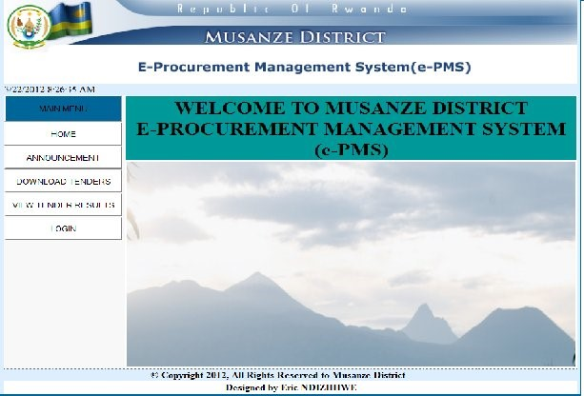

**Figure 16**: Home page

Figure 16 shows the starting point of E-PMS. This screen has 4 main functions namely “Announcement” for public to get information, “Download tenders” for public to get tender document online, “View tender result” for bidders to get the final result of evaluation and ”Login” for users to log into the system.

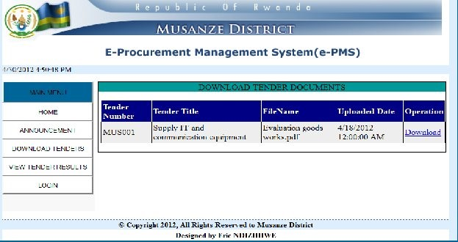

**Figure 17**: Download tender document

Figure 17 shows how the public and bidders can download tender document by clicking on file name for tender document.

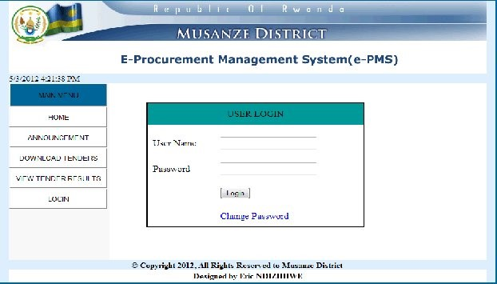

# Figure 18: Login page

Figure 18 above shows the login page of E-PMS. Each user of the system must be authenticated to access system resources.

This aspect takes into consideration the system security and information integrity.

Depending on the rights held, one can login as Administrator, Procuring Entity or Committee member.

After selecting role of user and typing username and password, the system will display main menu of each user according to its right.

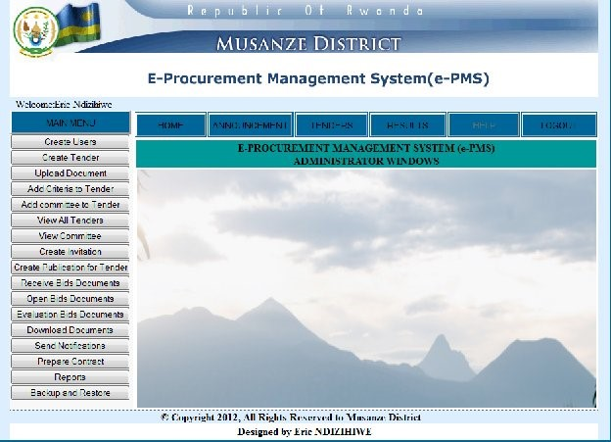

**Figure 19**: Administrator menu

Figure 19 show main menu for administrator at this level it is assumed that an administrator is the person with super rights to manage the system resources like the knowledge engineers.

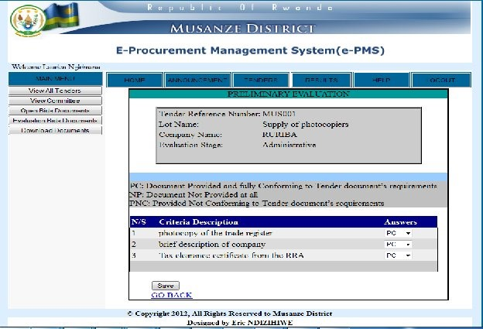

**Figure 20**: Evaluation form

Committee members log into the system and execute the evaluation task by selecting answers according to criteria description as shown in figure 20 above.

# CHAPTER 5: CONCLUSION AND RECOMMENDATION

## 5.1. Conclusion

Based on the findings from the study, the following conclusions were drawn.

E-Procurement Management System can improve the procurement process significantly. It can help in terms of having an easy access on data, easy storage of data and in the evaluation process in the procuring unit of the Musanze district. The project improves the quality of existing operations in Procurement system in Musanze District. It is considered to be successful with the objectives met and with the new system working as it should be.

## 5.2. Recommendation

Recommend to Musanze District the scope of study to use this system in order to improve their services. The people with similar objectives are encouraged to provide future enhancement of the system. This will allow making adjustments to increase the efficiency of the system, for example to facilitate the procurement unit to keep the bidders’ details and evaluate accuracy of the bidders’ submissions.

**REFERENCES**

# 1. Bibliography

Dan, P., Neil, P. (2005).**UML 2.0 in a Nutshell,** O'Reilly, the United States of America.

Doug, R., Matt, S. (2007).**Use Case Driven Object Modeling with UML**: Theory and Practice, Apress, the United States of America.

Jim, A., Ila, N. (2002).**UML and the Unified Process** Practical object-oriented analysis and design, Pearson Education, Great Britain.

Mukwende, P. (2011).**Course of Software Engineering**, Adventist University of Central Africa, Kigali, Rwanda.

Mathieu, M., Adam, F., Mario, S. (2010**).Pro ASP.NET 4 in C# 2010**, Apress, the United States of America.

Nsegiyumva, S., Kayoranga, R. E. (2007).**Module de formation sur les procedures de passion des marches publics**, RPPA, Kigali, Rwanda.

Official Gazette of the Republic of Rwanda (2007). **Law on Public Procurement.**

Sebahashyi, N. A.(2011).**Cours de Methodologies de conception de système d’information**, Adventist University of Central Africa, Kigali, Rwanda.

# 2. Websites

http://www.musanze.gov.rw http://www.wikipedia.com http://www.google.com http://www.msdn.microsoft.com