POE Part 1

PROG6212

JOSH NAPIER ST10291238

2024

**Documentation:**

When it came to the design of my Contract Monthly Claim System, I decided to take a simpler approach as to not overwhelm and intimidate the user when making use of the system. The design of every page makes use of large, bold text to convey important information and colourful buttons to indicate to the user the importance of each function. The look of every page is very clean without any unnecessary decorations in order to appear professional and in line with an academic environment (Lepard, 2023).

The type and structure of my database is very important as security and reliability are needed when dealing with sensitive information such as the information being used by this proposed system. The type of database I will be using is a secure SQL database and it will be structured in the form of relational tables that each contain data for their own specified entities. These tables also share certain pieces of data in the form of Primary and Foreign keys which creates the relationship between them. The system will make major use of this database for its functionality (Amazon Web Services, 2024).

The layout of the GUI is simple and straightforward so as to make the user experience more enjoyable. (Note: It is assumed that the user is signed in as an administrator which means that all concept functionality is available to use.) When first booting up the system, the user is presented with the name of the system in the top left corner, a navigation bar with multiple options, a home page with multiple buttons, and a claim status overview section. Clicking on the “Submit Claim” option in the navigation bar or the blue “Submit” button on the home page will take the user to the “Claims” page where a lecturer would be able to provide details on the claim they wish to submit, such as date, the programme name, the claim amount, and any supporting documentation related to the claim. Clicking on “Submit Claim” would then add these details to the database to be stored and used later. Back on the home page, clicking on “My Claims” in the navigation bar or the grey “View Claims” button will bring the user to the “My Claims” page where they’ll be able to view all the claims they’ve submitted in the past. From here they can view the details of their claim, edit its details, or delete it entirely. Again on the home page, clicking on “Approvals” in the navigation bar or the yellow “View Approvals” button will bring the user to the “Approval” page. Here, they’ll be able to view all the claims made on the system as well as which lecturer they were made by and have the option to view the claim details, approve the claim, or reject the claim. At any page the user can click on the “Admin” option in the navigation bar to be taken to the “Admin” page. Here the user can manage all the other base users on the system and edit or delete them if necessary (Lepard, 2023).

URL to my GitHub repository with my source code: <https://github.com/JoshNapier/ST10291238-PROG6212-POE.git>

**Class Diagram:**

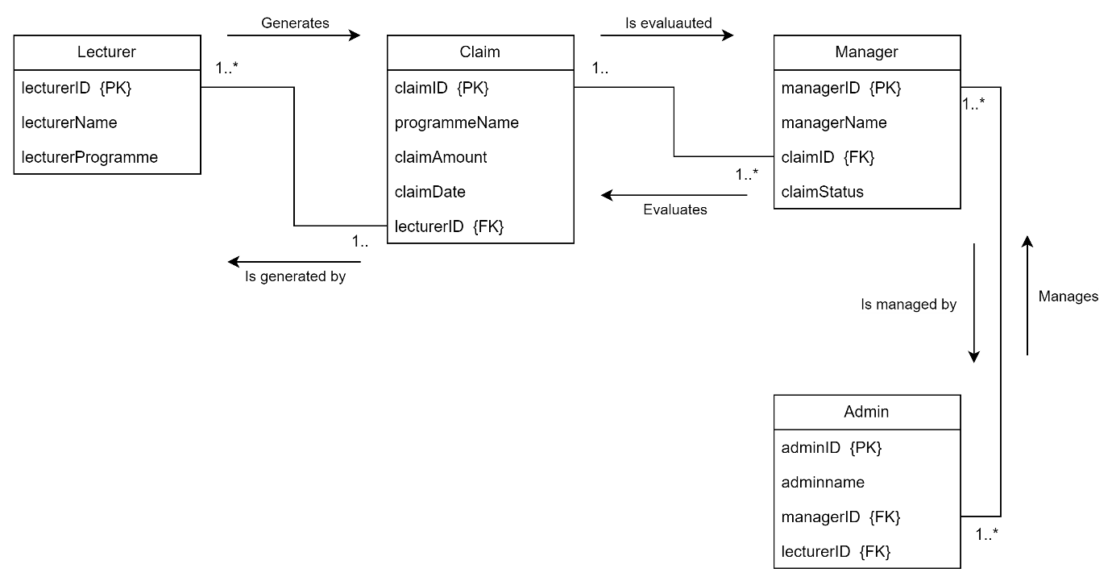

**Project Plan:**

Phase 1:

Goals:

* Draw up documentation that explains the rationale for design choices, structure of the database, and the layout of the User Interface
* Design a UML Class Diagram that accurately describes the layout of the database being used and its data requirements
* Design a prototype User Interface using .NET Core MVC that showcases the functionality of the proposed system.

Time Requirement: 1 Week

Phase 2:

Goals:

* Add functionality to the prototype so that its able to accomplish the following:
  + Users can input the details for their claim and submit at any time
  + Implement a separate view coordinators and managers to able to approve or reject each claim made on the system
  + Allow users to upload supporting documentation and have it be stored safely
  + Implement a claim status tracker that updates in real time the status of a claim
  + Implement unit testing and exception handling to account for all possible wrong outcomes
* Implement lecturer feedback obtained from Phase 1

Time Requirement: 1 Month

Phase 3:

Goals:

* Implementing the automation of features introduced in the previous phases:
  + Implementing automatic calculation features to determine final payment based on the hours worked and hourly rate of the lecturer.
  + Developing a system to automatically check submitted claims against certain criteria
  + Developing a system that automatically generates invoices and reports that summarise approved claims
* Creating a PowerPoint presentation that is informative to showcase the functionality of the finished system

Time Requirement: 1 Month

**Screenshots of User Interface:**

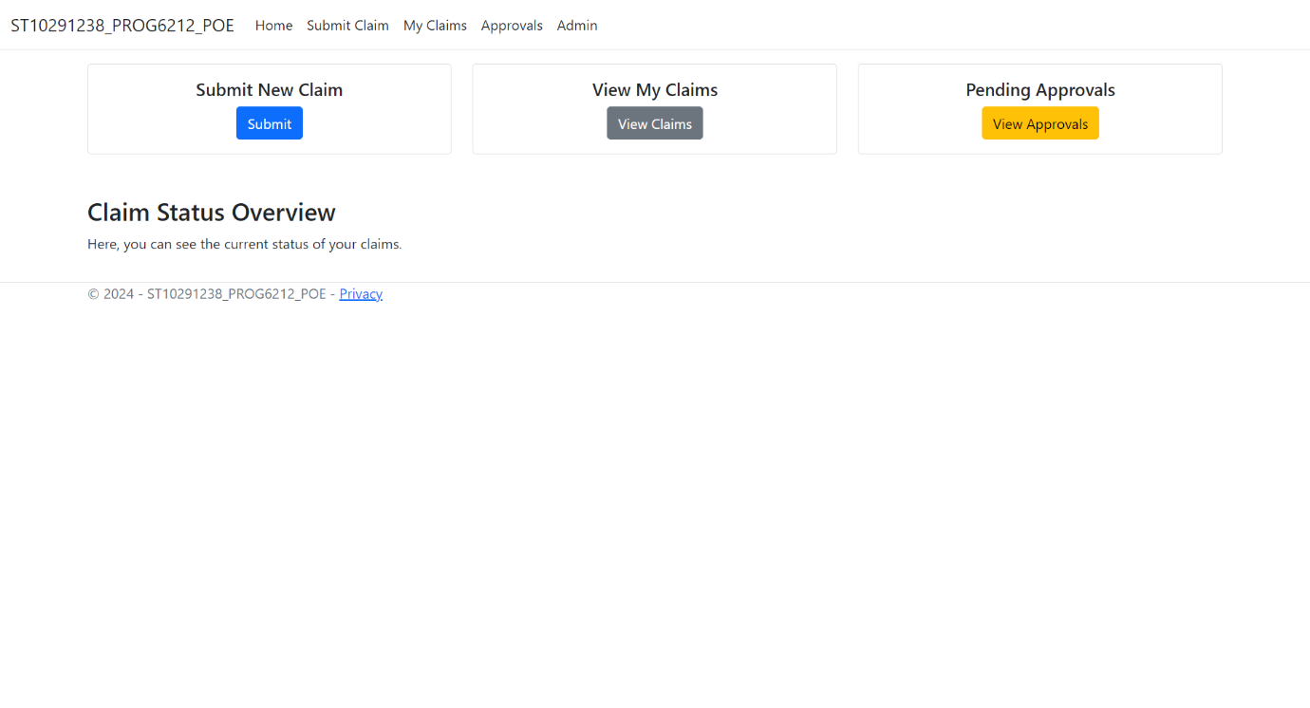

# References

Amazon Web Services, 2024. *What is SQL (Structured Query Language)?.* [Online]   
Available at: https://aws.amazon.com/what-is/sql/#:~:text=Structured%20query%20language%20(SQL)%20is,relationships%20between%20the%20data%20values.  
[Accessed 10 September 2024].

Lepard, C., 2023. *5 web design tips for an outstanding site.* [Online]   
Available at: https://www.wix.com/blog/5-design-tips-for-a-professional-site  
[Accessed 10 September 2024].