

**Computer Science and Engineering**

A.A. 2016/2017

Software Engineering 2 Project:

**“Power&Joy”**

**R**equirements **A**nalysis and **S**pecification **D**ocument

November 11, 2016

Prof. Luca Mottola

Joshua Nicolay Ortiz Osorio Matr. 806568  
Michelangelo Medori Matr. 878025

**Contents**

1 **Introduction**............................................................................................................................

1.1 Purpose....................................................................................................................  
 1.2 Description of the Given Problem............................................................................  
 1.3 Stakeholders.............................................................................................................  
 1.4 Glossary....................................................................................................................  
 1.5 Reference Documents..............................................................................................  
 1.6 Overview..................................................................................................................

2 **Overall Description**.................................................................................................................

2.1 Product Perspective.................................................................................................  
2.2 Actors Identifying.....................................................................................................  
2.3 Goals (Product Functions)........................................................................................  
2.4 Domain Properties...................................................................................................  
2.5 Text Assumptions.....................................................................................................  
2.6 Constrains.................................................................................................................

3 **Specific Requirements**...........................................................................................................

3.1 Functional Requirements.........................................................................................  
 3.2 Non-Functional Requirements.................................................................................  
3.3 Mockup……………………………………………………………………………………………………………..

4 **UML Models**

4.1 Use Case……………………………………………………………………………………………………………  
4.2 Activity Diagram………………………………………………………………………………………………..  
4.3 Class Diagram……………………………………………………………………………………………………  
4.4 State Diagram……………………………………………………………………………………………………  
4.5 Sequence Diagrams…………………………………………………………………………………………..

**5 Alloy**………………………………………………………………………………………………………………………………...

5.1 Model…………………………………………………………………………………………………………………  
5.2 World Generated……………………………………………………………………………………………….

**6 Other Features**…………………………………………………………………………………………………………………

6.1 Future Development………………………………………………………………………………………..  
6.2 Used Tools…………………………………………………………………………………………………………  
6.3 Hours Of Work……………………………………………………………………………………………………

**1.Introduction**  
  
**1.1 Purpose**

This is the first of a series of documents aimed to project a digital management system for a car sharing service. Identifying stakeholders, modeling scenarios and formalizing requirements and constrains of the system are the main topics of this document.

**1.2 Description of the given problem**

We are going to design a digital management system for a car sharing service that only employs electric cars (i.e. cars powered by rechargeable batteries), which are environment-friendly and noise-free.  
Precisely, we want to offer the possibility to users to choose a car among an amount of cars dislocated into Milan's urban area, to travel across the city.  
Electric cars gather their fuel when they are plugged into proper power grids; these grids are placed all around the city: they can be found into specific charging stations, beyond near a decent number of parking lots around Milan.  
Cars can be parked everywhere inside Milan urban area (i.e. any kind of appropriate car park, accordingly to Italian laws, including pay and display parking lots).   
Operators are available to make sure that cars are never left with less than 20% battery charge by charging them into near charging stations or in place.  
The final aim of the system is to provide a service within anyone's reach, that stands for a solid alternative to public transport.

**1.3 Stakeholders**The only stakeholders that we have is Power&Joy society that require the management system of car sharing.

**1.4 Glossary**

* **System**: is the system we will create which is going to manage the car sharing service. The system has a dedicated database where it can store and access all needed information.
* **User** : every person registered into the system that wants to use a car.
* **Not Register User (NRU)** : all people not registered in the system.
* **Operators:**  employees working on charging stations whose job is recharge every car that has less 20% battery level and to provide assistance to the users.
* **Passenger :** a person who is traveling in a car (included the driver).
* **Registration (for Users):** consists in the act of inserting all the needed information into the system as
  + First name and Last name
  + E-mail
  + Password
  + Phone number
  + Birth date
  + ID card code
  + Drive license code
  + Credit card number
  + Fiscal code
* **Safe Area:** Milan’s urban centre.
* **Power grid station:** a stopping place for electric cars equipped with electric socket and where operators work.
* **Available car:** is a car that is not currently used by other users and has the battery charge level over 20%.
* **Parking lot:** everyavailable car park inside the Safe Area that respects the Italian traffic laws.
* **Special Parking lot:** every parking lot equipped with electric socket.
* **Safe Zone**: is a circular zone with 3 km of diameter which centre is a power grid station.
* **Reservation:** is the ability to reserve a car for at maximum 1 hour, then the reservation expires.
* **Contactless card:** card acquired by users at the moment of the registration used to unlock the reserved cars.
* **Special contactless card:** Magnetic card acquired by operators at the moment of the registration that can be used to unlock any car.
* **Unlock Car:** to undo the lock of car’s doors by placing the contactless cards or special contactless cards near specific sensors placed over the car doors.
* **Password:** is the key to log in to the system.
* **Status (of a car)**: any of the possible conditions of the cars (low charge/assistance needed/accident/no issues).
* **Reserved Operator area:** special section of the system where operators can register and log in, and from which they can access information about the position and the status of all the cars.
* **Ride:** it starts one minute after the user unlocks the car and ends when the user shuts down the car and pushes on the display “end the ride” button.
* **Pit Stop:** it happen when the user stops the car for a short period of time (maximum 60 minutes) and keep the car reserved in order to continue the ride.
* **End the ride:** user stops the car, leaving it in a safe parking lot so that the car is made available for other reservations by other users.
* **Scalability:** is the capability of a system, network, or process to handle a growing amount of work, or its potential to be enlarged in order to accommodate that growth.
* **Quality of Service:**  is the overall performance of a computer network, particularly the performance seen by the users of the network. His attributes are: Performance, Reliability, Scalability, Capacity, Accuracy, Availability, Robustness, Integrity and Confidentiality.
* **On-board computer**: a computer equipped with a touch screen and a GPS navigation device, placed in every car. It can also perform calls (in particular, it can perform accident calls, as defined below).
* **CID module**: a document that must be filled in case of accident by the people involved with the accident details (according to Italian traffic laws)
* **Assistance call**: call made by an user from his phone to ask for assistance about how to use the cars. These calls are picked up by the call center
* **Call center:** place where assistance calls are picked up by operators. The only job of the operators who work on the call center is to pick up assistance call (they do not provide physical assistance to users). Call center is NOT equipped with power grids.
* **Accident calls**: calls automatically started by the on-board computer when a user taps on the “REPORT ACCIDENT” button on the on-board computer.
* **Card ID:** a number associated to each operator (written on their contactless card) that identifies them

**1.5 Reference Documents**

These are the documents we used as guideline:

* Specification Document: Assignment AA 2016-2017 (RASD)
* IEEE Std 830-1998 IEEE Recommended Practice for Software Requirements Specifications.
* Examples Documents: RASD sample from Oct. 20 lecture.

**1.6 Overview**

After a short description of the system’s properties, we define goals (e.g. the functions the system has to be able to perform) and constrains, and make assumptions that we suppose hold in the analyzed world. Then we analyze and formalize the goals with the help of UML diagrams (use case, sequence diagrams, class diagram) and the formal language Alloy.

**2. Overall Description  
  
2.1 Product Perspective**

We want this service to be accessible via mobile or web app. Every user (i.e. person who wants to reserve and ride a car) must register to the system via the mobile or web app providing general information (full name, age, e-mail etc.) and specific ID's (fiscal code, drive license code). Once registered and logged in, the system allows user to view on a map the current geographical position of every available car, thanks to GPS sensors on each car. Cars already in use by other users do not display, but the system can access the information about the positions and the batteries of every single car, weather they are being used or not, any time it needs to (in case of assistance requests et al.).  
  
Users can choose a car at the time, and make a reservation for it. They shall reach the car within 60 minutes from the moment the reservation is made, to be able to use the car.  
When near, users can unlock the car by simply placing their contactless card (provided at the moment of the registration) near the sensor placed on the car door.  
The system unlocks the car soon after and the user is able to get in. In order to start the ride, the user simply needs to turn the key placed inside the car.

Every car is equipped with an on-board computer, that can be used to communicate the existence of damages over the car as well as GPS navigator device.  
Before starting the ride, the system encourages the user to make sure the car is not damaged or compromised, and to communicate it, in case issues are found, via the mobile app or the on-board computer.

Once the car is started, the user starts to be charged per minute of ride.  
Once they end the ride, users can park cars in every available car park inside the urban area (which includes any kind of parking lot, accordingly to Italian laws, pay and display car parks included, private parking lots excluded).   
Some special parking lots are equipped with power grids to recharge the car, and discounts are available in case users take care to plug the car in.  
Discounts are also available in case the user leaves the car with more than 50% battery charge or if he takes on the ride 2 more passengers , while the user is going to pay 30% more of the price of his ride in case he leaves the car with 20% battery charge or more than 3 km away from the nearest charging station.  
Payments are always carried out through the credit card that the user has to insert at the moment of the registration and a receipt is available to view with the mobile app or via e-mail.

A group of operators is available to give assistance to users and to make sure cars are never left under 20% battery charge. Operators work at charging stations and can access all the information about cars positions and batteries.   
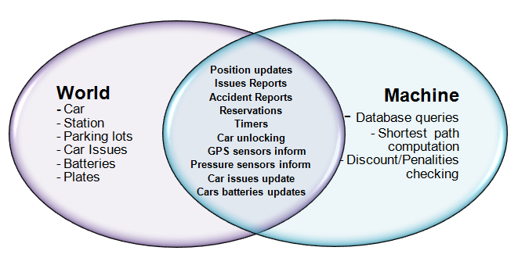  
**2.2 Actors Identifying**

There are two main kind of people the System needs to interact with:

* Users
* Operators

Both of them need to be registered into the system.  
Operators work at the charging stations and need to pick up and recharge every car below 20% battery charge and provide assistance to users, if needed.  
The goals concerning the interaction between these two groups of people and the system are described below.

**2.3 Goals (Product Functions)  
  
Users:**

1. The system shall allow users to register via the web or mobile app by inserting all the required information
2. The system shall allow users to log in
3. The system shall allow users to see the positions of all the available cars on a map
4. The system shall allow users to make a reservation for an available car
5. The system shall allow users who reserved a car to cancel the reservation
6. The system shall allow users to unlock the car they reserved
7. The system shall allow users to start the ride
8. The System shall allow users to make a pit stop of maximum 60 minutes
9. The system shall allow users to end the ride only if the car is parked inside the safe area
10. The system shall allow users to communicate if the car they reserved is damaged or issues are found (e.g. dirt, damages, etc.)
11. The system shall compute the price of every ride taking into account discounts and penalties and send it to the system which takes care of the payment
12. The system shall allow users to report an accident via the on-board computer

**Operators:**

1. The system shall allow operators to log into a dedicated area .
2. The system shall allow operators to view the updated status and position of every car
3. The system shall allow operators to be able to select a car from the list in order to take care of it.
4. The system allow an operator who took care of a car to communicate that the issues are resolved to all the other operators

**2.4 Domain Properties**

* The contact-less card is received by users not later than 3 days after the registration is performed.
* Parking a car where is not allowed by the traffic laws is subject to penalties for the user that parked it, according to Italian laws.
* Damages found on the cars are paid by the last user before the one who signals the found damages
* In case a user needs assistance he can call an operator with the number displayed on the window of every car
* All cars are equipped with a GPS navigation device.

**2.5 Text Assumptions**

* There are no identical fiscal codes or license numbers related to different users or operators
* The credit card inserted at the moment of the registration by the user is a valid (existing and working) one
* Users only register into the system once
* The user who unlocks the car is the owner of the contact-less card he uses and is the same who is actually going to drive that car
* Cars are equipped with GPS sensors in order to be localized by the system
* Cars are equipped with pressure sensors on every seat, in order to let the system know exactly how many passengers are onto the car anytime
* Users start the ride after at maximum 1 minute after they unlock the cars
* Users will not leave the car in a zone where is not possible to detect the GPS sensor, even if it is inside the safe area
* Users do not leave cars into private parking lots
* User will not perform any kind of maintenance or reparation operations to the car
* User will not leave the car in any kind of condition which could cause damage or any issue on the surrounding area.
* Users will not try to leave cars outside the safe area.
* Users will not try to reserve more than a car at once
* The credit card used by the users always has enough money to pay for the rides
* Users will always leave the car with the windows closed, handbrake activated, lights and radio off and all the documents stored in their right place at the end of every ride
* Users will always instantly receive, after they end a ride, the information about the ride itself via e-mail and the mobile app. These information include time and money spent, distance traveled , etc
* All the payments are correctly performed at the end of every ride
* In case of issues on a car, users always notice them and notify it to the system before starting the ride
* If an operator taps the button “OPERATE" associated to an issued car, he actually performs all the needed actions in order to fix that car within 4 hours , and always remembers to tap the button “ISSUE SOLVED” once they finished
* Operators are registered into the system and all their data is stored onto the database. The information inserted by operators at the moment of the registration is always consistent
* Operators have a special section of the system where they can log and access all the information they need to perform their job. They can log using a password chosen during the registration
* Operators working on the call center are always available to pick up calls from users who need assistance
* The assistance number users can call is written on the window of every car, and is visible both from inside and from outside the car
* The number used for accident calls is different from the one used for assistance calls, and is not available for user to call unless they tap on the “REPORT ACCIDENT” on the onboard computer
* User only tap the “REPORT ACCIDENT” on the on-board computer if they were actually involved in an accident
* Once a user makes an accident call, the call is redirected to the nearest charging station, and always instantly picked up by an operator.
* Once a user makes an accident call, an operator always reaches the place of the accident in less than 15 minutes
* If the presence of a passenger is detected by the sensor at the beginning of the ride as well as at the end, the system supposes that the passenger has been on the car for the whole ride.
* User only pay for damages found on the cars if they actually performed those damages
* Accident calls are picked up by operators who do not work on the call center (only charging stations)
* Operators have a special contact-less card they can use to unlock the cars, acquired at the moment of the registration into the system
* Operators can drive any car unlocking them via the special contact-less card, and without paying for the ride
* In case of accident the user always takes care of stopping the car in some place where it doesn’t create problems to the traffic flow, never panics, fills the CID modules (according to Italian laws) and remains in the place where the accident happened until the arrive of the operator
* In case users leave any kind of items into the cars after ending the ride, they can inform operators about that via a phone call, and operators will pick their stuff; users will collect it in one of the charging station

**2.6 Constrains**

* The implementation language must be Java
* The credit card payment system must be able to be dynamically invoked by other systems relying on it

**Network connections**

“Power&Joy” webApp needs internet connection for working. In particular if a user needs to make a reservation or cancel it , he has to switch on 3G or LAN wireless connection.

**Concurrent operations**

The system has to guarantee multiple processes from different connected users.

**Hardware limitations**

All the mobile phone must have GPS to localize and reach the cars. They required a space for App package too.

**Interfaces to other applications**

The system will interface with a new MySQL database. All the information about users and operators are saved here and the system through queries can use them.

**3. Specific Requirements**

* 1. **Functional Requirements**

1. **The system shall allow users to register via the web or mobile app by inserting all the required information**
   1. The system requires to insert all personal information that consist on :   
      - First name and Last name  
      - E-mail  
      - Password  
      - Phone number  
      - Birth date   
      - ID card code   
      - Drive license code   
      - Credit card number   
      - Fiscal code
   2. The system shall check that all information inserted are valid (e.g. all text boxes must be not empty, the name cannot contain numbers etc).
   3. The system includes the information of the new user onto the database
   4. The system sends a confirmation e-mail to the new user.
2. **The system shall allow users to log in**
3. In order to log in, the system shall require users to insert their credentials (consisting of an e-mail/username and a password) into an input form accessible from the web or mobile app.
4. The system shall verify that the credentials are valid , and only in that case give access to the area where cars positions are displayed.
5. In case the credentials are not valid, the system shall negate the access .
6. **The system shall allow users to see the positions of all the available cars on a map**
7. The car are equipped with a GPS sensors that allow the system to localize them anytime.
8. The system puts all the cars positions on a map that can be visualized by users via web or mobile application.
9. The user shall be able to insert a specific address or geographical position, in order for the system to show the available cars around the wanted location.
10. The system shall allow users to view all the positions of the cars which are strictly placed around users current position by simply tapping a button on the app. This is only possible if GPS sensor are working on the device the user is utilizing to view the map.
11. **The system shall allow users to make a reservation for an available car**
    1. When the user finds a suitable car he can reserve it by clicking on the “RESERVE” button on the application.
    2. After doing the reservation the system starts a timer of 60 minutes. If the user is not able to unlock the reserved car before the time expires, the system cancels the reservation making the car available again for other users.
12. **The system shall allow users who reserved a car to cancel the reservation**
    1. Once a user reserved a car, the system shall allow him to cancel the reservation for it before the timer of 60 minutes expires by clicking on a button “CANCEL RESERVATION” on the mobile or web app.
    2. If the user cancels a reservation, the system shall make the car available again for other users.
13. **The system shall allow users to unlock the car.**
    1. Any reserved car can only be unlocked using the contactless card owned by the user that reserved that specific car, and before the timer of 60 minutes expires.
    2. When the user places the contactless card near the sensor of the car, the system shall acquire information about the card, verify that it corresponds to the user that actually reserved that car and, in that case, the system shall unlock the car in order for the user to get in
    3. In case the contactless card is not recognized as valid by the system, the system denies access to the car, until a valid card is recognized by the time the timer expires.
14. **The system shall allow users to communicate if the car they reserved is damaged or issues are found (e.g. dirt, damages, etc.).**
    1. Before starting the engine the system shall remind the user through the on-board computer to check for damages on the car and to communicate it in case issues are found via the mobile app or the same on-board computer
    2. In case of issues, the system shall cancel the reservation , make the car unavailable for users, marking it as “ASSISTANCE NEDEED" in order to inform all operators.
15. **The system shall allow users to start the ride.**
    1. In order to start the engine the user shall turn the key.
    2. The system shall start to charge the user by minute of ride as soon as he ignites the car engine.
    3. The system shall display on the onboard computer the updated amount of money spent for the ride.
16. **The System shall allow users to make a pit stop of maximum 60 minute.**
17. The system shall allow users to make a pit stop of maximum 60 minutes communicating it tapping a button “START PIT STOP” on the onboard computer. When they do it, the system starts a timer of 60 minutes.
18. When the user wants to end the pit stop he needs to tap again a button “END PIT STOP” on the onboard computer, or simply restarting the car.
19. During the pit stop the system shall still go on charging users for 50% of the price during all the time the pit stop lasts or since the timer expires.
20. During the pit stop the system shall always make the car stay reserved for the current user, and unavailable to other users.
21. When the Timer expires the system cancels the reservation for that car, making it available for other users to use.
22. **The system shall allow users to end the ride only if the car is parked inside the safe area.**
    1. When the user wants to end the ride, he has to communicate it to the system by tapping a button “END THE RIDE” on the onboard computer.
    2. The system shall check if the car is parked inside the safe area using the GPS sensor information, and only in that case allow user to end the ride.
    3. If the car is not parked into a safe area, the system shall go on charging users until they move the car inside the safe area and tap the button “END THE RIDE” on the onboard computer.
    4. The button “END THE RIDE” shall only be available to press if the car engine is shut down.
23. **The system shall compute the price of every ride taking into account discounts and penalties and send it to the system which take care of the payment.**
24. When a ride ends (if the users taps the “END THE RIDE “ button while the car is parked inside the safe area ,or if the pit stop timer of 60 minutes expires) the system shall compute the total cost of the ride using the price currently displayed on the on-board computer and taking into account the following rules:

* If the system detects the user took at least two other passengers onto the car, the system applies a discount of 10% on the last ride. In order to detect the presence of a passenger, the system shall check that the pressure sensors of the car seats are active both at the beginning and at the end of the ride.
* At the end of the ride, the system shall check the battery charge: if a car is left with no more than 50% of the battery empty, the system applies a discount of 20% on the ride.
* At the end of the ride, the system shall check if a car is left plugged into one of the power grids available through the charge sensor: in that case the system applies a discount of 30% on the last ride.
* At the end of the ride the system shall check if a car is left at more than 3 KM from the nearest power grid station or with more than 80% of the battery empty, the system charges 30% more on the ride (in order to do that, the system shall compute the shortest path from the final position of the ride to all the charging stations, find the minimum one and compare it with 3km).

1. **The system shall allow operators to log into a dedicated area .**
   1. In order to log in, the system shall require operators to insert their credentials (consisting of an e-mail/username and a password) into an input form accessible from the web or mobile app.
   2. The system shall verify that the credentials are valid , and in that case give access to the dedicated area.
   3. In case the credentials are not valid, the system shall negate the access
2. **The system shall allow operators to view the updated status and position of every car**
   1. Once they are logged in , the system shall allow operators to view (via web or the mobile app) the positions of all the cars on a list, associating to each car a status: “ NO ISSUES” is for charged (or currently on charge) and working cars, “LOW CHARGE” is for cars under 20% battery charge, “ASSISTANCE NEEDED” is for cars that need some kind of maintenance or reparations, “ACCIDENT" in case a user is involved in a car accident while riding the car.
   2. The system shall always keep all the positions and the status of the cars updated
3. **The system shall allow operators to be able to select a car from the list in order to take care of it.**
   1. Operators shall be able to communicate to the system they are taking care of a car by selecting a row on the list and tapping a button “OPERATE”.
   2. Once an operator pressed the “ OPERATE” button on a row of the list corresponding to a car, the system shall deny other operators to take care of the very same car, substituting the “ OPERATE” button with a writing “ in progress..” (this is only valid for all the operators except the one that is taking care of the car, to whom another kind of button is displayed by the system, as described below)
4. **The system allow an operator who took care of a car to communicate that the issues are resolved to all the other operators**
   1. Once issues are resolved for a specific car , the specific operator who took care of it, shall be able to communicate it to the system by tapping a “ISSUES SOLVED” button (only available to the operator who pressed the “ OPERATE” button earlier). The system shall then mark the car as “NO ISSUES” again for all the operators.
5. **The system shall allow users to report an accident via the on-board computer**
   1. Once the ride is started, the system shall display on the on-board computer a button “REPORT ACCIDENT”
   2. In case the “REPORT ACCIDENT” button is pressed by a user, the system shall stop charging the user, forcing him to end the ride and inform operators marking the car with the “ACCIDENT” writing .
   3. **Non-Functional Requirements**

* The system must be available 24 hours a day
* The system must respect Quality of Service (QoS) attributes .
* The system shall start all the required timers within 1 second after the user’s input.
* The system shall unlock the car within 5 seconds after the contactless card is placed near the car sensor
* The system shall start charging the users within 2 seconds after they start the car engine at the beginning of a ride
* The system shall stop charging users within 2 seconds after they tap on the “END THE RIDE “ button on the on-board computer, having the engine shut down, the car parked inside the safe area, and the car GPS signal available.
* The system shall change the status of every car within 2 seconds from one of the following events:

1. A car switches from 20% to 19% battery charge
2. An operator taps the “OPERATE” button associated to an issued car to take care of it
3. An operator taps the “ISSUES SOLVED” button associated to a car they took care of
4. A user taps on the button “ISSUES FOUND” on the on-board computer of a car
5. A user taps on the “REPORT ACCIDENT” on the on-board computer  
   1. **Mockups**

**3.3.1 Users Log in/ Operators Log in**

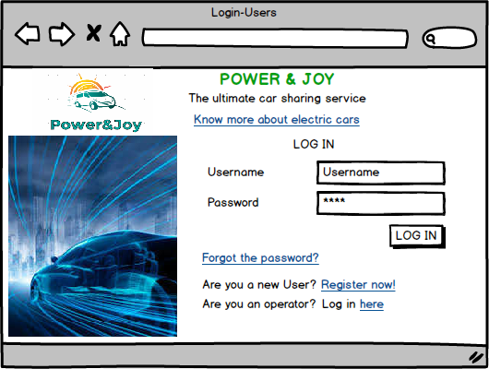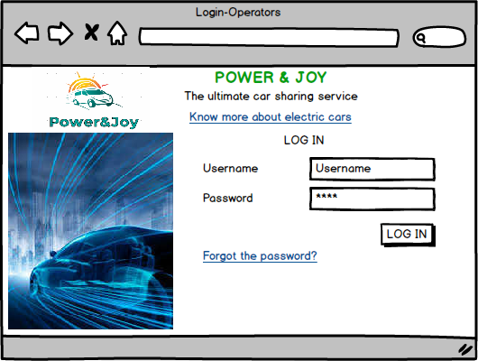

**3.3.2 Registration Users/ User Home Page/ Countdown Reservation**

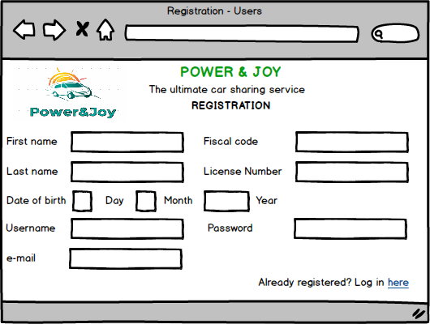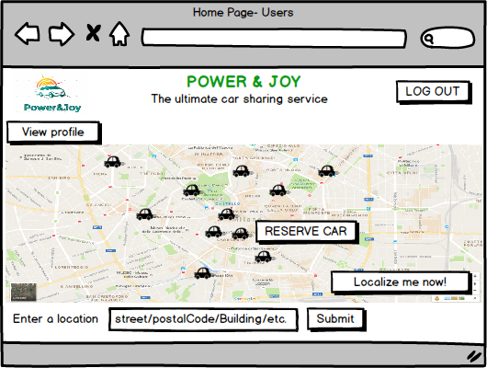

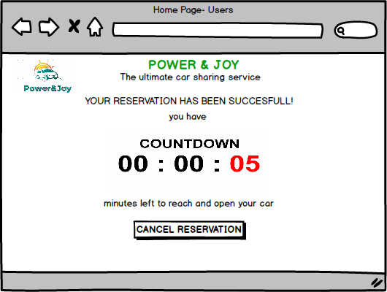

**3.3.3 Operators Home page**

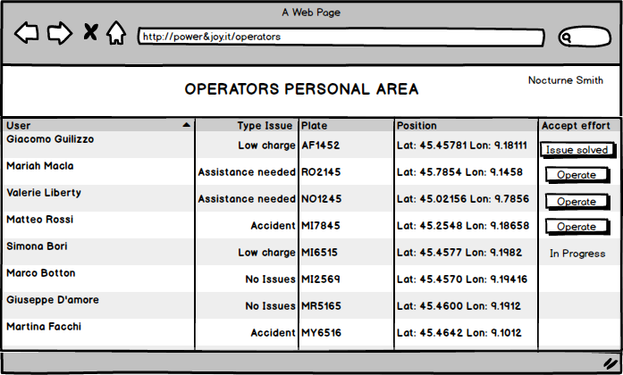

**3.3.4 Mobile : User Log in / User Home Page**

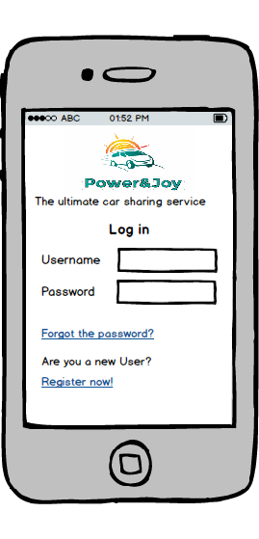 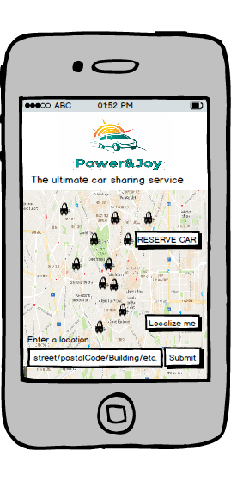

**3.3.5 Mobile: Countdown Reservation/ Operator Home Page**

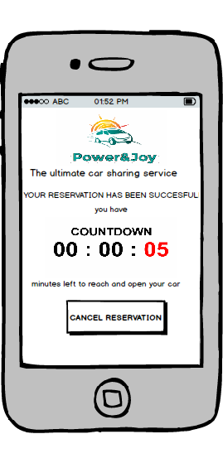 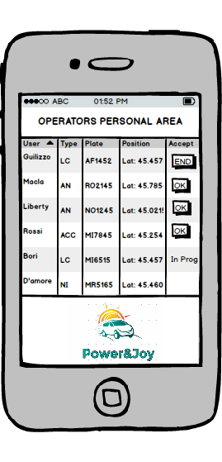

**3.3.6 On-Board Computer: Signal Issues / Map**

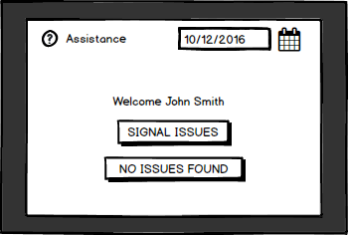

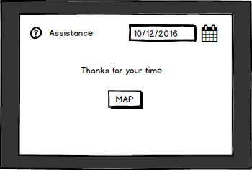

**3.3.7 On-Board Computer: Start Pit Stop / End Pit Stop**

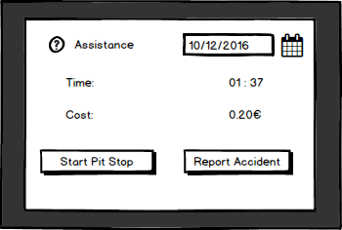

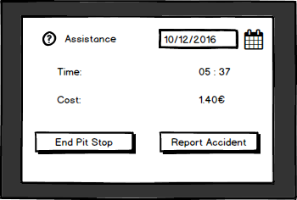

**3.3.8 On-Board Computer: End the ride /**

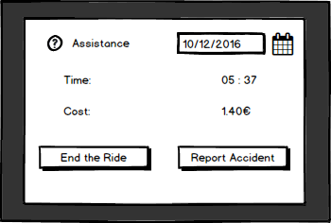

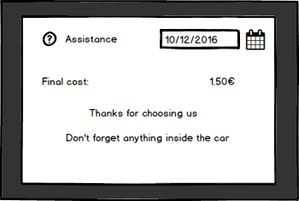

* + 1. **On-Board Computer: Accident Reported**

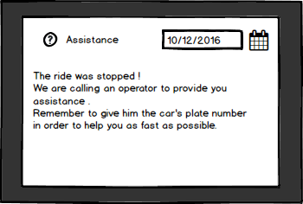

**4. UML Model**

**4.1 Use case**

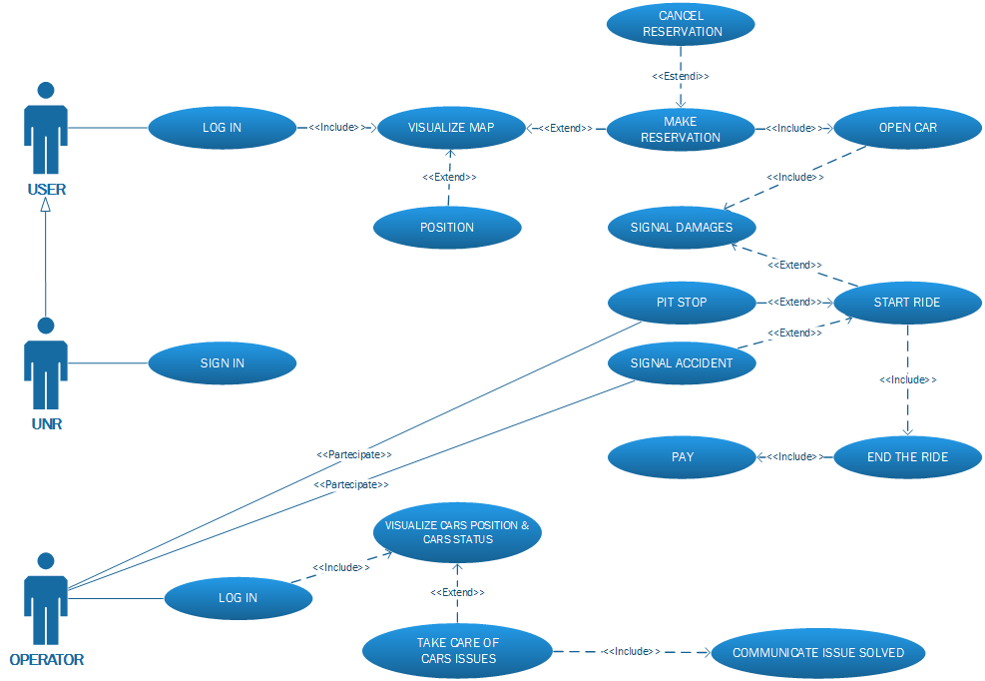

**Use case description**

In this paragraph some use cases will be described. These use cases can be derived from the scenarios and the use case diagram.

|  |  |
| --- | --- |
| Name | Log in |
| Description | A user logs into the system logs in |
| Actors | User |
| Entry conditions | The user must be registered into the system |
| Flow of events | * A user opens the user’s log in page in the web or mobile app * The user inputs his credentials, consisting of a username and a password * The user clicks on the “LOG IN” button * The system checks that the credentials are valid (they are associated to an existing user) and redirects the user to the User’s Home page |
| Exit conditions | The user is redirected to the User’s home page. |
| Exceptions | If the username or password inserted by the user are not valid, the system does not redirect the user to the user’s home page. Instead, it notifies him that the credentials he inserted are not valid and tells him to try again |

|  |  |
| --- | --- |
| Name | User visualizes a map of the cars |
| Description | A user visualizes a geographical map where are enlighten the current positions of all available cars |
| Actors | User |
| Entry conditions | The user must be successfully logged in |
| Flow of events | * The user can visualize from the user’s home page, directly accessible from the login page, a map of Milan’s urban area, where are enlighten the current geographical positions of all the available cars |
| Exit conditions | The user is now aware of the positions of all the available cars (i.e. cars which can be reserved) |
| Exceptions | None |

|  |  |
| --- | --- |
| Name | Location of cars whiten 1 km from a given position |
| Description | A user inserts specific location and visualize all near available cars |
| Actors | User |
| Entry conditions | The user must be logged in |
| Flow of events | * The user inputs a geographical location (consisting of a street/postal code/building etc.) into an input area at the bottom of the user’s home page * The user clicks on the “SUBMIT” button * The system dynamically changes the geographical area shown on the map, in order to highlight the cars within 1 km from the location inserted by the user |
| Exit conditions | The user can now see highlighted on the map the cars near the location he inserted |
| Exceptions | If the position inserted by the user is not recognized by the system as an existing location inside Milan’s urban area, the user won’t see any changes on the map, and the system notifies him that the location he inserted is not a valid one, telling him to try again |

|  |  |
| --- | --- |
| Name | Car reservation |
| Description | A user reserves a car, chosen among the available cars |
| Actors | User |
| Entry conditions | The user must be logged in |
| Flow of events | * The user select a car on the map, among the available cars shown. * The system shows a “RESERVE CAR" button near the selected car * The user clicks on the “RESERVE CAR” button * The system reserves a car for the user, making it unavailable to others, and redirects him to the reservation page, where he can visualize a message confirming that the reservation has been successful and a timer that shows the remaining minutes before the reservation expires, the position of the car etc al.. |
| Exit conditions | The user is redirected to the reservation page, where he can visualize the details of his reservation. |
| Exceptions | In case problems occur on the reservation process, an error message is shown, and the car remains available for other reservations |

|  |  |
| --- | --- |
| Name | Reservation cancellation |
| Description | A user cancels a reservation he made |
| Actors | User |
| Entry conditions | The user must be logged into the system, and must have successfully reserved a car |
| Flow of events | * From the reservation page, the user is able to visualize a “CANCEL RESERVATION” button * The user clicks on the “CANCEL RESERVATION “ button * The system cancels the reservation, making the car available to other users * The system shows a message to inform that the reservation has been correctly cancelled * The system redirects the user to the user’s home page |
| Exit conditions | The user is redirected to the User’s home page |
| Exceptions | None |

|  |  |
| --- | --- |
| Name | Open Car |
| Name | A user opens the car he reserved |
| Actors | User |
| Entry conditions | The user must have logged into the system and have successfully reserved a car. The user has reached the car he reserved and has the contactless card needed to unlock the car with him |
| Flow of events | * The user places his contactless card near the car sensor before the timer expires * The system retrieves the information about the card and verifies that it corresponds to the user that reserved that car * The system unlocks the car |
| Exit conditions | The user has successfully unlocked the car |
| Exceptions | * If the timer has expired by the time the user places the contactless card near the car sensor, the system denies access to the car, notifying the user with a message on the mobile app and with a red light appearing on the car * If the contactless the user uses to try unlock the car is not belonging to him, the system denies access to the car and notifies the user with a red light appearing on the car * If the car the user tries to unlock is not the one he reserved, the system denies access to the car and notifies the user with a red light appearing on the car |

|  |  |
| --- | --- |
| Name | Car issues signaling |
| Name | A user communicate o the system weather there are issues on the car he reserved or not |
| Actors | User |
| Entry conditions | The user has successfully reserved and unlocked a car |
| Flow of events | * The system reminds the user to check for issues on the car with a message on the onboard computer before letting the user start the ride * The user checks if there are issues and do not find any * The user taps on a button “NO ISSUES FOUND” on the on-board computer * The system let the user know he can start the ride with a message on the on-board computer |
| Exit conditions | The user can now start the ride |
| Exceptions | If the user find issues on the car, he communicate it to the system tapping a “ISSUES FOUND” button on the on-board computer. The system cancels the reservation, making the car not available to the current user as well as all the others. The system tells the user to leave the car with a message on the on-board computer. The user is unable to start the ride and leaves the car. The system informs operators about the issue by marking the car as “ASSISTANCE NEEDED”. |

|  |  |
| --- | --- |
| Name | Start the ride |
| Name | A user starts a ride with the car he reserved and unlocked |
| Actors | User |
| Entry conditions | The user has successfully reserved and unlocked a car, found no issues on that car and communicated it to the system. |
| Flow of events | * The user inserts and turns the car key and starts the engine * The user starts to be charged by the system * The user starts to be able to visualize the updated amount of money spent for the ride on the on-board computer |
| Exit conditions | The user successfully started the ride |
| Exceptions | None |

|  |  |
| --- | --- |
| Name | Pit Stop |
| Description | The user makes a pit stop |
| Actors | User |
| Entry conditions | The user has correctly started a ride on a car he reserved and unlocked |
| Flow of events | * The user parks the car and stops the engine turning the key * The user taps on the “START PIT STOP” button on the on-board computer * The user starts to be charged by the system for half the price of a normal ride * The user can now leave the car parked for maximum 60 minutes, keeping it reserved for future use * The user gets back to the car, unlocks the car placing his contactless card near the car sensor * The user taps on the “ END PIT STOP” button placed on the on-board computer * The system restarts to charge the user for the full price as soon as the user taps on the “ END PIT STOP” button , and the user is able to restart the engine and continue to ride the car |
| Exit conditions | The user has successfully made a pit stop |
| Exceptions | In case the timer of 60 minutes expires by the time the user unlocks the car again in order to end the pit stop, the reservation for the car is cancelled, the system stops to charge the current user and makes the car available for other users. |

|  |  |
| --- | --- |
| Name | End of the ride |
| Description | The user ends a ride |
| Actors | User |
| Entry conditions | The user must have successfully started a ride |
| Flow of events | * The user parks the car and stops the engine turning the key * The user taps on the “END THE RIDE” button on the on-board computer * The system stops charging the user * The system reminds the user to close the windows and to leave the car in the same conditions in which he found it at the beginning of the ride with a message on the on-board computer |
| Exit conditions | The user has successfully ended a ride |
| Exceptions | None |

|  |  |
| --- | --- |
| Name | Accident |
| Description | A user reports an accident he is involved in while riding the car |
| Actors | User, Operator |
| Entry conditions | The user must have successfully started a ride |
| Flow of events | * The user taps on the “REPORT ACCIDENT” button on the on-board computer, which is available to press once the ride is started * The system marks the car as “accident” and at the same time makes a call start from the on-board computer to allow the user to talk to an operator in order to provide the details of the accident and receive instructions. * The operator that has been called taps on the “OPERATE” button on the row of the list associated to that car and provides assistance to the user. * Once the issue is resolved , the operator taps on the “ISSUE SOLVED” on the same row of the list. * The system marks back the car as “NO ISSUE” |
| Exit conditions | The user has successfully reported an accident to the operator, and the operator provided assistance. |
| Exceptions | None |

|  |  |
| --- | --- |
| Name | Operator Log in |
| Description | An operator logs into the system |
| Actors | Operator |
| Entry conditions | None |
| Flow of events | * An operator opens the operator’s log in page on the web or mobile app * The operator inputs his credentials, consisting of a username and a password * The operator clicks on the “LOG IN” button * The system checks that the credentials are valid (they are associated to an existing operator) and redirects the operator to the Operator’s Home page |
| Exit conditions | The operator has successfully logged into the section of the system dedicated to operators |
| Exceptions | If the credentials inserted by the operator are not valid, the system shows an error message, inviting to try again and doesn’t redirect the operator anywhere |

|  |  |
| --- | --- |
| Name | Operator views cars information and takes care of a car |
| Description | An operator visualizes the status and position of all the cars on a list |
| Actors | Operator |
| Entry conditions | The operator must be logged into the system |
| Flow of events | * The operator visualizes from the Operator’s home page, directly accessible from the login page, a table: each row of the table is associated to a car, and it features the position (expressed in terms of latitude and longitude, the status (consisting of a writing among “NO ISSUES”, “ASSISTANCE NEEDED”, “LOW CHARGE” and “ACCIDENT”), the name of the user who is using the car and the ID of the car. The list also shows if other operators already decided to take care of a car by showing a writing “in progress” or a button “OPERATE “ on the rows associated to issued cars. * An operator taps on the “OPERATE “ button related to a car which status is “ASSISTANCE NEEDED”, “LOW CHARGE” or “ACCIDENT" * After he took care of the issue, the operator taps on the button “ISSUE SOLVED” on the same row of the list, to communicate that the car is now back to its regular functions. * The system marks back the car as “NO ISSUE” |
| Exit conditions | The operator has successfully solved an issue of a car. |
| Exceptions | None |

**4.2 Activity Diagram**

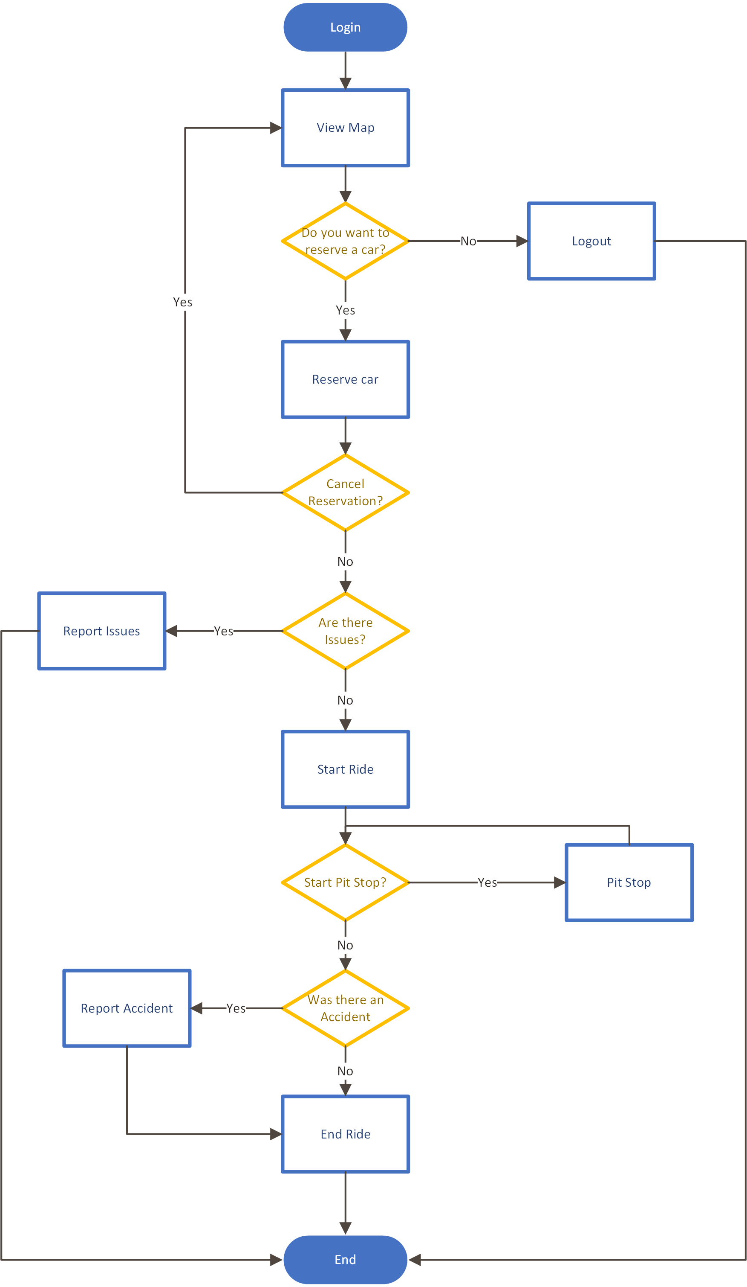

**4.3 Class Diagram**

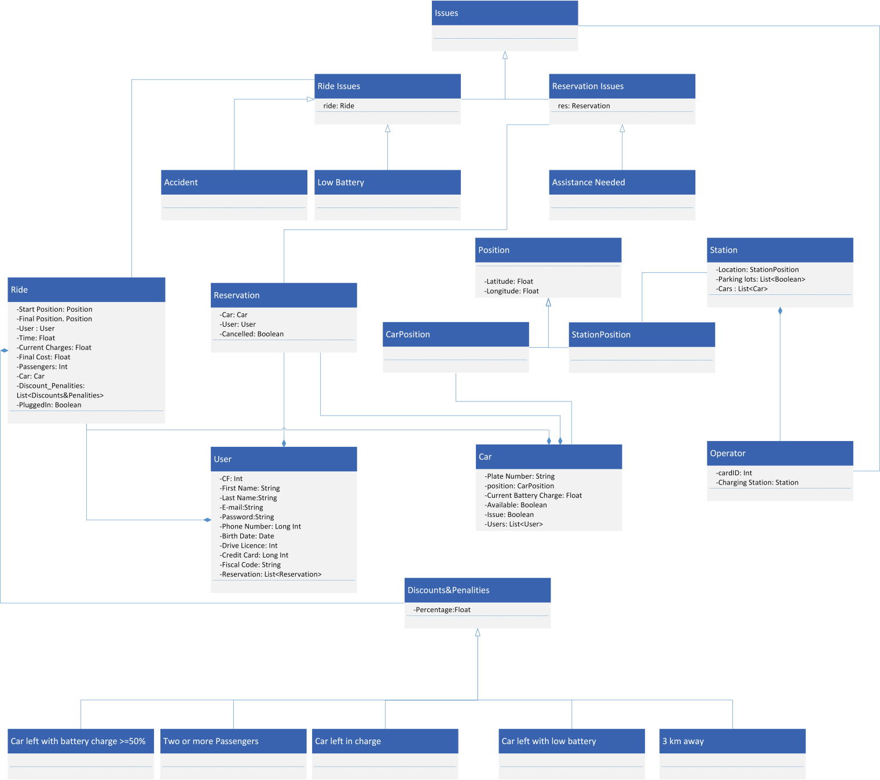

**4.4 State Diagram**

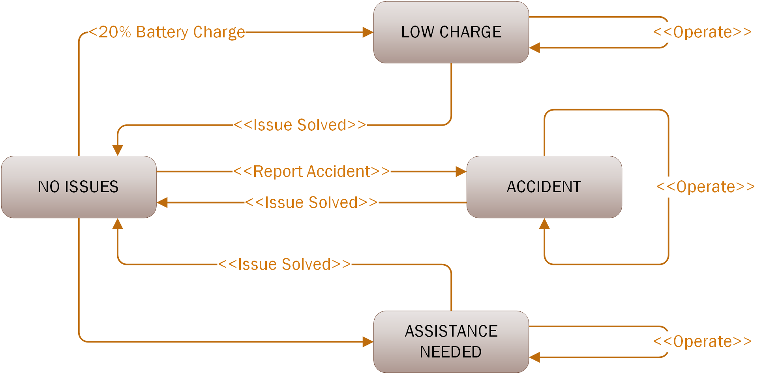

**4.5 Sequence Diagram**

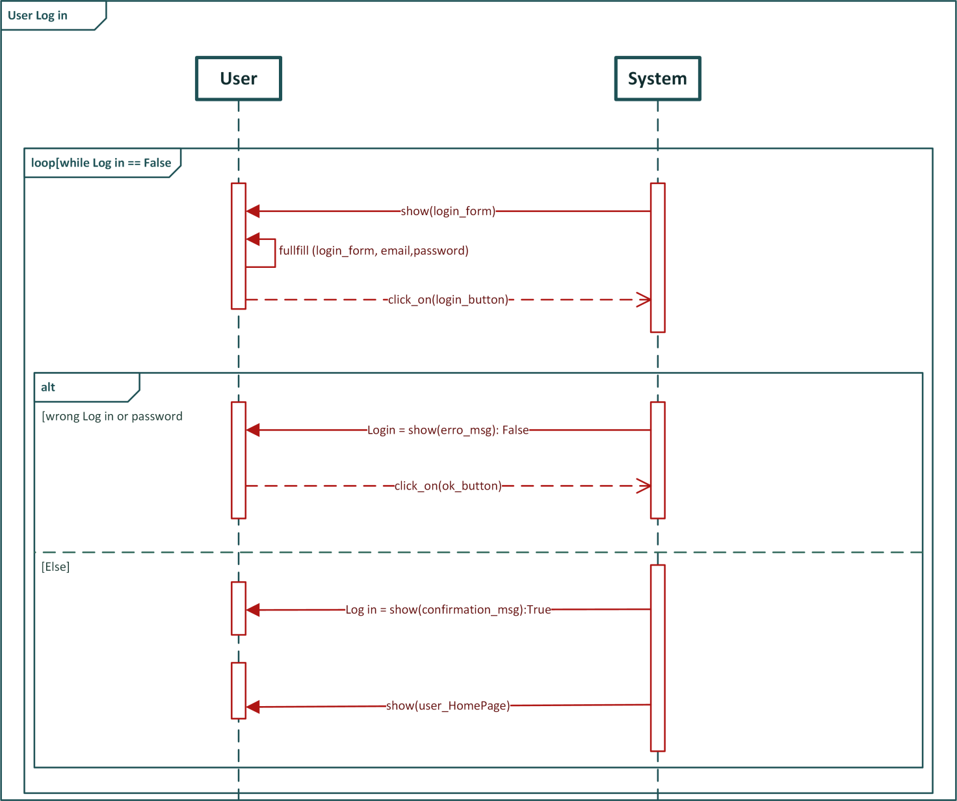

**Sequence Diagram : Home Page**

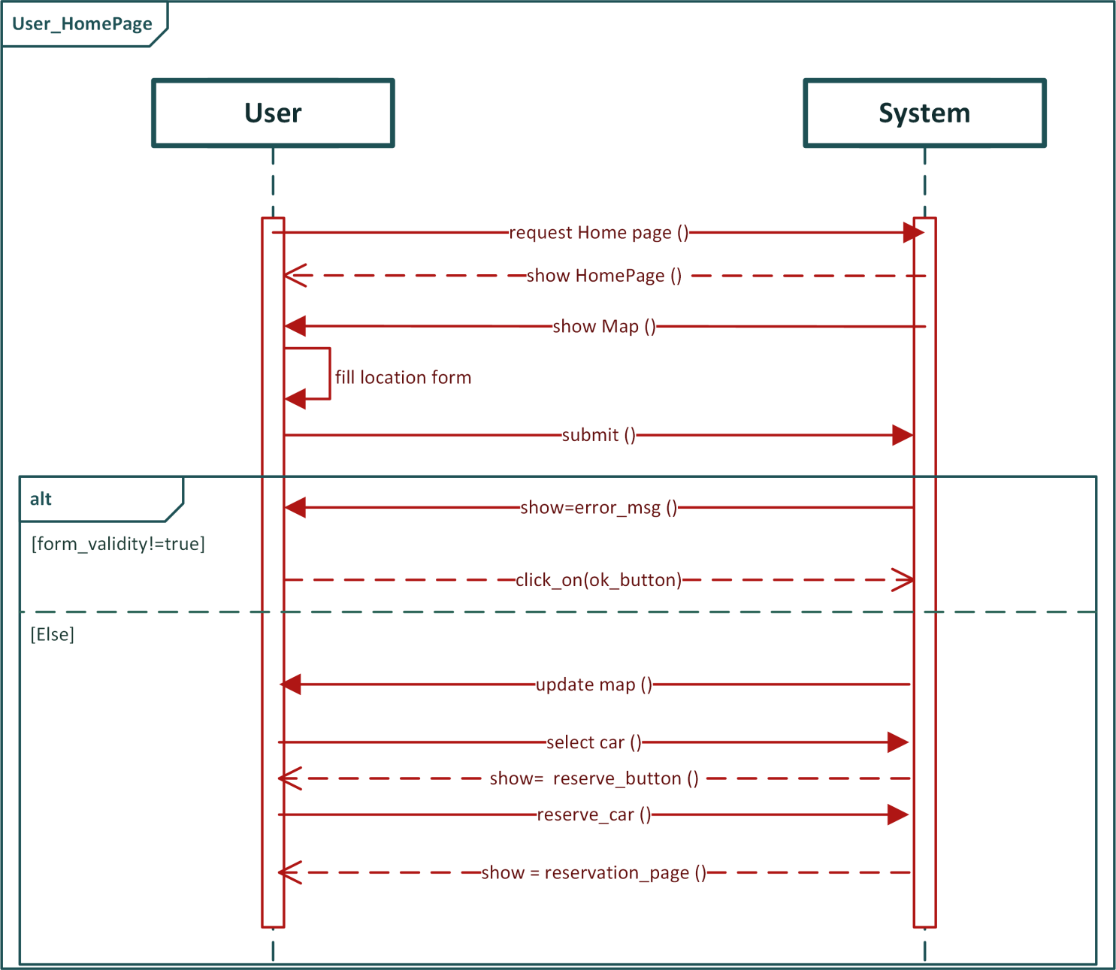

**Sequence Diagram : Report Accident**

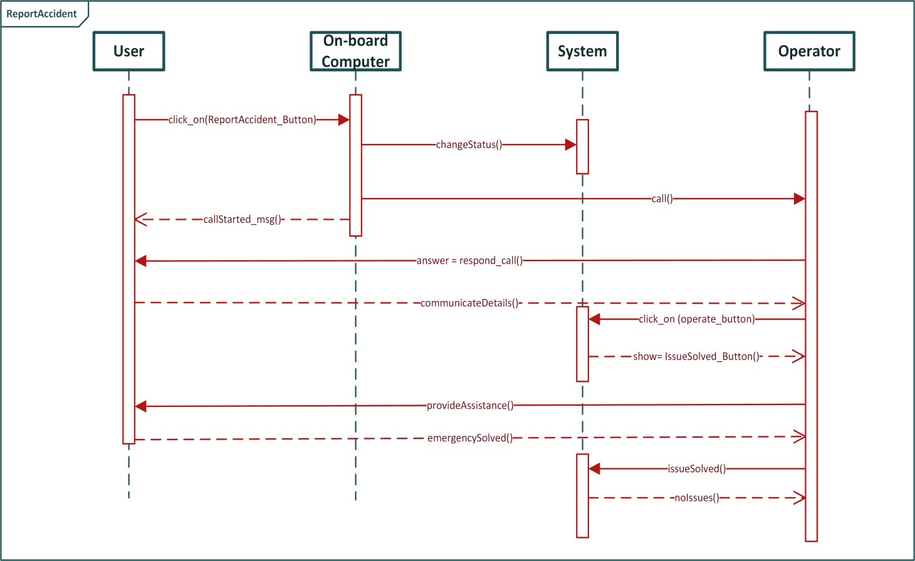

**5 Alloy Modelling**

**5.1 Model**

open util/boolean

sig Email{}

sig User {

identifyby:Email,

}

fact UniqueEmail{

User.identifyby=Email

}

fact OneEmailperUser {

all u1,u2 : User | u1!=u2 => u1.identifyby != u2.identifyby

}

sig Car {

plate: Int,

position : CarPosition

}{plate>0}

fact OnlyOnePlatePerCar{

all c1,c2 :Car | c1!=c2 => c1.plate != c2.plate

}

fact UniqueCarPosition {

Car.position = CarPosition

}

fact OnlyOnePositionPerCar{

all c1,c2 :Car | c1!=c2 => c1.position != c2.position

}

sig Reservation {

reservedby: one User,

car: Car,

issue : lone ReservationIssue

}

fact UniqueRes {all r1,r2 :Reservation | r1!=r2 => r1.reservedby!=r2.reservedby}

fact UniqueCar{all r1,r2 :Reservation | r1!=r2 => r1.car!=r2.car }

fact AllReservationIssuesAreAssociatedToAReservation { Reservation.issue = ReservationIssue}

fact NoReservationsAssociatedToTheSameIssue{ all r1, r2 : Reservation | r1!=r2 => r1.issue!=r2.issue}

sig Ride {

driveby: one User,

car:Car,

passengers :Int ,

issue : set RideIssue ,

discountsPenalities : set DiscountPenalities

}{

passengers<5

passengers>1

#issue=1 or #issue =0

}

fact LowChargeIssueImpliesLowChargePenality {

no r: Ride | all i : LowCharge | all dp: CarWithLowCharge | (dp in r.discountsPenalities && !(i in r.issue)) || (i in r.issue && !(dp in r.discountsPenalities))

}

fact LowChargeIssueImpliesNoPluggedInCar {

no r:Ride | some dp: CarWithLowCharge | some dp2: CarPluggedIn | (dp in r.discountsPenalities) && (dp2 in r.discountsPenalities)

}

fact LowChargeIssueImpliesNoChargedCar {

no r: Ride | some dp: CarWithLowCharge | some dp2 : ChargedCar | (dp in r.discountsPenalities) && (dp2 in r.discountsPenalities)

}

fact morePassengerDiscountImpliesAtLeastThreePassengers {

all r:Ride | all dp: MorePassengers | (dp in r.discountsPenalities) && r.passengers>2

}

fact d1 {

all r: Ride | all dp1: CarPluggedIn | all dp2: CarWithLowCharge | dp1 in r.discountsPenalities <=>!(dp2 in r.discountsPenalities)

}

fact AllDiscountsHaveARide {

Ride.discountsPenalities=DiscountPenalities

}

fact d2 {

all r:Ride ,dp1 , dp2 : ThreeKmAway | dp1!=dp2 && dp1 in r.discountsPenalities <=>!(dp2 in r.discountsPenalities)

}

fact d2 {

all r:Ride, dp1, dp2 : CarWithLowCharge | dp1!=dp2 && dp1 in r.discountsPenalities <=>!(dp2 in r.discountsPenalities)

}

fact d2 {

all r:Ride, dp1, dp2 : CarPluggedIn| dp1!=dp2 && dp1 in r.discountsPenalities <=>!(dp2 in r.discountsPenalities)

}

fact d2 {

all r:Ride, dp1, dp2 : ChargedCar | dp1!=dp2 && dp1 in r.discountsPenalities <=>!(dp2 in r.discountsPenalities)

}

fact d2 {

all r:Ride, dp1, dp2 : MorePassengers | (dp1!=dp2 && dp1 in r.discountsPenalities) <=>!(dp2 in r.discountsPenalities)

}

fact AllRideIssuesAreAssociatedToARide {

Ride.issue = RideIssue

}

fact NoRidesAssociatedToTheSameIssue{

all r1, r2 : Ride | r1!=r2 => r1.issue!=r2.issue

}

fact UniqueRide {

all r1,r2 :Ride | r1!=r2 => r1.driveby!=r2.driveby

}

fact UniqueRideCar {

all r1,r2 :Ride | r1!=r2 => r1.car!=r2.car

}

fact CarRideOrRes1 {

Ride.car = Ride.car - Reservation.car

}

fact CarRideOrRes2 {

Reservation.car= Reservation.car- Ride.car

}

fact ResOrRide {

Ride.driveby = Ride.driveby - Reservation.reservedby

}

fact ResOrRide1 {

Reservation.reservedby= Reservation.reservedby- Ride.driveby

}

sig CardID{}

sig Operator{

id: CardID,

station : one ChargingStation,

issueToTakeCareOf : lone Issues

}

fact everyIssueHasAnOperator {

Operator.issueToTakeCareOf = Issues

}

fact DifferentOperatorsAssociatedToDifferentIssues {

all o1, o2: Operator | o1!=o2 => o1.issueToTakeCareOf !=o2.issueToTakeCareOf

}

fact OneIDperOperator {

all o1,o2 : Operator | o1!=o2 => o1.id != o2.id

}

fact UniqueCardID{

Operator.id=CardID

}

sig ChargingStation {

position: StationPosition,

}

fact UniqueWorker {

Operator.station=ChargingStation

}

fact OnePositionPerStation {

all cg1, cg2 : ChargingStation | cg1!= cg2 => cg1.position != cg2. position

}

fact UniquePosition{

ChargingStation.position = StationPosition

}

abstract sig DiscountPenalities{}

abstract sig Discounts extends DiscountPenalities{}

abstract sig Penalities extends DiscountPenalities{}

sig MorePassengers extends Discounts{}

sig CarPluggedIn extends Discounts{}

sig ChargedCar extends Discounts{}

sig ThreeKmAway extends Penalities{}

sig CarWithLowCharge extends Penalities{}

abstract sig Issues {}

abstract sig RideIssue extends Issues {}

abstract sig ReservationIssue extends Issues{}

fact ItsAlwaysIssuesWeAreTalkingAbout {

RideIssue + ReservationIssue = Issues

}

sig Accident extends RideIssue {}

sig AssistanceNeeded extends ReservationIssue {}

sig LowCharge extends RideIssue {}

fact AllRideIssues{

Accident + LowCharge = RideIssue

}

abstract sig Position{}

sig StationPosition extends Position {}

sig CarPosition extends Position {}

pred show {

#Ride = 1

#Reservation = 1

#User = 3

#ChargingStation = 1

#Operator = 2

}

assert everyOperatorDoesHisJob {

all r:Ride |all i : RideIssue | some op: Operator | ( i in r.issue) =>i in op.issueToTakeCareOf

}

assert everyOperatorDoesHisJob2 {

all res: Reservation | all i: ReservationIssue | some op: Operator| (i in res.issue ) =>i in op.issueToTakeCareOf

}

assert everyRideLowChargeIssueHasALowChargePenality {

all r:Ride | some i: LowCharge | some dp: CarWithLowCharge | i in r.issue <=> dp in r.discountsPenalities

}

assert noLowChargeIssueOnPluggedInCars {

no r:Ride |some dp:CarWithLowCharge | some i: LowCharge | some dp2 : CarPluggedIn | (i in r.issue || dp in r.discountsPenalities) && (dp2 in r.discountsPenalities)

}

assert noLowChargeIssueChargedInCars {

no r:Ride |some dp:CarWithLowCharge | some i: LowCharge | some dp2 : ChargedCar | (i in r.issue || dp in r.discountsPenalities) && (dp2 in r.discountsPenalities)

}

check noLowChargeIssueChargedInCars

check noLowChargeIssueOnPluggedInCars

check everyOperatorDoesHisJob

check everyOperatorDoesHisJob2

check everyRideLowChargeIssueHasALowChargePenality

run show for 5

**Alloy Result**

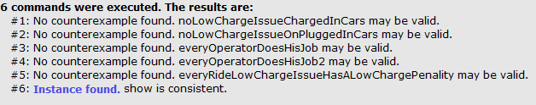

**5.2 World Generated**

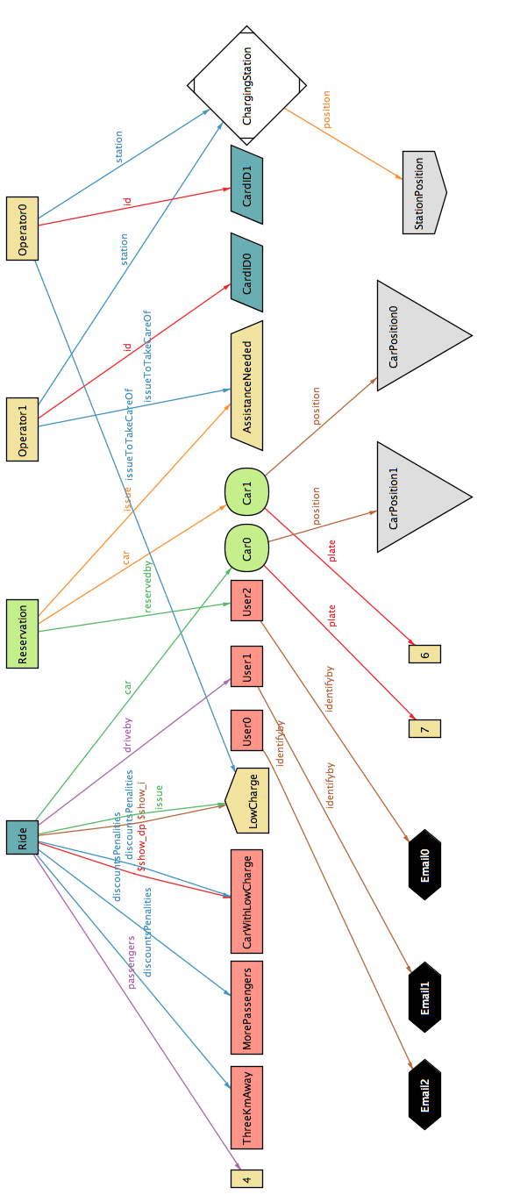

**6 Other Features**

**6.1 Future Development**

We are thinking about extending the perimeter of the safe area to the whole region, and possibly applying it to other regions. We also plan to implement a more innovative and computationally efficient method to let the system check whether a car is parked within 3 km of distance from the nearest safe area , using a special signal created by emitters placed into charging stations instead of using the GPS sensor.

**6.2 Hours of Work**

**Joshua Nicolay Ortiz Osorio**

* **26/10/2016 : 1h30m**
* 28/10/2016 : 2h30m
* 29/10/2016 : 1h
* **1/11/2016 : 2h**
* **4/11/2016 : 2h**
* 5/11/2016 : 1h
* 8/11/2016 : 3h
* 9/11/2016 : 3h
* **10/112016 : 3h**
* **11/11/2016 :2h30m**
* **12/11/2016 : 4h**
* **13/11/2016 : 4h**

**Michelangelo Medori**

* **26/10/2016 : 1h30m**
* 27/10/2016 : 2h
* 29/10/2016 : 2h30m
* **1/11/2016 : 2h**
* **4/11/2016 : 2h**
* 5/11/2016 : 1h
* 8/11/2016 : 3h
* **10/112016 : 3h**
* **11/11/2016 :2h30m**
* **12/11/2016 : 4h**
* **13/11/2016 : 4h**

**6.3 Used Tools**

* Visio: for Use Case Diagram, Sequence Diagrams, State Diagram and Activity Diagram
* Balsamiq : to make mock-ups
* Office World: to write document
* Github: for version controller
* Alloy Analizer 4.2 . to prove the consistency of our model
* Dropbox : to share documents online