CS 303 Assignment 3 ReadMe

Queues
The queues are implemented as circular arrays with front and rear index trackers as well as trackers for the current capacity of the queue and the current number of items in the queue.
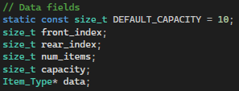
The push() function works by taking an input as the desired value to input into the queue and places it at the location after the position of the rear index. The rear_index and num_items trackers are then updated accordingly. If the number of items in the queue already meets the capacity of the queue, the function calls the reallocate() function to make more space.
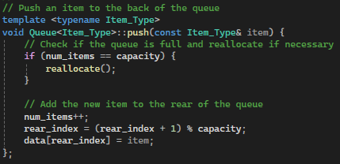

The pop() function checks if the queue is empty first and throws an error if the list is empty. Otherwise, the front_index tracker is simply updated beyond the item popped and the num_items tracker is reduced.
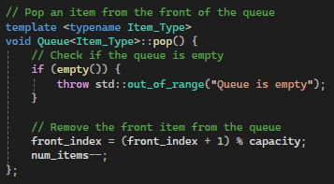
The front() function checks if the queue is empty first and throws an error if the list is empty. Otherwise, the function returns the item at the front_index.
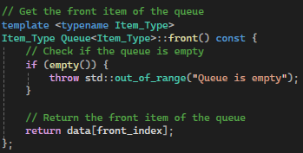
The size() function returns num_items.
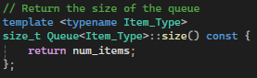
The empty() function returns true if num_items is 0 and false in every other instance.
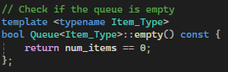

The reallocate() function doubles the size of the queue by creating a temporary array of twice the size of the original array and copying everything in the queue into the temporary array. The values in the temp array are then swapped with the original array and then the temp array is deleted. Finally, the front_index and rear_index trackers are updated.
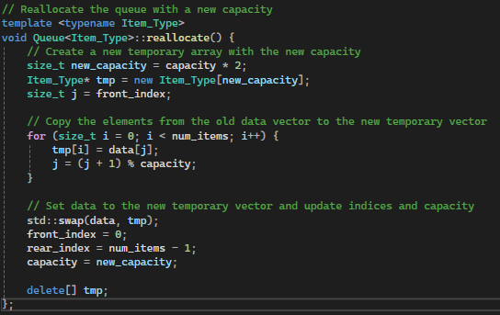
The move_to_rear() function checks if the queue is empty first and throws an error if the list is empty. The item at the front of the list is saved to a variable using the front() function, removed with pop(), and enqueued with push().
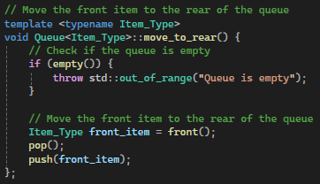
Finally, in the Queue.cpp file, any desired variable type to use with the queues will need to be explicitly instantiated.
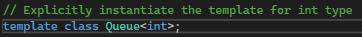

Linear Search
The linear search function was updated to find the last occurrence of an item in a vector using recursion. The function works by iterating through the list in reverse by starting with a wrapper function that takes the vector and the target. The wrapper function then calls the lin_search() function with the vector, target, and the last index of the vector. The function searches for the item at the given index and calls itself with the previous index.
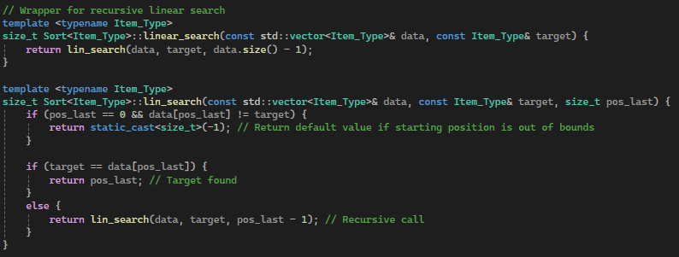
Finally, in the Sort.cpp file, any desired variable type to use with this function will need to be explicitly instantiated.
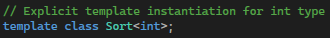

Insertion Sort
The insertion sort function was updated to work on a doubly linked list. The function first checks if the list can even be sorted by checking if the size is at least greater than 2. The function then iterates through the linked list using an iterator starting from the second item in the list. The function sets the item to be compared to the variable “key.” It compares the key to every previous item in the list by iterating backwards through the list starting from the item before the key. If the item is greater than the key, the two swap places. Otherwise, it continues to iterate through the list until it reaches the beginning.
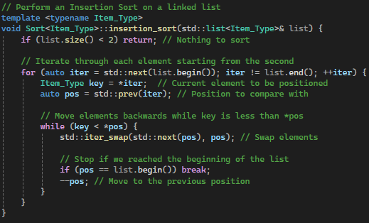
Finally, in the Sort.cpp file, any desired variable type to use with this function will need to be explicitly instantiated.

