Joshua Pattani
ATLS4141 - Color
Professor Carson Bruns
Final Project Write-up
Dec 20, 2023

ChromaFreq: Harmonizing Sound and Color

Introduction
"ChromaFreq: Harmonizing Sound and Color" is a digital art project aimed at creating an immersive experience that unites music and visual elements. This venture is driven by a fascination with the intersection of auditory and visual realms and is rooted in a deep appreciation for the emotional power of music and the evocative nature of colors.

Goals

ChromaFreq endeavors to translate music into a visual language, using color and form to represent different sounds and rhythms. The primary goal is to offer a new way to experience music, appealing not just to the ears but also to the eyes, and to explore the concept of synesthesia – the interplay of senses.

Methods
The project employs p5.js for real-time audio processing and visual rendering. Techniques like Fast Fourier Transform (FFT) are utilized to analyze audio frequencies, which are then mapped to corresponding colors and shapes. The visualizations include dynamic spectrum analysis and waveform representation, alongside creative interpretations using generative art principles.

The original logic for this project was to statically analyze sound frequencies and transcribe them to coordinate wavelengths of light, based on a specific direct relationship between the continuous spectrum of frequencies of electromagnetic energy in the band of visible light and the pitches of sound in a continuous frequency spectrum of sound that are 40 octaves (a factor of 2⁴⁰ = 1,099,511,627,776) below the frequencies of visible light.

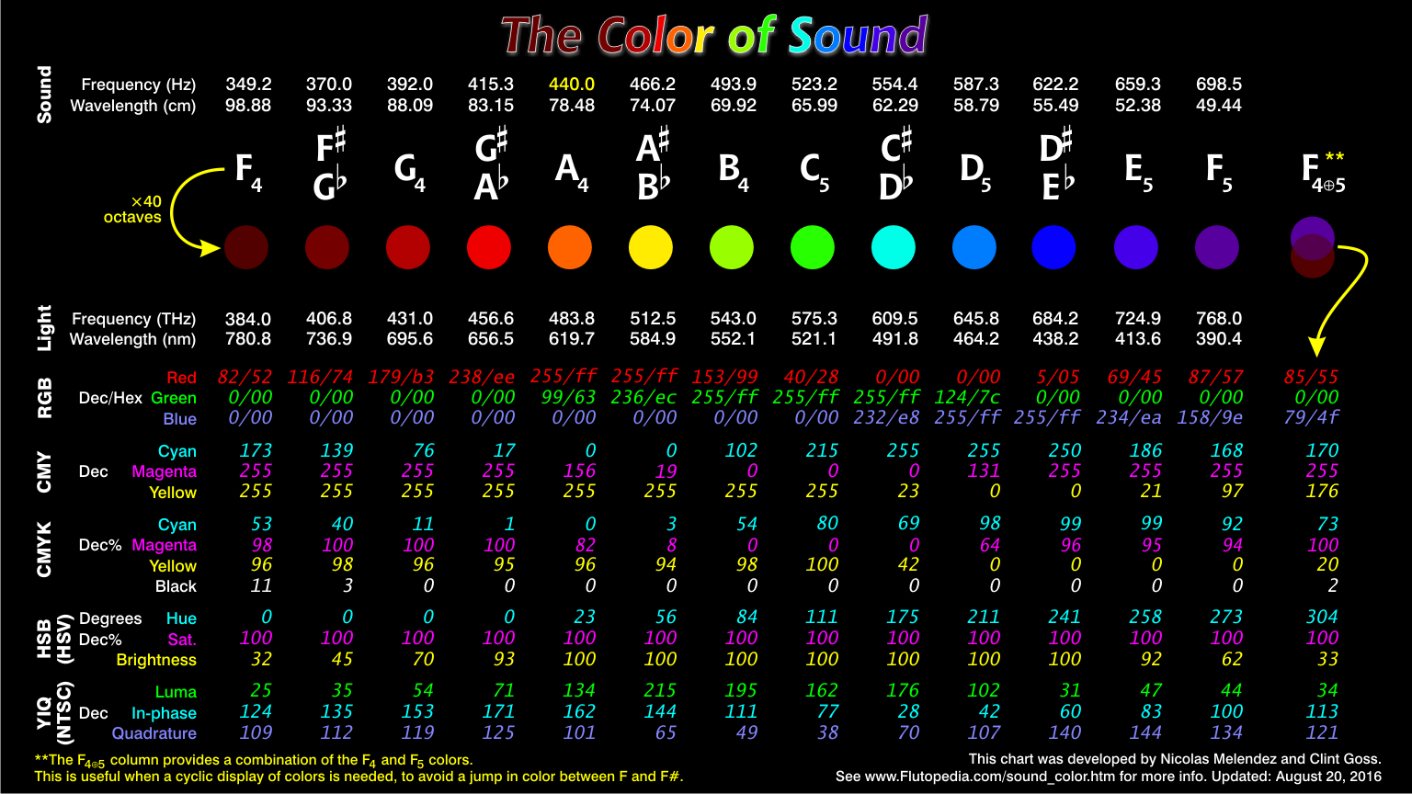

These calculations were found in a project conducted by Flutopedia. You can see their full write up HERE.
The creation of ChromaFreq involved iterative development, where initial concepts were continuously refined through experimentation with different audio-visual techniques. This led into a robust scaling of the project to analyze and convert sound frequencies to consonant colors in real-time.

Several mathematical equations and concepts are used in this program, primarily related to sound processing and the conversion of sound frequencies to light wavelengths. Here's a summary of the key equations:
Original Approach:
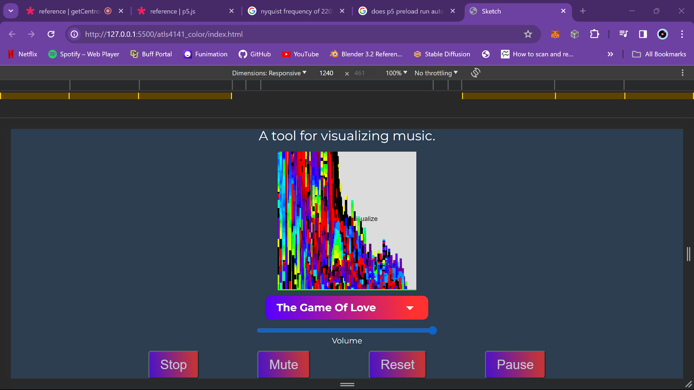

- Sound Frequency Scaling:
$scaledFrequency = soundFrequency × \frac{343}{speedOfSound}$
- This equation scales the sound frequency based on the speed of sound. Currently, this project simulates sound in a vacuum.

The frequency of sound is then scaled compoundly by a factor of 2 until it reaches the frequency band of visible light.

- Light wavelength Calculation:
$lightWavelengthNM = \frac{speedOfLightVacuum}{light frequency} × {10}^{9}$
- The scaled frequency is then converted to wavelength using the standard physics conversion

The original method involved scaling the sound frequency to the light frequency range and then converting it to a corresponding wavelength. It's a more direct approach but does not consider the logarithmic nature of human perception. The image above shows an output example of using this linear color mapping logic.
Final Approach
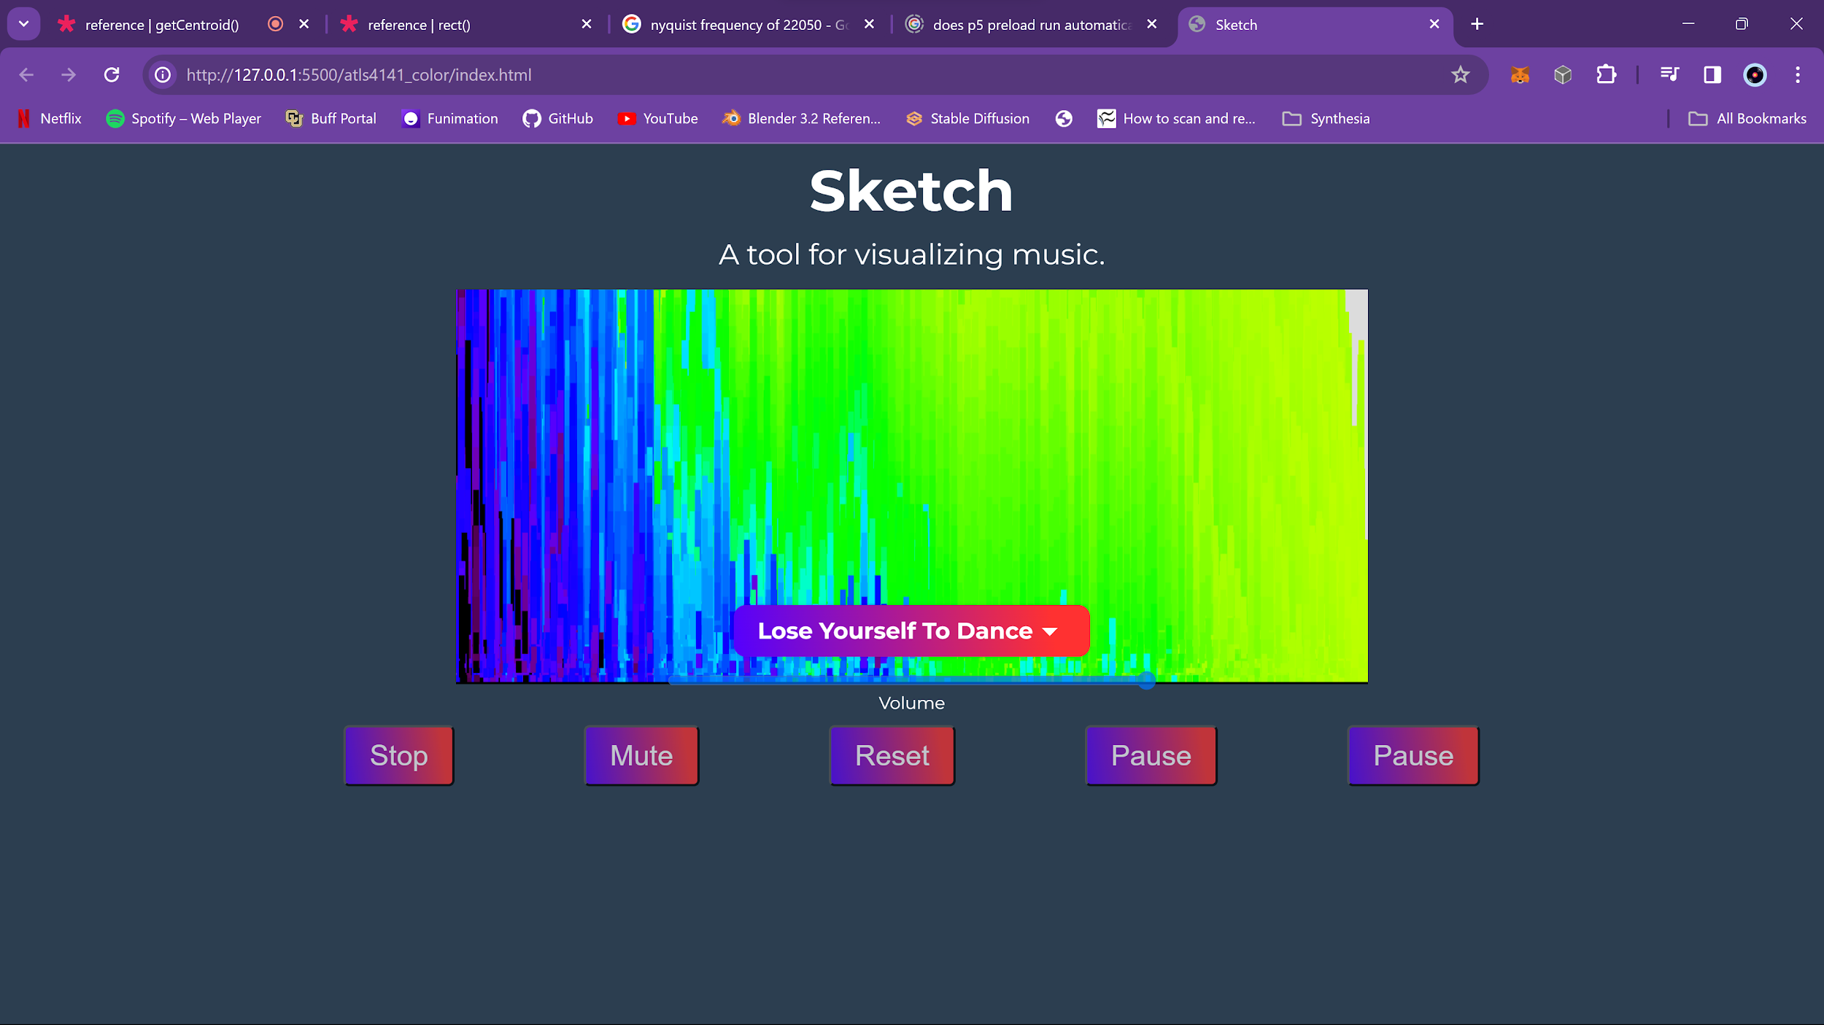

This method uses a logarithmic scale to map sound frequencies directly to light wavelengths. It's designed to align more closely with how humans perceive sound, providing a perceptually uniform mapping.

- Logarithmic Mapping for Sound to Light Wavelengths:
  - soundFreq is the same speed of sound scaled frequency from the original approach
$logFreq = \frac{log(soundFreq/minFreq)}{log(maxFreq/minFreq)}$
$wavelength = minWavelength + (maxWavelength - minWavelength) × logFreq$

This approach allowed for greater perceptual uniformity in the visual display. The color spectrum shown in the image above blends into a smooth, almost gradient like color distribution.
This JavaScript code calculates an intensity factor based on a given wavelength (wl) of light. The intensity factor is used to simulate the way the human eye perceives light at different wavelengths.
Breakdown
The code uses a series of if statements to determine the intensity factor based on the wavelength range. Here's a step-by-step explanation:

Range 1: 350-420 nm (UV to Violet)
javascript
Edit
Copy code
1if (wl >= 350 && wl < 420) {
2 factor = 0.3 + (0.9 * (wl - 350)) / (420 - 350);
3}
In this range, the intensity factor increases linearly from 0.3 to 1.0 as the wavelength increases from 350 nm to 420 nm.

Range 2: 420-645 nm (Visible Light)
javascript
Edit
Copy code
1else if (wl >= 420 && wl < 645) {
2 factor = 1.0;
3}
In this range, the intensity factor is constant at 1.0, indicating that the human eye is most sensitive to light in this range.

Range 3: 645-780 nm (Red to Near-Infrared)
javascript
Edit
Copy code
1else if (wl >= 645 && wl <= 780) {
2 factor = 0.2 + (0.8 * (780 - wl)) / (780 - 645);
3}
In this range, the intensity factor decreases linearly from 1.0 to 0.2 as the wavelength increases from 645 nm to 780 nm.

Out of Range
javascript
Edit
Copy code
1else {
2 factor = 0.0;
3}
If the wavelength is outside the range of 350-780 nm, the intensity factor is set to 0.0, indicating that the human eye is not sensitive to light at these wavelengths.
In Summary
This code calculates an intensity factor based on the wavelength of light, simulating the way the human eye perceives light at different wavelengths. The intensity factor is used to adjust the intensity of light in a simulation or visualization.

Wavelength to RGB color mapping logic

In addition, an entire web application was created to execute the functionality and interface to audio-color display.
ChromaFreq

Statement

ChromaFreq is deeply personal, blending my passions for music, coding, and visual arts. It reflects a journey of exploration and learning, integrating concepts from various disciplines, including physics, color theory, and computer programming. This project is a representation of my curiosity and continuous pursuit of interdisciplinary understanding.

In conclusion, ChromaFreq is more than just a technical achievement; it's an artistic expression and a personal endeavor to bridge the gap between different sensory experiences. It's an invitation to perceive the world in a multifaceted way, encouraging others to explore the boundless potential of creative technology.

