Joshua Rodstein
0590 – Social Implications of CS
Case Study: Right to Repair

As we move from a purely mechanical world, to a world in which hardware and software are (almost) seamlessly blended into one, the lines that separate ownership from subscriber-ship are almost equally blurred. Ownership seems a straight forward concept, especially in terms of items received for monetary compensation. In this sense, ownership remains unchanged. The distinction between renting, owning, and leasing are familiar concepts that require little further definition. These concepts are tied to the foundation of our culture and American ingenuity has led to developments of awesome machinery and apparatus, which spur an equally awesome desire to possess and take pride in the ownership of such items.
Craftsmanship has been at the forefront of design and manufacturing for centuries. The idea being that profit and revenue were not to be gained at the expense of quality and workmanship. Quality and longevity of products and services was the goal to strive for. Perhaps, however, this mode of design and production was a result of the slow, long lasting trends of by gone eras. In a world where technological developments move at a much slower (comparably) pace to that of today, the by product of such slow development means that existing products must last longer. In a sense, these products merely bridge a gap to the next best iteration. This is not an unfamiliar concept to the younger generation of this era, and yet it seems a reality that society as a whole is struggling to come to terms with.
In centuries past, owners of such high quality and long lasting products, through repetitive use, would indeed need to affect repairs upon these products. The idea of ownership here being the same clearly defined tangible possession of a product after payment. This means that once in possession of said product, the clearly defined owner would have options. Either render repairs upon the device themselves or take the product to a skilled, third party specialist. The need for such third party specialists seems clear. However, the level of technological expertise was not out of reach of the owner. Much of the technological and mechanical advances in the past few centuries have been driven by agriculture. An obvious example of such ownership with accompanying needs for repair would be that of a farmer.
From the perspective of a farmer, agricultural machinery should last. This equipment is expensive and lies at the crux of production for these farmers. For generations farmers have affected their own repairs upon their machinery, should it fail. Famers had to become experts of their own machines. With clearly defined ownership and property, this concept is straightforward and very uncomplicated. In a previous era a farmer could get by without upgrading to the latest model, or perhaps even the past 5 models. In theory, and I am sure in practice, farmers could be working with decades old equipment, and depending on the size of their farms and the nature of their crops or livestock, would get by just fine.
It is at this point that we being to see how the increase in speed and shifting of production cycles, changing profit models, and technological necessities, can dictate a change to our autonomy and agency within the realm of ownership. The once clearly defined concept of ownership starts to muddy and blur. The effects of this change are not lost on the manufacturers and corporations behind these products. The increased speed of development cycles means that increasingly, companies see less incentive in developing high quality, long lasting products. The increase in speed of new iterations of a product means that the need for quality and durability slowly decreases. Companies shift their models towards high powered sexy products that run fast, but die quickly.
This bring us to our topic of study, the Right to Repair. “Repair” as a term, holding varying degrees of specificity, depending on whether we look at this from the perspective of manufacturers and holders of intellectual and technical property, or from the perspective of consumers. The idea of Right to Repair can be most easily identified from the consumer perspective. In the case of agriculture, we have moved from purely mechanical devices to mere mechanical skeletons with varying levels of automation and programmable parameters. Software has so slowly saturated the raw materials that America is so familiar with, and as much as we claim to understand what this means, perhaps this is not so clear to the general populace. Farmers are all to familiar with this. The moment it became infeasible to affect repairs upon their own equipment without an advanced degree in electrical, mechanical, or computer engineering, is the moment the front lines of the agricultural profession changed.
This creeping saturation of software into the fiber of the mechanical work means that the ideas of ownership change as well. The moving parts of an item start to play second fiddle to the software that drives its core functionality. Even if one knows how to repair a mechanical part, who is to say that the software will still interface with the hardware? The lines of new-ownership can now, not so clearly be defined. Where as in the past, a purchased product became the sole property of the customer, now we must take into account the nuances of all included technology and intellectual property.
For large, expensive industry intensive items such as John Deere tractors, the ability to opt out of updates does not make much sense. At what point does a farmer in todays connected world truly own their tractor? Which is the more cost effective model for the consumer and for the manufacturer? Should a farmer have the right to repair his own products if he also has the expertise (or access to it)? Is this model purely a product of more efficient and faster technological updates and features? Or is this merely another means of generating revenue more quickly?
In September of this year (2018), representatives of California famers and equipment dealers signed the ‘California Dealer-Farmer Agreement’. According to it’s proponents, the agreements aim is to ‘make it easier for farmers to diagnose and repair equipment without accessing or downloading proprietary software or code’. Farm-equipment.com details the “right-to-repair” agreement as follows,
...With the “right-to-repair” agreement, equipment dealers commit to providing
access to service manuals, product guides, on-board diagnostics and other information that would help a farmer or rancher to identify or repair problems
with the machinery. The agreement includes restrictions. Among them: Source
code for proprietary software would not be accessible, and owners would not
be able to change equipment in ways that would affect compliance with safety or emissions regulations.
Essentially, this is an agreement aimed at giving famers the tools they need in order to diagnose any mechanical issues with the machinery. They are not authorized to augment any code driven functionality, and are not allowed to circumvent safety standards. This seems a reasonable compromise, as one might imagine the typical farmer not possessing the necessary skills to affect software repairs. Assuming that companies like John Deere have the best interest of the farmers in mind, and from an outward perspective, this seems a reasonable agreement. Traditionally, farmers need to affect their own mechanical repairs. A large hurdle in doin so in this era is the software. Of course, larger mechanical issues need little diagnoses. If an axle break, it’s a very straight forward assessment of damage and procedures moving forward. However, if the issues is smaller, or if perhaps a warning of wear and an impending mechanical failure, how does one go about detecting, diagnosing, and finally moving forward with repairs?
This agreement seems to provide the necessary tools and support for farmers to move forward with repairs, or seek out certified John Deere technicians to do so without violating any warranty or contractual terms. This does however, narrow the field of available technicians. No more third party repairs, and no more do it yourself (assuming possession of necessary skills). The claims of this being a “right-to-repair” bill seem more a hijacking of the term in order to ease fears of a more controlling manufacturer effectively squashing any repair or upgrade competition. The only articles that seem to appropriate this term are articles in favor of the agreement.
There is a very clear narrative being pushed in regards to what this agreement means for farmers and manufacturers moving forward. The president of the California Farm Bureau Federation, Jamie Johansson was quoted as saying, “This agreement gives farmers the information they need to (make repairs quickly), even as equipment has become increasingly complex.” Highlighting the perspective of both sides of the agreement, President and CEO of the Far West Equipment Dealers Association (FWEDA), Joani Woelfel, said the agreement “says a lot about the relationship between dealers and their customers.”. Woelfel goes on to say, “This agreement is especially important because whenever we can resolve issues that concern us without passing laws, everybody wins” (cfbf.com, 2018)
The dealer-farmer agreement comes in response to legislation introduced earlier in the year by Assembly Member Susan Talamantes, known as the “Right to Repair Act”, that according the an article on CFBF.com, would have “...ensured (that) consumers of a wide array of electronic products would receive access to manufacturers’ diagnostic and repair information.” What the article fails to mention is that the bill would have also required electronics manufacturers to make parts and information available to product owners and to third-party repair shop and service technicians. 16 states other than California have proposed similar legislation (Gartenberg, 2018).
Of course, major tech companies such as Apple and Microsoft wagered their not so favorable opinions of the proposed legislation, expressing their concerns over possible security risks to users. The Right to Repair act died a quiet and unceremonious death with the introduction of the dealer-farmer agreement, which is seen by those at the helm of the memorandum as a compromise to the legislation. It is important to note that California already has some of the most progressive and customer favorable laws in the nation. The CA Civil Code
requires that for warranties for any electronic or appliance between 50 and 100 dollars wholesale, the manufacturer must provide parts and literature to repair technicians and facilities for up to three years. The time frame is extended to 7 years for products exceeding 100 dollars wholesale.
These warranty periods make it easier for third party technicians in the state to operate and generate income. Now, for products like cell phones or televisions, this might seem like enough. One might ask why there exists such a clamor for more rights when it comes to affecting repairs. Simply, a tractor isn’t a cellphone. It is an entirely more expensive and more crucial part to the life of a farmer then say, the latest iteration of a cellphone is to a business man or someone surviving solely off of the gig economy. A tractor as mentioned previously, is meant to last years. Of course warranties can be purchased through John Deere and dealers, this however is a pay for service model. It has little to do with ones right to repair. If a farmer manages to maintain his equipment for over a decade, and suddenly finds himself out of warranty, then his only options are to seek out more service on a separate pay scale form John Deere themself. The farmer has little flexibility when it comes to finding a level of service and price that works for their needs and their budget. It seems that this new agreement serves to narrow the options at a farmers disposal.
Not surprisingly, there are more than a few critics and dissenting opinions towards the agreement and what is means for the industry now and in the future. Highlighted in these opinions is a reality that perhaps the authors of the new agreement would like to overlook, and that reality is that in these machines, the hardware without the software, and conversely the software without the hardware, would be useless. “Keeping a device in working order often means fixing both its hardware and software. But a big California farmers’ lobbying group just blithely signed away farmers’s rights to access or modify the source code of any farm equipment software.” (wired.com, 2018). The article points out that changing of engine settings, retrofitting old equipment, or modifying tractors to meet new standards is prohibited by the agreement.
In effect, “big ag” is carving out their path for planned obsolescence. The industry has even gone so far as to distribute literature explaining their feelings on the distinction between right-to-repair and right-to-modify. This the clarifying that manufacturers’ opinion on this issue, is something that serves big-ag more than is serves the farmers. Jeff Buckingham, a San Luis Obispo ranch owner was quoted as saying, “I will gladly welcome more ways to fix the equipment on my farm. Let’s be clear, though, this is not right-to-repair”, He goes on to say “ At the end of the day, I bought this equipment, and I want everything I need to keep it running without relying on the manufacturer or dealer.” Let’s make no mistake here, it is clear that these farmers are intensely aware of the position they so precariously occupy. With a growing and expanding economy, economic models show a proportionate decline in agricultural sectors (Anderson, 1987). This only adds to the delicate situation these farmers face. As equipment becomes more expensive, it seems that companies like John Deere are content to restrict, in proportion, the available sources for repair.
Farmers are a notoriously resourceful, clever, hard working bunch. There exists a stigma that equipment with the level of sophistication of a new John Deere tractor, is beyond the capacity for todays farmers to fix, or modify, or “hack”. That is however, not the case. With even simple repairs becoming impossible to affect without paying $130 to a John Deere rep to drive out and authorize, In recent years, however, farmers started are “hacking” their tractors. There exist forums on which pirated John Deere firmware are sold. A recent Motherboard article, details and attempt by a journalist to to acquire pirated software. “After I found (the forum), I couldn’t do much of anything without joining… Once I was on it, I found dozens of threads from farmers desperate to fix and modify their own tractors.” (Motherboard, 2017). According to the article, much fo the software is cracked in Poland and Ukraine. There are a number of products being sold on these forums, including one tagged as as, JOHN DEERE OLD FILE ENCRYPTOR/DECRYPTOR (EDITOR) v0.1. (pictured on next page).
These devices require little further training or expertise to acquire. Simple knowledge of the internet will suffice, which these days is not uncommon. Couple with an already intimate knowledge of their own equipment capabilities and functionality, the implementation and installation seems rather trivial. Essentially, the PLD file tool is a way around the encryptions of John Deere software payloads. This allows a tractor’s software to interface with John Deeres API, without requiring a technician to drive out for a $130 fee, in order to authorize the part with a special dongle.

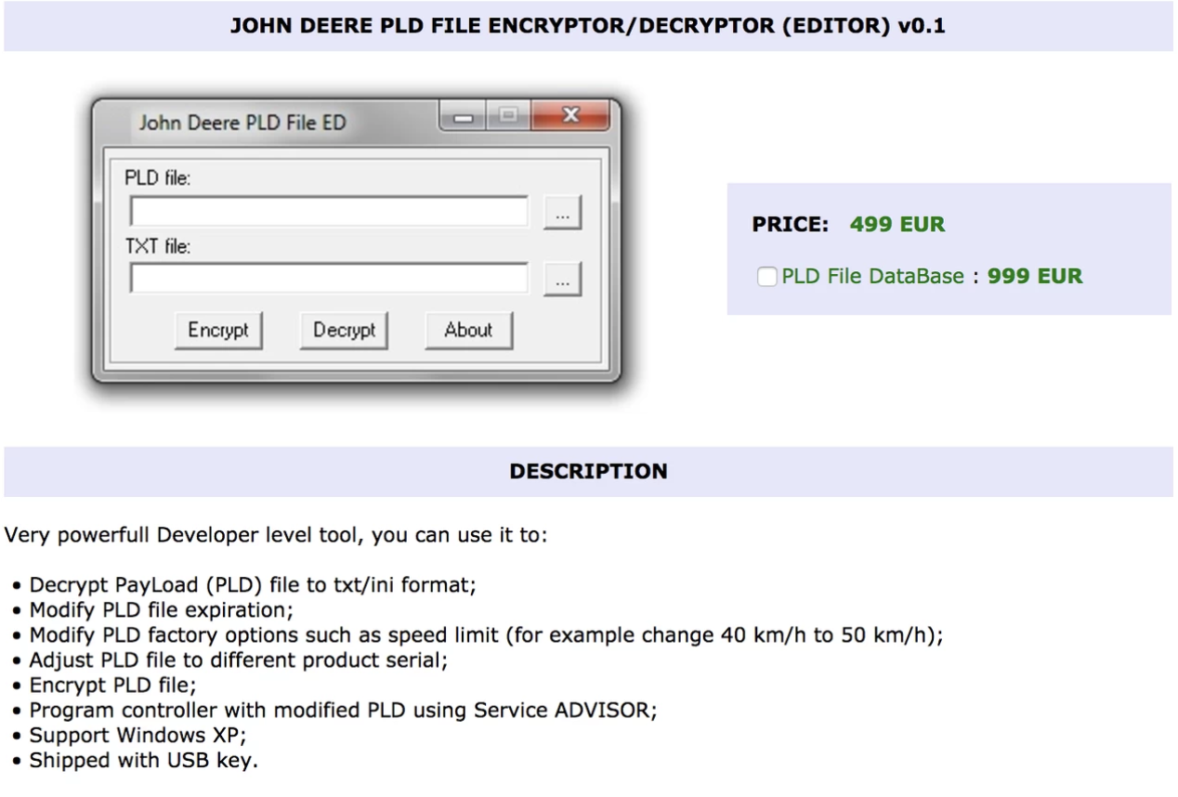

The website also offers: license key generators, speed-limit modifiers, and reverse-engineered cables to interface a tractor CPU with a computer. Yes, this is technically pirating, however, as of the 2015 approval of the Digital Millennium Copyright Act for Land Vehicles by the Librarian of Congress, modification of embedded systems is legal. As long as the vehicles can still meet emissions standards, the farmers are within their rights to modify their software should they need to. There is some murkiness surrounding the issue of whether or not the Act covers downloading of cracked software, however. Never the less, it seems a widely accepted idea that when something needs fixed, the owner should be within their rights to do so.
Close to the time of the approval of the act, John Deere began requiring that farmers sign a licensing agreement. Breaching this agreement would imply a federal copyright violation, giving John Deere the grounds to sue customers to enforce the contract.
It is clear that farmers have many concerns about the future of their products and with their ability to maintain them. The question for them is, what might happen to those products if for some reason the manufacturer would no longer be able to provide the necessary support perhaps from a sale of the company? Fromm the perspective of the owners, they are taking necessary steps to ensure that they have the ability to maintain their products no matter what fate might befall a the company. From John Deere’s perspective, it is evident that they realize a certain organization of power and control over their products and over the farmers who rely on them. By restricting repair options to dealers only, and by forcing farmers into licensing agreements that limit their abilities keep there equipment in operation, John Deere is solidifying and presiding over a monopolization of software, and a suffocation of the wider agricultural industry equipment industry in the United States.
How does John Deere’s strangle hold on the ag-tech industry effect the greater technology and software market at large? We have briefly touched upon the term, Planned Obsolescence. A quick google search defines this as
a policy of producing consumer goods that rapidly become obsolete and so require replacing, achieved by frequent changes in design, termination of the supply of spare parts, and the use of nondurable materials.
By restricting ability of farmers to keep older models of tractors in operation, John Deere is implementing planned obsolescence almost in lock step with the above definition. Why then is there not more outcry in support of farmers rights? Its easy to find articles about the demands of users of more socially visible technology like the iPhone or any number of other devices that hit the market every six months to a year. As it turns out, on the LibreOffice word application that I am currently using, ‘iphone’ is not a recognized word. However, iPhone is. This high visibility is perhaps stealing some of the spotlight. When asked to think about technology today, how many people would refer to the agricultural industry as one of their first 5, or even first 10 examples. I’d wager that not many would even consider agriculture as a major player.
Public outcry is what is fueling much of the legislation aimed at ensuring more rights for electronics owner. When public outcry seems wholly unaware of an industry, that industry will understandably receive less attention. It seems that this has allowed lobbyists to undermine the welfare of farmers across the country. As frustrating as this lack of care seems at the moment, there are those that feel it will become a non issue in the coming decades. This issue is something that has been mentioned at length in the essay up to this point. John Deere tractors are more of a software device than a hardware device (Janzen, 2017). An article on aglaw.com claims that as tractors become more and more a piece of software, the desire and need for farmers to repair them will eventually fade. There are comparison being drawn between a piece of machinery like a tractor and a laptop computer. What I will reiterate in response to this opinion, is the a tractor is not a laptop, or phone, or TV.
The underlying issue at the heart of all of this debate is time and money. Per Forbes, John dear is a company with a $47.7 billion market cap, and did $30.5 billion in sales last year. (Forbes, 2018). They exist in a market that dictates profit as the goal. Anything John Deere can do to solidify their margin and growth, they are going to try their hardest to do. Maintaining a tight grip on their software is something that I am sure is key to their assessment of how they plan to grow and profit as a company. If you’re John Deere, you are looking ahead, planned obsolescence is a fact of life. The speed at which software is creeping its way into the fabric of our everyday lives is incredible, and tractors are no exception. To large manufacturers like John Deere, Im sure it makes sense to limit the level of support offered for a particular model as the years go by and newer models are released. In an ideal world, and with an ideal level of software integration, a mechanical portion of a tractor would undergo annual service, while the software would continuously patch and upgrade over time. However, when your models change as rapidly as the software does, it becomes harder for a company to maintain support for models that by traditional standards are relatively new. From a company’s perspective, there comes a point when providing service for a model stops making sense.
From a farmer’s perspective, a tractor needs to last as long as possible. As mentioned before, the farmer wants to insure that long after support for a product stops, they are able to keep the machine functioning. I would venture to say that most farmers don’t come remotely close to John Deere’s profit. In most instances they are trying to keep food on the table. The most cost effective way for them to do that is the longevity of equipment. It seems I am beating a dead horse, for lack of a better term. But the idea that right to repair for a cell phone, and right to repair for a tractor are the same thing, ignores a lot of the realities of the implication of keeping these devices functioning. It is much easier to downgrade to a phone with base functionality to save money, then it is to downgrade a tractor. Without the proper equipment, these farmers make no money. Plain and simple.
Up until this point, I have perhaps done everything save for come right out and claim that John Deere operates under a model of planned obsolescence. I will go ahead and make that claim now, however, I will also claim that at this point in our society, in terms of the speed of technical development, planned obsolescence is necessary to some degree. The question is not whether or not new technology is emerging at an ever increasing and head spinning pace, the question becomes, who is driving that pace of development? It is necessary to consider this question when assessing moral and ethical implications of the business practices of John Deere. Again, it is easy to find literature tackling this issue form the perspective and in regards to mobile technology such as smart phones. In an article from the Center for Digital Ethics & Policy, Thomas J. Newhouse was quoted as saying, “Electronics are challenging because they are inherently obsolete from the moment they’re being shipped,”. The article states the obvious, that clearly, maintaining a product overtime is something these companies are not striving for, and a practice that the electronics industry at large has not made a priority (Dybis, 2012).
In the consumer electronics realm, it is very easy to see the cycle driving this practice. Consumers clammer for the new iteration of their device, for fear of being left behind, or perhaps for fear of people perceiving them differently. Social status and perception certainly come into play from the perspective of the consumer. This need to consume newer iterations more quickly is being driven by companies whose model is to release just enough new technology and features to keep the customer coming back. A minimum viable product regardless of available technology means adding release cycles. A stockpile of new, yet to be released features guarantees that for at least the next few iterations, a company will have a product to release. In terms of profit and longevity for stockholders, this makes perfect sense, and in the long run largely does not effect our day to day lives. We may still opt out of purchasing a new phone and retain our older model for a number of years, provided that we keep it in working order. Many third party technicians exist to provide repairs and service to products that are non longer covered or supported by the manufacturer. As long as your phone is able to receive service from one of todays mobile providers, than it continues to function as intended.

