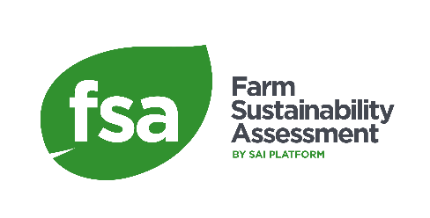

FSA Verification Audit Annual Reporting Template for FMGs
  - FSA 3.0
  - Version 1

THE FSA REQUIREMENT
Following the issue of a Letter of Attestation the FMG Coordinator must provide the VB with an annual report confirming that there has been no change in the composition of the FMG that is:
- a turnover > 10% in membership of the FMG (i.e., farms are replaced by other farms)
- an increase of >10% in the total number of farms
This report must include:
- a list of all the farms included in the FMG for the year of the annual report
- a statement confirming that any changes in FMG Composition do not exceed the 10% marks above.
One report must be provided for each Letter of Attestation.
A report must be submitted within 4 weeks of the 1 year and 2-year anniversaries of the start date of the validity of the Letter of Attestation.
The VB must review this list, confirm receipt, and confirm to the FMG if any changes in the group exceed the requirement.
If changes exceed these marks, the Letter of Attestation is invalidated. It will maintain validity for six months from the start date anniversary of the year in question, to allow time for a new audit to take place.
If the FMG wishes to continue making FSA claims, a new verification of on-farm performance levels must be carried out to confirm the performance level of the new group. There is no requirement to repeat the FSA Management System audit if it was completed in the previous 3 years.

THE REPORT

Year in Letter of Attestation (LOA) Cycle
YEAR 1
YEAR 2
Mark the year for which you are completing this report.

Farm Management Group Details
Name of Farm Management Group
Name and address of FMG Coordinator
Name and role of person completing the report
Identification Number (GGN or SPN) of LOA
Start and End Date of LOA
Number of farmers in Farm Management Group at audit
SIZE: Number of farmers in FMG for the year you are completing this form.
TURNOVER: Number of farmers in FMG this year that were not in list at audit

- Please attach a list of the farms in the FMG.

FMG Statement
On behalf of [name of Farm Management Group Coordinator] I confirm that there has been no change in the composition of the FMG that is:
- a turnover > 10% in membership of the FMG (i.e., farms are replaced by other farms)
- an increase of >10% in the total number of farms
If changes exceed these marks, the Letter of Attestation is invalidated. It will maintain validity for six months from the start date anniversary of the year in question, to allow time for a new audit to take place.
If the FMG wishes to continue making FSA claims, a new verification of on-farm performance levels must be carried out to confirm the performance level of the new group. There is no requirement to repeat the FSA Management System audit if it was completed in the previous 3 years.
Signed by:
Name:
Role:
Date:

Verification Body review
Name of Verification Body
Name and role of person reviewing the report
Date received
Date reviewed
Signature of reviewer

