# Areas of Expertise (Topics We Advise On)
- Regenerative Agriculture
- Regenerative Rangeland
- Agroforestry
- Aquaculture
- Biodiversity & Ecosystem Resilience
- Sustainable Supply Chains
- Low Carbon Energy & Biofuels
- Purpose Driven Food Brands & Retailers
- Food Waste (Prevention, Diversion, Recovery)
Notes: These roughly break down into:
- How agricultural raw materials and commodities are produced (“Cultivated”)
  - On land
    - Regenerative Agriculture
    - Rangeland
    - Agroforestry
  - Below water
    - Aquaculture
  - Across communities & ecosystems
    - Biodiversity & Ecosystem Resilience
- How raw materials are purchased, moved, stored, processed, sold, & delivered
  - Sustainable Supply Chains
- How raw materials are transformed into either food & feed, or energy (fuels)
  - Purpose Driven Food Brands & Retailers (that feed people and animals)
  - Low Carbon Energy & Biofuels (that create energy from agricultural products)
- How we fully utilize those resources to create circular value chains and reduce the impact of food emissions in landfills
  - Food Waste (Prevention, Diversion, Recovery)

# Who We Work With - The Food & Agribusiness Value Chain
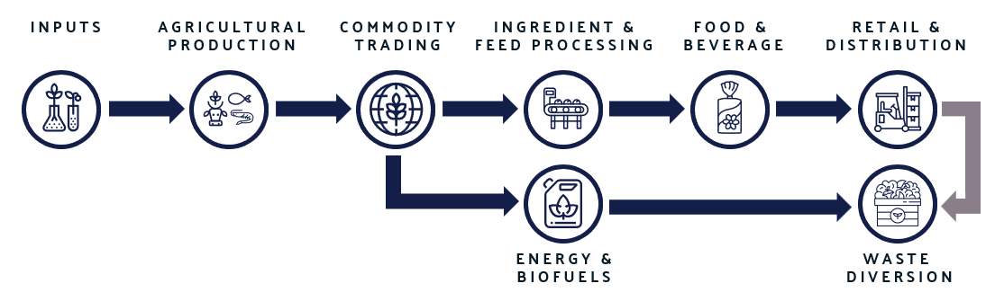
Inputs Companies
Seed, fertilizer, crop protection, biologicals, equipment, animal health, and agronomy solution providers.
Examples: Bayer, Syngenta, Corteva, Nutrien, BASF, Beck’s Hybrids, Yara, WinField United.
Agricultural Producers & Integrated Protein Companies
Large-scale crop producers, livestock and poultry companies, dairy cooperatives, palm producers, and vertically integrated food production systems.
Examples: JBS, Tyson, Smithfield, Perdue Farms, Pilgrim’s Pride, Seaboard Foods, Marfrig, Wilmar, SLC Agrícola, Land O’Lakes.
Commodity Traders
Originators, traders, handlers, processors, exporters, and supply-chain intermediaries that move agricultural commodities from producers to downstream markets.
Examples: ADM, Bunge/Viterra, Cargill, Louis Dreyfus Company, CHS, Scoular, Gavilon, The Andersons.
Ingredient & Feed Processors
Companies converting crops, grains, oils, proteins, and byproducts into food ingredients, feed ingredients, and animal nutrition products.
Examples: Ingredion, Ardent Mills, Grain Craft, Miller Milling, Benson Hill, Cargill Animal Nutrition, ADM Animal Nutrition, Purina Animal Nutrition, Darling Ingredients, BioMar.
Energy & Biofuels Refiners
Ethanol, renewable diesel, biodiesel, SAF, RNG, and low-carbon fuel producers.
Examples: POET, Valero, Green Plains, Neste, Marathon/Martinez Renewables, Phillips 66, Diamond Green Diesel, Gevo.
Food & Beverage Companies
Branded food, beverage, alcohol, snack, dairy, packaged food, and food manufacturing companies.
Examples: Nestlé, Mars, Danone, General Mills, McCain, PepsiCo, Coca-Cola, Keurig Dr Pepper, Kraft Heinz, Mondelez, Bimbo, Conagra, Diageo, Suntory, AB InBev.
Food Retail & Distribution
Grocery retailers, club stores, foodservice distributors, wholesalers, and institutional foodservice operators.
Examples: Walmart, Kroger, Ahold Delhaize, ALDI, Whole Foods Market, Costco, Target, Sprouts, Misfits Market, Sysco, Aramark, US Foods, Gordon Food Service.
Food Waste Prevention, Diversion & Recovery
Organizations focused on food waste prevention, surplus food recovery, donation, composting, organics recycling, anaerobic digestion, and circular food systems.
Examples: Goodr, Too Good To Go, Flashfood, Full Harvest, Divert, Feeding America, WM, Recology, Republic Services.

# Who We Work With - The Associated Value Chain that Enables Food & Agribusinesses
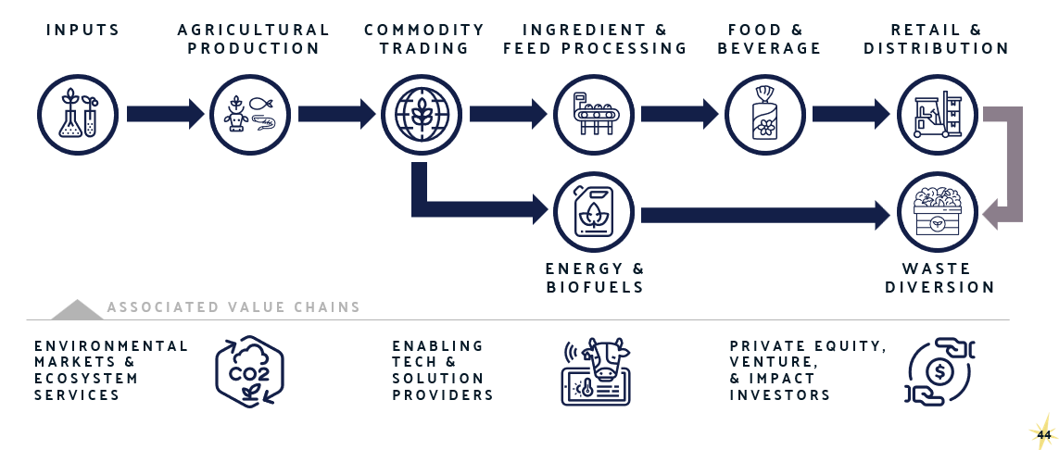
Environmental Markets & Ecosystem Services
Project developers, ecosystem service program operators, standards bodies, registries, verifiers, credit buyers, marketplaces, ratings providers, and other market infrastructure organizations that turn environmental outcomes into credible assets, claims, and incentives.
Examples: Indigo Ag, Grassroots Carbon, Kateri, Agoro Carbon Alliance, Truterra, Soil and Water Outcomes Fund, ESMC, Native, Verra, Climate Action Reserve, ACR, Gold Standard, BCarbon, SustainCert, EcoEngineers, SCS Global Services, DNV, SGS, LRQA, Rubicon Carbon, Carbon Direct, Patch, Xpansiv, CME Group, Calyx Global, Sylvera, BeZero Carbon.

Enabling Tech & Solution Providers
MRV platforms, remote sensing providers, farm data systems, traceability tools, lifecycle assessment platforms, soil data companies, supplier engagement platforms, and sustainability software providers that make environmental performance measurable, reportable, and actionable.
Examples: Regrow, CIBO, Klim, Habiterre, Yard Stick, EarthOptics, Perennial, Downforce Technologies, Planet, Satelligence, Climate FieldView, Bushel, John Deere Operations Center, Sourcemap, Provenance, BanQu, HowGood, Planet FWD, Cool Farm Alliance / Cool Farm Tool, Sphera, Watershed, Persefoni.

Private Equity, Venture Capital & Impact Investors
Capital providers, strategic investors, project finance partners, infrastructure investors, asset managers, institutional asset owners, sovereign investors, and impact funds that invest in food, agriculture, climate, nature, circular economy, and environmental market solutions.
Examples: Rabo Investments, Paine Schwartz, S2G Investments, Astanor Ventures, The Production Board, AgFunder, Acre Venture Partners, Tenacious Ventures, Fall Line Capital, Flagship Pioneering, TELUS Global Ventures, KKR Global Impact, TPG Rise Climate, Generate Capital, Nuveen Natural Capital, Manulife Investment Management, Climate Asset Management, Temasek, CalPERS.

