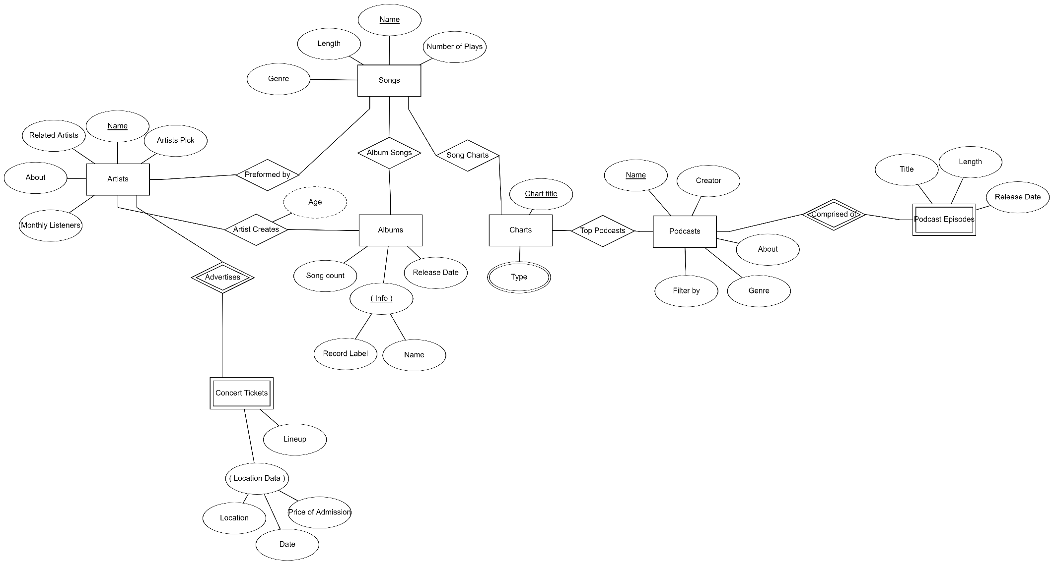

1

1

M

N

M

N

M

N

M

N

N

M

1

N