CS-330 7-1 Final Project Reflection
Joshua Sevy
June 21, 2026

For my scene, I completed my simplified 3D printing workstation. My scene includes a 3D-printed tool caddy, an enclosed 3D printer, a filament spool, a 3D-printed filament spool holder, and a wood workbench. I picked these objects because they go together naturally and let me show off different visual details, like matte plastic, blue accents, glass panels, metal, wood, filament, and even drywall for my background. These all made the scene feel whole and intentional and not just random objects on a plane.
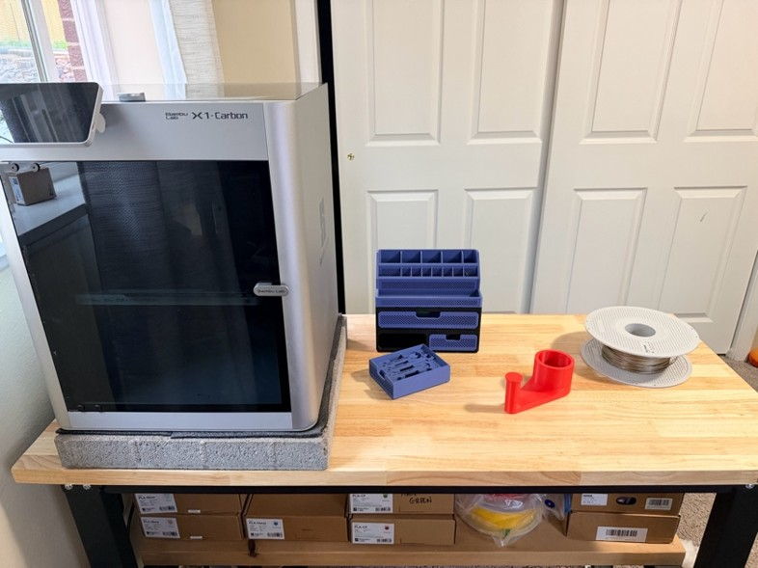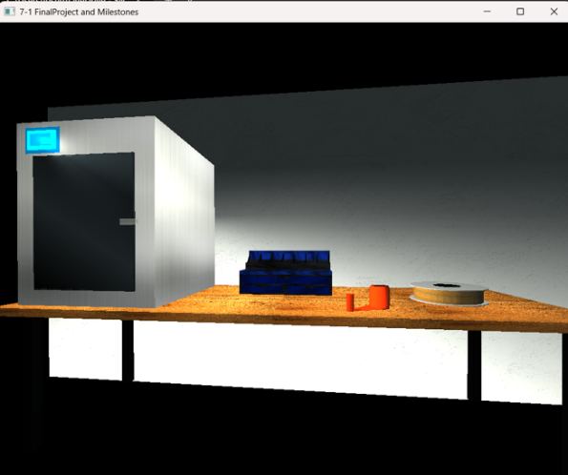
The biggest improvement I made during the final project was refactoring the more complex 3D-printed tool caddy after the full scene came together. In the earlier milestones, the top of the tool caddy used a larger angled prism to represent the pen/tool holder section. It did form structurally, but it looked more and more off as we continued with the textures and lighting portions of the project, especially the texture mapping on the prism. With the shape, it became skewed and hard to read in the tool caddy.
The feedback was incredibly helpful; it helped identify areas for visual polish, material design, and fine-tuning the scene. I decided to revisit that part rather than simply adding more to it to make it work for the scene. I completely rebuilt the top holder using smaller, repeated prisms and box meshes so the caddy would align better with the actual tool holder I was modeling. This also gave me more control over the dark-printed plastic sections, the blue accent pieces, and the individual tool slots. The refactor made the object feel complete, and it helped the caddy fit better with the entire scene.
This was a great lesson in maintainability. At first, I was manually building many parts of the scene one piece at a time. For the repeated tool holder slots, I used a loop to avoid duplicating the same transformation and to prevent the repeated code from drying up. This approach was inspired by an online tutorial from freeCodeCamp that showed repeated vertex patterns in large, complex 3D scenes; it made me realize it was just C++ and that I could use a similar pattern for the equally spaced slots needed for the top of the tool caddy. Using loops made the code cleaner and the final caddy much easier to adjust or expand.
I also used custom functions to keep the program more modular and organized. The larger scene objects are separated into their own render functions, such as the tool caddy, 3D printer, filament spool, and loose printed part. This made the code easier to navigate because each object could be adjusted without searching through one large render method. I also moved texture loading into its own function, so all scene textures are loaded and bound in one place. The material setup and lighting setup are also separated into their own functions, which made it easier to fine-tune how different surfaces react to light. These functions are reusable because the same textures, materials, transformations, and drawing patterns can be applied to many objects throughout the scene.
For the required functionality, I used transformations to scale, rotate, and position the primitives that made up the scenes. I also applied several textures and materials to create more realistic surface differences between the objects. For example, the wood table uses a different material response than the matte printed plastic, and the glass panels use a glass texture with a darker material, so they read more like reflective panels. I also adjusted the light after the scene was mostly complete. The final lighting consists of a main overhead light, a softer front-fill light, a small colored-screen accent light, and a subtle background light. This helped improve the mood, shadow contrast, and material detail without making the scene look flat.
A user can navigate the scene using the camera controls built into the project. The keyboard controls allow movement through the 3D space, including moving forward, backward, left, right, up, and down. Mouse movement controls the camera direction so the user can look around the scene; the scroll wheel adjusts the movement speed. I also added a perspective and orthographic view toggle so a user can inspect the scene in both a realistic 3D view and a flatter view that can help with alignment of the scene. These controls make it possible to move around the workstation, view the objects from different angles, and inspect the details that were added throughout the project.
The project really helped me understand that meeting technical requirements is only part of building a strong 3D scene. The final polish came from going back through the scene, experimenting with different lighting and materials, refining textures, and reworking the areas that just didn’t fit quite right. Refactoring the caddy was a great example of that process; being able to circle back with more practice gave me the confidence to scrap a portion of the complex part and focus on making it more intentional and aligned with the rest of the caddy.

