Lembar pengamatan

Joshua Putra Setyadi / 71170173

1.

Private Sub FlipHorizontalToolStripMenuItem_Click(sender As Object, e As EventArgs) Handles FlipHorizontalToolStripMenuItem.Click

Dim r, g, b, r1, g1, b1 As Integer

Dim bmp = New Bitmap(PictureBox1.Image)

'bmp.RotateFlip(RotateFlipType.RotateNoneFlipX)

PictureBox1.Image = bmp

For bar As Integer = 0 To PictureBox1.Image.Height - 1

For kol As Integer = 0 To (PictureBox1.Image.Width - 1) / 2

r1 = bmp.GetPixel(kol, bar).R

g1 = bmp.GetPixel(kol, bar).G

b1 = bmp.GetPixel(kol, bar).B

r = bmp.GetPixel(PictureBox1.Image.Height - 1 - kol, bar).R

g = bmp.GetPixel(PictureBox1.Image.Height - 1 - kol, bar).G

b = bmp.GetPixel(PictureBox1.Image.Height - 1 - kol, bar).B

bmp.SetPixel(PictureBox1.Image.Height - 1 - kol, bar, Color.FromArgb(r1, g1, b1))

bmp.SetPixel(kol, bar, Color.FromArgb(r, g, b))

Next

Next

PictureBox1.Image = bmp

End Sub

2. berikut adalah contoh untuk fungsi greyscale

Private Sub GreyscaleToolStripMenuItem_Click(sender As Object, e As EventArgs) Handles GreyscaleToolStripMenuItem.Click

Dim r, g, b, gray As Integer

If namafile = "" Then

MsgBox("empty pic, please open pic")

Else

Dim bmp = New Bitmap(PictureBox1.Image)

For bar As Integer = 0 To PictureBox1.Image.Height - 1

For kol As Integer = 0 To PictureBox1.Image.Width - 1

r = bmp.GetPixel(kol, bar).R

g = bmp.GetPixel(kol, bar).G

b = bmp.GetPixel(kol, bar).B

gray = Math.Round(0.2126 * r + 0.7152 * g + 0.0722 * b)

bmp.SetPixel(kol, bar, Color.FromArgb(gray, gray, gray))

Next

Next

'Dim img As Image

'img = CType(bmp, Image)

'PictureBox1.Image = img

PictureBox1.Image = bmp

End If

End Sub

3. Kernel yang saya tambahkan adalah kernel filter sharpen alternatif dari yang ada pada modul.

Dim kernel As Integer() = {0, -1, 0, -1, 5, -1, 0, -1, 0}

Perubahannya yakni sebagai berikut, dari kiri ke kanan

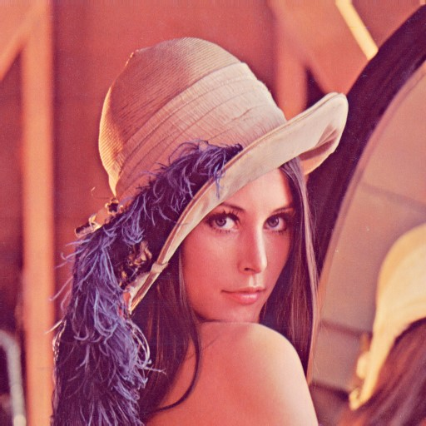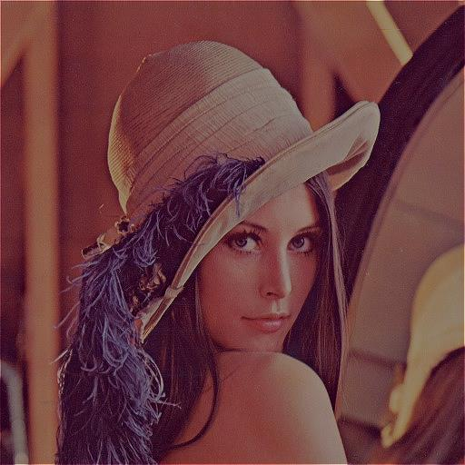

4. histogram sebelumnya (kiri) dan sesudahnya (kanan). Terlihat bahwa setelah pengurangan kontras, histogram gambar menjadi semakin tidak tersebar dan lebih ternormalisir.

