LEMBAR TUGAS PENGAMATAN

NAMA: JOSHUA PUTRA SETYADI

NIM: 71170173

1. 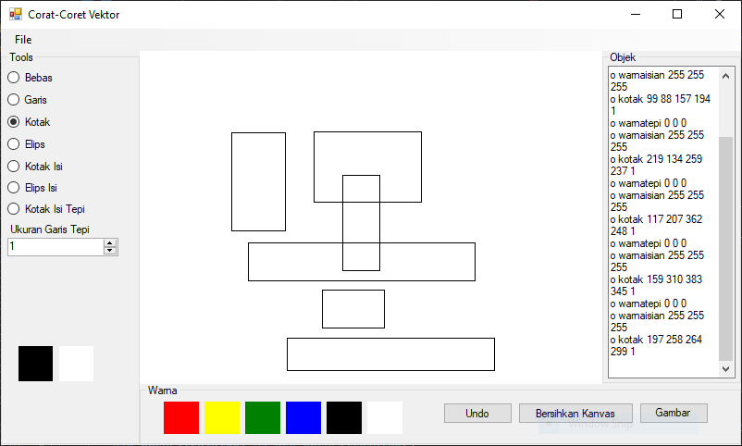

2.

Private Sub BaruToolStripMenuItem_Click(sender As Object, e As EventArgs) Handles BaruToolStripMenuItem.Click

btnBersihkan.PerformClick()

TextBox1.Clear()

End Sub

3.

Untuk menyimpan tebal garis tepi, maka pada penambahan teks diubah menjadi berikut

TextBox1.AppendText("o garis " + titik.X.ToString + " " + titik.Y.ToString + " " + e.X.ToString + " " + e.Y.ToString + " " + tepi.Width.ToString & vbNewLine)

TextBox1.AppendText("o " + modegambar + " " + titik.X.ToString + " " + titik.Y.ToString + " " + e.X.ToString + " " + e.Y.ToString + " " + tepi.Width.ToString & vbNewLine)

Untuk memuat ulang tebal garis tepi, maka sebelum penggambaran ditambahkan kode berikut

tepi.Width = CByte(pecah(6))

4.

Case "kotakisitepi"

Dim rect As New Rectangle(titik.X, titik.Y, e.X - titik.X, e.Y - titik.Y)

Using g As Graphics = Graphics.FromImage(PictureBox1.Image)

g.FillRectangle(isian, rect)

g.DrawRectangle(tepi, rect)

End Using

Case "kotakisitepi"

tepi.Width = CByte(pecah(6))

Dim rect As New Rectangle(CInt(pecah(2)), CInt(pecah(3)),

CInt(pecah(4)) - CInt(pecah(2)), CInt(pecah(5)) - CInt(pecah(3)))

Using g As Graphics = Graphics.FromImage(PictureBox1.Image)

g.FillRectangle(isian, rect)

g.DrawRectangle(tepi, rect)

End Using