GameWinningStats
April 2026
Joshua Stradford
Bachelor of Science- Cybersecurity
Project Advisor: Prof. Henderson

Statement of Purpose
Looking up player stats should be a quick and effective way for fans to gain access to their favorite players. Fans should be able to find everything they are looking for from advanced analytics to visuals that allow them to see how players stack up with the rest of the league with a simple player search. The current situation is that there are multiple steps in trying to get this information. Sometimes there are multiple sites you have to go to. Some sites may have the advanced analytical stats of a player but no player comparison tools to use. This makes it less attractive for fans to go see how their favorite players are doing because the process is so long. A solution to this problem could be to have a website or excel sheet that contains all of this in one setting. A search for a player can display all of their advanced analytics, allow fans to compare with other players, as well as make rankings to show where they compare with other players at their position. The benefits of this would provide the fan with an experience where they can see every stat and see how their favorite players compare to other players. The purpose of this project is to design and develop a centralized sports analytics platform that allows users to quickly access player statistics across multiple leagues and use visuals to compare their favorite players.

Research & Background
First, the main source of research was understanding python libraries. Then research I looked at wass basketball reference scrapers, espn scrapers, and baseball reference scrapers. I decided to use the beautifulsoup and requests libraries from a developer named Gabriel Cano. He coded a python scraper using those libraries so I decided to give it a try. There are other espn scrapers I looked at but decided python libraries was what I best understood. Originally, I just wanted to scrape stats from one specific year, but decided I can include players’ whole careers with it only taking a little bit more time. For espn, a video by Learning A-Z was a great help in understanding how that step-by-step process worked. I also wanted to add some other features fans could use. For the ranking game, I did some research on using skill ratings and elo. An article from Matt Mazzola was something I found that really helped know how to implement elo ratings. For Stat Comparisons, I just used motivations from twitter accounts Dattabllr and BBall Index.

Project Languages, Software, Hardware
Languages
- Python
- JavaScript for react and Gatsby
- HTML/CSS
Software
- BeautifulSoup, pandas, requests, math, re, os, glob, datetime, time, json python libraries
- React and Gatsby
- Git
- Netlify for deployment
Hardware
- Personal computer
- Ubuntu for virtual environment and Windows for deployment

Project Requirements
FUNCTIONAL REQUIREMENTS
FR-01
- Type: Functional
- Description: The system shall allow users to search for a player by name using a search bar.
- Rationale: Core access point for all features
- Fit Criterion: Entering a valid player name returns results within 2 seconds
- Priority: Must

FR-02
- Type: Functional
- Description: The system will display a player profile page when a player is selected.
- Rationale: Primary feature of the application
- Fit Criterion: Clicking a search result loads a profile page with player data
- Priority: Must

FR-03
- Type: Functional
- Description: The system shall display player metadata including height, weight, position, and team.
- Rationale: Provides essential player info
- Fit Criterion: Metadata fields appear if available, otherwise display “N/A”
- Priority: Must

FR-04
- Type: Functional
- Description: The system shall display per-season and/or per-game statistics for each player.
- Rationale: Core analytical data
- Fit Criterion: At least one stats table is rendered per player
- Priority: Must
FR-05
- Type: Functional
- Description: The system shall support multiple sports leagues (NBA, NFL, MLB).
- Rationale: Multi-sport platform goal
- Fit Criterion: Users can navigate to at least 3 league sections
- Priority: Must
FR-06
- Type: Functional
- Description: The system shall allow navigation by team pages.
- Rationale: Supports browsing beyond search
- Fit Criterion: Each league page lists teams with clickable links
- Priority: Must
FR-07
- Type: Functional
- Description: The system shall display filtered rosters (NBA full roster, NFL QBs, MLB pitchers).
- Rationale: Matches your project design
- Fit Criterion: NFL pages show only QBs; MLB pages show only pitchers
- Priority: Must

FR-08
- Type: Functional
- Description: The system shall aggregate player data from multiple data sources.
- Rationale: Ensures completeness of stats
- Fit Criterion: At least two data attributes per player originate from scraped sources
- Priority: Must

FR-09
- Type: Functional
- Description: The system shall display a player headshot when available.
- Rationale: Improves UI experience
- Fit Criterion: Valid image URL renders without breaking layout
- Priority: Should

FR-10
- Type: Functional
- Description: The system shall allow comparison of player statistics.
- Rationale: Adds analytical depth
- Fit Criterion: At least two players can be visually compared in a table or chart
- Priority: Should
FR-11
- Type: Functional
- Description: The system shall display rankings or leaderboards.
- Rationale: Provides context for stats
- Fit Criterion: At least one leaderboard per sport is visible
- Priority: Should
FR-12
- Type: Functional
- Description: The system shall allow users to navigate using a header menu (sports dropdown).
- Rationale: Improves navigation
- Fit Criterion: Header contains working links to all league pages
- Priority: Must
LOOK & FEEL REQUIREMENTS
LF-01
- Type: Look & Feel
- Description: The system shall use a consistent “aura-style” visual theme across pages.
- Rationale: Matches your design goal
- Fit Criterion: All pages use the same CSS classes (ex. profile-container, nba-team-aura)
- Priority: Must
LF-02
- Type: Look & Feel
- Description: The system shall display dark-mode styling with high contrast text.
- Rationale: Improves readability
- Fit Criterion: Background is dark and text contrast ratio ≥ 4.5:1
- Priority: Must

LF-03
- Type: Look & Feel
- Description: Tables shall have consistent styling across all sports.
- Rationale: Prevents UI inconsistency
- Fit Criterion: All stat tables share identical CSS structure
- Priority: Must
USABILITY REQUIREMENTS
US-01
- Type: Usability
- Description: The system shall allow users to find player data within 3 clicks.
- Rationale: Minimizes friction
- Fit Criterion: 90% of users locate a player within 3 clicks
- Priority: Must
US-02
- Type: Usability
- Description: The system shall be responsive for mobile devices.
- Rationale: Fixes your current mobile issues (headshot overlap)
- Fit Criterion: Layout adapts correctly for screens ≤ 768px
- Priority: Must
US-03
- Type: Usability
- Description: The system shall provide clear labeling of statistics.
- Rationale: Prevents confusion
- Fit Criterion: All stat columns include readable headers
- Priority: Must
PERFORMANCE REQUIREMENTS
PE-01
- Type: Performance
- Description: The system shall load pages within 3 seconds.
- Rationale: User experience
- Fit Criterion: 95% of page loads complete under 3 seconds
- Priority: Must
PE-02
- Type: Performance
- Description: The system shall return search results quickly.
- Rationale: Core interaction
- Fit Criterion: Search results appear within 2 seconds
- Priority: Must
PE-03
- Type: Performance
- Description: The system shall support at least 100 concurrent users.
- Rationale: Scalability baseline
- Fit Criterion: No crashes under simulated load of 100 users
- Priority: Should
SECURITY REQUIREMENTS
SEC-01
- Type: Security
- Description: The system shall prevent unauthorized modification of data files.
- Rationale: Protect scraped data
- Fit Criterion: Only backend scripts can modify JSON files
- Priority: Must
SEC-02
- Type: Security
- Description: The system shall validate user input in the search bar.
- Rationale: Prevent injection attacks
- Fit Criterion: Invalid characters are sanitized before processing
- Priority: Must
MAINTAINABILITY REQUIREMENTS
MA-01
- Type: Maintainability
- Description: The system shall allow easy updates to scraping scripts.
- Rationale: Sites change frequently
- Fit Criterion: Scraper logic is modular and updated in one file
- Priority: Must
MA-02
- Type: Maintainability
- Description: The system shall separate data, logic, and UI components.
- Rationale: Clean architecture
- Fit Criterion: Data stored in JSON, UI in React components
- Priority: Must
RELIABILITY REQUIREMENTS
RE-01
- Type: Reliability
- Description: The system shall handle missing or incomplete data gracefully.
- Rationale: Scraping inconsistencies
- Fit Criterion: Missing values display “N/A”
- Priority: Must
RE-02
- Type: Reliability
- Description: The system shall not crash due to malformed data.
- Rationale: Stability
- Fit Criterion: App continues running when encountering bad data
- Priority: Must
SCALABILITY / EXTENSIBILITY
SC-01
- Type: Scalability
- Description: The system shall support adding new sports in the future.
- Rationale: Long-term growth
- Fit Criterion: New league added without modifying core architecture
- Priority: Should
SC-02
- Type: Scalability
- Description: The system shall support adding new players without UI changes.
- Rationale: Data growth
- Fit Criterion: New JSON file automatically appears in search results
- Priority: Must

Project Implementation
Frontend Implementation- the frontend of the website was developed using React and Gatsby. The site includes a navigation header with a search bar and navigation for different sports leagues. Each league page displays teams, and each team page links to individual player profiles.
Fig 1. Homepage with navigation and featured players
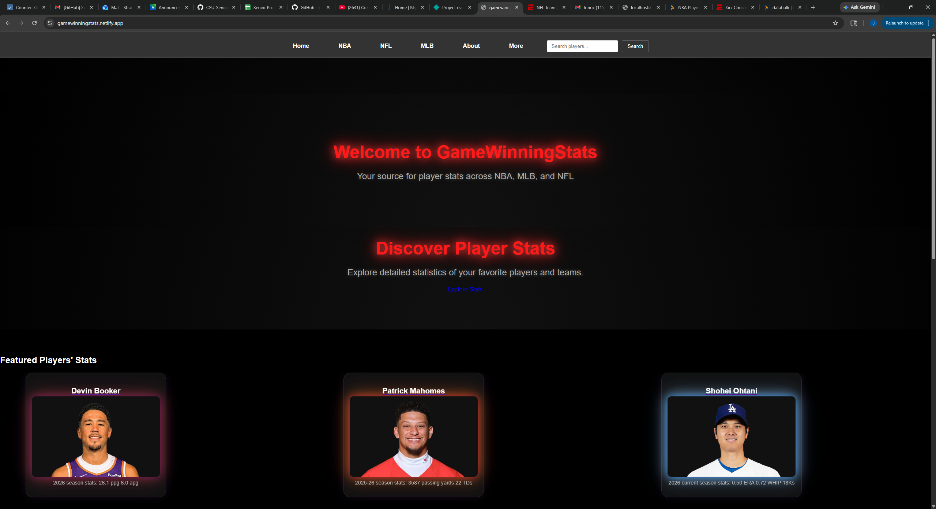
Fig 2. NBA team roster page
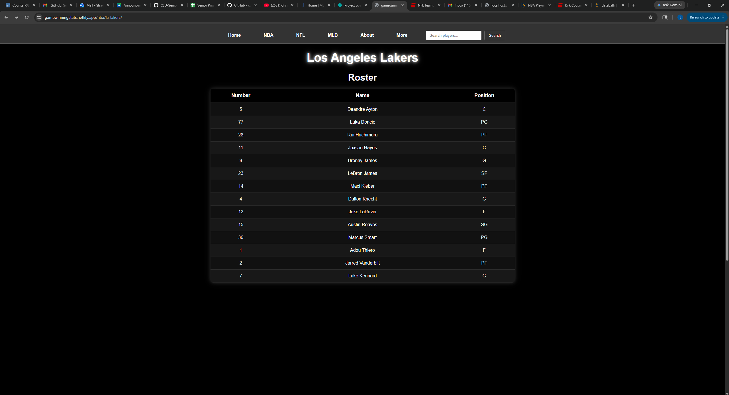
Player Profile- Player profile pages dynamically load structured JSON data generated from scraping scripts. These pages include metadata such as height, weight, and team, as well as statistical tables. Each sports league player page has a different feel, for example MLB pages include their MLB debut date and when they exceeded rookie status and NFL pages have a latest season table that highlights the season they just played.
Fig 3. Player Profile Page
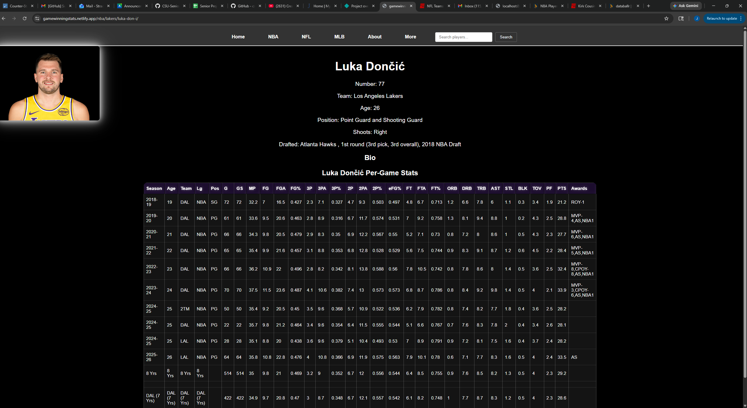

Data Pipeline- Data for MLB and NBA was collected using python scripts that scrape HTML pages from sports reference websites. The scripts extract tables using BeautifulSoup and pandas, then convert the data into JSON format for use in the frontend. Data for NFL was collected using ESPN. Same structure as the other leagues as I loaded the data on a JSON file to have them stored locally to use in the frontend.

Fig 4. JSON data structure
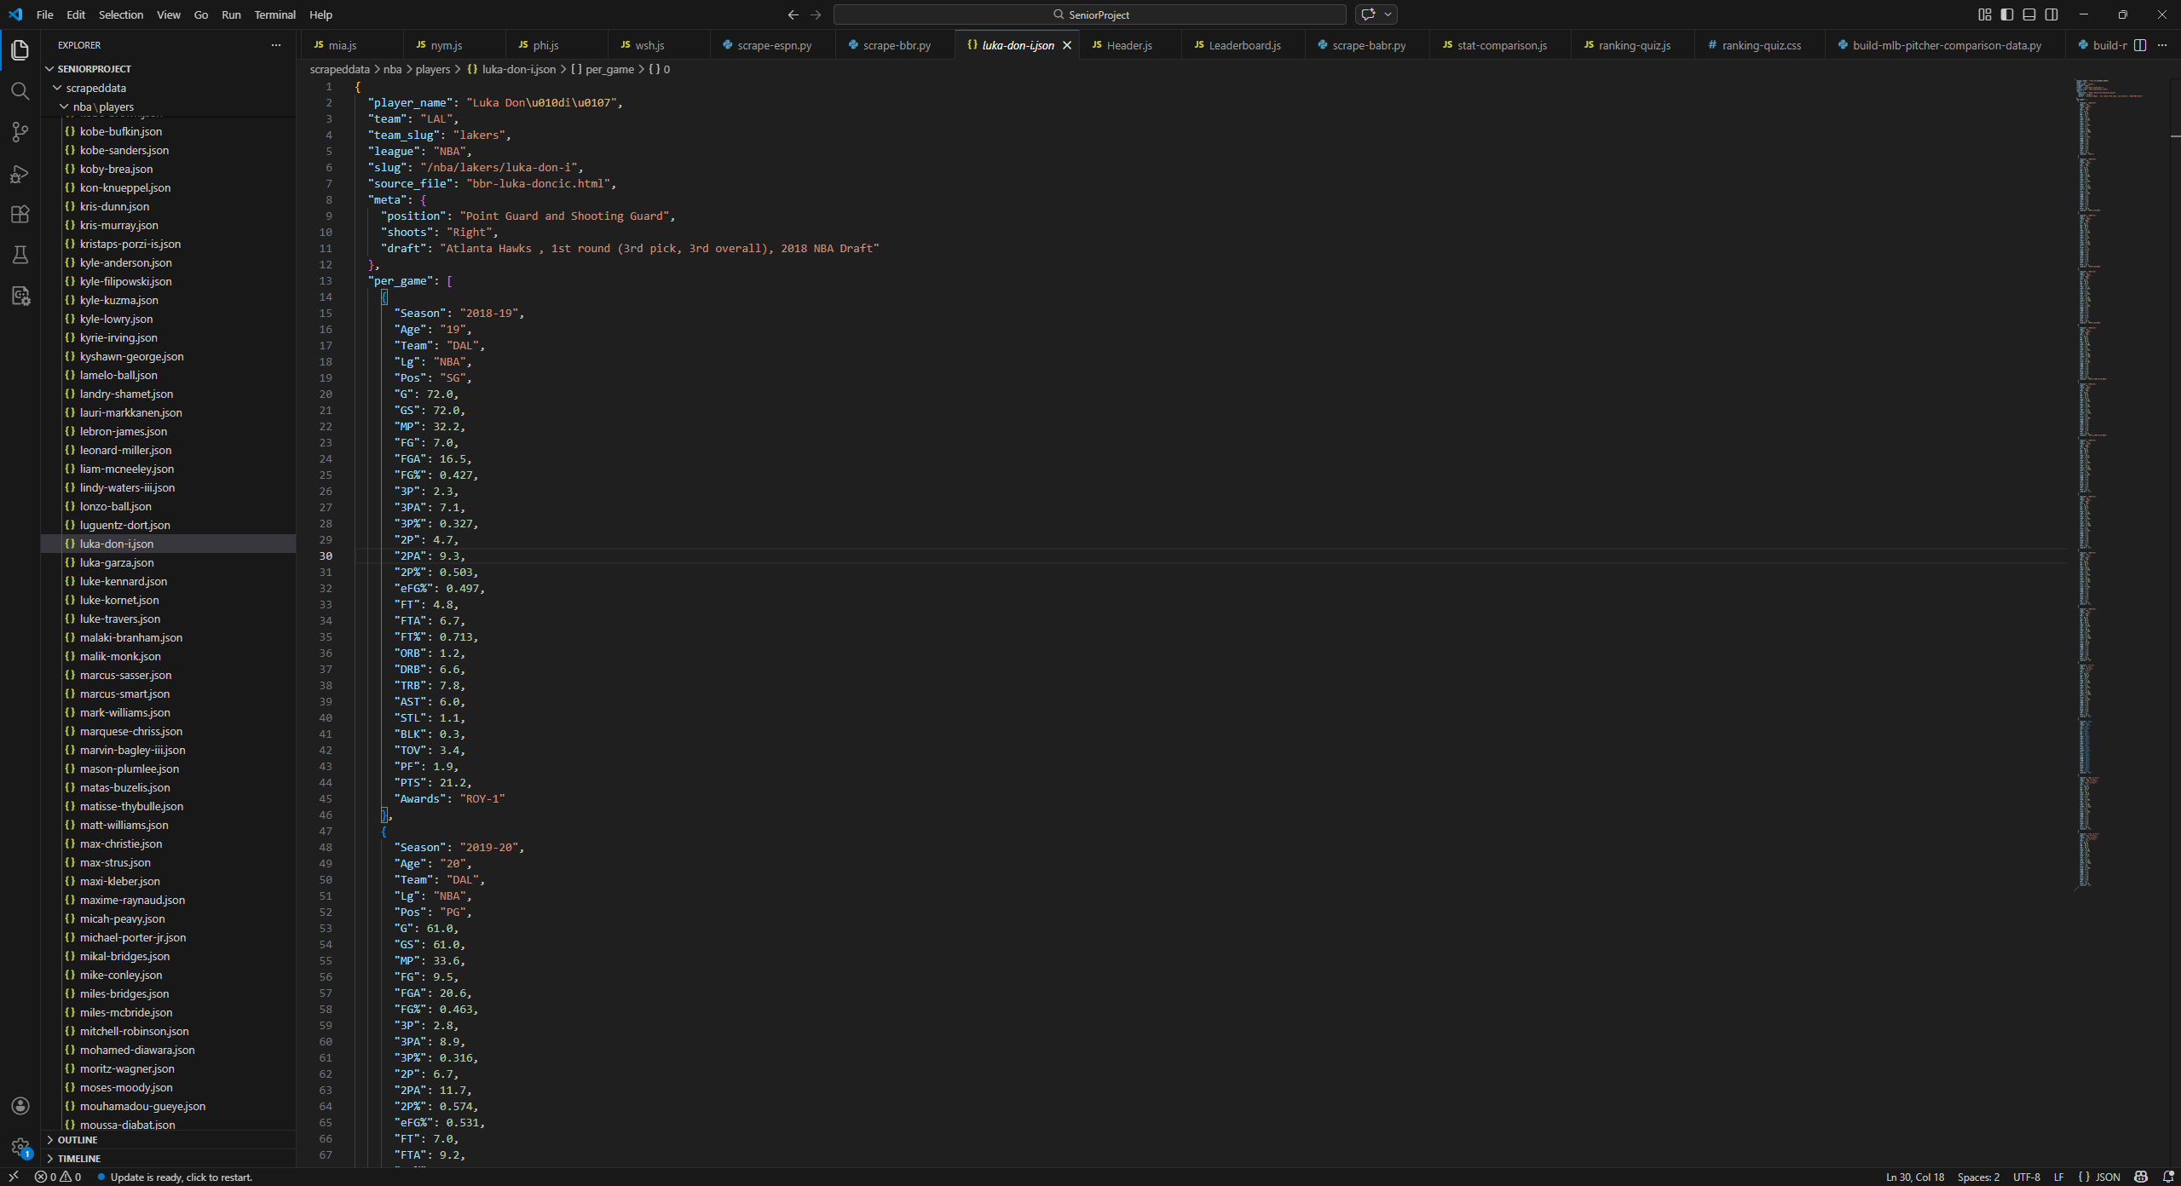
Deployment- The website was deployed using Netlify, allowing users to access the site publicly. Also allows for changes I make to automatically trigger redeployment
Source Code-
Test Plan
The system was tested using both manual testing and automated testing using pytest. Python test scripts were used to confirm JSON data, and frontend testing ensured pages search functions was working as well as page rendering. I created test scripts that tested every sports league parser by confitming the right data was collected into the JSON file. I also tested error handling for missing stats and to ensure that the website does not stop just because some stats did not render.
Test Results
All core functionality was successfully tested. Player searches returned correct results, profile pages loaded without errors, and stat tables displayed accurate data.
Challenges Overcome
The reason I had to pivot to ESPN for NFL QBs is because cloudflare was blocking scraping of those pages. One solution I found was to act as a user-agent of a browser to ensure the scraper isn’t being blocked. Maybe one or two times it worked for a QB but the rest it did not so I pivoted to ESPN for scraping NFL QBs. I also had this problem with some of the NBA and MLB pages but after multiple attempts I was able to get those HTML pages by downloading the HTML files using curl and parsing them locally. Another challenge was extracting tables hidden inside HTML comments. This required parsing from lxml tables within HTML. Also with ESPN there was an issue I had where it was giving fake 0’s for a QB’s interception and sacks stats. The solution to that was to make sure the parser only filtered passing stats because interceptions and sacks get overlapped as defensive stats.
Future Enhancements
The future of this is exciting to me because this can be so much more.
- Live API integration instead of hard coding and scraping.
- Even more player comparison tools
- User accounts
- Real-time stats such as recent game-logs
- More Sports Leagues

References:
https://mattmazzola.medium.com/implementing-the-elo-rating-system-a085f178e065
https://databallr.com/
https://medium.com/analytics-vidhya/web-scraping-nba-data-with-pandas-beautifulsoup-and-regex-pt-1-e3d73679950a
https://www.youtube.com/watch?v=kSfnvIp4INA
https://www.basketball-reference.com/
https://www.espn.com/nfl/
https://www.baseball-reference.com/

