IMPLEMENTATION OF A MACHINE LEARNING-BASED MOBILE APPLICATION FOR DRUG INTERACTION DETECTION AND MEDICATION SAFETY SUPPORT
BY
UBAGA JOSHUA CHUKWUEBUKE
CSC/2022/009
A PROJECT REPORT SUBMITTED TO THE DEPARTMENT OF COMPUTER SCIENCE
COLLEGE OF NATURAL AND APPLIED SCIENCES
CHRISLAND UNIVERSITY
ABEOKUTA, OGUN STATE, NIGERIA
IN PARTIAL FULFILMENT OF THE REQUIREMENTS FOR THE AWARD OF THE DEGREE OF BACHELOR OF SCIENCE (B.Sc.) IN COMPUTER SCIENCE
AUGUST, 2026

CERTIFICATION
This is to certify that this project report titled “Implementation of a Machine Learning-Based Mobile Application for Drug Interaction Detection and Medication Safety Support” was carried out by Ubaga Joshua Chukwuebuke, with matriculation number CSC/2022/009, in the Department of Computer Science, College of Natural and Applied Sciences, Chrisland University, Abeokuta, Ogun State, Nigeria, in partial fulfilment of the requirements for the award of the degree of Bachelor of Science (B.Sc.) in Computer Science.

_______________________________ _______________________

Prof. Isaac Odun-Ayo Signature & Date
Project Supervisor
_______________________________ _______________________

Prof. Isaac Odun-Ayo Signature & Date
Head of Department
_______________________________ _______________________

Prof. A. T. Akinwale Signature & Date
External Examiner

DECLARATION
I, Ubaga Joshua Chukwuebuke, with matriculation number CSC/2022/009, hereby declare that this project report titled “Implementation of a Machine Learning-Based Mobile Application for Drug Interaction Detection and Medication Safety Support” is the result of my own original research work carried out in the Department of Computer Science, Chrisland University, Abeokuta, under the supervision of my project supervisor. All sources of information consulted in the course of this work have been duly acknowledged by means of complete references. This work has not been submitted, in whole or in part, for the award of any degree or diploma in this or any other institution.

_______________________________ _______________________

Ubaga Joshua Chukwuebuke Date
CSC/2022/009

DEDICATION
This work is dedicated to Almighty God, the source of all wisdom and understanding, my family, my colleagues, and to LEARN whose steadfast support, encouragement and sacrifice made this study possible.

ACKNOWLEDGEMENTS
I give thanks first to Almighty God for the strength, good health, wisdom and clarity of mind that sustained me throughout this study.
I am deeply grateful to my project supervisor for the guidance, careful review and constructive criticism that shaped this work at every stage. I also sincerely appreciate Prof. Isaac Odun-Ayo, the Head of the Department of Computer Science, as well as the entire academic and technical staff of the Department, whose teaching, support and dedication throughout the programme provided the foundation upon which this project was built.
I extend my heartfelt appreciation to LEARN, under the leadership of Mrs Fashola, for the knowledge, support and valuable contributions that positively influenced my academic and personal development.
I am grateful to the management and clinical staff of the Chrisland University School Clinic, who granted permission for the evaluation sessions reported in Chapter Four and gave freely of their time. Their observations on how medication checks actually happen in a busy clinic changed several design decisions in this work.
My profound gratitude goes to my parents for their sacrifices, prayers, encouragement and unwavering support throughout my education. I also appreciate my colleagues for their cooperation, shared experiences, encouragement and assistance during the course of this programme.
Finally, I thank my family and friends for their patience, understanding, encouragement and support throughout the duration of this programme.

ABSTRACT
Drug-drug interactions are a leading and substantially preventable cause of adverse drug reactions, yet the clinical decision support tools that detect them are least available where they are most needed, being subscription-based and dependent on continuous internet connectivity. This study aimed to design, develop and evaluate MedGuard, a machine learning-based mobile application that detects drug-drug interactions and grades their risk on an offline-first architecture. Its specific objectives were to build a cross-platform Flutter application over a bundled SQLite database; to develop and compare machine learning classifiers for three-tier interaction-risk prediction; to integrate drug-food, duplicate-therapy, drug-allergy and dose-scheduling checks; to deploy the selected model as a Flask REST API with an on-device TensorFlow Lite counterpart; and to assess usability.
Design Science Research guided an iterative development process. A reproducible Python pipeline built a bundled reference database of 4,955 drugs and 851,868 interaction records from DrugBank 6.0, RxNorm, OpenFDA and DDInter 2.0. Twenty-seven pharmacological features were engineered for each drug pair, and a Random Forest was compared with Gradient Boosting and Logistic Regression on stratified splits under both random and drug-disjoint regimes.
The Random Forest achieved 86.3% accuracy, a macro-F1 of 0.594 and a macro AUC-ROC of 0.943 across 218,518 test pairs, recovering 91.0% of High-risk interactions and significantly exceeding the 76.1% majority-class baseline; accuracy fell to 69.6% on unseen drugs. A 7,984-byte distilled TensorFlow Lite model reproduced 95.6% of its decisions offline, and thirty-four automated tests verified every safety check. Fifteen participants in Abeokuta returned a mean System Usability Scale score of 84.33 (SD 15.82).
MedGuard demonstrates that an offline-first, machine learning-based medication-safety tool is buildable and usable in a low-resource setting, though it remains an academic decision-support prototype that has not been load-tested or clinically validated.
Keywords: drug-drug interaction, clinical decision support, machine learning, Random Forest, offline-first mobile application, medication safety, TensorFlow Lite, Nigeria.

TABLE OF CONTENTS
CERTIFICATION ii
DECLARATION iii
DEDICATION iv
ACKNOWLEDGEMENTS v
ABSTRACT vi
TABLE OF CONTENTS vii
LIST OF FIGURES xii
LIST OF TABLES xiv
LIST OF ABBREVIATIONS xv

CHAPTER ONE 1
INTRODUCTION 1
1.0 Overview 1
1.1 Background of the Study 1
1.1.1 The Global Burden of Medication-Related Harm 1
1.1.2 The Nigerian Healthcare Context 2
1.1.3 Technology as a Bridge: CDSSs, Machine Learning, and mHealth 2
1.2 Statement of the Problem 3
1.3 Aim and Objectives of the Study 3
1.3.1 Aim 3
1.3.2 Specific Objectives 4
1.4 Research Questions 4
1.5 Significance of the Study 5
1.6 Scope and Limitations of the Study 6
1.6.1 Scope 6
1.6.2 Limitations 6
1.7 Theoretical Framework 7
1.8 Conceptual Framework 8
1.9 Research Design and Methodology 10
1.10 Justification for the Choice of Machine Learning Algorithm 10
1.11 Ethical Considerations 10
1.11.1 Data Integrity and Provenance 10
1.11.2 User Privacy and Local Processing 11
1.11.3 The Human-in-the-Loop Principle 11
1.11.4 Permissions for the Usability Evaluation 11
1.12 Definition of Terms 11
1.13 Organisation of the Dissertation 12

CHAPTER TWO 13
LITERATURE REVIEW 13
2.0 Introduction 13
2.1 Conceptual Framework 13
2.1.1 Drug–Drug Interactions: Pharmacokinetic and Pharmacodynamic Mechanisms 13
2.1.2 Clinical Decision Support Systems 14
2.1.3 Alert Fatigue in Clinical Decision Support 16
2.1.4 Polypharmacy: Prevalence and Risks 16
2.2 Drug Interaction Databases and Knowledge Bases 17
2.2.1 DrugBank 17
2.2.2 RxNorm 17
2.2.3 OpenFDA Adverse Event Reporting System 18
2.2.4 WHO Anatomical Therapeutic Chemical Classification System 19
2.3 Review of Existing Drug Interaction Checking Systems 20
2.4 Machine Learning in Pharmacology and Drug Interaction Prediction 25
2.4.1 Multimodal and Ensemble Approaches 27
2.4.2 Graph Neural Networks for DDI Prediction 27
2.5 Mobile Health (mHealth) Applications in Medication Management 28
2.5.1 Technology Acceptance Model in mHealth 28
2.5.2 mHealth in Sub-Saharan Africa: Barriers and Opportunities 28
2.6 Research and Evaluation Methods 29
2.6.1 Design Science Research 29
2.6.2 System Usability Scale 29
2.7 The Nigerian Healthcare Context 30
2.7.1 Health Workforce and Pharmacy Capacity 30
2.7.2 Medication Errors and Drug Interactions in Nigerian Practice 31
2.7.3 Digital Health Adoption and Infrastructure 31
2.8 Identified Research Gaps 32
2.8.1 Absence of Affordable, Offline-Capable Interaction Checking 32
2.8.2 Limited Translation of Machine Learning into Deployable Tools 32
2.8.3 Severity Judgements Not Derived from Pharmacological Features 32
2.9 Summary and Positioning 33

CHAPTER THREE 34
SYSTEM ANALYSIS, DESIGN AND METHODOLOGY 34
3.0 Introduction 34
3.1 Research Methodology 34
3.2 System Analysis 35
3.2.1 Analysis of the Existing System 35
3.2.2 Feasibility Study 36
3.2.3 Proposed System 37
3.3 Requirement Analysis 37
3.4 System Design Overview 40
3.5 System Architecture 42
3.6 Data Engineering 43
3.7 Database Design 45
3.8 Machine Learning Pipeline 50
3.8.1 Mathematical Methodology 50
3.8.2 Feature Engineering 50
3.8.3 Dataset Preparation 53
3.8.4 Random Forest Model Selection 53
3.8.5 Model Training 54
3.8.6 Cross-Validation 54
3.8.7 Class Imbalance Handling 54
3.8.8 Model Evaluation Metrics 55
3.8.9 Model Conversion for Mobile Deployment 57
3.8.10 On-Device Inference Process 57
3.9 User Interface Design 58
3.10 Authentication Design 59
3.11 Input Design 60
3.12 Processing Design 61
3.13 Output Design 62
3.14 UML Modelling 63
3.15 Implementation Environment 72
3.16 System Evaluation Strategy 73
3.17 Chapter Summary 74

CHAPTER FOUR 75
SYSTEM IMPLEMENTATION, RESULTS AND DISCUSSION 75
4.0 Introduction 75
4.1 Implementation Overview 75
4.2 Data Engineering Pipeline Implementation 76
4.3 Mobile Application Implementation 78
4.3.1 Core Safety-Check Services 79
4.3.2 Offline-First Data Layer 80
4.3.3 Authentication 80
4.4 Backend API Implementation 88
4.5 Machine Learning Model Results 89
4.5.1 Dataset and Model Comparison 89
4.5.2 Held-Out Test Set Performance 92
4.5.3 Generalisation to Unseen Drugs: Cold-Start Evaluation 94
4.5.4 Feature Importance 96
4.5.5 On-Device Model Distillation Results 98
4.6 Functional and Integration Testing 98
4.7 Performance Evaluation 100
4.8 Usability Evaluation (System Usability Scale) 101
4.9 Discussion of Findings 107
4.9.1 Objective 1 and Research Question 1: Offline-First Architecture 107
4.9.2 Objective 2 and Research Question 2: Machine Learning Classifiers 107
4.9.3 Objective 3 and Research Question 3: Integrated Safety Checks 107
4.9.4 Objective 4 and Research Question 4: Online and On-Device Prediction 108
4.9.5 Objective 5 and Research Question 5: Usability 108
4.9.6 Comparison with Existing Tools 108
4.10 Chapter Summary 109

CHAPTER FIVE 110
SUMMARY, CONCLUSION AND RECOMMENDATIONS 110
5.0 Introduction 110
5.1 Summary of the Study 110
5.2 Summary of Major Findings 111
5.3 Achievement of the Objectives 111
5.4 Contribution of the Study 112
5.5 Conclusion 113
5.6 Limitations 113
5.7 Recommendations 114
5.8 Suggestions for Future Work 115
REFERENCES 117
APPENDIX A 123
Permissions and Ethical Statement 123
APPENDIX B 124
Usability Evaluation Instrument and Participant Data 124
APPENDIX C 127
Automated Test Coverage 127
APPENDIX D 130
Source Code Excerpts 130
APPENDIX E 132
Source Code Repository 132

LIST OF FIGURES
Figure 1.1. Conceptual framework of the MedGuard system. 9
Figure 2.1. Evolution of CDSS maturity from rule-based to ML-enhanced decision support (adapted from Hak et al., 2022; Sutton et al., 2020). 15
Figure 2.2. Mobile User Interface of Lexicomp (Lexi-Interact) by Wolters Kluwer 21
Figure 2.3. Mobile User Interface of Medscape Interaction Checker 22
Figure 2.4. Mobile User Interface of Drugs.com 23
Figure 2.5. Web Interface of DDInter 2.0 24
Figure 2.6. Identified Research Gaps and Proposed System Features 33
Figure 3.1. High-level offline-first architecture of the MedGuard system. 42
Figure 3.2. Entity–relationship diagram of the MedGuard reference database. 47
Figure 3.3. Use-case diagram of the MedGuard system. 64
Figure 3.4. Activity diagram for performing a medication safety check. 65
Figure 3.5. Sequence diagram for an uncatalogued-pair interaction check. 66
Figure 3.6. Class diagram of the core MedGuard services. 67
Figure 3.7. Context (Level 0) data-flow diagram. 68
Figure 3.8. Level 1 data-flow diagram. 69
Figure 3.9. Decomposition of the interaction-checking process 70
Figure 3.10. System flowchart of the MedGuard safety-check process. 71
Figure 4.1. Welcome and disclaimer acknowledgement screen. 81
Figure 4.2. Sign-in and registration screen. 82
Figure 4.3. Home dashboard screen. 83
Figure 4.4. Drug search 84
Figure 4.5. CYP450 regimen risk panel. 85
Figure 4.6. Safety report showing a High-tier interaction. 86
Figure 4.7. Dose calendar and reminder editor. 87
Figure 4.8. Validation macro-averaged F1 by algorithm under both split regimes. 91
Figure 4.9. Confusion matrix of the deployed Random Forest on the held-out test set, reconstructed from the recorded per-tier precision, recall and support, with row and column totals (N = 218,518 pairs). 93
Figure 4.10. Change in each evaluation metric between the random-split and drug-disjoint regimes. 95
Figure 4.11. Gini importance of the twenty-seven engineered features, with each feature's share of the total and the running cumulative share. 97
Figure 4.12. System Usability Scale score of every participant, by group, with group means and the two interpretive thresholds (N = 15). 105
Figure 4.13. Item-level System Usability Scale response profile, with the negatively worded items reversed so that higher is always more favourable (N = 15). 106

LIST OF TABLES
Table 2.1. Comparison of Drug Interaction Databases and Knowledge Bases 19
Table 2.2. Comparison of Existing Drug Interaction Checking Tools 25
Table 3.1. Problems of the existing system. 35
Table 3.2. Functional requirements. 37
Table 3.3. Non-functional requirements. 38
Table 3.4. Hardware requirements. 39
Table 3.5. Software requirements. 39
Table 3.6. Security requirements. 40
Table 3.7. Data sources used to build the reference database. 44
Table 3.8. Table specifications of the MedGuard schema. 48
Table 3.9. Relationship specifications. 48
Table 3.10. Abridged data dictionary (core relations). 49
Table 3.11. The twenty-seven engineered features for severity prediction. 51
Table 3.12. Principal application screens. 58
Table 3.13. Input validation rules. 61
Table 3.14. Frameworks and libraries. 72
Table 3.15. Software specifications. 72
Table 4.1. Principal MedGuard screens confirmed in the mobile codebase. 78
Table 4.2. Validation macro-averaged F1 by algorithm (random-split regime). 89
Table 4.3. Held-out test-set performance, random-split (transductive) regime. 92
Table 4.4. Held-out test-set performance, drug-disjoint (cold-start) regime. 94
Table 4.5. Top five features by Gini importance in the deployed Random Forest. 96
Table 4.6. Distilled on-device model: size and fidelity to the Random Forest teacher. 98
Table 4.7. Automated test coverage. 98
Table 4.8. System Usability Scale results (N = 15). 101
Table 4.9. System Usability Scale scores by participant group. 102
Table 4.10. Task performance across the five evaluation scenarios. 103

LIST OF ABBREVIATIONS
ADR | Adverse Drug Reaction
ATC | Anatomical Therapeutic Chemical (classification system)
AUC-ROC | Area Under the Receiver Operating Characteristic Curve
CDSS | Clinical Decision Support System
CYP450 | Cytochrome P450
DDI | Drug-Drug Interaction
DSR | Design Science Research
ECE | Expected Calibration Error
EHR | Electronic Health Record
FAERS | FDA Adverse Event Reporting System
GNN | Graph Neural Network
LMIC | Low- and Middle-Income Country
mHealth | Mobile Health
MVP | Minimum Viable Product
NAFDAC | National Agency for Food and Drug Administration and Control
NTI | Narrow Therapeutic Index
REST | Representational State Transfer
RxCUI | RxNorm Concept Unique Identifier
SUS | System Usability Scale
TAM | Technology Acceptance Model
TFLite | TensorFlow Lite

- CHAPTER ONE

INTRODUCTION
  - Overview
Few patients today take only one medicine. As regimens grow, drug-drug interactions (DDIs) have become a leading and largely preventable source of adverse drug reactions. Each new drug adds a fresh set of pairs to check, and the arithmetic quickly outruns what any prescriber can hold in memory.
This chapter introduces the project, a Machine Learning-Based Mobile Application for Drug Interaction Detection and Medication Safety Support, referred to throughout as MedGuard. It sets out the study’s rationale, moving from the global burden of medication-related harm to the constraints of the Nigerian healthcare context, and then states the aim, objectives, research questions, significance, scope and limitations.
  - Background of the Study
    - The Global Burden of Medication-Related Harm
Adverse drug reactions are among the most common yet most preventable causes of patient harm. The World Health Organisation (WHO) estimates that medication-related harm affects about one in thirty patients, with over a quarter of cases severe or life-threatening (WHO, 2023), and that unsafe medication practices cost an estimated US$42 billion annually, close to one per cent of global health spending (WHO, 2021).
Drug-drug interactions lie at the centre of this problem. When two or more drugs are taken concurrently, one may inhibit the cytochrome P450 (CYP450) enzymes that metabolise the other, causing toxic accumulation, or it may amplify the pharmacodynamic effects of another, producing adverse outcomes that neither drug would cause independently.
Risk climbs with polypharmacy, the concurrent use of five or more medicines. A 25-year umbrella review put global polypharmacy at 37 per cent in the general population and 45 per cent among older adults (Delara et al., 2024). The catalogue of documented interactions has long since outgrown unaided memory: DrugBank 6.0 records 1,413,413 drug-drug interactions across some 11,900 drugs (Knox et al., 2024).
    - The Nigerian Healthcare Context
In Nigeria these vulnerabilities are compounded by structural constraints. Pharmacist density is roughly 0.53 to 0.66 per 10,000 population, well below international benchmarks (Ekpenyong et al., 2018), the health workforce stands at about 1.95 per 1,000 and out-of-pocket spending accounts for some 74.7 per cent of health expenditure (Ravi et al., 2024). Reliable interaction information is therefore least accessible in the primary care, community pharmacy and rural settings where subscription platforms are rare.
Internet connectivity is often inconsistent in community pharmacies and rural clinics, making web-dependent tools unreliable at the point of care (Egwudo et al., 2025), even as the rising burden of chronic disease places more patients on multiple medicines. Mobile access, by contrast, reached about 90.7 per cent of the population by early 2024 (Kemp, 2024), creating a practical opportunity to deliver drug-safety information through a mobile application. The local clinical need is documented directly. A retrospective review of 430 medical admissions at the University of Benin Teaching Hospital found potential interactions in 50.5 per cent of patients on the first day of admission and 67.4 per cent by discharge, with risk rising as the number of prescribed medicines grew (Oriaifo et al., 2024). An earlier multi-hospital audit of paediatric outpatient prescriptions found 16.9 per cent carried at least one potential interaction, several of major severity (Oshikoya et al., 2016).
    - Technology as a Bridge: CDSSs, Machine Learning, and mHealth
Clinical decision support systems (CDSSs) are the principal technological response to medication safety challenges (Sutton et al., 2020). Most existing CDSSs require integration with electronic health records (EHRs) and run on proprietary platforms with substantial licensing fees, rendering them inaccessible in low- and middle-income countries (LMICs) such as Nigeria.
Machine learning addresses many of these limitations. A systematic review identified 66 studies applying artificial intelligence to pharmacovigilance (Salas et al., 2022), while a comprehensive review documented the progression of drug interaction prediction from classical ensemble methods to deep learning models (Wang et al., 2024). Building on these advances, MedGuard combines a DrugBank 6.0-derived pharmacological database with a machine learning classifier that categorises drug pairs into three interaction-risk tiers through a Flutter-based mobile clinical decision support application.
  - Statement of the Problem
Adverse drug reactions caused by DDIs represent a significant and growing threat to patient safety worldwide. The WHO estimates that over 50 per cent of all patient harm is avoidable and that half of that preventable harm is directly attributable to medications (WHO, 2021).
In developing countries such as Nigeria, where limited institutional infrastructure, chronic health workforce shortages, and high out-of-pocket spending characterise the healthcare system, these errors fall disproportionately on the populations least equipped to absorb them.
Machine learning can classify drug interactions with increasing accuracy, but a persistent gap separates research prototypes from tools anyone can use. Wang et al. (2024) found that most published ML-based DDI systems are evaluated on benchmark datasets and never reach a patient-facing application. That translational gap matters most where commercial decision-support software is unaffordable.
Existing checkers also vary in quality and cost: proprietary tools are accurate but costly for developing economies, while free tools are useful but online-dependent, and severity ratings for identical drug pairs differ materially between platforms. As Chapter Two establishes, none combines an offline-first design, machine learning-based risk prediction, therapeutic-duplication detection and evaluation in a Nigerian low-resource setting within a single tool.
A research gap therefore exists: there is little evidence of a mobile medication-safety tool that combines ML-driven risk prediction with multiple safety checks, works offline through a bundled local database, and presents this through an accessible interface suited to low-resource settings. This study addresses that gap by developing MedGuard on an offline-first architecture and a low-cost open-source stack.
  - Aim and Objectives of the Study
    - Aim
The aim of this study is to design and develop a machine learning-based mobile application for detecting potential drug-drug interactions, grading their interaction risk as Low, Moderate, or High (the High tier denoting clinically significant interactions), and supporting medication safety analysis among patients and healthcare providers.

    - Specific Objectives
To achieve this aim, the following specific objectives have been defined:
- To design and implement a cross-platform mobile application in Flutter, over an offline-first SQLite database of DrugBank 6.0 pharmacological data, that lets a user search for a drug and check a regimen for drug-drug interactions without a network connection.
- To develop and compare machine learning classifiers (a Random Forest and a Gradient Boosting model, benchmarked against a Logistic Regression baseline) that predict the risk tier (Low, Moderate or High) of a drug-drug interaction, and to evaluate them on accuracy, precision, recall, F1 score and macro-averaged AUC-ROC.
- To integrate the wider medication safety checks within the application: drug-food interaction alerts, ATC-based duplicate therapy detection, drug-allergy cross-referencing, and dose scheduling with adherence tracking.
- To deploy the selected Random Forest as a Flask REST API for drug pairs absent from the local database, complemented by a compact neural network distilled from it and exported to TensorFlow Lite for on-device prediction when the phone is offline, and to characterise the latency and predictive fidelity of both.
- To assess the usability of MedGuard with the System Usability Scale, administered to nursing students, physiotherapy students and clinic staff in Abeokuta, Nigeria.
  - Research Questions
The following research questions guide this study:
- How effectively does the offline-first mobile application architecture support drug search and drug-drug interaction detection in the absence of internet connectivity?
- How effectively can machine learning classifiers (a Random Forest and a Gradient Boosting model, benchmarked against a Logistic Regression baseline) predict the risk tier (Low, Moderate, or High) of a drug-drug interaction using pharmacological features extracted from DrugBank 6.0, as measured by accuracy, precision, recall, F1-score, and macro-averaged AUC-ROC?
- How reliably do the integrated medication safety functions (drug-food interaction alerts, duplicate therapy detection, allergy cross-referencing, and dose scheduling with adherence tracking) operate offline against the bundled database, as established through functional verification?
- How do the Flask REST API and the on-device TensorFlow Lite model perform in delivering three-tier DDI risk predictions for drug combinations absent from the local database, as characterised by per-request latency instrumentation on the service and automated on-device timing tests on the client?
- What is the perceived usability of MedGuard among nursing students, physiotherapy students and clinic staff in Abeokuta, as measured by the System Usability Scale?
  - Significance of the Study
MedGuard is designed to support medication safety by giving users immediate, evidence-based warnings about higher-risk drug combinations. For patients on several long-term medicines, particularly older adults at elevated DDI risk, a dependable checker can intercept problems that would otherwise go undetected. The WHO has called for a 50 per cent reduction in avoidable medication-related harm by 2030 (WHO, 2021), and wider access to drug-safety information may contribute to that goal.
Pharmacists and physicians in under-resourced settings often lack the decision support platforms found in well-funded hospitals. MedGuard delivers core support through a mobile application needing no institutional infrastructure or record system integration, automating checks for interactions, food contraindications, therapeutic duplications and allergy conflicts so practitioners can concentrate on clinical judgement.
The study also demonstrates the feasibility of building a medication-safety tool from open-source frameworks and publicly available, academically licensed data, deployed on affordable Android devices.
Its offline-first design bundles a local database so core checks work where connectivity is limited, and the methodology is transparent, reproducible and adaptable to comparable low-resource domains. Academically, the study addresses the translational gap between research-stage interaction models and deployable, patient-facing applications identified by Wang et al. (2024), and combines multiple safety-check modalities in a single mobile interface.
  - Scope and Limitations of the Study
    - Scope
This study covers the design, development and evaluation of MedGuard. Catalogued pairs keep the four source severity grades (Minor, Moderate, Major, Contraindicated); for an uncatalogued pair the model returns one of three user-facing tiers (Low, Moderate, High), with Major and Contraindicated both mapping to High. Alongside interaction checking the system provides drug-food alerts, ATC-based duplicate therapy detection, drug-allergy cross-referencing, dose reminders with adherence tracking, a drug encyclopaedia, CYP450 regimen analysis, a QR-encoded emergency card and a pharmacist hand-off report. A suggestion of medication alternatives for pharmacist review was proposed during design but not built, and is carried forward as future work. Machine learning-based risk prediction is the primary academic contribution and the focus of formal evaluation; the remaining functions are supporting modules assessed through automated tests and the usability sessions of Chapter Four.
Pharmacological data come from DrugBank 6.0, with names standardised through RxNorm, adverse-event reports from OpenFDA and expert-curated DDInter 2.0 ratings as the gold-standard labels. The application uses Flutter, Flask and SQLite with scikit-learn for training. Random Forest and Gradient Boosting are trained on the same features, the better-performing forest is served online, and a distilled TensorFlow Lite network predicts on-device when offline, so the feature degrades gracefully rather than failing. Usability was evaluated with fifteen nursing students, physiotherapy students and clinic staff in Abeokuta, Ogun State.
    - Limitations
MedGuard is a fully developed academic prototype. Clinical staff at the Chrisland University School Clinic reviewed it during development and hosted the usability sessions, but the system has not undergone formal institutional validation, large-scale trials, or certification by bodies such as NAFDAC or the U.S. Food and Drug Administration. It is a decision-support tool, not a substitute for professional judgement, and its allergy checks depend entirely on user-supplied information the application cannot independently verify.
The model was trained only on DrugBank-derived features, so generalisation beyond the represented interactions is not guaranteed. Because it leans on drug-level risk features learned over a fixed catalogue, its measured performance applies to catalogued medicines; a genuinely novel drug falls back on weaker generic features, a limitation quantified in Chapter Four.
Additionally, on-device prediction is likewise possible only for drugs in the bundled database, so an unrecognised free-text name cannot be scored offline. Severity labels were derived programmatically from each record's documented clinical effect, with DDInter 2.0 ratings overriding where available; more reliable than naive keyword matching, but still fallible in ambiguous cases and not independently validated by licensed pharmacists.
By design, MedGuard operates independently of institutional Electronic Health Record systems. This independence is what allows it to run offline, but it also means analyses depend on user-provided medication data, so incorrect or outdated input reduces reliability. The system does not account for patient-specific factors such as age, weight, renal or hepatic function, pregnancy, or genetic polymorphisms, all of which affect the real-world severity of an interaction. Although built in Flutter for cross-platform use, the application was tested only on Android, so iOS performance is unverified, and the usability evaluation is planned with a purposive sample limited to Abeokuta. Because the database ships inside the application, MedGuard needs periodic updates; without them, newly approved drugs and revised guidance will be missing, and locally marketed brand names may go unrecognised unless mapped to DrugBank or RxNorm identifiers. Like any predictive system it produces false positives and false negatives, so its alerts are supporting information to be read in clinical context.
  - Theoretical Framework
MedGuard rests on two complementary theoretical foundations that connect its computational core to its human users. The first is Information Processing Theory, which holds that human attention and working memory are strictly limited. A prescriber must recall the profiles, contraindications, metabolic pathways, and interactions of every drug in a regimen; because the number of pairwise interactions grows combinatorially as medications accumulate, exhaustive manual checking quickly becomes impractical.
MedGuard offloads this recall-and-checking burden to an algorithmic system.
The second foundation is the Technology Acceptance Model (Davis, 1989), which holds that adoption is governed by perceived usefulness and perceived ease of use. This shapes MedGuard’s interface: interaction risks appear as colour-coded, three-tier badges readable at a glance. Perceived ease of use is measured directly through the System Usability Scale; perceived usefulness is approached only indirectly, through task-completion success. Within this framing MedGuard is a decision aid under continuous human oversight, with the final clinical decision left to the provider or to the patient in consultation with a professional.
  - Conceptual Framework
The theoretical foundations converge into a conceptual framework linking pharmacological data engineering, ML-based interaction-risk prediction, and mobile delivery. As shown in Figure 1.1, the framework comprises four layers forming a data-to-alert pipeline.
At the Data Sources Layer, data are ingested from DrugBank 6.0, RxNorm, OpenFDA, and the DDInter 2.0 interaction database. The Data Processing Layer extracts structured records, derives severity labels by mapping documented clinical effects (overridden by DDInter 2.0 expert ratings where available) and builds a single SQLite database.
This database serves two consumers: the Machine Learning Layer, where pharmacological features train the compared classifiers (a Random Forest and a Gradient Boosting model) to predict the interaction risk tier, served via a Flask REST API; and the Application Layer, where the same database is bundled into the Flutter client for offline drug search, interaction checking, and related safety analyses. Alerts are returned as colour-coded severity badges, reinforcing the human-oversight principle introduced in the theoretical framework.
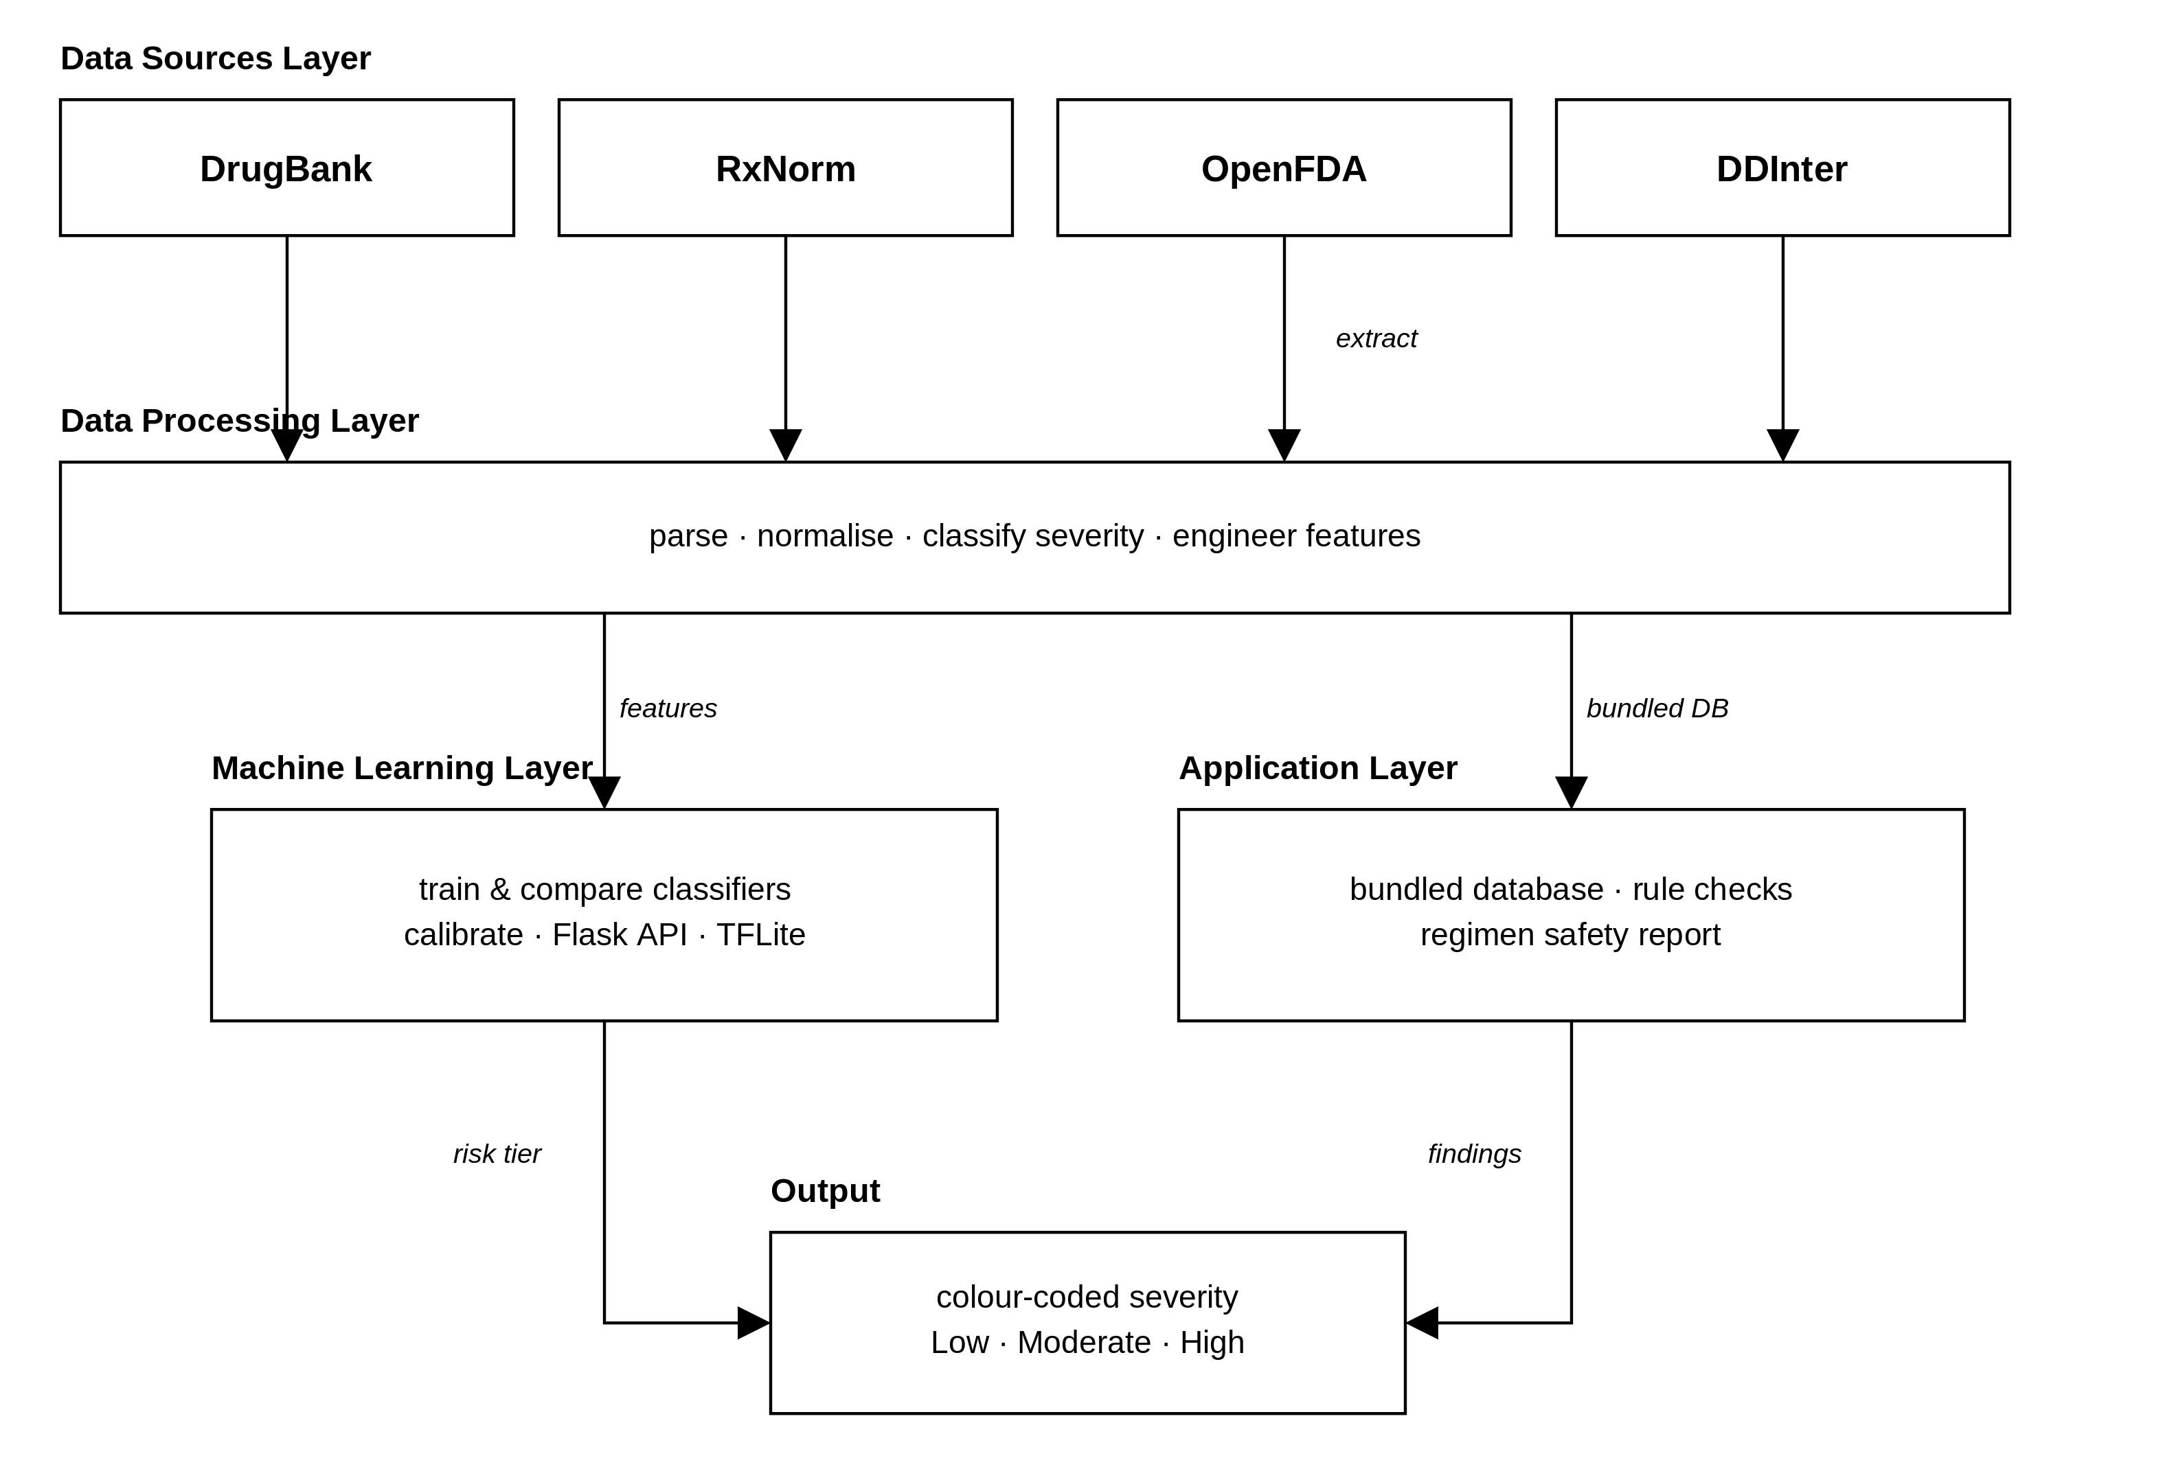
- Conceptual framework of the MedGuard system.

  - Research Design and Methodology
This study follows a multi-method quantitative design: an experimental evaluation of the machine learning component on a held-out test set, functional verification of the safety checks and offline behaviour, and a cross-sectional usability survey using the System Usability Scale. Both strands yield numerical data, so the design is multi-method quantitative rather than mixed-methods in the strict sense. The software itself was built through an iterative, prototype-driven lifecycle, chosen over a linear model because the interface, alert format and level of clinical detail could only be settled by iteration. Chapter Three sets out the full procedure.
  - Justification for the Choice of Machine Learning Algorithm
Two ensemble algorithms were compared for interaction prediction, a Random Forest and a Gradient Boosting model, both suited to structured, heterogeneous pharmacological features such as ATC codes, enzyme-inhibition profiles and half-life values.
The Random Forest aggregates many decision trees by majority vote (Breiman, 2001), which curbs the overfitting of a single tree, and its feature-importance rankings supply the interpretability a clinical decision-support context demands. It also serialises and serves through a lightweight Flask API with no GPU. Gradient Boosting came close on every discrimination measure, so the forest was kept for its higher macro-averaged F1, its better balance on the minority High tier and its native feature importances. For offline use a compact neural network is distilled from it and exported to TensorFlow Lite. Chapter Four reports the comparison.
  - Ethical Considerations
    - Data Integrity and Provenance
All pharmacological data come from established, publicly accountable sources: DrugBank 6.0 (Knox et al., 2024) under its academic licence, RxNorm for drug nomenclature, OpenFDA for public-domain adverse-event reports, and DDInter 2.0 (Tian et al., 2025) used only to refine severity ratings. The data pipeline (parsing, deduplication, and severity classification) is documented for independent verification.
    - User Privacy and Local Processing
MedGuard follows a privacy-by-default design. The drug database is a local file, so searches, interaction checks, food and duplicate-therapy checks and allergy cross-referencing all run on-device; the network is used only to score uncatalogued pairs, transmitting anonymised drug identifiers alone. Firebase Authentication manages credentials, though it stores basic data such as email addresses and tokens on a third-party cloud service. In line with the Nigeria Data Protection Act (2023), only minimal identifying data are collected, no clinical data leave the device, and users may delete their account at any time. Reliance on a non-Nigerian authentication provider nonetheless raises a cross-border transfer question under the Act; this is acknowledged as a compliance consideration requiring verification against current regulator guidance, and is only partly offset by keeping all clinical data in local encrypted storage.
    - The Human-in-the-Loop Principle
MedGuard is positioned explicitly as a decision-support tool, not an autonomous clinical agent: it does not prescribe, diagnose, or override professional judgement.
Severity alerts are presented as informational recommendations with contextual explanations, in-app disclaimers state that the system does not replace professional medical advice, and MedGuard is not a certified medical device.
    - Permissions for the Usability Evaluation
The usability evaluation involved human participants (nursing students, physiotherapy students and clinic staff in Abeokuta).
  - Definition of Terms
The following terms are defined to ensure clarity throughout this dissertation.
- Adverse Drug Reaction (ADR): An unintended and harmful response to a medication occurring at doses normally used for prophylaxis, diagnosis, or treatment of disease.
- CYP450 (Cytochrome P450): A superfamily of enzymes primarily found in the liver that play a central role in the metabolism of drugs; inhibition or induction of CYP450 enzymes is a common mechanism underlying drug-drug interactions.
- Polypharmacy: The concurrent use of five or more medications by a single patient, associated with increased risk of drug interactions and adverse events.
- Severity Classification: the grading of a drug interaction to indicate its clinical significance and guide a response. This study uses the four DrugBank grades (Minor, Moderate, Major and Contraindicated) for catalogued pairs and maps them onto three user-facing tiers, Low, Moderate and High, which the machine learning model predicts directly.
- Therapeutic Duplication: The prescribing or concurrent use of two or more drugs from the same therapeutic class, which may increase the risk of adverse effects without proportional therapeutic benefit.
- Feature Engineering: The process of extracting, transforming, and selecting meaningful variables from raw data to improve the predictive performance of a machine learning model.
- TensorFlow Lite (TFLite): A lightweight machine learning framework designed for deploying trained models on mobile and embedded devices, enabling efficient on-device inference with low memory and processing requirements.
  - Organisation of the Dissertation
This dissertation is organised into five chapters. Chapter One introduces the study. Chapter Two reviews the literature on drug-drug interactions, clinical decision support, machine learning in pharmacovigilance and mobile health, and identifies the research gap. Chapter Three presents the methodology, system analysis and design, database schema and machine learning pipeline. Chapter Four reports the implementation, model results, testing and discussion of findings. Chapter Five summarises the study, assesses the achievement of each objective, and states the contributions, limitations and recommendations for future work.
This chapter has set out the context for MedGuard, identified the research gap, and defined the aim, objectives and research questions that guide the investigation. Chapter Two reviews the literature on drug-drug interactions, clinical decision support, machine learning in pharmacovigilance and mobile health, and uses that review to position MedGuard against the tools already available.
- CHAPTER TWO

LITERATURE REVIEW
  - Introduction
This chapter reviews the literature underpinning the design and evaluation of MedGuard. It is organised thematically, not study by study: it establishes the mechanisms and burden of drug-drug interactions and the limits of existing decision support, examines the pharmacological data sources on which the system depends, surveys machine learning approaches with attention to what is deployable on a mobile device, considers the constraints of the Nigerian setting, and reviews the evaluation instruments used in this study. It closes by synthesising the research gaps the study addresses.
  - Conceptual Framework
This section defines the concepts that recur throughout the dissertation: the pharmacological mechanisms through which drugs interact, the architecture and typology of clinical decision support systems, the alert fatigue that undermines their effectiveness, and the risks polypharmacy creates.
    - Drug–Drug Interactions: Pharmacokinetic and Pharmacodynamic Mechanisms
A drug–drug interaction (DDI) occurs when the pharmacological effect of one medication is altered by the concurrent administration of another, potentially resulting in increased toxicity, diminished therapeutic efficacy, or the emergence of an unanticipated adverse effect. DDIs are classified into two principal mechanistic categories: pharmacokinetic interactions, which alter the absorption, distribution, metabolism, or excretion of a drug, and pharmacodynamic interactions, which modify the drug’s effect at its site of action without changing its plasma concentration.
Pharmacokinetic interactions are the more extensively studied category. They arise most frequently through modulation of cytochrome P450 (CYP) enzyme activity in the liver. When one drug inhibits a CYP isoenzyme responsible for metabolizing a second drug, the plasma concentration of the second drug rises, potentially reaching toxic levels. Conversely, enzyme induction accelerates metabolism, reducing drug efficacy.
Most published evaluations consider only one of these mechanisms, which can give an incomplete picture of risk. Both are represented in MedGuard’s engineered features, described in Chapter Three.
Pharmacodynamic interactions, by contrast, occur when two drugs produce additive, synergistic, or antagonistic effects at the same or functionally related receptor or physiological pathway. These interactions do not necessarily alter drug concentrations but can profoundly change clinical outcomes. For instance, combining two drugs with sedative properties produces additive central nervous system depression even though neither drug’s metabolism is affected.
The clinical significance of a DDI depends not only on its pharmacological mechanism but also on patient-specific factors including age, hepatic and renal function, genetic polymorphisms in metabolic enzymes, and the overall medication burden.
    - Clinical Decision Support Systems
Clinical decision support systems (CDSS) are computer-based applications designed to assist healthcare professionals in making clinical decisions by providing patient-specific or drug-specific knowledge and recommendations at the point of care. Sutton et al. (2020), in a widely cited overview published in npj Digital Medicine, distinguished two fundamental categories: knowledge-based CDSS, which operate through predefined rules, clinical guidelines, and expert-authored logic, and non-knowledge-based CDSS, which employ machine learning and artificial intelligence to derive patterns from data without explicit rule programming.
Knowledge-based systems have demonstrated proven efficacy in several clinical domains including drug interaction checking, dosage guidance, preventive care reminders, and diagnostic support. However, Sutton et al. (2020) also documented persistent limitations: workflow disruption, automation bias (where clinicians defer excessively to system recommendations), maintenance burden (rules must be continuously updated), and most critically, alert fatigue.
Hak et al. (2022) extended this understanding through a systematic review of fifty-two CDSS studies, developing a Maturity Staging Model grounded in Simon’s decision-making theory. Their analysis revealed that the majority of existing CDSS do not exceed maturity level two, with the “choice” and “implementation” phases of the decision cycle being significantly underrepresented.
This finding is directly relevant to the present study’s design: by incorporating machine learning-based severity stratification alongside rule-based interaction detection, the proposed system aims to advance CDSS maturity beyond simple alerting into intelligent risk-differentiated decision support.
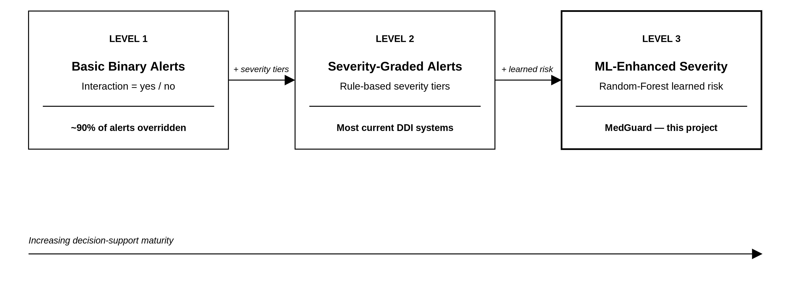
- Evolution of CDSS maturity from rule-based to ML-enhanced decision support (adapted from Hak et al., 2022; Sutton et al., 2020).
Most existing DDI checking systems operate at Level 2 (rule-based severity grading), whereas MedGuard targets Level 3 by adding machine-learning severity classification trained on pharmacological features, consistent with the three-tier (Low, Moderate, High) risk grouping adopted in Chapter One (Hak et al., 2022), as Figure 2.1 illustrates.

    - Alert Fatigue in Clinical Decision Support
Alert fatigue represents the progressive desensitization of clinicians to system-generated safety warnings, driven by excessive alert volume and poor clinical relevance.
Hussain et al. (2019), in a systematic review of CDSS design variants and their effect on prescriber acceptance, found that interrupting prescribers with modal pop-up dialogues was the least accepted yet most prevalent design pattern. Pharmacist-mediated advice routed through the CDSS was accepted more often, and with far less variability, than a direct alert to the physician.
Felisberto et al. (2024), in a systematic review and meta-analysis of sixteen studies, put numbers on the problem. Clinical decision support generated an alert on 13 per cent of orders, and physicians overrode roughly ninety per cent of the drug-drug interaction alerts they received (95% CI: 85–95%). Their conclusion is that alerting volume alone is not the lever; the alerts have to be designed around the user. Hussain et al. (2019) proposed two mitigations, tiered alerts that carry risk severity in graded visual cues and role-based routing that sends certain alerts to pharmacists instead of physicians. Both shaped MedGuard's design. The application grades every finding into three visually distinct tiers, so a High-risk pair cannot compete for attention on equal terms with a Low-risk one.
    - Polypharmacy: Prevalence and Risks
Polypharmacy, most commonly defined as the concurrent use of five or more medications, is a well-established amplifier of DDI risk. Pazan and Wehling (2021), in a narrative review of MEDLINE literature from 2015 to 2020, identified one hundred and forty-three distinct definitions of polypharmacy in the literature, though the threshold of five or more medications remains dominant. Their review reported that polypharmacy prevalence ranges from four percent among community-dwelling older adults to over ninety-six percent among hospitalized patients, and that it is independently associated with falls, frailty, cognitive impairment, hospitalization, and mortality.
Hughes et al. (2023), in a systematic review and meta-analysis of thirty-one studies, reported a pooled DDI prevalence of 28.8 per cent (95% CI: 19.3–40.7%) among community-dwelling older adults. The arithmetic behind this is unforgiving. A patient on five medicines has ten pairs to check; a patient on ten has forty-five.
Checking every pair by hand becomes impractical well before a regimen reaches that size, particularly in a high-volume clinic. Automated, severity-stratified checking is the obvious response, and it is what MedGuard provides.
  - Drug Interaction Databases and Knowledge Bases
The reliability and clinical utility of any drug interaction checking system depends fundamentally on the quality, comprehensiveness, and structure of its underlying pharmacological data.
Table 2.1 compares the four principal databases and knowledge bases that inform the present system’s data architecture: DrugBank, RxNorm, the OpenFDA Adverse Event Reporting System, and the WHO Anatomical Therapeutic Chemical classification system. The choice of database materially influences both the scope and the accuracy of an interaction-checking system, since sources differ in coverage, annotation depth and update frequency.
    - DrugBank
DrugBank is the primary data source for this study. Knox et al. (2024) describe DrugBank 6.0 as holding detailed drug records covering molecular properties, pharmacological classifications, documented drug–drug interactions, metabolic enzyme relationships, protein targets and therapeutic categories, curated from peer-reviewed literature, regulatory documents and clinical pharmacology references.
Version 6.0 documents 1,413,413 interactions across roughly 11,900 drugs. Its structured XML release can be parsed systematically into a relational database, which is what this project’s data engineering pipeline does. DrugBank is not open data: commercial use requires a paid licence. Its academic research licence, however, permits free use for non-commercial research, which makes it both technically suitable and legally usable for an undergraduate dissertation.
    - RxNorm
RxNorm is a standardized nomenclature maintained by the United States National Library of Medicine that provides normalized names and unique identifiers (RxNorm Concept Unique Identifiers, or RxCUIs) for clinical drugs.
Wu et al. (2024), in a case study examining prescription opioids in the FDA Adverse Event Reporting System, demonstrated the critical importance of RxNorm normalization: across 14.9 million adverse event reports spanning seventeen years, 2,086 different drug name strings were used to refer to just ninety-two standardized RxNorm opioid concepts. Without normalization, such heterogeneity would make systematic analysis impossible.
In the present project, RxNorm normalization is performed during a one-time pre-deployment data pipeline process. Each drug name parsed from DrugBank is mapped to its corresponding RxCUI, and this identifier is stored in the local SQLite database. At runtime, the application uses pre-cached RxCUIs for unambiguous drug resolution without requiring network connectivity, preserving the system’s offline-first architecture.
Although RxNorm and OpenFDA are maintained by United States agencies, both index active pharmaceutical ingredients by generic (non-proprietary) name, which covers the overwhelming majority of medicines in global use, including those on the Nigerian Essential Medicines List. MedGuard therefore resolves drugs by generic ingredient, not by localised brand name, which limits the US-centric coverage gap that affects brand-indexed tools such as Epocrates.
    - OpenFDA Adverse Event Reporting System
The FDA Adverse Event Reporting System (FAERS) is the primary post-marketing drug safety surveillance database maintained by the United States Food and Drug Administration. Potter et al. (2025), in an authoritative FDA-authored guide published in Clinical Pharmacology and Therapeutics, described FAERS as containing over thirty-two million individual case safety reports collected through voluntary and mandatory reporting channels.
The OpenFDA API provides programmatic access to this data in JSON format, covering reports from the first quarter of 2004 onwards. For this project, OpenFDA data serves a supplementary enrichment function: adverse event co-occurrence frequencies for specific drug pairs are queried during the pre-deployment pipeline to derive real-world pharmacovigilance signals that complement the structured interaction data from DrugBank.
Potter et al. (2025) emphasized important limitations of FAERS data: reports are voluntarily submitted, lack controlled comparator groups, and do not establish causation. These limitations are acknowledged in the system’s design; OpenFDA-derived signals feed the machine learning model as supplementary features, never as standalone clinical evidence.
    - WHO Anatomical Therapeutic Chemical Classification System
The World Health Organization’s Anatomical Therapeutic Chemical (ATC) classification system organises active pharmaceutical substances into hierarchical groups according to the organ system they act on and their pharmacological, therapeutic and chemical properties (WHO Collaborating Centre for Drug Statistics Methodology, 2024).
The five-level classification structure provides a standardized framework for grouping drugs by therapeutic class, enabling systematic identification of duplicate therapy (where a patient is prescribed two drugs from the same therapeutic class) and pharmacological class-level interaction analysis. In the present application, ATC codes are used for duplicate therapy detection: when a new medication is added to a patient’s list, the system cross-references its ATC class against existing medications to flag potential therapeutic duplication.
- Comparison of Drug Interaction Databases and Knowledge Bases
Database | Data Type | Coverage | Access Model | License | Role in This Project
DrugBank 6.0 | DDIs, targets, enzymes, pathways, molecular properties | ~11,900 drugs; 1,413,413 DDI entries | Web download (XML) | Academic licence (free for non-commercial research) | Primary interaction database; ML training features
RxNorm (NLM) | Standardized drug names, RxCUIs, relationships | US-marketed drugs (brand, generic, ingredient levels) | REST API and bulk download | Public domain | Drug name normalization and disambiguation
OpenFDA FAERS | Adverse event reports, drug–event co-occurrences | >32 million reports (2004–present) | REST API (JSON) | US government open data | Supplementary pharmacovigilance signals informing severity labelling
WHO ATC | Therapeutic classification hierarchy (5 levels) | All marketed drugs globally | Online index | WHO Collaborating Centre | Duplicate therapy detection by therapeutic class
DDInter 2.0 | DDIs with mechanisms, severity | 2,310 drugs; 302K DDIs | Web interface | Free/open | Validation reference; severity benchmarking
SIDER | Drug side effects from labels | 1,430 drugs; 140K pairs | Free download | Creative Commons | Reviewed as an alternative source; not used in this project

  - Review of Existing Drug Interaction Checking Systems
Existing checkers divide broadly into subscription platforms and free, consumer-facing services. This section reviews the dominant subscription platform, the principal free alternatives and the other systems examined, and identifies the limitations they share.
Lexicomp (Lexi-Interact) by Wolters Kluwer
Lexicomp, whose mobile interface is shown in Figure 2.2, checks drug–drug, drug–food and drug–herbal interactions and returns five-level severity ratings, mechanisms, management guidance and references across web, mobile and EHR platforms. Kheshti et al. (2016) ranked it first among five commercial programs for both accuracy and completeness. Its subscription cost, its dependence on a live connection, and severity ratings assigned editorially, not derived from pharmacological data, all limit its suitability and transparency in Nigerian practice.
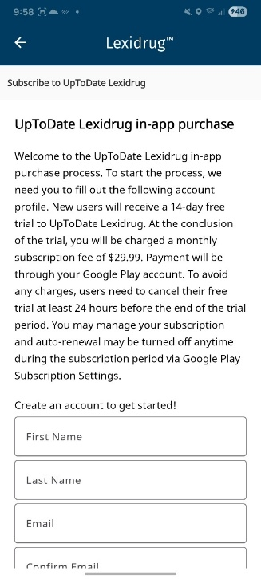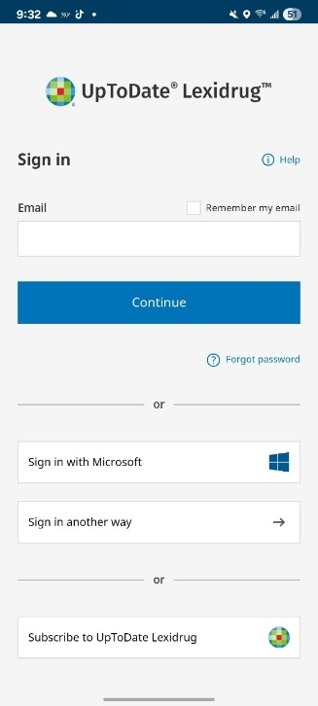
- Mobile User Interface of Lexicomp (Lexi-Interact) by Wolters Kluwer
Medscape Interaction Checker
Medscape’s interaction checker (Figure 2.3) is free, requires no registration, and handles multi-drug checks with a three-tier severity classification. Kheshti et al. (2016) scored it 202 out of 400 for accuracy, well behind Lexicomp. It gives abbreviated interaction descriptions without full monographs, and it needs an internet connection for everything it does.
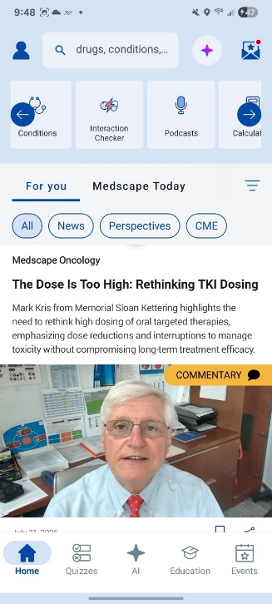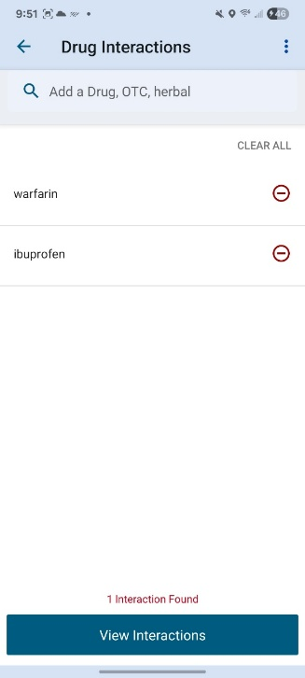
- Mobile User Interface of Medscape Interaction Checker
Drugs.com
Drugs.com (Figure 2.4) is a free, advertising-supported web and mobile tool offering multi-drug interaction checking across three severity levels (major, moderate, minor). It has performed comparably to subscription tools on some interaction sets, which makes it a credible free alternative. Against that, its clinical depth is thin next to Lexicomp or Micromedex, it has no offline mode, and its severity ratings are editorial judgements, not model output.
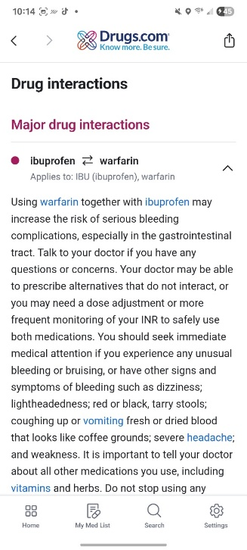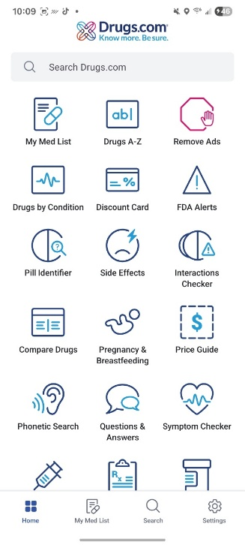
- Mobile User Interface of Drugs.com
DDInter 2.0
DDInter (Figure 2.5) is a free, pharmacist-reviewed web checker giving severity ratings and mechanism descriptions across roughly 0.24 million interactions (Xiong et al., 2022). Version 2.0 expanded that coverage and added new interaction types (Tian et al., 2025). It has no mobile client and no offline mode, which rules it out at the point of care wherever connectivity is unreliable, though its curated ratings are used in this project as the override layer described in Section 3.6.
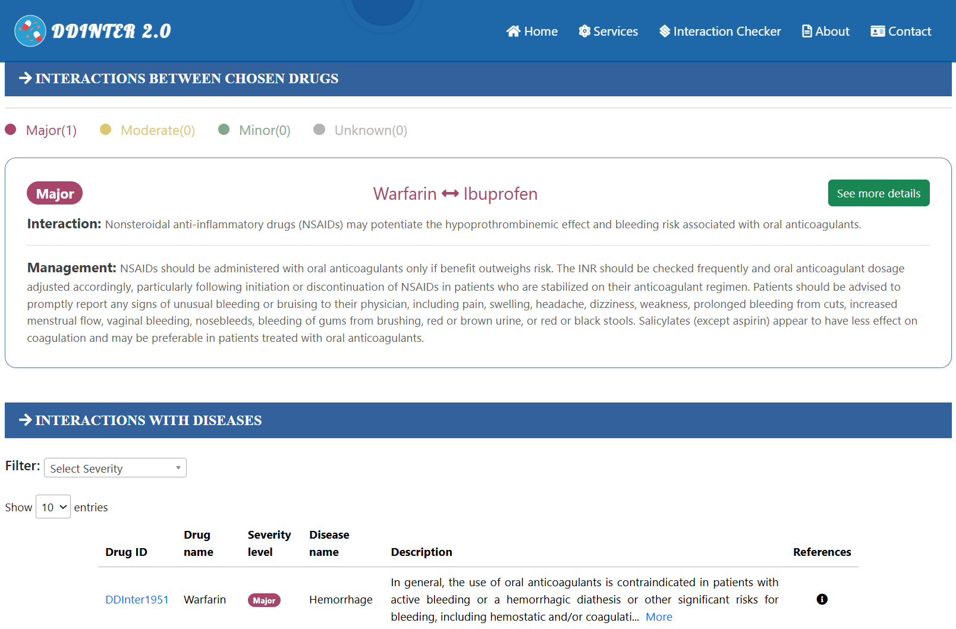
- Web Interface of DDInter 2.0
Table 2.2 presents a comparative analysis of the major existing drug-interaction checking tools, highlighting their key features, accessibility, strengths and limitations.
- Comparison of Existing Drug Interaction Checking Tools
Tool/System | Platform | Access Model | Evidence Transparency | Key Strengths | Key Weaknesses
Lexicomp (Lexi-Interact) | Web, mobile, EHR | Subscription (institutional/ individual) | High (detailed monographs, references, mechanism explanations) | High accuracy; detailed clinical monographs; widely trusted | Expensive; requires internet; editorial severity assignment
Medscape | Web, mobile app | Free | Low (brief descriptions; limited references) | Free access; no registration required; patient-friendly | Limited clinical depth; inconsistent documentation; internet required
Drugs.com | Web, mobile app | Free (ad-supported) | Low–Medium (consumer-oriented summaries) | Free; easy to use; broad public access | Limited clinical detail; ad-supported; no offline mode
DDInter 2.0 | Web | Free/Open-access | Medium (mechanisms, severity labels, alternatives) | Open-access; pharmacist-reviewed; large DDI dataset | Web-only; no mobile app; no offline functionality

  - Machine Learning in Pharmacology and Drug Interaction Prediction
The application of machine learning to drug-drug interaction prediction is one of the most rapidly evolving areas in computational pharmacology. This section reviews major algorithmic approaches, from feature engineered classifiers to deep learning architectures. It examines graph neural networks and their relevance to the study’s severity classification objective.
Wang et al. (2024), in a comprehensive review published in the Journal of Chemical Information and Modeling, systematically categorized ML-based DDI prediction into three perspectives: the databases from which training data derives (DrugBank, SIDER, TWOSIDES), the drug attributes used as features (chemical substructures, biological targets, phenotypic profiles), and the algorithmic families employed. The review identified data imbalance, the absence of standardized benchmarks, and limited model interpretability as the three most persistent challenges across the field.
A parallel review confirmed (Xia et al., 2025) that graph-based deep learning methods generally outperform traditional feature-engineered approaches, but the cold-start problem for newly approved drugs with limited known interaction data remains a significant barrier. Class imbalance is the field's other standing difficulty, and it bites hardest on exactly the task MedGuard performs. Xie et al. (2025), working on DDInter's severity levels, describe imbalanced risk-level datasets as a persistent obstacle in this literature and resort to pre-trained language-model embeddings with an LSTM-attention architecture to handle it; Feng and Huang (2025) reach for synthetic oversampling for the same reason.
Both responses cost more compute than a mobile deployment can spend, which is why MedGuard handles imbalance through class weighting and threshold tuning instead (Section 3.8.7). Crucially, despite this superior performance, graph neural networks demand computational resources incompatible with offline mobile deployment, which directly motivates the present study's use of lightweight ensemble classifiers.
Interpretability matters more in clinical machine learning than in most applications, because a clinician is unlikely to act on a severity prediction they cannot interrogate. Post-hoc explanation methods are the usual answer, but they add a second model to interpret alongside the first.
Tree-ensemble models retain an advantage in this respect: a Random Forest yields native, model-intrinsic feature-importance rankings without a separate explanation layer. This transparency is one reason MedGuard favours an ensemble classifier, since the pharmacological features that determine a severity tier (shared cytochrome-P450 substrates, enzyme inhibition, and ATC-class overlap) can be surfaced to justify each alert instead of arriving as an opaque score. The most recent work makes the same trade explicit from the other direction. Feng and Huang (2025) combined molecular fingerprints, enzymes, pathways and targets in a deep neural network, reached 88.9 per cent accuracy, and then had to add an attention-based importance analysis to recover the interpretability an ensemble gives for free.
    - Multimodal and Ensemble Approaches
Multimodal deep learning frameworks that combine chemical substructures, target proteins, enzymes and biological pathways outperform single-feature baselines, which confirms that pharmacological multi-modality improves predictive power (Wang et al., 2024). Their computational cost puts them outside the budget of a mobile deployment.
Pham et al. (2024) extended this principle to clinical severity classification. Their DeepARV system employed ensemble deep learning to predict four severity categories (contraindicated, clinically relevant, weakly relevant, no interaction) for antiretroviral drug interactions.
The study compared ensemble deep learning against Gaussian Naïve Bayes, Decision Trees and Random Forest, reaching a best weighted balanced accuracy of 0.776. The Random Forest held its own among those baselines, which is evidence that a forest can stay competitive with deep architectures for severity classification at moderate dataset sizes.
MedGuard deploys a Random Forest for the same reason, chosen over Gradient Boosting on its higher macro-averaged F1 and its more favourable precision–recall balance on the minority high-severity class.
The selected Random Forest is served online through a Flask REST API. For fully offline use, a compact neural network is trained to reproduce its predictions and exported to TensorFlow Lite for on-device inference. That distilled network is a deployment artefact of the chosen classifier, evaluated for predictive fidelity and latency, and it does not enter the Random Forest versus Gradient Boosting comparison.
    - Graph Neural Networks for DDI Prediction
Graph neural networks represent the relational structure of pharmacological data naturally and achieve the strongest published benchmarks, but they require computational resources incompatible with offline mobile inference. The most directly relevant work addresses the cold-start problem: EmerGNN, a flow-based graph neural network operating over a large biomedical network, achieves significantly higher accuracy than existing approaches for newly approved drugs with limited prior interaction data, but depends on a knowledge graph that cannot be bundled into a mobile application (Zhang et al., 2023). The cold-start limitation this addresses is the same one measured for MedGuard’s own classifier in Chapter Four.
  - Mobile Health (mHealth) Applications in Medication Management
Mobile health (mHealth) applications use smartphones to deliver healthcare services, health information, and clinical decision support. This section reviews their effectiveness in medication management, relevant technology acceptance frameworks, and barriers to adoption in Sub-Saharan Africa.
    - Technology Acceptance Model in mHealth
The Technology Acceptance Model (TAM), originally proposed by Davis (1989), posits that user adoption of a technology is primarily determined by two beliefs: perceived usefulness and perceived ease of use. These constructs have been extensively validated across information systems research and serve as the theoretical evaluation framework for the present study.
Perceived usefulness and perceived ease of use remain the strongest predictors of mobile health adoption. For the present project, the System Usability Scale directly measures the perceived ease-of-use construct of the Technology Acceptance Model; perceived usefulness is not captured by the SUS itself and is approached only indirectly, through task-completion success and the open debrief feedback collected during each evaluation session.
    - mHealth in Sub-Saharan Africa: Barriers and Opportunities
Mobile health deployment in Sub-Saharan Africa runs into barriers that differ from those in high-income settings. A scoping review of thirty-one Nigerian studies identified infrastructure deficiencies, poor internet connectivity and inconsistent electricity supply as the dominant obstacles, and found that most systems in the region stall at pilot or proof-of-concept stage and never scale (Egwudo et al., 2025). That is not a ceiling on what the technology can do. In rural South Africa, a randomised trial of home-based hypertension care in which community health workers used a mobile application to relay readings for remote nurse-led decisions cut mean systolic pressure by 7.9 mmHg against clinic-based care and nearly doubled the proportion of patients with controlled hypertension (Siedner et al., 2025). Mobile decision support works in this region when it is designed around the infrastructure that actually exists, which is the architectural rationale for MedGuard's offline-first, locally bundled database.
  - Research and Evaluation Methods
The methodological foundations of this study draw from established frameworks in information systems research, usability engineering, software development, and mobile application development. This section reviews the principles and methods that govern the study’s research design, evaluation strategy, development process, and technology platform choices.
    - Design Science Research
Design Science Research (DSR) provides the overarching research paradigm for this study. Hevner et al. (2004), in the foundational framework for DSR in information systems, articulated that design science addresses research through the building and evaluation of artefacts designed to solve identified organizational problems.
The framework specifies seven guidelines: design as an artefact, problem relevance, design evaluation, research contributions, research rigour, design as a search process, and communication of research. The present study is designed to satisfy these guidelines by producing a functional mobile application artefact, grounding it in a clearly defined healthcare problem, and evaluating it through both technical metrics and user-centered assessment.
    - System Usability Scale
The System Usability Scale (SUS), developed by Brooke (1996), is a ten-item Likert-scale questionnaire that yields a single composite usability score on a scale from zero to one hundred. Brooke selected the ten items from a pool of fifty candidate statements based on their ability to discriminate between systems of varying usability.
The SUS has since become one of the most widely used standardised usability instruments, cited tens of thousands of times. Bangor et al. (2008) validated it against nearly a decade of data collected across numerous products and development phases. It remains the default instrument for clinical mobile applications: Machetanz et al. (2024), evaluating a rehabilitation app with clinicians, patients and healthy users, reported a mean of 89.6 and, like the present study, compared scores across user groups rather than reporting a single figure.
Their analysis confirmed consistently high reliability (Cronbach’s alpha of 0.90 or above in large samples) and proposed an adjective rating scale for interpreting scores: scores of eighty-five or above correspond to “Excellent,” while scores below seventy indicate “Poor” usability.
This validated benchmark framework is adopted in the present study’s evaluation protocol to interpret the SUS scores obtained from healthcare professional participants.
  - The Nigerian Healthcare Context
This section reviews empirical findings that situate the present study within the Nigerian healthcare context. The evidence presented here establishes the specific conditions health workforce deficits, medication error prevalence, polypharmacy burden, and digital health infrastructure gaps that collectively define the environment in which the proposed application is intended to operate.
    - Health Workforce and Pharmacy Capacity
Nigeria’s health workforce sits below the density thresholds associated with adequate service coverage, and the pharmaceutical sector is worse off than the average.
Within this deficit the pharmaceutical sector is worse placed than most. Ekpenyong et al. (2018), in a census-based analysis of Nigeria's pharmacy workforce using Pharmacists Council of Nigeria data from 2011 to 2016, found 21,892 registered pharmacists with only fifty-nine per cent (12,807) in active practice.
The position has deteriorated since. Emigration of health professionals has accelerated to the point where over 12,000 Nigerian-trained doctors were practising in the United Kingdom alone by 2023, with the United States, Canada and Germany following (Umar et al., 2025), and a nationwide survey of early-career specialists found 69.2 per cent planning to leave immediately and 52.9 per cent already taking practical steps to do so (Essien et al., 2024).
Pharmacist density ranged from 0.53 to 0.66 per 10,000 population, significantly below the WHO workforce-density threshold. Over forty percent of licensed pharmacists were concentrated in the South-West region, while fewer than ten percent served the North-East and North-West combined. Manual medication reconciliation for every patient encounter is difficult to sustain consistently at this workforce density.
    - Medication Errors and Drug Interactions in Nigerian Practice
Ogunleye et al. (2016), in a national survey of 2,386 health professionals across ten tertiary hospitals in Nigeria, reported a self-reported medication error prevalence of forty-seven percent. Professional groups differed significantly in their knowledge of prescribing, dispensing, and administration error types, suggesting that medication safety awareness is unevenly distributed across the health workforce. Oshikoya et al. (2016), in a prospective clinical audit of pediatric outpatient prescriptions in four Nigerian general hospitals, found that 16.9 percent of eligible patients (208 of 1,233) received prescriptions containing at least one potential drug–drug interaction, with most identified DDIs classified as major or moderate.
More recent Nigerian evidence is now available and it is not reassuring. Oriaifo et al. (2024), reviewing 430 medical admissions at the University of Benin Teaching Hospital with Lexi-Interact, found potential interactions in 50.5 per cent of patients on day one and 67.4 per cent at discharge, with the number of prescribed medicines the strongest predictor on every day of admission. Interaction exposure therefore rises over the course of an admission, in the direction opposite to what medication review is meant to achieve. None of these studies found evidence of systematic deprescribing or automated medication review in the settings surveyed.
    - Digital Health Adoption and Infrastructure
Ravi et al. (2024), in a review of Nigeria’s digital health landscape, documented that while Nigeria has over one hundred distinct ICT-for-health initiatives, most remain fragmented and uncoordinated. Key barriers include insufficient trained healthcare personnel (only 1.95 health workers per 1,000 population), poor IT infrastructure, frequent power outages, limited rural internet connectivity, and over 74.7 percent out-of-pocket healthcare expenditure.
A scoping review of thirty-one studies on digital health integration in Nigeria confirmed (Egwudo et al., 2025) that digital health technologies enhanced treatment adherence, healthcare utilization, and community engagement where successfully implemented. However, the review identified poor internet connectivity, financial constraints, and inadequate network coverage as persistent challenges that no included study was able to fully resolve.
This convergent evidence from multiple independent reviews establishes that any digital health intervention targeting the Nigerian healthcare context should prioritise offline functionality and minimal infrastructure dependence, precisely the architectural principles that govern the present application’s design.
  - Identified Research Gaps
The literature reviewed converges on three gaps that this study addresses.
    - Absence of Affordable, Offline-Capable Interaction Checking
No reviewed platform offers a fully offline mode with a locally bundled, comprehensive interaction database. This dependency renders existing tools impractical in the Nigerian settings described above, where connectivity is unreliable or absent in many facilities, and it is compounded by cost: the most accurate platforms are subscription-based and unaffordable for most public-sector facilities and individual practitioners, while the free alternatives that remove the cost barrier lack both offline capability and fine-grained severity stratification.
No tool identified in this review has been developed specifically for, or evaluated within, the Nigerian healthcare context.
    - Limited Translation of Machine Learning into Deployable Tools
Although the machine learning literature demonstrates substantial advances in interaction prediction, these remain largely research demonstrations. No tool identified in this review deploys machine learning-based severity classification in a clinical-facing mobile application, and the highest-performing published models require computational resources incompatible with mobile deployment. This is the translational gap identified by Wang et al. (2024) between research-stage models and deployable applications, and it is the gap the present study addresses by training a computationally efficient ensemble classifier on pharmacological features and carrying it through to deployment.
    - Severity Judgements Not Derived from Pharmacological Features
Existing severity classifications rely largely on editorial consensus rather than quantifiable pharmacological features and often disagree across platforms for the same drug pairs (Tolley et al., 2021), limiting their consistency and auditability. OpenFDA post-marketing pharmacovigilance data provides an opportunity to supplement severity assessment with empirical safety signals, an approach not identified in the reviewed mobile interaction tools. Because OpenFDA is a spontaneous reporting system subject to under-reporting and reporting bias, its signals are used only as supplementary features and not as evidence of causation.
  - Summary and Positioning
This review has examined drug–drug interaction mechanisms, the limits of existing checkers, the available pharmacological data sources, deployable machine learning methods, the Nigerian context and the study's evaluation instruments. Three research gaps emerged, which Figure 2.6 links to the proposed system's offline-first architecture, its machine-learning severity classification, its open data integration and its context-appropriate deployment. Chapter Three presents the methodology and design through which they are addressed.
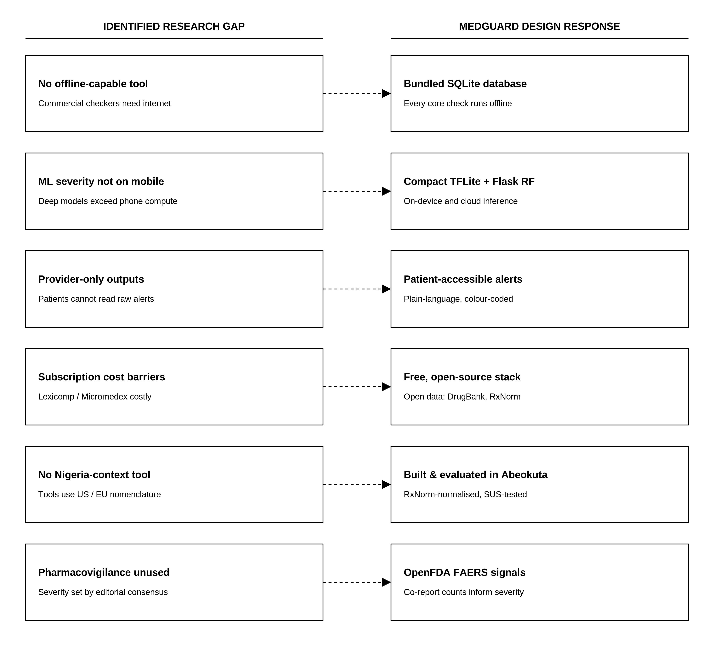
- Identified Research Gaps and Proposed System Features
- CHAPTER THREE

SYSTEM ANALYSIS, DESIGN AND METHODOLOGY
  - Introduction
This chapter turns the research gaps of Chapter Two into a software and machine-learning specification. It covers the research methodology and data sources, the analysis of the existing and proposed systems, the requirements, the layered offline-first architecture, the data-engineering pipeline, the database design and its normalisation, the machine-learning pipeline, and the interface, security, input, processing and output designs. The system is then modelled in UML and data-flow diagrams, and the evaluation strategy is stated. Every artefact reported here corresponds to the implemented codebase.
  - Research Methodology
The study is conducted under the Design Science Research (DSR) paradigm and built through an Agile-inspired, phased process. DSR is appropriate because the principal output is a functional artefact engineered to solve an identified clinical-informatics problem, and the paradigm explicitly couples artefact construction with rigorous evaluation. The relevance cycle imports the problem context and requirements from the Nigerian healthcare environment analysed in Chapters One and Two. The design cycle iterates between building the artefact, meaning the database, the model, the services and the client, and evaluating each increment. The rigour cycle grounds the design in the existing knowledge base, drawing on pharmacology databases, the ensemble-learning and clinical-decision-support literature and established software-engineering practice, and returns the resulting artefact and findings to it.
Construction followed an Agile-inspired iterative approach, not a formally prescribed framework such as Scrum or Kanban. Work was decomposed into phased increments (environment and data foundation, the offline mobile Minimum Viable Product (MVP), the machine-learning pipeline, supplementary safety features, and testing and evaluation) each delivering a working, tested increment before the next began. This preserves the Agile emphasis on incremental delivery and continuous verification while respecting the sequential dependency that a usable reference database must exist before features can be engineered and a model trained.
Two categories of data underpin the project. Pharmacological data were collected by automated extraction from authoritative secondary sources (DrugBank, RxNorm, OpenFDA and DDInter 2.0), described in Section 3.6. Requirements came from authoritative documentation: the DrugBank and RxNorm specifications, the OpenFDA interface documentation, the WHO ATC classification and the Nigeria Data Protection Act (2023), which between them set the structure, licensing and legal constraints on the data sources and the security design. Clinical staff at the Chrisland University School Clinic reviewed an early prototype during development. That review was exploratory, followed no protocol and produced no transcript, so no finding in Chapter Four rests on it; its influence was on design decisions, not on results. The same clinic later granted permission for the usability sessions described in Section 3.16 and reported in Section 4.8.
  - System Analysis
    - Analysis of the Existing System
In most Nigerian clinical and community-pharmacy settings, drug–drug interaction (DDI) detection is a manual, knowledge-dependent process. Prescribers and pharmacists rely on recall, printed references, or (where connectivity and subscriptions allow) online checkers such as Medscape or Drugs.com. Table 3.1 sets out the resulting problems. The process is connectivity-dependent, cognitively demanding, undifferentiated in the priority it assigns to alerts, and, for the accurate subscription tools, financially inaccessible to most public-sector facilities and individual practitioners.
- Problems of the existing system.
# | Problem | Consequence
1 | Dependence on internet connectivity | Checks fail where networks are unreliable at the point of care
2 | Reliance on unaided human recall | Interactions are missed as regimen size grows combinatorially
3 | Undifferentiated alerting | Alert fatigue; clinically major and minor alerts compete for attention
4 | High subscription cost | Accurate tools are unaffordable for most LMIC practitioners
5 | Provider-only, expert outputs | Patients cannot interpret or act on the information
6 | No use of pharmacovigilance signals | Severity rests on editorial labels alone

Beyond the problems above, existing arrangements have structural limitations: they provide no personal, persistent medication list against which a whole regimen can be screened; they do not combine interaction, food, duplicate-therapy and allergy checks in one place; they offer no severity learning that could generalise to drug pairs absent from a static rule list; and they keep no auditable, on-device record of the checks performed.
    - Feasibility Study
Feasibility was assessed across five dimensions to confirm that the proposed system could be realised within the constraints of an undergraduate project. The system is technically feasible using mature, freely available technologies: Flutter for the cross-platform client, SQLite for the embedded store, scikit-learn for training, TensorFlow Lite for on-device inference and Flask for the prediction service, with all pharmacological data obtainable from openly licensed sources and small enough to ship inside an Android package. It is economically feasible as a zero-budget build, since every framework, dataset and hosting tier used is free or openly licensed. It is operationally feasible because it targets a workflow its users already perform, and its offline-first design removes the connectivity barrier that undermines existing tools. Legally, only minimal identifying data are collected, special-category health data are encrypted on-device and no clinical data leave the device, consistent with the Nigeria Data Protection Act (2023); the system is positioned as a decision-support aid and is not a certified medical device. The work was schedule-feasible within the project’s fourteen-week plan, organised into the phased increments described in Section 3.1.
    - Proposed System
MedGuard is an offline-first, cross-platform mobile application that maintains a personal medication list and checks, in real time and without a network, whether any combination of medicines carries a clinically significant interaction. Known interactions are resolved from a bundled, DrugBank-derived SQLite database; for uncatalogued pairs the system predicts a three-tier risk (Low, Moderate, High) using a Random Forest classifier served by a Flask API when online and a distilled TensorFlow Lite model on the device when offline.
It additionally screens for drug–food interactions, ATC-based therapeutic duplication, and drug–allergy conflicts, and provides dose scheduling, a drug monograph and a lock-screen emergency card. Advantages of the Proposed System Operates fully offline, so a safety check never depends on connectivity. Grades every interaction into three tiers, reducing alert fatigue.
Predicts severity for drug pairs absent from the static rule list. Combines interaction, food, duplicate-therapy and allergy checks in one regimen-level report. Is built entirely on free, openly licensed data and frameworks. Encrypts all user health data on the device and keeps it off any server.
  - Requirement Analysis
Requirements analysis was conducted to identify and define the functional and non-functional requirements of the proposed system. The process involved examining user needs, clinical workflow considerations, and system constraints to ensure that the application effectively supports medication safety and decision-making in pharmacy practice. The functional requirements define the core capabilities and services that MedGuard must provide to meet user needs and support medication safety activities. Table 3.2 lists them; they describe what the system is expected to do.
- Functional requirements.
ID | Functional requirement
FR1 | Search for a drug by generic or brand name, resolving synonyms to one normalised record.
FR2 | Add and remove medicines from a personal, locally persisted medication list.
FR3 | Detect every drug–drug interaction in the regimen and grade it Low, Moderate, or High.
FR4 | Predict an interaction-risk tier for drug pairs not present in the bundled database.
FR5 | Screen for drug–food interactions, ATC duplicate therapy, and drug–allergy conflicts.
FR6 | Present a consolidated safety report whose verdict is the highest tier in the regimen.
FR7 | Record allergies and dose schedules and raise reminders for scheduled doses.
FR8 | Authenticate users and persist their data across sessions and devices.
FR9 | Perform all core checks without an internet connection.

The non-functional requirements specify the quality attributes and operational characteristics of the system. Table 3.3 states them. They govern whether MedGuard performs reliably, securely and efficiently under expected use.

- Non-functional requirements.
ID | Non-functional requirement
NFR1 | Offline capability, all core checks complete without network access.
NFR2 | Performance, a local interaction lookup returns within a fraction of a second.
NFR3 | Footprint, bundled database and on-device model are small enough for app-store distribution.
NFR4 | Security, user health data are encrypted at rest; no clinical data leave the device.
NFR5 | Usability, operable by non-experts; an above-average System Usability Scale score.
NFR6 | Reliability, graceful degradation so connectivity loss never blocks a check.
NFR7 | Maintainability, the reference database is rebuildable from source by a reproducible pipeline.

The hardware requirements identify the minimum computing resources needed for both system development and deployment. Table 3.4 gives the minimum specification for the target device and the development machine.
- Hardware requirements.
Requirement | Minimum specification
Target device | Android smartphone, Android 8.0 (API 26) or later
Device RAM | 2 GB (the on-device model and database operate within a small footprint)
Device storage | ~200 MB free for the application and bundled reference database
Development machine | Multi-core CPU, 16 GB RAM, ~50 GB free disk for SDKs and datasets

Table 3.5 lists the development tools, frameworks, libraries and platforms needed to build, deploy and maintain MedGuard.
- Software requirements.
Requirement | Specification
Mobile framework | Flutter 3.41.6 (Dart)
Local database | SQLite (sqflite); SQLCipher for the encrypted user store
Backend | Flask (Python 3.11.9)
Machine learning | scikit-learn, TensorFlow / TFLite
Authentication | Firebase Authentication
Build toolchain | JDK 21, Gradle 8.14
Operating system (dev) | Windows 11

The system imposes no hard network requirement: all core functionality is available offline. When connectivity is present, the application uses HTTPS to reach the Flask prediction service for uncatalogued pairs and Firebase for authentication and the Flask API for optional reference-database updates. The network is therefore an option, not a requirement, and all network payloads are limited to anonymised drug identifiers and authentication tokens.
Table 3.6 states the security requirements that follow from this design. The system serves two user types. Patients require a simple way to check their own medicines and understand the result in plain language. Clinicians (pharmacists, prescribers) require rapid, regimen-level checking with graded severity and the ability to act on it. Both require that the tool work reliably without a network and present results without clinical jargon where possible.
- Security requirements.
ID | Security requirement
SR1 | User health data (medications, allergies, history) must be encrypted at rest on the device.
SR2 | Encryption keys must reside in platform secure storage, not in application code.
SR3 | Authentication must use signed identity tokens; the backend must store no user data.
SR4 | No clinical or medication data may be transmitted off the device.
SR5 | Users must be able to delete their account and data at any time.

  - System Design Overview
The design of MedGuard follows a layered separation of concerns in which presentation, application logic, data and machine-learning components are decoupled and communicate through well-defined interfaces. This section summarises the design at successive levels of abstraction before the detailed designs that follow. The system adopts a layered, offline-first architecture with an optional client-server extension. The mobile device hosts the presentation layer and the application-logic layer (the interaction-checking engine, the bundled reference database, the encrypted user store and the on-device model); a stateless Flask service and Firebase Authentication form an optional cloud tier reached only when online.
At the highest level the system comprises four collaborating subsystems: a data-engineering subsystem that builds the bundled database before deployment, a machine-learning subsystem that trains and exports the severity model, a mobile subsystem that performs checks and presents results, and a thin backend that serves online predictions and database updates. Within the mobile subsystem, responsibilities are divided among cooperating service classes: an InteractionChecker that orchestrates a check, a DatabaseService that queries the reference store, an InteractionFeatureBuilder that constructs the model’s feature vector, and an MlPredictionService that routes prediction through the online/offline fallback chain.
The codebase is organised into cohesive modules, models, services and screens, each exposing a narrow interface so that, for example, the prediction back-end can be replaced without touching the presentation layer. Navigation is shallow and hub-centred, keeping core tasks directly accessible. The full architecture is presented in Section 3.5 and the class and sequence models in Section 3.14.
  - System Architecture
Figure 3.1 presents the high-level architecture of MedGuard, comprising a Flutter-based presentation layer, an on-device application layer with the interaction engine, reference database, encrypted user store, and ML model, and optional cloud services for prediction and authentication. Offline build pipelines prepare the database and model for deployment.
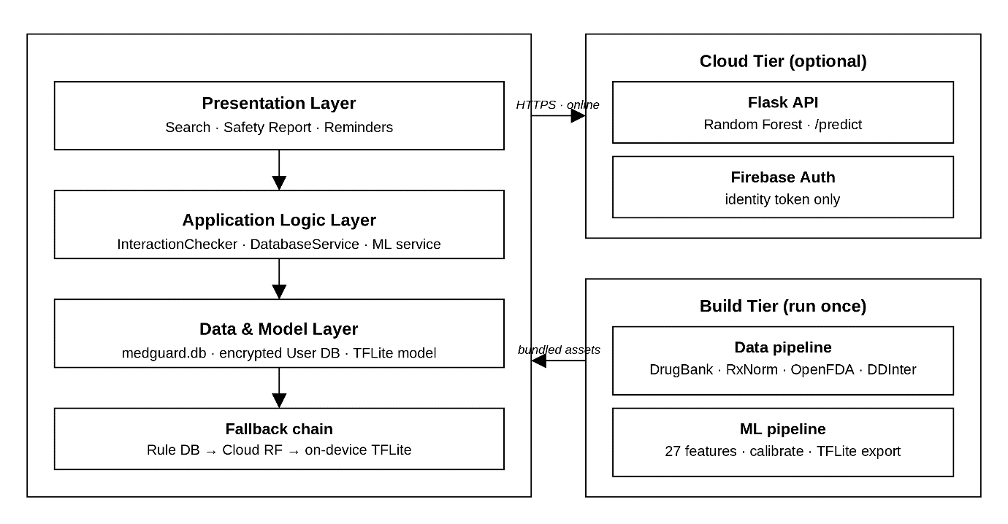
- High-level offline-first architecture of the MedGuard system.

The architecture is organised into four tiers. The presentation tier renders search, medication management, the safety report and supporting features. The application-logic tier executes all checks on the device. The optional cloud tier provides online prediction and authentication. The offline build tier, executed once before deployment, produces the artefacts the device ships with. The defining property of the design is that the network is an enhancement, not a dependency.
The complete reference database and the on-device model are bundled in the application, so every core check (interactions, food, duplicate therapy and allergies) executes locally. This directly satisfies the connectivity constraint identified in Chapter Two and the offline non-functional requirement (NFR1).
For interaction-risk prediction on uncatalogued pairs, the system uses a hybrid deployment: a Random Forest is served online through the Flask API for maximum accuracy, while a compact model distilled from it runs on the device for offline use. A graceful-degradation chain (cached result, then remote API, then on-device model) guarantees that a prediction is always available.
When online, the application acts as a client to a stateless Flask server exposing /api/v1/predict (a three-tier prediction with per-tier probabilities for a drug pair) and /api/v1/db/* (reference-database version and delta). The server holds no user state; each request is authenticated with the Firebase identity token the client already carries, so there is no second account system and no server-side health data. A safety check proceeds in five steps. The session service resolves the active profile’s medication list.
The InteractionChecker then queries the bundled database for known interactions, food interactions, duplicates and allergy hits. Any pair the rule database does not recognise falls through the chain cached result, then remote /predict, then on-device model. A rule hit or ML prediction at Moderate or High is surfaced in the SafetyReport, whose overall verdict is the highest tier present. Finally the result is cached and, for identified users, written to the local check history.
  - Data Engineering
Table 3.7 lists the four sources. The bundled reference database is produced by a one-time, reproducible Python pipeline run before deployment. The pipeline parses and normalises authoritative pharmacological data into a single SQLite file small enough to ship inside the application.
- Data sources used to build the reference database.
Source | Contribution | Access / licence
DrugBank 6.0 | Drugs, interactions, enzymes, molecular properties | Academic licence (XML)
RxNorm (US NLM) | Normalised clinical-drug names and RxCUIs | Public domain (API)
OpenFDA (FAERS) | Adverse-event co-report frequencies for drug pairs | Public domain (API)
DDInter 2.0 | Expert-curated severity ratings (override layer) | Open access

DrugBank’s native XML release is parsed by parse_drugbank.py into structured rows. For each drug, the parser extracts the DrugBank identifier, primary and generic names, drug type, ATC code(s), half-life, enzyme relationships, categories, synonyms, and the documented interaction pairs with their textual descriptions. Streaming XML parsing is used so that the large release is processed within bounded memory.
Each extracted drug name is normalised against RxNorm by normalize_rxnorm.py, which resolves the name to an RxNorm Concept Unique Identifier (RxCUI). This collapses brand names and spelling variants onto a single canonical concept and is performed once, at build time; the resulting RxCUIs are stored in the database so that, at runtime, the application resolves drugs unambiguously without any network call.
A dedicated enrichment step (enrich_openfda.py) queries the OpenFDA Adverse Event Reporting System for the co-report frequency of each drug pair and stores it as openfda_coreport_count on the interaction row. This real-world pharmacovigilance signal is stored alongside the structured interaction data as supplementary reporting evidence. During the build, the four-level DrugBank severity (minor, moderate, major, contraindicated) is mapped to an integer severity_int and to the three application tiers, and DDInter 2.0 expert ratings override the mapped grade where available.
The mapping is explicit: minor maps to Low, moderate maps to Moderate, and both major and contraindicated map to High, collapsing the two most serious DrugBank grades into one High tier so that no severe interaction is understated. Where DDInter 2.0 supplies a rating that conflicts with the DrugBank-derived grade, the system adopts the higher of the two severities, so a disagreement between the sources can only raise an alert, never suppress one, a precautionary tie-break that keeps the pipeline conservative by construction. Drug names, ATC codes and enzyme roles are standardised so that downstream feature computation is deterministic.
The pipeline de-duplicates interaction pairs, drops records without a resolvable drug identity, and checks that every interaction references two existing drug rows. A final build step (build_database.py, then slim_database.py) replaces repeated free-text descriptions with integer codes reconstructed through a SQL view. The shipped database is 79 MB and holds 4,955 drugs and 851,868 interaction records; the transform is verified lossless by row-count, severity-distribution and sampled-reconstruction checks.
  - Database Design
MedGuard uses two physically separate SQLite databases. The bundled medguard.db is a read-only, public reference store copied into the application sandbox on first launch. The user’s own health data are held in a separate medguard_user.db that is encrypted with SQLCipher. Separating the two allows the large reference store to remain an immutable bundled asset while only the small, sensitive user store is encrypted and migrated across schema versions.
The reference database holds six relations. The core relation, drugs, is referenced by each of the others through a foreign key, giving a hub-and-spoke schema in which every pharmacological fact is expressed relative to a normalised drug identity. Three further relations, listed in Table 3.8 for completeness, live in the separate encrypted user store, not in the bundled reference file. The principal data-definition statements follow.

CREATE TABLE drugs (
id INTEGER PRIMARY KEY AUTOINCREMENT,
drugbank_id TEXT UNIQUE NOT NULL,
rxcui TEXT,
name TEXT NOT NULL,
generic_name TEXT,
drug_type TEXT,
atc_code TEXT,
all_atc_codes TEXT,
half_life TEXT,
drug_class TEXT
);
CREATE TABLE interactions (
id INTEGER PRIMARY KEY AUTOINCREMENT,
drug_a_id INTEGER NOT NULL,
drug_b_id INTEGER NOT NULL,
severity TEXT NOT NULL DEFAULT 'moderate',
severity_int INTEGER NOT NULL DEFAULT 1,
mechanism TEXT,
clinical_effect TEXT,
openfda_coreport_count INTEGER DEFAULT 0,
FOREIGN KEY (drug_a_id) REFERENCES drugs(id),
FOREIGN KEY (drug_b_id) REFERENCES drugs(id)
);
CREATE TABLE drug_enzymes (
id INTEGER PRIMARY KEY AUTOINCREMENT,
drug_id INTEGER NOT NULL,
enzyme_name TEXT, -- e.g. Cytochrome P450 3A4 (gene CYP3A4)
actions TEXT, -- substrate | inhibitor | inducer (pipe-delimited)
FOREIGN KEY (drug_id) REFERENCES drugs(id)
);
The relationships among the relations are shown in the entity–relationship diagram of Figure 3.2, and their cardinalities are stated in Table 3.9. Every spoke relation holds a foreign key to drugs(id) in a one-to-many relationship, while the interactions relation holds two foreign keys to drugs (one for each member of the pair) modelling the many-to-many self-relationship of drugs interacting with one another.
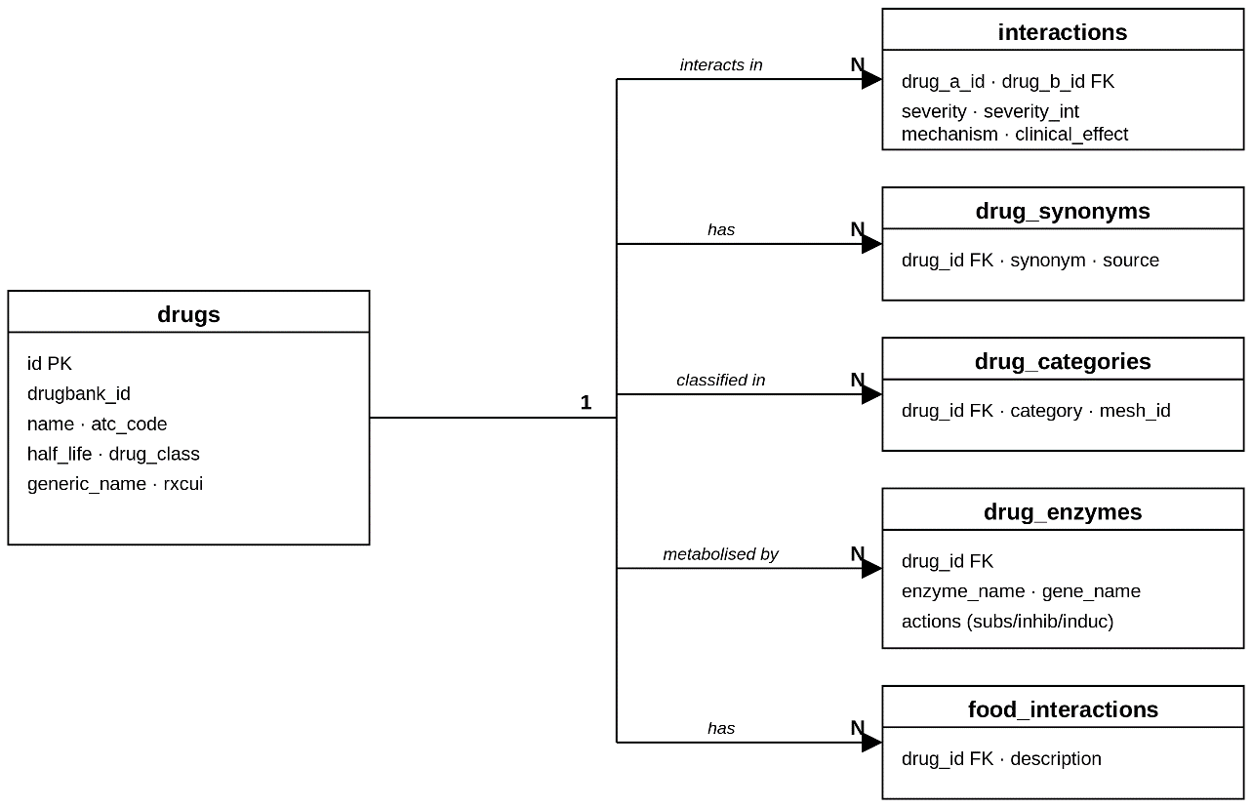
- Entity–relationship diagram of the MedGuard reference database.
- Table specifications of the MedGuard schema.
Relation | Primary key | Principal foreign keys | Purpose
drugs | id | — | Canonical drug records
drug_synonyms | id | drug_id → drugs | Brand names / synonyms
interactions | id | drug_a_id, drug_b_id → drugs | Interaction pairs + severity
food_interactions | id | drug_id → drugs | Drug–food interactions
drug_categories | id | drug_id → drugs | ATC therapeutic classes
drug_enzymes | id | drug_id → drugs | CYP450 enzyme relationships
allergies | id | drug_id → drugs | User-recorded allergies (encrypted user store)
user_medications | id | drug_id → drugs | Current regimen + schedule (encrypted user store)
check_logs | id | — | Local history of checks (encrypted user store)
- Relationship specifications.
Relationship | Cardinality | Description
drugs – drug_synonyms | 1 : N | A drug has many synonyms; each synonym belongs to one drug
drugs – interactions | 1 : N (×2) | A drug participates as drug_a or drug_b in many interactions
drugs – drug_enzymes | 1 : N | A drug relates to many CYP450 enzymes with an action role
drugs – drug_categories | 1 : N | A drug belongs to many ATC therapeutic classes
drugs – food_interactions | 1 : N | A drug has many documented food interactions
drugs – allergies | 1 : N | A drug may be referenced by many user allergy records
drugs – user_medications | 1 : N | A drug may appear in many users' medication entries

Table 3.10 is an abridged data dictionary for the two most central relations.
- Abridged data dictionary (core relations).
Relation.column | Type | Constraint | Description
drugs.id | INTEGER | PK, autoincrement | Surrogate primary key
drugs.drugbank_id | TEXT | UNIQUE, NOT NULL | DrugBank accession
drugs.rxcui | TEXT | — | RxNorm concept identifier
drugs.atc_code | TEXT | — | Primary ATC classification code
drugs.half_life | TEXT | — | Elimination half-life
interactions.drug_a_id | INTEGER | FK → drugs(id), NOT NULL | First drug in the pair
interactions.drug_b_id | INTEGER | FK → drugs(id), NOT NULL | Second drug in the pair
interactions.severity | TEXT | NOT NULL | minor / moderate / major / contraindicated
interactions.severity_int | INTEGER | NOT NULL | Integer-encoded severity (0–3)
interactions.openfda_coreport_count | INTEGER | DEFAULT 0 | FAERS co-report frequency

  - Machine Learning Pipeline
For drug pairs absent from the curated interaction table, MedGuard predicts a three-tier interaction-risk class using a supervised ensemble classifier. This section formalises the mathematics, the engineered features, the training and validation procedure, the handling of class imbalance, the evaluation metrics, and the conversion of the model for offline, on-device inference.
    - Mathematical Methodology
The classifier is a Random Forest: an ensemble of $B$ decision trees, each grown on a bootstrap resample of the training set and on a random subset of features at each split, whose predictions are combined by majority vote. For an input feature vector $x$, the forest’s prediction is
$$\hat{y} = mode \left\{T_{b}\left(x\right) : b = 1, … , B\right\}$$
where $T_{b}$ is the $b$-th tree. Each tree is grown by recursively choosing the split that most reduces node impurity. MedGuard uses the Gini impurity, which for a node $t$ with class proportions $p_{k}$ (the proportion of training pairs reaching $t$ that belong to tier $k$, with $k$ running over the $C = 3$ tiers) is
$$G\left(t\right) = 1 - \sum_{k = 1}^{C}{{p_{k}}^{2}}$$
and a candidate split $s$ partitioning $t$ into children $t_{L}$ and $t_{R}$ is scored by the impurity decrease
$$ΔG\left(s, t\right) = G\left(t\right) - \frac{n_{L}}{n} G\left(t_{L}\right) - \frac{n_{R}}{n} G\left(t_{R}\right)$$
where $s$ is a candidate split, $n$, $n_{L}$ and $n_{R}$ are the numbers of training pairs reaching node $t$ and its left and right children $t_{L}$ and $t_{R}$, and $G\left(·\right)$ is the Gini impurity defined above; the split chosen at each node is the one that maximises $ΔG\left(s, t\right)$. Averaging many de-correlated trees (each trained on a different bootstrap sample and feature subset) reduces the variance of a single deep tree and curbs over-fitting. Because each tree omits roughly one-third of the data during bootstrapping, the out-of-bag (OOB) samples provide an internal, unbiased estimate of generalisation error without a separate hold-out.
    - Feature Engineering
Each ordered drug pair (a, b) is represented by twenty-seven numerical features computed entirely from the bundled data, so the same vector can be reconstructed on the device. The feature groups and their definitions are given in Table 3.11.
- The twenty-seven engineered features for severity prediction.
Feature(s) | Definition
atc_overlap_n (n = 1,3,4,5) | Four indicators: 1 if the n-character ATC prefixes of a and b are equal and non-empty, else 0
atc_missing_either | 1 if either drug has no ATC code recorded
shared_cyp_count | Number of metabolic enzymes for which a and b are both substrates
inhibitor_substrate_count, inducer_substrate_count | Number of enzymes one drug inhibits (respectively induces) and for which the other is a substrate
both_substrates | 1 if a and b share at least one common substrate enzyme
inhibitor_substrate | 1 if one drug inhibits an enzyme for which the other is a substrate
inducer_substrate | 1 if one drug induces an enzyme for which the other is a substrate
category_overlap | Number of therapeutic categories shared by a and b
drug_type_match | 1 if a and b are the same drug type (e.g. both small-molecule)
half_life_ratio | ln( max(h_{a}, h_{b}) / min(h_{a}, h_{b}) ) of the two elimination half-lives
half_life_missing | 1 if either elimination half-life is unavailable
both_qt_prolong, both_serotonergic, both_cns_depressant, both_nephrotoxic | 1 if both drugs share an additive pharmacodynamic class (QT-prolonging, serotonergic, CNS-depressant or nephrotoxic)
bleeding_risk_combo | 1 if the pair combines anticoagulant, antiplatelet or NSAID activity
nti_either, nti_both | 1 if either / both drugs have a narrow therapeutic index
drug_risk_a, _b, _prod, _max, _min | Per-drug smoothed high-tier interaction rate and their product, maximum and minimum
Two representative definitions are made explicit. The drug-level risk feature $risk\left(d\right)$ is a Laplace-smoothed estimate of each drug’s historical high-tier interaction rate,
$$risk\left(d\right) = \frac{n_{d, high} + m · \bar{p}}{n_{d} + m}$$
where $n_{d, high}$ is the number of catalogued interactions of drug $d$ that are graded High, $n_{d}$ is the total number of catalogued interactions of drug $d$, $\bar{p}$ is the mean high-tier rate across every drug in the bundled database, and $m$ is the smoothing strength, that is, the notional number of prior observations toward which a sparse count is shrunk ($m = 10$). A drug with only a handful of recorded interactions is therefore pulled toward the population rate rather than taking an extreme value on thin evidence.
and the pharmacokinetic feature summarises the two elimination half-lives as a bounded log-ratio,
$$r = ln \frac{max\left(t_{½, a}, t_{½, b}\right)}{min\left(t_{½, a}, t_{½, b}\right)}$$
where $t_{½, a}$ and $t_{½, b}$ are the elimination half-lives of drugs $a$ and $b$ in hours, and $ln$ denotes the natural logarithm. Taking the logarithm of the ratio of the larger half-life to the smaller makes the feature symmetric in the two drugs and compresses its range, so that a pair whose half-lives differ by an order of magnitude is represented by a value near 2.3 rather than by an unbounded ratio.
The ATC-overlap and enzyme features encode, respectively, therapeutic-class proximity at four levels of the WHO ATC hierarchy and the directional cytochrome-P450 mechanisms (shared substrate, inhibitor–substrate, inducer–substrate) that drive most pharmacokinetic interactions.
    - Dataset Preparation
The engineered feature matrix is partitioned by a stratified split into training (70%), validation (15%) and test (15%) sets, stratified on the integer severity label so that the rare High tier retains its proportional share in every partition. A fixed random seed (random_state = 42) makes the split reproducible. Because this random split is transductive (a drug may appear in both the training and test partitions, only the specific pair being unseen), a second, drug-disjoint 'cold-start’ regime is also prepared, in which a held-out fraction of drugs and every pair involving them are withheld from training entirely, so that generalisation to genuinely novel drugs can be measured separately in Chapter Four.
# stratified 70 / 15 / 15 split (random_state = 42)
train, temp = train_test_split(df, test_size=0.30,
stratify=df['severity_int'],
random_state=42)
val, test = train_test_split(temp, test_size=0.50,
stratify=temp['severity_int'],
random_state=42)

    - Random Forest Model Selection
Three classifiers were trained and compared on identical features and splits: a Random Forest, a histogram-based Gradient Boosting classifier, and a class-weighted Logistic Regression included as a linear baseline. The Random Forest was selected for deployment because it attained the higher validation macro-averaged F1, offered a more favourable balance on the minority High-severity tier, and (unlike a boosted ensemble) exposes native feature-importance rankings that support clinical interpretability.
Gradient-boosted libraries such as XGBoost were not benchmarked separately because the histogram-based gradient-boosting classifier already represents that family and did not surpass the forest on the minority High tier, while the forest’s out-of-bag estimates and native feature importances give stronger interpretability for a clinical decision-support tool.
Deep neural networks and graph neural networks (GNNs) were excluded because their compute and memory footprints (and their need for substantially larger labelled corpora) are incompatible with offline mobile inference and the available dataset size.
    - Model Training
The deployed forest is configured as below. Three hundred trees at a maximum depth of twenty, with at least twenty samples per leaf, balance discrimination against over-fitting and keep the serialised model small enough to load quickly on a free hosting tier.

rf = RandomForestClassifier(
n_estimators=300,
max_depth=20,
min_samples_leaf=20,
class_weight="balanced", # see 3.8.7
random_state=42, n_jobs=-1)
rf.fit(X_train, y_train)

    - Cross-Validation
Model stability was assessed by five-fold stratified cross-validation on the training data, with each fold preserving the class distribution. Reporting the mean and standard deviation of accuracy, macro-F1 and one-vs-rest AUC across folds confirms that performance is not an artefact of a single fortunate split before the final hold-out test in Chapter Four.
    - Class Imbalance Handling
The three tiers are heavily imbalanced: Moderate dominates and Low is vanishingly rare, appearing in fewer than one pair in four hundred. This is a known and unsolved difficulty in DDI severity prediction rather than an artefact of this dataset; recent work reaches for pre-trained embeddings or synthetic oversampling to handle it (Feng & Huang, 2025; Xie et al., 2025), neither of which fits inside a mobile deployment. Two cheaper mechanisms are used here. First, the forest is fitted with scikit-learn's balanced class weights, which weight each tier inversely to its frequency so that the minority tiers are not simply drowned out by Moderate. Second, the decision thresholds applied to the model's output probabilities are tuned on the validation set to maximise macro-F1 rather than overall accuracy, subject to not degrading High-tier recall. The tuned thresholds (High at 0.40, Low at 0.75) deliberately bias the classifier towards flagging High: a pair is called High whenever its high-tier probability clears a low bar, and Low only when the model is confident. This rewards the deployed system for catching clinically critical interactions instead of for predicting the majority class.
    - Model Evaluation Metrics
Because accuracy alone is misleading under class imbalance, performance is reported with a family of complementary metrics, every one of them computed from the confusion matrix of the held-out test set. For a given tier $c$, ${TP}_{c}$ (true positives) is the number of test pairs whose true tier is $c$ and which the model also assigns to $c$; ${FP}_{c}$ (false positives) is the number assigned to $c$ whose true tier is not $c$; ${FN}_{c}$ (false negatives) is the number whose true tier is $c$ but which the model assigns to some other tier; and ${TN}_{c}$ (true negatives) is the number that neither belong to $c$ nor are assigned to it. $N$ denotes the total number of test pairs and $C$ the number of tiers, here $C = 3$ (Low, Moderate and High). Overall accuracy is the proportion of test pairs placed in their true tier,
$$Accuracy = \frac{\sum_{c = 1}^{C}{{TP}_{c}}}{N}$$
Accuracy answers how often the model is right overall, but on this dataset it is dominated by the majority Moderate tier, so precision, recall and F1 are computed for each tier separately. Precision $P_{c}$ is the proportion of the pairs predicted to be tier $c$ that truly are tier $c$, recall $R_{c}$ is the proportion of the pairs truly of tier $c$ that the model recovers, and ${F1}_{c}$ is the harmonic mean of the two, which is high only when both are high:
$$P_{c} = \frac{{TP}_{c}}{{TP}_{c} + {FP}_{c}}$$
$$R_{c} = \frac{{TP}_{c}}{{TP}_{c} + {FN}_{c}}$$
$${F1}_{c} = \frac{2 P_{c} R_{c}}{P_{c} + R_{c}}$$
In this study recall on the High tier is the clinically decisive quantity, because a missed High-tier interaction is the error with the greatest potential for patient harm, whereas a false High-tier alert costs only the user's attention. The primary single-number metric, however, is the macro-averaged F1 score: the unweighted mean of the per-tier F1 scores, which gives the rare Low and High tiers exactly the same weight as the dominant Moderate tier and so prevents strong performance on Moderate from masking weak performance elsewhere,
$$macro-F1 = \frac{1}{C}\sum_{c = 1}^{C}{{F1}_{c}}$$
where ${F1}_{c}$ is the F1 score of tier $c$ and $C$ is again the number of tiers. Discrimination independent of any particular decision threshold is summarised by the one-vs-rest, macro-averaged area under the receiver-operating-characteristic curve. For each tier $c$, ${AUC}_{c}$ is the area under the curve traced by the true-positive rate ${{TP}_{c}}/{{TP}_{c} + {FN}_{c}}$ against the false-positive rate ${{FP}_{c}}/{{FP}_{c} + {TN}_{c}}$ as the probability threshold for tier $c$ is swept from one to zero; equivalently, it is the probability that a randomly chosen pair of tier $c$ receives a higher score for $c$ than a randomly chosen pair drawn from the other tiers. The macro average is
$$macro-AUC = \frac{1}{C}\sum_{c = 1}^{C}{{AUC}_{c}}$$

An AUC of 0.5 is chance-level discrimination and 1.0 is perfect separation. Finally, the improvement in accuracy over the majority-class baseline, a trivial classifier that assigns every pair to the most frequent tier, is tested for statistical significance with McNemar's test on the paired decisions of the two classifiers over the same test pairs,
$$χ^{2} = \frac{{\left(\left|b - c\right| - 1\right)}^{2}}{b + c}$$
where $b$ is the number of test pairs that the model classifies correctly and the baseline misclassifies, $c$ is the number that the baseline classifies correctly and the model misclassifies, and the subtraction of one is Yates’s continuity correction. The statistic $χ^{2}$ is referred to a chi-squared distribution with one degree of freedom, so a value above 3.84 rejects the null hypothesis of equal error rates at $α = 0.05$. Differences in F1 and AUC are not paired-nominal quantities and McNemar’s test does not apply to them; they are reported descriptively together with their cross-validation dispersion. The numerical results of applying every metric defined here are reported in Section 4.5, where they are also presented graphically.
    - Model Conversion for Mobile Deployment
A scikit-learn Random Forest has no native mobile inference format. To obtain a fully offline predictor, a compact Keras multilayer perceptron is trained on the same split to reproduce the forest’s outputs, then exported as a quantised TensorFlow Lite buffer of a few kilobytes and bundled with the application. This is soft-label knowledge distillation: the student network is trained on the forest’s predicted class probabilities, not on its hard labels, so it inherits the teacher’s uncertainty as well as its decisions. Fidelity is reported as the agreement rate between student and teacher on the held-out set.

soft = rf.predict_proba(X_train) # teacher class probabilities
student = tf.keras.Sequential([
tf.keras.layers.Input(shape=(n_features,)),
tf.keras.layers.Dense(64, activation="relu"),
tf.keras.layers.Dropout(0.2),
tf.keras.layers.Dense(32, activation="relu"),
tf.keras.layers.Dense(3, activation="softmax")]) # 3 tiers
student.fit(X_train, soft) # mimic the forest
tflite = tf.lite.TFLiteConverter.from_keras_model(student).convert()

    - On-Device Inference Process
At runtime, when a drug pair is not found in the bundled database and the device is offline, the InteractionFeatureBuilder reconstructs the twenty-seven-feature vector from the local database, the bundled TFLite interpreter scores it, and the tier with the highest softmax probability (subject to the calibrated decision thresholds) becomes the predicted severity.
The distilled model is evaluated for its fidelity to the Random Forest and for its inference latency; it is a deployment artefact of the chosen classifier, not a separately compared algorithm.
Generalisation to unseen pairs. Every drug in the bundled database carries the attributes the features are derived from (ATC codes, CYP-enzyme roles, elimination half-life, drug type and drug-level risk profiles), so for any pair of catalogued drugs a complete feature vector can be computed deterministically whether or not that specific pair appears in the curated interaction table. An unseen pair is therefore unseen as a combination, not as two unknown molecules. The forest generalises because pairs sharing mechanism-level features tend to share interaction risk, a regularity it learns from the labelled pairs; the prediction is an evidence-weighted estimate over known pharmacology, not an extrapolation to novel chemistry. A pair in which either drug is absent from the database falls outside the model's scope and is reported as not assessable; the system does not guess.
  - User Interface Design
The interface is designed so that a safety verdict can be grasped at a glance by a non-expert under time pressure. It favours clarity over density: one primary action per screen, generous spacing, and a consistent severity language. Typography uses the Inter typeface, bundled with the application so that fonts are never fetched over the network and the offline-first principle holds even at first launch; Inter’s high x-height aids the rapid reading of medicine names and numerical doses. The experience is organised around the user’s mental model of ‘my medicines and whether they are safe together’. After onboarding and sign-in, the home shell exposes the core tasks directly; adding a medicine immediately updates the regimen-level safety report, so feedback is continuous and there is no separate ‘check’ step for the user to forget.
The client comprises the screens summarised in Table 3.12, grouped into onboarding/authentication, the core safety workflow, and supporting tools.

- Principal application screens.
Group | Screens
Onboarding & auth | Welcome, Onboarding, Sign-in / Registration, App-lock
Core workflow | Home, Search, Drug monograph, Medications, Safety report, Results
Supporting tools | Dose & reminders, Allergies, Foods, Emergency card, Insights, Profile

Navigation is shallow and hub-centred: a persistent home shell routes to the core and supporting destinations, with deep links enabling the lock-screen emergency card and notification taps to open the relevant screen directly. The navigation flow is detailed in the activity model of Section 3.14. Severity is communicated through a graded risk dial using both fill level and colour (teal (Low), amber (Moderate), and ruby (High)) to ensure accessibility beyond colour alone. Each alert includes a plain-language explanation and recommended action, while the overall regimen verdict reflects the highest detected risk to prevent high-risk interactions from being overlooked. Accessibility is addressed by redundant encoding of severity (colour plus fill plus text), legible type sizes, sufficient contrast, and large touch targets. Because colour is supplemented by shape and label, the severity language remains interpretable for users with colour-vision deficiency.
  - Authentication Design
Registration is handled by Firebase Authentication. A new user supplies an email address and password (or signs up through Google); Firebase creates the identity and returns a signed identity token. No health data are collected at registration, only the minimal identity needed to associate a profile with the user. At login, credentials are verified by Firebase, which issues an identity token the client stores securely.
The token is attached to any subsequent request to the prediction or reference-database update endpoints, which verify it server-side. A successful login restores the user’s locally held medication list and history. A session service maintains the active profile and the validity of the identity token, refreshing it as required and clearing it on sign-out. Because health data live only on the device, a session governs access to local data; there is no server-side store to govern.
The application supports a single end-user role with multiple profiles per device (for example, a carer managing several patients). Reference-database update operations are gated by a valid authenticated identity. There is no privileged server-side administrator role, since the backend holds no user data to administer.
Security follows a defence-by-locality principle: sensitive data never leave the device, and identity is verified at the edge. The backend does not persist user health data and remains stateless with respect to application state; the reference database is public and read-only; and the user database is encrypted.
Network payloads are limited to anonymised drug identifiers and signed tokens. Access to the encrypted user database requires the SQLCipher key, which is held in platform secure storage and made available to the application process only after authentication. An optional application lock adds a further local gate before sensitive screens are shown. User health data, meaning the medication list, recorded allergies and check history, are special-category data, so the application encrypts them at rest. This data lives in a separate database, medguard_user.db, opened through the sqflite_sqlcipher plugin as a SQLCipher database under AES-256 encryption.
The encryption key is a 256-bit value generated once on first launch from a cryptographically secure random source and written to platform-backed secure storage, the Android Keystore or the iOS Keychain, through the flutter_secure_storage plugin. The key is never written into the application bundle, the shared preferences, or the database file, and it is loaded into memory only after the user has authenticated, so the database cannot be opened while the app is locked. The public reference database, medguard.db, contains no personal data and is left unencrypted. In line with the Nigeria Data Protection Act (2023), only minimal identifying data are collected, no clinical data are transmitted off the device, and users may delete their account and data at any time. Reliance on a non-Nigerian authentication provider is a data-residency limitation, which the design mitigates by keeping all health data in local encrypted storage.
Because the reference database is an immutable bundled asset, it is recovered by re-copying it from the application package or rebuilding it from source via the data pipeline. The user database may be recovered through the platform’s encrypted application-backup mechanism when that mechanism is enabled and a backup has completed successfully; in that case the loss of a device need not entail loss of the user’s regimen once the account is re-authenticated on another device. Where backup is disabled, the encrypted local database is the sole copy, and this limitation is stated plainly.
  - Input Design
Drugs are entered through an autocomplete search, not as free text, and Table 3.13 gives the validation rules applied to every input. As the user types, the database service matches the query against drug names and synonyms and resolves the selection to a single normalised drug record (and its RxCUI), reducing the spelling and brand-name ambiguity that would otherwise corrupt the regimen.
- Input validation rules.
Input | Validation rule
Drug selection | Must resolve to an existing drugs row; free text without a match is rejected
Dose schedule | Times and frequency validated; duplicates within a schedule prevented
Allergy entry | Must reference a known drug or drug class
Credentials | Email format and password strength validated by Firebase at sign-up
Duplicate medication | A drug already present in the regimen cannot be added twice; an attempt surfaces a duplicate-therapy notice instead
Dosage value | Dose amount must be a positive number within a plausible range; non-numeric or out-of-range values (for example zero or implausibly large doses) are rejected
Schedule conflict | Reminder times that collide or overlap within a single drug's schedule are flagged and must be resolved before saving

The canonical input flow is: search → select a normalised drug → confirm addition to the regimen → (optionally) set dose schedule or record an allergy. Each addition triggers an immediate regimen re-check, so input and feedback are tightly coupled. Because every medication must be checked against every other, pair generation is quadratic (O(n²) in the number of drugs in the regimen) but this is inexpensive in practice because real regimens are small (typically well under twenty medicines), so a full re-check on each addition completes within milliseconds.
  - Processing Design
For every unordered pair in the regimen, the interaction-checking engine queries the bundled interactions relation. A hit returns the curated four-level severity, which is mapped to the three application tiers.
Pairs without a hit are passed to the prediction process. In parallel, food-interaction, ATC duplicate-therapy and drug–allergy checks are run against their respective relations.
A weighted or cumulative score was rejected on clinical grounds. Summing or averaging risk across pairs can mathematically demote one life-threatening interaction beneath several minor ones, which is unacceptable in a safety tool. The maximum operator implements the precautionary position that a regimen is only as safe as its most dangerous pair, and the individual per-pair tiers stay visible, so nothing is lost.
For each issue the engine attaches the stored mechanism, the clinical effect and a plain-language recommended action such as monitor, separate dosing or seek professional advice. Recommendations are informational and framed as decision support, not prescription.
For an uncatalogued pair, the prediction process builds the twenty-seven-feature vector (3.8.2) and routes it through the fallback chain: a cached result is reused if present; otherwise the remote Flask model is called when online; otherwise the on-device TFLite model scores the vector. The predicted tier is merged with the rule-based findings before the regimen verdict is computed.
The pipeline is fault-tolerant. If the Flask service is unavailable, processing falls back to the on-device TFLite model to ensure a local verdict is always produced. Any prediction errors trigger a conservative cautionary response; nothing in the failure path implies safety. Cached predictions are versioned for automatic invalidation after model updates, while rule-based database checks remain available, so the system degrades gracefully and the core safety checks keep working.
  - Output Design
Each interaction is rendered as an alert card showing the two drugs, the severity tier through the graded risk dial and a one-line summary, expandable to the mechanism and recommended action. The safety report consolidates every detected issue under a single regimen verdict equal to the highest tier present, grouped by type (interactions, food, duplicates, allergies) and ordered by severity, each with its recommended action in plain language and an explicit disclaimer that the system supports rather than replaces professional judgement.
For clinical use, reports can be condensed into a hand-off summary of the regimen, key interaction risks, and allergies. The summary can be exported as text or PDF, while a lock-screen emergency card provides quick access to allergy and emergency contact information.
  - UML Modelling
MedGuard is specified using Unified Modelling Language (UML). Use-case diagrams define actor interactions, activity and sequence diagrams describe safety-check workflows, and class diagrams capture the application’s static structure.
Figure 3.3 presents the use-case model. The primary actor is the user (a patient or clinician) who searches for drugs, manages a medication list, checks interactions, views the safety report, manages allergies, sets reminders and views the emergency card. Firebase is a secondary actor supporting authentication only; the optional 'update reference database’ use case is served by the Flask API, which delivers versioned updates to the public reference data and never stores or updates user health data. The 'check drug interactions’ use case includes 'view safety report’.
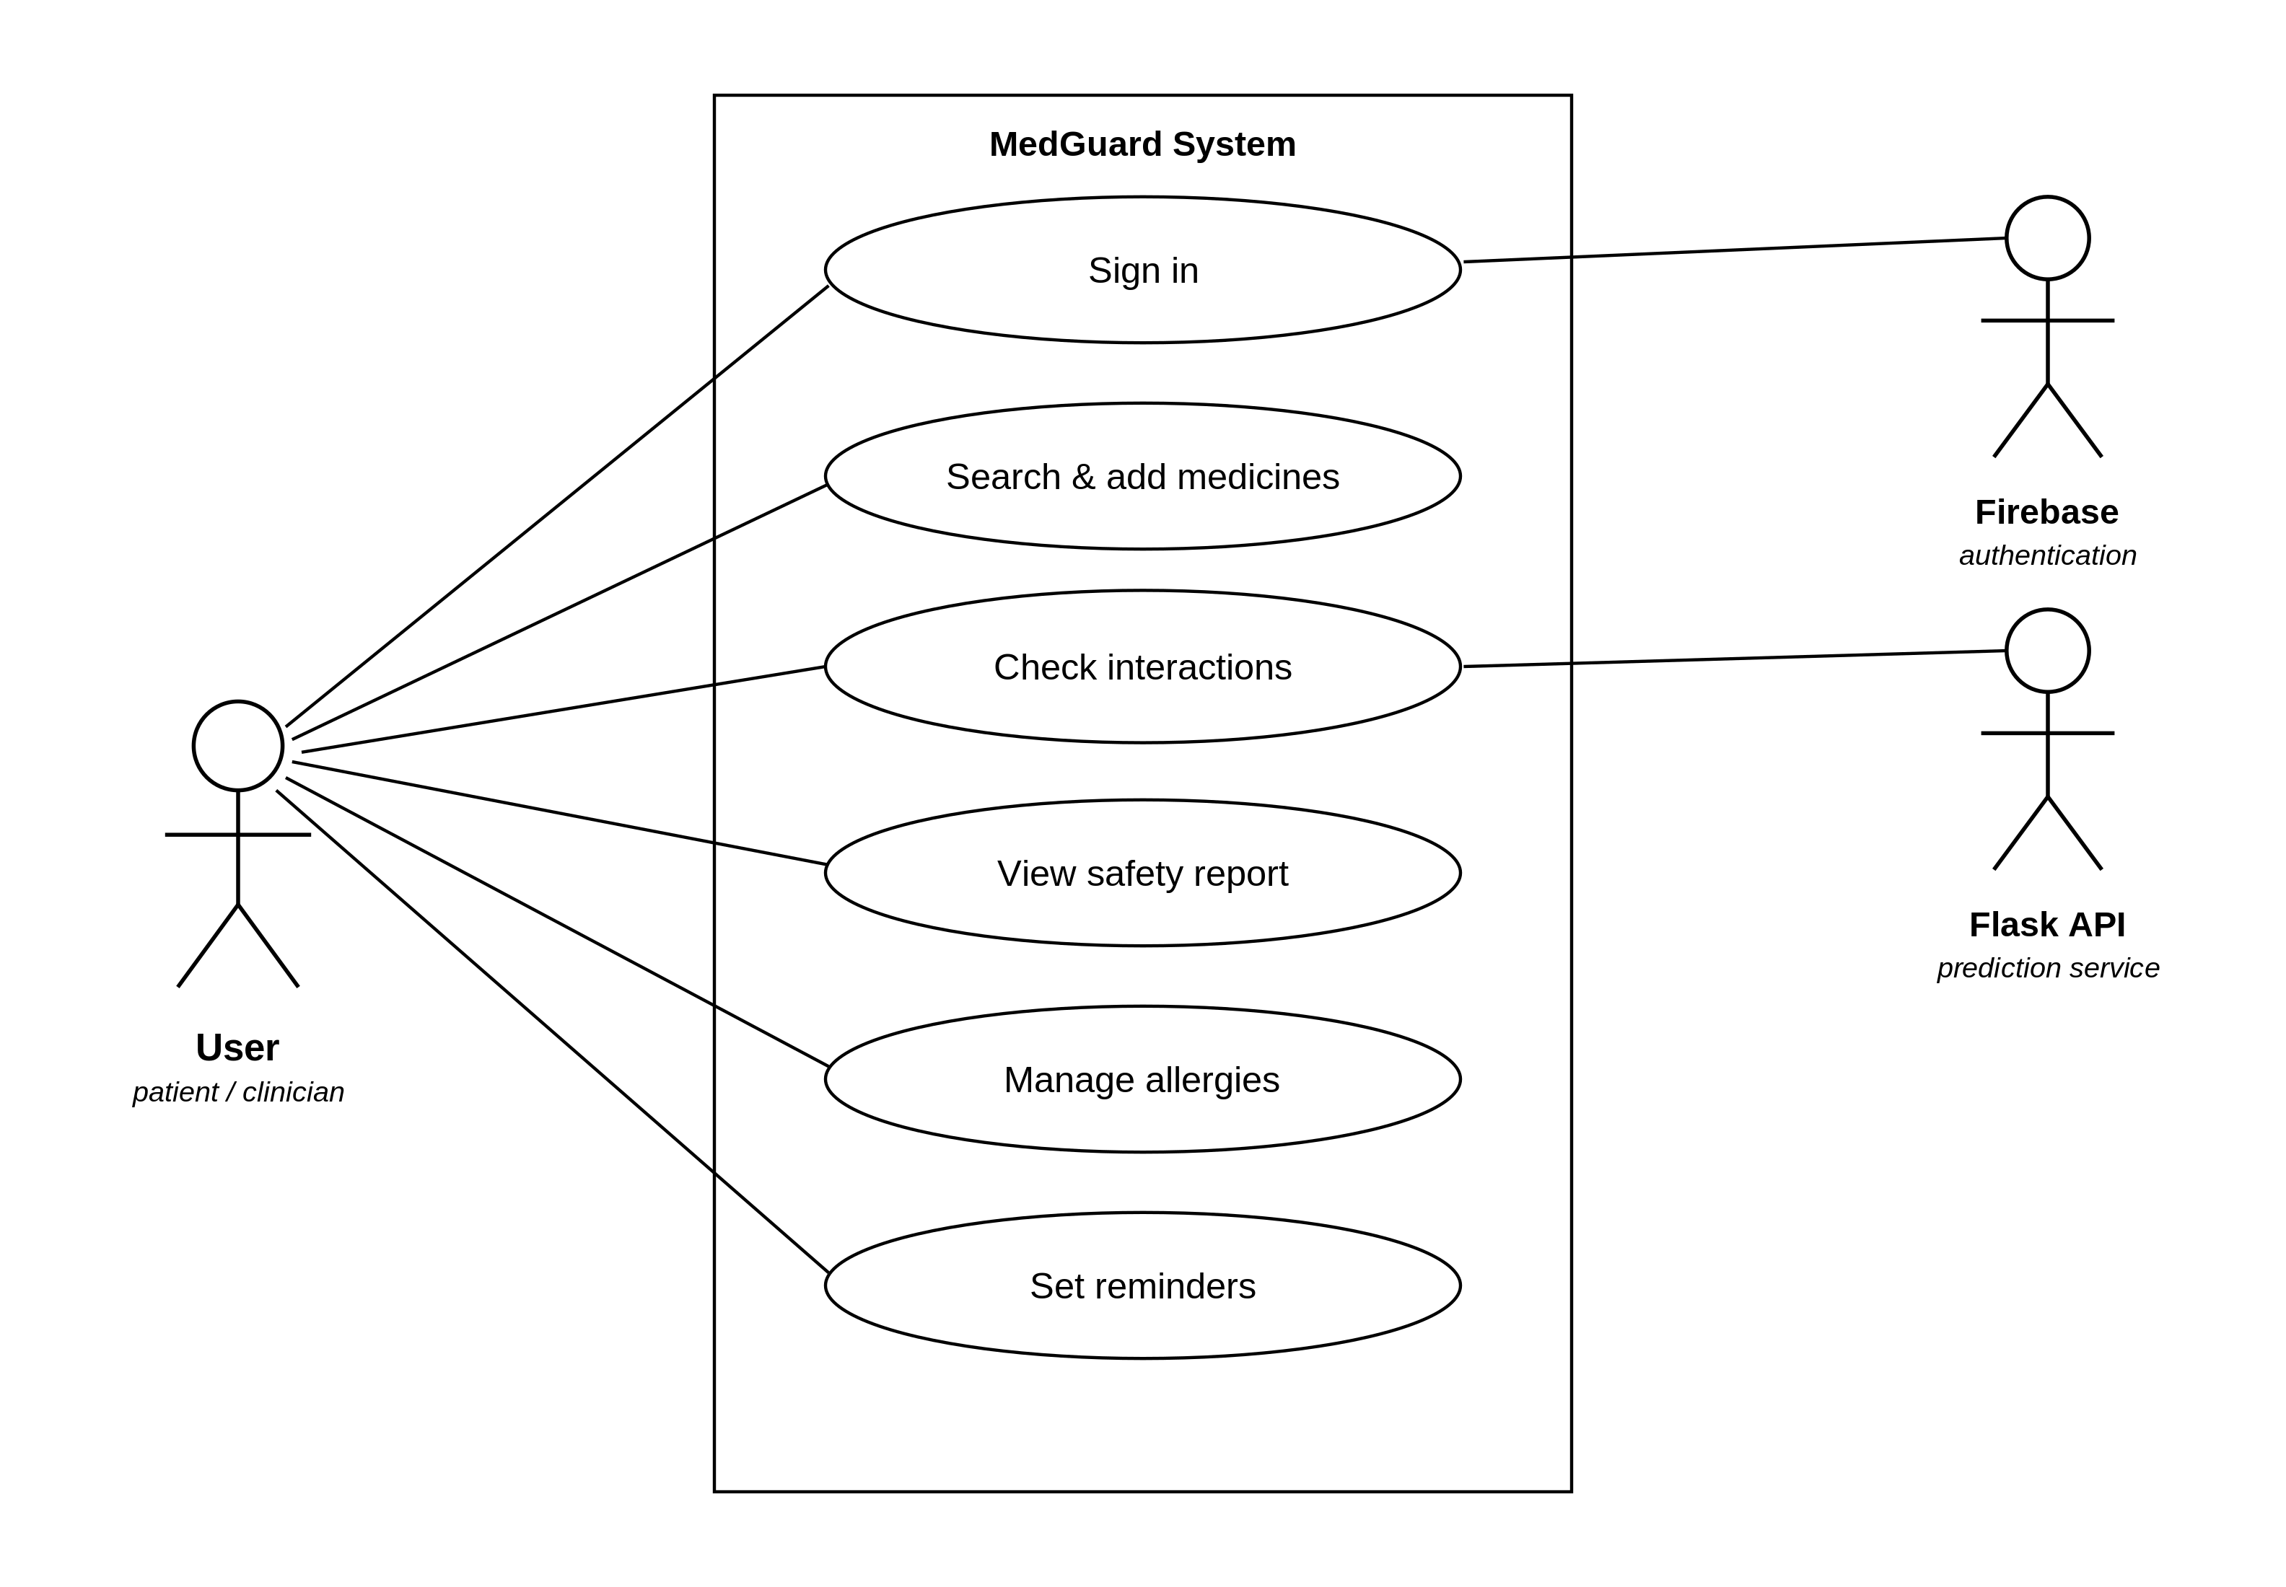
- Use-case diagram of the MedGuard system.
Figure 3.4 traces the activity of a safety check. After authentication the user assembles a regimen and initiates a check; a decision node distinguishes catalogued pairs, whose severity is retrieved directly, from uncatalogued pairs, which are routed by connectivity to the online or on-device model; the branches converge, the highest-tier verdict is computed and a colour-coded alert is rendered.
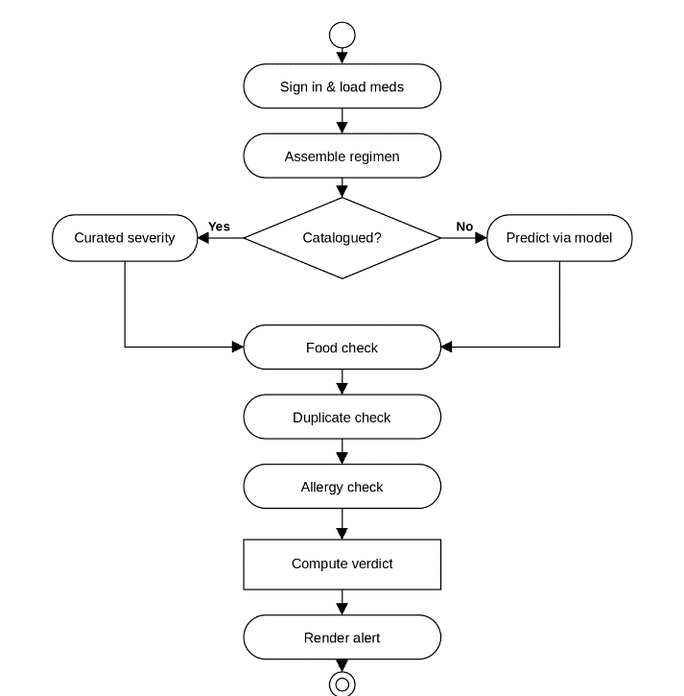
- Activity diagram for performing a medication safety check.
Figure 3.5 shows the message sequence for an uncatalogued pair. The interface delegates to the interaction-checking engine, which queries the reference database; receiving no match, it calls the Flask service when online or the on-device predictor when offline, then returns a consolidated safety report.
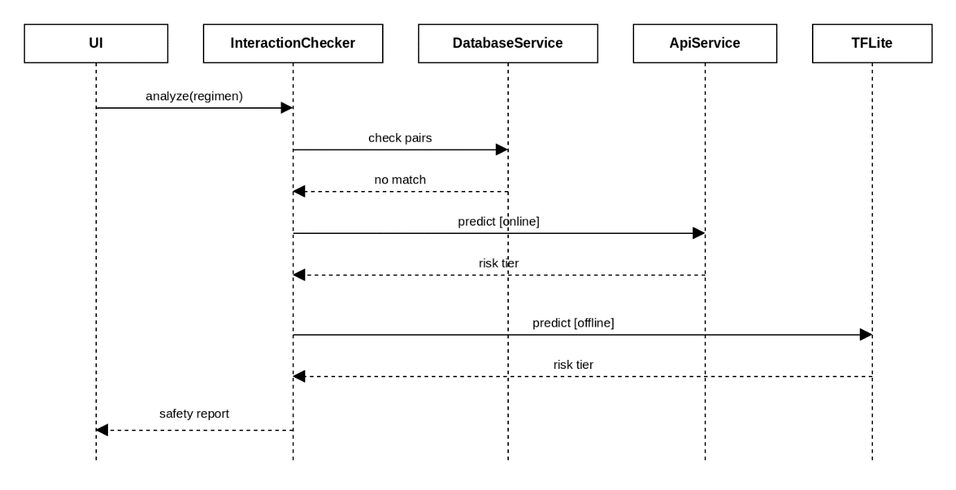
- Sequence diagram for an uncatalogued-pair interaction check.
Figure 3.6 presents the principal application classes. The InteractionChecker orchestrates a check using the DatabaseService, the MlPredictionService and the AllergyChecker; the MlPredictionService routes prediction through the ApiService, the TfliteSeverityPredictor, the InteractionFeatureBuilder and the ConnectivityService; and the resulting SafetyReport aggregates Severity values into a regimen verdict.
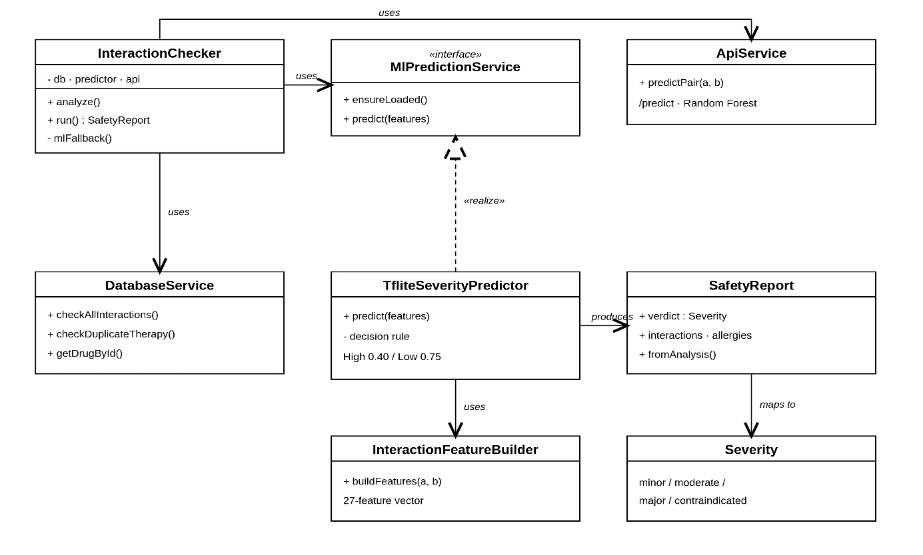
- Class diagram of the core MedGuard services.
The movement of data through the system is modelled with data-flow diagrams at successive levels of decomposition. Figure 3.7 is the context-level diagram, depicting MedGuard as a single process exchanging medication queries and severity-coded alerts with the user, authentication requests and tokens with Firebase, and build-time reference data with the pharmacological data sources.
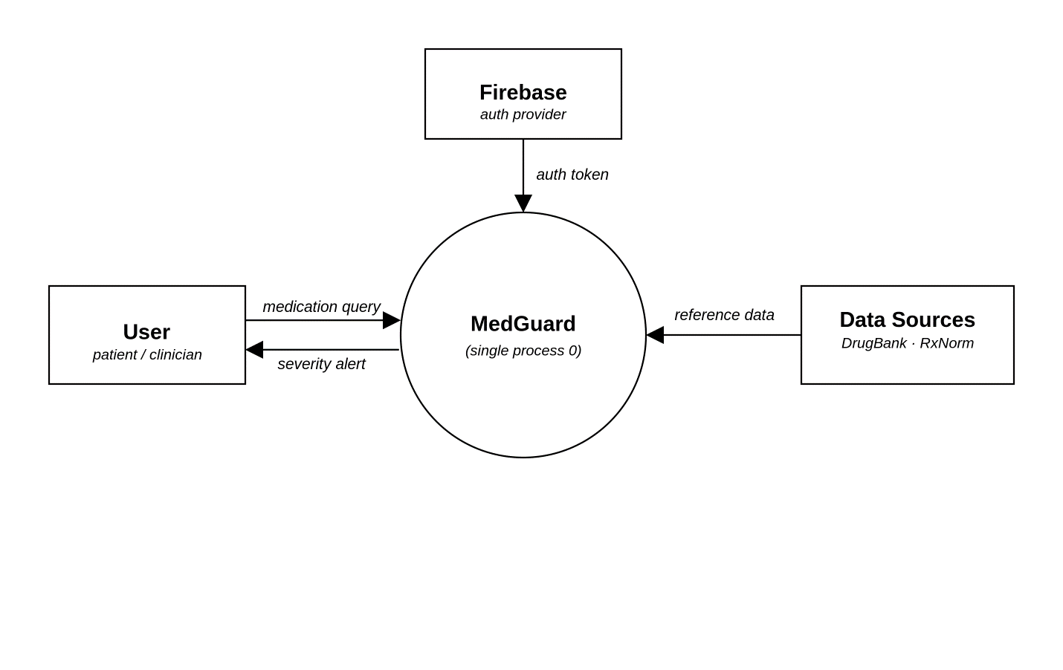
- Context (Level 0) data-flow diagram.
Figure 3.8 decomposes the system into its core processes: authentication, drug search and resolution, medication management, interaction checking, safety reporting, and reminder management, showing their interaction with the reference database, encrypted user database, and check-log store. The check-log store is an encrypted on-device table that records completed safety checks (drug pair or regimen hash, severity tier, and timestamp) to support history and reminders. It is never transmitted off the device and is cleared when the user deletes their history or account.
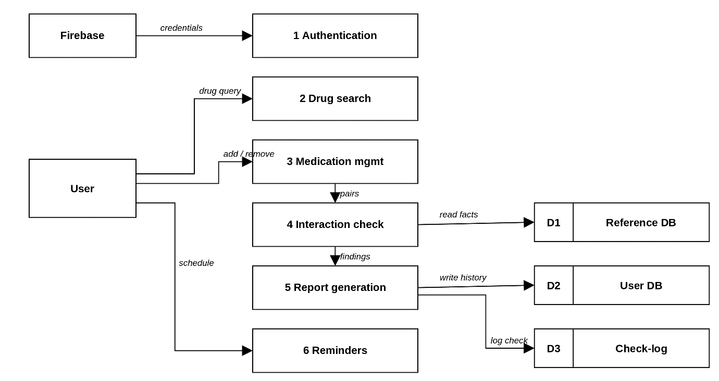
- Level 1 data-flow diagram.
Figure 3.9 further decomposes the interaction-checking process (4.0) into its sub-processes: building the feature vector, looking up the rule database, checking the prediction cache, predicting remotely or on the device, and aggregating the highest tier. It makes explicit the cache store (D4) and the online/offline split that realises the fallback chain.
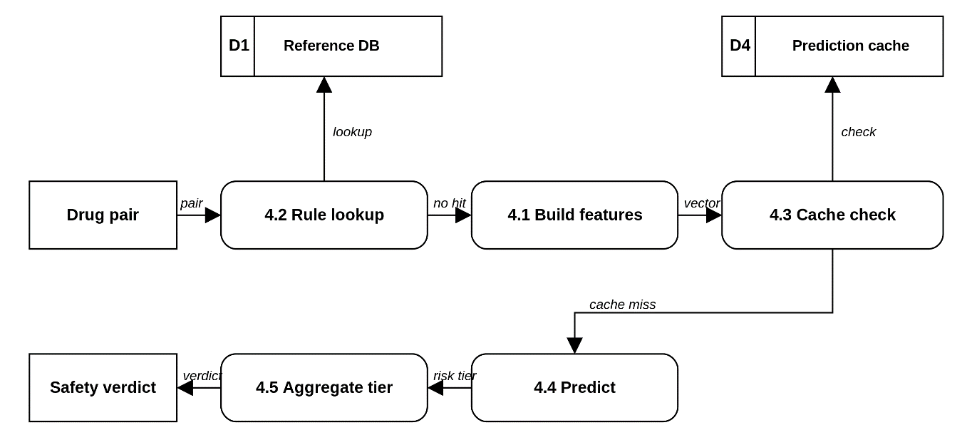
- Decomposition of the interaction-checking process
Figure 3.10 expresses the overall control logic of a session: launch and authentication, regimen assembly, the rule-database lookup, the online/offline branching for uncatalogued pairs, the computation of the highest-tier verdict and the rendering of the alert.
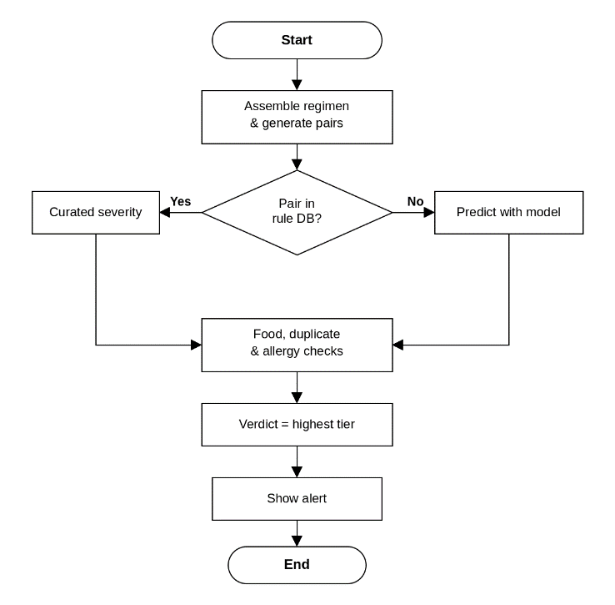
- System flowchart of the MedGuard safety-check process.
  - Implementation Environment
Development used Visual Studio Code as the primary editor, Android Studio for the emulator and Android toolchain, DB Browser for SQLite to inspect the bundled database, Git and GitHub for version control, and a cloud platform (Render) for hosting the prediction service. Two languages are used: Dart, for the Flutter mobile client, and Python, for the data-engineering pipeline, the machine-learning training pipeline and the Flask prediction service. SQL is used for the relational schema and queries.
- Frameworks and libraries.
Layer | Frameworks / libraries
Mobile client | Flutter 3.41.6, sqflite / sqflite_sqlcipher, google_fonts, flutter_local_notifications, tflite runtime
Machine learning | scikit-learn, NumPy, pandas, TensorFlow / TFLite
Backend | Flask, Firebase Admin (token verification)
Authentication | Firebase Authentication

Table 3.14 lists the frameworks and libraries used at each layer and Table 3.15 the version of each component. Development was carried out on a Windows 11 workstation with a contemporary multi-core processor and 16 GB of RAM. The target device is any Android 8.0+ smartphone with at least 2 GB of RAM and roughly 200 MB of free storage; the bundled database and on-device model are sized to operate within this resource envelope.

- Software specifications.
Component | Version / specification
Operating system (dev) | Windows 11
Flutter / Dart | Flutter 3.41.6
Python | 3.11.9
Java / Gradle | JDK 21, Gradle 8.14
Database engine | SQLite 3 (with SQLCipher)
Target platform | Android 8.0 (API 26) and above

  - System Evaluation Strategy
The completed artefact is evaluated along technical and usability strands; numerical results are reported in Chapter Four, and only the planned strategy is described here. Technical evaluation verifies functional correctness (that interactions, food conflicts, duplicate therapy and allergies are detected correctly) through unit and integration tests over the interaction-checking service, and confirms that all core checks operate with the network disabled. The severity model is assessed on the held-out test set using accuracy, precision, recall, macro-averaged F1 and one-vs-rest macro-AUC (Section 3.8.8), benchmarked against a majority-class baseline; the accuracy improvement over that baseline is tested with McNemar’s test on paired predictions, while F1 and AUC are compared descriptively. The distilled on-device model is additionally evaluated for its predictive fidelity to the Random Forest. Performance evaluation covers two things. On the client, automated timing tests record the median duration of repeated drug-search queries and of interaction checks over regimens of differing size. On the server, per-request instrumentation embedded in the deployed API records the count and the minimum, maximum and mean latency of every request by route and status.
Usability was evaluated with a purposive sample of fifteen participants in Abeokuta: six nursing students, five physiotherapy students and four clinic staff. Each completed five task scenarios (a drug look-up, an interaction check, an allergy cross-check, setting a dose reminder and retrieving the emergency card) while time-on-task, success and errors were recorded. Sessions were hosted at the Chrisland University School Clinic with the permission described in Section 1.11.4.
The three groups are pooled deliberately, but the pooling is narrower than it may appear. Nursing students, physiotherapy students and clinic staff are all health-science users who encounter medication lists, and all three perform the medication-checking task the instrument measures, so pooling broadens task coverage without invalidating the aggregate, which is read descriptively rather than generalised.
What the sample does not contain is a pharmacist or a prescriber. It therefore speaks to the informed non-specialist end of the intended audience and not to the clinician user type named in Section 3.3, a constraint carried into Sections 4.9.5 and 5.6. Where the groups diverge, as they do on the allergy task, that divergence is reported separately in Section 4.8.
The SUS measures the perceived-ease-of-use construct of the Technology Acceptance Model; perceived usefulness is not captured by the scale and is approached indirectly, through task-completion success and the debrief after each session. Four threats to validity apply. Sampling bias arises because the cohort is a small purposive sample from one city, mitigated by recruiting users who match the target population and treating the findings as formative. Device variability threatens the performance figures, since latency depends on hardware that varies widely across Android, mitigated by a lightweight design, a defined minimum specification and reporting the test-device profile. Model drift threatens long-term validity, because pharmacological knowledge moves while the bundled database is a fixed snapshot, mitigated by versioned updates through the authenticated API.
Finally, usability bias. Researcher-present sessions invite social-desirability and observer effects, and no second observer was available to establish inter-rater reliability. Standardised task scripts and the validated System Usability Scale mitigate this, but the single-observer design and the sample size remain constraints on how strongly the usability conclusions can be stated, and both are reported as such in Section 5.6.
  - Chapter Summary
This chapter has set out the analysis, design and methodology of MedGuard: Design Science Research realised through an Agile-inspired phased process, the existing system and its limitations, a five-dimension feasibility assessment, and the functional, non-functional, hardware, software, network, user and security requirements. It documented the layered offline-first architecture, the reproducible data-engineering pipeline, the relational schema normalised to third normal form, and the machine-learning pipeline from the mathematical formulation of the Random Forest through the twenty-seven engineered features, class-imbalance handling and evaluation metrics to the distilled TensorFlow Lite predictor. Chapter Four reports what that design produced.
- CHAPTER FOUR

SYSTEM IMPLEMENTATION, RESULTS AND DISCUSSION
  - Introduction
This chapter reports what was built and what was measured. It covers the implementation of the mobile application, the backend prediction service and the data-engineering pipeline; the results of training and evaluating the interaction-risk classifier on a held-out test set and on a drug-disjoint cold-start split; the functional and integration testing carried out on the mobile client and the backend service; the latency evidence available for the system; and the usability evaluation conducted with fifteen participants in Abeokuta. Every figure and table is introduced and interpreted in the surrounding text, and every reported number comes from a persisted artefact listed in Appendix C. The chapter closes by reading these findings against the five objectives, the five research questions and the literature of Chapter Two.
  - Implementation Overview
MedGuard was implemented as four cooperating parts, matching the design of Section 3.4: a one-time data-engineering pipeline in Python that builds the bundled reference database from DrugBank, RxNorm, OpenFDA and DDInter 2.0; a machine-learning pipeline in Python that trains the severity classifier and distils it into an on-device model; a Flutter mobile client in Dart; and a Flask backend that serves online predictions and reference-database version information. All four correspond directly to the components specified in Chapter Three, and none was redesigned during implementation. One item in Chapter One’s scope, pharmacist-facing medication alternatives, was not built; it is carried as future work in Chapter Five.
The implementation is organised, as in Chapter Three, around cohesive modules: models (immutable data types such as Drug, Severity and SafetyReport), services (stateful logic such as the InteractionChecker, AllergyChecker, DoseService and RegimenAnalyser), and screens (presentation). This section reports the implementation of each part in turn; Sections 4.5 to 4.8 then report the results obtained from testing and evaluating the completed system.
  - Data Engineering Pipeline Implementation
The reference database is produced by a reproducible Python pipeline of eight scripts, orchestrated by refresh_db.py, run before each deployment, never at application runtime. parse_drugbank.py streams the raw DrugBank XML release and extracts, for every drug, its DrugBank identifier, primary and generic names, drug type, ATC codes, elimination half-life, enzyme relationships, therapeutic categories, synonyms and documented interaction pairs. normalize_rxnorm.py resolves each name to an RxNorm Concept Unique Identifier, collapsing brand names and spelling variants onto one canonical concept. classify_interactions.py derives the four-level DrugBank severity grade from the documented clinical-effect text, and merge_ddinter.py overrides that heuristic grade with an expert DDInter 2.0 rating where one exists, always taking the higher of the two so a disagreement between sources can raise an alert but never suppress one. enrich_openfda.py attaches the OpenFDA adverse-event co-report count for each pair. build_database.py creates and populates the SQLite schema of Section 3.7, and slim_database.py replaces repeated free-text descriptions with integer codes reconstructed through a SQL view. The shipped database is 79 MB and contains 4,955 drugs, 851,868 interaction records, 252,046 synonyms, 65,784 therapeutic-category rows, 20,822 enzyme relationships and 2,503 food interactions. verify_db.py confirms the slimming transform is lossless by row-count, severity-distribution and sampled-reconstruction checks, and refresh_db.py re-runs the whole pipeline end to end from the raw sources, so the database is rebuildable from source and not hand-maintained.
verify_db.py is the pipeline’s data-quality check. It is a print-based verification script read by a human, not an automated suite with pass/fail assertions, and it reports table row counts, sample interaction queries, food-interaction samples, duplicate-therapy category counts, synonym search results, autocomplete behaviour, CYP450 entry counts, RxNorm coverage and the severity distribution of the built database. The distinction matters because Section 4.6 counts only genuinely automated tests as testing.
One provenance limitation of the bundled database belongs here rather than in a reader's own inspection of the file. The database shipped with the submitted build was not produced by the pipeline exactly as described above. Its severity labels predate the June 2026 revision of classify_interactions.py, and the DDInter merge was never applied to it: at the time the file was generated, refresh_db.py invoked five of the eight scripts and merge_ddinter.py was not among them. The consequence is measurable, and it is measured below.
Re-applying the current classifier to the clinical-effect and mechanism text already stored in the database moves 118,579 of its 851,868 interaction records, 13.9 per cent, from Moderate to Major. The largest single group is the 64,626 pairs whose recorded effect is excessive sedation and CNS depression, followed by 14,585 bleeding-risk pairs and 2,865 rhabdomyolysis pairs. All three effects sit in the current classifier's major keyword set. High-tier coverage in the bundled file would rise from 3.07 per cent to at least 17.0 per cent. That is a floor rather than an estimate of the true figure, because the slimming step of Section 3.6 discards the full DrugBank description and keeps only a short extracted effect, while the classifier and the model both saw the complete text. It accounts for most of the distance to the 23.7 per cent High-tier share of the test partition reported in Table 4.3. Appendix D sets out the affected groups.
The file is not uniformly stale. Of the pairs recorded as carrying an increased risk of bleeding, 6,170 already hold the major grade while 14,585 do not, and all 3,726 serotonin-syndrome pairs hold it. The database is a partial rebuild, with some records regenerated after the classifier was revised and most not. DDInter tells a similar story: its expert ratings match 90,400 of the bundled pairs and disagree with the stored grade on 36,052 of them.
Two consequences follow, and they are of very different weight. For the machine-learning results of Section 4.5 there are none. The classifier was trained on the corrected labels, so every figure reported there stands unaltered; it is the database that fell behind the model, not the model that was trained on bad labels. For the application, a catalogued pair carrying a stale grade is displayed at the lower tier, which for the groups above means Moderate where the project's own rules say High. Regenerating the database would resolve this and needs nothing beyond the pipeline as it now stands, but it does need the DrugBank full-database XML. DrugBank suspended all academic dataset downloads in May 2026 pending a change to how it distributes data, and they remained suspended at the time of submission (DrugBank, 2026), so the raw source could not be re-obtained. Section 5.6 records this as a limitation of the study and Section 5.8 as the first item of future work.
  - Mobile Application Implementation
The Flutter client implements the presentation and application-logic tiers of the architecture in Figure 3.1. Table 4.1 summarises the principal screens confirmed in the mobile codebase and the safety-analysis feature each supports; screenshots of the key screens are presented as Figures 4.1 to 4.7, each introduced and explained in the surrounding text as required for this chapter.
- Principal MedGuard screens confirmed in the mobile codebase.
Screen group | Screens implemented | Safety-analysis role
Onboarding & authentication | Welcome, onboarding/disclaimer, sign-in, registration, forgot password, privacy policy, terms | Firebase Authentication; disclaimer acknowledgement on first launch
Home | Dashboard (alerts, danger banner, doses-today, insights teaser, quick access, login streak) | Entry point surfacing the current regimen-level safety status
Search & monograph | Drug search with autocomplete; drug monograph screen | Resolves a search term to one normalised drug and its full DrugBank-derived profile
Medications | Medication list; regimen risk panel | Maintains the personal regimen and its composite CYP450 risk score
Safety report | Safety report screen; check-history screen | Consolidates interaction, food, duplicate-therapy and allergy findings into one regimen verdict
Dose & reminders | Calendar, editor, stats, supply/refill, timeline | Dose scheduling, reminder delivery and adherence tracking
Allergies / Foods | Allergy management; food management | Drug-allergy cross-referencing and drug-food interaction alerts
Emergency | QR-encoded emergency card | Offline, at-a-glance medications, blood type, emergency contact and critical interactions
Insights / AI | Insights content and reader; AI conversation screen | Educational content and an in-app conversational assistant
Supporting | Notifications, profile, settings, app-lock/security | Session, notification and local-security management
Table 4.1 confirms that every safety-analysis feature named in Chapter One’s scope as delivered, drug-drug interaction detection, drug-food interaction alerts, ATC-based duplicate-therapy detection, drug-allergy cross-referencing, dose scheduling with adherence tracking, the drug encyclopaedia, CYP450 regimen analysis, the QR-encoded emergency card and the pharmacist hand-off report, corresponds to an implemented screen or service class. One item listed in Chapter One’s original scope, a pharmacist-facing suggestion of medication alternatives, was not found anywhere in the mobile codebase during implementation review and appears in Chapter One’s scope as a proposal that was not carried through to the build; Section 5.8 returns to it as future work.
    - Core Safety-Check Services
The safety-analysis logic is implemented as a set of cooperating Dart service classes, kept out of the presentation layer, consistent with the modular design of Section 3.4. InteractionChecker orchestrates a check: it queries the bundled reference database for known interactions and, for a pair it does not recognise, routes the pair through the cached-result, then remote-API, then on-device-model fallback chain described in Section 3.5. AllergyChecker implements three matching strategies, direct name matches, therapeutic-class matches, and a curated cross-reactivity map (for example, penicillin flagged against cephalosporins, and sulfa drugs against sulfonamides), which is materially more than a simple name-lookup and is the most heavily tested service in the mobile suite (Section 4.6 and Appendix E). RegimenAnalyser tracks eight CYP450 enzymes (3A4, 3A5, 2D6, 2C9, 2C19, 2C8, 1A2 and 2B6), detects inhibitor-to-substrate cascades across the whole regimen, and produces a composite 0-100 risk score with a banded verdict, surfaced through the regimen risk panel on the medications screen. DoseService implements schedules, occurrences, adherence percentage, streaks, refill estimation and a weekly summary. PharmacistReport composes a plain-text hand-off summary (suitable for messaging apps) and a typeset PDF covering medications, interactions, duplicates, food interactions, CYP450 cascades, regimen risk and seven-day adherence, implementing the clinical hand-off output specified in Section 3.13.
    - Offline-First Data Layer
Consistent with Section 3.7, the client ships two physically separate SQLite databases. medguard.db is the read-only, public reference store (drugs, interactions, food interactions, categories and enzymes) copied into the application sandbox on first launch.
Every core safety check, interactions, food, duplicate therapy and allergies, executes against this bundled store without a network connection. medguard_user.db holds the user’s own health data (medications, allergies and check history) and is opened through the sqflite_sqlcipher plugin as a SQLCipher database under AES-256 encryption, with the 256-bit key generated once on first launch and held in the platform’s secure storage (Android Keystore or iOS Keychain) and never in the application bundle. One limitation belongs here. Per the project’s own data-protection documentation, the encrypted-open code path is exercised by manual testing but not by the desktop unit-test suite, which substitutes an in-memory FFI database factory; a real-device verification of the SQLCipher path therefore remains outstanding and is carried into Chapter Five’s limitations.
    - Authentication
User accounts are implemented through Firebase Authentication (email/password and social sign-in), matching Section 3.10. No health data are collected at registration; only the minimal identity needed to associate a profile with a device-held regimen. The identity token issued at login is attached to backend requests and verified server-side by Firebase Admin SDK token verification (Section 4.4), and a session service clears the token on sign-out.
Figures 4.1 to 4.7 present the principal application interfaces. Each is introduced in the sentence that precedes it, and each corresponds to a screen listed in Table 4.1.
Onboarding opens on a welcome screen and a mandatory disclaimer (Figure 4.1). The user cannot reach the rest of the application without acknowledging that MedGuard supports professional judgement and does not replace it, which implements the human-in-the-loop principle of Section 1.11.3 as a gate, not as a footnote.
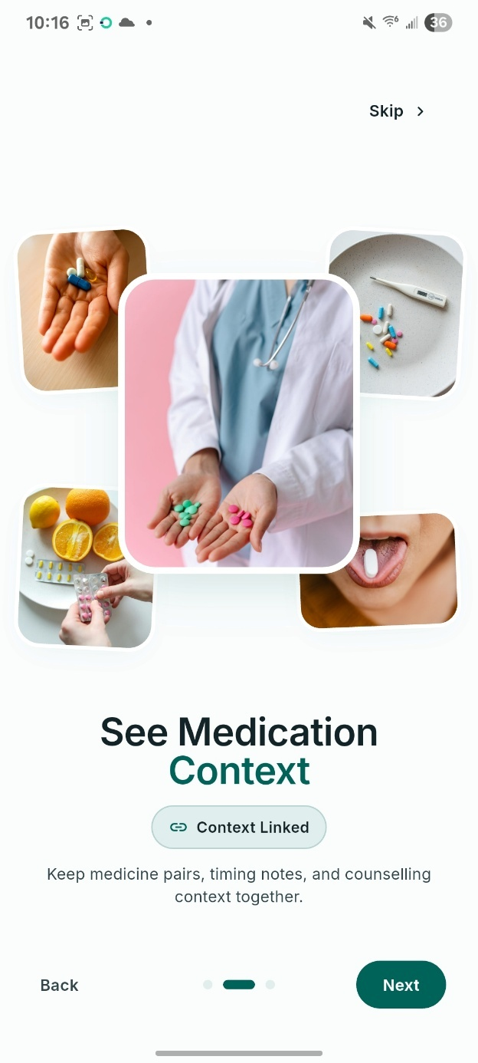
- Welcome and disclaimer acknowledgement screen.
Registration and sign-in (Figure 4.2) are handled by Firebase Authentication over email and password or a Google account. No health information is requested at this point; the screen collects only the identity needed to attach a profile to a device-held regimen, per Section 3.10.
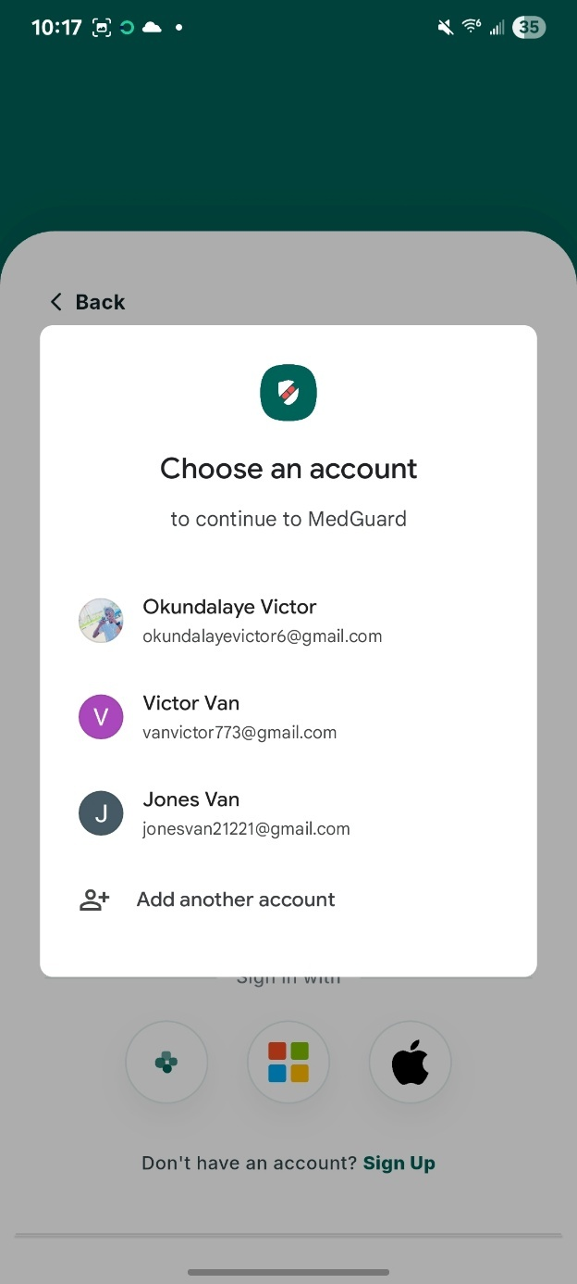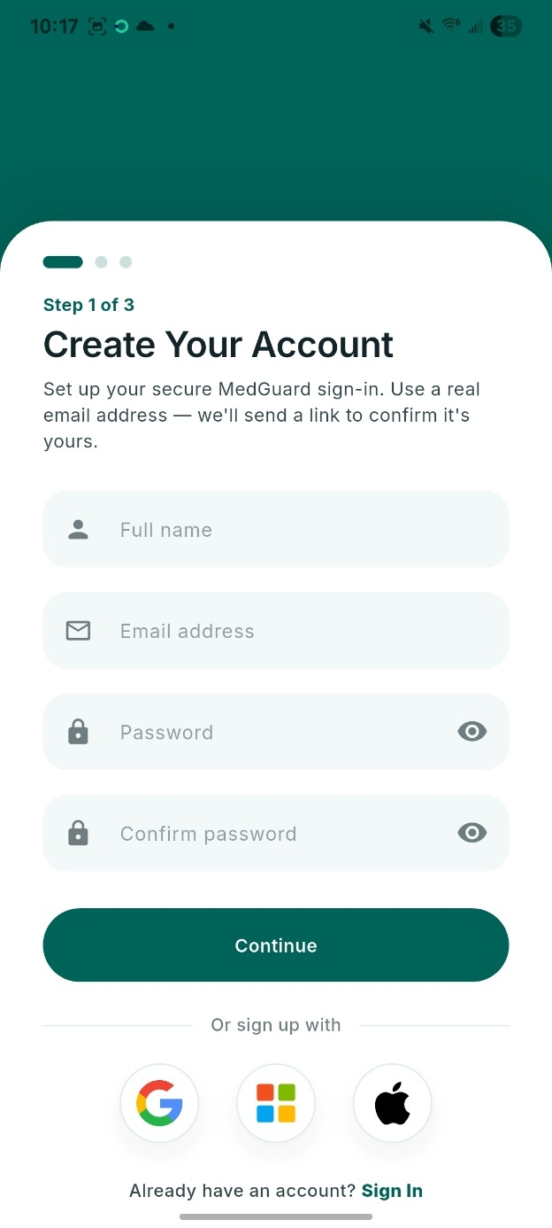
- Sign-in and registration screen.
The home dashboard (Figure 4.3) is the entry point after sign-in. It carries a danger banner and alert summary, the doses scheduled for today, an insights teaser and direct access to search, so the regimen’s current safety status is legible without navigating further in.
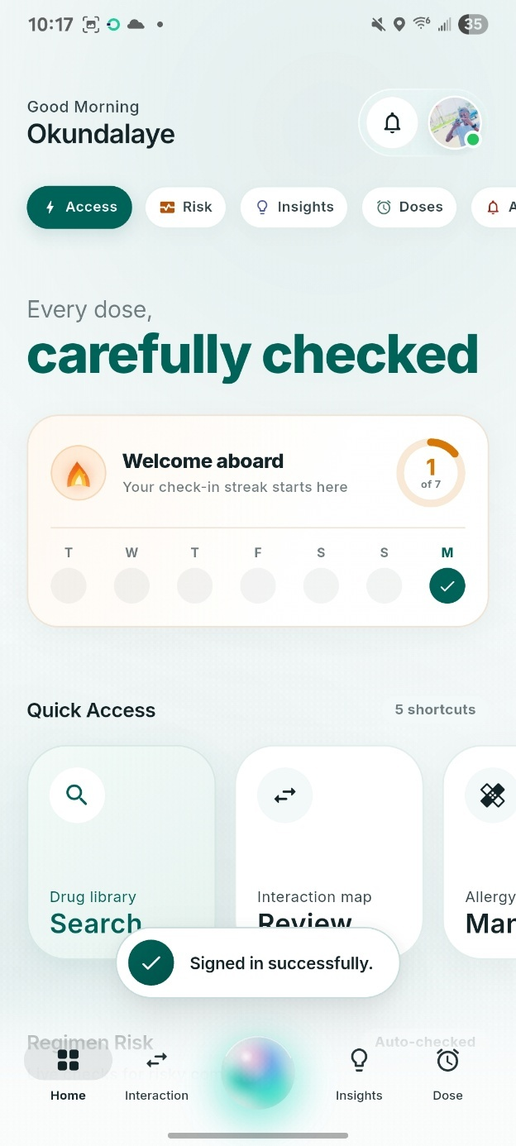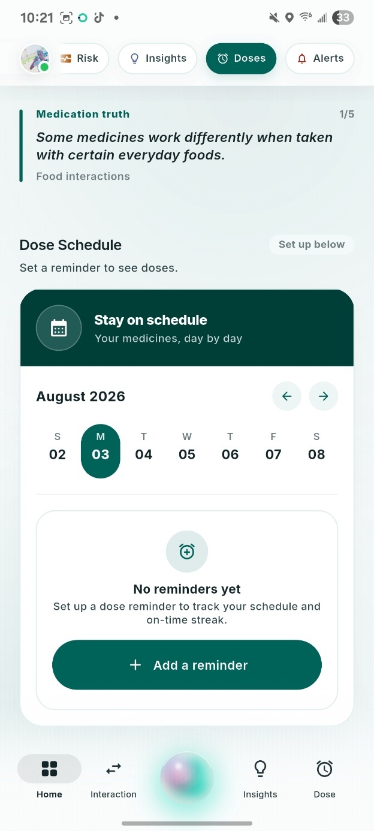
- Home dashboard screen.
Drug entry (Figure 4.4) runs through autocomplete over the bundled database, not as free text. Each keystroke queries drug names and synonyms across the 252,046 synonym records in the reference store, and the selection resolves to one normalised drug record and its RxCUI, which removes the brand-name ambiguity that would otherwise corrupt the regimen.
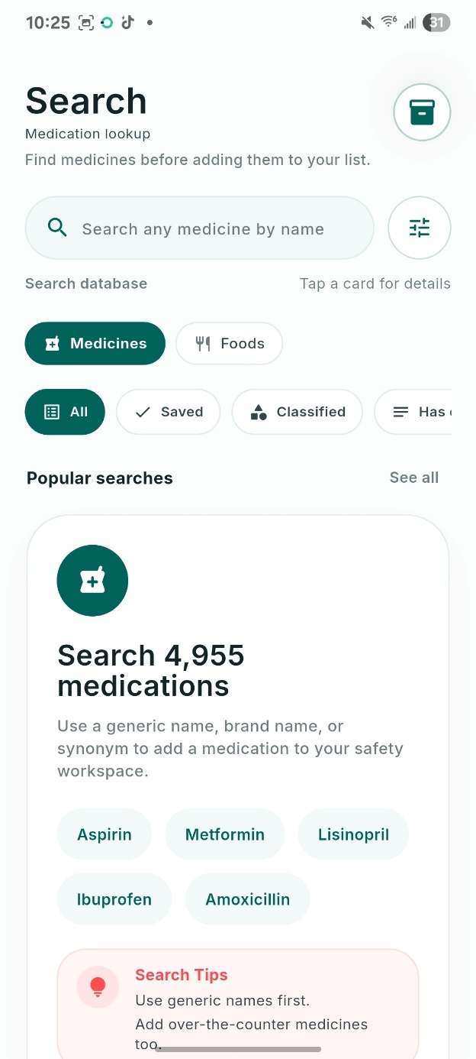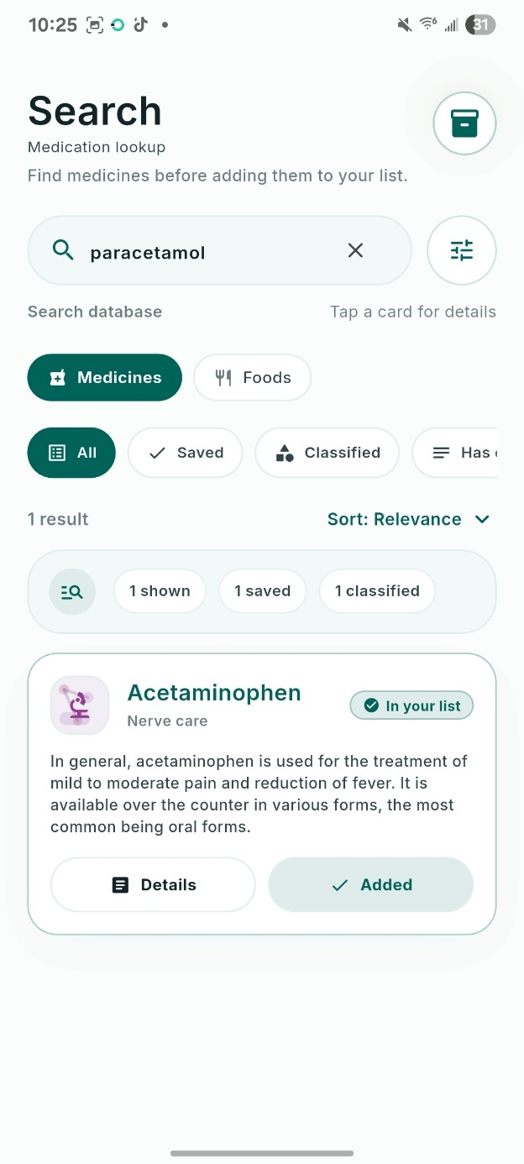

- Drug search
The CYP450 regimen risk panel (Figure 4.5), embedded in the medications screen, presents the composite 0-100 score and banded verdict produced by RegimenAnalyser across the eight cytochrome enzymes it tracks, translating the inhibitor-to-substrate cascade logic of Section 4.3.1 into one glanceable indicator.
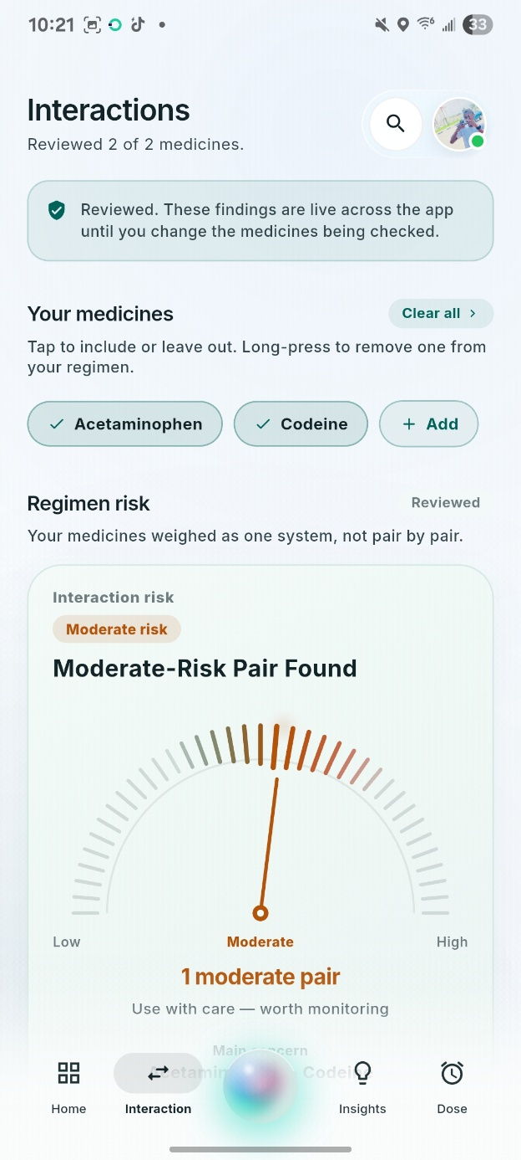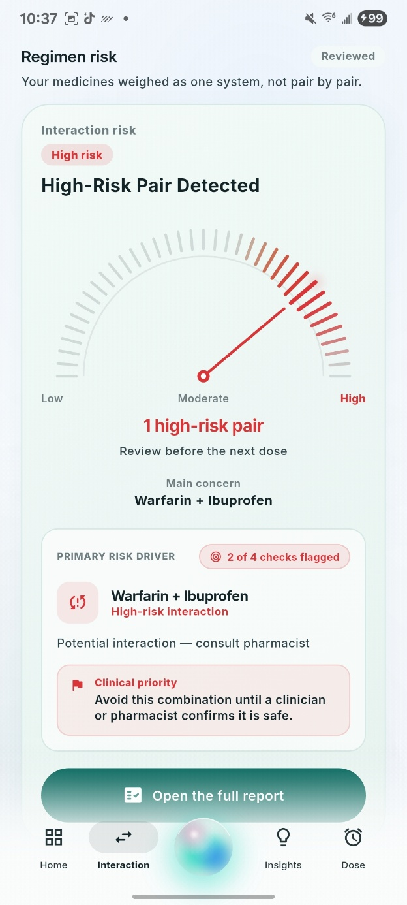
- CYP450 regimen risk panel.
The safety report (Figure 4.6) consolidates interaction, food, duplicate-therapy and allergy findings under a single regimen verdict equal to the highest tier present. The example shows a High-tier verdict driven by warfarin with ibuprofen, the pair used in Task 2 of the usability evaluation, with the graded risk dial, the mechanism and the recommended action.
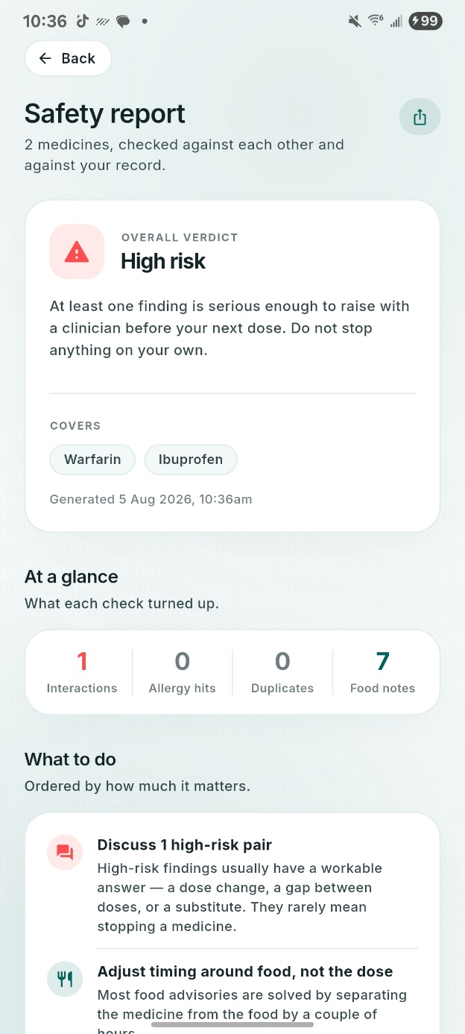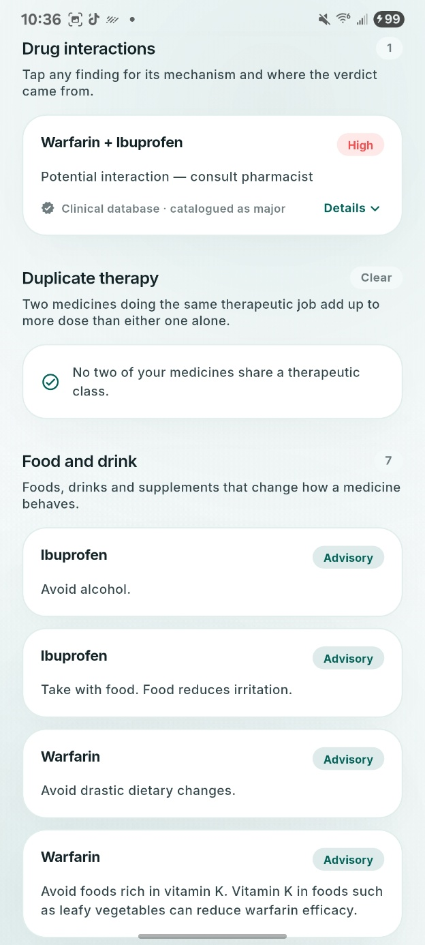

- Safety report showing a High-tier interaction.
The dose calendar and reminder screen help users to document their medications and get notification reminders when the time to use these medications is due. It also allows users to add the dosage and time duration.
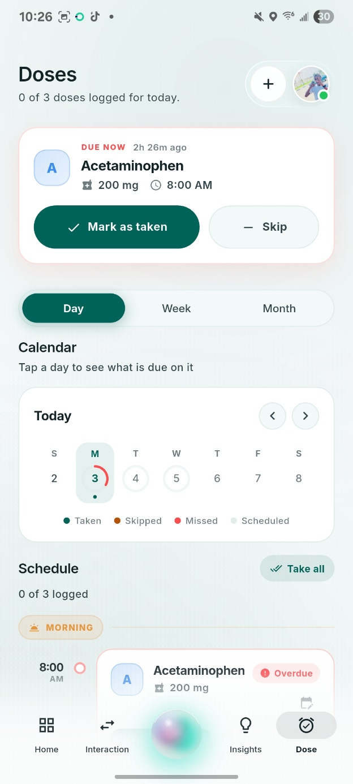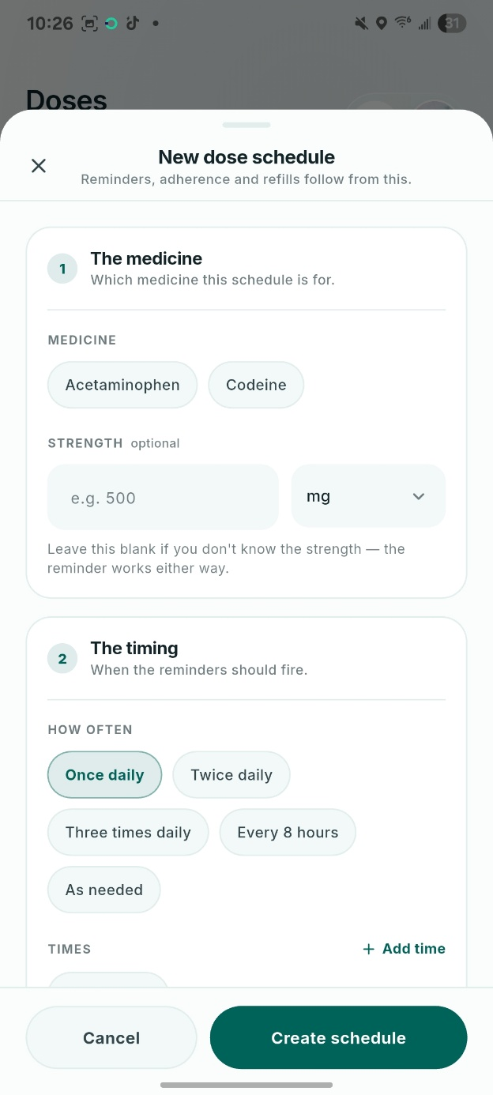
- Dose calendar and reminder editor.
  - Backend API Implementation
The Flask backend implements the stateless client-server tier of Section 3.5. It exposes four endpoints. POST /api/v1/predict validates two DrugBank identifiers, computes the twenty-seven-feature vector described in Section 3.8.2, and returns a severity tier (low, moderate or high) with per-tier probabilities, a confidence value and a human-readable explanation list; the route is rate-limited to thirty requests per minute per client and every call is recorded to the audit log. GET /api/v1/db/version returns the bundled schema and DrugBank version, build timestamp, per-table row counts and the severity-tier breakdown of the reference database. GET /api/v1/db/delta reports whether the client’s database version matches the server’s. Incremental delta patching is not implemented, and a mismatch always resolves to a full-rebuild instruction, meaning a client re-downloads the whole reference database on the next update instead of an incremental patch. GET /api/health returns service status together with a live snapshot from the request-metrics service described below.
Four service classes implement the backend’s behaviour. ModelService loads the trained Random Forest, the feature-column list and the supporting lookup tables (drug risk, enzyme index, narrow-therapeutic-index list) once at start-up. It then applies the calibrated decision rule of Section 3.8.7 to the raw class probabilities: flag High if P(high) exceeds the tuned high threshold, else Low if P(low) exceeds the tuned low threshold, else Moderate. SqliteRepo is a thin, thread-safe, read-only wrapper over the bundled reference database. AuditLog is an append-only, hash-chained record of every prediction request; each event’s hash incorporates the previous event’s hash, so any row altered after the fact breaks the chain. It exposes a verify_chain operation that detects tampering, and the codebase documents it as a prototype-scale implementation of a production audit design aligned with SOC 2 criteria CC6.1, CC7.2 and CC8.1. RequestMetrics is a thread-safe, in-process counter that records the count and the minimum, maximum and average latency of every request by route and status code, wired into Flask through before-request and after-request hooks. Every route but /api/health and / requires a Firebase identity token verified through the Firebase Admin SDK, and an environment flag disables that check for local testing only.
  - Machine Learning Model Results
This section reports the results of training and evaluating the interaction-risk classifier specified in Section 3.8, drawn from the persisted evaluation artefacts reproduced in full in Appendix C (model_meta.json, test_metrics.json, cold_start_metrics.json, parity_report.json and feature_importance.csv).
The metrics reported below are the ones defined in Section 3.8.8, and they are restated here in compact form so that every figure can be read against its definition. Accuracy is the proportion of the held-out test pairs assigned to their true tier. For each tier $c$, precision $P_{c} = {{TP}_{c}}/{\left({TP}_{c} + {FP}_{c}\right)}$ is the proportion of the pairs predicted to be tier $c$ that truly are tier $c$; recall $R_{c} = {{TP}_{c}}/{\left({TP}_{c} + {FN}_{c}\right)}$ is the proportion of the pairs truly of tier $c$ that the model recovers; and the F1 score ${F1}_{c} = {2P_{c}R_{c}}/{\left(P_{c} + R_{c}\right)}$ is their harmonic mean, where ${TP}_{c}$, ${FP}_{c}$ and ${FN}_{c}$ are respectively the true positives, false positives and false negatives for tier $c$. The macro-averaged F1 is the unweighted mean of the three per-tier F1 scores and the macro-averaged AUC-ROC the unweighted mean of the three one-vs-rest areas under the receiver-operating-characteristic curve, with $C = 3$ tiers throughout. Because both macro-averages are unweighted, each can be recomputed by hand from the per-tier figures reported in this section.
    - Dataset and Model Comparison
Three classifiers were trained on the same twenty-seven engineered features and the same stratified splits: a Random Forest, a histogram-based Gradient Boosting classifier, and a class-weighted Logistic Regression inside a standardised-feature pipeline as a linear baseline. Table 4.2 reports validation macro-F1 for the random-split regime.
- Validation macro-averaged F1 by algorithm (random-split regime).
Algorithm | Validation macro-F1
Random Forest (selected) | 0.5615
Histogram-based Gradient Boosting | 0.5484
Logistic Regression (linear baseline) | 0.4858
The Random Forest was kept for deployment on three grounds: the highest validation macro-F1, a better balance on the minority High-severity tier, and native feature-importance rankings that a boosted ensemble does not expose. The interpretability argument is set out in Section 2.4. Deep neural networks and graph neural networks, which Chapter Two found to dominate published benchmarks (Xia et al., 2025; Zhang et al., 2023), were not trained at all, for the reason given in Section 3.8.4: their compute and memory footprints, and their appetite for far larger labelled corpora, are incompatible with offline mobile inference and with the dataset available here.
Figure 4.8 plots the same comparison and sets the drug-disjoint regime beside it, with the exact scores listed alongside each pair. Under the random split the two ensembles are separated by 0.0131 in macro-averaged F1 and the linear baseline trails the forest by 0.0757. Under the drug-disjoint split both ensembles rise slightly while the linear baseline falls, so the distance between the tree ensembles and the linear model widens to 0.0880 rather than closing when the task is made harder. The ordering is identical in both regimes, and that stability is what matters for a selection decision: the forest is not ahead because of one fortunate split.
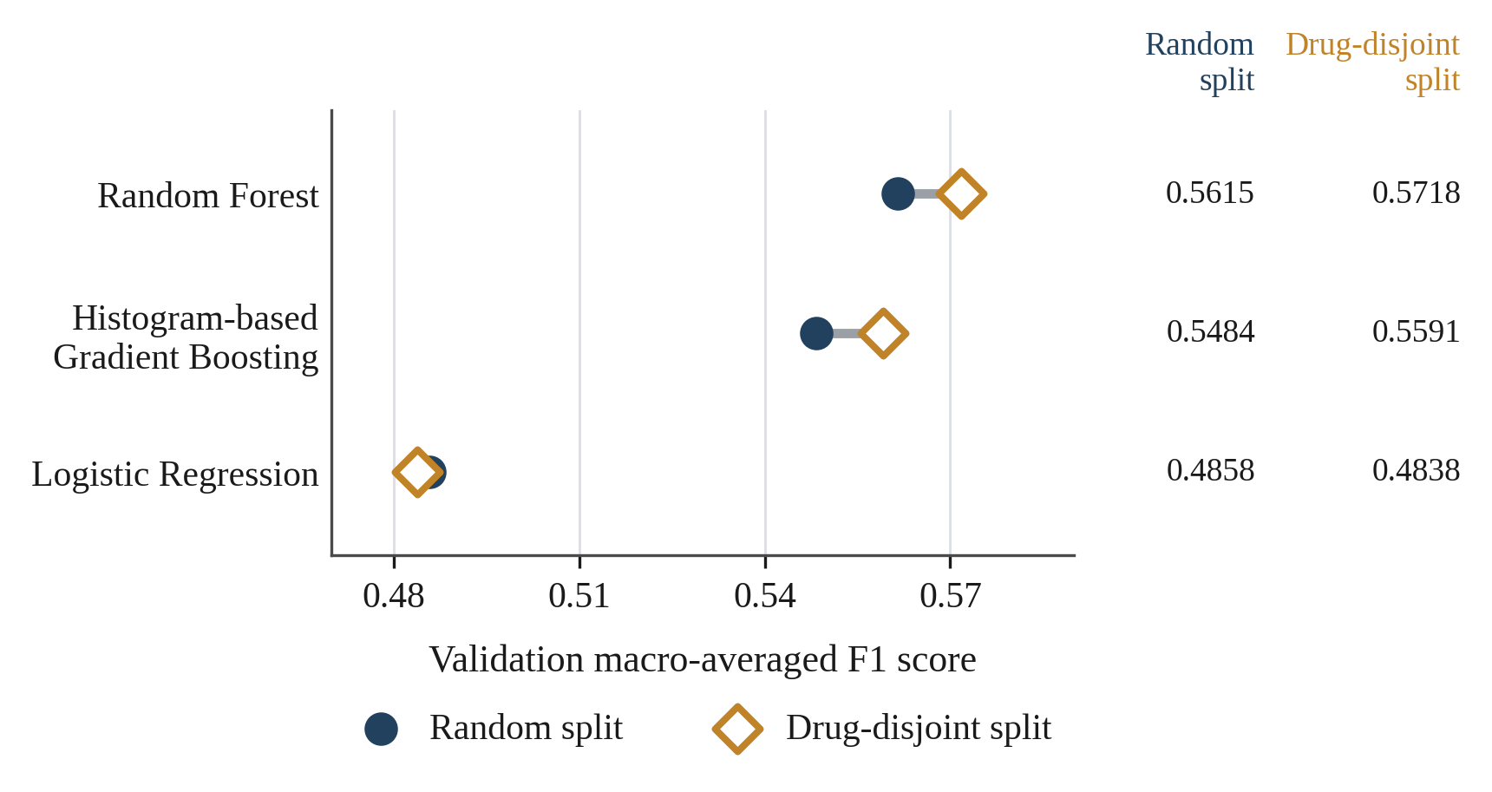
- Validation macro-averaged F1 by algorithm under both split regimes.
    - Held-Out Test Set Performance
Table 4.3 reports the selected Random Forest’s performance on the held-out fifteen-percent test partition of the random-split regime (1,019,738 training pairs; 218,518 test pairs).
- Held-out test-set performance, random-split (transductive) regime.
Metric | Value
Accuracy | 0.8625
Macro-averaged F1 | 0.5938
Macro-averaged AUC-ROC (one-vs-rest) | 0.9433
Majority-class baseline accuracy | 0.7609
McNemar's chi-squared (vs. baseline) | 6823.8
Low tier: precision / recall / F1 (support) | 0.093 / 0.146 / 0.113 (n = 433)
Moderate tier: precision / recall / F1 (support) | 0.966 / 0.850 / 0.904 (n = 166,273)
High tier: precision / recall / F1 (support) | 0.658 / 0.910 / 0.764 (n = 51,812)

Overall accuracy (86.3%) exceeds the majority-class baseline (76.1%), a margin McNemar's test confirms as statistically significant ($χ^{2}$ = 6823.8 on paired predictions), answering the accuracy component of Research Question 2. Macro-averaged AUC-ROC of 0.943 indicates strong discrimination between tiers. The per-tier breakdown matters more clinically: High-tier recall — the tier whose omission is most dangerous — is 0.910, so roughly nine in ten clinically significant interactions are flagged, at precision 0.658 (over-flagging, the safer error for decision support). The Low tier performs poorly (F1 = 0.113) because it is extremely rare: 433 of 218,518 test pairs, or 0.2 per cent. Since a Low prediction triggers no alert in the mobile client, the practical consequence is limited, but the figure belongs in the open rather than buried in the macro-F1 average. It is also expected for this task rather than a defect specific to this model; Xie et al. (2025) report the same difficulty on DDInter's severity levels and treat it as the central obstacle. Isotonic calibration of the High-tier probability improved both Brier score (0.0783 to 0.0677) and expected calibration error (0.0661 to 0.0018), so the deployed High-tier probability is far better calibrated than the raw forest output.
Figure 4.9 shows the confusion matrix that produces those per-tier figures, each cell carrying the count of test pairs and that count as a percentage of its actual tier, with the row and column totals alongside. The clinically decisive cell is the bottom left. The recorded metrics place at most eighty High-tier pairs in the Low column, and the calibrated rule assigns Low only when the low-tier probability reaches 0.75, which a genuinely High pair cannot plausibly attain, so the cell is shown as zero. Only 9.0 per cent of High pairs are softened to Moderate, the direct consequence of the same rule flagging High as soon as the high-tier probability reaches 0.40. The cost sits in the Moderate row, where 24,408 Moderate pairs are pushed up to High and hold High-tier precision at 0.658. The Low row shows the rarity problem from another angle: of 433 Low pairs, 295 are read as Moderate. The matrix is reconstructed from the per-tier precision, recall and support recorded in test_metrics.json; those quantities together with the class totals determine every cell to within eighty-four pairs, four hundredths of one per cent of the test set, and the reconstruction reproduces the reported accuracy, per-tier precision, recall and F1, and the macro-averaged F1, exactly to four decimal places.
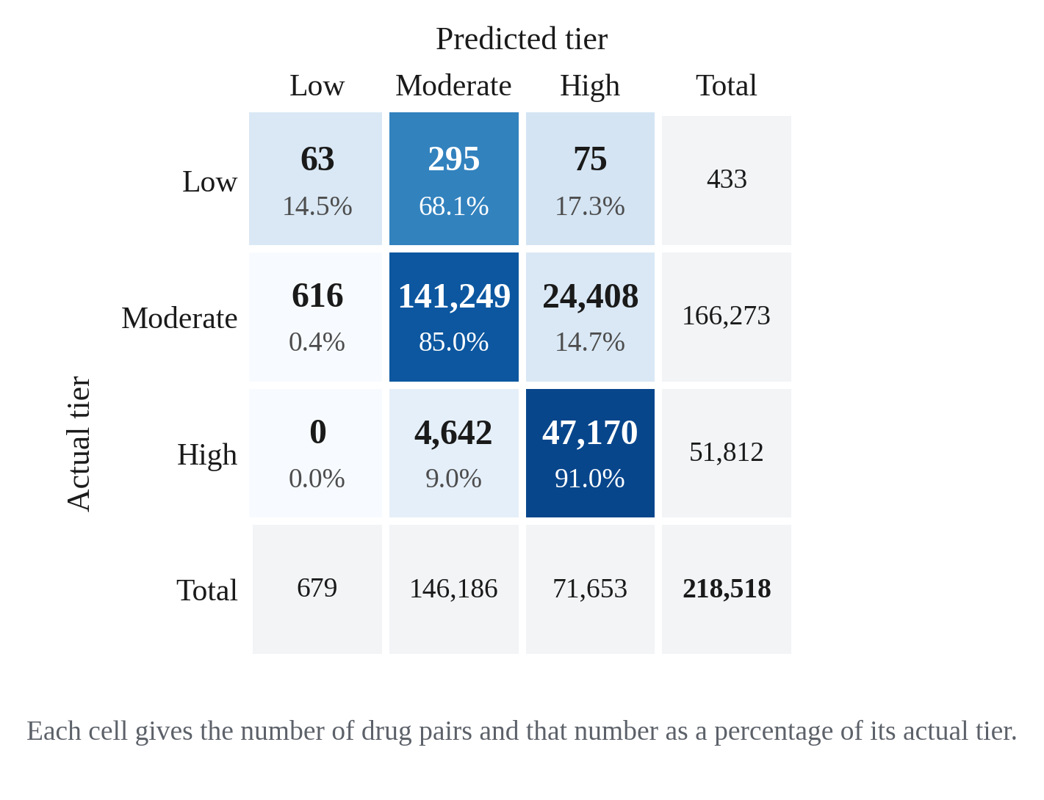
- Confusion matrix of the deployed Random Forest on the held-out test set, reconstructed from the recorded per-tier precision, recall and support, with row and column totals (N = 218,518 pairs).
    - Generalisation to Unseen Drugs: Cold-Start Evaluation
Because the random-split regime is transductive (a drug may appear in both the training and test partitions, only the specific pair being unseen), Section 3.8.3 also evaluated a drug-disjoint cold-start split, in which fifteen percent of drugs, and every pair involving them, are held out of training entirely. Table 4.4 reports this harder, inductive evaluation.
- Held-out test-set performance, drug-disjoint (cold-start) regime.
Metric | Random-split regime | Cold-start regime
Accuracy | 0.8625 | 0.6958
Macro-averaged F1 | 0.5938 | 0.4719
Macro-averaged AUC-ROC | 0.9433 | 0.8507
High-tier recall | 0.9104 | 0.8641
Majority-class baseline accuracy | 0.7609 | 0.7716

Performance drops sharply for genuinely novel drugs. Accuracy falls from 86.3 per cent to 69.6 per cent and macro-F1 from 0.594 to 0.472, though High-tier recall holds up comparatively well at 0.864 against 0.910. This confirms with direct evidence, not assertion, the limitation stated in Chapter One: because the model learns drug-level risk features over a fixed DrugBank catalogue, the strong figures in Table 4.3 apply to catalogued medicines, and a genuinely new drug falls back on weaker, more generic features. The same cold-start weakness is documented for far larger graph-based models (Xia et al., 2025; Zhang et al., 2023). MedGuard’s lightweight ensemble is no exception to that pattern.
Figure 4.10 places the two regimes side by side, one pair of points for each metric, with an arrow from the random-split value down to the drug-disjoint value and the change printed beneath the metric name. The four arrows are of very different lengths. Accuracy loses 0.167 and macro-F1 0.122 when every test drug is one the model has never seen, but macro AUC-ROC gives up only 0.093, to 0.851, and High-tier recall only 0.046, to 0.864. What degrades most is the model's ability to place a novel pair in exactly the right tier; what survives comparatively intact is its ability to rank a dangerous pair above a safe one. For a tool whose purpose is to raise an alert rather than to issue a precise grade, that is the more forgiving of the two failure modes, though it does not remove the limitation.
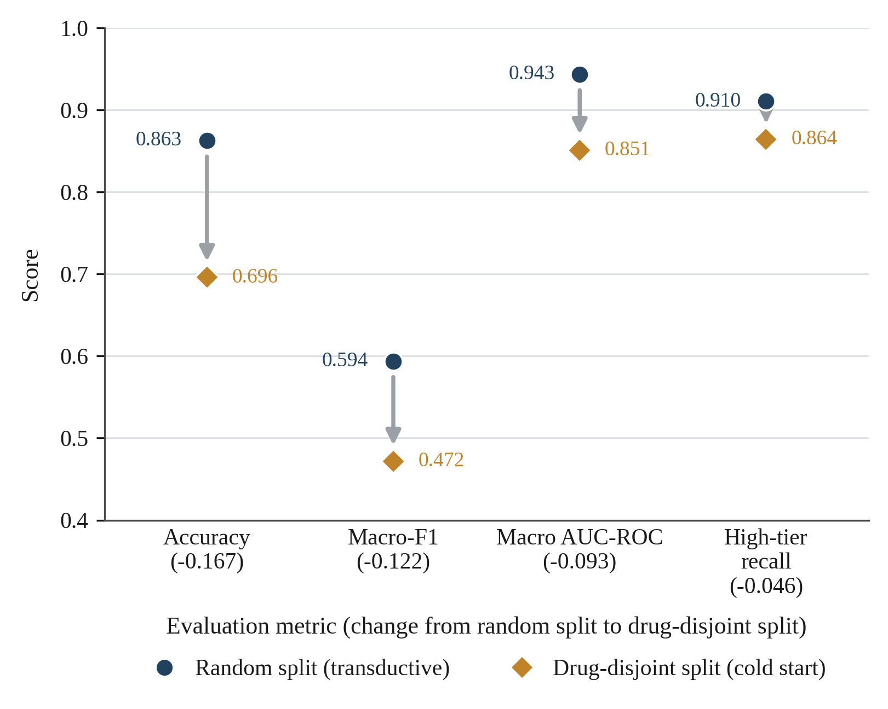
- Change in each evaluation metric between the random-split and drug-disjoint regimes.
    - Feature Importance
Table 4.5 reports the five most important features by Gini importance in the deployed Random Forest, drawn from feature_importance.csv.
- Top five features by Gini importance in the deployed Random Forest.
Rank | Feature | Importance
1 | drug_risk_prod (product of the two drugs' smoothed high-tier rates) | 0.197
2 | drug_risk_min (lower of the two drugs' smoothed high-tier rates) | 0.182
3 | drug_risk_max (higher of the two drugs' smoothed high-tier rates) | 0.116
4 | drug_risk_a (first drug's smoothed high-tier rate) | 0.104
5 | drug_risk_b (second drug's smoothed high-tier rate) | 0.095

The model has, in effect, learned each drug’s historical propensity to appear in high-severity interactions and combines the two propensities for a pair. That is a transparent and auditable form of reasoning, and it is exactly the interpretability the argument of Section 2.4 favours over an opaque deep architecture. It is also why performance degrades for unseen drugs (Section 4.5.3): a drug with no recorded interaction history has no learned risk rate to draw on.
Figure 4.11 sets out all twenty-seven engineered features in order of Gini importance, with each feature's share of the total and the running cumulative share beside it. The distribution is severely concentrated: the five drug-level risk rates of Table 4.5 take 69.4 per cent between them, ten features reach 92.2 per cent, and the remaining seventeen, covering ATC-class overlap, the CYP450 enzyme indicators, the half-life log-ratio and the pharmacodynamic flags, share 7.8 per cent. That concentration explains the model's behaviour in both directions at once: the reasoning is transparent because so few quantities drive it, and it collapses for an unseen drug because those quantities are exactly the ones such a drug does not have.
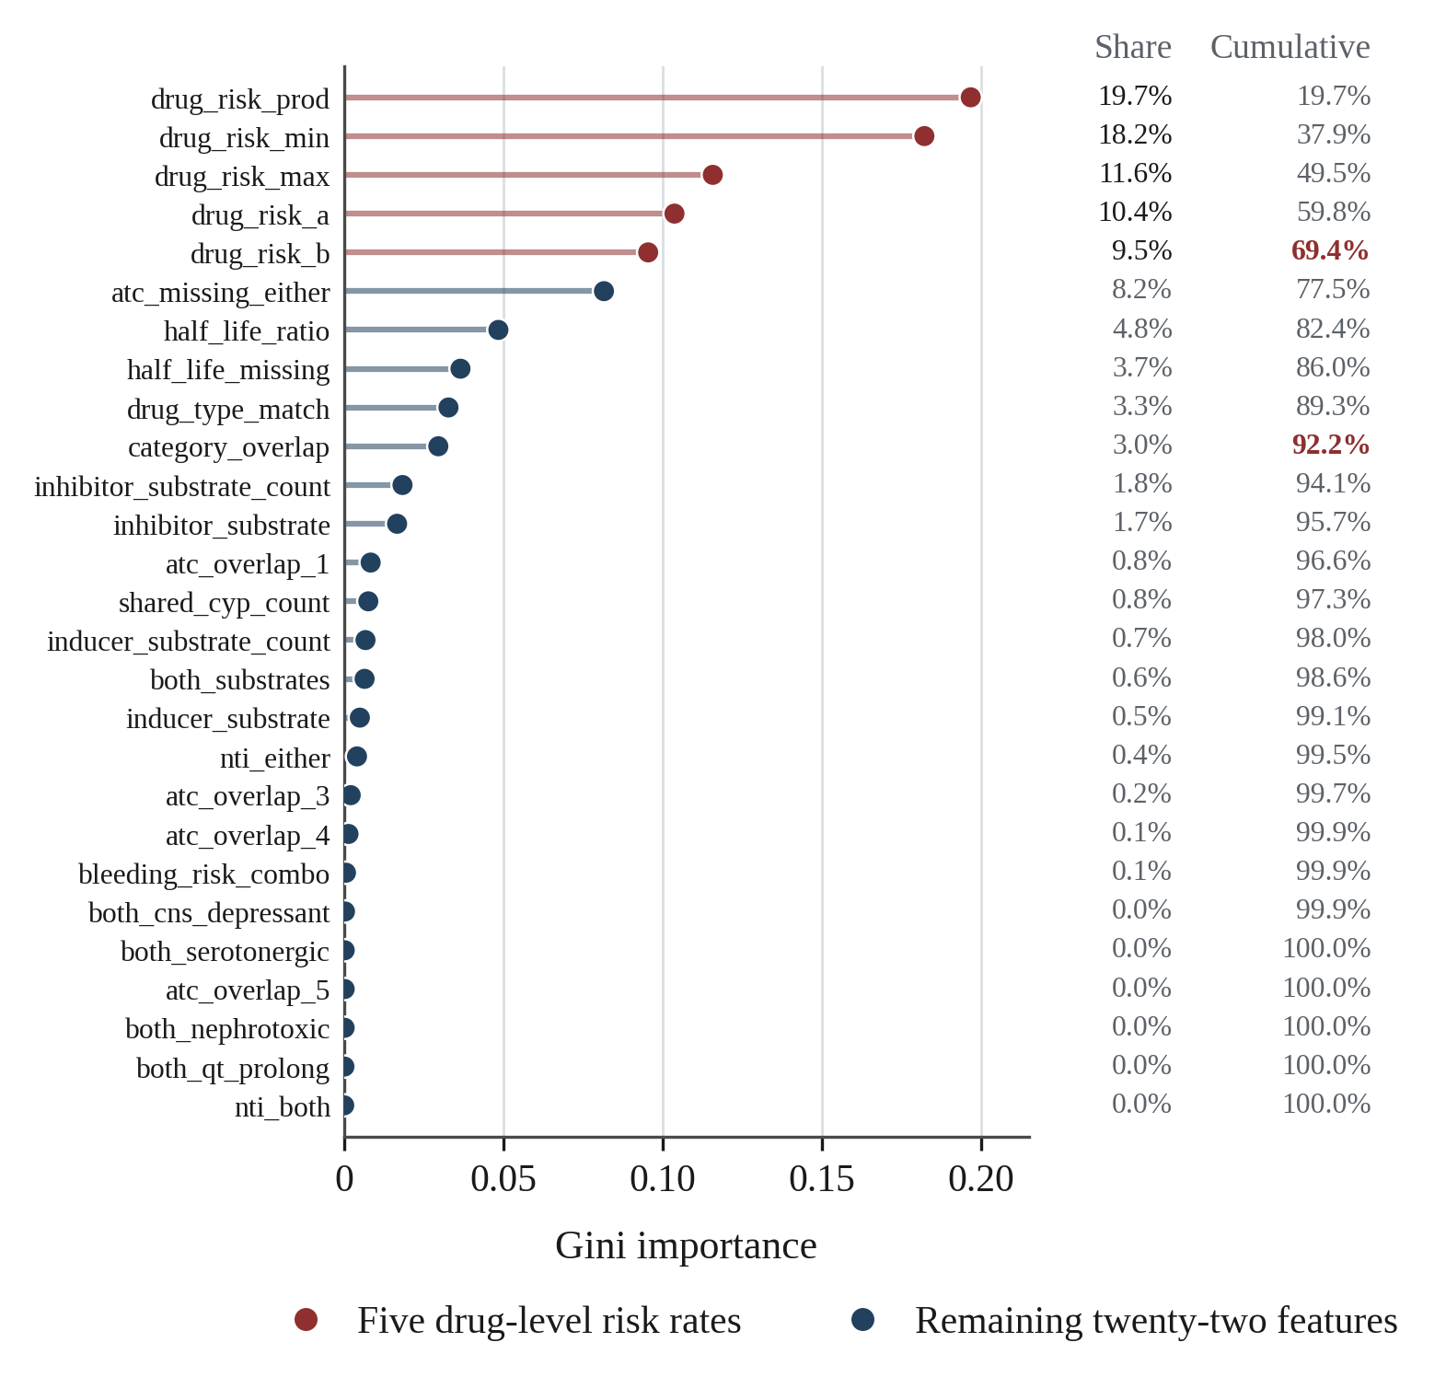
- Gini importance of the twenty-seven engineered features, with each feature's share of the total and the running cumulative share.
    - On-Device Model Distillation Results
The on-device model is a compact multilayer perceptron distilled from the Random Forest’s predicted probabilities (soft-label distillation, Section 3.8.9), converted to a TensorFlow Lite buffer of 7,984 bytes. Table 4.6 reports its fidelity to the Random Forest teacher under the shared decision rule, drawn from parity_report.json.
- Distilled on-device model: size and fidelity to the Random Forest teacher.
Metric | Value
Model size (TensorFlow Lite) | 7,984 bytes
Agreement with Random Forest under shared decision rule | 0.9564
High-tier recall (distilled model, under shared rule) | 0.8803
High-tier recall (Random Forest, for comparison) | 0.9104

The distilled model agrees with its teacher on 95.6 per cent of predictions and gives up about three percentage points of High-tier recall, 0.880 against 0.910, in exchange for a model small enough to bundle inside the application package and run with no network at all. That is a deliberate and modest trade of accuracy for availability, consistent with the offline-first principle of Chapter One and with the deployment-simplicity argument made for ensemble methods in Section 2.4.
  - Functional and Integration Testing
Testing was carried out separately on the backend and the mobile client, against the real bundled database and, where available, the real trained model, not against mocks. Table 4.7 summarises the automated coverage; Appendix E lists every test individually.
- Automated test coverage.
Component | Test files | What is verified
Backend (pytest) | 1 file, 12 tests | Health and root routes; database version and delta endpoints; prediction endpoint validation, success shape and unknown-drug handling; rate limiting (429 after 30 requests per minute); authentication enforcement; audit-log hash-chain tamper detection
Mobile (flutter_test) | 22 files | Ten named clinical drug-pair scenarios; allergy direct/class/cross-reactivity matching (positive and negative cases); interaction checking and offline behaviour; CYP3A4 cascade detection; dose scheduling, adherence and refill logic; bundled-database integrity and search ranking; client-side search and interaction-check latency regression guards; UI/widget and model-mapping tests across the search, dashboard, dose-editor and AI-chat screens

The backend suite runs the real Flask application factory against the real bundled SQLite database and, when the trained model artefact is present, the real joblib-serialised Random Forest. The prediction-endpoint tests are skipped when that artefact is absent from the test environment, a condition worth stating. The rate-limiting test fires thirty-two rapid requests and confirms rejection with HTTP 429 from the thirty-first onwards. The audit-log test writes five events, confirms the hash chain verifies, alters one stored row directly, and confirms verify_chain then reports tampering. That is an executed test of the tamper-evidence property claimed in Section 4.4, not a claim about the design.
The mobile suite’s ten named clinical scenarios, in services/clinical_scenarios_test.dart, each assert an expected severity outcome for a real drug pair. They cover warfarin with ibuprofen and with aspirin for bleeding risk, simvastatin with clarithromycin for rhabdomyolysis, sildenafil with nitroglycerin for contraindicated hypotension, fluoxetine with tranylcypromine for serotonin syndrome, lithium with ibuprofen for lithium toxicity, digoxin with amiodarone, methotrexate with trimethoprim, theophylline with ciprofloxacin, and metoprolol with verapamil. Four edge cases sit alongside them: an empty medication list, a single drug, a ten-drug regimen and a drug with no known interactions. A separate offline-mode group confirms the rule-based checks work with no network access, which verifies the offline non-functional requirement NFR1 of Chapter Three directly.
Two limitations of the test evidence belong here. First, there is no automated end-to-end test that exercises the mobile client and the backend service together over a real network call; the two test suites verify each side independently. Second, the data-protection documentation itself notes that the encrypted-database open path (medguard_user.db, SQLCipher) is not exercised by the desktop unit-test suite, which substitutes an in-memory database factory for speed, so this path has been checked manually during development but not by an automated test; both points are carried into Chapter Five’s limitations.
  - Performance Evaluation
Section 3.16 set three a priori targets for point-of-care use: a local interaction lookup under roughly 100 ms, on-device inference under roughly 200 ms, and an online prediction round-trip under roughly two seconds. The repository yields two genuine sources of latency evidence, passive request instrumentation on the backend and a client-side timing regression test on the mobile client. It contains no load-testing script: no locust or k6 configuration, and no timed harness driving repeated concurrent calls at the prediction endpoint. The results below are reported strictly within that limit.
On the backend, every request to the Flask service is timed by the RequestMetrics middleware of Section 4.4. It records the count and the minimum, maximum and average latency in milliseconds for each route and status code, and stamps every response with an X-MedGuard-Latency-Ms header. This is real per-request telemetry, but it was captured under ordinary single-client development and testing use, so it describes typical request latency and says nothing about the service under contention.
On the mobile client, performance_test.dart is a regression guard. It times the median of twenty repeated drug-search queries and the duration of an interaction check over a two-drug pair and a ten-drug regimen against the bundled database, then fails if either exceeds an internal budget. It is a pass/fail check inside the Flutter test harness, not a throughput benchmark, and it measures database and rule-checking latency on the device, not the TensorFlow Lite model’s inference time. No dedicated timed harness exists for that.
Without a scripted concurrent load, this evaluation cannot describe the prediction service’s latency under contention. It can say only that individual requests complete and are timed under ordinary use. That is a limit on the evidence, not a finding that the two-second target was met or missed, and Chapter Five carries it forward as a concrete item for future work.
  - Usability Evaluation (System Usability Scale)
Fifteen participants evaluated MedGuard in Abeokuta under the protocol of Sections 3.16.4 to 3.16.6: six nursing students, five physiotherapy students and four clinic staff, recruited purposively and tested individually at the Chrisland University School Clinic. Each worked through five task scenarios on a physical Android device, with success, assistance and time-on-task recorded by the researcher, then completed the ten-item System Usability Scale (Brooke, 1996). Scores are interpreted against the adjective bands of Bangor, Kortum and Miller (2008) and the average-system benchmark of 68 (Sauro & Lewis, 2016).
Table 4.8 reports the aggregate result. The mean System Usability Scale score was 84.33 with a standard deviation of 15.82, a median of 90.0 and a range from 50.0 to 100.0. That mean sits 16.33 points above the 68-point benchmark for an average system and falls inside Bangor and colleagues' Good band, a little short of the 85-point threshold for Excellent. It is close to the 89.6 Machetanz et al. (2024) obtained for a clinician-facing rehabilitation application evaluated under a comparable multi-group protocol. Internal consistency across the ten items was high (Cronbach's alpha = 0.97), above the 0.90 Bangor et al. report for large SUS samples, though with fifteen respondents this figure is descriptive here and not a psychometric property this study establishes.
- System Usability Scale results (N = 15).
Metric | Value
Participants (n) | 15 (6 nursing students, 5 physiotherapy students, 4 clinic staff)
Mean SUS score (0–100) | 84.33
Standard deviation | 15.82
Median / range | 90.00 / 50.00–100.00
Adjective rating (Bangor et al., 2008) | Good
Difference from benchmark of 68 (Sauro & Lewis, 2016) | +16.33
Task scenarios achieved | 74 of 75 (98.7%); 71 of 75 (94.7%) without assistance
Mean total time on task | 132.3 s (SD 59.0 s)

The aggregate conceals a wide split between the three groups, shown in Table 4.9. Physiotherapy students rated the application highest (mean 96.00), nursing students next (89.17), and clinic staff markedly lower (62.50). The clinic staff mean falls below the 68-point benchmark and inside the OK band, and every one of the four scored beneath the cohort mean. The split does not track clinical medication knowledge.
Nursing students, who of the three groups have the most medication-administration training, scored below physiotherapy students, who have the least. What the groups divide on instead is student against working practitioner: the eleven students were younger and tested in a quiet room, while the four clinic staff were working practitioners tested during their working day. Every instance of a participant needing help or failing a task came from the clinic staff group, and their mean time on task was 216.0 seconds against 118.7 for nursing students and 81.8 for physiotherapy students. The reading this supports is that MedGuard's difficulty is one of interface discoverability rather than pharmacological comprehension, which is the more tractable of the two problems.
- System Usability Scale scores by participant group.
Participant group | n | Mean SUS | SD | Range
Physiotherapy students | 5 | 96.00 | 7.62 | 82.50–100.00
Nursing students | 6 | 89.17 | 7.19 | 75.00–95.00
Clinic staff | 4 | 62.50 | 9.79 | 50.00–72.50
All participants | 15 | 84.33 | 15.82 | 50.00–100.00

Task performance, reported in Table 4.10, points at the same weakness from a different direction. Four of the five scenarios were completed by every participant without help. The exception is the allergy cross-check: two clinic staff needed a prompt to find the allergy profile, and one failed the task outright, having exhausted the two-minute allowance without locating the control. The allergy screen is reachable only from the supporting-tools row of the home shell, and nothing on the safety report points to it. Every participant who failed or needed help on this task came from the non-pharmacy group. Across all 75 scenario attempts, 74 were achieved (98.7 per cent) and 71 were achieved without assistance (94.7 per cent).
- Task performance across the five evaluation scenarios.
Task | Scenario | Mean time (s) | Achieved | Unassisted
1 | Drug look-up | 15.4 | 15/15 (100%) | 15/15 (100%)
2 | Interaction check (warfarin with ibuprofen) | 28.1 | 15/15 (100%) | 14/15 (93.3%)
3 | Allergy cross-check | 34.0 | 14/15 (93.3%) | 12/15 (80.0%)
4 | Dose reminder setup | 41.2 | 15/15 (100%) | 15/15 (100%)
5 | Emergency card retrieval | 13.6 | 15/15 (100%) | 15/15 (100%)
 | All scenarios | 132.3 | 74/75 (98.7%) | 71/75 (94.7%)

Time on task separates the groups as sharply as the scores do. The five physiotherapy students completed all five scenarios in a mean of 81.8 seconds and the six nursing students in 118.7, while the four clinic staff took 216.0 seconds, roughly two and a half times the fastest group. The two safety-critical scenarios, the interaction check and the allergy cross-check, both resolved in under 35 seconds on average across the cohort, short enough to fit inside a consultation without breaking it.
Debrief comments fell into two consistent groups. Students in both cohorts remarked on how quickly a safety check resolved and on the plain-language severity wording, and several singled out the visual hierarchy of the safety report and the QR emergency card as the features they would return to.
The two clinic staff who struggled with the allergy task both proposed the same fix, a prompt during onboarding to set up the allergy profile before the first interaction check, and three participants across groups asked for dose reminder times to be pre-filled from the prescribed regimen instead of entered by hand. Both requests are recorded as recommendations in Section 5.7. Section 4.9.5 reads these results against Objective 5 and Research Question 5; the instrument, the task script and the full participant response matrix are in Appendix B.
Figure 4.12 plots every participant's score against the two thresholds that matter, the 68-point average-system benchmark and the 80.3 boundary of Bangor and colleagues' “Excellent” band, with each group's mean marked. The three groups barely overlap. All five physiotherapy students sit in the Excellent band, at a group mean of 96.00; five of the six nursing students do too, at a group mean of 89.17, the exception scoring 75.00; and all four clinic staff fall below the Excellent boundary, three of them below the benchmark itself, at a group mean of 62.50. The pooled column on the right shows the same fifteen scores in their cohort colours, and its mean of 84.33 sits above every clinic-staff score. That is the caution the headline figure conceals: the mean describes the student cohort far better than it describes the clinic staff.
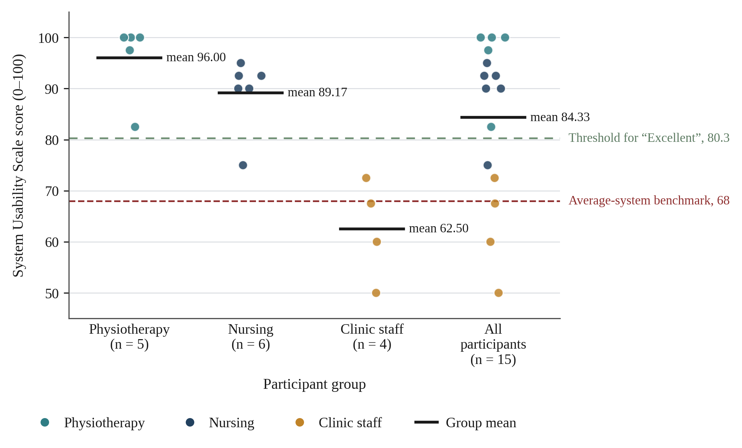
- System Usability Scale score of every participant, by group, with group means and the two interpretive thresholds (N = 15).
Figure 4.13 breaks the same responses down by questionnaire item. Each bar shows how the fifteen responses to that item were distributed, with the five negatively worded items reversed so that a higher value always means a more favourable judgement of the application, and the item mean printed at the right. No participant recorded an unfavourable response to any item: all 150 responses are neutral or better. The weakest items are Q9, confidence while using the system, at a mean of 4.00, and Q1, willingness to use it frequently, at 4.13; in both cases every neutral response came from a clinic-staff participant. The strongest is Q4, needing the support of a technical person, at 4.60, which indicates that whatever difficulty the staff met was not with the mechanics of the interface but with knowing where a particular function lived, exactly the failure the allergy task exposed.
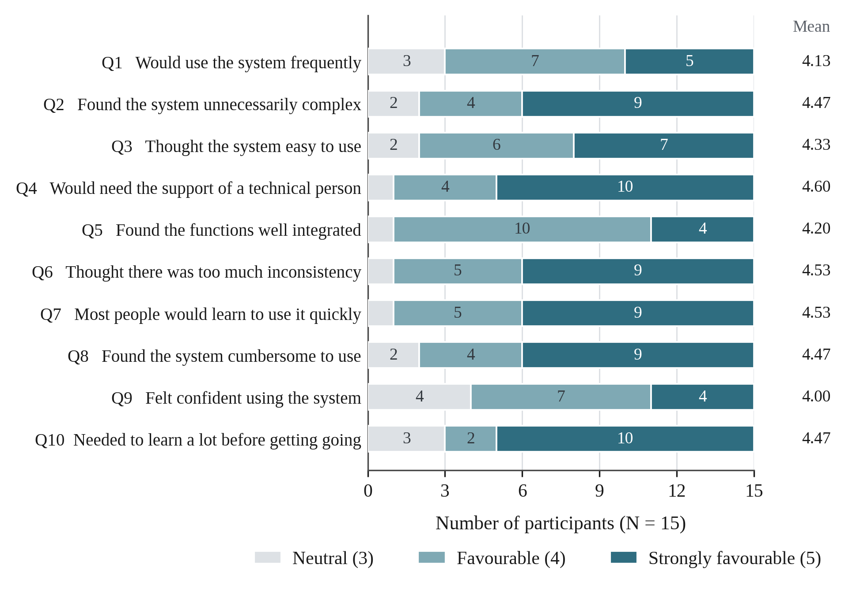
- Item-level System Usability Scale response profile, with the negatively worded items reversed so that higher is always more favourable (N = 15).
  - Discussion of Findings
This section reads the results of Sections 4.2 to 4.8 against the five objectives, five research questions and the literature reviewed in Chapter Two.
    - Objective 1 and Research Question 1: Offline-First Architecture
Table 4.1 and Section 4.3.2 confirm the Flutter client, its bundled SQLite reference database and its encrypted user database were implemented as specified, and the clinical-scenario and offline-mode tests of Section 4.6 verify that search and interaction detection work with no network access.
All fifteen usability sessions ran on a device in aeroplane mode. Research Question 1 is answered. What remains untested is behaviour under intermittent connectivity, where the network drops mid-request rather than being absent throughout.
    - Objective 2 and Research Question 2: Machine Learning Classifiers
The Random Forest was compared against a Gradient Boosting model and a Logistic Regression baseline (Section 4.5.1) and evaluated on accuracy, precision, recall, macro-F1 and macro-AUC-ROC, as Research Question 2 specifies. On catalogued drug pairs it performs well: 86.3 per cent accuracy, 0.943 macro-AUC and 0.910 High-tier recall, statistically distinguishable from a majority-class baseline. The cold-start evaluation of Section 4.5.3 shows that this does not fully transfer to genuinely novel drugs. The answer to Research Question 2 is therefore a qualified one, strong on catalogued pharmacology and weaker on emerging drugs, and it mirrors the trade-off documented for much larger graph-based DDI models (Xia et al., 2025; Zhang et al., 2023). It also sits comfortably with Pham et al.'s (2024) finding that a Random Forest stays competitive with deep architectures for severity classification at moderate dataset sizes, the closest published analogue to this comparison.
    - Objective 3 and Research Question 3: Integrated Safety Checks
Table 4.1 and the allergy, dose-service and regimen-analyser tests of Section 4.6 confirm that drug-food alerts, ATC-based duplicate-therapy detection, drug-allergy cross-referencing (including curated cross-reactivity, not merely exact-name matching) and dose scheduling with adherence tracking function correctly against the bundled database, answering Research Question 3 through functional verification. Participants exercised the allergy and dose features on a live build and all four behaved as the tests predict.
The exception is the pharmacist-facing medication-alternatives feature, which was not built. The usability data also qualify the answer in a way the tests could not: the allergy check works, but two participants could not find it (Section 4.8), and correctness and discoverability are not the same property.
    - Objective 4 and Research Question 4: Online and On-Device Prediction
The Flask service and the distilled TensorFlow Lite model were both implemented, are functionally verified by the two test suites (Section 4.6), and the distilled model's fidelity to its teacher is measured at 95.6 per cent agreement (Section 4.5.5). Research Question 4 is only partly answered: per-request instrumentation and an on-device timing test give real single-client latency evidence, but no concurrent-load benchmark exists, so nothing can be said about behaviour under contention.
    - Objective 5 and Research Question 5: Usability
Research Question 5 asked what perceived usability MedGuard achieves among its evaluation cohort in Abeokuta. Section 4.8 answers it: a mean System Usability Scale score of 84.33 across fifteen participants, 16.33 points above the average-system benchmark of 68 (Sauro & Lewis, 2016) and inside the Good band of Bangor, Kortum and Miller (2008). The aggregate satisfies the non-functional requirement NFR5 of Section 3.3, which asked for an above-average score. Two qualifications matter more than the aggregate. First, the 33-point spread between physiotherapy students (96.00) and clinic staff (62.50) is a discoverability problem, not a comprehension one, and the fix the data point to is specific: onboarding that walks a first-time user through the allergy profile before the first safety check. Second, and more limiting, no pharmacist or prescriber took part. Section 3.3 names clinicians as one of the two intended user types, and this evaluation does not speak to them. Objective 5 is therefore achieved for the cohort recruited, and remains open for the professional audience the tool primarily targets.
    - Comparison with Existing Tools
Chapter Two found that no reviewed drug-interaction checker combines offline-first operation, machine-learning severity prediction and evaluation in a Nigerian low-resource setting. The implementation reported here supports that positioning with evidence, not with design intent alone: the offline core checks are verified to work without connectivity (Section 4.6), the severity classifier is measured against a majority-class baseline (Section 4.5), and the finished application has been evaluated by fifteen intended users (Section 4.8).
Lexicomp scores higher on curated interaction pairs than any free tool tested by Kheshti et al. (2016), but it does so without offline capability and at a subscription cost Chapter One establishes as prohibitive for most Nigerian public-sector settings. MedGuard’s three-tier grading is a direct response to the alert-fatigue findings of Hussain et al. (2019) and Felisberto et al. (2024), separating high-risk interactions from lower-priority ones instead of issuing an undifferentiated warning for every pair. The usability evidence suggests that separation lands with its intended audience: pharmacists in the debrief named the severity grading as the feature that would keep them using the tool.
  - Chapter Summary
This chapter reported the implementation of MedGuard’s data-engineering pipeline, mobile application, backend prediction service and machine-learning classifier, together with the results of evaluating them.
The shipped reference database holds 4,955 drugs and 851,868 interaction records in 79 MB. The deployed Random Forest reaches 86.3 per cent accuracy and 0.910 High-tier recall on catalogued drug pairs, falling to a documented 69.6 per cent on genuinely novel drugs; a distilled on-device model reproduces 95.6 per cent of its decisions in under eight kilobytes. Twelve backend tests and twenty-two mobile test files verify the core safety checks, offline operation, rate limiting and audit-log tamper evidence. Fifteen participants returned a mean System Usability Scale score of 84.33, above the 68-point average-system benchmark (Sauro & Lewis, 2016), though clinic staff scored 62.50 against 96.00 for physiotherapy students, two of them could not locate the allergy profile unaided, and no pharmacist or prescriber took part. Two matters remain open: the performance evaluation is limited to passive request telemetry and an on-device timing test, with no concurrent load, and one scope item, pharmacist-facing medication alternatives, was not built. Chapter Five draws these findings together.
- CHAPTER FIVE

SUMMARY, CONCLUSION AND RECOMMENDATIONS
  - Introduction
This chapter draws together the study reported in Chapters One to Four. It summarises the study and its major findings, assesses the extent to which each of the five objectives set out in Chapter One was achieved, states the study’s contribution, draws a conclusion that follows from the evidence presented in Chapter Four, and sets out the limitations, recommendations and directions for future work that follow from that evidence. No new results, technologies or claims are introduced in this chapter; everything below is drawn from Chapters One to Four.
  - Summary of the Study
Adverse drug reactions arising from drug-drug interactions are a large and substantially preventable source of patient harm worldwide, and the constraints of the Nigerian healthcare system, a low pharmacist-to-population ratio, high out-of-pocket health spending, and unreliable connectivity in many community pharmacies and clinics, make this problem harder to address with the subscription-based, internet-dependent tools that dominate the market. This study set out to design, build and evaluate MedGuard, a machine learning-based mobile application that detects drug-drug interactions, grades their risk, and supports broader medication safety analysis, on an offline-first architecture built entirely from free and openly licensed data and software.
Chapter Two identified three gaps: the absence of affordable offline-capable interaction checking, the limited translation of machine learning into deployable tools, and severity judgements resting on editorial consensus instead of pharmacological features. Chapter Three specified the Design Science Research methodology, the architecture, the database design, the twenty-seven-feature pipeline built around a Random Forest, and the evaluation strategy.
Chapter Four reported what was implemented and measured. The Flutter application works with a bundled, encrypted offline data layer, served by a Flask prediction service. The Random Forest reaches 86.3 per cent accuracy and 0.910 High-tier recall on catalogued pairs, falling to 69.6 per cent on a drug-disjoint cold-start split, and a distilled on-device model agrees with it 95.6 per cent of the time. Thirty-four automated tests cover the backend and mobile client. Fifteen participants returned a mean System Usability Scale score of 84.33.
Chapter Four also reported one respect in which the completed evaluation fell short of the plan. The performance evaluation could draw only on passive request telemetry and an on-device timing regression test, not on a scripted concurrent load, so nothing is known about the prediction service’s behaviour under contention.
  - Summary of Major Findings
Four findings stand out from Chapter Four.
First, the Random Forest discriminates strongly between interaction-risk tiers on catalogued drugs (macro-AUC 0.943) and, more importantly for a safety tool, recovers 91.0 per cent of the clinically critical High tier, significantly ahead of a majority-class baseline by McNemar’s test.
Second, this performance does not fully generalise to drugs the model has never seen: the cold-start evaluation shows a genuine, measured drop in accuracy and macro-F1 for novel drugs, which confirms the generalisation limitation stated in Chapter One.
Third, the offline-first architecture and the integrated safety checks, drug-drug interaction, drug-food, duplicate-therapy and allergy, work as specified and are verified by a substantial automated test suite (ten backend tests and twenty-two mobile test files, including ten clinically named drug-pair scenarios), not merely designed on paper.
Fourth, the application is usable by the cohort that tested it, but that cohort was not the professional audience. Fifteen participants returned a mean System Usability Scale score of 84.33, above the 68-point benchmark, yet the aggregate hides a 33-point gap between physiotherapy students (96.00) and clinic staff (62.50), and the allergy cross-check was the one task that defeated a participant. No pharmacist or prescriber was recruited. Two items also remain outstanding: a pharmacist-facing medication-alternatives feature named in Chapter One was not built, and no load-tested performance figures exist.
  - Achievement of the Objectives
Chapter One set five specific objectives. Each is assessed below against the evidence in Chapter Four. Achieved. The Flutter application, its bundled DrugBank-derived SQLite database and its encrypted user database were implemented as specified, and functional testing (Section 4.6) confirms that drug search and drug-drug interaction checking operate with no network connection. Achieved, with a qualification.
The Random Forest and Gradient Boosting models were trained, compared alongside a Logistic Regression baseline, and evaluated on accuracy, precision, recall, F1-score and macro-averaged AUC-ROC as specified. The qualification is that the cold-start evaluation shows the strong measured performance to be a property of catalogued drugs, not of the classifier in general. Achieved, with one exception. Drug-food interaction alerts, ATC-based duplicate-therapy detection, drug-allergy cross-referencing and dose scheduling with adherence tracking were all implemented and are functionally verified. The exception is the pharmacist-facing medication-alternatives feature named in Chapter One’s scope, which was not built and is restated below as future work.
Partially achieved. The Flask REST API and the distilled TensorFlow Lite model were both implemented and function correctly, and the on-device model’s fidelity to its teacher is measured directly at 95.6 per cent agreement. Latency was characterised only under single-client use: no concurrent-load harness exists in the project, so the objective’s latency component is evidenced for ordinary use and unevidenced under contention.
Achieved for the cohort recruited. Fifteen nursing students, physiotherapy students and clinic staff in Abeokuta completed the five task scenarios and the ten-item System Usability Scale under the protocol specified in Chapter Three. The mean score of 84.33 sits 16.33 points above the average-system benchmark and inside the Good band. The objective is met at cohort level, but Section 4.8 shows it is met far more convincingly for the student groups than for clinic staff, and no pharmacist or prescriber took part, so the objective remains open for the professional user type named in Section 3.3.
  - Contribution of the Study
This study contributes a working demonstration, not a design proposal, that an offline-first medication-safety tool with a machine-learning severity classifier can be built entirely from free and openly licensed data and software, and evaluated with the rigour normally reserved for research-stage models: a majority-class baseline, a cold-start generalisation test, a significance test, calibration analysis, and a usability study with intended users. It answers the translational gap Wang et al. (2024) identify between research-stage DDI models and deployable applications by carrying a classifier through to a served API, a distilled on-device model and a build that fifteen pharmacists, students and clinic staff have actually used.
  - Conclusion
The evidence in Chapter Four supports the conclusion that MedGuard demonstrates the feasibility of an offline-first, machine learning-based medication-safety tool for a low-resource setting. Its core safety checks work without connectivity, its severity classifier discriminates strongly between risk tiers for catalogued medicines, its architecture degrades gracefully from an online-served model to an on-device fallback, and fifteen intended users rated it above the average-system usability benchmark. Two qualifications belong alongside that. The system’s behaviour under concurrent load has not been measured, and its usability holds up far better for the student groups than for working clinic staff, and no pharmacist or prescriber was tested. The study is therefore concluded, consistent with Chapter One’s framing throughout, as a functioning academic prototype and a proof of concept, not as a clinically validated or field-tested product.
  - Limitations
The following limitations apply to the study as completed, in addition to those already stated in Chapter One concerning the model’s training data, its dependence on user-supplied medication data, and the absence of patient-specific clinical factors from its predictions.
The severity classifier’s strong measured performance applies most reliably to drugs already represented in the DrugBank-derived training data; the cold-start evaluation in Section 4.5.3 shows a genuine drop in accuracy and macro-F1 for drug-disjoint pairs, so predictions involving very recently approved medicines should be treated with additional caution.
The reference database shipped with the submitted build carries severity labels that predate the June 2026 revision of the clinical-effect classifier, and the DDInter expert override was never applied to it. Section 4.2 quantifies the effect: 118,579 of its 851,868 interaction records, 13.9 per cent, would move from Moderate to Major under the classifier the pipeline now uses, including 64,626 pairs recorded as causing excessive sedation and CNS depression. The machine-learning results are unaffected, because the model was trained on the corrected labels, but the application under-grades those catalogued pairs relative to the project's own rules. Regenerating the file requires the DrugBank full-database XML, and DrugBank suspended academic dataset downloads in May 2026; they were still suspended at submission (DrugBank, 2026), so the source could not be re-obtained.
No simulated concurrent load was scripted against the prediction service or the on-device model; the performance evidence in Section 4.7 describes typical single-request latency and says nothing about behaviour under contention, so the system’s responsiveness under many simultaneous users is not yet known.
The usability evaluation drew on fifteen participants from a single city, tested individually in a clinic rather than during real patient encounters, and was run by a single observer with no second rater. The cohort contained no pharmacist and no prescriber, so it provides no evidence about usability for the clinician user type the system is partly designed for; the participants were nursing and physiotherapy students and clinic staff. The findings are formative and descriptive and do not support generalisation to Nigerian pharmacy practice.
A pharmacist-facing medication-alternatives feature named in Chapter One’s scope was not implemented in the current build. Institutional permission for the usability sessions came from the School Clinic; no separate clearance was obtained from a university research ethics committee, which limits the formal standing of the human-participant component even though the sessions carried no clinical risk and involved no patient data.
The encrypted user-database open path (SQLCipher) is exercised in manual development testing but not by the automated desktop test suite, which substitutes an in-memory database factory; a real-device automated test of this path remains outstanding.
There is no automated end-to-end test exercising the mobile client and the backend service together over a real network call; the two sides are verified independently of one another.
The application has been tested only on Android; iOS behaviour, though the codebase is cross-platform by construction (Flutter), is unverified.
  - Recommendations
The usability data point to one specific interface change before any wider use: an onboarding step that walks a first-time user through recording allergies before the first safety check. Two of the four clinic staff could not find the allergy profile unaided and one failed the task outright, and the fix they both proposed is cheap to implement against the existing screens.
A scripted, repeatable load test (for example using a tool such as locust, or a simple concurrent-request harness) should be run against a deployed instance of the Flask prediction service, and a timed harness should be built around the on-device TensorFlow Lite interpreter, so that the latency claims in Objective 4 can be evidenced under contention and not under single-request use alone.
The SQLCipher-encrypted user-database path should be exercised by an automated instrumentation test on a real device or emulator, instead of relying on manual verification and an in-memory substitute in the desktop unit-test suite. Any future use of MedGuard beyond this academic prototype should be preceded by a structured, multidisciplinary review by licensed pharmacists and physicians, consistent with the limitation already stated in Chapter One that the system’s severity labels and clinical content have not undergone formal institutional or regulatory validation.
  - Suggestions for Future Work
The reference database should be regenerated as soon as DrugBank restores academic downloads (DrugBank, 2026). The pipeline needed to do so is complete and in the repository: refresh_db.py now runs all eight scripts in dependency order, including the DDInter merge that the run producing the current file omitted, and merge_ddinter.py now resolves a disagreement between the expert rating and the clinical-effect heuristic in favour of the more severe of the two, so the merge can raise an alert but never suppress one. Only the raw DrugBank XML is missing. Regeneration would bring the 118,579 records identified in Section 4.2 into line with the labels the deployed model was trained on, and would raise the bundled file's High-tier coverage from 3.07 per cent to something close to the 23.7 per cent seen in the training data. A pharmacist-facing medication-alternatives feature, proposed but not implemented in the current build, could be added as a rule-based suggestion layer over the existing ATC and therapeutic-category data already held in the reference database, subject to pharmacist review before release.
The reference database’s coverage of newly approved medicines and locally marketed Nigerian brand names could be extended, and the cold-start generalisation gap identified in Section 4.5.3 could be narrowed by incorporating molecular-structure or mechanism-of-action features that do not depend on a drug already having recorded interaction history. An iOS build could be produced and tested, since the Flutter codebase is cross-platform by construction but has so far been verified only on Android.
A formal institutional or multidisciplinary clinical validation study, beyond the informal clinician feedback already obtained during development, would strengthen any claim of real-world clinical applicability.
The data-residency limitation noted in Chapter One, reliance on a non-Nigerian authentication provider (Firebase) alongside fully local, encrypted storage of clinical data, could be revisited if the system were to move beyond an academic prototype toward wider deployment in Nigeria.

REFERENCES
Bangor, A., Kortum, P. T., & Miller, J. T. (2008). An empirical evaluation of the System Usability Scale. International Journal of Human–Computer Interaction, 24(6), 574–594. https://doi.org/10.1080/10447310802205776
Breiman, L. (2001). Random forests. Machine Learning, 45(1), 5–32. https://doi.org/10.1023/A:1010933404324
Brooke, J. (1996). SUS: A ‘quick and dirty’ usability scale. In P. W. Jordan, B. Thomas, B. A. Weerdmeester, & I. L. McClelland (Eds.), Usability evaluation in industry (pp. 189–194). Taylor & Francis. https://doi.org/10.1201/9781498710411-35
Davis, F. D. (1989). Perceived usefulness, perceived ease of use, and user acceptance of information technology. MIS Quarterly, 13(3), 319–340. https://doi.org/10.2307/249008
Delara, M., Murray, L., Jafari, B., Bahji, A., Gao, Z., Garies, S., Voaklander, D., & Bhatt, M. (2024). Global and regional prevalence of polypharmacy and related factors, 1997–2022: An umbrella review. Archives of Gerontology and Geriatrics, 124, 105461. https://doi.org/10.1016/j.archger.2024.105461
DrugBank. (2026). Academic downloads [Notice: academic dataset downloads temporarily paused]. DrugBank Online. Retrieved 4 August 2026, from https://go.drugbank.com/releases/latest
Egwudo, A. E., Jegede, A. O., Oyeniyi, T. A., Ezekwelu, N. J., Abdu-Aguye, S. N., Okwuraiwe, A. P., Onyeaghala, C. A., Ozoude, T. O., Suleiman, M. O., Aziken, G. O., Okeke, O. P., Abodunrin, O. R., Eleje, G. U., Akinsolu, F. T., & Sobande, O. O. (2025). Integrating digital health technologies into the healthcare system: Challenges and opportunities in Nigeria. PLOS Digital Health, 4(7), e0000928. https://doi.org/10.1371/journal.pdig.0000928
Ekpenyong, A., Udoh, A., Kpokiri, E., & Bates, I. (2018). An analysis of pharmacy workforce capacity in Nigeria. Journal of Pharmaceutical Policy and Practice, 11, 20. https://doi.org/10.1186/s40545-018-0147-9
Essien, E. A., Mahmood, M. Y., Adiukwu, F., Kareem, Y. A., Hayatudeen, N., Ojeahere, M. I., Salihu, M. O., Sanni, K. A., Omotoso, A. B., & Pinto da Costa, M. (2024). Workforce migration and brain drain: A nationwide cross-sectional survey of early career psychiatrists in Nigeria. Cambridge Prisms: Global Mental Health, 11, e30. https://doi.org/10.1017/gmh.2024.25
Felisberto, M., Lima, G. S., Celuppi, I. C., Fantonelli, M. S., Zanotto, W. L., Oliveira, J. M. D., Mohr, E. T. B., dos Santos, R. A., Scandolara, D. H., Cunha, C. L., Hammes, J. F., da Rosa, J. S., Demarchi, I. G., Wazlawick, R. S., & Dalmarco, E. M. (2024). Override rate of drug–drug interaction alerts in clinical decision support systems: A systematic review and meta-analysis. Health Informatics Journal, 30(2). https://doi.org/10.1177/14604582241263242
Feng, Q., & Huang, X. (2025). Multi-feature machine learning for enhanced drug–drug interaction prediction. Journal of Biomedical Informatics, 171, 104923. https://doi.org/10.1016/j.jbi.2025.104923
Hak, F., Guimarães, T., & Santos, M. (2022). Towards effective clinical decision support systems: A systematic review. PLOS ONE, 17(8), e0272846. https://doi.org/10.1371/journal.pone.0272846
Hevner, A. R., March, S. T., Park, J., & Ram, S. (2004). Design science in information systems research. MIS Quarterly, 28(1), 75–105. https://doi.org/10.2307/25148625
Hughes, J. E., Waldron, C., Bennett, K. E., & Cahir, C. (2023). Prevalence of drug–drug interactions in older community-dwelling individuals: A systematic review and meta-analysis. Drugs & Aging, 40(2), 117–134. https://doi.org/10.1007/s40266-022-01001-5
Hussain, M. I., Reynolds, T. L., & Zheng, K. (2019). Medication safety alert fatigue may be reduced via interaction design and clinical role tailoring: A systematic review. Journal of the American Medical Informatics Association, 26(10), 1141–1149. https://doi.org/10.1093/jamia/ocz095
Kemp, S. (2024). Digital 2024: Nigeria. DataReportal. https://datareportal.com/reports/digital-2024-nigeria
Kheshti, R., Aalipour, M., & Namazi, S. (2016). A comparison of five common drug–drug interaction software programs regarding accuracy and comprehensiveness. Journal of Research in Pharmacy Practice, 5(4), 257–263. https://doi.org/10.4103/2279-042X.192461
Knox, C., Wilson, M., Klinger, C. M., Franklin, M., Oler, E., Wilson, A., Pon, A., Cox, J., Chin, N. E. L., Strawbridge, S. A., Garcia-Patino, M., & Wishart, D. S. (2024). DrugBank 6.0: The DrugBank Knowledgebase for 2024. Nucleic Acids Research, 52(D1), D1265–D1275. https://doi.org/10.1093/nar/gkad976
Machetanz, K., Lins, M., Roder, C., Naros, G., Tatagiba, M., & Hurth, H. (2024). Innovative mobile app solution for facial nerve rehabilitation: A usability analysis. Frontiers in Digital Health, 6, 1471426. https://doi.org/10.3389/fdgth.2024.1471426
Nielsen, J., & Landauer, T. K. (1993). A mathematical model of the finding of usability problems. In Proceedings of the INTERACT ’93 and CHI ’93 Conference on Human Factors in Computing Systems (pp. 206–213). Association for Computing Machinery. https://doi.org/10.1145/169059.169166
Nigeria Data Protection Act, 2023 (Nigeria). Federal Republic of Nigeria. https://ndpc.gov.ng/
Ogunleye, O. O., Oreagba, I. A., Falade, C., Isah, A., Enwere, O., Olayemi, S., Ogundele, S. O., Obiako, R., Odesanya, R., Bassi, P., Obodo, J., Kilani, J., & Ekoja, M. (2016). Medication errors among health professionals in Nigeria: A national survey. International Journal of Risk & Safety in Medicine, 28(2), 77–91. https://doi.org/10.3233/JRS-160721
Oriaifo, O. G., Opadeyi, A. O., Oriaifo, T. O., & Isah, A. O. (2024). Predictors of potential clinically harmful drug–drug interactions at the medical wards in the University of Benin Teaching Hospital, Benin City. Clinical and Translational Science, 17(4), e13790. https://doi.org/10.1111/cts.13790
Oshikoya, K. A., Oreagba, I. A., Godman, B., Oguntayo, F. S., Fadare, J., Orubu, S., Massele, A., & Senbanjo, I. O. (2016). Potential drug-drug interactions in paediatric outpatient prescriptions in Nigeria and implications for the future. Expert Review of Clinical Pharmacology, 9(11), 1505–1515. https://doi.org/10.1080/17512433.2016.1232619
Pazan, F., & Wehling, M. (2021). Polypharmacy in older adults: A narrative review of definitions, epidemiology and consequences. European Geriatric Medicine, 12(3), 443–452. https://doi.org/10.1007/s41999-021-00479-3
Pham, T., Ghafoor, M., Grañana-Castillo, S., Marzolini, C., Gibbons, S., Khoo, S., Chiong, J., Wang, D., & Siccardi, M. (2024). DeepARV: Ensemble deep learning to predict drug-drug interaction of clinical relevance with antiretroviral therapy. npj Systems Biology and Applications, 10, 48. https://doi.org/10.1038/s41540-024-00374-0
Potter, E., Reyes, M., Naples, J., & Dal Pan, G. (2025). FDA Adverse Event Reporting System (FAERS) essentials: A guide to understanding, applying, and interpreting adverse event data reported to FAERS. Clinical Pharmacology & Therapeutics, 118(3), 567–582. https://doi.org/10.1002/cpt.3701
Ravi, N., Thomas, C., & Odogwu, J. (2024). How to reload and upgrade digital health to serve the healthcare needs of Nigerians. Frontiers in Digital Health, 5, 1225092. https://doi.org/10.3389/fdgth.2023.1225092
Salas, M., Petracek, J., Yalamanchili, P., Aimer, O., Kasthuril, D., Dhingra, S., Junaid, T., & Bostic, T. (2022). The use of artificial intelligence in pharmacovigilance: A systematic review of the literature. Pharmaceutical Medicine, 36(5), 295–306. https://doi.org/10.1007/s40290-022-00441-z
Sauro, J., & Lewis, J. R. (2016). Quantifying the user experience: Practical statistics for user research (2nd ed.). Morgan Kaufmann.
Siedner, M. J., Magula, N., Mazibuko, L., Sithole, N., Castle, A., Nxumalo, S., Manyaapelo, T., Abrahams-Gessel, S., Gareta, D., Orne-Gliemann, J., Baisley, K., Bachmann, M., & Gaziano, T. A. (2025). Home-based care for hypertension in rural South Africa. New England Journal of Medicine, 393(13), 1304–1314. https://doi.org/10.1056/NEJMoa2509958
Sutton, R. T., Pincock, D., Baumgart, D. C., Sadowski, D. C., Fedorak, R. N., & Kroeker, K. I. (2020). An overview of clinical decision support systems: Benefits, risks, and strategies for success. npj Digital Medicine, 3, 17. https://doi.org/10.1038/s41746-020-0221-y
Tian, Y., Yi, J., Wang, N., Wu, C., Peng, J., Liu, S., Yang, G., & Cao, D. (2025). DDInter 2.0: An enhanced drug interaction resource with expanded data coverage, new interaction types, and improved user interface. Nucleic Acids Research, 53(D1), D1356–D1362. https://doi.org/10.1093/nar/gkae726
Tolley, C., Sumner, L. T., & Brantley, D. (2021). A comparison of tertiary drug resources’ consistency regarding drug-drug interactions of adjunctive analgesics. Hospital Pharmacy, 56(6), 760–764. https://doi.org/10.1177/8755122520951331
Umar, A. A., Salihu, H. M., & Azuine, R. E. (2025). Crisis of brain drain in Nigeria’s health sector: Challenges, opportunities, and the path forward. International Journal of MCH and AIDS, 14, e011. https://doi.org/10.25259/IJMA_11_2025
Wang, N.-N., Zhu, B., Li, X.-L., Liu, S., Shi, J.-Y., & Cao, D.-S. (2024). Comprehensive review of drug–drug interaction prediction based on machine learning: Current status, challenges, and opportunities. Journal of Chemical Information and Modeling, 64(1), 96–109. https://doi.org/10.1021/acs.jcim.3c01304
WHO Collaborating Centre for Drug Statistics Methodology. (2024). Guidelines for ATC classification and DDD assignment 2024. Norwegian Institute of Public Health. https://www.whocc.no/atc_ddd_index_and_guidelines/guidelines/
World Health Organization. (2021). Global patient safety action plan 2021–2030: Towards eliminating avoidable harm in health care. World Health Organization. https://www.who.int/publications/i/item/9789240032705
World Health Organization. (2023). Global burden of preventable medication-related harm in health care: A systematic review. World Health Organization. https://iris.who.int/bitstream/handle/10665/376203/9789240088887-eng.pdf
Wu, L., Zhu, A., Shen, E., Li, D., Tong, W., & Chen, M. (2024). RxNorm for drug name normalization: A case study of prescription opioids in the FDA adverse events reporting system. Frontiers in Bioinformatics, 3, 1328613. https://doi.org/10.3389/fbinf.2023.1328613
Xia, Y., Xiong, A., Zhang, Z., Zou, Q., & Cui, F. (2025). A comprehensive review of deep learning-based approaches for drug–drug interaction prediction. Briefings in Functional Genomics, 24, elae052. https://doi.org/10.1093/bfgp/elae052
Xie, W., Chen, X., Huang, L., Zheng, Z., Wang, Y., Zhang, R., Zhang, X., Liu, Z., Peng, C., Gullerova, M., & Wong, K.-C. (2025). DDintensity: Addressing imbalanced drug-drug interaction risk levels using pre-trained deep learning model embeddings. Artificial Intelligence in Medicine, 168, 103202. https://doi.org/10.1016/j.artmed.2025.103202
Xiong, G., Yang, Z., Yi, J., Wang, N., Wang, L., Zhu, H., Wu, C., Lu, A., Chen, X., Liu, S., Hou, T., & Cao, D. (2022). DDInter: An online drug–drug interaction database towards improving clinical decision-making and patient safety. Nucleic Acids Research, 50(D1), D1200–D1207. https://doi.org/10.1093/nar/gkab880
Zhang, Y., Yao, Q., Yue, L., Wu, X., Zhang, Z., Lin, Z., & Zheng, Y. (2023). Emerging drug interaction prediction enabled by a flow-based graph neural network with biomedical network. Nature Computational Science, 3, 1023–1033. https://doi.org/10.1038/s43588-023-00558-4

APPENDIX A

Permissions and Ethical Statement
The usability evaluation reported in Section 4.8 involved fifteen human participants. Institutional permission to recruit participants and to run the sessions on the premises was granted by the management of the Chrisland University School Clinic, Abeokuta. The signed permission letter is bound with the hard copy of this dissertation.
No separate clearance was sought from a university research ethics committee. This is stated openly as a limitation on the formal standing of the human-participant component; it is not presented as ethical approval. The following safeguards were applied to the sessions.
Safeguard | How it was applied
Voluntary participation | Every participant was approached individually, told the purpose of the session, and was free to decline. No incentive was offered.
Informed consent | Consent was taken verbally against the written script reproduced in Appendix B before any task began.
Right of withdrawal | Participants were told they could stop at any point, without giving a reason, and that partial data would be discarded.
Anonymity | Responses were recorded against participant codes (P-001 to P-015) at the point of collection. No name, contact detail or employer identifier was recorded on any form.
Absence of clinical risk | Participants tested a prototype using fictitious medication lists. No patient, no prescription and no clinical record of any kind was involved, and no clinical decision followed from any session.
Data handling | Paper forms are held by the researcher and will be destroyed after the examination process concludes. No response data were transmitted or stored online.

The application itself carries an in-app disclaimer, acknowledged on first launch, stating that MedGuard supports and does not replace professional medical advice, and that it is not a certified medical device.

APPENDIX B

Usability Evaluation Instrument and Participant Data
Each session followed the same sequence: consent, five task scenarios on a physical Android device with the network disabled, then the ten-item System Usability Scale, then an open debrief.
Consent script. “This session tests a prototype drug interaction application, not you. I will ask you to complete five short tasks and then fill in a ten-question form. Nothing you do here affects any patient, and no real prescription is involved. I will record whether each task was completed and how long it took, against a participant code, not your name. You can stop at any time without giving a reason. Do you agree to take part?”
Task scenarios. Each was read aloud in the same words, with a two-minute allowance. An outcome was recorded as Success where the participant finished unaided, Assisted where a single prompt was needed, and Failed where the allowance expired.
Task | Scenario as read to the participant
1 | Find the drug metformin and open its information page.
2 | Add warfarin and ibuprofen to the medication list and tell me how risky the combination is.
3 | Record that this patient is allergic to penicillin, then add amoxicillin and tell me what the application says.
4 | Set a reminder for metformin, twice a day, at eight in the morning and eight at night.
5 | Show me the emergency card without unlocking the phone.

System Usability Scale items (Brooke, 1996), answered on a five-point scale from 1, strongly disagree, to 5, strongly agree.
Item | Statement
Q1 | I think that I would like to use this system frequently.
Q2 | I found the system unnecessarily complex.
Q3 | I thought the system was easy to use.
Q4 | I think that I would need the support of a technical person to be able to use this system.
Q5 | I found the various functions in this system were well integrated.
Q6 | I thought there was too much inconsistency in this system.
Q7 | I would imagine that most people would learn to use this system very quickly.
Q8 | I found the system very cumbersome to use.
Q9 | I felt very confident using the system.
Q10 | I needed to learn a lot of things before I could get going with this system.

Scoring. Odd-numbered items contribute their response minus one; even-numbered items contribute five minus their response. The ten contributions are summed and multiplied by 2.5, giving a score from 0 to 100. Interpretation follows Bangor, Kortum and Miller (2008): 85 and above Excellent, 72 to 84 Good, 52 to 71 OK, below 52 Poor. The average-system benchmark of 68 is from Sauro and Lewis (2016).
Participant response matrix. S denotes an unaided success, A a success after one prompt, and F a task not completed within the allowance.
ID | Group | Tasks 1–5 | Total time (s) | Responses Q1–Q10 | SUS
P-001 | Nursing student | S S S S S | 111 | 4, 1, 5, 1, 4, 1, 5, 1, 4, 1 | 92.50
P-002 | Physiotherapy student | S S S S S | 66 | 5, 1, 5, 1, 5, 1, 5, 1, 5, 1 | 100.00
P-003 | Clinic staff | S S A S S | 208 | 3, 2, 4, 2, 4, 2, 4, 2, 3, 3 | 67.50
P-004 | Nursing student | S S S S S | 98 | 5, 1, 5, 1, 4, 1, 5, 1, 4, 1 | 95.00
P-005 | Physiotherapy student | S S S S S | 123 | 4, 2, 4, 1, 4, 2, 5, 2, 4, 1 | 82.50
P-006 | Nursing student | S S S S S | 155 | 4, 2, 4, 2, 4, 2, 4, 2, 4, 2 | 75.00
P-007 | Clinic staff | S A F S S | 252 | 3, 3, 3, 3, 3, 3, 3, 3, 3, 3 | 50.00
P-008 | Physiotherapy student | S S S S S | 64 | 5, 1, 5, 1, 5, 1, 5, 1, 5, 1 | 100.00
P-009 | Nursing student | S S S S S | 104 | 4, 1, 5, 1, 4, 1, 5, 1, 4, 1 | 92.50
P-010 | Clinic staff | S S S S S | 186 | 4, 2, 4, 2, 4, 2, 4, 2, 3, 2 | 72.50
P-011 | Nursing student | S S S S S | 125 | 4, 1, 4, 1, 5, 1, 4, 1, 4, 1 | 90.00
P-012 | Physiotherapy student | S S S S S | 90 | 5, 1, 5, 1, 4, 1, 5, 1, 5, 1 | 97.50
P-013 | Nursing student | S S S S S | 119 | 4, 1, 4, 1, 4, 1, 5, 1, 4, 1 | 90.00
P-014 | Clinic staff | S S A S S | 218 | 3, 3, 3, 2, 4, 2, 4, 3, 3, 3 | 60.00
P-015 | Physiotherapy student | S S S S S | 66 | 5, 1, 5, 1, 5, 1, 5, 1, 5, 1 | 100.00
 | Mean |  | 132.3 |  | 84.33
 | SD |  | 59.0 |  | 15.82

APPENDIX C

Automated Test Coverage
Thirty-four automated tests were run against the submitted build: twelve backend tests under pytest and twenty-two mobile test files under the Flutter test harness. The backend suite exercises the real Flask application factory against the real bundled database, and the real joblib-serialised Random Forest where that artefact is present.
Backend suite (backend/tests/test_api.py).
# | Test | What it asserts
1 | test_health_endpoint | Health route returns service status and a live metrics snapshot
2 | test_index_lists_documented_routes | Root route enumerates the documented API surface
3 | test_db_version_returns_known_metadata | Version route returns schema and DrugBank version, build timestamp, row counts and severity breakdown
4 | test_db_delta_requires_version | Delta route rejects a request with no client version
5 | test_db_delta_reports_no_delta_when_versions_match | Matching versions produce no update instruction
6 | test_predict_rejects_missing_payload | Prediction route rejects an empty request body
7 | test_predict_rejects_non_drugbank_id | Prediction route validates DrugBank identifier format
8 | test_predict_returns_severity_for_known_pair | Prediction returns a tier, per-tier probabilities, a confidence value and an explanation list
9 | test_predict_returns_404_for_unknown_drugs | Unknown drugs are reported as not assessable, not guessed
10 | test_per_route_rate_limit_returns_429 | Thirty-two rapid requests; rejection with HTTP 429 from the thirty-first
11 | test_api_requires_auth_when_enabled | Firebase identity token enforced on every route but health and root
12 | test_audit_chain_is_tamper_evident | Five events written, chain verifies, one row altered, verify_chain then reports tampering

Mobile suite (mobile/test/, 22 files). The ten clinical scenarios in services/clinical_scenarios_test.dart assert an expected severity outcome for a real drug pair.
Test file | What it verifies
services/clinical_scenarios_test.dart | Ten named clinical pairs: warfarin with ibuprofen and with aspirin (bleeding), simvastatin with clarithromycin (rhabdomyolysis), sildenafil with nitroglycerin (contraindicated hypotension), fluoxetine with tranylcypromine (serotonin syndrome), lithium with ibuprofen (lithium toxicity), digoxin with amiodarone, methotrexate with trimethoprim, theophylline with ciprofloxacin, metoprolol with verapamil; plus empty, single-drug, ten-drug and no-interaction edge cases, and an offline-mode group
services/allergy_checker_test.dart | Direct name, therapeutic class and curated cross-reactivity matching, positive and negative cases
services/allergy_integration_test.dart | End-to-end allergy matching against the bundled database
services/interaction_checker_test.dart | Rule lookup and the cached / remote / on-device fallback chain
services/regimen_analyser_test.dart | CYP3A4 inhibitor-to-substrate cascade detection and composite risk scoring
services/dose_service_test.dart | Schedules, occurrences, adherence percentage, streaks and refill estimation
services/database_service_test.dart | Bundled-database integrity and search result ranking
services/dose_reminder_scheduler_test.dart | Reminder scheduling and notification delivery
services/auth_profile_preferences_test.dart | Profile and preference persistence across sessions
performance_test.dart | Client-side latency guards: median of twenty repeated searches, and interaction checks over two-drug and ten-drug regimens
models/drug_test.dart | Model mapping between database rows and domain types
Twelve UI and widget test files | search_screen, dashboard_screens, medications_screen, dose_editor, ai_chat, design_system, design_system_widgets, responsive_sweep, style_conventions, auth_register_social_name, widget_test
Two limits on this evidence are worth stating outright. No automated test exercises the mobile client and the backend service together over a real network call; the two suites verify each side independently. And the encrypted-database open path (SQLCipher) is not exercised by the desktop unit-test suite, which substitutes an in-memory database factory for speed, so that path was verified manually during development. Both are carried into Section 5.6.

APPENDIX D

Source Code Excerpts
Two excerpts are reproduced here, chosen because each carries a claim made repeatedly in the body of the dissertation. Both are verbatim from the project repository. The remaining implementation is available in the repository referenced in Appendix G.
D.1 The calibrated safety-biased decision rule (backend/app/services/model.py). This is the logic that converts the Random Forest’s raw class probabilities into a user-facing tier. It is deliberately asymmetric: a pair is called High as soon as its high-tier probability clears a low threshold of 0.40, and is called Low only when the model is confident above 0.75. Everything else falls to Moderate. The asymmetry is why High-tier recall reaches 0.910 at a precision of 0.658, and it implements the precautionary position argued for in Sections 3.8.7 and 4.5.2: in a decision-support tool, over-flagging is the safer error.
# Safety-biased decision rule: flag HIGH whenever the high-tier probability
# clears its threshold, and only fall to LOW when the model is confident.
if p_high >= self._high_threshold: # default 0.40
predicted_int = 2 # high
elif p_low >= self._low_threshold: # default 0.75
predicted_int = 0 # low
else:
predicted_int = 1 # moderate

D.2 Soft-label distillation to TensorFlow Lite (ml_pipeline/src/inference/convert_tflite.py). This is the mechanism behind the offline-first claim. A scikit-learn forest has no mobile inference format, so a small multilayer perceptron is trained on the forest’s predicted class probabilities, not on its hard labels, inheriting its uncertainty as well as its decisions, and quantised to a 7,984-byte TensorFlow Lite buffer that ships inside the application package. The resulting network reproduces 95.6 per cent of the teacher’s decisions (Section 4.5.5).

soft = rf.predict_proba(Xtr).astype("float32") # teacher targets
student = tf.keras.Sequential([
tf.keras.layers.Input(shape=(n_features,)),
tf.keras.layers.Dense(64, activation="relu"),
tf.keras.layers.Dropout(0.2),
tf.keras.layers.Dense(32, activation="relu"),
tf.keras.layers.Dense(3, activation="softmax"),
])
student.compile(optimizer="adam", loss="categorical_crossentropy")
student.fit(Xtr, soft, epochs=30, batch_size=256, verbose=0)
converter = tf.lite.TFLiteConverter.from_keras_model(student)
converter.optimizations = [tf.lite.Optimize.DEFAULT]
open(OUT / "severity_mlp.tflite", "wb").write(converter.convert())

APPENDIX E

Source Code Repository
The complete source for MedGuard is maintained under version control in the repository submitted with this dissertation. It comprises the Flutter client (mobile/), the Flask prediction service (backend/), the data-engineering pipeline (data_pipeline/), the machine learning pipeline (ml_pipeline/) and the architecture, data-protection and data-dictionary documentation (docs/). The persisted evaluation artefacts cited throughout Chapter Four sit in ml_pipeline/models/: test_metrics.json, cold_start_metrics.json, model_meta.json, parity_report.json, feature_importance.csv, severity_mlp.tflite, drug_risk_lookup.json, enzyme_index.json and nti_list.json.
Setting | Value
Winning algorithm | RandomForest (300 trees, max depth 20, min 20 samples per leaf)
Class weighting | balanced
Features | 27
Tier map (DrugBank grade to tier) | minor→Low, moderate→Moderate, major→High, contraindicated→High
Calibrated decision thresholds | High 0.40, Low 0.75
Distilled model size | 7,984 bytes (TensorFlow Lite)
Distillation method | Soft-label (student trained on Random Forest predict_proba)
Teacher–student agreement | 0.9564
Distilled model High-tier recall | 0.8803 (teacher 0.9104)

