COM2002 Human-Centred Systems Design Group Project: Team 12

Introduction (How we organised work) (1 page)

We held numerous team meetings. At first we all worked together on the diagrams then allocated them to certain people to complete. We then allocated certain people to begin aspects of the code (one person started GUI and another started the SQL databases).

UML Use Case Diagram (1 page)

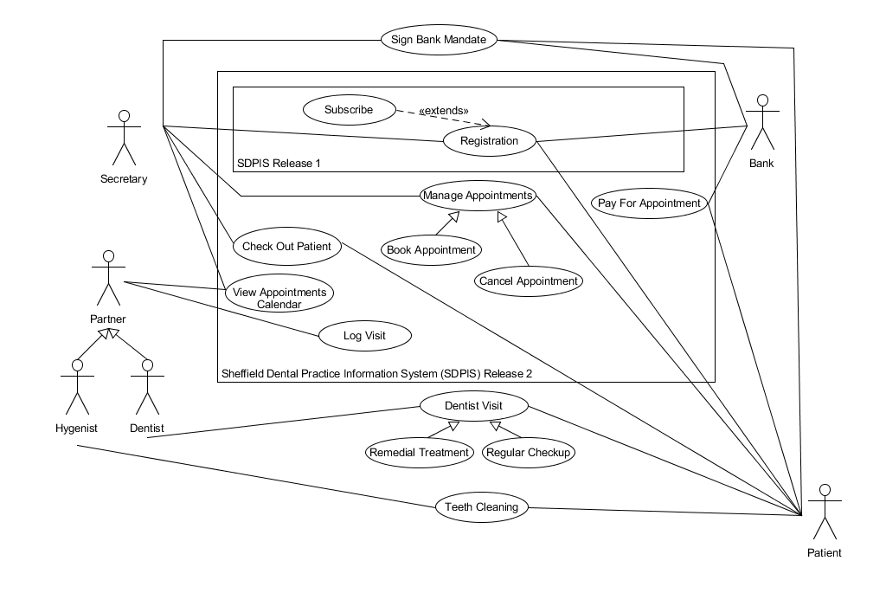

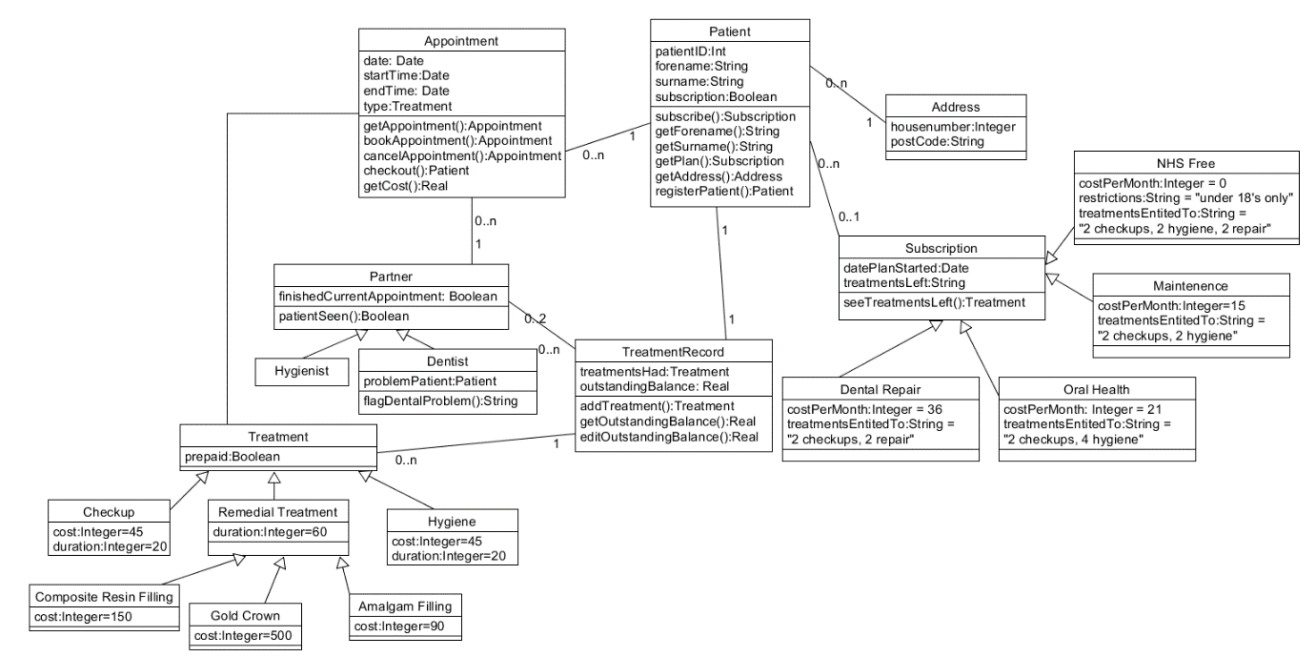UML Information Model (1 page)

UML Normalised Data Model (1 page)

Secretary UI Screenshots (1 page)

Partner UI Screenshots (1 page)

Evidence of Query Processing (6 pages)

Effort Declaration (Reflecting on how effectively we worked) (1 page) (2 tables)(SIGNED)