Prometheus Studio

Frame review design

STATUS  Implementation record |  | OWNER  Prometheus frontend |  | LAST UPDATED  October 15 2026

Authors | Codex implementation
Reviewers | Team review pending
Related docs | docs/video-review-annotations.md
Scope | Floating frame notes and voice input in Compare versions

1. Abstract
The comparison view supports quick feedback without changing its two-player layout. Each video has a compact floating pill for typing or dictation. Enter saves a note with the captured frame; the pill remains ready. One header download exports every frame, note and screenshot as portable JSON.
This implementation covers review feedback on original and rendered video. Screenshots and notes remain in the current browser. Speech uses the existing authenticated transcription endpoint. Shared team storage, video editing and rendering changes are outside this feature.

2. Goals and Non-Goals
Goals | Non-goals
Preserve comparison and native video controls | Replace the comparison layout
Save multiple typed or spoken notes per frame | Apply feedback as video edits
Export all notes and screenshots in one JSON | Add a shared server review database
Release microphone resources on stop or close | Change authentication, billing or provider credentials

3. Background and Problem Statement
The initial implementation used a separate annotation editor and a review toolbar. The requested primary workflow is simpler: stay in comparison, type or speak, press Enter, continue. Drawing tools remain available through a pencil action when a reviewer needs to identify an area.
The invariant is that a note retains its captured frame even if playback or selection changes during transcription. The client owns capture, grouping, recovery and export. The existing speech service owns transcription; existing media endpoints continue to serve the videos.

4. Proposed Architecture

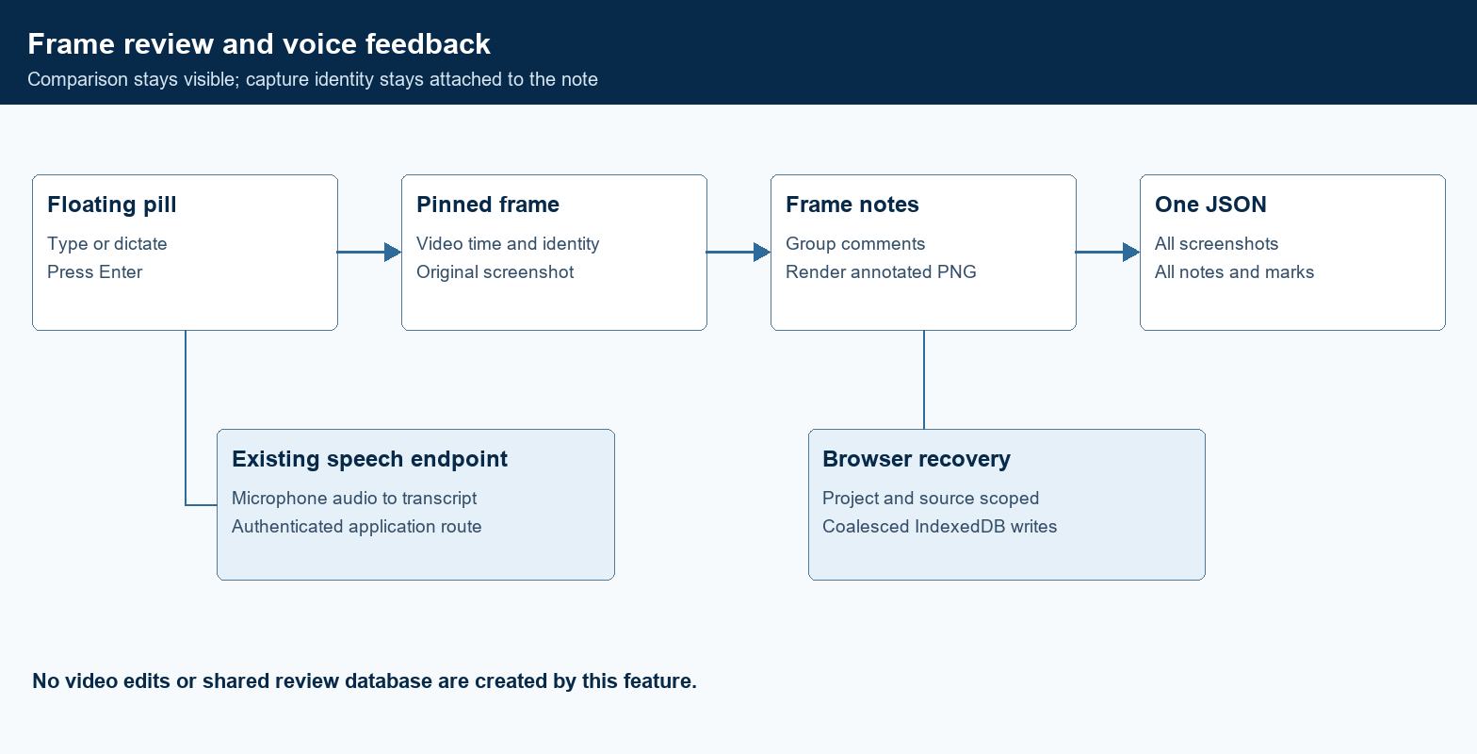
Figure 1. Frame feedback capture and export boundaries.

Core components

Component | Responsibility | Primary storage | Failure behavior
Floating pill | Text entry, microphone, Enter submission and save status | Current note and frame | Keep typed text when saving fails
Frame capture | Pause and capture the decoded source or rendered frame | PNG data URLs | Reject loading, seeking or blocked frames
Dictation hook | Record, transcribe, cancel and deliver text | Temporary microphone stream | Stop tracks and expose a retryable error
Review provider | Group notes, keep drawing drafts and serialize recovery writes | Browser IndexedDB | Show local persistence failures
JSON export | Package identity, notes, marks and embedded screenshots | Downloaded JSON | Keep saved review data available on failure

5. Request Lifecycle
- The reviewer seeks either video and begins typing, or selects the microphone in its pill.
- Capture requires a decoded frame and no pending seek. The video pauses; the source, render ID and timestamp are recorded.
- The provider restores saved entries from IndexedDB, scoped by project ID and source asset ID.
- Typing fills the pill. Dictation records audio for the existing speech endpoint while retaining the initial screenshot.
- Enter appends a note to the matching frame. The client renders an annotated PNG and updates its local review state.
- Recording stops after 60 seconds. Transcription is bounded by a 90 second client timer; closing comparison cancels audio and requests.
- The pill clears after a successful save. A header download serializes the saved frames, notes, identity fields and embedded PNGs.

6. API and Data Contracts

Primary data contract

Field | Type | Required | Description
schemaVersion | number | Yes | Version 1 with additive notes and image fields
projectId | string | Yes | Project containing the reviewed footage
sourceAssetId | string or null | Yes | Current source asset and recovery scope
source and renderId | string and nullable ID | Yes | Original or rendered; render identity when applicable
timeSec and timestamp | number and string | Yes | Exact seconds plus a readable millisecond timestamp
notes and marks | arrays | Yes | Plain text notes and editable normalized drawing marks
image and annotatedImage | PNG data URLs | Yes | Original and annotated screenshots with dimensions

Contract guarantees

- A saved entry contains a readable captured image; a loading or seeking video cannot produce a successful save.
- Frame identity combines source type, render ID and a millisecond timestamp. Repeated deliberate submissions append notes.
- Project, source asset, capture date, source type, render ID, dimensions and exact video time remain in the exported document.
- The review records feedback. It does not mutate the editorial timeline or prove that a requested video change was applied.
The TypeScript contract and usage guide are maintained in the frontend repository.
lib/editor/video-review-annotations.ts and docs/video-review-annotations.md

7. Consistency, Idempotency, and Replay

Submissions from a pill are guarded while saving. Notes at the same source, render and timestamp share a frame entry. Local writes are coalesced and serialized; reopening comparison waits for the prior instance to finish its final write. This is browser-local recovery, not cross-device synchronization or a server transaction.
Scenario | Expected behavior | Reasoning
Repeated Enter on one frame | Append text to that frame entry | Intentional notes are retained together
Frame capture or storage fails | Explain the failure and retain usable text or in-memory review | Do not imply that persistence succeeded
Speech error or timeout | Stop audio and leave typing available | Feedback can continue without microphone service
Playback moves during dictation | Keep the image and timestamp captured at recording start | Transcript latency cannot reassign a comment

8. Security and Privacy Considerations

- Video access continues through the existing authenticated project and render routes. Speech uploads use the existing session-protected transcription POST route.
- Screenshots and text are exported only when the reviewer chooses download. The JSON contains image data rather than expiring media URLs. Microphone audio is sent to the configured speech service; raw audio is not retained in the review JSON.
- The browser receives no new provider key. The dictation hook calls the current application endpoint; provider selection and credentials remain on the server.
- The browser regression test uses a synthetic microphone and intercepts transcription responses. It does not access a user profile or send test recordings to a paid provider.
- Reviews remain subject to browser storage availability and clearing. No account-level retention or cross-device recovery guarantee is introduced. A storage failure is shown to the reviewer so they can download the current review.

9. Operational Readiness
Signal | SLO or alert | Owner | Launch gate
Typed feedback | Enter clears the pill and retains the correct frame | Frontend | Required test
Voice feedback | Synthetic audio produces text for its pinned frame | Frontend | Required test
Resource cleanup | All microphone tracks end on stop and close | Frontend | Required test
Deployment compatibility | Browser bundle contains no Node crypto fallback | Frontend | Required test
Recovery and export | Reload retains entries; JSON carries notes and decodable PNGs | Frontend | Required test
Rollout constraint: run local checks, preserve remote main changes, push the reviewed commit and inspect the Vercel result. A local build is not proof of a production deployment.

10. Alternatives Considered

Alternative | Why it was considered | Why it was not selected
Always open an annotation modal | Supports detailed drawing and placement | Too many steps for routine comments; now optional
Separate text, image and ZIP downloads | Useful for several handoff formats | One portable JSON matches the requested primary action
Browser speech recognition only | Could reduce transcription latency | Support varies; the application already has a speech endpoint
Server synchronization now | Would support shared team state | Requires additional storage and policy beyond the requested frontend flow

11. Open Questions
- Shared review synchronization would require a separate storage and access-control design; it is outside this release.
- The existing speech service expects English recordings. Broader language selection remains a future product decision.
- A live authenticated production check is distinct from the isolated browser tests and should follow the Vercel deployment.
- No new telemetry target or latency SLO is claimed. Recording and transcription bounds are explicit client limits.

12. Decision and Next Steps
Use the floating pill as the default review interface and keep drawing tools optional. Validate typed and dictated notes, screenshot identity, cleanup and recovery before publishing. Fetch and preserve newer changes on main, review the source diff, and push the authorized frontend changes. Confirm the resulting Vercel deployment separately from local test results.
Milestone | Deliverable | Exit criteria
M1 | Minimal pills and frame grouping | Enter preserves source, time, screenshot and all notes
M2 | Dictation and cleanup | Audio produces review text; cancellation releases resources
M3 | Regression and release checks | Browser tests, typecheck and production build are verified
M4 | Main publication | Reviewed frontend commit reaches origin/main and deployment status is inspected

Use footnotes for definitions, assumptions, or terms that need precision without interrupting the main narrative.

