//first program
#include<stdio.h>
int main(){
int *p,*q,*r;
int a =90,b=50;
p=&a;
q=&b;
int c = *p+*q;
r = p-q;
printf("the value of variable a is :%d\n",*p);
printf("address is : %d\n",p);
printf("sum is %d \n",c);
printf("the diff is :%d\n",r);
if(p>q){
printf("trueee\n");
}
else{
printf("not\n");
}
return 0;
}

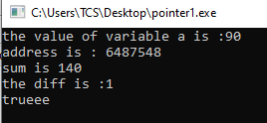
Output:
//second program.
#include<stdio.h>
int main(){
int *p,*q;
int a=30,b=40;
printf("a = %d b = %d\n",a,b);
int temp;
p=&a, q = &b;
temp = *p;
*p=*q;
*q=temp;
printf("swapped value is: \n");
printf("a = %d b = %d",a,b);
return 0;
}

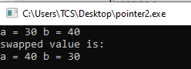
Output:
#include<stdio.h>
void swap(int *,int *);
int main(){
int a,b;
printf("enter any two numbers: \n");
scanf("%d%d",&a,&b);

swap(&a,&b);
printf("After swapping:\n a=%d,b=%d",a,b);
return 0;
}
void swap(int *a,int *b){
printf("Before swapping:\n a=%d,b=%d",*a,*b);
int temp;
temp=*a;
*a=*b;
*b=temp;
}

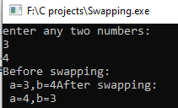
Output:
//pointer to pointer (chain of pointer)
#include<stdio.h>
int main(){
int n;
printf("enter any number\n");
scanf("%d",&n);
int *p;
p=&n;
int **q;
q=&p;
int ***d;
d=&q;
printf("address of pointer 1 is %d\n",p);
printf("address of chain of pointer is :%d\n",q);
printf("address of chain of pointer is :%d\n",d);
printf("value using pointer 1: %d\n",*p);
printf("value using chain of pointer: %d\n",**q);
printf("value using chain of pointer: %d\n",***d);
}

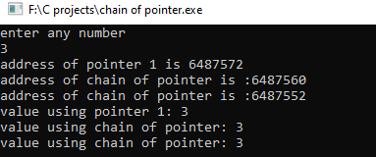
Output:
//without using DMA;
#include <stdio.h>

struct pointer {
int age;
char name[30];
};
int main() {
struct pointer p1;
struct pointer *p;
p = &p1;
printf("Enter your name: ");
scanf(" %[^\n]", p->name);
printf("Enter age: ");
scanf("%d", &p->age);
printf("\nAge is: %d\n", p->age);
printf("Name is: %s\n", p->name);

return 0;
}

Output:
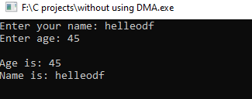
#include <stdio.h>
#include <stdlib.h> // For malloc()

struct pointer {
int age;
char name[30];
} *p;

int main() {
p = (struct pointer *)malloc(sizeof(struct pointer));
if (p == NULL) {
printf("Memory allocation failed!\n");
return 1;
}
printf("Enter your name: ");
scanf(" %[^\n]s", p->name);
printf("Enter age: ");
scanf("%d", &p->age);
printf("\nAge is: %d\n", p->age);
printf("Name is: %s\n", p->name);
free(p);
return 0;
}

Output:
