
Lab Number: 01 Date: 2083/03/29
Title: ER Modeling, Relational Schema Design, and SQL Query Implementation
OBJECTIVES:
- Understand entities, attributes, relationships, and cardinality.
- Convert ER diagrams into relational schemas.
- Create related tables and implement SQL queries in MySQL.
THEORY:
Entity-Relationship (ER) modeling is a conceptual design method used before a database is created. It identifies the main entities in a system, the attributes that describe each entity, and the relationships among them. Attributes may be simple, composite, multivalued, or derived, while relationship constraints describe cardinality such as one-to-one, one-to-many, and many-to-many. Participation constraints also show whether an entity must or may take part in a relationship.
During logical design, the ER model is converted into a relational schema. Each strong entity normally becomes a table, its identifier becomes a primary key, and a one-to-many relationship is represented by placing a foreign key on the many side. A many-to-many relationship requires an associative table containing the keys of both related tables. Correct keys, data types, and referential constraints reduce duplication and protect data integrity.
After the schema is prepared, SQL is used to implement and test the design in MySQL. DDL statements create the database and tables, DML statements insert or modify records, and SELECT queries retrieve information. WHERE filters rows, JOIN combines related tables, and GROUP BY with aggregate functions summarizes data. This progression connects conceptual modeling, relational design, and practical query implementation.
Language: SQL
IDE: MySQL Workbench
Question 1: Library Management System
A library contains books and members. Members can borrow many books, and each book can be borrowed by many members over time. Borrow_Date and Return_Date are stored for every transaction.
1. ER Diagram
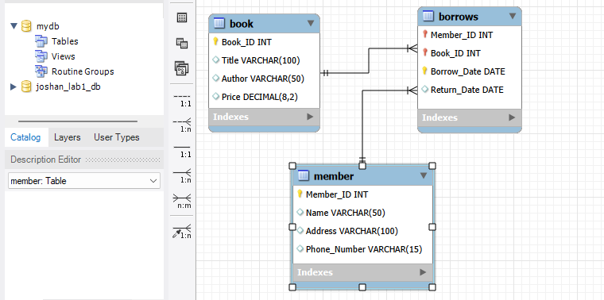
Output:
2. Relational Schema
BOOK (Book_ID PRIMARY KEY, Title, Author, Price)
MEMBER (Member_ID PRIMARY KEY, Name, Address, Phone_Number)
BORROWS (Member_ID, Book_ID, Borrow_Date, Return_Date, PRIMARY KEY(Member_ID, Book_ID, Borrow_Date), FOREIGN KEY(Member_ID) REFERENCES MEMBER(Member_ID), FOREIGN KEY(Book_ID) REFERENCES BOOK(Book_ID))
3. Table Creation and Data Insertion
Query:
DROP DATABASE IF EXISTS joshan_lab1_db;
CREATE DATABASE joshan_lab1_db;
USE joshan_lab1_db;
CREATE TABLE IF NOT EXISTS BOOK (
Book_ID INT PRIMARY KEY,
Title VARCHAR(100),
Author VARCHAR(50),
Price DECIMAL(8,2)
);
CREATE TABLE IF NOT EXISTS MEMBER (
Member_ID INT PRIMARY KEY,
Name VARCHAR(50),
Address VARCHAR(100),
Phone_Number VARCHAR(15)
);
CREATE TABLE IF NOT EXISTS BORROWS (
Member_ID INT,
Book_ID INT,
Borrow_Date DATE,
Return_Date DATE,
PRIMARY KEY (Member_ID, Book_ID, Borrow_Date),
FOREIGN KEY (Member_ID) REFERENCES MEMBER(Member_ID),
FOREIGN KEY (Book_ID) REFERENCES BOOK(Book_ID)
);

Query:
INSERT INTO BOOK VALUES
(101,'Database Systems','XYZ',850.00),
(102,'Operating System','Silberschatz',950.00),
(103,'Computer Networks','XYZ',700.00),
(104,'Java Programming','Herbert Schildt',1000.00);
INSERT INTO MEMBER VALUES
(1,'Joshan Koirala','Kathmandu','9841000001'),
(2,'Sita Karki','Pokhara','9841000002'),
(3,'Hari Thapa','Kathmandu','9841000003');
INSERT INTO BORROWS VALUES
(1,101,'2083-03-29',NULL),
(2,102,'2083-03-30','2083-04-10'),
(3,103,'2083-03-31',NULL);

a. Display the names and phone numbers of all members living in 'Kathmandu'.
Query:
SELECT Name, Phone_Number
FROM MEMBER
WHERE Address = 'Kathmandu';

Output:
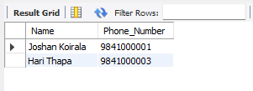
b. Display the Member_Name, Book_Title, and Borrow_Date for all current transactions.
Query:
SELECT
M.Name AS Member_Name,
B.Title AS Book_Title,
BR.Borrow_Date
FROM BORROWS BR
JOIN MEMBER M ON BR.Member_ID = M.Member_ID
JOIN BOOK B ON BR.Book_ID = B.Book_ID
WHERE BR.Return_Date IS NULL;

Output:
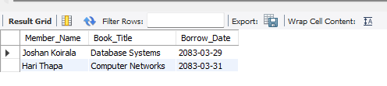

c. Find all books written by the author 'XYZ'.
Query:
SELECT *
FROM BOOK
WHERE Author = 'XYZ';

Output:
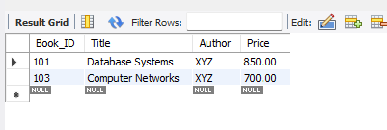

Question 2: School Management System
A school has many teachers and students. Each teacher teaches multiple students. The system stores Teacher_ID, Teacher_Name, Student_ID, Student_Name, and Class.
ER Diagram
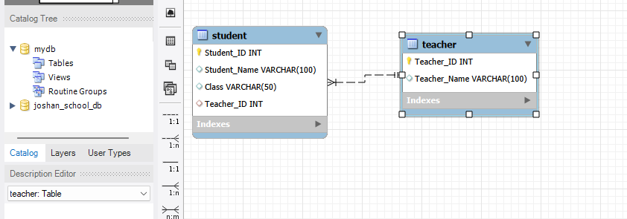
Output:
Relational Schema
TEACHER (Teacher_ID PRIMARY KEY, Teacher_Name)
STUDENT (Student_ID PRIMARY KEY, Student_Name, Class, Teacher_ID FOREIGN KEY REFERENCES TEACHER(Teacher_ID))
Table Creation and Data Insertion
Query:
CREATE DATABASE joshan_school_db;
USE joshan_school_db;
CREATE TABLE IF NOT EXISTS Teacher (
Teacher_ID INT PRIMARY KEY,
Teacher_Name VARCHAR(100)
);
CREATE TABLE IF NOT EXISTS Student (
Student_ID INT PRIMARY KEY,
Student_Name VARCHAR(100),
Class VARCHAR(50),
Teacher_ID INT,
FOREIGN KEY (Teacher_ID) REFERENCES Teacher(Teacher_ID)
);
INSERT INTO Teacher VALUES
(1,'Mr. Karki'),
(2,'Mrs. Neupane'),
(3,'Mr. Kafle');
INSERT INTO Student VALUES
(101,'Joshan','BSc CSIT',1),
(102,'Sagar','BSc CSIT',1),
(103,'Sandesh','BCA',2),
(104,'Manish','BSc CSIT',1),
(105,'pragya','BCA',2),
(106,'Soni','BBS',3);
a. List all students taught by a teacher named 'Mr. Karki'. Display Student Name and Class.
Query:
SELECT S.Student_Name, S.Class
FROM Student S
JOIN Teacher T ON S.Teacher_ID = T.Teacher_ID
WHERE T.Teacher_Name = 'Mr. Karki';

Output:
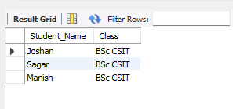

b. Find how many students are assigned to each teacher.
Query:
SELECT T.Teacher_Name,
COUNT(S.Student_ID) AS Total_Students
FROM Teacher T
LEFT JOIN Student S ON T.Teacher_ID = S.Teacher_ID
GROUP BY T.Teacher_ID, T.Teacher_Name;

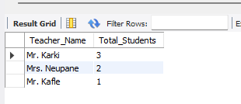
Output:

RESULT:
ER diagrams and relational schemas were prepared for the library and school management systems. The related tables were created successfully, sample records were inserted, and the required SELECT, JOIN, filtering, and aggregate queries produced the expected outputs.

CONCLUSION:
The lab successfully connected conceptual ER modeling with relational database implementation. Proper primary keys, foreign keys, associative tables, and SQL joins made it possible to store related data accurately and retrieve meaningful information.

Lab Number: 02 Date: 2083/03/30
Title: Relational Database Creation and SQL Queries
OBJECTIVES:
- Create related DEPARTMENT and STUD_MEMBER tables.
- Insert the supplied records accurately.
- Practice filtering, joins, counting, pattern matching, and sorting.
THEORY:
A relational database organizes information into tables composed of rows and columns. A row represents one record, a column represents an attribute, and the declared data type defines the permitted domain of each column. A primary key uniquely identifies every row, while a foreign key connects related tables. Entity integrity requires a valid primary key, and referential integrity prevents a foreign-key value from referring to a record that does not exist.
SQL provides different groups of commands for working with relational data. Data Definition Language (DDL), such as CREATE and ALTER, defines database structures. Data Manipulation Language (DML), such as INSERT, UPDATE, and DELETE, changes stored records. Data Query Language uses SELECT to retrieve information. Query clauses including WHERE, BETWEEN, LIKE, ORDER BY, GROUP BY, and aggregate functions make it possible to filter, arrange, count, and summarize the required rows.
In this lab, the DEPARTMENT and STUD_MEMBER tables represent a parent-child relationship. Department identifiers are stored as keys so that student records can be connected to their departments without repeating complete department details. Appropriate data types, NOT NULL rules, and key constraints improve accuracy. Once data is inserted, single-table and joined queries demonstrate how the relational model supports both detailed retrieval and meaningful summaries.
Language: SQL
IDE: MySQL Workbench
A. Create the Relational Database and Insert Data
Query:
DROP DATABASE IF EXISTS joshan_lab2_db;
CREATE DATABASE joshan_lab2_db;
USE joshan_lab2_db;
CREATE TABLE IF NOT EXISTS DEPARTMENT (
Dept_ID INT PRIMARY KEY,
Dept_Name VARCHAR(50) NOT NULL
);
CREATE TABLE IF NOT EXISTS STUD_MEMBER (
Roll_No INT PRIMARY KEY,
FName VARCHAR(30) NOT NULL,
MName VARCHAR(30),
SName VARCHAR(30) NOT NULL,
Dept_ID INT,
Semester INT,
Contact_No VARCHAR(15),
Gender CHAR(1),
FOREIGN KEY (Dept_ID) REFERENCES DEPARTMENT(Dept_ID)
);

Query:
INSERT INTO DEPARTMENT VALUES
(1,'Information Technology'),
(2,'Electrical'),
(3,'Civil'),
(4,'Mechanical'),
(5,'Chemical');
INSERT INTO STUD_MEMBER VALUES
(1,'Ankur','Samir','Kahar',1,1,'272121','M'),
(2,'Dhaval','Dhiren','Joshi',1,1,'232122','M'),
(3,'Ankita','Biren','Shah',1,1,'112121','F'),
(10,'Komal','Maheshkumar','Pandya',2,3,'123123','F'),
(13,'Amit','Jitenkumar','Mehta',3,3,'453667','M'),
(23,'Jinal','Ashish','Gandhi',2,1,'323232','M'),
(22,'Ganesh','Asha','Patel',2,3,'124244','M'),
(4,'Shweta','Mihir','Patel',3,1,'646342','F'),
(7,'Pooja','Mayank','Desai',3,3,'328656','F'),
(8,'Komal','Krishnaraj','Bhatia',2,3,'257422','F'),
(43,'Kiran','Viraj','Shah',1,1,'754124','F');

B. SQL Queries and Outputs
1. Display the names and contact numbers of all student members.
Query:
SELECT FName, MName, SName, Contact_No
FROM STUD_MEMBER;
Output:
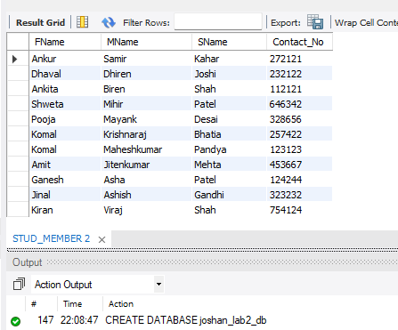

2. Give the names and roll numbers of all students of Information Technology who are members.
Query:
SELECT S.Roll_No, S.FName, S.MName, S.SName
FROM STUD_MEMBER S
JOIN DEPARTMENT D ON S.Dept_ID = D.Dept_ID
WHERE D.Dept_Name = 'Information Technology';
Output:
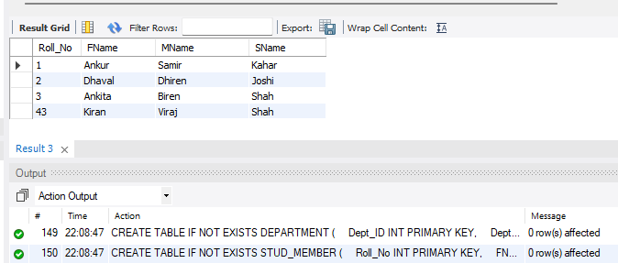
3. Display names of Departments whose students are members.
Query:
SELECT DISTINCT D.Dept_Name
FROM DEPARTMENT D
JOIN STUD_MEMBER S ON D.Dept_ID = S.Dept_ID;

Output:
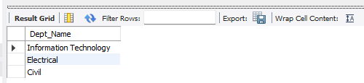

4. Display names of Departments for which no students are members.
Query:
SELECT D.Dept_Name
FROM DEPARTMENT D
LEFT JOIN STUD_MEMBER S ON D.Dept_ID = S.Dept_ID
WHERE S.Roll_No IS NULL;

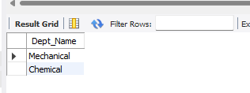
Output:

5. Display names of all Departments.
Query:
SELECT Dept_Name
FROM DEPARTMENT;
Output:
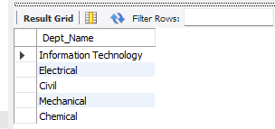

6. Find the number of students of Electrical Department who are members.
Query:
SELECT COUNT(*) AS Total_Students
FROM STUD_MEMBER S
JOIN DEPARTMENT D ON S.Dept_ID = D.Dept_ID
WHERE D.Dept_Name = 'Electrical';

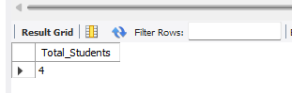
Output:

7. Display information of student members whose name begins with the letter "A".
Query:
SELECT *
FROM STUD_MEMBER
WHERE FName LIKE 'A%';

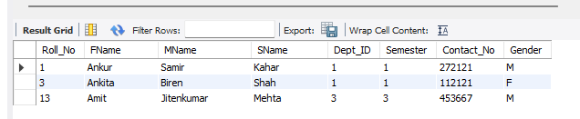
Output:
8. Display all details of Male members only.
Query:
SELECT *
FROM STUD_MEMBER
WHERE Gender = 'M';

Output:
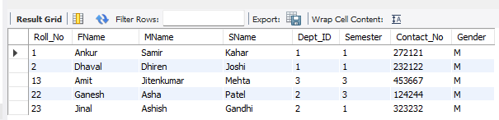
9. Display data of student members who are currently in semester 3.
Query:
SELECT *
FROM STUD_MEMBER
WHERE Semester = 3;

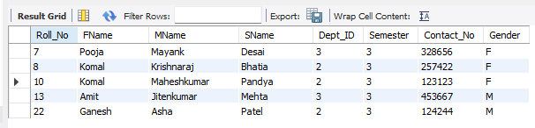
Output:
10. Display data of student female members in alphabetical order.
Query:
SELECT *
FROM STUD_MEMBER
WHERE Gender = 'F'
ORDER BY FName ASC, SName ASC;

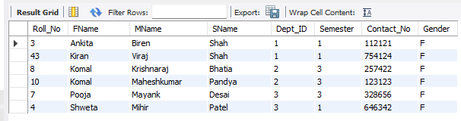
Output:

RESULT:
The DEPARTMENT and STUD_MEMBER tables were created and populated with the required records. Queries using projection, JOIN, DISTINCT, COUNT, LIKE, conditions, and ORDER BY returned the requested student and department information.
CONCLUSION:
The lab demonstrated that a well-designed relational schema reduces duplication and supports accurate data retrieval. Primary and foreign keys maintained the relationship between departments and students, while SQL clauses provided flexible filtering, sorting, and summarization.

Lab Number: 03 Date: 2083/03/31
Title: Database Creation and Table Management Using SQL DDL Commands
OBJECTIVES:
- Create a database and related tables.
- Modify table structures with ALTER and RENAME.
- Apply domain, key, uniqueness, nullability, and default constraints.
- Establish a foreign-key relationship.
THEORY:
Data Definition Language (DDL) is the part of SQL used to create, modify, and remove database structures. CREATE DATABASE and CREATE TABLE IF NOT EXISTS establish a schema, while ALTER TABLE adds, changes, or removes columns and constraints. RENAME changes an object's name, TRUNCATE removes all rows while retaining the table structure, and DROP permanently removes the object itself. IF NOT EXISTS can make creation scripts safer to run more than once.
Constraints enforce business rules at the database level. PRIMARY KEY provides a unique, non-null identifier; FOREIGN KEY maintains relationships between parent and child tables; NOT NULL requires a value; UNIQUE prevents duplicates; DEFAULT supplies a value when none is entered; and CHECK limits accepted values. Choosing suitable numeric, character, and date data types is equally important because a column's type controls storage and validation.
Schema changes must be planned carefully because they can affect existing data and dependent objects. A foreign key can be created only when the referenced key and both column definitions are compatible. Parent and child tables should also be created, altered, and removed in a valid dependency order. This lab therefore demonstrates both the syntax of DDL commands and the structural reasoning required to maintain a consistent relational schema.
Language: SQL
IDE: MySQL Workbench
SQL Questions and Outputs
1. Create a new database named YourName_Db and make it the active database.
Query:
DROP DATABASE IF EXISTS joshan_db;
CREATE DATABASE joshan_db;
USE joshan_db;
SELECT DATABASE();

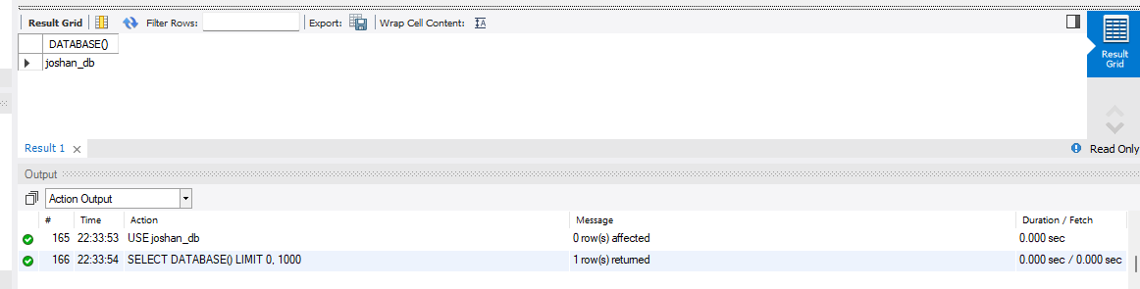
Output:
2. Create a new table Employees with columns for employee ID, first name, last name, and hire date.
Query:
CREATE TABLE IF NOT EXISTS Employees (
Employee_ID INT PRIMARY KEY,
First_Name VARCHAR(50),
Last_Name VARCHAR(50),
Hire_Date DATE
);
INSERT INTO Employees VALUES
(101,'Joshan','Shrestha','2026-01-10'),
(102,'Asha','Karki','2024-05-15'),
(103,'Nabin','Rai','2025-03-20');
DESCRIBE Employees;

Output:
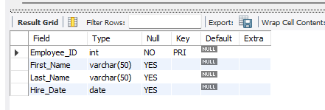
3. Modify the Employees table by adding a new column named Email.
Query:
ALTER TABLE Employees
ADD Email VARCHAR(100);
UPDATE Employees SET Email='joshan@gmail.com' WHERE Employee_ID=101;
UPDATE Employees SET Email='asha@gmail.com' WHERE Employee_ID=102;
UPDATE Employees SET Email='nabin@gmail.com' WHERE Employee_ID=103;
SELECT * FROM Employees;

Output:
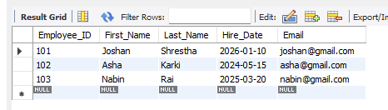

4. Rename the Employees table to Staff.
Query:
ALTER TABLE Employees
RENAME TO Staff;
SHOW TABLES;

Output:
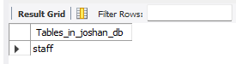

5. Add an Age column to the Employees table and apply a domain constraint to allow only non-negative values.
Query:
ALTER TABLE Staff
ADD Age INT CHECK (Age >= 0);
UPDATE Staff SET Age=21 WHERE Employee_ID=101;
UPDATE Staff SET Age=24 WHERE Employee_ID=102;
UPDATE Staff SET Age=23 WHERE Employee_ID=103;
SELECT * FROM Staff;

Output:
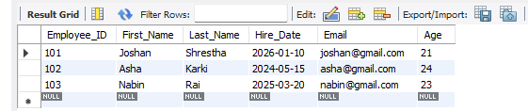
6. Create a Customers table using PRIMARY KEY, UNIQUE, NOT NULL, and DEFAULT constraints.
Query:
CREATE TABLE IF NOT EXISTS Customers (
Customer_ID INT PRIMARY KEY,
CustomerName VARCHAR(100) NOT NULL,
Email VARCHAR(100) UNIQUE,
City VARCHAR(50) DEFAULT 'Kathmandu'
);
DESCRIBE Customers;

Output:
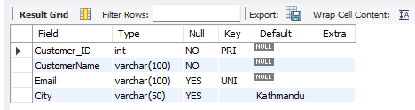

7. Create an Orders table and establish a foreign key relationship with the Customers table.
Query:
CREATE TABLE IF NOT EXISTS Orders (
Order_ID INT PRIMARY KEY,
OrderDate DATE,
Customer_ID INT,
FOREIGN KEY (Customer_ID)
REFERENCES Customers(Customer_ID)
);
DESCRIBE Orders;

Output:
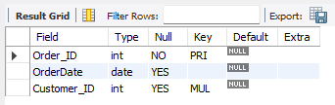

Output:

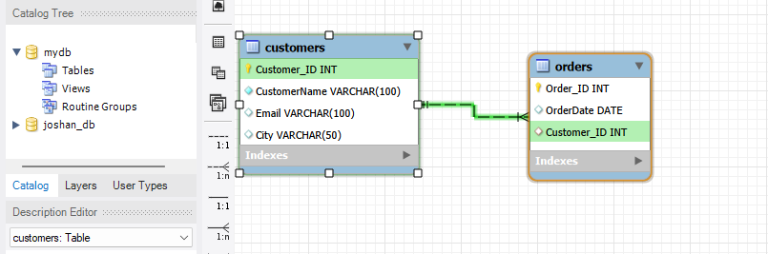
8. Delete the Employees table.
Query:
DROP TABLE Staff;
SHOW TABLES;

Output:
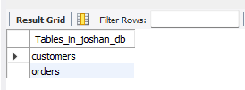

RESULT:
The joshan_db database and the required tables were created successfully. The Employees table was altered, renamed to Staff, and extended with constraints; the Customers and Orders tables were also created with the required primary-key, unique, default, and foreign-key rules.

CONCLUSION:
The lab showed how DDL commands create and modify database structures. Careful use of data types and constraints preserves domain, entity, and referential integrity even when a schema is changed.

Lab Number: 04 Date: 2083/03/32
Title: DML (Data Manipulation Language) and Aggregate Functions
OBJECTIVES:
- Perform INSERT, UPDATE, and DELETE operations.
- Use aggregate functions to summarize order information.
- Group customer totals and filter aggregate results.
THEORY:
Data Manipulation Language (DML) operates on the rows stored in existing tables. INSERT adds new records, UPDATE changes selected records, DELETE removes selected records, and SELECT reads data for verification. UPDATE and DELETE should normally include an accurate WHERE condition; without it, every row may be affected. In MySQL, the result grid and affected-row message help confirm that each statement produced the intended change.
Aggregate functions summarize a set of rows into calculated values. COUNT() returns a number of rows or non-null values, SUM() adds numeric values, AVG() calculates the mean, and MIN() and MAX() return the smallest and largest values. Most aggregate functions ignore NULL values. Aliases make calculated columns easier to understand and allow query output to use meaningful headings.
GROUP BY forms one group for each distinct value or combination of values. WHERE filters individual rows before grouping, whereas HAVING filters the completed groups after aggregate expressions have been evaluated. Aggregate queries are often combined with JOIN so descriptive customer information can be displayed beside order totals. These operations transform detailed transaction records into summaries useful for reporting and decision-making.
Language: SQL
IDE: MySQL Workbench
Database and Table Setup
Query:
DROP DATABASE IF EXISTS joshan_db;
CREATE DATABASE joshan_db;
USE joshan_db;
CREATE TABLE IF NOT EXISTS Customers (
CustomerID INT PRIMARY KEY,
FirstName VARCHAR(50) NOT NULL,
LastName VARCHAR(50) NOT NULL,
Email VARCHAR(100) UNIQUE
);
CREATE TABLE IF NOT EXISTS Orders (
OrderID INT PRIMARY KEY,
CustomerID INT,
OrderDate DATE,
TotalAmount DECIMAL(10,2),
FOREIGN KEY (CustomerID) REFERENCES Customers(CustomerID)
);

1a. Insert records into the Customers table.
Query:
INSERT INTO Customers VALUES
(1,'Joshan','Koirala’, ‘joshan.koirala@gmail.com'),
(2,'Sagar','Koirala’, ‘sagar.koirala@gmail.com'),
(3,'Diwash','Shrestha’, ‘diwash.shrestha@gmail.com'),
(4,'Pritik','Thapa Magar’, ‘pritik.thapa.magar@gmail.com');
SELECT * FROM Customers;

Output:
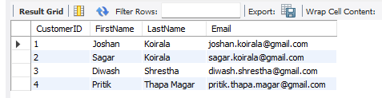

1b. Insert records into the Orders table.
Query:
INSERT INTO Orders VALUES
(1,1,'2026-07-16',150.00),
(2,2,'2026-07-17',200.00),
(3,1,'2026-07-18',250.00),
(4,3,'2026-07-19',100.00);
SELECT * FROM Orders;

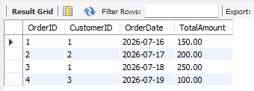
Output:

2a. Change the email address of CustomerID = 1 to CSIT2080@gmail.com.
Query:
UPDATE Customers
SET Email='CSIT2080@gmail.com'
WHERE CustomerID=1;
SELECT * FROM Customers;

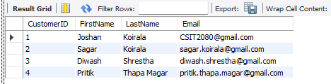
Output:
2b. Update the total amount of OrderID = 1 to 175.00.
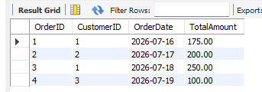
Query:
UPDATE Orders
SET TotalAmount=175.00
WHERE OrderID=1;
SELECT * FROM Orders;

Output:
3. Delete OrderID = 2 and then delete CustomerID = 2.
Query:
DELETE FROM Orders WHERE OrderID=2;
DELETE FROM Customers WHERE CustomerID=2;
SELECT * FROM Orders;
SELECT * FROM Customers;
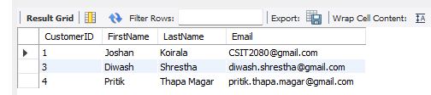
Output:
4a. Count the total number of customers.
Query:
SELECT COUNT(*) AS Total_Customers FROM Customers;

Output:
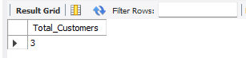

4b. Count the total number of orders.
Query:
SELECT COUNT(*) AS Total_Orders FROM Orders;

Output:
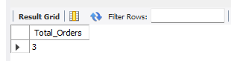

5a. Calculate the total sales amount of all orders.
Query:
SELECT SUM(TotalAmount) AS Total_Sales FROM Orders;

Output:

5b. Find the average order amount.
Query:
SELECT AVG(TotalAmount) AS Average_Order_Amount FROM Orders;

Output:
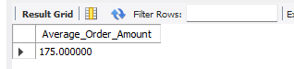

5c. Find the lowest order amount.
Query:
SELECT MIN(TotalAmount) AS Lowest_Order_Amount FROM Orders;


Output:

5d. Find the highest order amount.
Query:
SELECT MAX(TotalAmount) AS Highest_Order_Amount FROM Orders;


Output:

6. Calculate the total amount of orders for each customer.
Query:
SELECT C.CustomerID,C.FirstName,C.LastName,
SUM(O.TotalAmount) AS Total_Amount_Spent
FROM Customers C
JOIN Orders O ON C.CustomerID=O.CustomerID
GROUP BY C.CustomerID,C.FirstName,C.LastName;

Output:
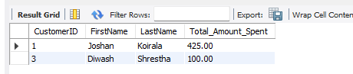

7. Display customers who have spent more than $200 in total.
Query:
SELECT C.FirstName,C.LastName,
SUM(O.TotalAmount) AS Total_Amount_Spent
FROM Customers C
JOIN Orders O ON C.CustomerID=O.CustomerID
GROUP BY C.CustomerID,C.FirstName,C.LastName
HAVING SUM(O.TotalAmount)>200;

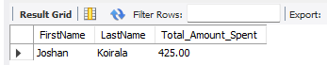
Output:

RESULT:
Customer and order records were inserted, updated, and deleted as required. COUNT, SUM, AVG, MIN, MAX, GROUP BY, and HAVING queries successfully generated overall and customer-wise summaries from the remaining data.

CONCLUSION:
The lab demonstrated how DML statements manage stored records and how aggregate functions convert transaction data into useful summaries. WHERE filters individual rows, while GROUP BY and HAVING analyze and filter groups of related records.

Lab Number: 05 Date: 2083/04/01
Title: Execute Complex Transactions and Realize DCL Commands
OBJECTIVES:
- Grant and revoke table privileges for a database user.
- Use COMMIT to save changes permanently.
- Create savepoints and perform partial rollbacks.
- Observe table states before and after rollback operations.
THEORY:
Data Control Language (DCL) manages authorization for database users. GRANT assigns privileges such as SELECT, INSERT, UPDATE, or DELETE on specific database objects, while REVOKE removes previously assigned privileges. Good database security follows the principle of least privilege: a user should receive only the permissions necessary for the assigned work. MySQL user and privilege statements therefore protect data without preventing legitimate access.
Transaction Control Language (TCL) manages a logical unit of database work. START TRANSACTION begins an explicit transaction, COMMIT makes its changes permanent, and ROLLBACK cancels uncommitted changes. A SAVEPOINT marks an intermediate position, allowing ROLLBACK TO SAVEPOINT to undo only the work performed after that point. Savepoints support controlled recovery during a longer sequence of related statements.
Reliable transactions follow the ACID properties. Atomicity treats the transaction as one complete unit; Consistency preserves constraints and valid states; Isolation limits interference between concurrent transactions; and Durability ensures committed changes survive failures. MySQL commonly uses autocommit, so transaction behavior must be considered before testing COMMIT and ROLLBACK. Some DDL statements also cause an implicit commit, which is why transaction exercises should use transactional DML on an appropriate storage engine.
Language: SQL
IDE: MySQL Workbench
DCL Commands
a. Create the Departments and Employees tables.
Query:
DROP DATABASE IF EXISTS company_db;
CREATE DATABASE company_db;
USE company_db;
CREATE TABLE IF NOT EXISTS Departments (
dept_no INT PRIMARY KEY,
dept_name VARCHAR(50),
dept_location VARCHAR(50)
);
CREATE TABLE IF NOT EXISTS Employees (
emp_id INT PRIMARY KEY,
emp_name VARCHAR(50),
emp_salary DECIMAL(10,2)
);
SHOW TABLES;

Output:
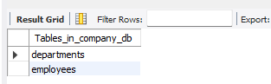

b. Grant all privileges on the Employees table to user 'Radha'.
Query:
CREATE USER IF NOT EXISTS 'Radha'@'localhost'
IDENTIFIED BY 'Radha123';
GRANT ALL PRIVILEGES
ON company_db.Employees
TO 'Radha'@'localhost';
SHOW GRANTS FOR 'Radha'@'localhost';

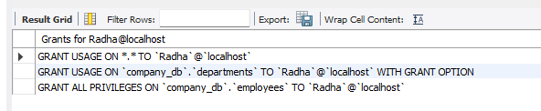
Output:

c. Grant SELECT, INSERT, and UPDATE privileges on Departments to 'Radha' with GRANT OPTION.
Query:
GRANT SELECT, INSERT, UPDATE
ON company_db.Departments
TO 'Radha'@'localhost'
WITH GRANT OPTION;
SHOW GRANTS FOR 'Radha'@'localhost';

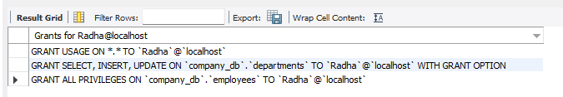
Output:
d. Revoke all privileges on Employees from 'Radha'.
Query:
REVOKE ALL PRIVILEGES
ON company_db.Employees
FROM 'Radha'@'localhost';
SHOW GRANTS FOR 'Radha'@'localhost';

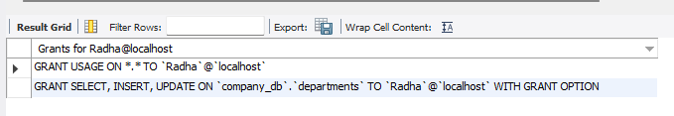
Output:
e. Revoke SELECT, INSERT, and UPDATE privileges on Departments from 'Radha'.
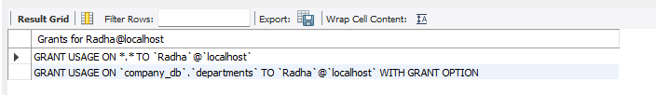
Query:
REVOKE SELECT, INSERT, UPDATE
ON company_db.Departments
FROM 'Radha'@'localhost';
SHOW GRANTS FOR 'Radha'@'localhost';
Output:
TCL Commands and Savepoints
f. Create the Class table.
Query:
SET autocommit=0;
CREATE TABLE IF NOT EXISTS Class (
Name VARCHAR(50),
ID INT PRIMARY KEY
) ENGINE=InnoDB;

g. Insert Name and ID values and permanently save them using COMMIT.
Query:
INSERT INTO Class VALUES
('Joshan Koirala',1),('Sagar Koirala',2),('Diwash Shrestha',3),
('Pritik Thapa Magar',4);
COMMIT;
SELECT * FROM Class;

Output:
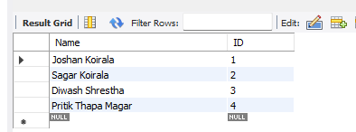

h. Insert a new record.
Query:
INSERT INTO Class VALUES ('Joshan Koirala',9);
SELECT * FROM Class;

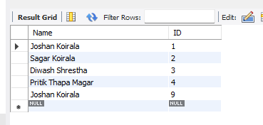
Output:
i. Update the student's name and create Savepoint A.
Query:
UPDATE Class
SET Name='Sagar Koirala'
WHERE ID=9;
SAVEPOINT A;
SELECT * FROM Class;

Output:
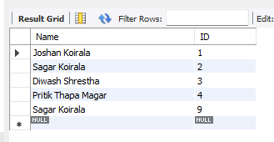

j. Insert another record and create Savepoint B.
Query:
INSERT INTO Class VALUES ('Diwash Shrestha',11);
SAVEPOINT B;

k. Insert one more record.
Query:
INSERT INTO Class VALUES ('Pritik Thapa Magar',13);

l. Display all records from the Class table.
Query:
SELECT * FROM Class;

Output:
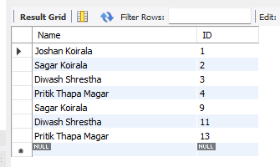
m. Roll back to Savepoint B and display the records.
Query:
ROLLBACK TO B;
SELECT * FROM Class;

Output:
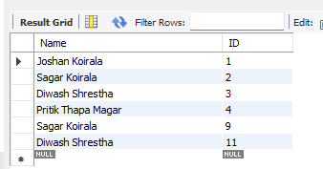

n. Roll back to Savepoint A and display the records.
Query:
ROLLBACK TO A;
SELECT * FROM Class;
COMMIT;

Output:
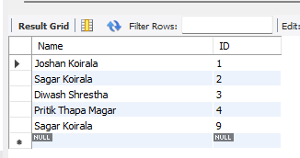

RESULT:
The required privileges were granted to and revoked from the database user. The transaction exercises also executed COMMIT, SAVEPOINT, ROLLBACK TO B, and ROLLBACK TO A successfully, and the displayed table states confirmed which changes were retained or undone.

CONCLUSION:
The lab demonstrated that DCL controls authorized access and TCL controls the permanence of database changes. Privileges enforce least-necessary access, while commits, savepoints, and rollbacks provide safe and selective recovery during transactions.

Lab Number: 06 Date: 2083/04/15
Title: BETWEEN, LIKE, GROUP BY and HAVING Clauses
OBJECTIVES:
- Use BETWEEN and LIKE for range and pattern filtering.
- Summarize orders by date and customer.
- Count grouped records and filter grouped totals using HAVING.
THEORY:
The BETWEEN operator tests whether a value lies within an inclusive lower and upper boundary. It is useful for numbers, dates, and other ordered values, and it is equivalent to using both greater-than-or-equal and less-than-or-equal comparisons. LIKE performs pattern matching on character data: percent (%) represents any sequence of characters, while underscore (_) represents exactly one character. The result may also depend on the column's collation and its case-sensitivity rules.
GROUP BY combines rows that have the same grouping value so aggregate functions can calculate one result for each group. COUNT, SUM, AVG, MIN, and MAX can then describe quantities, totals, averages, and ranges. Every selected column that is not aggregated should identify the group clearly. ORDER BY may be applied afterward to present grouped results in a predictable sequence.
WHERE and HAVING act at different stages of query processing. WHERE removes individual rows before groups are formed, making it appropriate for ordinary range and pattern conditions. HAVING evaluates completed groups and is used for conditions based on COUNT(), SUM(), or another aggregate result. Combining correct filtering, grouping, aliases, and ordering produces concise analytical queries from detailed customer and order records.
Language: SQL
IDE: MySQL Workbench
Database and Table Setup
Query:
DROP DATABASE IF EXISTS joshan_db;
CREATE DATABASE joshan_db;
USE joshan_db;
CREATE TABLE IF NOT EXISTS Customers (
CustomerID INT PRIMARY KEY,
FirstName VARCHAR(50) NOT NULL,
LastName VARCHAR(50) NOT NULL,
Email VARCHAR(100) UNIQUE
);
CREATE TABLE IF NOT EXISTS Orders (
OrderID INT PRIMARY KEY,
CustomerID INT,
OrderDate DATE,
TotalAmount DECIMAL(10,2),
FOREIGN KEY (CustomerID) REFERENCES Customers(CustomerID)
);

Query:
INSERT INTO Customers VALUES
(1,'Joshan','Koirala','joshan.koirala@gmail.com'),
(2,'Sagar','Koirala','sagar.koirala@gmail.com'),
(3,'Diwash','Shrestha','diwash.shrestha@gmail.com'),
(4,'Pritik','Thapa Magar','pritik.thapa.magar@yahoo.com');
INSERT INTO Orders VALUES
(101,1,'2026-07-01',250.00),(102,1,'2026-07-01',350.00),
(103,2,'2026-07-02',200.00),(104,2,'2026-07-03',400.00),
(105,3,'2026-07-02',150.00),(106,4,'2026-07-04',700.00);
1. Find customers whose email contains 'gmail.com' and whose CustomerID is between 2 and 5.
Query:
SELECT * FROM Customers
WHERE Email LIKE '%gmail.com%'
AND CustomerID BETWEEN 2 AND 5;

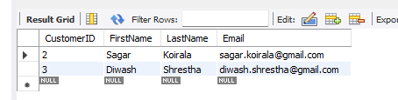
Output:

2. Find the sum of total amount spent for different dates.
Query:
SELECT OrderDate,
SUM(TotalAmount) AS Total_Amount
FROM Orders
GROUP BY OrderDate
ORDER BY OrderDate;

Output:
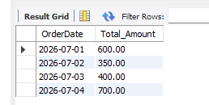

3. Determine the total number of orders placed by each customer.
Query:
SELECT C.CustomerID,
COUNT(O.OrderID) AS Total_Orders
FROM Customers C
LEFT JOIN Orders O ON C.CustomerID=O.CustomerID
GROUP BY C.CustomerID
ORDER BY C.CustomerID;

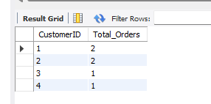
Output:

4. Group customers by LastName and count how many share the same last name.
Query:
SELECT LastName,
COUNT(*) AS Customer_Count
FROM Customers
GROUP BY LastName
ORDER BY LastName;

Output:
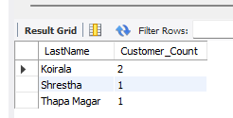

5. Find customer IDs whose total order amount is greater than $500.
Query:
SELECT CustomerID,
SUM(TotalAmount) AS Total_Order_Amount
FROM Orders
GROUP BY CustomerID
HAVING SUM(TotalAmount)>500
ORDER BY CustomerID;

Output:
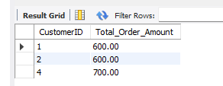

6. Display the first name and total amount spent for customers who placed more than one order.
Query:
SELECT C.FirstName,
SUM(O.TotalAmount) AS Total_Amount_Spent
FROM Customers C
JOIN Orders O ON C.CustomerID=O.CustomerID
GROUP BY C.CustomerID,C.FirstName
HAVING COUNT(O.OrderID)>1
ORDER BY C.CustomerID;

Output:
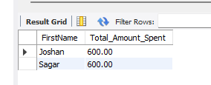

RESULT:
Queries using BETWEEN and LIKE filtered customer records by ranges and patterns. GROUP BY and aggregate functions summarized orders by date and customer, and HAVING correctly returned only the groups that satisfied the specified totals or order-count conditions.

CONCLUSION:
The lab clarified the difference between row-level filtering and group-level filtering. WHERE, BETWEEN, and LIKE select individual records before grouping, whereas HAVING evaluates conditions after aggregate results have been calculated.

Lab Number: 07 Date: 2083/04/18
Title: Perform SQL Queries for SQL Joins
OBJECTIVES:
- Use inner, left, right, natural, and simulated full outer joins.
- Join customers with orders and sales representatives.
- Join order details with products and combine three related tables.
THEORY:
A SQL JOIN combines rows from related tables by evaluating a matching condition. INNER JOIN returns only matching rows. LEFT JOIN preserves every row from the left table and fills unmatched right-side columns with NULL, while RIGHT JOIN preserves every row from the right table. These outer joins are important when a report must include records that do not yet have a related transaction.
MySQL has no direct FULL OUTER JOIN keyword. A comparable result can be produced by combining compatible LEFT JOIN and RIGHT JOIN queries with UNION; UNION removes duplicate rows, while UNION ALL retains them. NATURAL JOIN automatically matches columns with identical names, but it can change unexpectedly if the schema changes. An explicit JOIN ... ON condition is generally clearer because it documents the intended relationship.
Join results reflect the cardinality of the underlying relationships. A one-to-many join repeats the parent values for each matching child row, so aggregate calculations must group at the correct level. Table aliases remove ambiguity when different tables contain columns with the same name, and multi-table joins should connect each table through a valid key path. Understanding NULL values, duplicates, and join direction is essential for producing accurate combined reports.
Language: SQL
IDE: MySQL Workbench
Database and Table Setup
Query:
DROP DATABASE IF EXISTS joshan_lab7_db;
CREATE DATABASE joshan_lab7_db;
USE joshan_lab7_db;
CREATE TABLE IF NOT EXISTS Employee (
employeeNumber INT PRIMARY KEY,
firstName VARCHAR(50),
lastName VARCHAR(50)
);
CREATE TABLE IF NOT EXISTS Customers (
customerNumber INT PRIMARY KEY,
customerName VARCHAR(100),
salesRepEmployeeNumber INT,
FOREIGN KEY (salesRepEmployeeNumber)
REFERENCES Employee(employeeNumber)
);
CREATE TABLE IF NOT EXISTS Orders (
orderNumber INT PRIMARY KEY,
customerNumber INT,
status VARCHAR(30),
FOREIGN KEY (customerNumber)
REFERENCES Customers(customerNumber)
);
CREATE TABLE IF NOT EXISTS Products (
productCode VARCHAR(10) PRIMARY KEY,
productName VARCHAR(100)
);
CREATE TABLE IF NOT EXISTS OrderDetails (
orderNumber INT,
productCode VARCHAR(10),
quantityOrdered INT,
priceEach DECIMAL(10,2),
PRIMARY KEY (orderNumber,productCode),
FOREIGN KEY (orderNumber) REFERENCES Orders(orderNumber),
FOREIGN KEY (productCode) REFERENCES Products(productCode)
);

Query:
INSERT INTO Employee VALUES
(1001,'Asha','Sharma'),
(1002,'Raj','Karki'),
(1003,'Mina','Thapa'),
(1004,'Nabin','Rai');
INSERT INTO Customers VALUES
(101,'Himalayan Traders',1001),
(102,'Everest Supplies',1002),
(103,'Kathmandu Mart',1001),
(104,'Pokhara Store',NULL),
(105,'Lalitpur Wholesale',1003);
INSERT INTO Orders VALUES
(5001,101,'Shipped'),
(5002,101,'In Process'),
(5003,102,'Shipped'),
(5004,103,'Cancelled'),
(5005,105,'Shipped');
INSERT INTO Products VALUES
('P101','Keyboard'),('P102','Mouse'),
('P103','Monitor'),('P104','Printer');
INSERT INTO OrderDetails VALUES
(5001,'P101',5,25.00),(5001,'P102',10,15.00),
(5002,'P103',2,180.00),(5003,'P104',1,220.00),
(5004,'P102',4,16.00),(5005,'P101',3,24.00),
(5005,'P103',1,175.00);

1. What are the customerNumber, customerName, orderNumber, and status for all customers and their orders?
Query:
SELECT C.customerNumber,C.customerName,
O.orderNumber,O.status
FROM Customers C
LEFT JOIN Orders O
ON C.customerNumber=O.customerNumber;

Output:
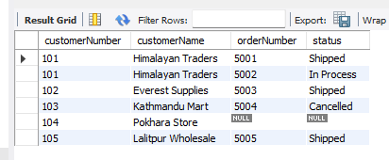
2. What productCode and productName are associated with each orderNumber?
Query:
SELECT OD.orderNumber,P.productCode,P.productName
FROM OrderDetails OD
JOIN Products P ON OD.productCode=P.productCode
ORDER BY OD.orderNumber,P.productCode;

Output:
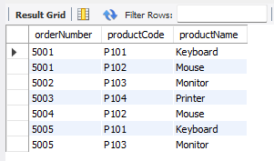

3. What are the customerNumber, orderNumber, status, and customerName for all orders and their associated customers?
Query:
SELECT O.customerNumber,O.orderNumber,O.status,
C.customerName
FROM Orders O
JOIN Customers C
ON O.customerNumber=C.customerNumber;

Output:
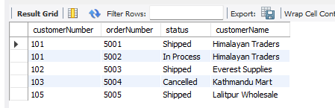

4. What customer and sales representative information is available for each customer?
Query:
SELECT C.customerNumber,C.customerName,
C.salesRepEmployeeNumber,E.lastName,E.firstName
FROM Customers C
LEFT JOIN Employee E
ON C.salesRepEmployeeNumber=E.employeeNumber;

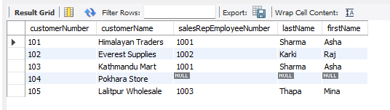
Output:

5. What employees and their associated customers can be displayed?
Query:
SELECT C.customerNumber,C.customerName,
E.employeeNumber,E.lastName,E.firstName
FROM Employee E
LEFT JOIN Customers C
ON E.employeeNumber=C.salesRepEmployeeNumber
ORDER BY E.employeeNumber,C.customerNumber;

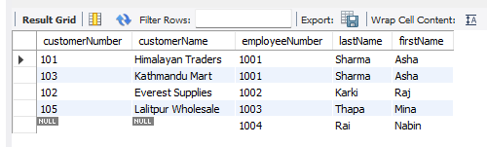
Output:

6. How can a FULL OUTER JOIN between Customers and Employee be performed in MySQL?
Query:
SELECT C.customerNumber,C.customerName,
E.employeeNumber,E.firstName,E.lastName
FROM Customers C
LEFT JOIN Employee E
ON C.salesRepEmployeeNumber=E.employeeNumber
UNION
SELECT C.customerNumber,C.customerName,
E.employeeNumber,E.firstName,E.lastName
FROM Customers C
RIGHT JOIN Employee E
ON C.salesRepEmployeeNumber=E.employeeNumber;

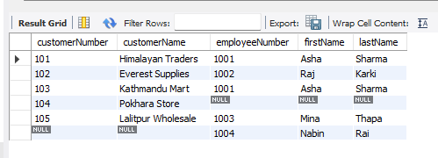
Output:

7. Display customerNumber, orderNumber, status, and customerName for all orders with associated customers.
Query:
SELECT O.customerNumber,O.orderNumber,O.status,C.customerName
FROM Orders O
JOIN Customers C
ON O.customerNumber=C.customerNumber;

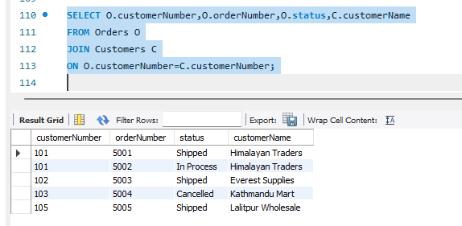
Output:

8. Display the same order and customer information using NATURAL JOIN.
Query:
SELECT customerNumber,orderNumber,status,customerName
FROM Orders
NATURAL JOIN Customers;

Output:
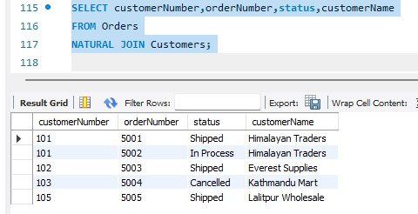

9. Display the same order and customer information using INNER JOIN.
Query:
SELECT O.customerNumber,O.orderNumber,O.status,C.customerName
FROM Orders O
INNER JOIN Customers C
ON O.customerNumber=C.customerNumber;

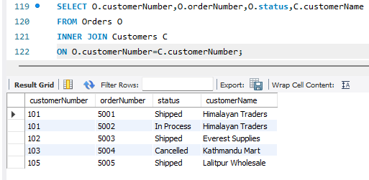
Output:

10. Join Orders and Customers explicitly on customerNumber.
Query:
SELECT O.customerNumber,O.orderNumber,O.status,C.customerName
FROM Orders O
JOIN Customers C
ON O.customerNumber=C.customerNumber;

Output:
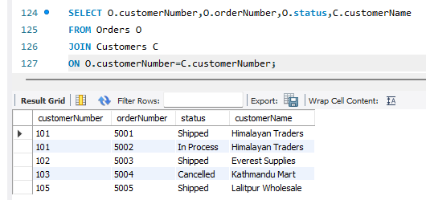

11. Perform a join across Customers, Orders, and OrderDetails.
Query:
SELECT C.customerNumber,C.customerName,
O.orderNumber,OD.productCode,
OD.quantityOrdered,OD.priceEach
FROM Customers C
JOIN Orders O ON C.customerNumber=O.customerNumber
JOIN OrderDetails OD ON O.orderNumber=OD.orderNumber
ORDER BY C.customerNumber,O.orderNumber,OD.productCode;

Output:
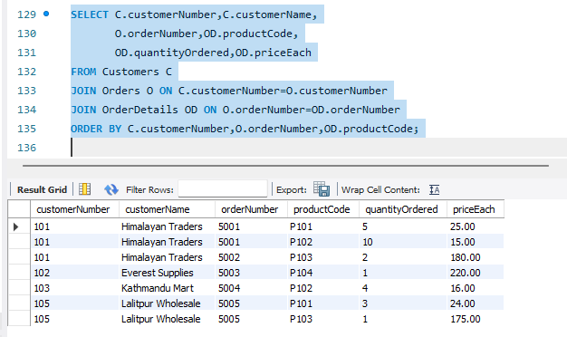
RESULT:
The required inner, left, right, natural, simulated full outer, and multi-table joins were executed successfully. The outputs combined customer, employee, order, order-detail, and product information according to the relationships defined by their matching keys.

CONCLUSION:
The lab demonstrated that SQL joins retrieve related information stored in separate tables. Selecting the correct join type determines whether only matching rows or also unmatched rows are included, while explicit join conditions make multi-table queries accurate and understandable.

