Lab Number: 08 Date: 2082/04/19
Title: SQL Queries Using the Nested Query Approach.
OBJECTIVES:
- Understand the purpose and execution of nested queries (subqueries) in SQL.
- Retrieve related information from customer, order, product, order-detail, and employee tables.
- Apply IN, NOT EXISTS, and multi-level subqueries correctly in MySQL Workbench.
THEORY:
A nested query, also known as a subquery, is an SQL query written inside another SQL statement. The inner query is evaluated first and its result is supplied to the outer query for filtering, comparison, or further processing. A subquery is enclosed in parentheses and may return one value, one row, one column, or a complete intermediate result set. This approach is useful when a problem naturally consists of several dependent retrieval steps.
Subqueries are commonly placed in WHERE and HAVING clauses and are used with operators such as IN, NOT IN, EXISTS, NOT EXISTS, ANY, ALL, and the usual comparison operators. IN is suitable when the inner query returns several possible key values. EXISTS and NOT EXISTS test whether a related row is present and are especially reliable for finding records with or without matching rows. A correlated subquery refers to a value from the outer query and is evaluated for each outer row.
In this lab, primary and foreign keys connect employees, customers, orders, order details, and products. Multi-level subqueries follow those relationships to identify products ordered by a customer, customers with shipped or pending orders, assigned sales representatives, and customers or products that have no related transaction. Well-designed subqueries make complex retrieval logic clear, but their returned column and data type must match the condition used by the outer query.

Language: SQL
IDE: MySQL Workbench
LAB 8: NESTED QUERIES USING THE SUBQUERY APPROACH
Create the following MySQL database, related tables, and sample records before running the required nested queries.
Database and Table Setup
Query:
DROP DATABASE IF EXISTS joshan_lab8;
CREATE DATABASE joshan_lab8;
USE joshan_lab8;
CREATE TABLE employees (
employeeNumber INT PRIMARY KEY,
firstName VARCHAR(50) NOT NULL,
lastName VARCHAR(50) NOT NULL
);
CREATE TABLE customers (
customerNumber INT PRIMARY KEY,
customerName VARCHAR(100) NOT NULL,
salesRepEmployeeNumber INT,
FOREIGN KEY (salesRepEmployeeNumber)
REFERENCES employees(employeeNumber)
);
CREATE TABLE products (
productCode VARCHAR(10) PRIMARY KEY,
productName VARCHAR(100) NOT NULL
);
CREATE TABLE orders (
orderNumber INT PRIMARY KEY,
customerNumber INT NOT NULL,
status VARCHAR(30) NOT NULL,
FOREIGN KEY (customerNumber)
REFERENCES customers(customerNumber)
);
CREATE TABLE orderdetails (
orderNumber INT,
productCode VARCHAR(10),
quantityOrdered INT NOT NULL,
PRIMARY KEY (orderNumber, productCode),
FOREIGN KEY (orderNumber) REFERENCES orders(orderNumber),
FOREIGN KEY (productCode) REFERENCES products(productCode)
);
Sample Data
Query:
INSERT INTO employees VALUES
(101, 'Joshan', 'Koirala'),
(102, 'Sagar', 'Koirala'),
(103, 'Diwash', 'Shrestha'),
(104, 'Pritik', 'Thapa Magar');
INSERT INTO customers VALUES
(1, 'ABC Traders', 101),
(2, 'Everest Suppliers', 102),
(3, 'Himalayan Mart', 101),
(4, 'Valley Stores', 103),
(5, 'No Order Customer', 104);
INSERT INTO products VALUES
('P001', 'Laptop'),
('P002', 'Keyboard'),
('P003', 'Mouse'),
('P004', 'Printer');
INSERT INTO orders VALUES
(1001, 1, 'Shipped'),
(1002, 2, 'Pending'),
(1003, 3, 'Shipped'),
(1004, 4, 'Pending');
INSERT INTO orderdetails VALUES
(1001, 'P001', 2),
(1001, 'P002', 5),
(1002, 'P003', 4),
(1003, 'P001', 1);
1. Find the product code and product name for the products ordered by customer number 1.
Query:
SELECT productCode, productName
FROM products
WHERE productCode IN (
SELECT productCode
FROM orderdetails
WHERE orderNumber IN (
SELECT orderNumber
FROM orders
WHERE customerNumber = 1
)
);
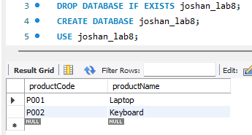
Output:

2. Find the customer’s name who placed orders with the status 'Shipped'.
Query:
SELECT customerName
FROM customers
WHERE customerNumber IN (
SELECT customerNumber
FROM orders
WHERE status = 'Shipped'
);
Output:
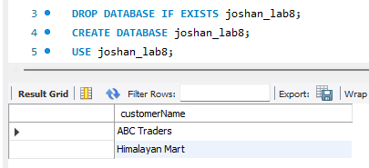

3. Find the customer’s name and sales representative employee number for customers who placed orders with order numbers 1001 and 1003.
Query:
SELECT customerName, salesRepEmployeeNumber
FROM customers
WHERE customerNumber IN (
SELECT customerNumber
FROM orders
WHERE orderNumber IN (1001, 1003)
);
Output:
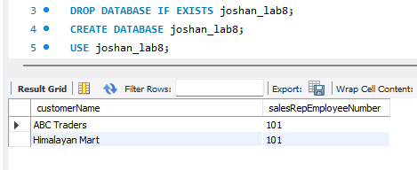

4. List the first name and last name of employees who are sales representatives of customer 'ABC Traders'.
Query:
SELECT firstName, lastName
FROM employees
WHERE employeeNumber IN (
SELECT salesRepEmployeeNumber
FROM customers
WHERE customerName = 'ABC Traders'
);
Output:
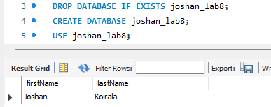

5. List the first name and last name of employees who are assigned to customers having orders with status 'Pending'.
Query:
SELECT firstName, lastName
FROM employees
WHERE employeeNumber IN (
SELECT salesRepEmployeeNumber
FROM customers
WHERE customerNumber IN (
SELECT customerNumber
FROM orders
WHERE status = 'Pending'
)
);
Output:
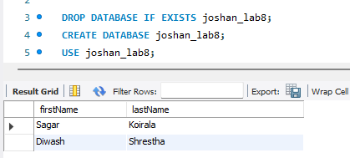

6. Find the customer names who ordered the product 'Laptop'.
Query:
SELECT customerName
FROM customers
WHERE customerNumber IN (
SELECT customerNumber
FROM orders
WHERE orderNumber IN (
SELECT orderNumber
FROM orderdetails
WHERE productCode IN (
SELECT productCode
FROM products
WHERE productName = 'Laptop'
)
)
);
Output:
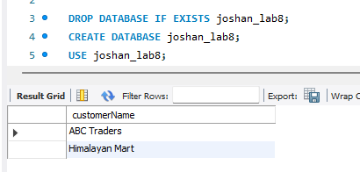
7. Find the names of customers who have not placed any orders.
Query:
SELECT customerName
FROM customers AS c
WHERE NOT EXISTS (
SELECT 1
FROM orders AS o
WHERE o.customerNumber = c.customerNumber
);
Output:
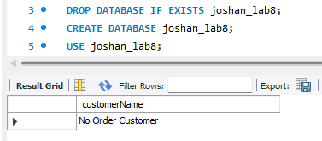

8. Find the product names that have never been ordered.
Query:
SELECT productName
FROM products AS p
WHERE NOT EXISTS (
SELECT 1
FROM orderdetails AS od
WHERE od.productCode = p.productCode
);
Output:
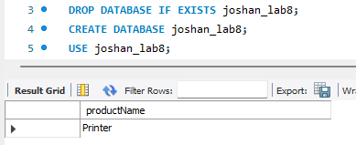
9. Find the customer names whose sales representative is employee number 101.
Query:
SELECT customerName
FROM customers
WHERE salesRepEmployeeNumber IN (
SELECT employeeNumber
FROM employees
WHERE employeeNumber = 101
);
Output:
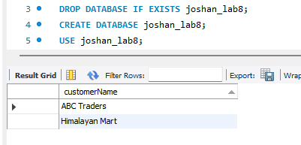

RESULT:
The nested queries were executed successfully in the joshan_lab8 database. They retrieved the required product, customer, order, and employee records based on order status, product selection, sales representative assignments, and the presence or absence of related orders.
CONCLUSION:
The lab successfully demonstrated the use of nested queries in MySQL. Subqueries using IN, NOT IN, and multiple levels of nesting efficiently extracted related data from interconnected tables and identified records with no corresponding transactions.

