Investigation of Celestial Events and Megaconstellation Effects on Space Telescopes
A Case Study of NASA's SPHEREx, with an Extended Real-Orbital-Data Analysis
Joshanraj C V
B.Sc. Physics, SRM Institute of Science and Technology (SRM KTR), Chennai
Original undergraduate project supervised by Dr. Tushar H. Rana, Department of Physics and Nanotechnology (submitted April 2026); extended analysis conducted independently thereafter
Status: manuscript in preparation, not yet submitted for publication

Abstract
Satellite megaconstellations in Low Earth Orbit increasingly share the altitudes used by space telescopes. NASA's SPHEREx — a wide-field (39.5 deg²), 102-band near-infrared all-sky survey launched in March 2025 into a ~650 km Sun-synchronous orbit — is a natural test case. This work has two parts. The first is an original reflectance-based photometric model (undergraduate project, 2025–26) of trail surface brightness versus range for four representative satellite types. The second is a from-scratch computational extension built on real orbital data: SGP4 propagation of real satellites, a Monte Carlo encounter model that applies SPHEREx's actual survey constraints (35° maximum zenith angle, 91° solar avoidance, 112.5 s exposures), a one-year real-orbit validation, blackbody thermal-infrared photometry across SPHEREx's 102 bands, and a TLE positional-uncertainty error budget.
The central physical result is geometric: under SPHEREx's 35° zenith limit every line of sight climbs away from Earth, so only satellites orbiting above ~650 km can ever cross the field. All Starlink and Amazon Leo shells contribute exactly zero (0 crossings in ~4.8 million simulated valid exposures). Averaged over a year, the publicly filed constellations above SPHEREx's orbit (OneWeb, Guowang GW-2, Qianfan, Telesat Lightspeed; ~28,500 satellites) give 5.9 ± 0.1 trails per exposure at full build-out, consistent with the 5.64 (+0.28/−0.27) published by Borlaff et al. (2025); the future figure depends mainly on how much of Qianfan is built (3.1 if only its 1,296-satellite near-term phase). A one-year comparison against a real OneWeb orbit validates the statistical model to about ±35% (real/model = 1.01). At today's population the rate is ~0.24 trails per exposure (about one exposure in four), from OneWeb, Guowang and Qianfan. Observable crossings are near-overhead (median range 640 km), last a few seconds, and beyond 3.4–4.1 μm are dominated by the satellite's own thermal emission. Earlier versions of this analysis reported ~2.3 and then 4.5 trails per exposure; both are superseded (§7.2).

1. Introduction
For decades, space telescopes were considered the definitive solution to ground-based light pollution: above the atmosphere, a telescope escapes the glow of city lights, atmospheric turbulence, and the wavelengths the atmosphere absorbs. That assumption held for roughly forty years. In May 2019, SpaceX launched its first batch of 60 Starlink satellites, and within days astronomers and photographers were reporting bright streaks across long-exposure images.
Since 2019, the number of active satellites in Low Earth Orbit has grown from roughly 2,000 to more than 15,000, and companies across the United States, Europe, and China have filed plans for over 560,000 satellites over the next decade and a half. If even partially realised, the orbital environment SPHEREx now occupies will be almost unrecognisable within its own operational lifetime.
This report documents, as clearly as possible, what the evidence says will happen to SPHEREx if current trends continue, what already has happened at today's real population (via an independent, from-scratch analysis using real orbital data), and what remains genuinely unresolved.

2. The Rise of Satellite Megaconstellations

2.1 Background
A megaconstellation is a group of hundreds to tens of thousands of satellites working toward a shared commercial goal, typically global broadband delivery from Low Earth Orbit. The concept is not new — Iridium launched 66 satellites for telephony in 1998 — but early systems were small, and launch costs were prohibitive. Reusable rockets (principally SpaceX's Falcon 9) and falling small-satellite manufacturing costs changed the economics: SpaceX's first Starlink launch in May 2019 carried 60 satellites at once, a number that quickly became routine.

2.2 Major Operators
Operator | Constellation | In orbit (2026) | Planned total | Altitude (km)
SpaceX (USA) | Starlink | ~9,400 (early 2026) | Up to 42,000 | 340–614
Amazon (USA) | Amazon Leo (fmr. Kuiper) | ~200 (early 2026) | 3,236 (Phase 1) | 590–630
Eutelsat/OneWeb (EU/UK) | OneWeb | 654 (Aug 2026) | ~6,372 (Gen 2 filing) | ~1,200
China (state) | Guowang | 186 (Sep 2026) | 12,992 | ~590 (GW-A59); ~1,145 (GW-2)
SSST (China) | Qianfan | ~248 (Sep 2026) | ~15,000 (filed; 1,296 near-term) | ~1,000–1,160
Starlink alone held roughly three quarters of all active satellites at the end of 2025. China's Guowang (state-owned) and Qianfan (commercial) together represent a comparable future Chinese LEO infrastructure, and unlike Starlink and Amazon Leo, both place most of their satellites above SPHEREx's ~650 km orbit. (In-orbit counts: KeepTrack and Orbital Radar, August–September 2026.)

2.3 Growth Trajectory
Active LEO satellite counts grew from roughly 400 in 2000, to 2,000 at Starlink's first launch (2019), to about 15,000 by 2025 — and industry filings project roughly 100,000 by 2030 and up to 560,000 at full constellation build-out by the late 2030s. That 560,000 figure is not a worst-case hypothetical; it is what has actually been filed with regulators.

2.4 Orbital Overlap with Astronomy
Almost all megaconstellation satellites operate between 340 and 1,200 km altitude — precisely the band most LEO space telescopes occupy. SPHEREx orbits at ~650 km; Hubble at ~540 km; China's planned Xuntian telescope at 400–450 km. This overlap is not accidental: Low Earth Orbit is where internet satellites need to be for competitive signal latency (a 550 km satellite has under 30 ms round-trip delay, versus ~600 ms from geostationary orbit).
Any LEO satellite, warmed by the Sun, radiates thermally in the infrared — a mechanism reflective-surface darkening (used to mitigate optical brightness for ground-based astronomers) does essentially nothing to address, since thermal emission is a function of temperature, not surface colour.

3. The SPHEREx Mission

3.1 Overview and Science Goals
SPHEREx (Spectro-Photometer for the History of the Universe, Epoch of Reionization, and Ices Explorer) launched 11 March 2025 on a Falcon 9 from Vandenberg Space Force Base, managed by JPL and Caltech under Principal Investigator James Bock, selected under NASA's MIDEX program at a cost of roughly $500 million. Its three science objectives: probing cosmic inflation via the large-scale distribution of hundreds of millions of galaxies (primordial non-Gaussianity, f_NL); tracing galaxy evolution via intensity mapping of the cosmic web; and surveying protostellar clouds and planet-forming disks for water ice and other pre-biotic molecules within the Milky Way.

3.2 Instrument
SPHEREx uses a 20 cm aperture telescope with an unusually wide field of view: 3.5° × 11.3°, about 39.5 deg² per exposure. Rather than dispersive optics, it uses linear variable filters over six Teledyne H2RG HgCdTe detector arrays arranged as two focal planes of three (0.75–2.44 μm and 2.40–5.01 μm, split by a dichroic beamsplitter), reconstructing a 102-channel spectrum per sky position from multiple offset exposures. The arrays are passively cooled below 80 K (short-wave) and 60 K (long-wave). SPHEREx completes an all-sky survey roughly every six months, four surveys over its two-year prime mission, with 112.5 s exposures (Crill et al. 2024).

3.3 Orbit and Pointing Constraints
SPHEREx flies a terminator-aligned Sun-synchronous orbit at ~650 km. Its survey pointings are restricted to within 35° of local zenith (i.e. looking away from Earth, never toward the limb) and to at least 91° from the Sun throughout each 112.5 s exposure, both primarily for thermal management (Borlaff et al. 2025, Methods). These two rules turn out to control SPHEREx's exposure to satellites almost completely: §7.3 shows that the zenith limit alone makes every satellite orbiting below SPHEREx geometrically invisible to it.

3.4 Comparison with Other LEO Telescopes
Parameter | SPHEREx | Hubble | Xuntian (China) | ARRAKIHS (ESA)
Altitude (km) | ~650 | ~540 | ~400–450 | ~700
Field of view (deg²) | 39.5 | ~0.01 | ~1.4 | ~0.7
Wavelength coverage | 0.75–5.0 μm | UV–near-IR | 0.255–1.0 μm | 0.6–1.65 μm
Status (2026) | Active (Mar 2025) | Active (1990) | Planned ~2026 | Planned 2030s
(Source: Borlaff et al. 2025, Nature, Table ED2.)

4. How Satellites Contaminate a Space Telescope

4.1 Trails in Optical and Infrared
A satellite crossing a telescope's field of view during an exposure leaves a straight streak on the detector. At optical wavelengths, brightness depends on reflected sunlight — satellite size, reflectivity, and Sun-satellite-telescope geometry. At infrared wavelengths, where SPHEREx operates, thermal self-emission becomes a second, independent contribution: any satellite warmed by the Sun radiates most strongly in the mid-infrared but still contributes meaningfully in SPHEREx's 2.4–5.0 μm band. Because satellites give off both reflected light and heat, blocking them out completely in the infrared is effectively impossible — darkening a surface reduces reflection but cannot reduce a satellite's temperature to absolute zero.

4.2 The Solar-Panel Problem
SpaceX orients Starlink satellites to reduce the reflected brightness seen by ground-based observers. For space telescopes the picture is different: brightness depends on the viewing geometry from orbit, and in the infrared on the satellite's temperature, which darkening does not change. For SPHEREx specifically this particular concern turns out to be moot, because Starlink orbits below it and its zenith-pointing survey can never see satellites below its own altitude (§7.3); it matters for telescopes that orbit above or among the Starlink shells.

4.3 Field-of-View Exposure
Contamination probability scales roughly with field-of-view area, and SPHEREx's 39.5 deg² field is thousands of times larger than the field of Hubble's main cameras. Borlaff et al. (2025) find that at full constellation build-out more than 92% of SPHEREx exposures would contain at least one trail, because even a single trail in such a large frame counts as contamination.

4.4 Surface Brightness
Surface brightness (mag/arcsec², lower = brighter) quantifies how a trail compares to the faint sky backgrounds SPHEREx is designed to measure. Borlaff et al. (2025) report a median SPHEREx trail surface brightness of 21.1 (+1.9/−3.0) mag/arcsec² — substantially brighter than the science signal, and wide enough (several arcminutes) that the affected region, once local-background recalibration is included, exceeds the trail's own width.

5. Original Analysis: Reflectance-Based Brightness Modelling
The following is the original undergraduate-level photometric analysis (2025–26): a first-principles reflectance model for four representative satellite types, evaluated as a function of range. It does not include orbital propagation, thermal-IR modelling, or population statistics — those are addressed from scratch in the extension beginning at §6.
Satellite | Diameter D (m) | Albedo p | Angular velocity ω (arcsec/s)
Starlink V1.0 | 6.50 | 0.250 | 237.37
Starlink V1.5 | 5.30 | 0.250 | 241.94
Starlink V2 Mini | 11.50 | 0.055 | 246.00
OneWeb (Gen 1) | 3.91 | 0.250 | 243.00
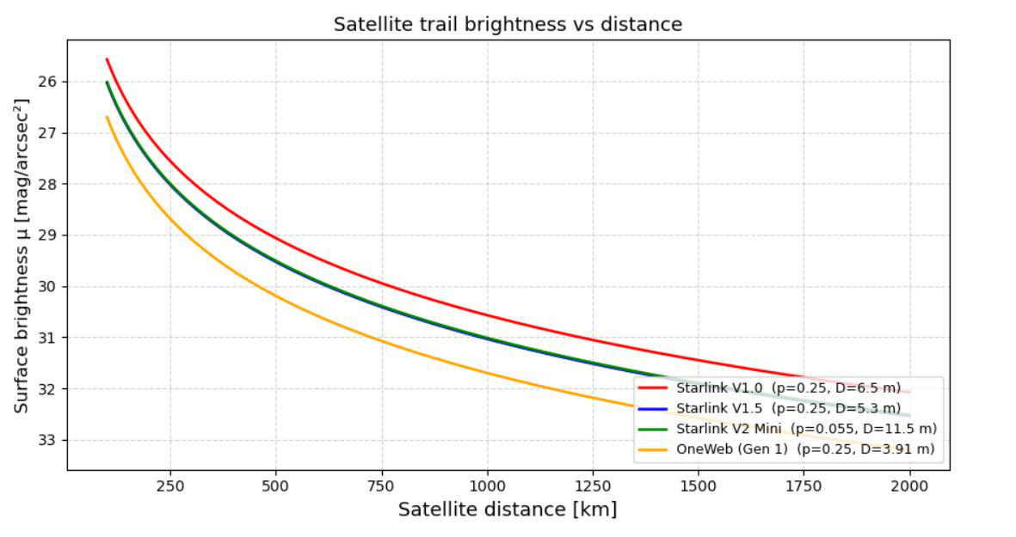
Figure 5.1. Reflectance-based surface brightness vs. range for four satellite types (original analysis).
Surface brightness decreases roughly as the square of distance for all four satellites, most steeply within the first few hundred kilometres. At short range even the smallest satellite (OneWeb Gen 1) produces a trail bright enough to seriously contaminate an exposure; by 2,000 km all four have faded substantially, though remain measurable.
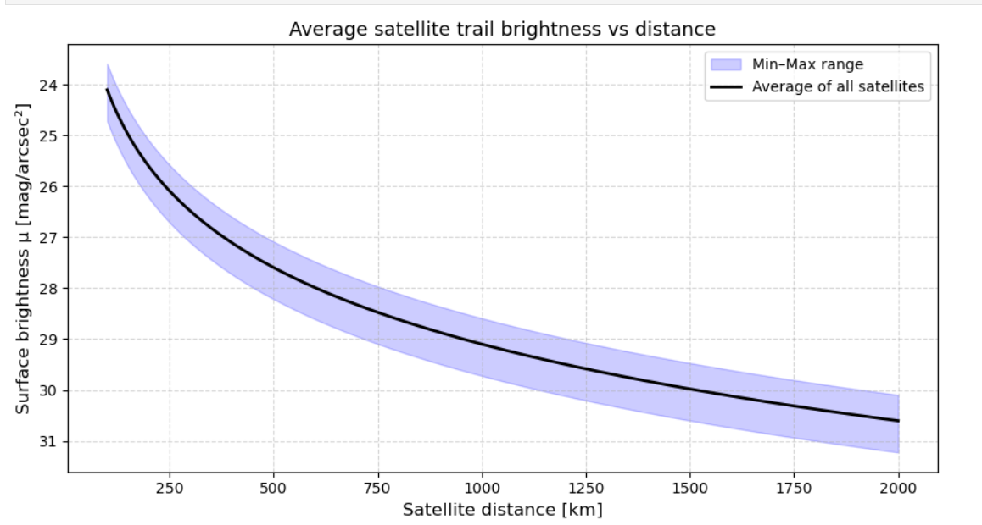
Figure 5.2. Population-averaged surface brightness vs. range, with min–max band across all modelled satellite types (original analysis).
The black curve is the range-dependent mean surface brightness across the full modelled population (not just the four satellites plotted individually); the shaded band gives the brightest-to-faintest spread at each range. This average — rather than any single satellite's curve — is the physically relevant quantity for mission-level contamination assessment, since SPHEREx has no way to know in advance which satellite type will cross its field of view. This analysis notes, but does not model, that SPHEREx's own thermal self-emission contribution would further raise these brightness estimates at the reddest wavelengths — the gap addressed directly in §7.8 below.

6. Extended Methodology: Real Orbital Data
Sections 6–9 report a from-scratch extension built independently of §5. Every number is either printed by a script in the accompanying repository (github.com/Joshan006/Spherex; script named in brackets) or is an explicitly cited external value. Superseded earlier scripts are kept separately in scripts/superseded for the record.

6.1 Real orbital data
Orbital elements are real two-line element sets (TLEs) from the public NORAD catalogue (Celestrak, via KeepTrack), retrieved September 2026; every line passes the TLE checksum. SPHEREx: NORAD 63182 (epoch 19 Jul 2026). OneWeb-0617: NORAD 55158 (~1,220 km, 87.9°; epoch 15 Sep 2026). Propagation uses the reference sgp4 library in the TEME frame; all derived quantities are differences of state vectors in the same frame. Where orbits are propagated months from their TLE epoch (§6.4), SGP4 does not predict where a satellite will actually be; it provides physically consistent reference orbits (altitudes stay stable to within a few km over a year), which is what a statistical comparison requires.

6.2 Pointing and field-of-view model
SPHEREx's survey rules (Borlaff et al. 2025, Methods) are applied directly. For each simulated exposure, SPHEREx's position is drawn from one real SGP4-propagated orbit at the chosen date; a boresight is drawn uniformly in solid angle within 35° of local zenith (the outward radial direction at SPHEREx) and redrawn until it is at least 91° from the Sun. Over the year the angle between zenith and the Sun ranges from about 60° to 120°, and a valid pointing is found at every sampled orbital phase on every date. The 3.5° × 11.3° field (Crill et al. 2024) is centred on the boresight with a random roll, fixed inertially during the exposure. A satellite counts as a trail if, at any instant of the 112.5 s exposure, it lies inside the field, is not behind Earth, and is sunlit (cylindrical Earth shadow). The Sun direction uses the standard low-precision solar ephemeris including the equation of centre (accurate to ~0.01°). [spherex_geometry.py]

6.3 Constellation model and averaging
Each constellation is modelled as circular-orbit shells (altitude and inclination from public filings) with right ascension of ascending node and orbital phase drawn uniformly at random. Shells above SPHEREx: OneWeb 1,200 km / 87.9° (6,372 filed); Guowang GW-2 ~1,145 km, split equally between 50° and 86.5° (6,912); Qianfan ~1,160 km / ~89° (~15,000 filed); Telesat Lightspeed 1,015 km / 99° (78) and 1,325 km / 50.9° (120). Below-SPHEREx control shells: Starlink 550 km / 53° and 530 km / 43°, Amazon Leo 630 km / 51.9°, Guowang GW-A59 590 km / 85°. The model is averaged over 12 dates spread across a year (Sep 2026 – Aug 2027), with 400,000 simulated exposures per shell per date and two independent random seeds: 9.6 million exposures per above-orbit shell, about 62 million in total. [13_final_model_year_averaged.py, 17_summarise_results.py]
Time resolution matters because observable crossings are near-overhead and fast (§7.7). A convergence test on identical random draws recovers 0.58, 0.85 and 0.97 of the converged count at 7.5 s, 2.5 s and 1 s steps, with no change at 0.5 s or below. The model therefore flags candidates in a 2.5 s pass with the field padded by 4° and re-checks only those at 0.1 s; on identical draws this reproduces brute-force 0.1 s detection exactly (33 of 33 crossings). [14_convergence_test.py]

6.4 Real-orbit validation
The real OneWeb-0617 orbit is propagated against the real SPHEREx orbit across twelve 30-day windows spread over a year, so that the Sun-synchronous SPHEREx plane rotates through every orientation relative to the OneWeb plane. Every 112.5 s exposure receives 20 independent random valid pointings, with the same random roll, Sun ephemeris and coarse-plus-fine detection as the model. The pooled crossing probability is compared with the idealised OneWeb shell evaluated on the same 12 dates. Because the 20 pointings share one satellite trajectory, their crossings are not independent, so the uncertainty is taken from bootstrap resampling of the twelve windows. [15_real_oneweb_validation.py]

6.5 Photometry and TLE error budget
Thermal emission and reflected sunlight are computed across 0.75–5.01 μm for three surface models, because the wavelength at which they cross depends on the model: (A) a flat plate face-on to both Sun and observer; (B) a Lambertian sphere at each event's phase angle, with the flat-plate equilibrium temperature; (C) an isothermal sphere. Albedo 0.25 and emissivity 0.9 are used consistently for both the equilibrium temperature and the emitted flux. The TLE error budget takes ~1 km at epoch plus ~2 km/day (mid-range of the 1–3 km/day literature figure) as an isotropic 1-sigma error on both objects and propagates it by Monte Carlo into range and magnitude for every observable crossing, for operational TLE ages of 1, 3 and 7 days. [16_observable_events_photometry.py]

7. Extended Results

7.1 Single-pair full-exposure propagation
SPHEREx and OneWeb-0617 propagated together across one 112.5 s exposure (0.5 s steps, 16 Sep 2026 06:00 UTC) establish the geometry machinery: range 12,770 → 13,161 km, apparent angular velocity 196–207 arcsec/s, no field crossing. Individual conjunctions are rare, which is why the population approach below is needed. [01_full_window_propagation.py]
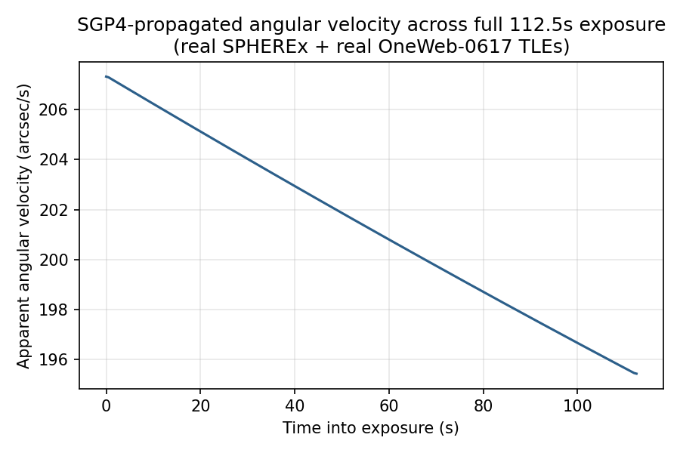
Figure 7.1. Apparent angular velocity of OneWeb-0617 seen from SPHEREx across one exposure, from real SGP4 state vectors.

7.2 How the discrepancy with the literature was found and corrected
The first version of the model (fixed North Ecliptic Pole boresight, no survey constraints, a representative shell set scaled proportionally to 560,000 satellites) predicted 64.9 trails per exposure at full build-out, 11.5× Borlaff et al.'s 5.64. Figure 7.2 traces each step. Eclipse and brightness cuts changed nothing. Random unconstrained pointings made it worse (95.2). Applying SPHEREx's 35° zenith limit and 91° solar avoidance, which the paper's Methods specify and the first model had omitted, brought it to 11.4 and then 7.0–7.7. Correcting two constellation altitudes (Guowang and Qianfan had been placed at 800 km and 580 km; their filed shells are ~1,145 km and ~1,160 km), dropping proportional scaling, and converging the time step gave 4.5.
An independent review of the code then found that the field's roll had been effectively fixed in inertial space although the text described it as random, that the model had been evaluated on a single date, and that the time-step test had not actually varied the time step. Fixing these (random roll, 12 dates across a year, accurate Sun, the true 3.5° × 11.3° field) raised the result by about 30% to the value in §7.4. The roll correction was the largest single change.
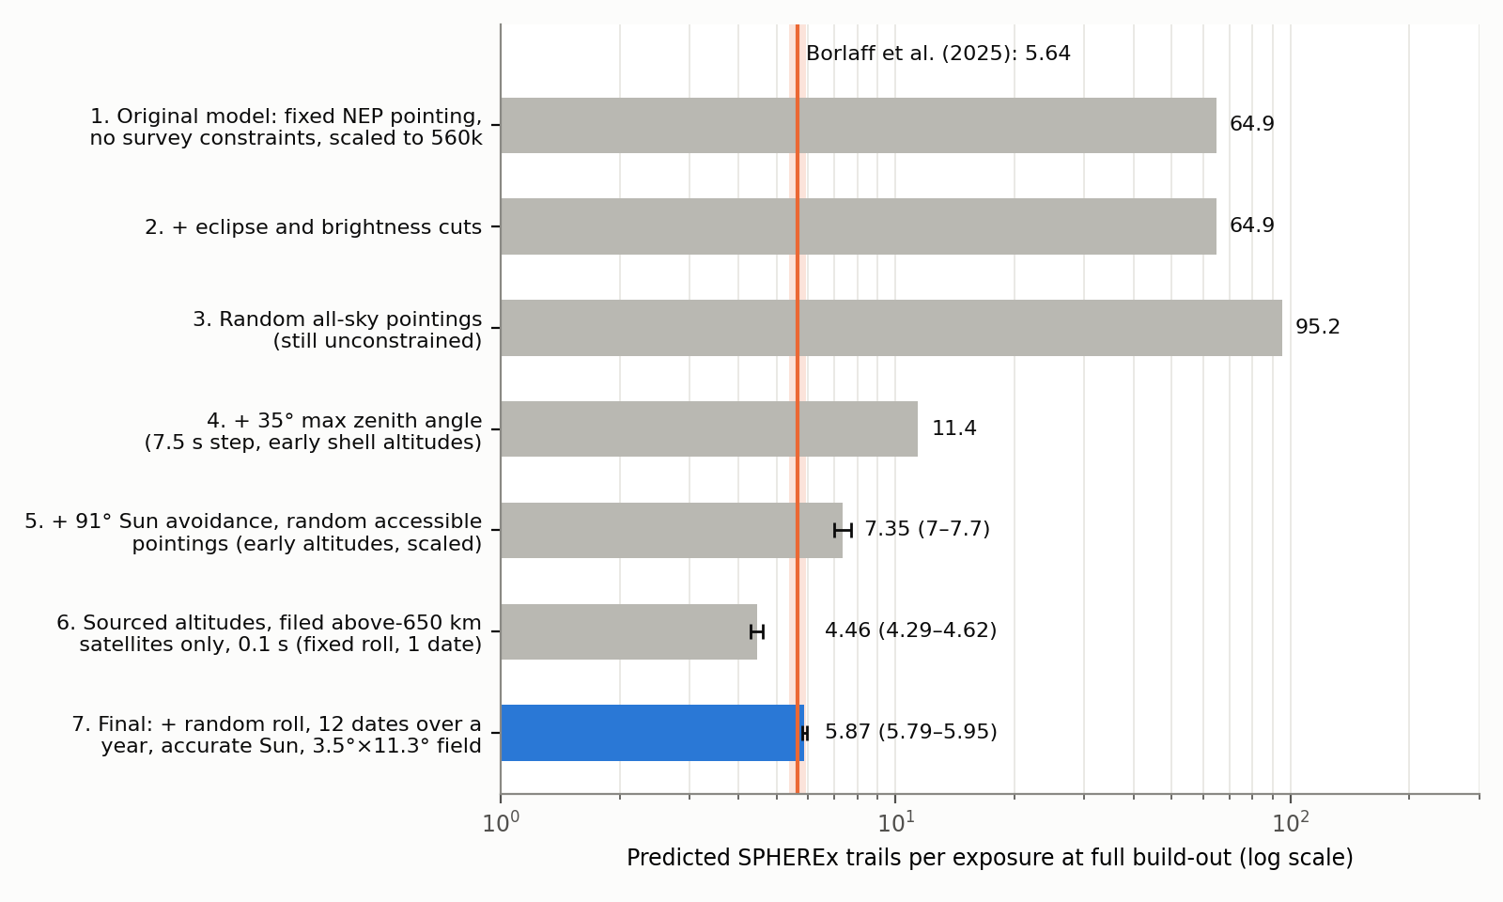
Figure 7.2. Predicted full-build-out trail rate at each stage of the investigation (log scale). Grey: superseded stages. Blue: final model. Orange band: Borlaff et al. (2025).
The investigation also invalidates a headline figure from the earliest version of this work, ~2.3 trails per exposure for today's population “at a representative sky pointing”. That rate came from the fixed North Ecliptic Pole boresight: at all 36 real crossings behind it the pole was 101–164° from SPHEREx's zenith, a direction SPHEREx never points, and about 80% of it came from Starlink, which SPHEREx cannot see (§7.3). The figure is withdrawn and replaced by §7.5.

7.3 Only satellites above SPHEREx's orbit can cross its field
With the boresight within 35° of zenith, every line of sight inside the field stays well below 90° from local vertical during the exposure, so it climbs monotonically away from Earth and can only intersect orbits higher than SPHEREx's own. The simulation confirms this: the four below-orbit control shells (Starlink 550 and 530 km, Amazon Leo 630 km, Guowang GW-A59 590 km) produced 0 crossings in about 4.8 million valid exposures. Most satellites in orbit today are Starlink, so most of today's satellite population is invisible to SPHEREx's survey.

7.4 Full build-out prediction versus Borlaff et al. (2025)
Constellation (above SPHEREx) | Altitude / incl. | Filed sats | P(cross) per sat per exposure | Trails / exposure
OneWeb | 1,200 km / 87.9° | 6,372 | 2.31 × 10⁻⁴ | 1.47
Guowang GW-2 (half) | 1,145 km / 50° | 3,456 | 1.45 × 10⁻⁴ | 0.50
Guowang GW-2 (half) | 1,145 km / 86.5° | 3,456 | 2.26 × 10⁻⁴ | 0.78
Qianfan | 1,160 km / 89° | ~15,000 | 2.06 × 10⁻⁴ | 3.09
Telesat Lightspeed | 1,015 / 1,325 km | 198 | 1.3–1.8 × 10⁻⁴ | 0.03
Total |  | ~28,500 |  | 5.87 ± 0.08
Borlaff et al. (2025) |  | ~560,000 (all altitudes) |  | 5.64 (+0.28/−0.27)
The two random seeds give 5.84 and 5.91; ±0.08 is the statistical error. The prediction is 1.04× the published value and lies inside its uncertainty. This agreement should be read as consistency, not as a precise confirmation, because the model's systematic uncertainties are larger than 4%:
- Qianfan dominates (3.1 of 5.9). Its ~15,000 figure is a filing; the committed near-term phase is 1,296 satellites. With only that phase the total would be 3.1 trails per exposure.
- The real-orbit validation (§7.6) tests the idealised-shell approach to about ±35% (68% interval), for one OneWeb satellite.
- Guowang's inclination split, Qianfan's exact altitude and inclination, and whether Borlaff et al.'s registry contains further high-altitude constellations are not known precisely; their constellation table could not be read as data for this work.
- Roll matters: with the field fixed in inertial space instead of randomly rolled, per-satellite rates were 8–28% lower depending on the shell. SPHEREx's real roll follows its scan strategy, which is not modelled.

7.5 Today's population
Three constellations have satellites above SPHEREx today: OneWeb (654), Guowang GW-2 (186) and Qianfan (~248) (KeepTrack, Orbital Radar, Aug–Sep 2026; Guowang split evenly between its two inclinations). Together they give about 0.24 trails per exposure, so roughly one SPHEREx exposure in four carries a trail, about two thirds of them from OneWeb. The ~9,400 Starlink and ~200 Amazon Leo satellites contribute nothing under SPHEREx's survey geometry. [17_summarise_results.py]

7.6 Real-orbit validation
The real OneWeb orbit produced 1,289 crossings in 5.53 million valid exposure-pointings over the year, a per-satellite probability of 2.33 × 10⁻⁴, against 2.31 × 10⁻⁴ for the idealised shell on the same dates: real/model = 1.01, with a 68% bootstrap interval of 0.62–1.37. The rate varies strongly from window to window (0.8 to 11.7 per 10⁴ exposures) as the relative orbital-plane geometry rotates; a single November window contributes about 40% of all crossings, which is why the interval is wide. The idealised-shell model is therefore validated to roughly ±35%, not better.
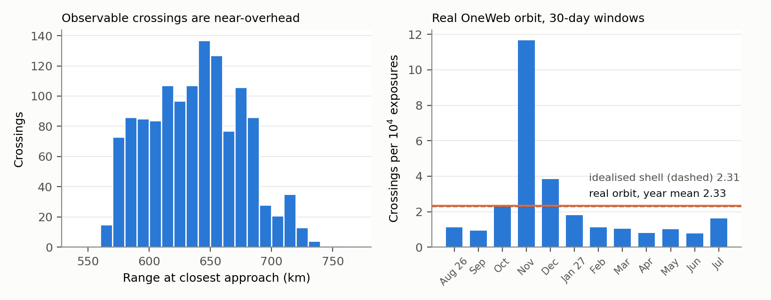
Figure 7.3. Left: range at closest approach for the 1,289 observable real OneWeb crossings. Right: crossing rate in each 30-day window of the one-year real-orbit comparison, with the year means of the real orbit (solid) and the idealised shell (dashed).

7.7 What an observable crossing looks like
Quantity (1,289 observable crossings) | Value
Range at closest approach | median 640 km (5–95%: 578–704 km)
Apparent angular rate | median 1.19°/s
Time inside the field | median 3.4 s (5–95%: 0.6–13.4 s) of a 112.5 s exposure
Sun–satellite–SPHEREx phase angle | median 80° (5–95%: 48–90°)
Because only higher satellites are visible and SPHEREx looks nearly straight up, crossings happen close to the minimum possible range (1,200 − 650 ≈ 550 km). They are close and fast, and because SPHEREx always points at least 91° from the Sun, the satellites are seen at phase angles of 90° or less (partly to fully lit faces).

7.8 Thermal-infrared versus reflected light
The wavelength beyond which a satellite's own thermal emission outshines reflected sunlight lies between 3.4 and 4.1 μm, depending on the surface model: 3.81 μm for a face-on flat plate at its 316 K equilibrium temperature, 3.39 μm (median over events) for Lambertian-sphere reflection at the observed phase angles with the plate temperature, and 4.12 μm for an isothermal sphere at 266 K. In every case SPHEREx's longest-wavelength band (4.41–5.01 μm) is thermally dominated, a regime the original reflectance model (§5) could not describe and where surface darkening does not help.
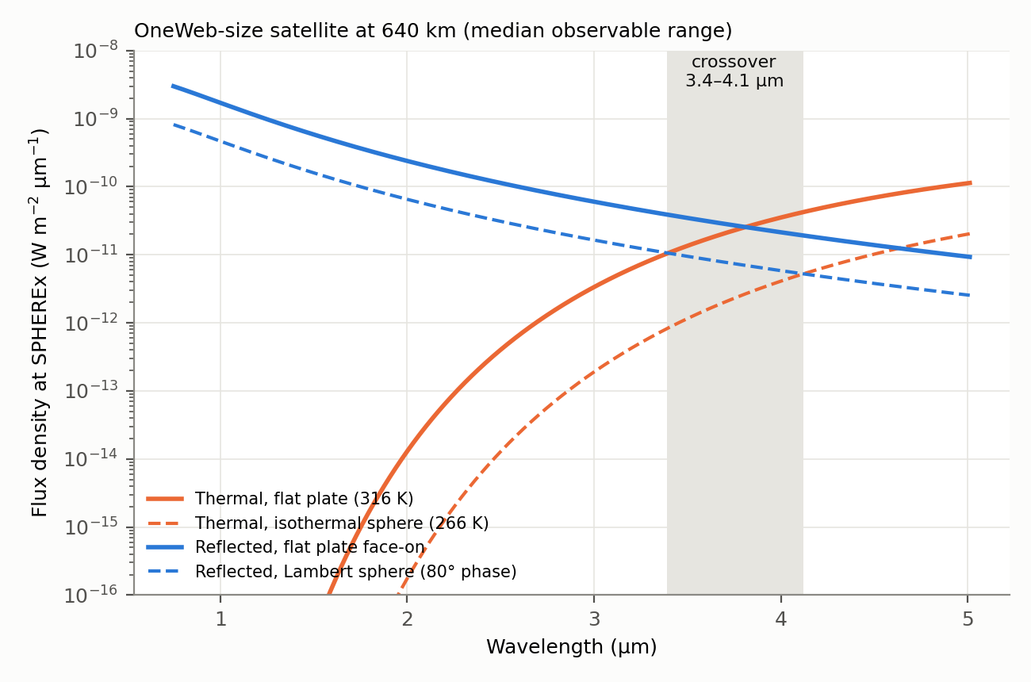
Figure 7.4. Thermal and reflected flux across SPHEREx's wavelength range for a OneWeb-size satellite at the median observable range, for the surface models in §6.5. The shaded band marks the range of crossover wavelengths.

7.9 TLE error budget
TLE age (per object) | 1-sigma position | Median range uncertainty | Median magnitude uncertainty
1 day | 3 km | 0.66% | 0.014 mag
3 days | 7 km | 1.55% | 0.034 mag
7 days | 15 km | 3.32% | 0.072 mag
With TLEs refreshed every few days, as is operationally normal, predicted trail positions and brightnesses are good to a few percent and a few hundredths of a magnitude: enough to flag contaminated exposures, though not for sub-pixel trail masking. This budget describes operational prediction; it does not describe the months-old TLEs used as reference orbits in §6.4.

8. Limitations
- The full-build-out result depends most on how many high-altitude satellites are eventually launched, above all Qianfan (1,296 committed versus ~15,000 filed).
- Constellations are idealised as uniformly random circular shells rather than real Walker plane structures; the real-orbit check covers one OneWeb satellite and validates the approach to about ±35%.
- Pointings are drawn uniformly over the accessible sky with a random roll, not from SPHEREx's actual survey sequence and scan-driven roll.
- Guowang's inclination split and Qianfan's altitude and inclination are approximations from secondary sources; in-orbit counts come from satellite-tracking websites.
- Photometry uses simple surface models (flat plate or Lambertian sphere) with representative size and albedo; it ignores attitude, eclipse thermal history and material-specific properties, which is why the crossover is quoted as a range.

9. Conclusions
SPHEREx's own survey rules are its best defence against megaconstellations. Because it only points within 35° of zenith, every satellite orbiting below it, including all of Starlink and Amazon Leo, is geometrically invisible. Its exposure is set by the smaller population of high-altitude constellations: about 0.24 trails per exposure today (one exposure in four), rising to 5.9 ± 0.1 if the filed high-altitude constellations are completed. That is consistent with the 5.64 published by Borlaff et al. (2025), with the caveat that the future number depends mainly on how much of Qianfan is actually built.
The crossings that do occur are near-overhead, fast and short (a few seconds in a 112.5 s exposure), and at the longest SPHEREx wavelengths they are dominated by the satellite's thermal emission, which darkening cannot suppress. The investigation also showed how sensitive such estimates are to modelling choices: unconstrained pointing inflated the prediction by more than an order of magnitude, and a fixed field orientation and single date lowered it by about a quarter, errors caught only by testing against the literature and by an independent code review.
Next steps: extend the real-orbit validation to many OneWeb, Guowang and Qianfan satellites across multiple planes; replace random pointings and roll with SPHEREx's published survey sequence; obtain the full constellation registry; and compare predicted crossings with trails identified in public SPHEREx images.

References
Borlaff, A. S., Marcum, P., & Howell, S. (2025). Satellite megaconstellations will threaten space-based astronomy. Nature. https://doi.org/10.1038/s41586-025-09759-5
Crill, B. P., et al. (2020). SPHEREx: NASA's near-infrared spectrophotometric all-sky survey. Proceedings of SPIE 11443.
Crill, B. P., et al. (2024). SPHEREx: NASA's near-infrared spectrophotometric all-sky survey. arXiv:2404.11017.
Gong, Y., et al. (2019). Cosmology from the Chinese Space Station Optical Survey (CSS-OS). The Astrophysical Journal, 883, 203.
Corral van Damme, C., et al. (2024). ARRAKIHS: ESA's new fast-implementation science mission. Proceedings of SPIE 13092.
Celestrak (T.S. Kelso). NORAD two-line element sets, retrieved September 2026. https://celestrak.org
python-sgp4 library documentation — cited SGP4/TLE accuracy (~1 km at epoch, 1–3 km/day growth).
Borlaff, A. S., Marcum, P., & Howell, S. (2026). Author Correction: Satellite megaconstellations will threaten space-based astronomy. Nature 654, E14. https://doi.org/10.1038/s41586-026-10553-0 (corrects ARRAKIHS values only; SPHEREx values unchanged).
Guowang constellation shells (GW-2 ~1,145 km; GW-A59 ~590 km) and Qianfan planned altitude (~1,160 km): CircleID, “Chinese LEO Satellite Internet Update: Guowang, Qianfan, and Honghu-3”; Wikipedia, “Guowang” (accessed September 2026).

